鸡皮疙瘩

[TypeScript Tutorial (w3schools.com)](https://www.w3schools.com/typescript/index.php)

目录

TS HOME

TS Introduction

[TS Get Started](https://www.w3schools.com/typescript/typescript_getstarted.php" \t "https://www.w3schools.com/typescript/_top)

[TS Simple Types](https://www.w3schools.com/typescript/typescript_simple_types.php" \t "https://www.w3schools.com/typescript/_top)

[TS Special Types](https://www.w3schools.com/typescript/typescript_special_types.php" \t "https://www.w3schools.com/typescript/_top)

TS Arrays

TS Tuples

[TS Object Types](https://www.w3schools.com/typescript/typescript_object_types.php" \t "https://www.w3schools.com/typescript/_top)

[TS Enums](https://www.w3schools.com/typescript/typescript_enums.php" \t "https://www.w3schools.com/typescript/_top)

[TS Aliases & Interfaces](https://www.w3schools.com/typescript/typescript_aliases_and_interfaces.php" \t "https://www.w3schools.com/typescript/_top)

[TS Union Types](https://www.w3schools.com/typescript/typescript_union_types.php" \t "https://www.w3schools.com/typescript/_top)

[TS Functions](https://www.w3schools.com/typescript/typescript_functions.php" \t "https://www.w3schools.com/typescript/_top)

[TS Casting](https://www.w3schools.com/typescript/typescript_casting.php" \t "https://www.w3schools.com/typescript/_top)

[TS Classes](https://www.w3schools.com/typescript/typescript_classes.php" \t "https://www.w3schools.com/typescript/_top)

[TS Basic Generics](https://www.w3schools.com/typescript/typescript_basic_generics.php" \t "https://www.w3schools.com/typescript/_top)

[TS Utility Types](https://www.w3schools.com/typescript/typescript_utility_types.php" \t "https://www.w3schools.com/typescript/_top)

[TS Keyof](https://www.w3schools.com/typescript/typescript_keyof.php" \t "https://www.w3schools.com/typescript/_top)

[TS Null](https://www.w3schools.com/typescript/typescript_null.php" \t "https://www.w3schools.com/typescript/_top)

[TS Definitely Typed](https://www.w3schools.com/typescript/typescript_definitely_typed.php" \t "https://www.w3schools.com/typescript/_top)

## TypeScript tutorial

[TS HOME](https://www.w3schools.com/typescript/index.php" \t "https://www.w3schools.com/typescript/_top)[TS Introduction](https://www.w3schools.com/typescript/typescript_intro.php" \t "https://www.w3schools.com/typescript/_top)[TS Arrays](https://www.w3schools.com/typescript/typescript_arrays.php" \t "https://www.w3schools.com/typescript/_top)

[TS Tuples](https://www.w3schools.com/typescript/typescript_tuples.php" \t "https://www.w3schools.com/typescript/_top)

# TypeScript tutorial

**TS HOME**

We recommend reading this tutorial(教程) in the sequence(顺序，次序) listed in the left menu.

**TS Introduction**

What is TypeScript?

TypeScript is a syntactic superset(语法超集) of JavaScript which adds **static typing**.

This basically means that TypeScript adds syntax on top of JavaScript, allowing developers to add **types**.

TypeScript being a "Syntactic Superset" means that it shares the same base syntax as JavaScript, but adds something to it.

TS Simple Types

Type Assignment

When creating a variable, there are two main ways TypeScript assigns a type:

* Explicit
* Implicit

In both examples below **firstName**is of type **string**

Explict Type

**Explicit**- writing out the type:

let firstName: string = "Dylan";

**Explicit**type assignment are easier to read and more intentional(故意的).

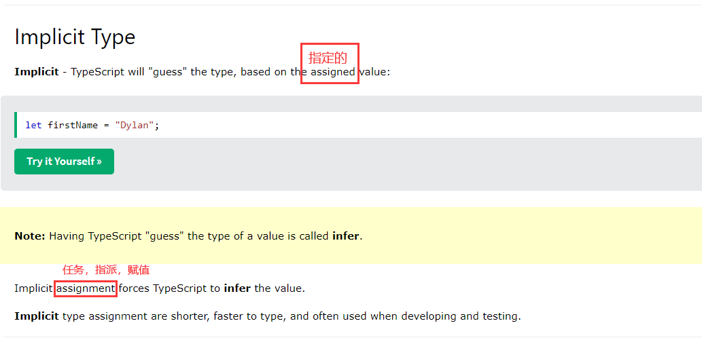

developing and testing(开发和测试).

**TS Special Types**

**TS Arrays**

Sequences(有序列)

**TS Tuples**

**TS Object Types**

**TS Enums**

**[TS Aliases(别名) & Interfaces](https://www.w3schools.com/typescript/typescript_aliases_and_interfaces.php)**

1. Type Aliases allow defining types with a custom name (an Alias).
2. Type Aliases can be used for primitives(原始事物；基本体) like string or more complex types such as objects and arrays:

|  |  |  |
| --- | --- | --- |
|  |  | diff |
| Type Aliases | Type Aliases allow defining types with a custom name (an Alias).  Type Aliases | example |
| Interfaces |  | **Only** apply to object types |
|  |  |  |

Type Aliases can be used for primitives like string or more complex types such as objects and arrays.

**Interfaces** are similar to type aliases, except they **only apply to object types.**

**Interfaces 定义对象类型**

Type Aliases

**TS Union Types**

Union types(联合类型) are used when a value can be more than a single type.

Union | (OR)

Using the | we are saying our parameter is a string or number:

**Example**

**TS Functions**

**TS Casting**(类型转换)

1. **Casting with as**

A straightforward way to cast a variable is using the as keyword, which will directly change the type of the given variable.

1. **Casting with <>**

Using <> works(从事……工作,起到...作用) the same as casting with as.

1. **Force casting**

To override(覆盖) type errors that TypeScript may throw when casting, first cast to unknown, then to the target type.

**TS Classes**

**TS Basic Generics**

**TS Tuples(固定有序列)**

**TS Utility Types 实用类型: Partial, Required,Record**

TypeScript comes with a large number of types that can help with **some common type manipulatio**(一些常见类型操作), usually referred to as utility types.

This chapter **covers**(涵盖) the most popular utility types

**#Partial**

Partial changes all the properties in an object to be optional.

**#Required**

Required changes all the properties in an object to be required.

**#Record**

Record is a shortcut to defining an object type with a specific key type and value type.

Record 是一种便捷方式，用来定义一个对象的key的类型和value的类型

Record<string, number> is equivalent(等效的) to { [key: string]: number }

**TS Keyof**

keyof with explicit keys

When used on an object type with explicit keys, keyof creates a union type with those keys.

Example1

**注释**：keyof 把对象的属性name作为类型，用来创建一种类型，这个类型是一个联合类型，是取对象属性的类型创建的，从某方面来说他限定了类型的范围是对象的所有属性name

// `keyof Person` here creates a union type of "name" and "age", other strings will not be allowed

Example2

**TS Null**

**TS Definitely Typed**

1. number doesn't have *access* to it.

1. `The type of the value returned by the function can be explicitly defined.`

**[typescriptlang](https://www.typescriptlang.org/)**

**TypeScript for the New Programmer**

You’ve probably already heard that TypeScript is a **“flavor**”(风格) or “**variant**”(变体) of JavaScript. The relationship between TypeScript (TS) and JavaScript (JS) is rather **unique**(独特的) among modern programming languages, so learning more about this relationship will help you understand how TypeScript adds to JavaScript.

Utility Types

TypeScript provides several utility types to facilitate(使更容易) common type transformations. These utilities are available(可访问) globally.