注册

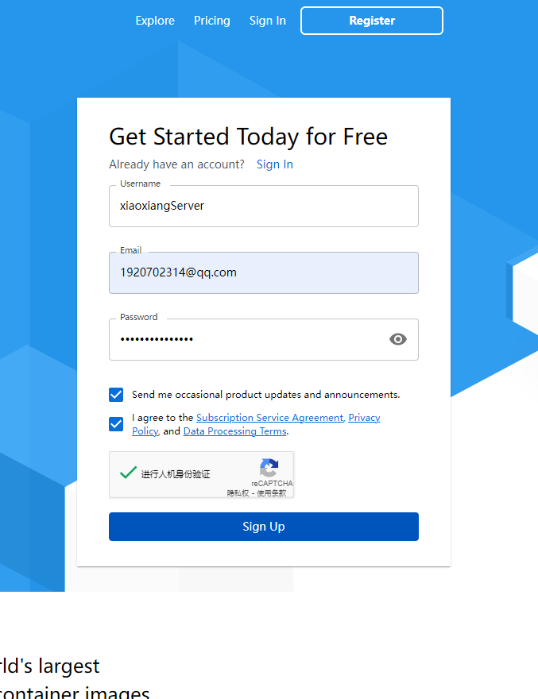

1. [什么是Docker？原理，作用，限制和优势简介](https://link.segmentfault.com/?enc=0UQ7kZIy9mDDlpVBlIjhrg==.wiE2xtD2qYSbnOtEFMl6CCWC1FUlJzfh47M4HgT7W9b51WE18ukJ+kfSucutXeZlyNfX9xbpwUU2e8ISHeVaTA==" \t "https://segmentfault.com/a/_blank)
2. [虚拟化简介：特点，优势，管理与应用](https://link.segmentfault.com/?enc=hkF2KxT2RGgpROtYcpdgtQ==.Aj7fM3C2w7QieI+cg345ZsI88rD7GdDC5wZwE5UKtDzvqWfC5b+oKGxqWFNbUUfm" \t "https://segmentfault.com/a/_blank)
3. [何为虚拟化？](https://link.segmentfault.com/?enc=ER6v7aV28oDS61TJLCE0Aw==.GAPsdKFHvTU5dSbAJ0QIJXJoJyRiLIWx2kEi6ZaSpp69pleeyd+8IWVEtAYc3IdnIlfbtEo2ayG5rUgNmm0/ayjqo2AGGzIr7Mzq+YlPJBw=" \t "https://segmentfault.com/a/_blank)
4. [Linux® 容器（LXC技术）](https://link.segmentfault.com/?enc=y0l6ciWCUbXNoi3Vuo5ECA==.3osVs8bcabcyK9VSTJ9Lae3/4mG4bC+w5imNCiRPfSlIEpBeYQVdGYm5b4aQ+T5H" \t "https://segmentfault.com/a/_blank)
5. [知乎问题 - docker容器与虚拟机有什么区别？](https://link.segmentfault.com/?enc=2JHtAaelxHhSs0vjSa6w5A==.NgZMbxa+JaNQcffbOWRCO8XjFFq3HeGRfP42ECP0gsFUp5okMNFUsiat5IOdOF4L" \t "https://segmentfault.com/a/_blank)
6. [知乎问题 - wsl 2 是否需要启用 Hyper-V？](https://link.segmentfault.com/?enc=PFHpJSl2wT4JMv/BjwgYfQ==.VYvWz4XLONTfyK+fMioS3aZ7IKN5qLi8pce9kG4QhDgT8+EXqTTenk2Pzt7NOvp9" \t "https://segmentfault.com/a/_blank)
7. [Docker 官网DOCS](https://link.segmentfault.com/?enc=SROfwBqrO76HaWx38M7cyg==.Y8+xWXHlCGEtNPcJ5AV9ZGrUHNh9yt3sCwLy99VNCM0=" \t "https://segmentfault.com/a/_blank)
8. [Hyper-V 微软官方文档](https://link.segmentfault.com/?enc=0fQUaPcYprdRLiCOzRMtJQ==.+Q3xUycLucuMddaFRillOCV+kuXZ5wX9MUNMnN8cnH1ueypGZY7h4fyLhR+ubbcaH6KUjkRv0rIuyNH5EBp/x+amrcfxrL/Yx3xMRzgqTDk=" \t "https://segmentfault.com/a/_blank)
9. [WSL 微软官方文档（Windows Subsystem for Linux，适用于windows的linux子系统）](https://link.segmentfault.com/?enc=Ye5Hmv2DQhBd23eYEw6+Lg==.N6hz1Atqgk001eEgUD6YVomgQm9PBO11uTfRcne06ySG01ra/u8PHoMVXWcaQR1D" \t "https://segmentfault.com/a/_blank)
10. [Windows10安装Docker使用Hyper-v还是WSL2](https://link.segmentfault.com/?enc=4EpfiuweKxGy/RBufMIcoA==.VvFctx5wdPJV94W68m5VmpipNszFU3todoreUVujrKttIxDq8m0G8rrC1eQb95gDjNs+iN3y7gYKRJ8Z+9THng==" \t "https://segmentfault.com/a/_blank)
11. [Docker on Hyper-V vs WSL 2](https://link.segmentfault.com/?enc=I28lOc+4nJgD/LCAb0gzeg==.AK6pmkiPuO/w43OWHxZBWUMI3DjnU9/rybY5Kp3378znOZFCvb228Y3OddnQERPKlUYI8bm/T3jzn672Hi3E1sRlE7bDe3uIoTh+BEiG36Y=" \t "https://segmentfault.com/a/_blank)
12. [Working with Node.js on Hyper-V and WSL2](https://link.segmentfault.com/?enc=sR3MBPivmXeqa4G8N/GU5g==.Sel0ntPPGok3ZhGt8T/yxuyX1ubjBv7wVgQTQvOGYt3y1nEx5jtv9+0dvdIJvgGmj8JyIXUdolZfnYX8eqOEdtJbBVU6b+hvhUEmyGcspUU=" \t "https://segmentfault.com/a/_blank)

[docker - Win10 安装 Docker Desktop ( 基于WSL2，WSL vs Hyper-V)_个人文章 - SegmentFault 思否](https://segmentfault.com/a/1190000041078669)

Uaername: xiaoxiangserver

Pass: xiaoxiangServer

[Quick Start Guide and sign in | Docker Documentation](https://docs.docker.com/desktop/get-started/)

Two-factor(因素，要素) authentication