D:\工具\node

培养大家思考研究的习惯

求知：不懂就问，不怕笑话，勇于发言，不要怕错

**更新日志**

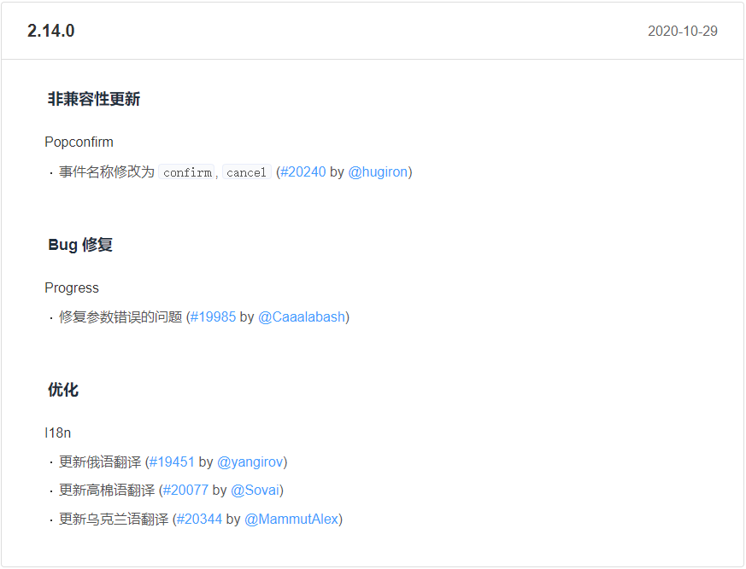

[2.13.1](https://github.com/ElemeFE/element/releases/tag/v2.13.1" \t "https://element.eleme.cn/" \l "/zh-CN/component/_blank) 2020-04-13

#### **新特性**

* Autocomplete
  + 添加 change 事件 ([#17913](https://github.com/ElemeFE/element/issues/17913" \t "https://element.eleme.cn/" \l "/zh-CN/component/_blank) by [@sxzz](https://github.com/sxzz" \t "https://element.eleme.cn/" \l "/zh-CN/component/_blank))

\* 在网站上动态渲染任意 HTML 是非常危险的，因为容易导致 [XSS 攻击](https://en.wikipedia.org/wiki/Cross-site_scripting)。因此请在 dangerouslyUseHTMLString 打开的情况下，确保 message 的内容是可信的，永远不要将用户提交的内容赋值给 message 属性。

## UNPKG

unpkg is a fast, global content delivery network for everything on [npm](https://www.npmjs.com/). Use it to quickly and easily load any file from any package using a URL like:

unpkg.com/:package@:version/:file

#### Examples

Using a fixed version:

* [unpkg.com/react@16.7.0/umd/react.production.min.js](https://unpkg.com/react@16.7.0/umd/react.production.min.js)
* [unpkg.com/react-dom@16.7.0/umd/react-dom.production.min.js](https://unpkg.com/react-dom@16.7.0/umd/react-dom.production.min.js)

You may also use a [semver range](https://docs.npmjs.com/misc/semver) or a [tag](https://docs.npmjs.com/cli/dist-tag) instead of a fixed version number, or omit the version/tag entirely to use the latest tag.

* [unpkg.com/react@^16/umd/react.production.min.js](https://unpkg.com/react@^16/umd/react.production.min.js)
* [unpkg.com/react/umd/react.production.min.js](https://unpkg.com/react/umd/react.production.min.js)

If you omit the file path (i.e. use a “bare” URL), unpkg will serve the file specified by the unpkg field in package.json, or fall back to main.

* [unpkg.com/jquery](https://unpkg.com/jquery)
* [unpkg.com/three](https://unpkg.com/three)

Append a / at the end of a URL to view a listing of all the files in a package.

* [unpkg.com/react/](https://unpkg.com/react/)
* [unpkg.com/react-router/](https://unpkg.com/react-router/)

#### Query Parameters

?meta

Return metadata about any file in a package as JSON (e.g./any/file?meta)

?module

Expands all [“bare” import specifiers](https://html.spec.whatwg.org/multipage/webappapis.html" \l "resolve-a-module-specifier) in JavaScript modules to unpkg URLs. This feature is very experimental

#### Cache Behavior

The CDN caches files based on their permanent URL, which includes the npm package version. This works because npm does not allow package authors to overwrite a package that has already been published with a different one at the same version number.

Browsers are instructed (via the Cache-Control header) to cache assets indefinitely (1 year).

URLs that do not specify a package version number redirect to one that does. This is the latest version when no version is specified, or the maxSatisfying version when a [semver version](https://github.com/npm/node-semver) is given. Redirects are cached for 10 minutes at the CDN, 1 minute in browsers.

If you want users to be able to use the latest version when you cut a new release, the best policy is to put the version number in the URL directly in your installation instructions. This will also load more quickly because we won't have to resolve the latest version and redirect them.

#### Workflow

For npm package authors, unpkg relieves the burden of publishing your code to a CDN in addition to the npm registry. All you need to do is include your [UMD](https://github.com/umdjs/umd) build in your npm package (not your repo, that's different!).

You can do this easily using the following setup:

* Add the umd (or dist) directory to your .gitignore file
* Add the umd directory to your [files array](https://docs.npmjs.com/files/package.json" \l "files) in package.json
* Use a build script to generate your UMD build in the umd directory when you publish

That's it! Now when you npm publish you'll have a version available on unpkg as well.

#### About

unpkg is an [open source](https://github.com/mjackson/unpkg) project built and maintained by [Michael Jackson](https://twitter.com/mjackson). unpkg is not affiliated with or supported by npm, Inc. in any way. Please do not contact npm for help with unpkg. Instead, please reach out to [@unpkg](https://twitter.com/unpkg) with any questions or concerns.

The unpkg CDN is powered by [Cloudflare](https://www.cloudflare.com/), one of the world's largest and fastest cloud network platforms.

[](https://www.cloudflare.com/)

The origin server runs on auto-scaling infrastructure provided by [Fly.io](https://fly.io/). The app servers run in 17 cities around the world, and come and go based on active requests.

[](https://fly.io/)

Build: a7ebffa

© 2022 UNPKG

# 安装

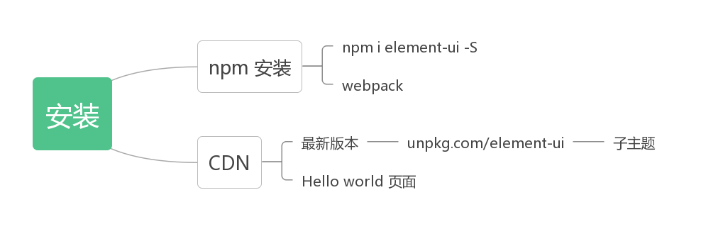

## 快速上手

本节将介绍如何在项目中使用 Element。

### 使用 vue-cli@3

### 使用 Starter Kit

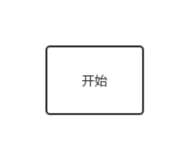

Element.ui CDN形式引入组件库

你好像很好吃a

于 2020-09-10 10:07:27 发布

1551

 收藏 3

分类专栏： Element.ui

版权

Element.ui

专栏收录该内容

6 篇文章1 订阅

订阅专栏

1、通过CDN的形式加载语言文件：【官网提供的】

<!-- 引入样式 -->

<link rel="stylesheet" href="https://unpkg.com/element-ui/lib/theme-chalk/index.css">

<!-- 引入组件库 -->

<script src="https://unpkg.com/element-ui/lib/index.js"></script>

1

2

3

4

而使用官网引入以后响应速度不是很快，后来找到一个响应很快的链接，记录一下：

<!-- 引入Vue -->

<script src="https://cdn.bootcss.com/vue/2.6.10/vue.min.js"></script>

<!-- 引入样式 -->

<link href="https://cdn.bootcss.com/element-ui/2.4.5/theme-chalk/index.css" rel="stylesheet">

<!-- 引入组件库 -->

<script src="https://cdn.bootcss.com/element-ui/2.6.1/index.js"></script>

1

2

3

4

5

6

2、接下来就可以根据官方提供的组件来进行使用了，下面我拿其中的走马灯来举例：

<div id="app">

<template>

<el-carousel :interval="4000" type="card" arrow="never" >

<el-carousel-item v-for="item in 6" :key="item.id" :id="item.id">

<img class="element-img" alt="" :src="item.url" @click="">

</el-carousel-item>

</el-carousel>

</template>

</div>

1

2

3

4

5

6

7

8

9

var vm = new Vue({

el: "#app",

});

————————————————

版权声明：本文为CSDN博主「你好像很好吃a」的原创文章，遵循CC 4.0 BY-SA版权协议，转载请附上原文出处链接及本声明。

原文链接：https://blog.csdn.net/weixin\_44296929/article/details/108508113

目标：渲染组件button到页面

