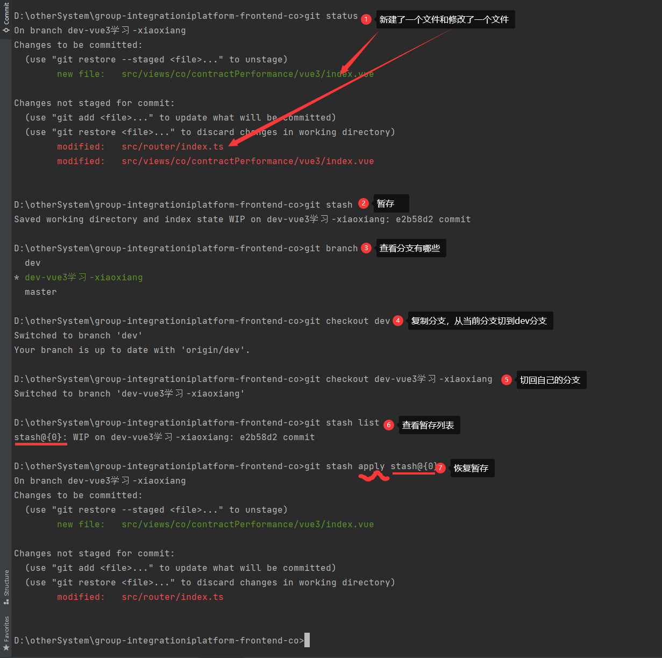

<https://www.bookstack.cn/read/git-tutorial/docs-commands-git-stash.md>

1. # 暂时保存没有提交的工作
2. $ git stash
3. Saved working directory and index state WIP on workbranch: 56cd5d4 Revert "update old files"
4. HEAD is now at 56cd5d4 Revert "update old files"
5. # 列出所有暂时保存的工作
6. $ git stash list
7. stash@{0}: WIP on workbranch: 56cd5d4 Revert "update old files"
8. stash@{1}: WIP on project1: 1dd87ea commit "fix typos and grammar"
9. # 恢复某个暂时保存的工作
10. $ git stash apply stash@{1}
11. # 恢复最近一次stash的文件
12. $ git stash pop
13. # 丢弃最近一次stash的文件
14. $ git stash drop
15. # 删除所有的stash
16. $ git stash clear

Error updating changes: The Git process exited with the code -1,073,741,819