vue-cli,webpack-cli

the Command Line Interface (**CLI**)

**命令行界面(Command Line Interface)**

* **abbr. 命令行界面（Command Line Interface for batch scripting）；生活指数（Cost of Living Index）**

GUI英 [ˈɡuːi; ˌdʒiː juː ˈaɪ]

* **abbr. 图形用户界面（Graphical User Interface**

**<https://docs.npmjs.com/about-npm>**

# **About npm**

**Table of contents**

* [Use npm to . . .](https://docs.npmjs.com/about-npm" \l "use-npm-to---)
* [Getting started](https://docs.npmjs.com/about-npm" \l "getting-started)
* [Sharing packages and collaborating with others](https://docs.npmjs.com/about-npm" \l "sharing-packages-and-collaborating-with-others)
* [Learn more](https://docs.npmjs.com/about-npm" \l "learn-more)
  + [CLI reference documentation](https://docs.npmjs.com/about-npm" \l "cli-reference-documentation)

npm is the world's largest software registry. Open source developers from every continent use npm to share and borrow packages, and many organizations use npm to manage private development as well.

npm consists of three distinct components:

* the website
* the Command Line Interface (**CLI**)
* the registry

Use the [website](https://npmjs.com/) to discover packages, set up profiles, and manage other aspects of your npm experience. For example, you can set up [organizations](https://www.npmjs.com/features) to manage access to public or private packages.

The [CLI](https://docs.npmjs.com/cli/npm) runs from a terminal, and is how most developers interact with npm.

The [registry](https://docs.npmjs.com/misc/registry) is a large public database of JavaScript software and the meta-information surrounding it.

## **Use npm to . . .**

* Adapt packages of code for your apps, or incorporate packages as they are.
* Download standalone tools you can use right away.
* Run packages without downloading using [npx](https://www.npmjs.com/package/npx).
* Share code with any npm user, anywhere.
* Restrict code to specific developers.
* Create organizations to coordinate package maintenance, coding, and developers.
* Form virtual teams by using organizations.
* Manage multiple versions of code and code dependencies.
* Update applications easily when underlying code is updated.
* Discover multiple ways to solve the same puzzle.
* Find other developers who are working on similar problems and projects.

**太多隐藏资源**

**\*\*\*\*\***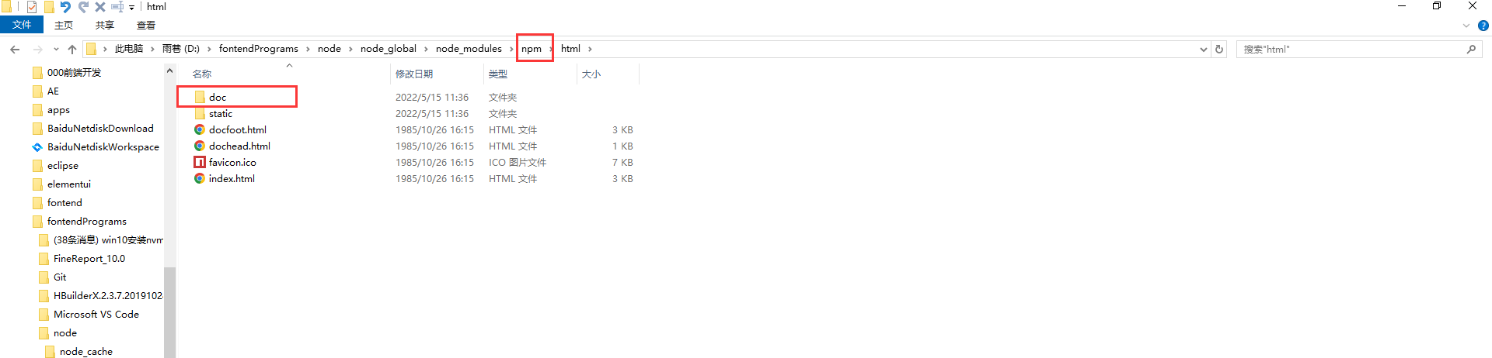

**D:\工具\node>npm help json**

没有package.json 直接npm install出现的是node_modules,package-lock.json**，不会有**package.json

D:\elementui\v2> npm install vue-loader@15.7.0 vue-template-compiler@2.6.14 webpack@2.6.14 [webpack-cli@3.0.8](mailto:webpack-cli@3.0.8)

**D:\elementui\v1>npm config list**

* Template

D:\elementui\v2\juejin-element-ui>npm install vue-loader@15.7.0

vue-**tempalte**-complier@2.6.14 -D

D:\elementui\v2\juejin-element-ui>npm run build

D:\elementui\v2\juejin-element-ui>npm run build

D:\elementui\v2\juejin-element-ui>npm run build

D:\elementui\v2>npm config ls -l

npm install -g @vue/cli@2.9.6

0 info it worked if it ends with ok  
 1 verbose cli [  
 1 verbose cli 'D:\\fontendPrograms\\nodejs\\node.exe',  
 1 verbose cli 'D:\\fontendPrograms\\node\\node_global\\node_modules\\npm\\bin\\npm-cli.js',  
 1 verbose cli 'install',  
 1 verbose cli '-g',  
 1 verbose cli '@vue/cli@2.9.6'  
1 verbose cli ]  
2 info using npm@6.11.3  
3 info using node@v12.12.0  
4 verbose npm-session 4792be2b7e381c3e  
5 silly install loadCurrentTree  
6 silly install readGlobalPackageData  
7 http fetch GET 304 https://registry.npmmirror.com/@vue%2fcli 417ms (from cache)  
 8 silly registry:manifest no matching version for @vue/cli@2.9.6 in the cache. Forcing revalidation.  
9 http fetch GET 200 https://registry.npmmirror.com/@vue%2fcli 140ms  
 10 silly fetchPackageMetaData error for @vue/cli@2.9.6 No matching version found for @vue/cli@2.9.6.  
11 timing stage:rollbackFailedOptional Completed in 0ms  
12 timing stage:runTopLevelLifecycles Completed in 576ms  
13 verbose type version  
14 verbose stack @vue/cli: No matching version found for @vue/cli@2.9.6.  
14 verbose stack at pickManifest (D:\fontendPrograms\node\node_global\node_modules\npm\node_modules\npm-pick-manifest\index.js:122:13)  
14 verbose stack at D:\fontendPrograms\node\node_global\node_modules\npm\node_modules\pacote\lib\fetchers\registry\manifest.js:43:18  
14 verbose stack at tryCatcher (D:\fontendPrograms\node\node_global\node_modules\npm\node_modules\bluebird\js\release\util.js:16:23)  
14 verbose stack at Promise._settlePromiseFromHandler (D:\fontendPrograms\node\node_global\node_modules\npm\node_modules\bluebird\js\release\promise.js:517:31)  
14 verbose stack at Promise._settlePromise (D:\fontendPrograms\node\node_global\node_modules\npm\node_modules\bluebird\js\release\promise.js:574:18)  
14 verbose stack at Promise._settlePromise0 (D:\fontendPrograms\node\node_global\node_modules\npm\node_modules\bluebird\js\release\promise.js:619:10)  
14 verbose stack at Promise._settlePromises (D:\fontendPrograms\node\node_global\node_modules\npm\node_modules\bluebird\js\release\promise.js:699:18)  
14 verbose stack at _drainQueueStep (D:\fontendPrograms\node\node_global\node_modules\npm\node_modules\bluebird\js\release\async.js:138:12)  
14 verbose stack at _drainQueue (D:\fontendPrograms\node\node_global\node_modules\npm\node_modules\bluebird\js\release\async.js:131:9)  
14 verbose stack at Async._drainQueues (D:\fontendPrograms\node\node_global\node_modules\npm\node_modules\bluebird\js\release\async.js:147:5)  
14 verbose stack at Immediate.Async.drainQueues [as _onImmediate] (D:\fontendPrograms\node\node_global\node_modules\npm\node_modules\bluebird\js\release\async.js:17:14)  
14 verbose stack at processImmediate (internal/timers.js:439:21)  
15 verbose cwd C:\Windows\system32  
16 verbose Windows_NT 10.0.17763  
17 verbose argv "D:\\fontendPrograms\\nodejs\\node.exe" "D:\\fontendPrograms\\node\\node_global\\node_modules\\npm\\bin\\npm-cli.js" "install" "-g" "@vue/cli@2.9.6"  
18 verbose node v12.12.0  
19 verbose npm v6.11.3  
20 error code ETARGET  
21 error notarget No matching version found for @vue/cli@2.9.6.  
22 error notarget In most cases you or one of your dependencies are requesting  
22 error notarget a package version that doesn't exist.  
23 verbose exit [ 1, true ]

C:\Windows\system32>npm install -g @vue/cli@2.9.6