# 新的公网服务器如何做部署

1. 安装虚拟环境

**pip3 install virtualenv**

**pip3 install virtualenvwrapper**

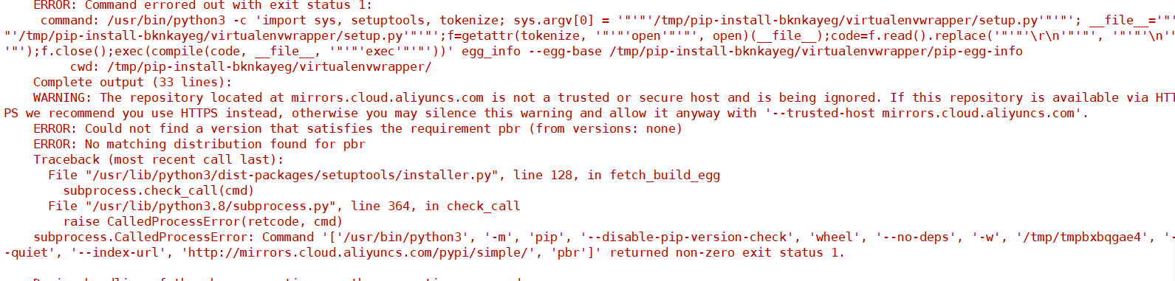

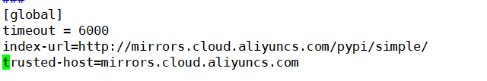

vim ~/.bashrc

**VIRTUALENVWRAPPER_PYTHON=/usr/bin/python3**

**export WORKON_HOME=$HOME/.virtualenvs**

**source /usr/local/bin/virtualenvwrapper.sh**

**下一步**

source ~/.bashrc

1. 安装依赖包

pip install -r requirements.txt

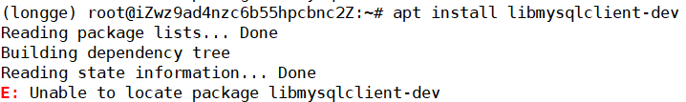

dpkg -l|grep ssl 查询ubuntu是否安装某个包

3 安装mysql

Ubuntu18.04 需要首先 dpkg -i mysql-apt-config_0.8.12-1_all.deb

apt install mysql-server

apt install mysql-client

ALTER USER 'root'@'localhost' IDENTIFIED WITH mysql_native_password BY '123';

FLUSH PRIVILEGES;

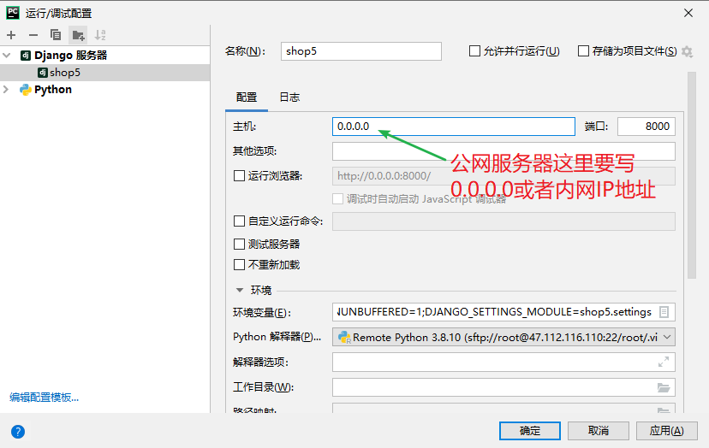

# 支付功能

<https://developers.alipay.com/developmentAccess/developmentAccess.htm>

1. 通过支付宝开发平台助手生成私钥和公钥，把私钥填入**private_2048**
2. 把本地生成的公钥，放入支付宝的RSA2中去加签，得到的支付宝公钥放入本地文件alipay_key_2048内

return_url = **'http://'**+IP+**'/alipay/return/?charset=utf-8&out_trade_n=20191115999&method=alipay.trade.page.pay.return&total_amount=100.00&sign=K1QkuZEX5nQDHzL%2BuCh3chDLesPXWyqmA2Trc5IYbH06jqUfAUle8mezNAFcGld6Lcv4KKXlwAs7a84y3yoYdjl7nxWaxk4sif%2F1DsWT6FvLJQsCjc8hsiE%2BDHLoeaiiHtJ9LsmYDtKyT4vUcg3yA3b3Q%2B4ybejLBQRjlu9r4WtlxO3oaloE880Ujwq4TthnVWzzeWMdIKdacCnnYVI9Fc2H1RdxfTQtRHXEWWW2dCBe5e4BzYOD7i4DQBYPtA4lFM%2FcTY700t0%2B7etjSzC5fS8l%2B6IO3Ea393UWVAvmJkzfYj9wRapai4qMh9KdR%2BEiGsBkXnl7lfXz9o767QQPOA%3D%3D&trade_no=2019111522001490421000021393&auth_app_id=2016101400687743&version=1.0&app_id=2016101400687743&sign_type=RSA2&seller_id=2088102179599265&timestamp=2019-11-15+17%3A08%3A40'**