<https://maven.apache.org/>

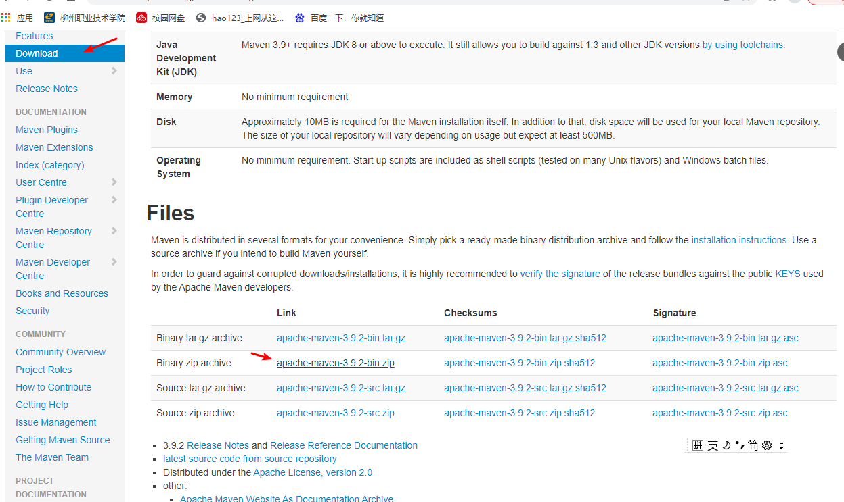

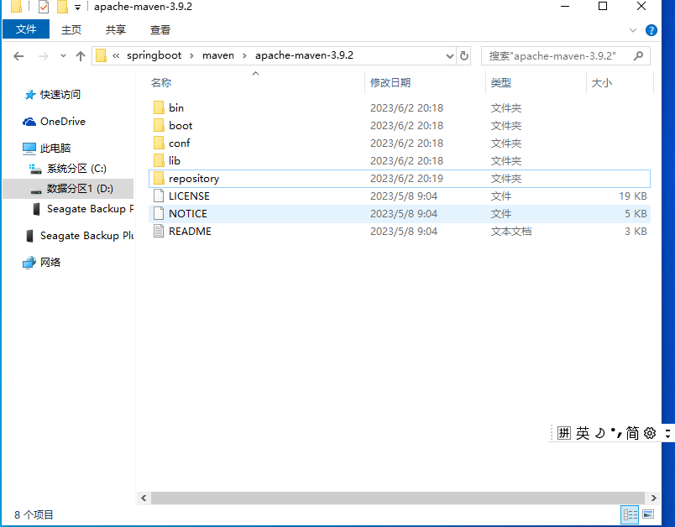

<!--设置本地仓库位置-->

<localRepository>E:\Maven\apache-maven-3.9.2\repository</localRepository>

<mirror>

<id>nexus-aliyun</id>

<mirrorOf>central</mirrorOf>

<name>Nexus aliyun</name>

<url>http://maven.aliyun.com/nexus/content/groups/public</url>

</mirror>

<profile>

<!-- settings.xml中的id不能随便起的 -->

<!-- 告诉maven我们用jdk1.8 -->

<id>jdk-1.8</id>

<!-- 开启JDK的使用 -->

<activation>

<activeByDefault>true</activeByDefault>

<jdk>1.8</jdk>

</activation>

<properties>

<!-- 配置编译器信息 -->

<maven.compiler.source>1.8</maven.compiler.source>

<maven.compiler.target>1.8</maven.compiler.target>

<maven.compiler.compilerVersion>1.8</maven.compiler.compilerVersion>

</properties>

</profile>

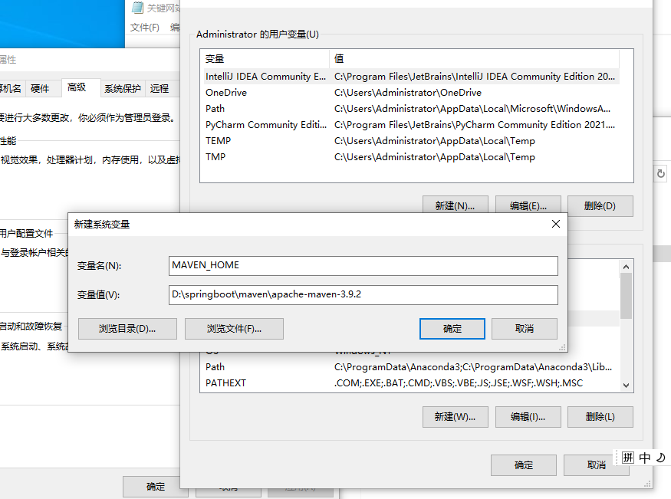

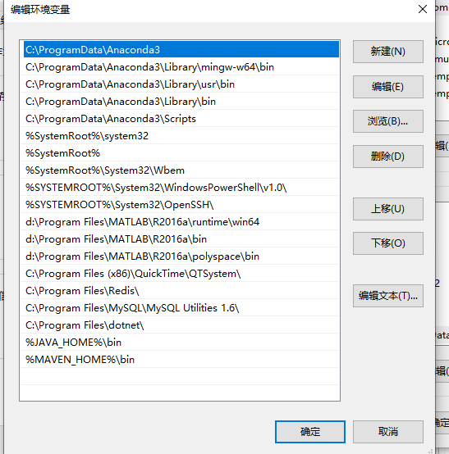

AVA_HOME

C:\Program Files\Java\jdk1.8.0_281

PATH

%JAVA_HOME%\bin;%JAVA_HOME%\jre\bin

java -version

java -verbose

maven环境配置

https://blog.csdn.net/weixin_57979826/article/details/123987610

MAVEN_HOME

E:\Maven\apache-maven-3.9.2

PATH

%MAVEN_HOME%\bin

mvn -version

