**WareMaster**

Shiyuan Xu | Jing Wei | Xiaoxing Pan

# PART1:

### **PROJECT DESCRIPTION**

WAREMASTER is a desktop application for efficient warehouse management, designed to provide a user-friendly interface for streamline inventory tracking, order processing, and overall warehouse operations. It will help reduce human errors, enhance efficiency, and provide valuable insights through reporting and analytics. Ultimately, the application will contribute to the successful and organized management of warehouse inventory.

### **FEATURES**

* User Authentication: Implement user authentication with different permission levels, admin, warehouse staff to ensure data security.
* Inventory Management:
  + Add, edit, and delete items with details (name, description, unit, price, store location etc.).
  + Track real-time inventory levels.
  + Periodic inventory count.
* Receiving and Dispatching: Record items reception and track items dispatch.
* Reporting and Analytics:
  + Generate reports on inventory levels, incoming and order history, and more.
  + Visualize data with charts and graphs for better decision-making.
* Search and Filters: Implement advanced search and filtering options to quickly locate items, orders,
* Data Export
* Data Backup and Recovery:
  + Regularly back up data to prevent loss due to system failures.
  + Enable data recovery.

### **TECHNOLOGIES & LIBRARIES CHANLLENGES**

* WPF, C#
* SQL Server on Azure
* Entity Framework
* Visual Studio unit testing
* Ribbon
* ModernWpf/ awesome-dotnet/ awesome-wpf
* PDF-generation, export to Excel
* Printing using WPF

# PART 2:

**DATABASE DESIGN: E.R. DIAGRAM**

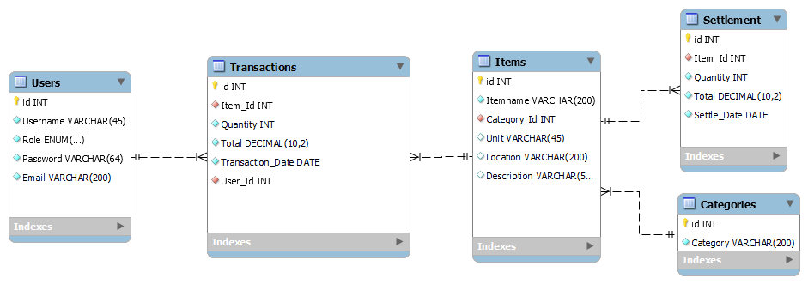

# PART 3:

### CASE DIAGRAM: ACTORS & ACTIONS

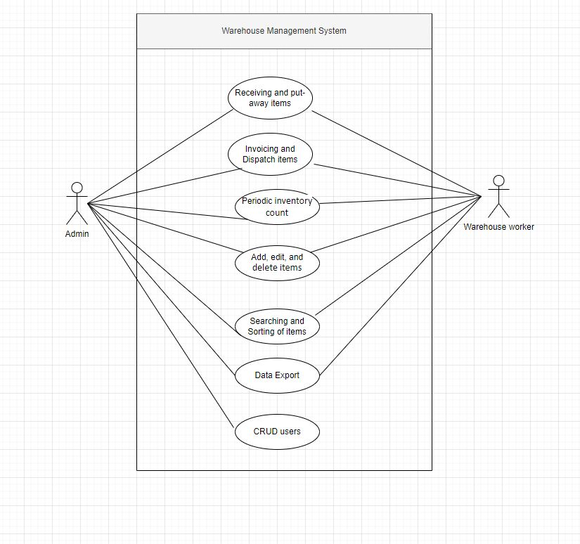

# PART 4:**MOCKUPS**

Main Window：

Items Management Dialog：

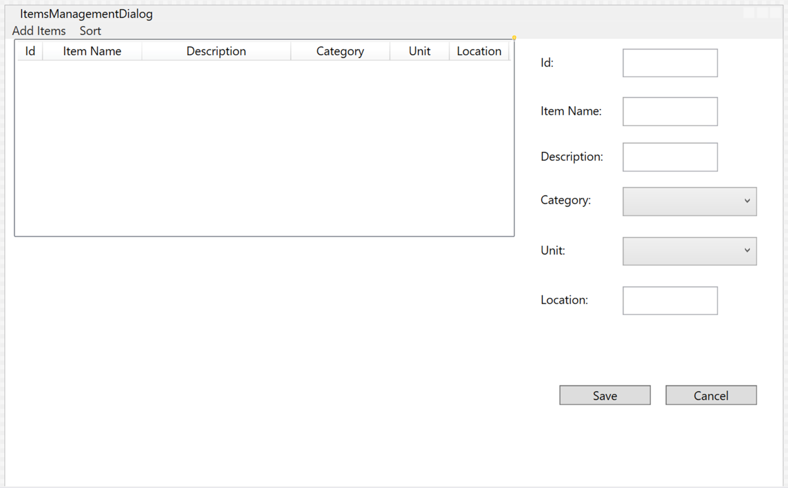

Query:

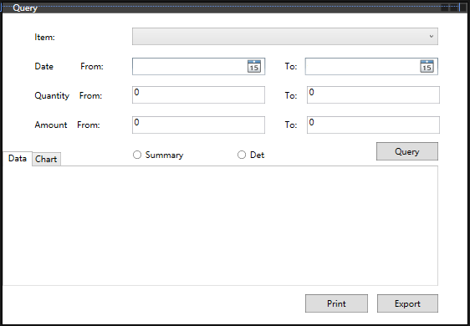

Analyse:

