Online DVD Rental Business

Database Design and Implementation for Business

CS 669 Term project

Xiaoxuan Wang

Objective

Create an initial design for the database schema for an online DVD rental business that is similar to the DVD rental portion of the business pioneered by NetFlix®.

Project Description

Design a database for a DVD rental business such as Netflix.com. The store rents DVDs online. In order to rent a movie, a person must be enrolled a membership with a specific plan(2 or 3 movies at a time) at the online store. Then they can add movies to the queue, which is a waiting-list for next shipping movie. Netflix mails to the customer the first 2 or 3 movies in their queue. When the customer watches and returns the first movie to Netflix, Netflix mails out the next movie in the queue to the customer. When a movie is ordered to ship to the customer, the sytem will store this rental history. The rental history can be used for many purposes, such as reviewing what customers have rented or analyzing many customers’ rental histories to determine the least popular and most popular movies for marketing purposes.

Business rules

Entity: Customer, Membership, Queue, Rental_history, Bill, Shipment, Movie, Returned_package, Shipping_company.

One customer signs up for one membership. (Mandatory)
One membership can be signed up by one customer.(Mandatory)

One customer adds zero up to many movies to the queue.(Optional)
One movie in queue belongs to only one customer.(Mandatory)

One customer can pay for one up to many bills.(Mandatory)
One bill can be paied by only one customer.(Mandatory)

One movie in the queue belongs to one movie in the store.(Mandatory)
One movie in the store can be added to zero up to many queue.(Optional)

One customer can generate zero up to many rental_histories.(Optional)
One rental_history is generated by only one customer.(Mandatory)

One rental_history has only one movie.(Mandatory)
One movie can generate zero up to many rental_histories.(Optional)

One movie has one genre.(Mandatory)
One genre can has zero up to many movie.(Optional)

Each rental_order generates one or many shipments.(Mandatory)
One shipment is reserved by one rental_order.(Mandatory)

One shipment is operated by only one shipping_company.(Mandatory)
One shipping_company services many shipments.(Mandatory)
Conceptual ERD

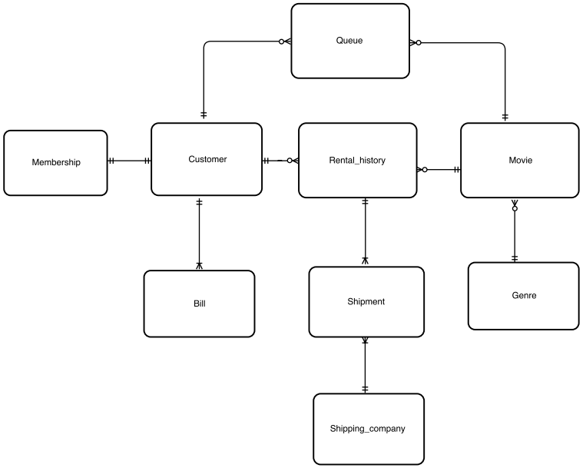

Logical ERD

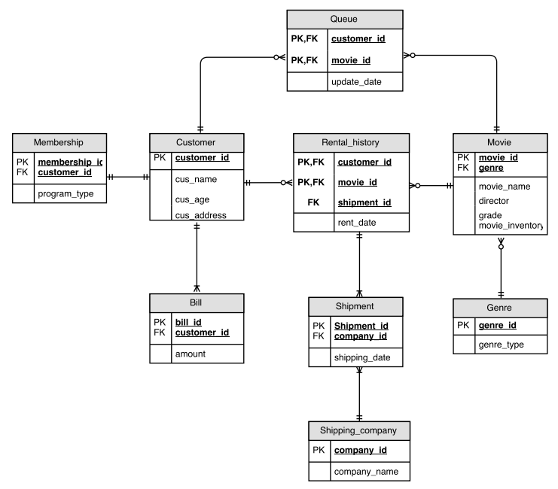
Normalization

All the tables in the logical ERD are normalized into BCNF, which means each determinant in the table is a candidate key.

Tables & Explanation

Customer: Storing information about the customer.
Membership: Storing information about membership representing customer.
Queue: Storing information about the movie which is added in the waiting list .
Movie: Storing information of movie along with their descriprions.
Genre: Storing information about genre.
Bill: Storing the paying information of customer.
Rental_history: Storing the transaction between store and customer.
Shipment: Storing the shipping information.
Shipping_company: Storing information about companies which provide the shipping service.

Use Cases

Use Case 1a: A customer rents the movies “X-Men: Days of Future Past” and “The Angry Birds Movie”. Develop a parameterized stored procedure that supports a customer renting a movie, then invoke the stored procedure two times (to satisfy the use case) for a customer of your choosing.
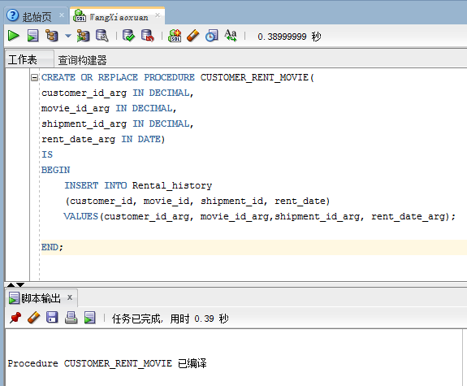

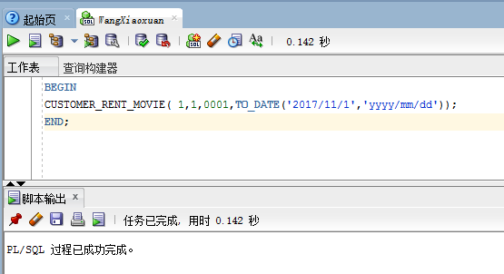

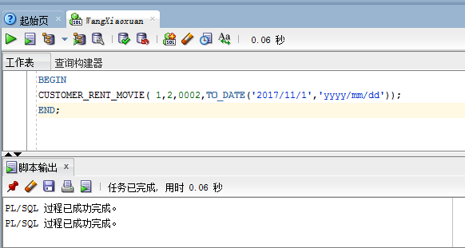

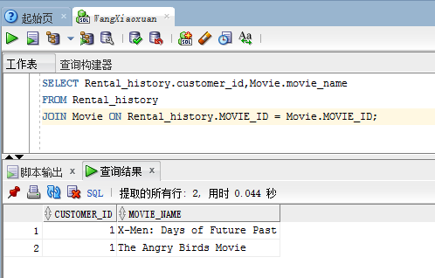

Use Case 1b: A customer requests the titles of all movies they have rented that are directed by “George Lucas” and “Rich Christiano”. Write a single query that retrieves this information for a customer of your choosing.
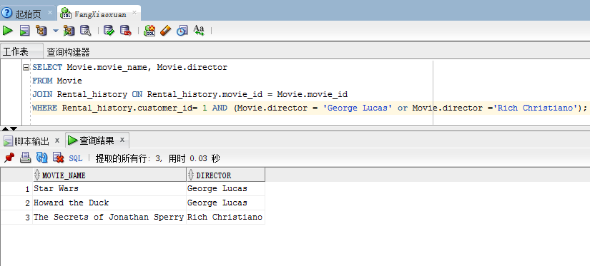

Use Case 2a: A customer adds a movie to their queue so that the newly added movie will be the next movie they receive. Develop a parameterized stored procedure that accomplishes this, then invoke the stored procedure for a customer and movie of your choosing.
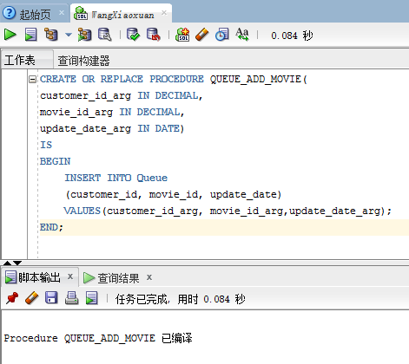

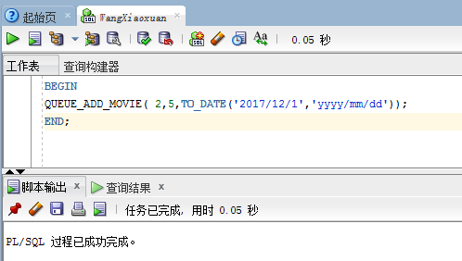
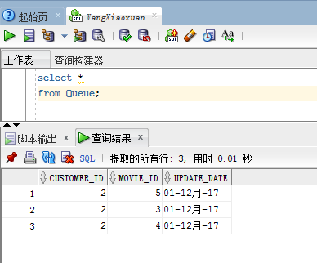

Use Case 2b: A customer wants to see the names of the first three movies in their queue. Write a single query that retrieves this information for a customer of your choosing.
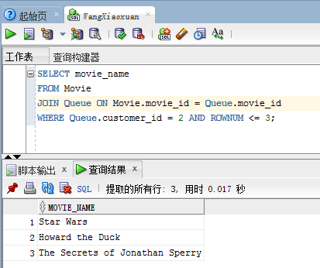

Use Case 3a: A customer enrolls in the two-at-a-time plan and another customer enrolls in the three-at-a-time plan. Develop a parameterized stored procedure that accomplishes this, then invoke the stored procedure two times (to satisfy the use case) for customers of your choosing.
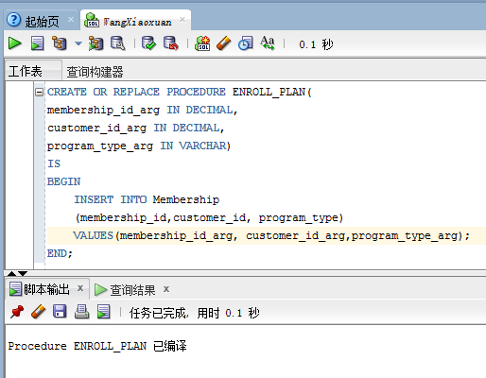

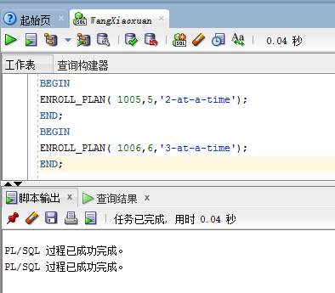

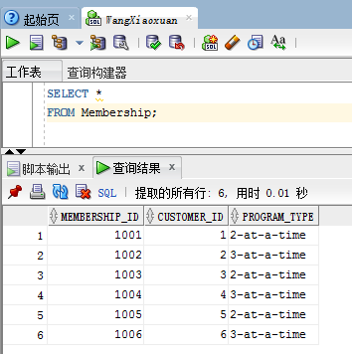

Use case 3b: Management requests the names of all currently active customers that are enrolled in the two-at-a-time plan. Write a single query that retrieves this information.
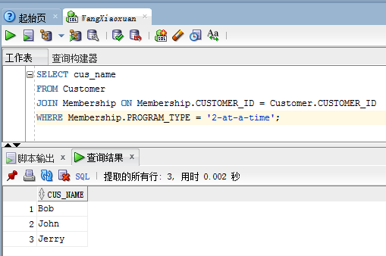

Use Case 4a: Netflix acquires three more copies of the movie “Star Trek Into Darkness”, and two more copies of “Dredd”, and a staff member records these inventory changes in the database. Develop a parameterized stored procedure and invoke it multiple times to satisfy the use case.
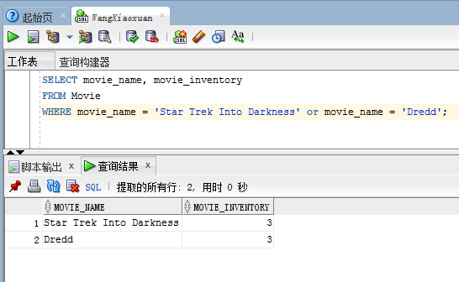
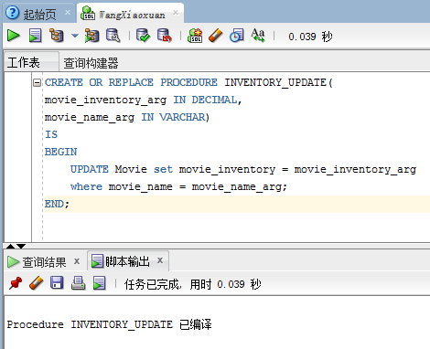
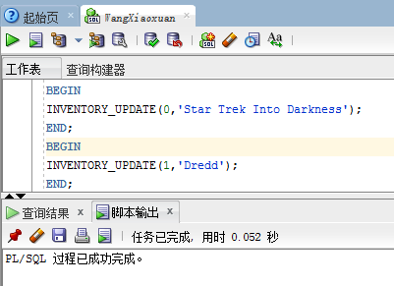

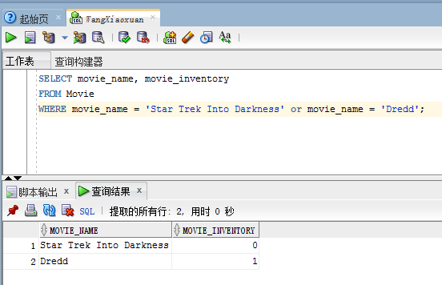

Use Case 4b: Management requests the names of all movies that are currently sold out. A movie is sold out if all copies of the movie are currently rented and not yet returned. Write a single query that retrieves this information for management
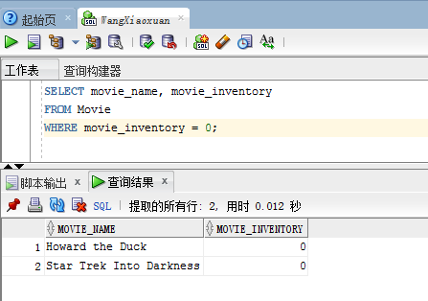

Use Case 5a: The store manager want to defer the shipping date of the movies “X-Men: Days of Future Past” rented by the customer in Use case 1a to the next day. Develop a parameterized stored procedure that supports a manager changing the shipping_date for a specific movie and specific customer, then invoke the stored procedure.

Before updating:
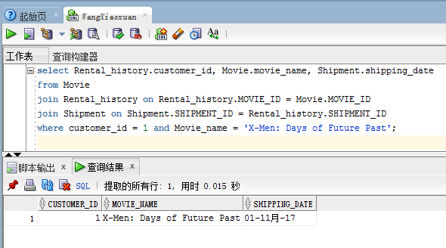

Create and invoke stored procedure:
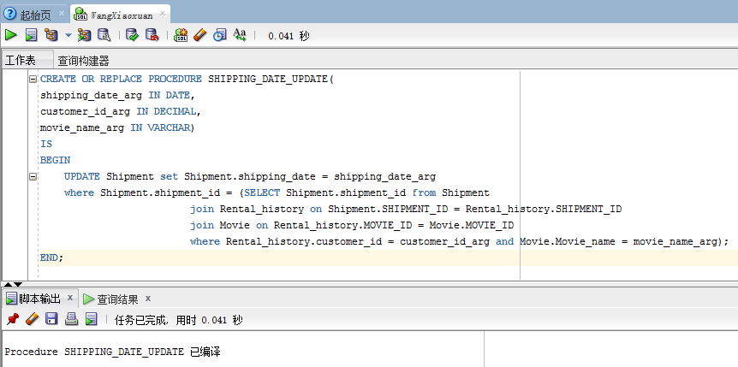

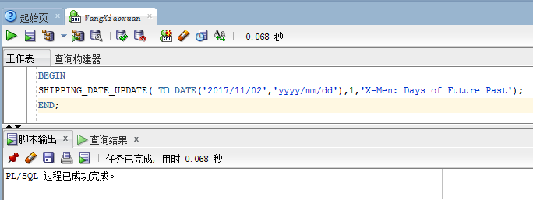

After updating：
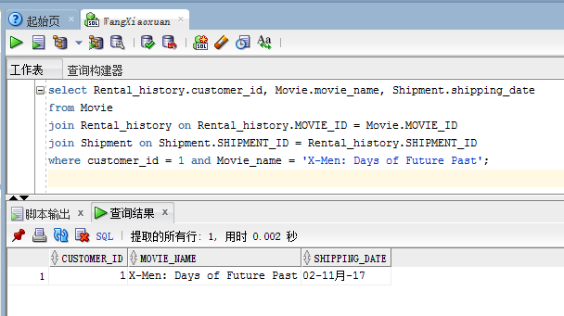

Use Case 5b: The store manager want to know the number of movies which would be shipped in 2017/11/2.
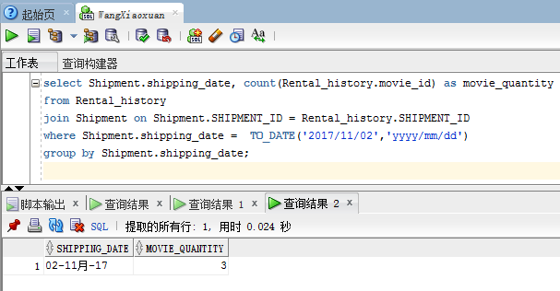

Index

Using an index is usually more efficient than scanning a table. We can creat index on Rental_history.rent_date because it can help store manager to obtain the statistic of the transaction in each day, speeding up SQL queries that use it more than a negligible amount. The index is non-unique since many rental records can be dealed in the same rental_date.
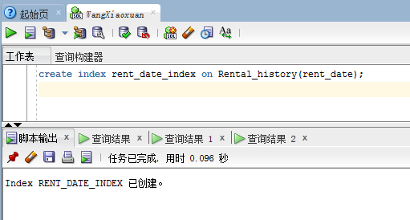

We can also create index on Rental_history.customer_id, since the customer_id is a foreign key in this table. Index in this column can help display the renting information about specific customers without canning the entire table to determine which rows have the value.
