Presentation Oral Script

Slide 1: Title

Today I want to show two connected parts of the project. First, the clustered LIF simulation that gives us controlled spike recordings with known ground-truth connectivity. Second, the learned-LIF inference model that tries to recover that connectivity from the recorded activity. The main point is that I am not just fitting a black-box predictor. I am using a differentiable LIF-style model as an interpretable bridge between spike timing and connectivity.

Slide 2: Simulation

On the simulation side, the network is built as a clustered topology with distance-dependent connectivity, excitatory and inhibitory structure, and stimulus-driven bursts. I simulate at very high temporal resolution, with dt = 0.1 ms, so the network dynamics are realistic at the spike level. Then I save both the raw outputs and a coarser acquisition-style representation for visualization.

What this gives me is a clean benchmarking environment. For each session, I know the true network graph, I know neuron positions, and I have the actual spike recordings and optional voltage traces. That means when I later evaluate connectivity recovery, I am comparing against known truth rather than an uncertain biological target.

Slide 3: Preprocessing

Before getting to the model, the most important preprocessing decision is that I do not train on full recordings end to end. The recordings are extremely sparse, so if I trained on the full sequence, the model could get a deceptively low loss just by predicting silence.

So I first convert the spike times into a 1 ms binary spike matrix. Then I build a hybrid candidate set for each postsynaptic neuron. In the current setup, that means mostly spatially nearby neurons, plus a smaller set of temporal candidates whose spikes tend to occur shortly before the target neuron spikes.

After that, I construct event windows. Positive windows are centered on real postsynaptic spikes. Negative windows are centered on times that are sufficiently far away from any postsynaptic spike. Each window has a warmup segment, a pre-spike context segment, and a short post-spike segment. The warmup lets the membrane settle, and the event-centered design forces the optimizer to focus on informative causal context instead of long stretches of zeros.

Slide 4: Pipeline Architecture

On this slide, the key is to walk left to right.

We start with the session files. For one simulated network, I have the saved network structure and one or more recordings. I load all recordings from the same session because they share the same underlying graph, so they give me more training examples without changing the ground truth.

Next, I do spike preprocessing. I convert the spike times into a binary matrix at 1 ms resolution. That gives me a discrete representation that is easy to align across neurons and time. I also keep the recording boundaries, because I do not want any event window to accidentally cross from one recording into another.

The next stage is candidate proposal plus window construction. This is one of the main practical choices in the pipeline. I do not let every neuron try to explain every other neuron, because that would be too large and too noisy. Instead, for each postsynaptic neuron, I build a candidate set of size K. In the current operating point, K = 50. Most of those candidates are spatial neighbors, because nearby neurons are more likely to be connected in the simulated network. The remaining candidates are temporal neighbors, meaning neurons whose spikes tend to lead the target neuron's spikes within a short lag window, typically 1 to 8 bins. So this hybrid step injects both anatomical plausibility and temporal plausibility.

Once I have the candidate set, I build positive and negative event windows. Positive windows are centered on true postsynaptic spikes. Negative windows are sampled from times that are at least a fixed distance away from any postsynaptic spike. The purpose is to balance informative spike events against real non-spike events. This is much better than training on the full recording, where the optimization would be dominated by silence.

After that, I create the training and validation datasets. When multiple recordings are available, I prefer to hold out entire recordings for validation. That is a more meaningful generalization check than mixing all windows together. If only one recording is available, then I split windows within the same neuron. A very important point here is that I do not hold out postsynaptic neurons, because each postsynaptic neuron has its own learned weight row. If I held out neurons, I would be evaluating parameters that were never trained.

Finally, I fit the model one postsynaptic neuron at a time. The model takes the candidate presynaptic spike trains, passes them through a differentiable LIF forward model, and optimizes a spike-prediction loss plus a sparsity penalty. After training, I read out the learned weight magnitudes as connectivity scores, and then I evaluate those scores against the known ground truth using metrics like AUROC, average precision, and F1.

So the overall pipeline is: recordings to binned spikes, binned spikes to candidate inputs and event windows, event windows to a mechanistic differentiable model, and then learned weights back to a connectivity estimate.

Slide 5: Training Strategy

This slide explains why the training setup looks unusual if you are expecting standard sequence modeling.

The first point is candidate proposal. The current operating point is the hybrid K = 50 setting, because it gives a good tradeoff between proposal coverage and precision. In recent runs, it covers most of the true edges while keeping the optimization manageable.

The second point is event-window sampling. Positive windows are centered on real postsynaptic spikes, negative windows are centered away from spikes, and the warmup bins let the membrane state settle before the loss is evaluated. This avoids the trivial all-silence solution.

The third point is the validation split. If I have multiple recordings from the same network, I hold out whole recordings for validation. In the recent runs that gave me a clean 16-training, 4-validation split.

And the fourth point is why I do not hold out neurons. Each postsynaptic neuron owns one private row of weights and delay parameters. So if I held out neurons, I would not be testing generalization in the usual sense. I would just be scoring rows that the model never had a chance to learn.

Slide 6: Model Equations

I usually slow down on this slide and explain the equations in words rather than reading symbol by symbol.

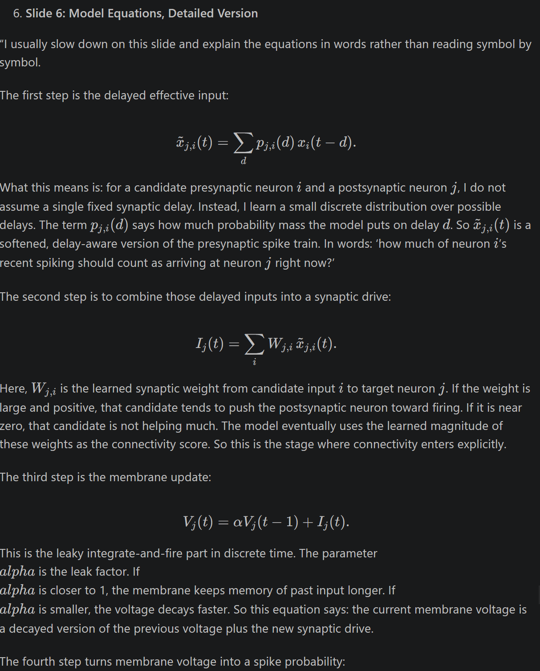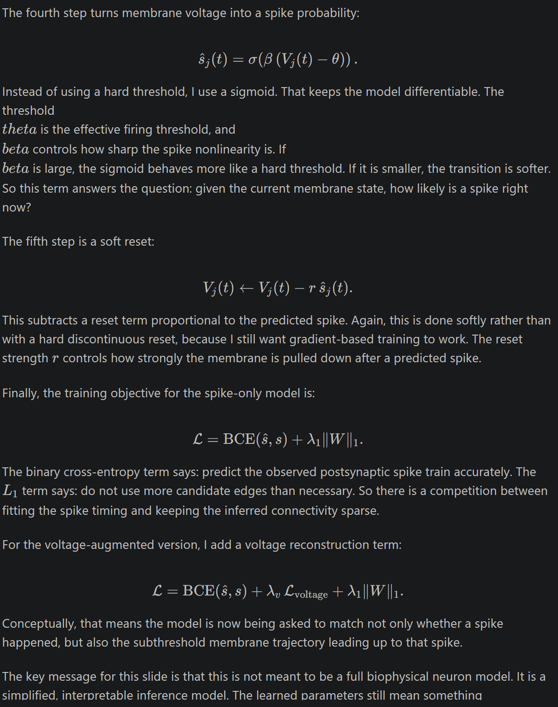
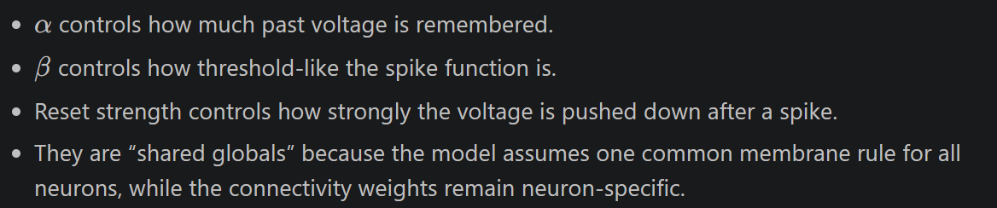

Slide 7: Voltage Augmentation

This slide shows the extension where I keep the same presynaptic spike inputs, but I add cleaned postsynaptic voltage as an extra supervision target.

The important point is that I am not changing the feature representation on the input side. The input is still spike trains. What changes is the target side. I clean the raw postsynaptic voltage, suppress the immediate spike-dominated regions, normalize it, and then ask the model to match that subthreshold trajectory in addition to matching spikes.

Why is that useful? Because the voltage trace contains information even when the neuron does not spike. It carries subthreshold integration dynamics that are invisible in a spike-only loss. In the current results, that tends to improve AUROC and sign recovery, although not every metric improves in every setting. So I present voltage augmentation as a richer supervision signal, not as a replacement for the spike-based interpretation.

Slide 8: Recent Results

This slide is the quantitative summary before the qualitative maps.
AUROC:
This is the area under the ROC curve. It measures how well the model ranks true connected edges above non-connected edges across all possible thresholds. A value of 0.5 is random ranking, and 1.0 is perfect ranking. In this code, the score for an edge is the absolute learned weight magnitude, so AUROC asks: if I pick one true edge and one false edge, how often does the true edge get a larger score?
AP:
This is average precision, which is the area under the precision-recall curve. It is especially useful when positives are rare, which is the case here because most possible edges are not real connections. AP focuses more on whether the top-ranked predicted edges are actually correct. In sparse connectivity problems, AP is often more informative than AUROC.
F1:
This is the harmonic mean of precision and recall:
F1 = 2 × precision × recall / (precision + recall)
In the code, they first sweep thresholds on the score, compute the precision-recall curve, then choose the threshold that gives the best F1. So the reported F1 is the best thresholded tradeoff between missing true edges and adding false ones. That logic is in learned_lif_connectivity.py:943 and voltage_augmented_learned_lif_connectivity.py:570.
Recall:
Recall is the fraction of true edges that the model successfully finds:
Recall = TP / (TP + FN)
High recall means you miss fewer real connections. But recall alone is not enough, because you can make recall high by predicting too many edges. That is why it is usually paired with precision and F1.
One subtle but important point: these connectivity metrics are computed only over the candidate edges, not over every possible neuron pair. So the model can only recover a true edge if that edge entered the candidate set in the first place. That is why the code also reports candidate coverage before training in learned_lif_connectivity.py:1228. If coverage is 86 percent, that means about 86 percent of the true edges were even available for the model to learn.
So if you want the shortest interpretation for your slides:
Held-out connectivity recovery means the model was fit using training windows, checked on held-out windows or recordings, and then its learned weights were compared with the known true connectivity. AUROC measures ranking quality, AP measures precision-recall quality under class imbalance, F1 measures the best thresholded balance of precision and recall, and recall measures how many real edges were recovered.

For the spike-only learned-LIF model, the recent held-out sessions show solid recovery. On 0423, the model reached AUROC about 0.863 and average precision about 0.729. On 0425, it reached AUROC about 0.861 and average precision about 0.744.

For the voltage-augmented model on 0425, AUROC went up further to about 0.885, and sign accuracy and weight correlation were also stronger. So the short version is: the spike-only model already works well, and the voltage-augmented version improves some important aspects of recovery, especially when I care about dynamical fidelity rather than only edge ranking.

Slides 9 to 14: Dataset Comparison Section

For the dataset comparison section, I usually repeat the same story in pairs of slides.

On the first slide of each pair, I compare ground truth with lagged correlation. The purpose there is to show what a simple baseline sees. Lagged correlation can pick up some broad synchronous structure, but it is coarse and it is not a final connectivity estimate.

On the second slide of each pair, I show the learned-LIF map and the learned parameters. That is where I emphasize that the model is doing more than correlating bursts. It is fitting a directed, delayed, membrane-based explanation of the postsynaptic spikes.

Across 0423, 0425, and 0426, the consistent message is that learned-LIF improves over the lagged baseline, but increasing the candidate set size is not automatically better. Higher candidate coverage can help recall, but it can also introduce more distractor edges and hurt precision-oriented metrics.

Slide 15: Tradeoff

This slide is where I make the practical modeling point. A larger candidate set sounds attractive because it covers more true edges, but beyond a point it also makes the optimization harder and the ranking less selective.

So the current takeaway is that the smaller hybrid candidate set, especially around K = 50, is the more balanced operating point. It gives strong proposal coverage without paying too much in precision-recall behavior.

Slide 16: Closing

To close, the simulation pipeline is stable, the preprocessing and event-window strategy are well motivated for sparse spike data, and the learned-LIF model gives an interpretable way to recover connectivity from activity. The voltage-augmented version adds useful subthreshold supervision, and the next questions are about transfer across sessions, perturbation-style validation, and comparison to other temporal inference approaches.

Short backup lines for likely questions

If someone asks why not train on the full recording:
Because the data are too sparse. Full-sequence training is dominated by zeros and rewards silence. Event windows make the model learn around real decision points.

If someone asks why not hold out neurons:
Because each postsynaptic neuron has its own private weight row. Holding out neurons would mean evaluating rows that were never trained.

If someone asks what alpha means:
Alpha is the discrete-time leak factor. It controls how much membrane memory carries from one time step to the next.

If someone asks what the connectivity score actually is:
The main score is the learned weight magnitude |W_j,i| for each candidate edge, after fitting the spike timing dynamics.

