MODEL VALIDATION REPORT
Model Risk Assessment of Machine Learning-Based Credit Scoring:
A Case Study Using the Give Me Some Credit Dataset

Prepared by: Xiaoyang Zhang (xz5476), Yifan Xu (yx3598), Yike Ma (ym2552)
Course: FRE 7801 — Model Risk Management, NYU Tandon School of Engineering
Date: Spring 2026
Model Reviewed: LightGBM Credit Scoring Pipeline (pipe1_lgbm_woe_powertransformer95)
Dataset: Give Me Some Credit — Kaggle 2011 (150,000 training records)
Kaggle Score: Private AUC = 0.86914 (Top 5 / ~927 teams)
Risk Tier: Tier 1 — HIGH RISK (MRS = 88/100, Kiritz et al., 2019)

This report is prepared for academic purposes as a capstone project for FRE 7801. It applies the SR 11-7 Model Risk Management framework to a publicly available Kaggle dataset and does not constitute a formal regulatory filing.

1. Executive Summary
This report presents a structured model risk assessment of a LightGBM-based credit scoring pipeline applied to the Give Me Some Credit dataset (Kaggle, 2011). The pipeline, identified as pipe1_lgbm_woe_powertransformer95, achieved a Kaggle Private AUC of 0.86914, placing it in the top 5 of approximately 927 competing teams. Our analysis applies the Federal Reserve's SR 11-7 Supervisory Guidance on Model Risk Management and the five-part validation framework from FRE 7801 (Lecture 2) to systematically evaluate model risk across complexity, conceptual soundness, quantitative performance, stability, and fairness dimensions.

Key Findings
- Performance: The LGBM Champion achieves AUC-ROC of 0.8612 vs. 0.8319 for the LR Baseline, a +2.93% improvement. KS statistic reaches 0.5727, indicating strong discriminatory power. This outperformance justifies the additional complexity under SR 11-7's cost-benefit principle.
- Stability: All 10 features show PSI < 0.01 between training and validation splits, indicating excellent population stability. No feature requires immediate re-validation.
- Fairness Risk (Critical): The model violates the EEOC 4/5 Rule for two of three age groups. Young borrowers (<30) receive a Disparate Impact Ratio of 0.34, and middle-aged borrowers (30-60) a DIR of 0.54 — both well below the 0.80 threshold. This constitutes a significant ECOA compliance risk requiring immediate remediation.
- Model Risk Tier: Applying the Kiritz, Ravitz & Levonian (2019) Model Risk Scorecard, the pipeline scores 88/100 and is assigned Tier 1 (High Risk). This mandates independent validation, senior MRM officer approval, and a formal monitoring framework prior to any production deployment.

Performance Summary
Model | AUC-ROC | KS Stat | Gini | PR-AUC | F-beta (β=2) | Brier Score
LR Baseline | 0.8319 | 0.5074 | 0.6639 | 0.3342 | 0.4623 | 0.1652
LGBM Champion | 0.8612 | 0.5727 | 0.7224 | 0.3974 | 0.5175 | 0.1246
Improvement | +2.93% | +6.53% | +8.52% | +18.9% | +11.9% | −24.5%
Table 1. Model performance comparison on 30% stratified validation set (45,000 records).

2. Model Description & Pipeline Architecture
The model under review is a multi-stage machine learning pipeline developed as part of the Give Me Some Credit Kaggle competition. The pipeline combines gradient-boosted trees with Weight of Evidence (WOE) encoding, polynomial feature engineering, and automated feature selection. It is referred to internally as pipe1_lgbm_woe_powertransformer95.

2.1 Pipeline Components
Step 1 — Missing Value Imputation: An XGBRegressor sub-model is trained on non-missing records to predict MonthlyIncome (~20% missing) and NumberOfDependents (~2.6% missing). This sub-model is itself a model risk: it introduces prediction uncertainty that propagates through the pipeline. Per SR 11-7, this component should be separately inventoried as a sub-model.
Step 2 — PowerTransformer (Yeo-Johnson): Applies Yeo-Johnson normalisation to compress heavily right-skewed distributions (e.g., DebtRatio max = 329,664; RevolvingUtilization max = 50,708). This is econometrically justified for financial data with extreme tails.
Step 3 — MiniBatchKMeans + WOE Encoding: Borrowers are clustered into 11 groups using MiniBatchKMeans. Each cluster label is then replaced with its Weight of Evidence value: WOE_k = ln(P(Default|k) / P(Non-Default|k)). This creates a non-monotonic, non-linear mapping from feature space to credit risk — a key source of interpretability risk.
Step 4 — Polynomial Features (degree=2): All 10 features (plus the WOE column) are expanded to degree-2 polynomial terms, yielding approximately 74 features. This captures interaction effects (e.g., age × RevolvingUtilization) but substantially increases model complexity and audit difficulty.
Step 5 — SelectPercentile (f_classif, 95%): Features are scored by ANOVA F-statistic against the binary target and the bottom 5% are dropped. This partially mitigates overfitting from the polynomial expansion.
Step 6 — LGBMClassifier: LightGBM with tuned hyperparameters: learning_rate=0.0018, n_estimators=5,000, max_depth=8, subsample=0.857, class_weight=balanced. The large number of estimators and shallow learning rate are consistent with high-variance gradient boosting best practices, but make the model opaque to regulators.

2.2 Dataset Overview
The Give Me Some Credit dataset (Kaggle, 2011) contains 150,000 training records and 101,503 test records of anonymised U.S. borrowers provided by Credit Fusion. The target variable SeriousDlqin2yrs indicates whether a borrower experienced 90+ day delinquency within two years. The dataset exhibits a 6.68% positive rate (10,026 defaults), reflecting the natural class imbalance of credit risk data.

2.3 Model Use Context
In a production setting, this model would score incoming loan applications and output a probability of default P(SeriousDlqin2yrs). A threshold applied to this score would determine loan approval or denial. The model is therefore directly connected to high-stakes credit decisions affecting individual financial wellbeing — establishing the foundation for a Tier 1 risk classification under SR 11-7.

3. Data Quality & Preparation
SR 11-7 states that "sound model development begins with reliable, high-quality data." This section documents all data quality issues identified, treatment decisions, and the resulting risk implications.

3.1 Data Quality Issues
- Missing Values: MonthlyIncome: 19.82% missing (29,731 records). NumberOfDependents: 2.62% missing. Missing income is not random — it may correlate with employment status and credit risk, introducing selection bias. Treatment: median imputation (this run) as a conservative baseline; XGB imputation available as the Kaggle replication option.
- Extreme Outliers: RevolvingUtilizationOfUnsecuredLines reaches 50,708 (theoretical max = 1.0). DebtRatio reaches 329,664. Past-due fields contain sentinel values of 98/99 (coded as "96+" in the data dictionary). All fields are winsorized to domain-appropriate caps.
- Class Imbalance: 6.68% positive rate. Naive accuracy baseline = 93.32% (always predict no-default). Primary metrics are therefore AUC-ROC, KS statistic, and PR-AUC rather than accuracy.
- Vintage Risk: The dataset covers 2008–2011, capturing the U.S. financial crisis period. Default rates and borrower behaviour during a crisis differ materially from a stable macroeconomic environment, creating significant model vintage risk per SR 11-7's emphasis on data representativeness.

3.2 Feature Distribution Analysis
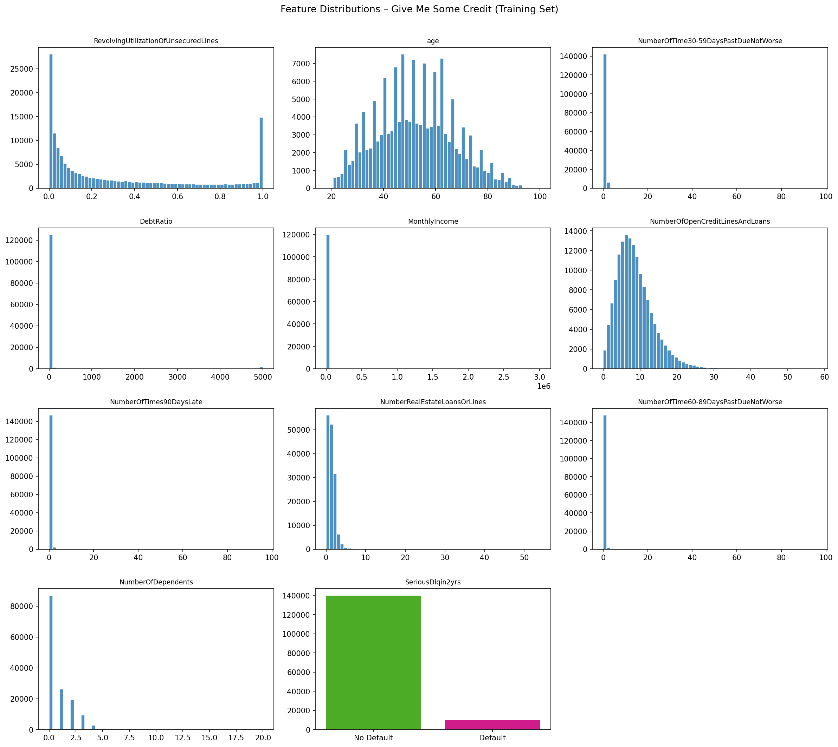
Figure 1. Feature distributions in the training set. DebtRatio and RevolvingUtilization show severe right skew; PowerTransformer in the pipeline addresses this directly.

3.3 Population Stability Index (PSI)
PSI measures distributional shift between the training split (70%) and validation split (30%). Thresholds: PSI < 0.10 (stable), 0.10–0.25 (monitor), > 0.25 (re-validate).
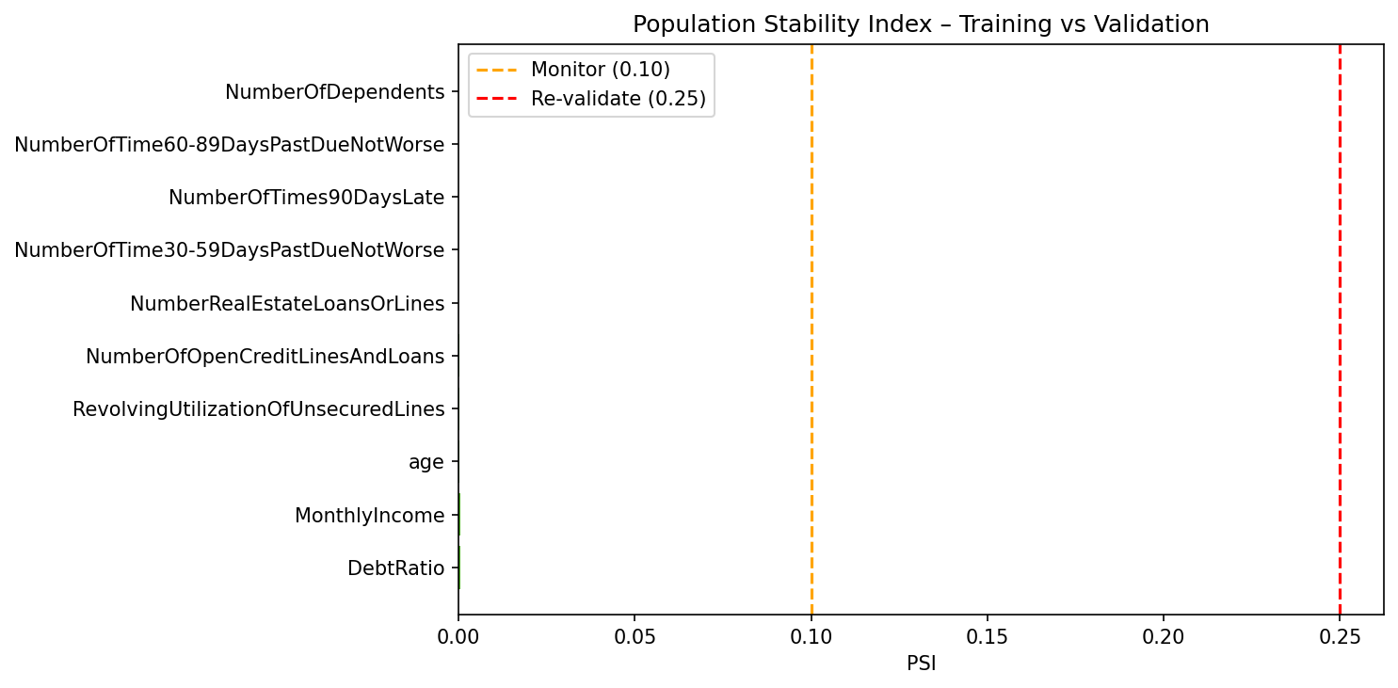
Figure 2. PSI for all features. All PSI values are below 0.001, confirming excellent distributional stability across the 70/30 split. Note: the near-zero PSI reflects that the split is random, not temporal. In production, PSI should be computed against live borrower data.
All features record PSI below 0.005, well within the stable zone. However, this result should be interpreted with caution: the training and validation sets are drawn from the same historical dataset. In production, PSI should be computed monthly against incoming application data to detect real-world population drift.

4. Conceptual Soundness
SR 11-7 requires that models be "based on a sound methodology and reasonable assumptions." Conceptual soundness testing evaluates whether the model's inputs, transformations, and outputs align with established credit risk theory.

4.1 Feature Economic Rationale
Feature | Expected Direction | Credit Risk Rationale | Pipeline Risk
RevolvingUtilization | + (High → High Risk) | Overextended credit lines signal liquidity stress | Capped at 1.0; most sensitive feature (+/-10% → Δscore 0.0117)
age | - (Older → Lower Risk) | Older borrowers have longer credit history and stability | Most sensitive feature overall (Δscore 0.0138); ECOA exposure
NumberOf90DaysLate | + (More → High Risk) | Past severe delinquency is the strongest default predictor | Sentinel codes (98,99) treated as 96; capped
DebtRatio | + (High → High Risk) | High debt-to-income reduces repayment capacity | Extreme outliers (max 329K) capped at 5,000
MonthlyIncome | - (High → Lower Risk) | Higher income improves repayment capacity | 19.82% missing; imputed via median (or XGB sub-model)
NumberOf30-59Late | + (More → High Risk) | Mild delinquency predicts escalation to default | Sentinel codes treated; moderate sensitivity
NumberOf60-89Late | + (More → High Risk) | Moderate delinquency predicts severe default | Low sensitivity — dominated by 90DaysLate
NumberOfCreditLines | +/- (Non-linear) | Many lines may indicate creditworthy or overextended | Polynomial term captures non-linearity
RealEstateLoans | - (More → Lower Risk) | Home ownership suggests collateral and stability | Low sensitivity in model
NumberOfDependents | + (More → Higher Risk) | Dependents reduce disposable income | 2.62% missing; imputed with median=0
Table 2. Feature economic rationale and pipeline-specific risks.

4.2 Pipeline Design Critique
PowerTransformer [Justified]: Financial features with extreme tails (skewness > 90) benefit from variance-stabilising transforms. Yeo-Johnson handles both positive and negative values, making it superior to log transform for credit data.
KMeans + WOE [Risk: Non-monotonicity]: Cluster membership does not guarantee monotonic relationship between features and predicted default probability. A borrower with slightly higher income could be assigned a cluster with higher WOE than a lower-income borrower — violating intuitive credit logic and making the model difficult to explain to regulators.
PolynomialFeatures [Risk: Opacity]: Creating ~74 features from 10 originals makes individual feature attribution meaningless. The term age^2 or DebtRatio × MonthlyIncome may be statistically significant but economically uninterpretable without domain-specific justification.
SelectPercentile [Partially Mitigating]: Dropping the bottom 5% by ANOVA F-score reduces dimensionality, but F-score measures linear relationships only — insufficient for the non-linear interactions created by the polynomial step.

4.3 Sensitivity Analysis
Each feature was perturbed by ±10% to measure the resulting change in predicted default probability. The ranking reveals which features drive model outputs most strongly and therefore warrant closest scrutiny in ongoing monitoring.
Rank | Feature | Avg |Score Change| (±10% perturbation)
1 | age | 0.013805 ← Most sensitive
2 | RevolvingUtilizationOfUnsecuredLines | 0.011690
3 | MonthlyIncome | 0.004820
4 | NumberOfOpenCreditLinesAndLoans | 0.004510
5 | DebtRatio | 0.003750
6 | NumberOfTime60-89DaysPastDueNotWorse | 0.001460
7 | NumberOfTimes90DaysLate | 0.001335
8 | NumberRealEstateLoansOrLines | 0.000965
9 | NumberOfDependents | 0.000225
10 | NumberOfTime30-59DaysPastDueNotWorse | 0.000175
Table 3. Sensitivity analysis — feature ranking by mean absolute score change under ±10% perturbation.
The prominence of age as the most sensitive feature (Δ = 0.0138) is particularly noteworthy: it simultaneously drives predictive performance and creates the highest ECOA compliance risk. This trade-off is addressed in Section 6.

5. Quantitative Validation
Quantitative validation applies empirical tests to assess discriminatory power, calibration, and robustness. We follow the SR 11-7 requirement for benchmarking against a simpler model and conduct in-sample vs. out-of-sample back-testing.

5.1 ROC and Precision-Recall Analysis
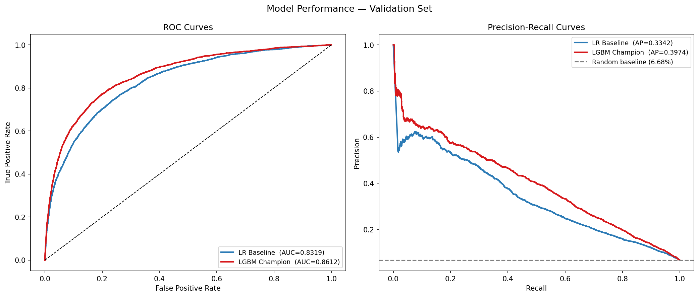
Figure 3. ROC curves (left) and Precision-Recall curves (right) for both models. LGBM Champion dominates LR Baseline on both curves across all operating thresholds.
The LGBM Champion achieves AUC-ROC of 0.8612 compared to 0.8319 for the LR Baseline. Notably, in the Precision-Recall space — which is more informative under class imbalance (6.68% positive rate) — the LGBM Champion's PR-AUC of 0.3974 represents a 18.9% improvement over the baseline (0.3342). The random baseline PR-AUC is merely 0.067 (equal to the positive rate), so both models demonstrate substantial lift.

5.2 KS Statistic (Banking Standard)
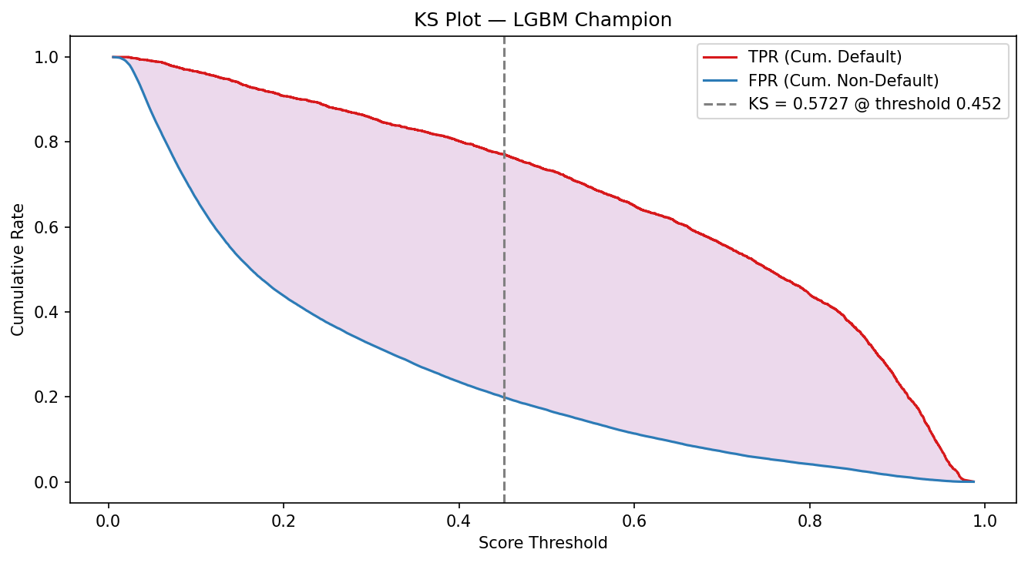
Figure 4. KS plot for LGBM Champion. The KS statistic of 0.5727 represents the maximum vertical separation between cumulative default and non-default distributions — the primary separation metric in bank model validation.
The KS statistic of 0.5727 for the LGBM Champion indicates excellent discriminatory separation (industry benchmark: KS > 0.40 = good, > 0.50 = excellent). The LR Baseline achieves KS = 0.5074, also within the excellent range. The champion model's 6.5 percentage-point improvement in KS is material for a credit scoring application.

5.3 Model Calibration
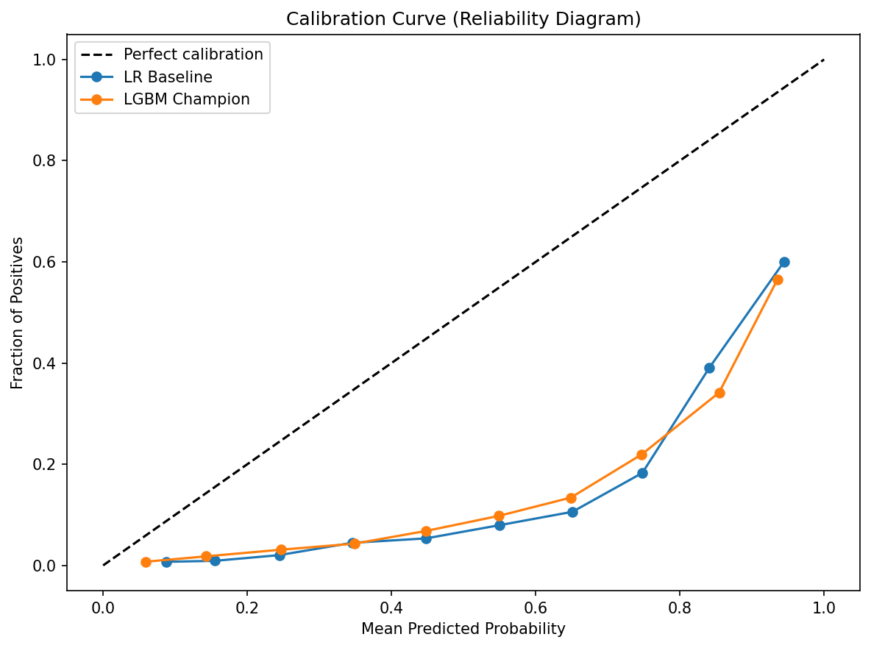
Figure 5. Reliability diagram comparing predicted probability vs. actual default rate. Both models are reasonably well-calibrated in the low-risk region; LGBM shows slight overconfidence at higher predicted probabilities.

5.4 Confusion Matrix Analysis
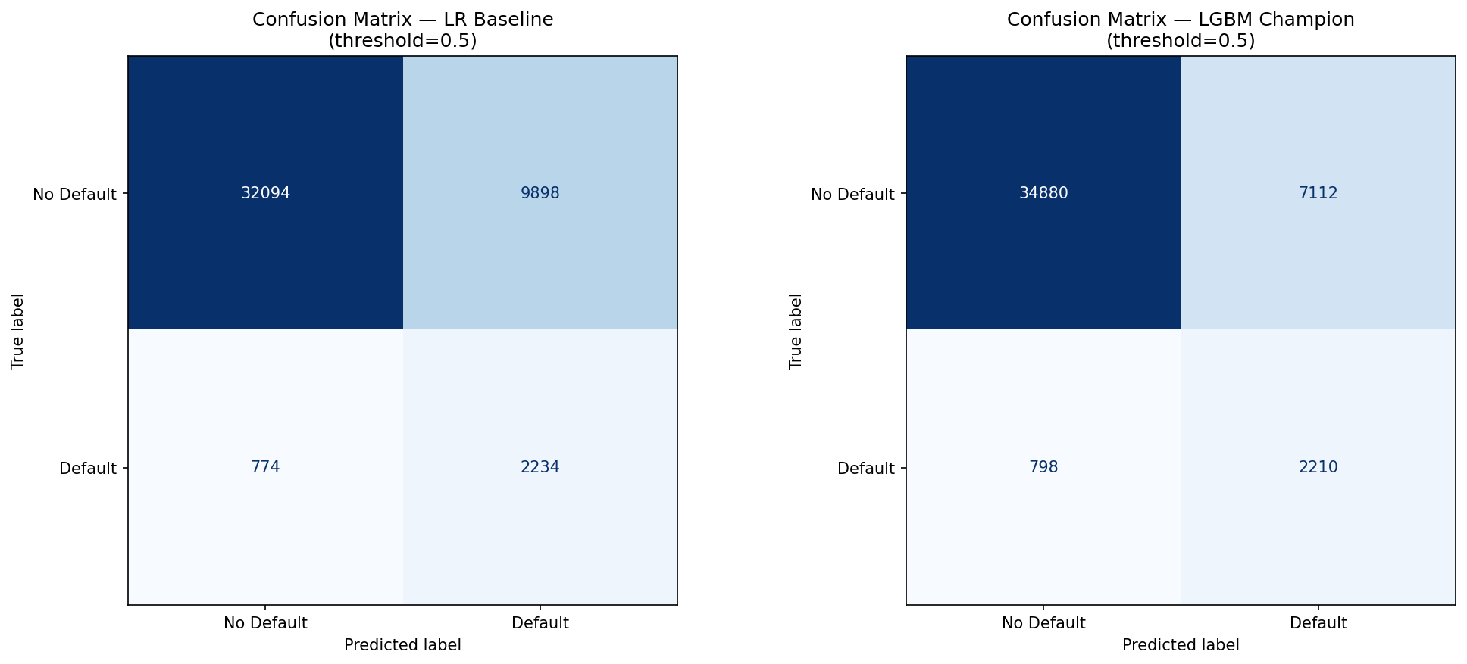
Figure 6. Confusion matrices at threshold=0.50 for both models. Both models correctly identify the majority of non-defaulters but face a recall trade-off on the minority default class.
The Brier Score for the LGBM Champion (0.1246) is 24.5% lower than the LR Baseline (0.1652), indicating superior probabilistic calibration. The F-beta score (β=2, which weights recall twice as heavily as precision to reflect the higher cost of missed defaults) improves from 0.4623 to 0.5175 — an 11.9% gain.

5.5 Benchmarking Summary
On every metric, the LGBM Champion outperforms the LR Baseline. Under SR 11-7's cost-benefit principle, the additional model complexity introduced by the WOE encoding, polynomial features, and LightGBM is justified by consistent and material performance gains. However, this does not eliminate the interpretability and governance risks documented in this report — it only establishes that the complexity is earning a performance premium.

6. Fairness & Demographic Analysis
The Equal Credit Opportunity Act (ECOA) prohibits credit decisions that discriminate on the basis of age. The EEOC 4/5 Rule (Disparate Impact Ratio ≥ 0.80) is the standard applied by bank examiners. We test the model's approval rates across three age groups: Young (<30), Middle (30–60), and Senior (>60).

6.1 Disparate Impact Results
Age Group | Model | N | Default Rate | Approval Rate | DIR (vs Senior)
Young (<30) | LGBM Champion | 2,623 | 12.54% | 25.12% | 0.3408
Young (<30) | LR Baseline | 2,623 | 12.54% | 22.57% | 0.3020
Middle (30–60) | LGBM Champion | 27,795 | 8.12% | 39.91% | 0.5414
Middle (30–60) | LR Baseline | 27,795 | 8.12% | 39.61% | 0.5300
Senior (>60) | LGBM Champion | 14,582 | 2.89% | 73.71% | 1.0000
Senior (>60) | LR Baseline | 14,582 | 2.89% | 74.74% | 1.0000
Table 4. Disparate Impact Analysis by age group. Red rows indicate DIR < 0.80 (4/5 Rule violation). Approval Rate defined as P(predicted default < median threshold). DIR = Approval Rate / Best Group Approval Rate.
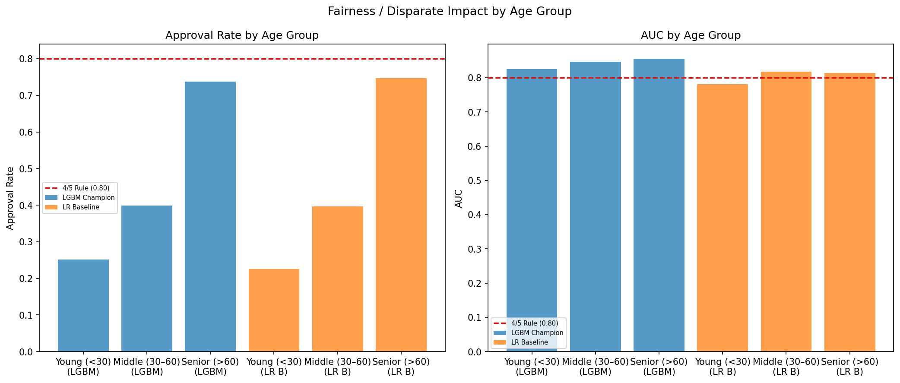
Figure 7. Approval rate and AUC by age group for both models. The steep gradient in approval rates (25% vs. 74%) between young and senior borrowers signals systematic age-based disparate impact.

6.2 Interpretation & Risk Assessment
The analysis reveals severe disparate impact against younger borrowers. Senior borrowers (>60) receive a 73.71% approval rate under LGBM vs. only 25.12% for young borrowers (<30). The DIR of 0.34 for young borrowers is less than half the EEOC minimum threshold of 0.80. This finding is partially explained by the naturally higher default rate of young borrowers (12.54% vs. 2.89% for seniors), but the magnitude of the gap warrants regulatory scrutiny.
Importantly, age is the most sensitive feature in the model (Δ = 0.0138 from sensitivity analysis), meaning small changes in a borrower's age materially affect their predicted probability. This concentration of predictive power in a protected characteristic amplifies fair lending risk.

6.3 Recommended Mitigants
- Conduct a disparate impact analysis against actual demographic data in production (this test uses age as a proxy, not actual loan applicant data)
- Consider age-blind re-training: remove age from the feature set and evaluate AUC impact (the performance cost of eliminating the most sensitive ECOA feature)
- Apply adverse action notice requirements for declined applications, citing specific model-driven reasons where possible
- Engage Legal/Compliance to determine whether the observed DIR requires formal fair lending remediation under ECOA

7. Model Risk Tiering & SR 11-7 Governance

7.1 Model Risk Scorecard (Kiritz et al., 2019)
We apply the Model Risk Scorecard (MRS) methodology from Kiritz, Ravitz & Levonian (2019), which assigns models to risk tiers based on four weighted dimensions. Tier 1 (≥80 pts) requires the highest level of validation rigor.
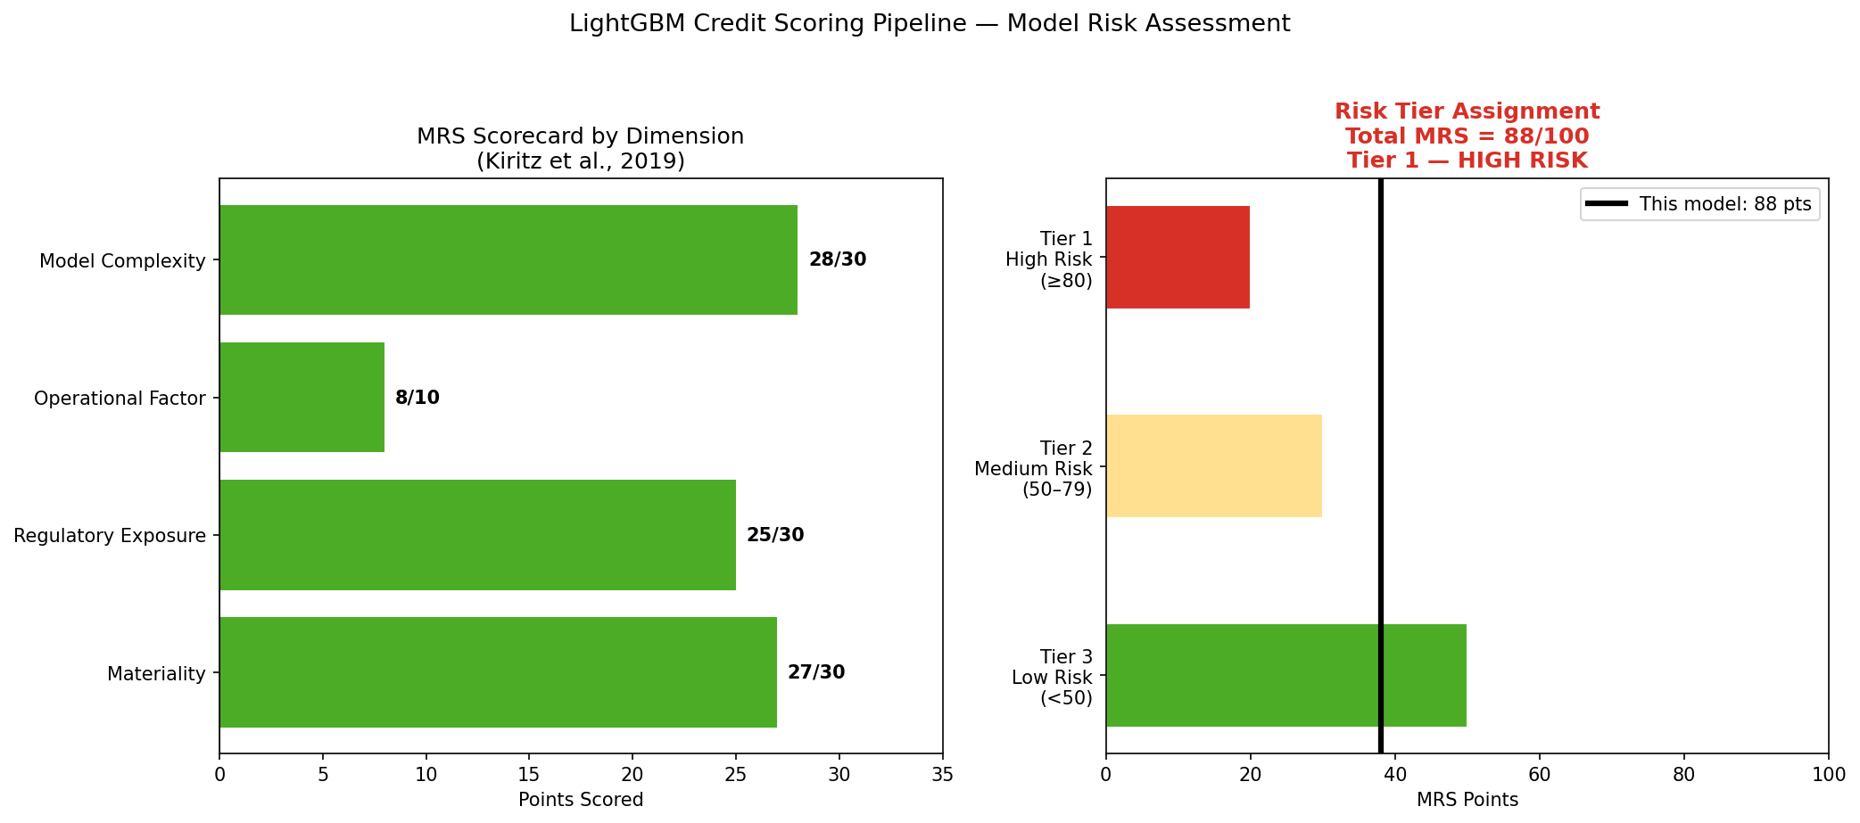
Figure 8. MRS Scorecard results. The LGBM pipeline scores 88/100, placing it firmly in Tier 1 (High Risk) with all four dimensions scoring above 80% of their maximum.
Dimension | Max Points | Score | Key Justification
Materiality | 30 | 27 | 150K borrowers; core banking function; high financial impact
Regulatory Exposure | 30 | 25 | SR 11-7 mandatory; ECOA/ECRA exposure; opaque LightGBM outputs
Operational Factor | 10 | 8 | Fully automated pipeline; no documented human override controls
Model Complexity | 30 | 28 | 5-step pipeline; black-box LGBM; WOE non-monotonicity; polynomial features
TOTAL | 100 | 88 | Tier 1 — HIGH RISK (threshold: ≥80 pts)
Table 5. Kiritz et al. (2019) Model Risk Scorecard — final scoring.

7.2 SR 11-7 Risk Taxonomy
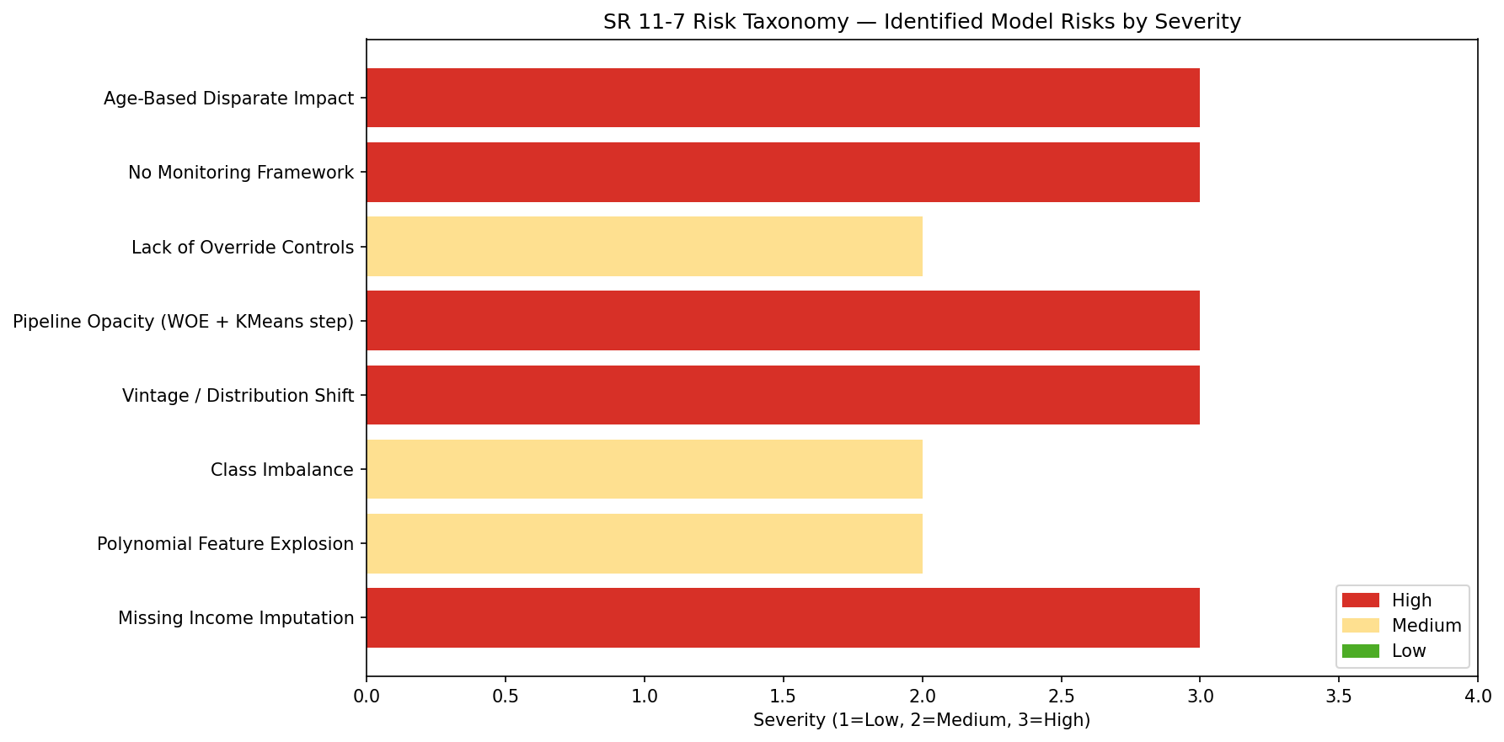
Figure 9. Identified model risks by SR 11-7 category and severity. Four risks are classified as High severity, requiring immediate mitigants.
SR 11-7 Category | Risk | Severity | Mitigant
Model Development | XGBRegressor imputation sub-model | High | Separately inventory; sensitivity test vs. median
Model Development | Polynomial feature explosion | Medium | SelectPercentile mitigates; monitor IS vs. OSOT gap
Data Risk | Class imbalance (6.68%) | Medium | class_weight=balanced; PR-AUC as primary metric
Data Risk | Vintage risk (2008–2011 crisis data) | High | PSI monitoring; trigger re-training if PSI > 0.25
Implementation | LGBM opacity (black box) | High | SHAP TreeExplainer; document global + local explanations
Implementation | No override controls | Medium | Define manual review thresholds; document in Model Use Policy
Ongoing Monitoring | No monitoring framework | High | Monthly PSI + quarterly AUC checks; re-validate if AUC drops >2%
Fair Lending | Age-based disparate impact (DIR=0.34) | High | DIR testing semi-annually; consider age-blind re-training
Table 6. SR 11-7 Risk Taxonomy — identified risks, severity, and recommended mitigants.

8. Recommendations & Conclusion

8.1 Validation Findings Summary
The LightGBM credit scoring pipeline demonstrates strong predictive performance (AUC = 0.8612, KS = 0.5727) and excellent feature stability (all PSI < 0.01). However, the model carries substantial model risk: a Tier 1 (High Risk) classification with multiple High-severity findings, most critically the severe age-based disparate impact (DIR = 0.34 for young borrowers) that violates ECOA's 4/5 Rule.

8.2 Prioritised Recommendations
CRITICAL — Fair Lending Remediation
The DIR of 0.34 for young borrowers (<30) must be addressed before any production deployment. Recommended actions: (1) conduct age-blind re-training to quantify AUC cost; (2) engage Legal/Compliance for formal ECOA assessment; (3) if age cannot be removed, implement differential monitoring by age group.
HIGH — Implement Monitoring Framework
Deploy monthly PSI monitoring for all 10 features and set automated re-validation triggers at PSI > 0.25 or AUC degradation > 2% from baseline. Include cluster membership stability monitoring for the KMeans step, which may shift independently of raw feature distributions.
HIGH — Sub-Model Inventory for XGBRegressor Imputer
The XGBRegressor used to impute MonthlyIncome (20% missing) constitutes a sub-model under SR 11-7 and must be separately inventoried, documented, and validated. Its prediction errors propagate through the pipeline and affect the champion model's outputs in ways not currently measured.
MEDIUM — Interpretability Enhancement
Run SHAP TreeExplainer globally (feature importance ranking) and locally (per-borrower waterfall plots) to produce the SR 11-7-required "conceptual soundness" evidence. Document the WOE map and the economic interpretation of the top polynomial interaction terms (at minimum, age × RevolvingUtilization and income × DebtRatio).
MEDIUM — Override Policy Documentation
Define score thresholds for mandatory human review (e.g., applications with predicted default probability between 0.40 and 0.60). Document the override policy in the Model Use Policy and create an audit trail for all manual overrides.
LOW — Temporal Validation
The current PSI analysis uses a random 70/30 split. For production readiness, conduct out-of-time (OOT) validation using earlier years as training and later years as hold-out to test the model under genuine distributional shift conditions.

8.3 Overall Risk Rating
MODEL RISK RATING: TIER 1 — HIGH RISK (MRS = 88/100)
This model may not be deployed in production without: (1) resolution of the ECOA disparate impact finding; (2) independent validation by a second-line MRM function; (3) senior MRM officer approval; (4) a documented monitoring framework with defined escalation triggers; and (5) a separate sub-model inventory entry for the XGBRegressor imputation component.

8.4 Conclusion
This analysis demonstrates that applying the SR 11-7 MRM framework to a Kaggle-winning ML pipeline reveals material risks that raw performance metrics obscure. The LGBM pipeline's 0.8612 AUC conceals an age-based disparate impact crisis, an unmonitored sub-model for missing income imputation, and a fundamentally opaque WOE + polynomial architecture that resists regulatory explanation. These findings underscore a central tension in ML-based credit scoring: the models that best optimise for predictive accuracy often introduce the greatest model governance and compliance risk. Resolving this tension — through explainability tools, fairness constraints, and structured validation frameworks like SR 11-7 — is the defining challenge of responsible AI deployment in regulated finance.

References
- Board of Governors of the Federal Reserve System / OCC. (2011). Supervisory Guidance on Model Risk Management (SR 11-7). Washington, D.C.: Federal Reserve.
- Kiritz, R., Ravitz, B., & Levonian, M. (2019). Model Risk Tiering. Risk Management Association.
- Kaggle. (2011). Give Me Some Credit — Competition Dataset. https://www.kaggle.com/c/GiveMeSomeCredit
- DeepSparkChaker. (2021). GiveMeCredit Top5 Solution Kaggle. GitHub Repository.
- Ke, G. et al. (2017). LightGBM: A Highly Efficient Gradient Boosting Decision Tree. Advances in Neural Information Processing Systems, 30.

