data description

Guangling Xu

2019/12/5

**Table 1: Summary Statistics of lawsuit Data**

|  |  |  |  |  |
| --- | --- | --- | --- | --- |
|  | Male (N=155) | Female (N=106) | Total (N=261) | p value |
| **Department** |  |  |  | < 0.0011 |
| Biochemistry/Molecular Biology | 30 (19.4%) | 20 (18.9%) | 50 (19.2%) |  |
| Physiology | 20 (12.9%) | 20 (18.9%) | 40 (15.3%) |  |
| Genetics | 10 (6.5%) | 11 (10.4%) | 21 (8.0%) |  |
| Pediatrics | 10 (6.5%) | 20 (18.9%) | 30 (11.5%) |  |
| Medicine | 50 (32.3%) | 30 (28.3%) | 80 (30.7%) |  |
| Surgery | 35 (22.6%) | 5 (4.7%) | 40 (15.3%) |  |
| Missing | 0 | 0 | 0 |  |
| **Clinical Emphasis** |  |  |  | 0.1971 |
| Primarily clinical emphasis | 100 (64.5%) | 60 (56.6%) | 160 (61.3%) |  |
| Primarily research emphasis | 55 (35.5%) | 46 (43.4%) | 101 (38.7%) |  |
| Missing | 0 | 0 | 0 |  |
| **Certification** |  |  |  | 0.0741 |
| Board certified | 118 (76.1%) | 70 (66.0%) | 188 (72.0%) |  |
| not certified | 37 (23.9%) | 36 (34.0%) | 73 (28.0%) |  |
| Missing | 0 | 0 | 0 |  |
| **Publication Rate** |  |  |  | 0.0022 |
| Mean (SD) | 4.646 (1.938) | 5.350 (1.886) | 4.932 (1.944) |  |
| Median (Q1, Q3) | 4.000 (3.100, 6.700) | 5.250 (3.725, 7.275) | 4.400 (3.200, 6.900) |  |
| Min - Max | 1.300 - 8.600 | 2.400 - 8.700 | 1.300 - 8.700 |  |
| Missing | 0 | 0 | 0 |  |
| **Experience** |  |  |  | < 0.0012 |
| Mean (SD) | 12.103 (6.704) | 7.491 (4.166) | 10.230 (6.227) |  |
| Median (Q1, Q3) | 10.000 (7.000, 15.000) | 7.000 (5.000, 10.000) | 9.000 (6.000, 14.000) |  |
| Min - Max | 2.000 - 37.000 | 1.000 - 23.000 | 1.000 - 37.000 |  |
| Missing | 0 | 0 | 0 |  |
| **Rank** |  |  |  | < 0.0011 |
| Assistant | 43 (27.7%) | 69 (65.1%) | 112 (42.9%) |  |
| Associate | 43 (27.7%) | 21 (19.8%) | 64 (24.5%) |  |
| Full professor | 69 (44.5%) | 16 (15.1%) | 85 (32.6%) |  |
| Missing | 0 | 0 | 0 |  |
| **Salary in 1994** |  |  |  | < 0.0012 |
| Mean (SD) | 177338.761 (85930.540) | 118871.274 (56168.006) | 153593.345 (80469.667) |  |
| Median (Q1, Q3) | 155006.000 (109687.000, 231501.500) | 108457.000 (75774.500, 143096.000) | 133284.000 (90771.000, 200543.000) |  |
| Min - Max | 52582.000 - 428876.000 | 34514.000 - 308081.000 | 34514.000 - 428876.000 |  |
| Missing | 0 | 0 | 0 |  |
| **Salary after Increment in 1995** |  |  |  | < 0.0012 |
| Mean (SD) | 194914.090 (94902.728) | 130876.915 (62034.507) | 168906.655 (88778.425) |  |
| Median (Q1, Q3) | 170967.000 (119952.500, 257163.000) | 119135.000 (82345.250, 154170.500) | 148117.000 (99972.000, 218955.000) |  |
| Min - Max | 58923.000 - 472589.000 | 38675.000 - 339664.000 | 38675.000 - 472589.000 |  |
| Missing | 0 | 0 | 0 |  |

1. Pearson’s Chi-squared test
2. Kruskal-Wallis rank sum test

* Values are count(percentage) for categorical variables or mean(SD), median(25% quantile, 75% quantile), min-max, count of missing values for continuous variables.* Publication Rate: Number of years between CV date and MD date;Experience: Number of years since obtaining MD; Rank: a proxy for productivity

# Data Description

Among the 261 participants in this study, 40.6% (n = 106) were female. As shown in *Table 1, Graph 1*, participants who were female were more likely to be in the department of medicine , premarily clinical emphasis, board certified and assistant. Participants who were male were more likely to be in the department of medicine, premarily clinical emphasis, board certified, full professor.The mean publication rate was 4.6(sd = 1.9) for male and 5.4(sd = 1.9) for female. The mean number of years since obtaining MD was 12.1(sd = 6.7)for male and 7.5(sd = 4.2) for female. The mean salary in 1994 was 177338.8(sd = 85930.5) for male and 118871.3(sd = 56168.0) for female. Salary after increment in 1995 was 194914.1(sd = 94902.7) for male and 130876.9(sd = 88778.4) for female.

# Data Distribution

In *Graph 1*, distributions of publication rate among male and female are alike.The publication rate of male concentrated around 3 pieces per year and 7.4 pieces per year,The publication rate of female concentrated around 3.7 pieces per year and 7.6 per year.Female published faster than male on average. Plot of distribution of number of years since obtaining MD showed that female, on average, had less experiences than male.The distributions of two genders were all right-skewed, meaning there were some extreme high values of experiences. Distribution plot of salary in 1994 indicated that female earned less than male on average.Some extreme high values of salary biased the distribution into right-skewed. Distribution plot of salary in 1995 after increment illustrated that female earned less than male on average.Some extreme high values of salary biased the distribution into right-skewed. Overall, salary distribution in 1994 and 1995 looks alike.Therefore, mean of these two years were used in our model as the response.

**Graph 1: Distribution of Categorical predictors and Continuous predictors in lawsuit dataset.Grouped by gender** 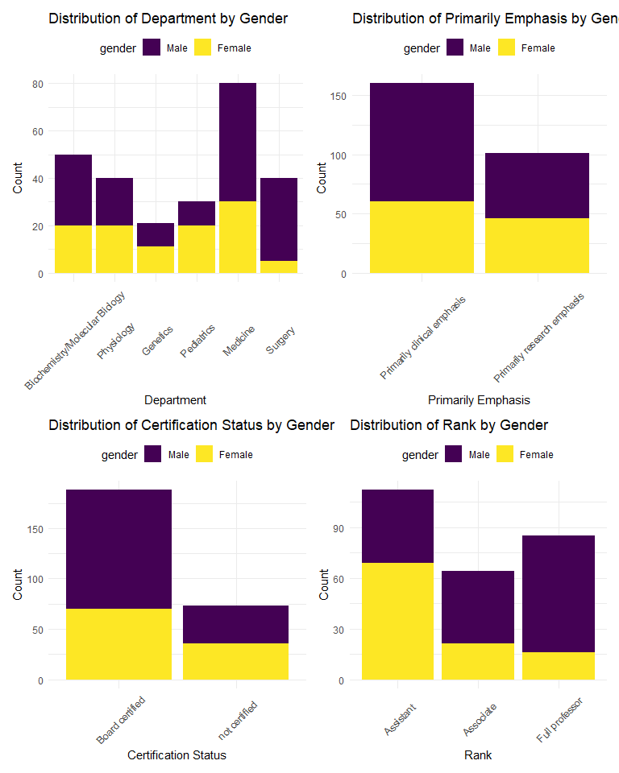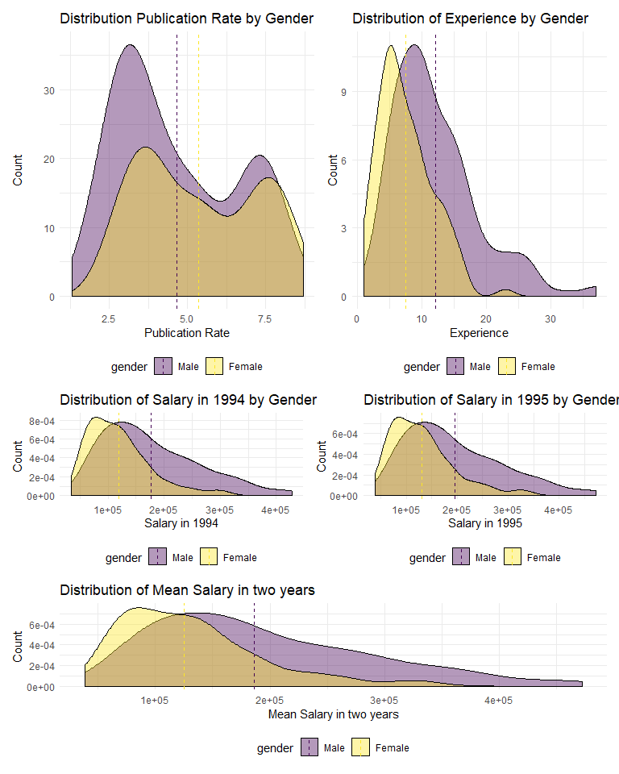

## Transformation

Based on the investigation of the distribution, to meet the assumption that response value y is normal, “salary” needs transformation.

## Joining, by = c("sal94", "sal95")

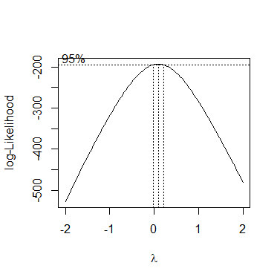 Based on the plot above, we need to do log-transformation for the mean value of sal94 and sal95 to meet the assumption of normality.