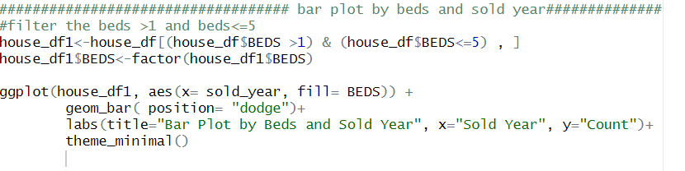

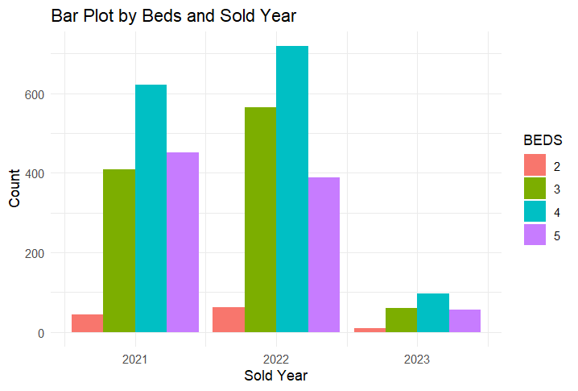

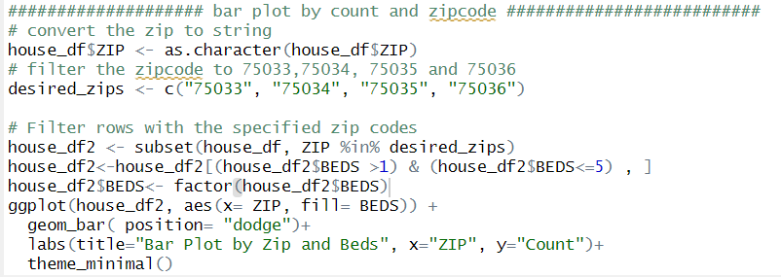

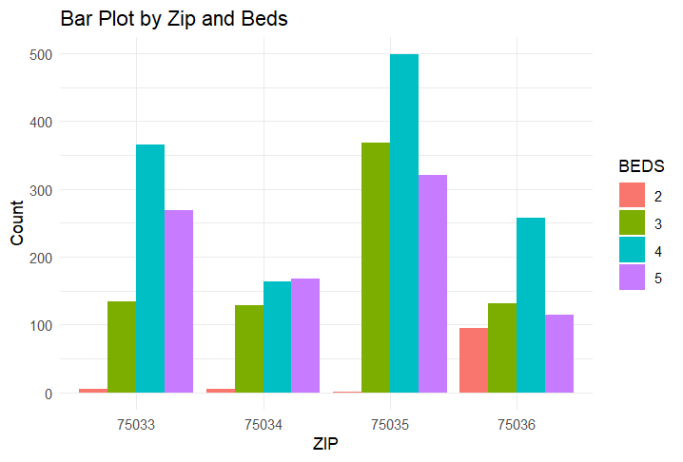

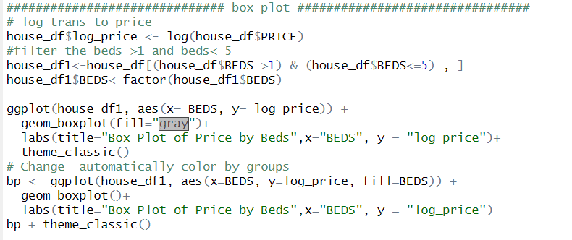

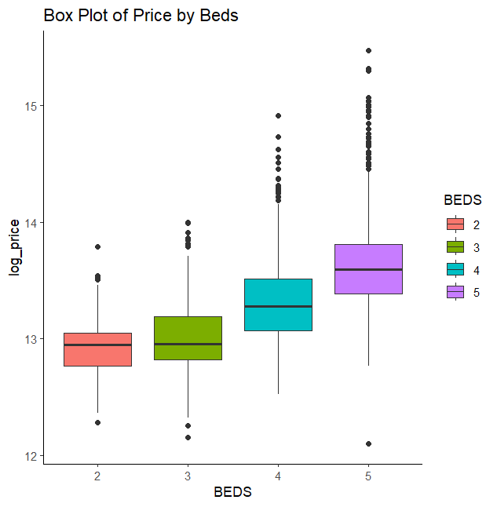

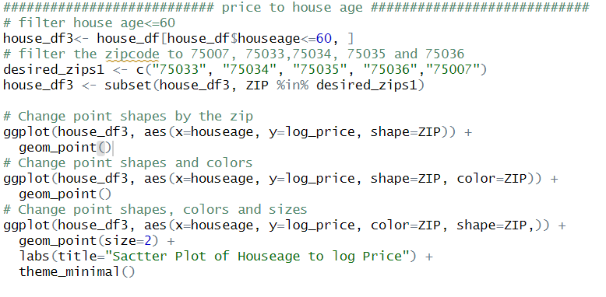

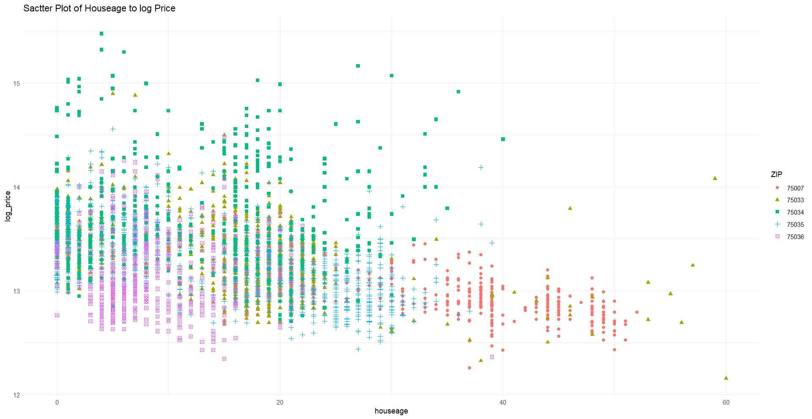

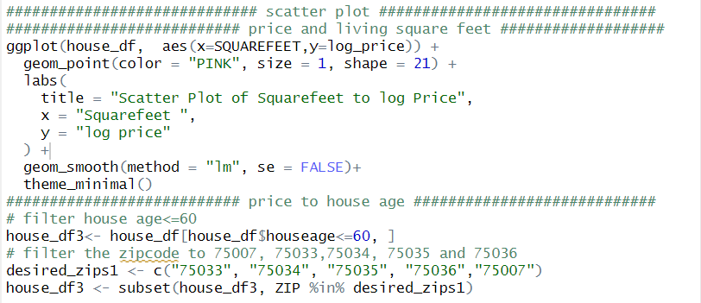

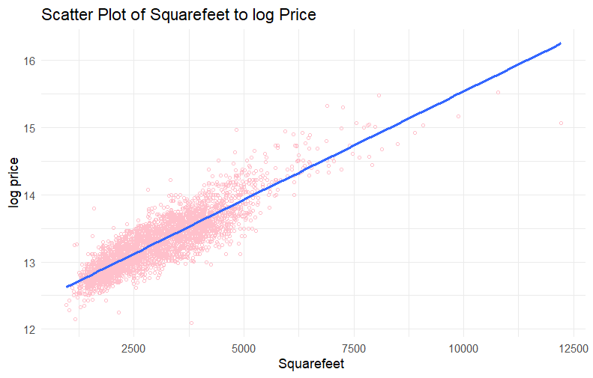

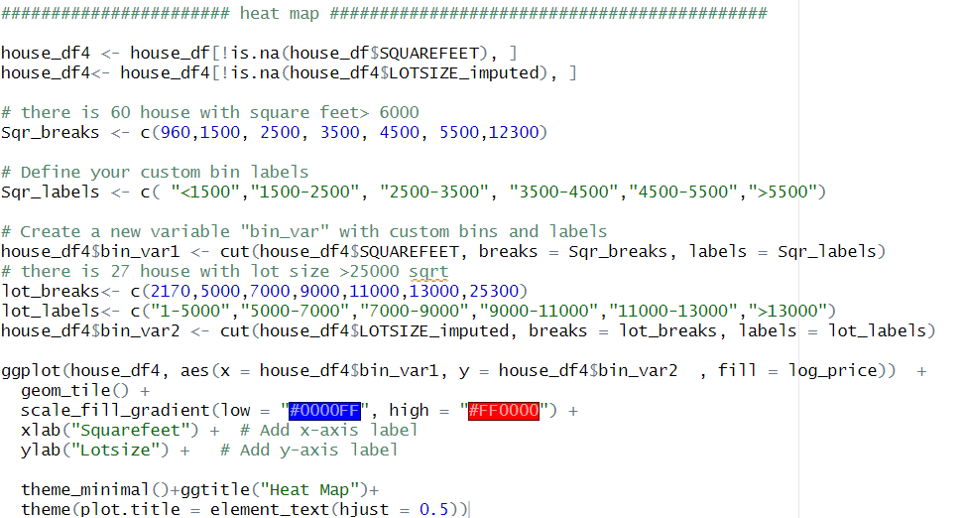

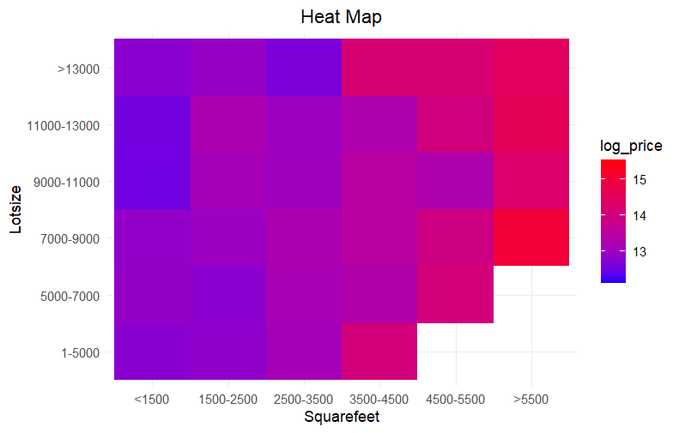

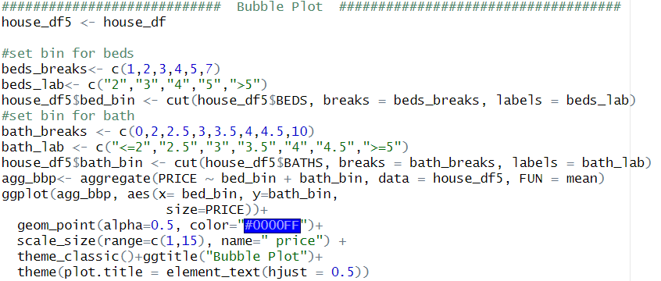

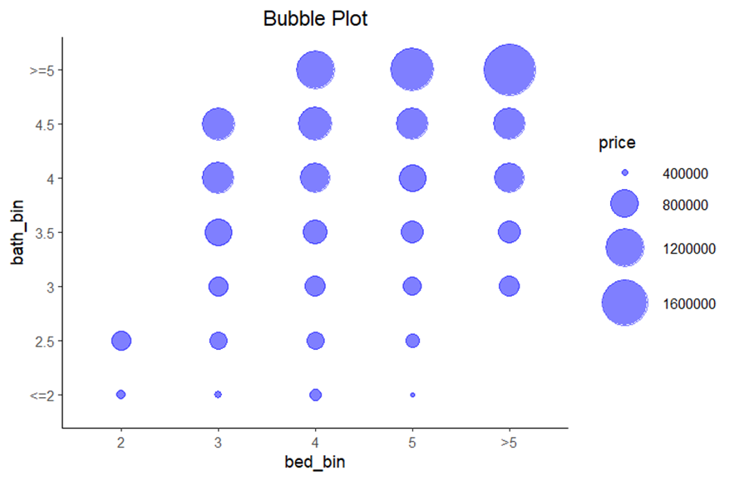

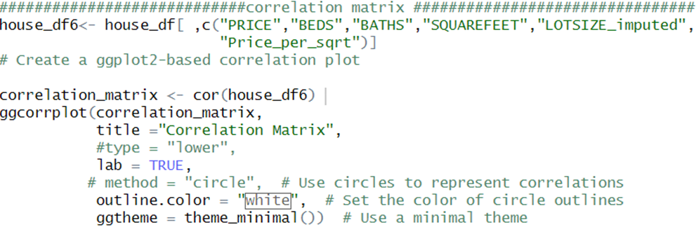

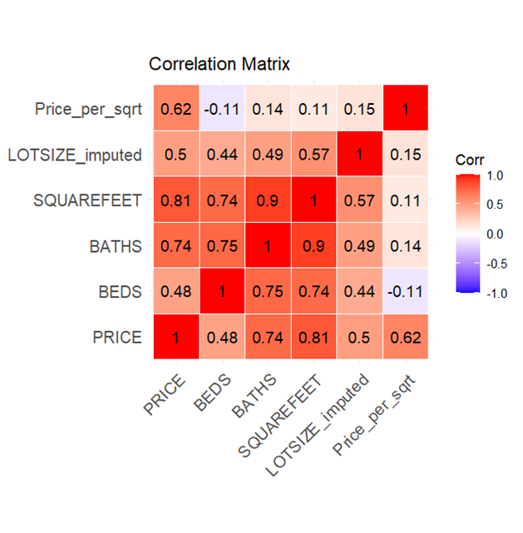

library(shiny)  
library(shinydashboard)  
library(ggplot2)  
library(leaflet)  
  
house <- house <- read.csv("Copy of house_data.csv")  
  
col <- c("PRICE","ADDRESS",  
 "CITY","STATE.OR.PROVINCE",  
 "ZIP.OR.POSTAL.CODE","SOLD.DATE",  
 "BEDS","BATHS","SQUARE.FEET",  
 "LOT.SIZE","YEAR.BUILT","LATITUDE",  
 "LONGITUDE","URL..SEE.https...www.redfin.com.buy.a.home.comparative.market.analysis.FOR.INFO.ON.PRICING.")  
house <- house[col]  
  
server <- function(input,output){  
 filtered_data <- reactive({  
 price_range <- switch(input$price_range,  
 "$100,000-$200,000" = house$PRICE >= 100000 & house$PRICE < 200000,  
 "$200,000-$300,000" = house$PRICE >= 200000 & house$PRICE < 300000,  
 "$300,000-$400,000" = house$PRICE >= 300000 & house$PRICE < 400000,  
 "$400,000-$500,000" = house$PRICE >= 400000 & house$PRICE < 500000,  
 "$500,000-$600,000" = house$PRICE >= 500000 & house$PRICE < 600000,  
 "$600,000-$700,000" = house$PRICE >= 600000 & house$PRICE < 700000,  
 "$700,000 and Above" = house$PRICE >= 500000)  
   
subset(house,   
 price_range&  
 BEDS >= input$bedroom_range[1] & BEDS <= input$bedroom_range[2] &  
 BATHS >= input$bathroom_range[1] & BATHS <= input$bathroom_range[2]  
 )  
 })  
   
 output$filtered_table <- renderDataTable({  
 filtered_data()  
 })  
   
 output$map <- renderLeaflet({  
 houseMap <- leaflet(data = filtered_data)   
   
 esri <- grep("^Esri", providers, value = TRUE)  
   
 for (provider in esri) {  
 houseMap <- houseMap %>% addProviderTiles(provider, group = provider)  
 }  
   
 houseMap %>%  
 addLayersControl(baseGroups = names(esri),  
 options = layersControlOptions(collapsed = TRUE)) %>%  
 addMarkers(data = filtered_data() %>% as.data.frame(),  
 lat = ~LATITUDE, lng = ~LONGITUDE,   
 popup = ~paste("Address: ", ADDRESS,   
 "<br>Price: $", PRICE,   
 "<br>Bed/Bath: ",BEDS,"/",BATHS,  
 "<br>Date of Sale: ", SOLD.DATE,  
 "<br>House on <a href='", URL, "'target='_blank'>Redfin</a>"))  
   
 })  
}  
  
header <- dashboardHeader(  
 title = "Frisco Home Sales"  
)  
  
body <- dashboardBody(  
 fluidRow(  
 column(width = 9,  
 box(width = NULL, solidHeader = T,  
 leafletOutput("map", height = 500)  
 )  
 ),  
 column(width = 3,  
 box(width = NULL,  
 radioButtons("price_range", "Select Price Range",  
 choices = c("$100,000-$200,000",   
 "$200,000-$300,000",   
 "$300,000-$400,000",   
 "$400,000-$500,000",   
 "$500,000-$600,000",  
 "$600,000-$700,000",  
 "$700,000 and Above"),  
 selected = "$100,000-$200,000"),  
 ),  
 box(width = NULL,  
 sliderInput("bedroom_range", "Select Number of Bedrooms",  
 min = min(house$BEDS),  
 max = max(house$BEDS),  
 value = c(min(house$BEDS), max(house$BEDS)),  
 step = 1),  
 ),  
 box(width = NULL,  
 sliderInput("bathroom_range", "Select Number of Bathrooms",  
 min = min(house$BATHS),  
 max = max(house$BATHS),  
 value = c(min(house$BATHS), max(house$BATHS)),  
 step = 0.5)  
 )  
 )  
 ),  
 fluidRow(  
 column(width = 12,  
 box(width = NULL, solidHeader = T, style = 'overflow-x: scroll',  
 dataTableOutput("filtered_table")  
 )  
 )  
 )  
)  
  
ui <- dashboardPage(  
 skin = "green",  
 header,  
 dashboardSidebar(disable = T),  
 body  
)  
  
shinyApp(ui, server)

