数据处理

缺失值填充

缺失值处理。取日龄0-25天的数据，去除日龄缺失超过一半的样本，并以同一农场日龄下的平均值进行缺失值的补充。最终样本量由1257降至989。日龄维度的样本数量为21953

Winter分位数: 0.1223
Winter数据量: 404, 正样本比例: 20.05%
Spring分位数: 0.1394
Spring数据量: 135, 正样本比例: 20.00%
Summer分位数: 0.0441
Summer数据量: 178, 正样本比例: 20.22%
Autumn分位数: 0.0643
Autumn数据量: 272, 正样本比例: 20.22%
总样本分布
9 163
12 148
10 142
3 135
11 130
1 128
2 128
8 15

高死淘样本分布
1 53
12 5
2 23
10 10
11 45
8 0
9 36
3 27

三天滑窗特征

冬季
=== 测试集评估 ===
AUC Score: 0.8136363636363637
Balanced Accuracy: 0.7165584415584416
F1-Score: 0.55
MCC: 0.4331168831168831
Confusion Matrix:
[[68 9]
[ 9 11]]

=== 跨期验证集评估 ===
Validation AUC Score: 0.7163461538461539
Validation Balanced Accuracy: 0.5644230769230769
Validation F1-Score: 0.3157894736842105
Validation MCC: 0.11533225472301789
Validation Confusion Matrix:
[[49 16]
[10 6]]

['HARVESTSTATUS_month', 'W3_15-17天_外部-平均_MEAN', 'DENSITY', 'W3_18-20天_平均温度变化率_MEAN', 'AGE', 'W3_0-2天_外部-平均_MEAN', 'W3_9-11天_平均温度变化率_MEAN', 'W3_9-11天_最低温度变化率_RANGE', 'W3_18-20天_每日温差_RANGE', 'W3_15-17天_最低温度变化率_RANGE', 'DOCAMOUNT', 'W3_6-8天_最低温度变化率_MEAN', 'W3_18-20天_外部-平均_RANGE', 'W3_9-11天_鸡舍温度-最高_RANGE', 'W3_18-20天_湿度内部平均_RANGE', 'W3_15-17天_平均
温度变化率_MEAN', 'W3_6-8天_平均温度变化率_RANGE', 'W3_15-17天_每日温差_RANGE', 'W3_21-23天_外部-平均_MEAN', 'W3_3-5天_平均温度变化率_MEAN']

回归：

数据分割结果：
训练集大小: (226, 119)
测试集大小: (97, 119)
验证集大小: (81, 119)
RMSE: 0.0345325881063042
MAE: 0.0264192148152416
R2 Score: 0.28213347924046206
=== 跨期验证结果 ===
Validation RMSE: 0.0427 (Test RMSE: 0.0345)
Validation MAE: 0.0305 (Test MAE: 0.0264)
Validation R2: 0.3751 (Test R2: 0.2821)

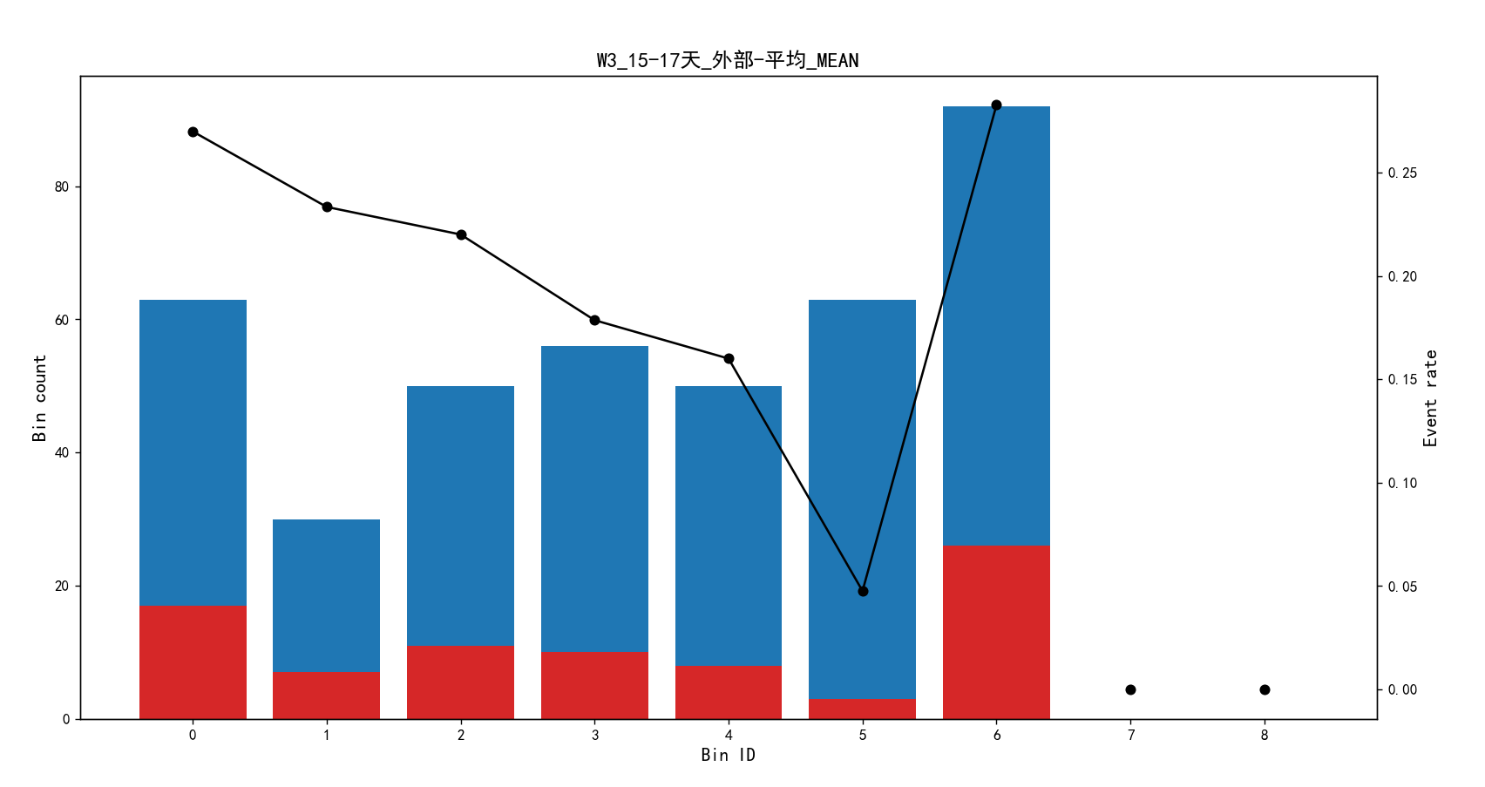
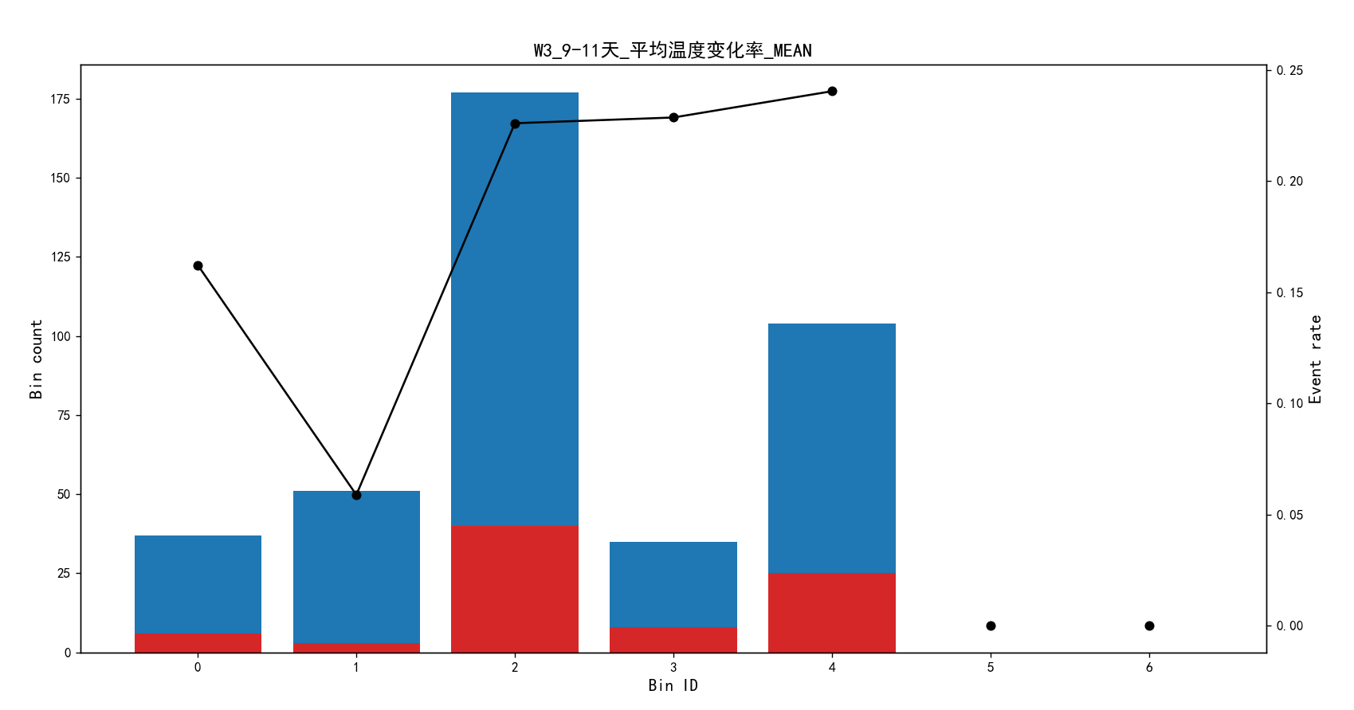
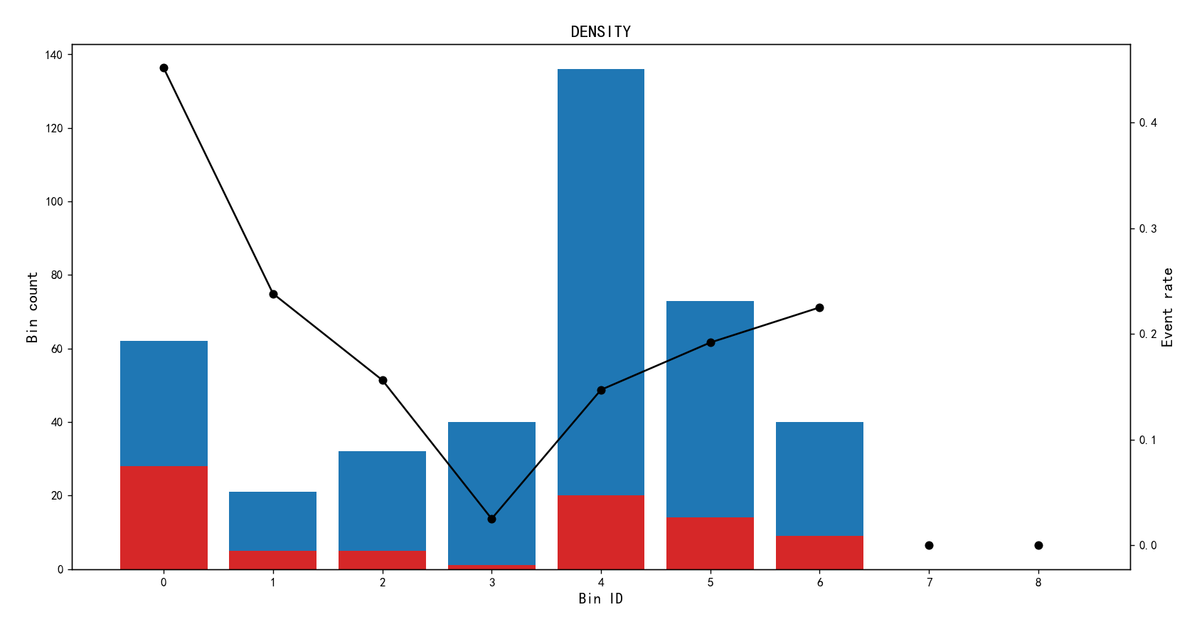
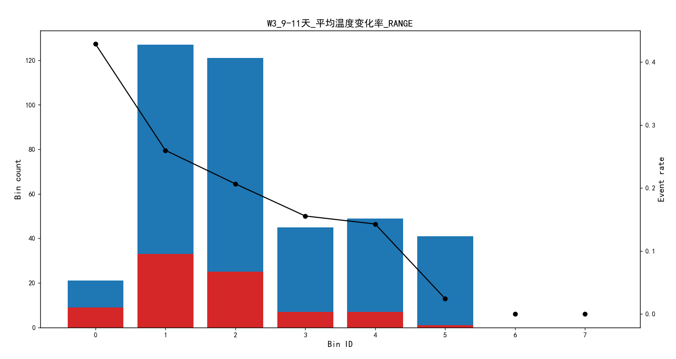
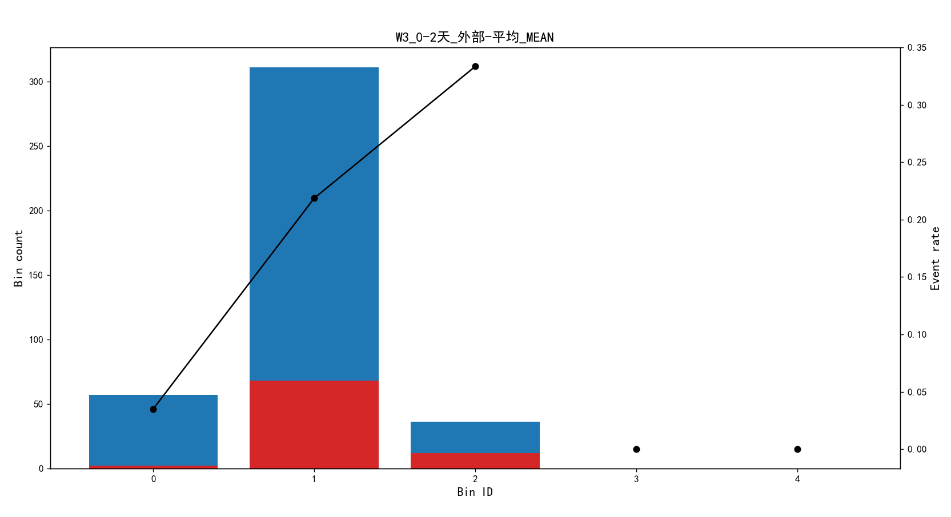
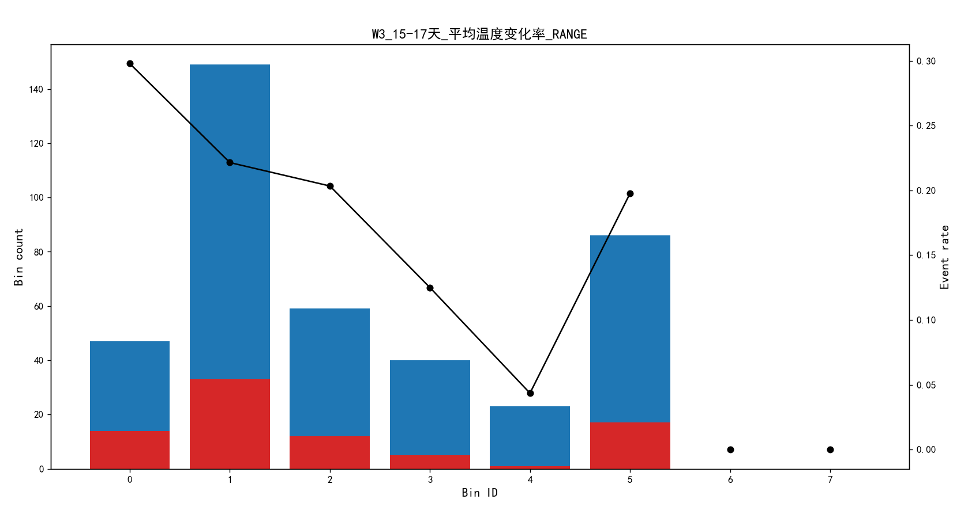
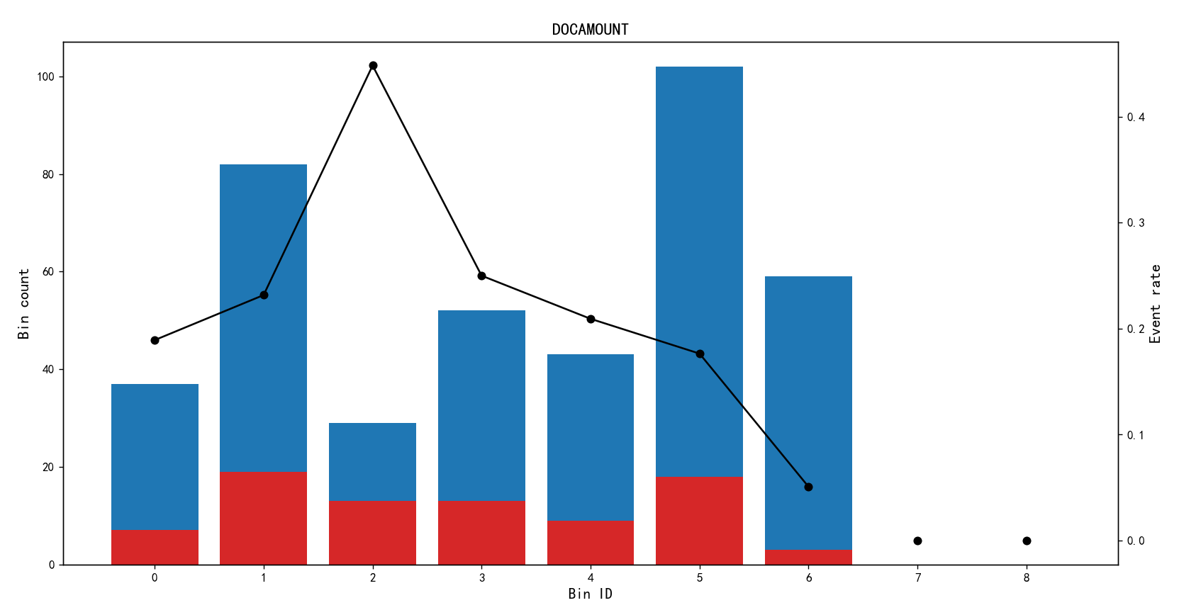
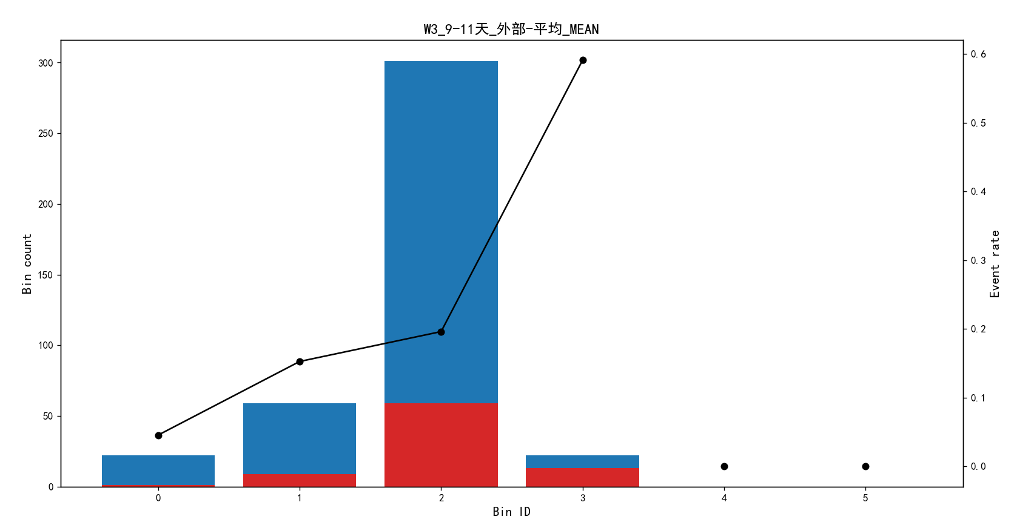
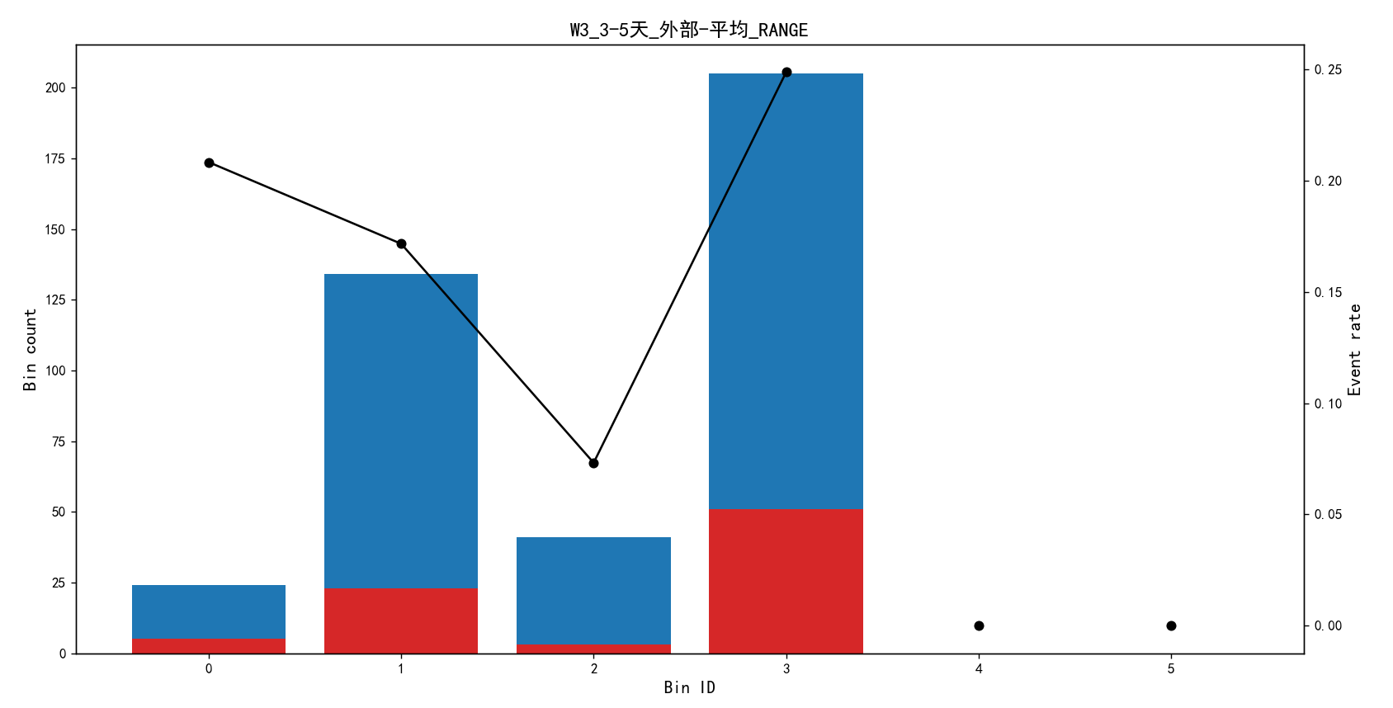
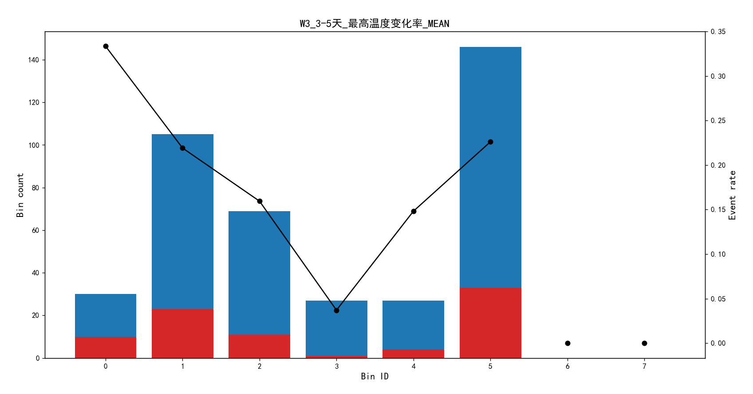
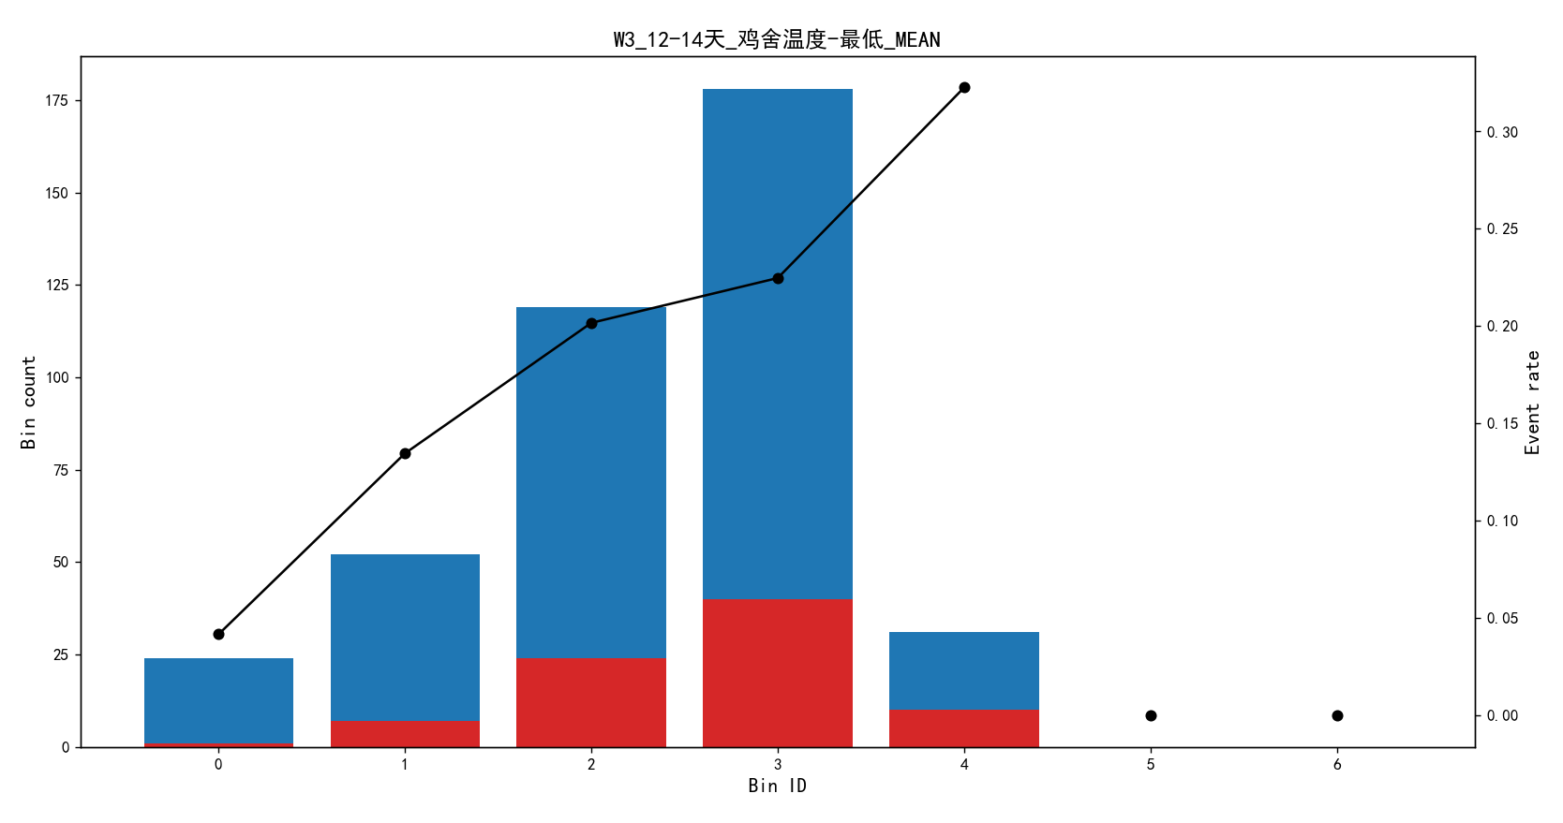
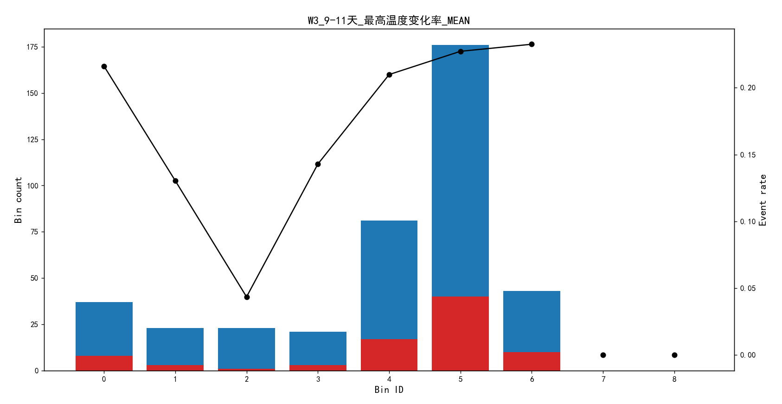
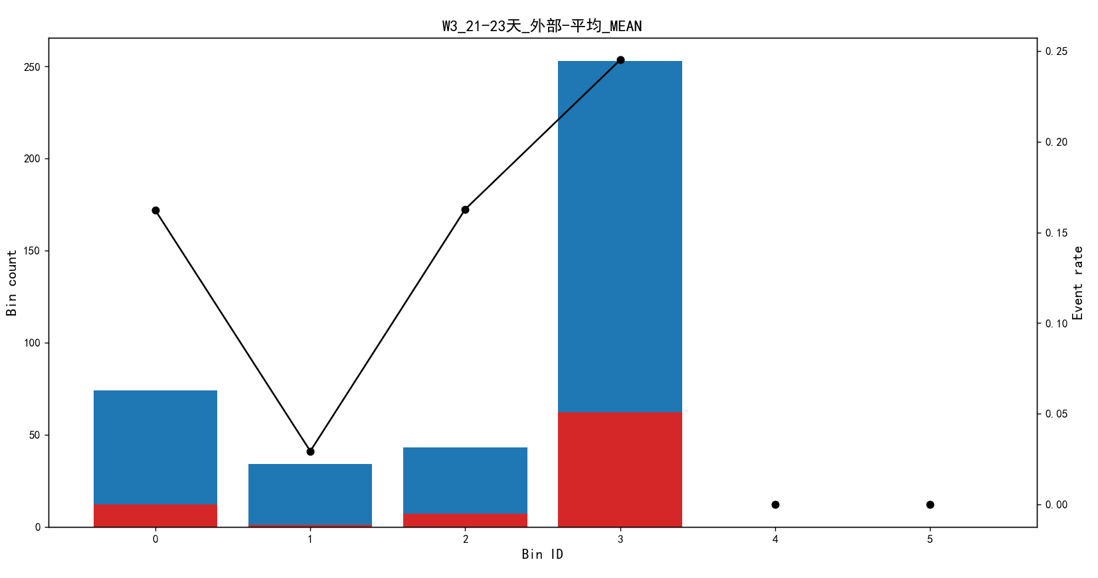
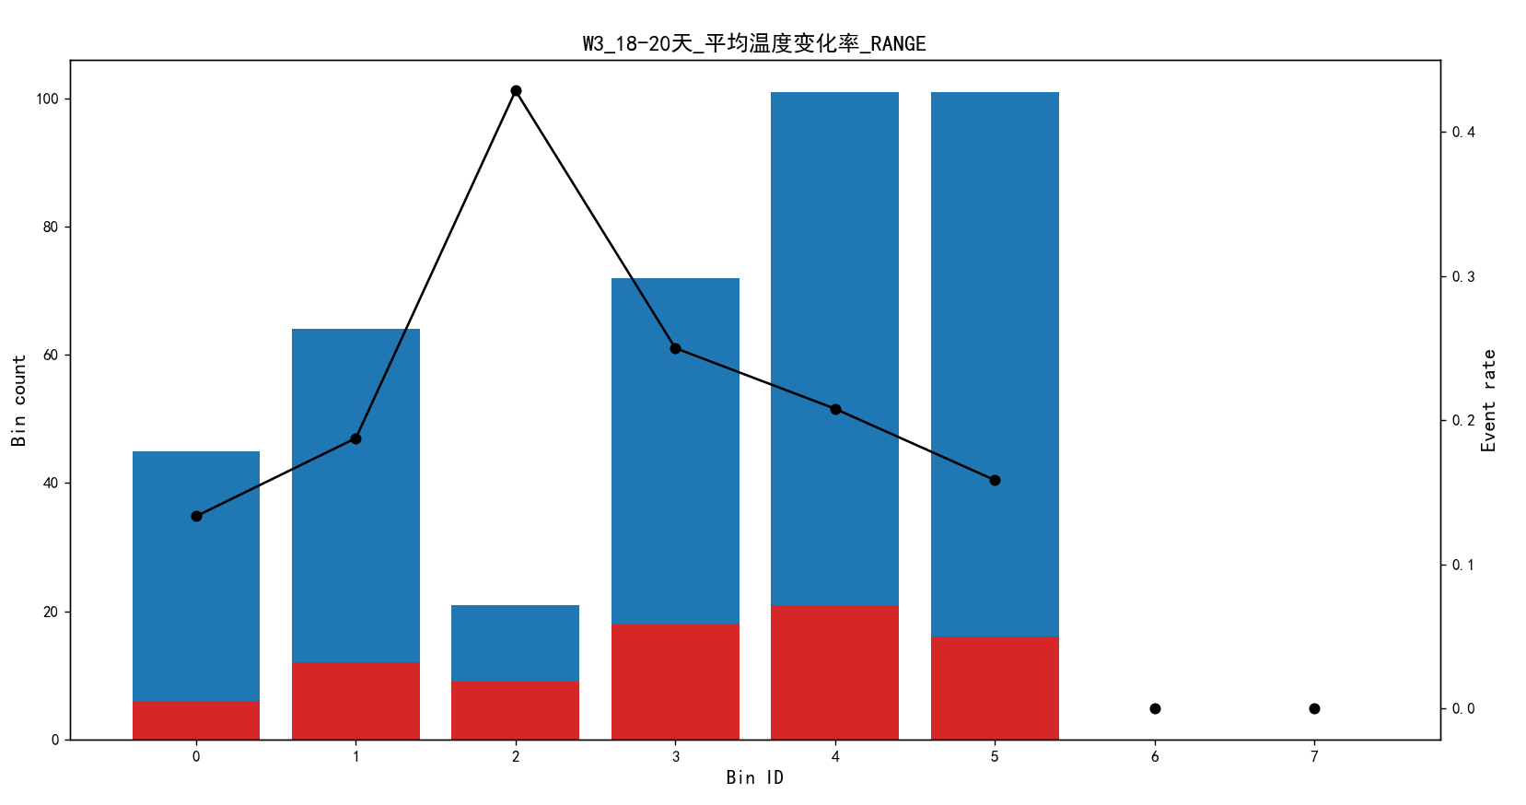
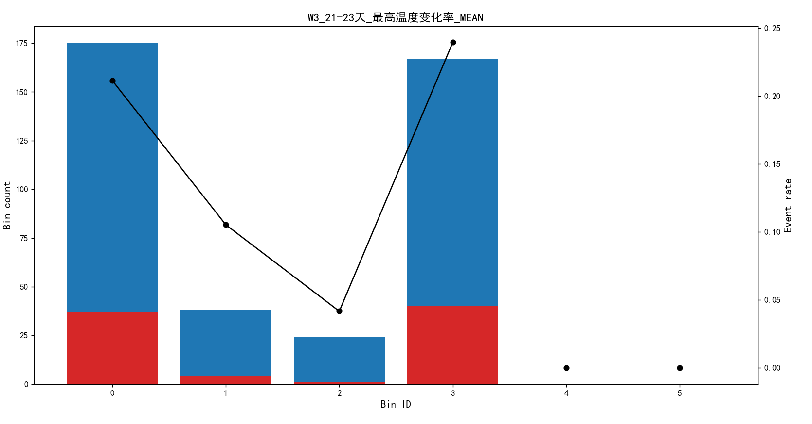
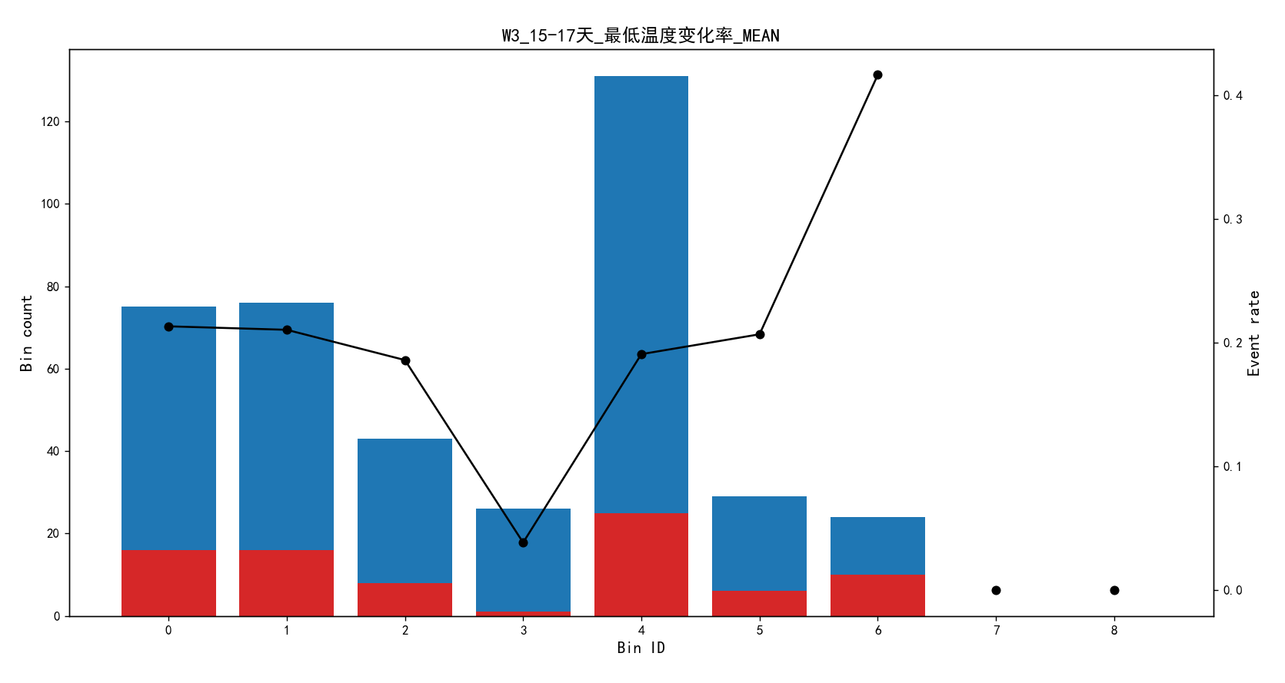
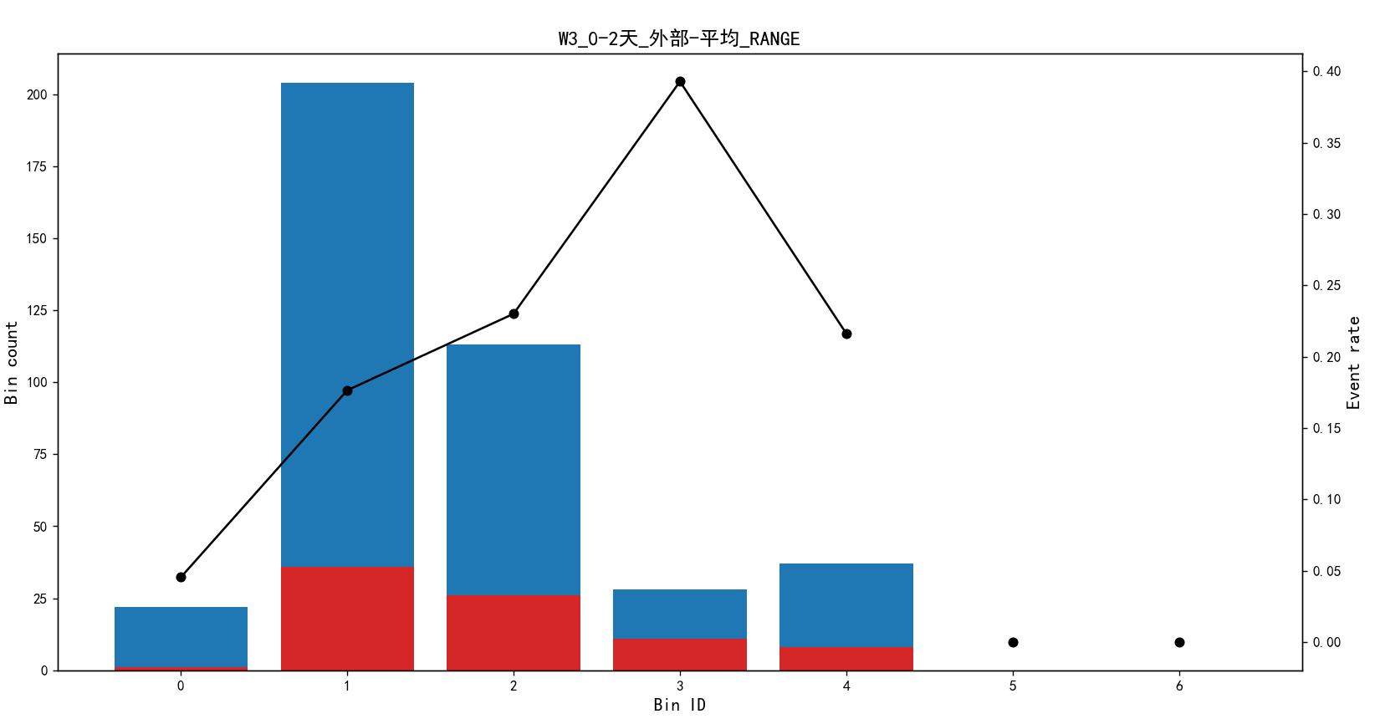
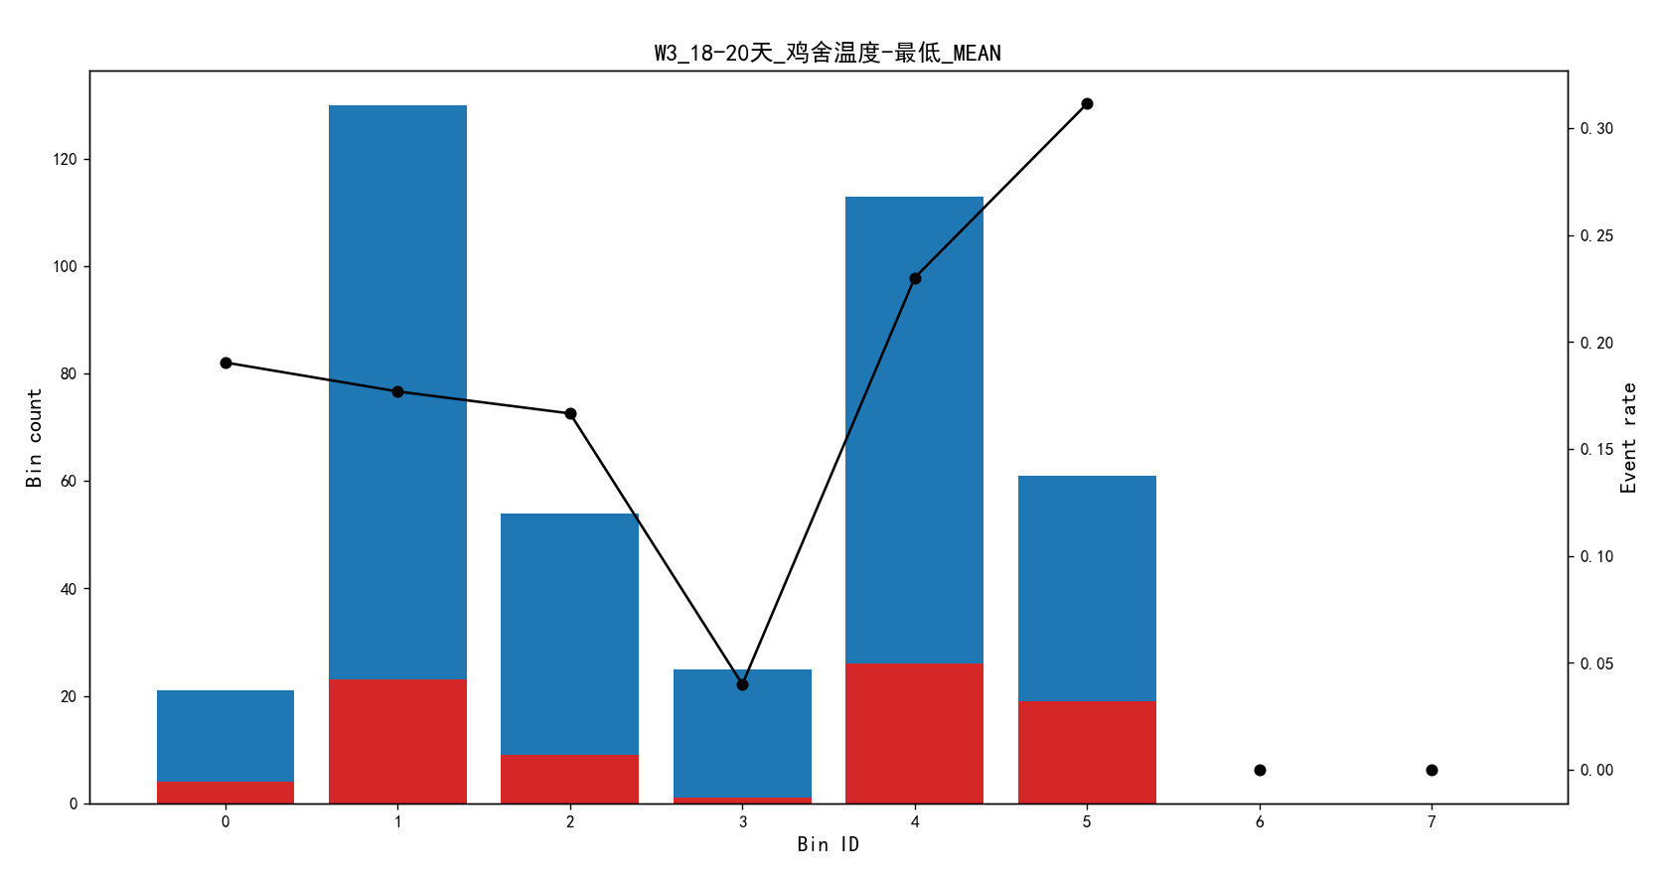

秋天

=== 测试集评估 ===
AUC Score: 0.8548621190130625
Balanced Accuracy: 0.7989840348330914
F1-Score: 0.6666666666666666
MCC: 0.5817306085852176
Confusion Matrix:
[[48 5]
[ 4 9]]

=== 跨期验证集评估 ===
Validation AUC Score: 0.7417355371900826
Validation Balanced Accuracy: 0.6477272727272727
Validation F1-Score: 0.43478260869565216
Validation MCC: 0.2861465445558277
Validation Confusion Matrix:
[[37 7]
[ 6 5]]

['W3_3-5天_每日温差_MEAN', 'W3_9-11天_鸡舍温度-平均_MEAN', 'W3_12-14天_平均温度变化率_RANGE', 'W3_6-8天_湿度内部平均_RANGE', 'W3_21-23天_最
低温度变化率_MEAN', 'W3_6-8天_鸡舍温度-最低_MEAN', 'W3_12-14天_湿度内部平均_RANGE', 'W3_0-2天_每日温差_RANGE', 'W3_12-14天_每日温差_RANGE',
'W3_15-17天_每日温差_RANGE', 'ELECTRICITY_COST', 'W3_3-5天_鸡舍温度-最低_RANGE', 'W3_6-8天_外部-平均_MEAN', 'W3_18-20天_平均温度变化率_RANGE', 'W3_18-20天_最高温度变化率_RANGE', 'W3_0-2天_最低温度变化率_MEAN', 'W3_6-8天_平均温度变化率_MEAN', 'W3_9-11天_最高温度变化率_MEAN', 'W3_21-23天_平均温度变化率_RANGE', 'W3_21-23天_最高温度变化率_RANGE']

回归
训练集大小: (151, 105)
测试集大小: (66, 105)
验证集大小: (55, 105)
RMSE: 0.013480864598460419
MAE: 0.009573836382602806
R2 Score: 0.1911767906806905
=== 跨期验证结果 ===
Validation RMSE: 0.0142 (Test RMSE: 0.0135)
Validation MAE: 0.0118 (Test MAE: 0.0096)
Validation R2: 0.3623 (Test R2: 0.1912)

夏天
=== 测试集评估 ===
AUC Score: 0.7777777777777777
Balanced Accuracy: 0.7189542483660131
F1-Score: 0.5555555555555556
MCC: 0.43790849673202614
Confusion Matrix:
[[30 4]
[ 4 5]]

=== 跨期验证集评估 ===
Validation AUC Score: 0.7389162561576355
Validation Balanced Accuracy: 0.7364532019704433
Validation F1-Score: 0.5263157894736842
Validation MCC: 0.3970333335883721
Validation Confusion Matrix:
[[22 7]
[ 2 5]]
['W3_0-2天_鸡舍温度-平均_MEAN', 'W3_21-23天_鸡舍温度-最高_MEAN', 'W3_21-23天_最低温度变化率_RANGE', 'GAS_COST', 'W3_6-8天_鸡舍温度-平均_MEAN', 'W3_21-23天_外部-平均_RANGE', 'W3_18-20天_外部-平均_RANGE', 'W3_6-8天_平均温度变化率_RANGE', 'W3_15-17天_鸡舍温度-平均_MEAN', 'W3_12-14天
_每日温差_MEAN', 'W3_12-14天_每日温差_RANGE', 'DENSITY', 'HOUSEAMOUNT', 'W3_3-5天_鸡舍温度-最低_RANGE', 'W3_12-14天_湿度内部平均_MEAN', 'W3_21-23天_湿度内部平均_RANGE', 'W3_21-23天_鸡舍温度-平均_MEAN', 'W3_15-17天_最高温度变化率_RANGE', 'W3_12-14天_外部-平均_RANGE', 'W3_15-17天_
鸡舍温度-最低_MEAN']

回归

数据分割结果：
训练集大小: (99, 90)
测试集大小: (43, 90)
验证集大小: (36, 90)
RMSE: 0.010400461359153316
MAE: 0.008140727958399938
R2 Score: 0.16177474447357088
=== 跨期验证结果 ===
Validation RMSE: 0.0125 (Test RMSE: 0.0104)
Validation MAE: 0.0099 (Test MAE: 0.0081)
Validation R2: 0.1051 (Test R2: 0.1618)

按日龄维度的水和温度建模结果

=== 测试集评估 ===
AUC Score: 0.7700309052561445
Balanced Accuracy: 0.6779970557847752
F1-Score: 0.484819734345351
MCC: 0.35599411156955035
Confusion Matrix:
[[3672 543]
[ 543 511]]

=== 跨期验证集评估 ===
Validation AUC Score: 0.7638138070959346
Validation Balanced Accuracy: 0.6694367228264428
Validation F1-Score: 0.47264260768335276
Validation MCC: 0.3445949369978017
Validation Confusion Matrix:
[[3079 434]
[ 472 406]]

重要变量
['Water_前7天变化百分比', 'Lowest_Temn_前7天', 'Lowest_Temn_前3天', 'Feed_前7天变化百分比', 'Ventilation_Coefficient_Cold_前
1天', 'Lowest_Temn_前5天', 'Ventilation_Coefficient_Warm_前3天', 'Ventilation_Coefficient_Warm_前5天', 'Water', 'Ventilation_Coefficient_Warm', 'Ventilation_Coefficient_Cold_前3天', 'Water_前7天变化', 'Lowest_Temp_Outside_前5天变化百分比', 'Lowest_Temp_Outside_前3天变化百分比', 'Lowest_Temn_前7天变化', '最高温度变化率_前1天', '每日温差', 'Ventilation_Coefficient_Warm_前
5天变化百分比', 'Highest_Temn_前5天', 'Water_前3天变化', 'Lowest_Temn_前7天变化百分比', 'Highest_Temn_前7天', 'Ventilation_Coefficient_Cold_前7天', '最高温度变化率_前5天变化百分比', '温度1平均_前7天变化', 'Ventilation_Coefficient_Cold_前7天变化', 'Ventilation_Coefficient_Warm_前7天变化百分比', 'Ventilation_Coefficient_Cold_前3天变化', '温度1平均_前3天变化', 'Ventilation_Coefficient_Warm_前3天变化百分比', '内部平均湿度_前3天变化', '每日温差_前5天', '最低温度变化率_前5天', 'Highest_Temp_Outside_前3天变化百分比', 'Lowest_Temp_Outside_前1天变化百分比', '温度1平均_前1天变化', 'Highest_humidity_前3天', 'Ventilation_Coefficient_Cold', 'Water_前1天变化', 'Ventilation_Coefficient_Cold_前1天变化', '内外温差_max', 'Ventilation_Coefficient_Cold_
前1天变化百分比', 'Highest_Temn_前7天变化百分比', 'Lowest_Humidity', '最高温度变化率_前3天变化百分比', '每日温差_前1天变化', '平均温度变化率_前1天', '最高温度变化率', '温度1-平均_max', '平均温度变化率_前3天变化百分比']

去掉内外温差和通风系数等数据结果
=== 测试集评估 ===
AUC Score: 0.7675022115378123
Balanced Accuracy: 0.6679159323010573
F1-Score: 0.4686907020872865
MCC: 0.3358318646021145
Confusion Matrix:
[[3655 560]
[ 560 494]]

=== 跨期验证集评估 ===
Validation AUC Score: 0.7629912845681547
Validation Balanced Accuracy: 0.6542033592118308
Validation F1-Score: 0.44837758112094395
Validation MCC: 0.31697270113782555
Validation Confusion Matrix:
[[3076 437]
[ 498 380]]

['Water_前7天变化百分比', 'Lowest_Temn_前7天', 'Lowest_Temn_前3天', 'Water',
'Feed_前7天变化百分比', 'Highest_Temp_Outside_前3天', 'Lowest_Temn_前5天',
'Highest_Temn_前7天', 'Lowest_Temp_Outside_前3天变化百分比', 'Highest_humidity_前3天',
'Lowest_Temn_前7天变化', 'Lowest_Temp_Outside_前5天变化百分比', '最高温度变化率_前1天',
'Water_前7天变化', '每日温差', '最低温度变化率_前5天', '每日温差_前5天', '温度1-平均_max',
'Highest_Temn_前1天', 'Highest_Temn_前3天']
重要变量
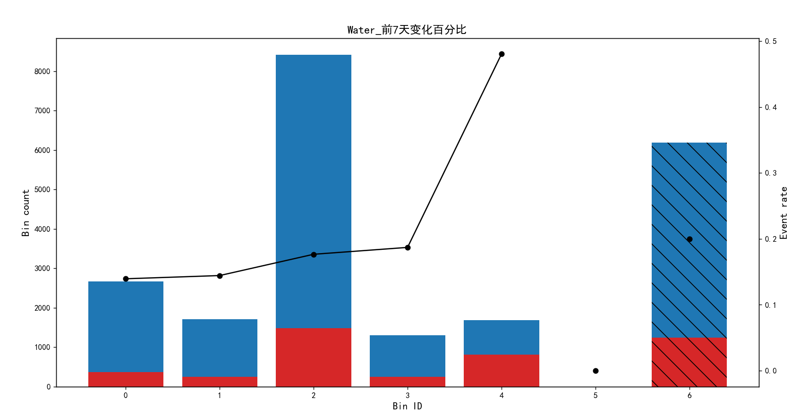
Bin Count Count (%) Non-event Event Event rate
0 (-inf, 49.10) 2660 0.121168 2289 371 0.139474
1 [49.10, 61.89) 1711 0.077939 1464 247 0.144360
2 [61.89, 140.00) 8413 0.383228 6927 1486 0.176631
3 [140.00, 164.34) 1299 0.059172 1056 243 0.187067
4 [164.34, inf) 1680 0.076527 873 807 0.480357
5 Special 0 0.000000 0 0 0.000000
6 Missing 6190 0.281966 4953 1237 0.199838
Totals 21953 1.000000 17562 4391 0.200018
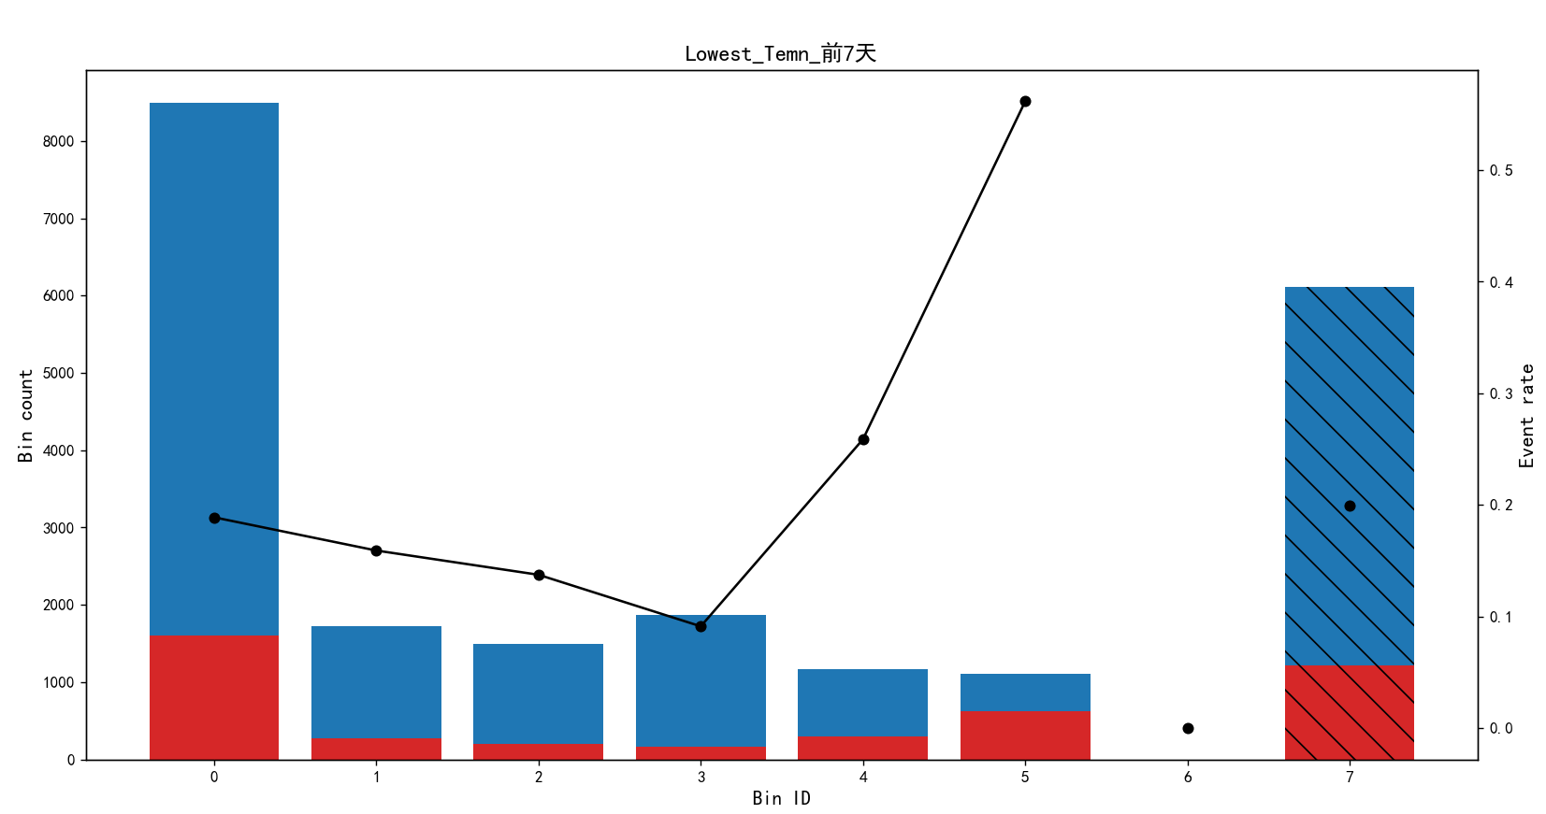
Bin Count Count (%) Non-event Event Event rate
0 (-inf, 28.75) 8492 0.386826 6888 1604 0.188884
1 [28.75, 29.43) 1722 0.078440 1448 274 0.159117
2 [29.43, 30.36) 1492 0.067963 1287 205 0.137399
3 [30.36, 31.85) 1864 0.084909 1694 170 0.091202
4 [31.85, 32.75) 1163 0.052977 862 301 0.258813
5 [32.75, inf) 1104 0.050289 484 620 0.561594
6 Special 0 0.000000 0 0 0.000000
7 Missing 6116 0.278595 4899 1217 0.198986
Totals 21953 1.000000 17562 4391 0.200018
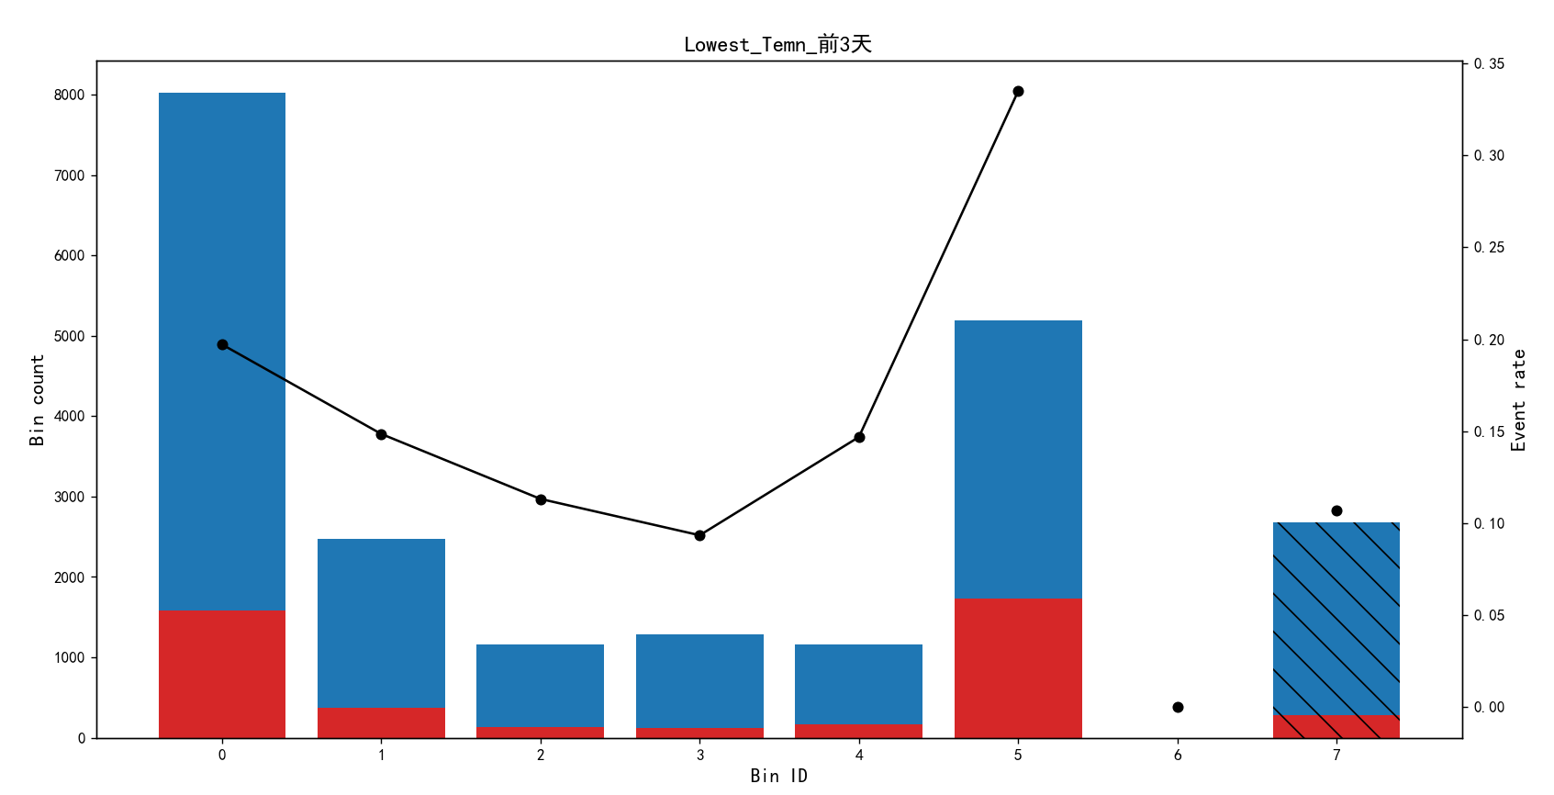
Bin Count Count (%) Non-event Event Event rate
0 (-inf, 27.31) 8021 0.365371 6440 1581 0.197108
1 [27.31, 28.25) 2472 0.112604 2105 367 0.148463
2 [28.25, 28.65) 1158 0.052749 1027 131 0.113126
3 [28.65, 29.15) 1285 0.058534 1165 120 0.093385
4 [29.15, 29.65) 1158 0.052749 988 170 0.146805
5 [29.65, inf) 5185 0.236186 3449 1736 0.334812
6 Special 0 0.000000 0 0 0.000000
7 Missing 2674 0.121806 2388 286 0.106956
Totals 21953 1.000000 17562 4391 0.200018
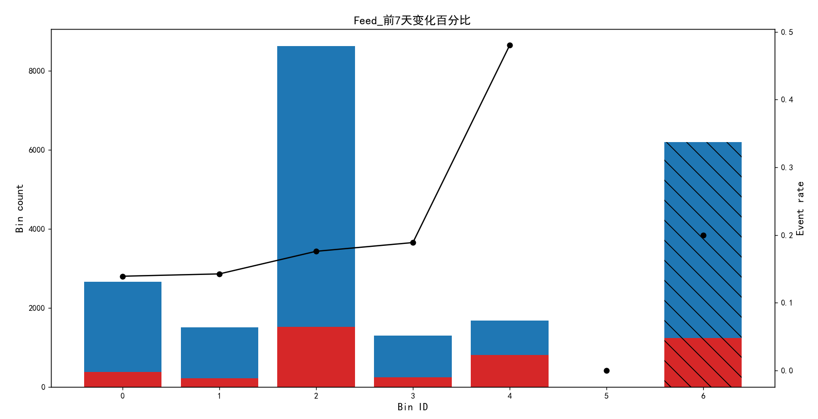
Bin Count Count (%) Non-event Event Event rate
0 (-inf, 49.10) 2665 0.121396 2294 371 0.139212
1 [49.10, 60.32) 1500 0.068328 1286 214 0.142667
2 [60.32, 140.12) 8624 0.392839 7106 1518 0.176020
3 [140.12, 164.43) 1297 0.059081 1052 245 0.188897
4 [164.43, inf) 1675 0.076299 871 804 0.480000
5 Special 0 0.000000 0 0 0.000000
6 Missing 6192 0.282057 4953 1239 0.200097
Totals 21953 1.000000 17562 4391 0.200018

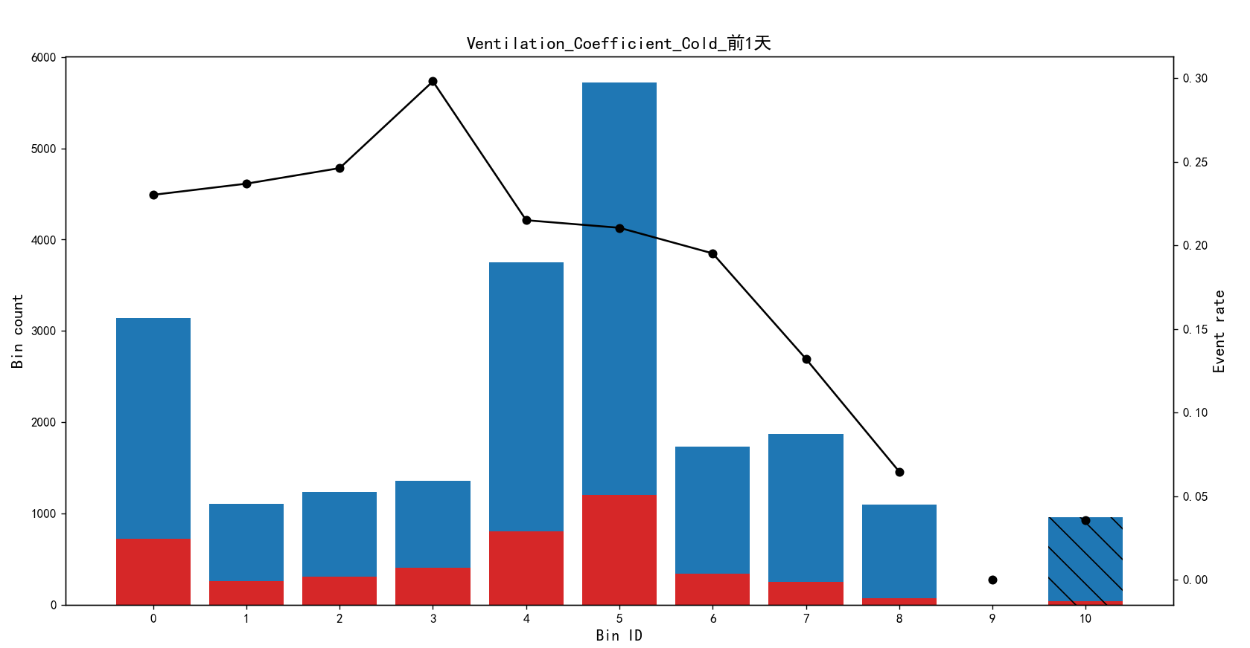

Bin Count Count (%) Non-event Event Event rate
0 (-inf, 0.36) 3137 0.142896 2415 722 0.230156
1 [0.36, 0.39) 1102 0.050198 841 261 0.236842
2 [0.39, 0.42) 1231 0.056074 928 303 0.246141
3 [0.42, 0.45) 1359 0.061905 954 405 0.298013
4 [0.45, 0.54) 3749 0.170774 2943 806 0.214991
5 [0.54, 1.09) 5721 0.260602 4517 1204 0.210453
6 [1.09, 1.63) 1732 0.078896 1394 338 0.195150
7 [1.63, 2.85) 1870 0.085182 1623 247 0.132086
8 [2.85, inf) 1098 0.050016 1027 71 0.064663
9 Special 0 0.000000 0 0 0.000000
10 Missing 954 0.043456 920 34 0.035639
Totals 21953 1.000000 17562 4391 0.200018

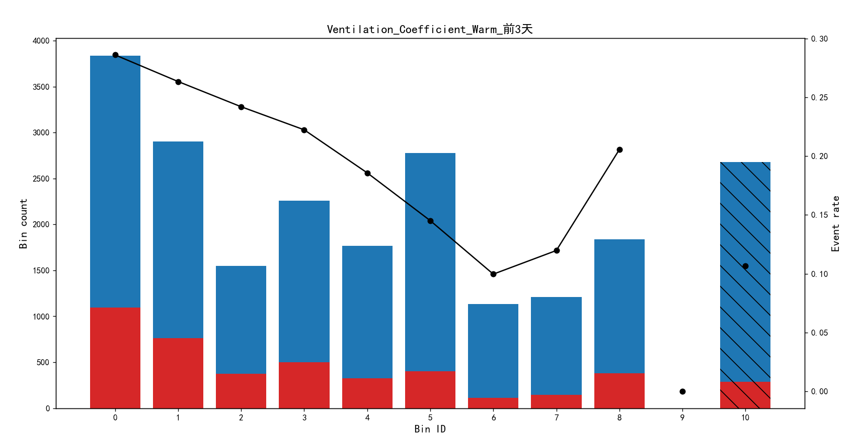
Bin Count Count (%) Non-event Event Event rate
0 (-inf, 0.46) 3836 0.174737 2739 1097 0.285975
1 [0.46, 0.57) 2901 0.132146 2137 764 0.263357
2 [0.57, 0.62) 1550 0.070605 1175 375 0.241935
3 [0.62, 0.82) 2258 0.102856 1756 502 0.222321
4 [0.82, 1.35) 1766 0.080445 1438 328 0.185730
5 [1.35, 4.40) 2777 0.126498 2374 403 0.145121
6 [4.40, 6.88) 1134 0.051656 1021 113 0.099647
7 [6.88, 10.10) 1211 0.055163 1066 145 0.119736
8 [10.10, inf) 1839 0.083770 1461 378 0.205546
9 Special 0 0.000000 0 0 0.000000
10 Missing 2681 0.122125 2395 286 0.106677
Totals 21953 1.000000 17562 4391 0.200018

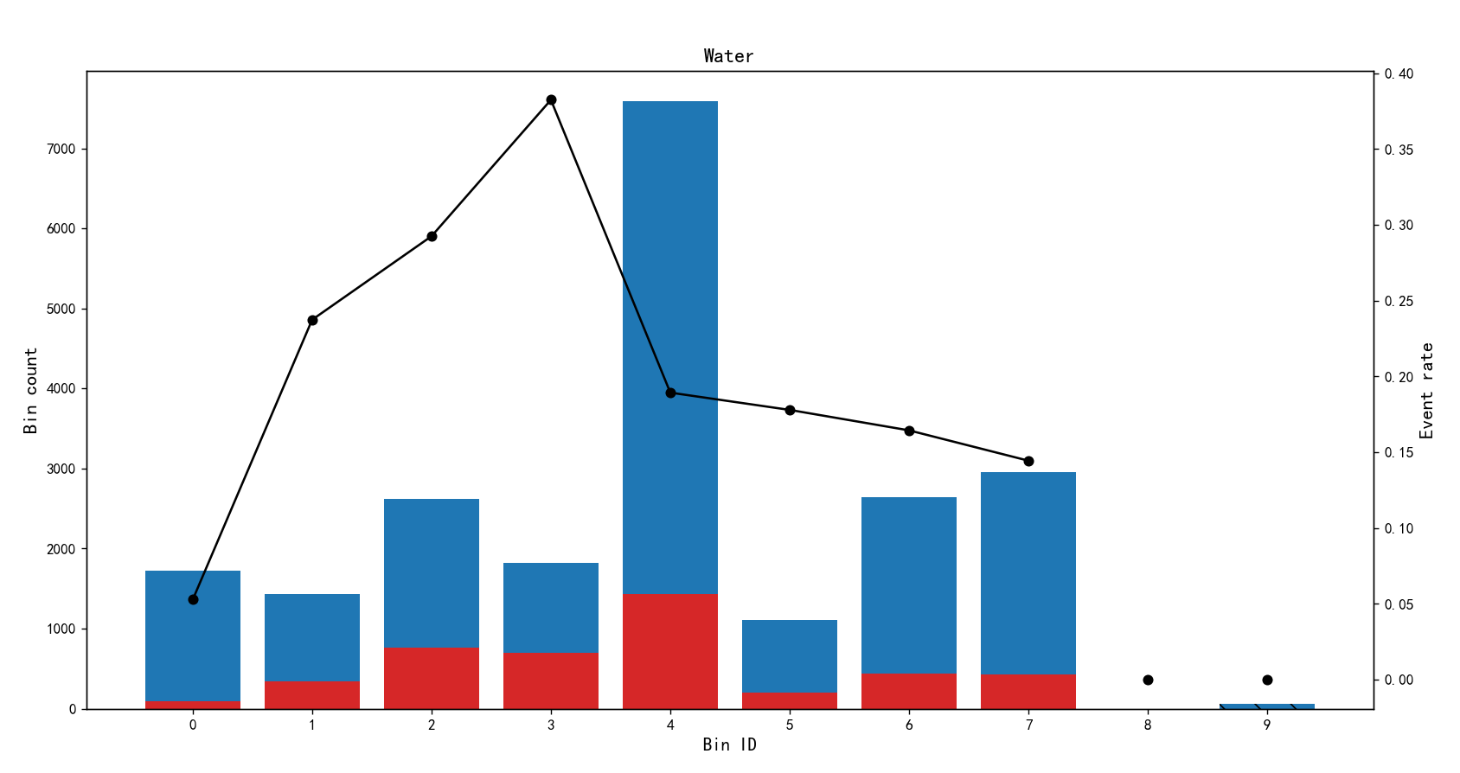
Bin Count Count (%) Non-event Event Event rate
0 (-inf, 0.97) 1723 0.078486 1632 91 0.052815
1 [0.97, 1.30) 1432 0.065230 1092 340 0.237430
2 [1.30, 1.95) 2622 0.119437 1855 767 0.292525
3 [1.95, 2.47) 1825 0.083132 1127 698 0.382466
4 [2.47, 5.79) 7589 0.345693 6152 1437 0.189353
5 [5.79, 6.22) 1107 0.050426 910 197 0.177958
6 [6.22, 7.27) 2639 0.120211 2205 434 0.164456
7 [7.27, inf) 2956 0.134651 2529 427 0.144452
8 Special 0 0.000000 0 0 0.000000
9 Missing 60 0.002733 60 0 0.000000
Totals 21953 1.000000 17562 4391 0.200018

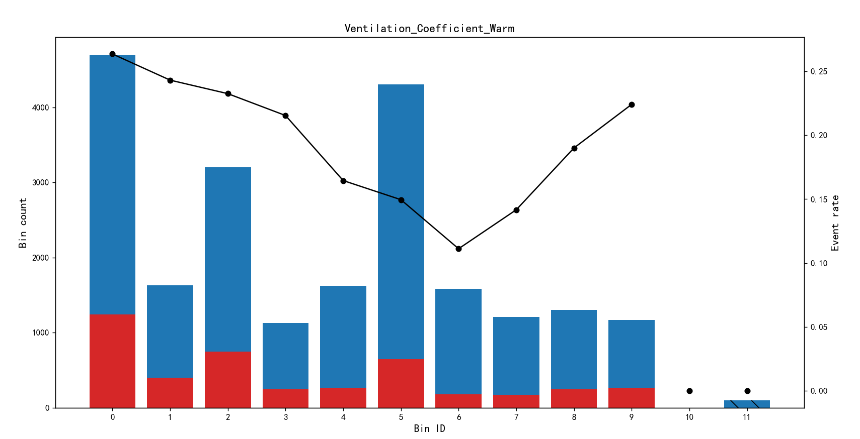
Bin Count Count (%) Non-event Event Event rate
0 (-inf, 0.48) 4701 0.214139 3462 1239 0.263561
1 [0.48, 0.52) 1629 0.074204 1233 396 0.243094
2 [0.52, 0.63) 3204 0.145948 2459 745 0.232522
3 [0.63, 0.70) 1128 0.051382 885 243 0.215426
4 [0.70, 0.91) 1623 0.073931 1356 267 0.164510
5 [0.91, 3.30) 4306 0.196146 3662 644 0.149559
6 [3.30, 5.89) 1583 0.072109 1407 176 0.111181
7 [5.89, 8.12) 1207 0.054981 1036 171 0.141674
8 [8.12, 13.53) 1305 0.059445 1057 248 0.190038
9 [13.53, inf) 1169 0.053250 907 262 0.224123
10 Special 0 0.000000 0 0 0.000000
11 Missing 98 0.004464 98 0 0.000000
Totals 21953 1.000000 17562 4391 0.200018

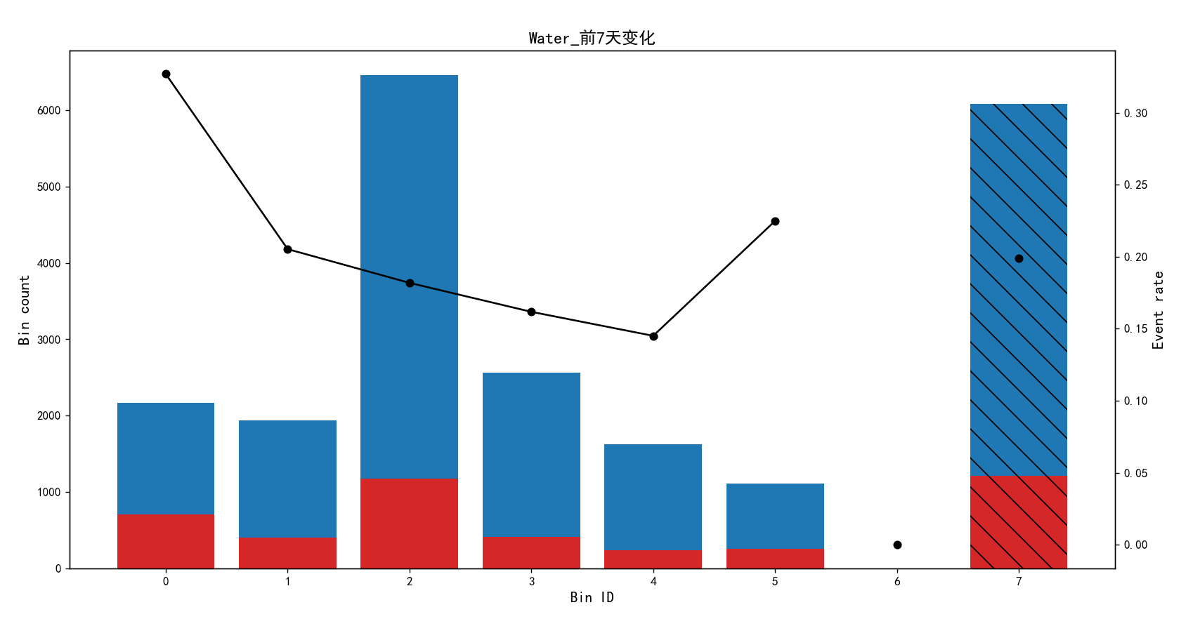
Bin Count Count (%) Non-event Event Event rate
0 (-inf, 1.53) 2166 0.098665 1458 708 0.326870
1 [1.53, 1.85) 1939 0.088325 1541 398 0.205260
2 [1.85, 2.55) 6462 0.294356 5287 1175 0.181832
3 [2.55, 2.84) 2560 0.116613 2146 414 0.161719
4 [2.84, 3.25) 1627 0.074113 1391 236 0.145052
5 [3.25, inf) 1112 0.050654 862 250 0.224820
6 Special 0 0.000000 0 0 0.000000
7 Missing 6087 0.277274 4877 1210 0.198784
Totals 21953 1.000000 17562 4391 0.200018

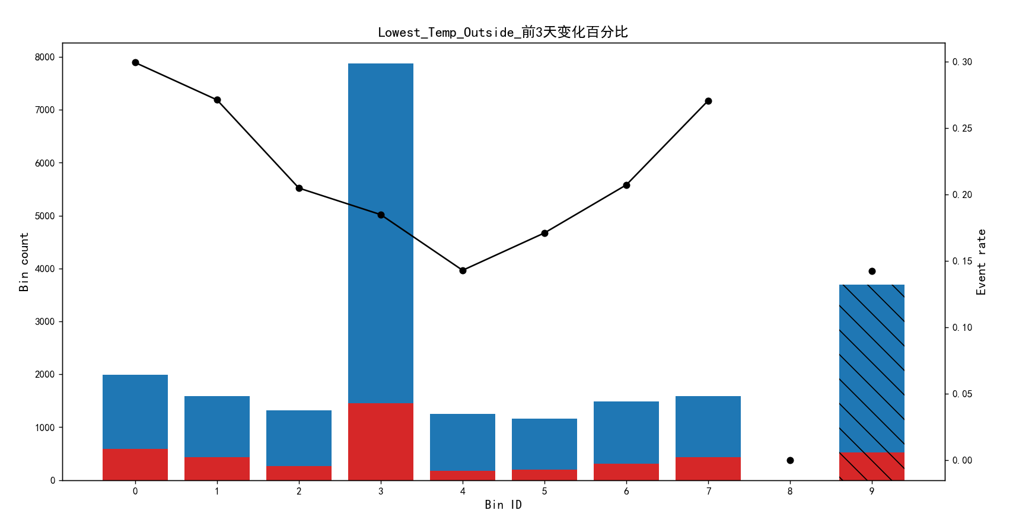
Bin Count Count (%) Non-event Event Event rate
0 (-inf, -115.48) 1989 0.090603 1394 595 0.299145
1 [-115.48, -73.21) 1590 0.072427 1159 431 0.271069
2 [-73.21, -47.34) 1314 0.059855 1045 269 0.204718
3 [-47.34, 3.77) 7876 0.358766 6421 1455 0.184738
4 [3.77, 8.17) 1246 0.056758 1068 178 0.142857
5 [8.17, 24.04) 1158 0.052749 960 198 0.170984
6 [24.04, 93.75) 1487 0.067736 1179 308 0.207128
7 [93.75, inf) 1593 0.072564 1162 431 0.270559
8 Special 0 0.000000 0 0 0.000000
9 Missing 3700 0.168542 3174 526 0.142162
Totals 21953 1.000000 17562 4391 0.200018

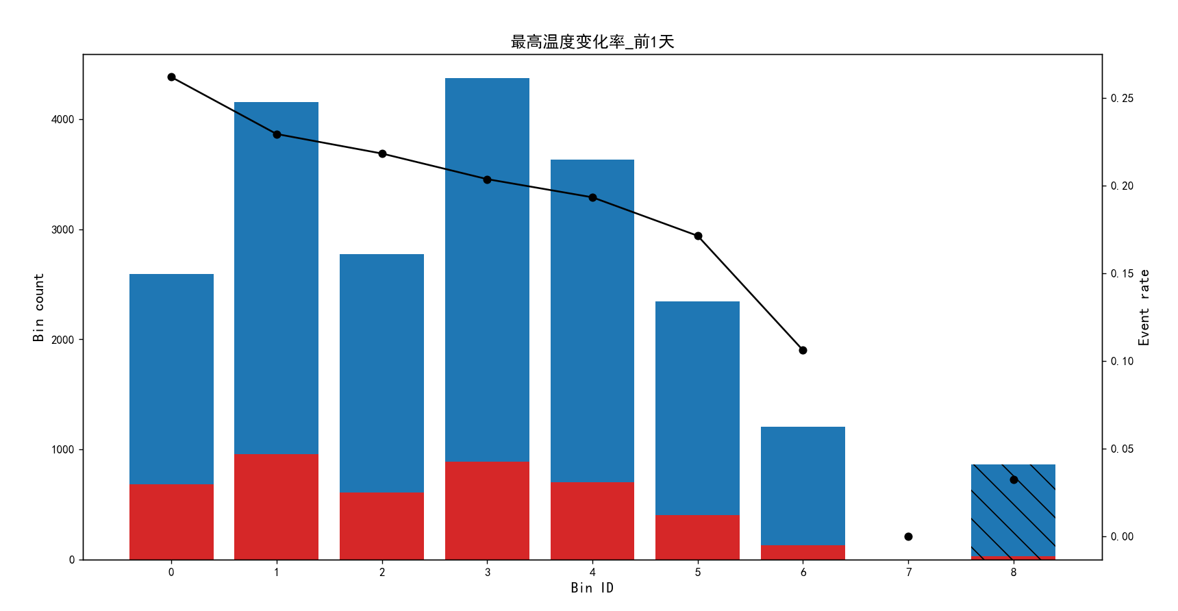
Bin Count Count (%) Non-event Event Event rate
0 (-inf, -0.00) 2597 0.118298 1917 680 0.261841
1 [-0.00, 0.00) 4159 0.189450 3205 954 0.229382
2 [0.00, 0.00) 2772 0.126270 2167 605 0.218254
3 [0.00, 0.00) 4375 0.199289 3484 891 0.203657
4 [0.00, 0.00) 3637 0.165672 2934 703 0.193291
5 [0.00, 0.00) 2346 0.106865 1944 402 0.171355
6 [0.00, inf) 1206 0.054936 1078 128 0.106136
7 Special 0 0.000000 0 0 0.000000
8 Missing 861 0.039220 833 28 0.032520
Totals 21953 1.000000 17562 4391 0.200018

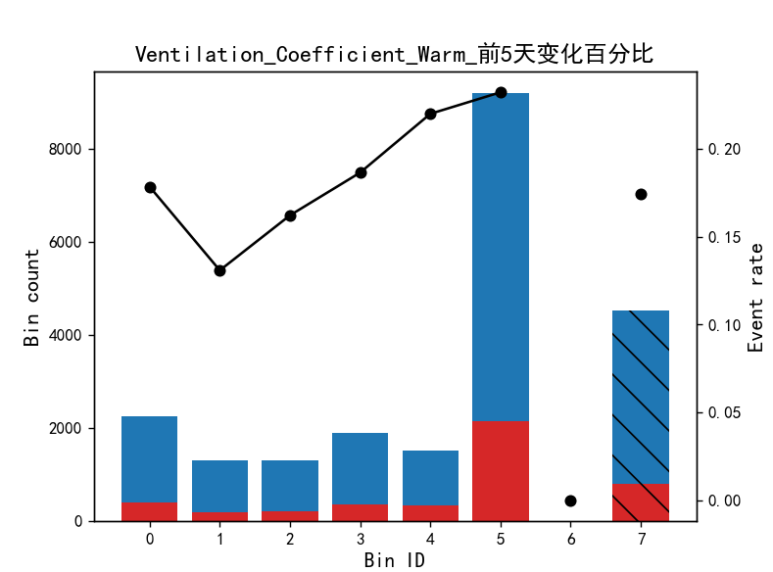
Bin Count Count (%) Non-event Event Event rate
0 (-inf, -41.64) 2240 0.102036 1840 400 0.178571
1 [-41.64, -31.28) 1306 0.059491 1135 171 0.130934
2 [-31.28, -22.84) 1288 0.058671 1079 209 0.162267
3 [-22.84, -12.92) 1897 0.086412 1543 354 0.186610
4 [-12.92, -6.81) 1504 0.068510 1173 331 0.220080
5 [-6.81, inf) 9202 0.419168 7064 2138 0.232341
6 Special 0 0.000000 0 0 0.000000
7 Missing 4516 0.205712 3728 788 0.174491
Totals 21953 1.000000 17562 4391 0.200018

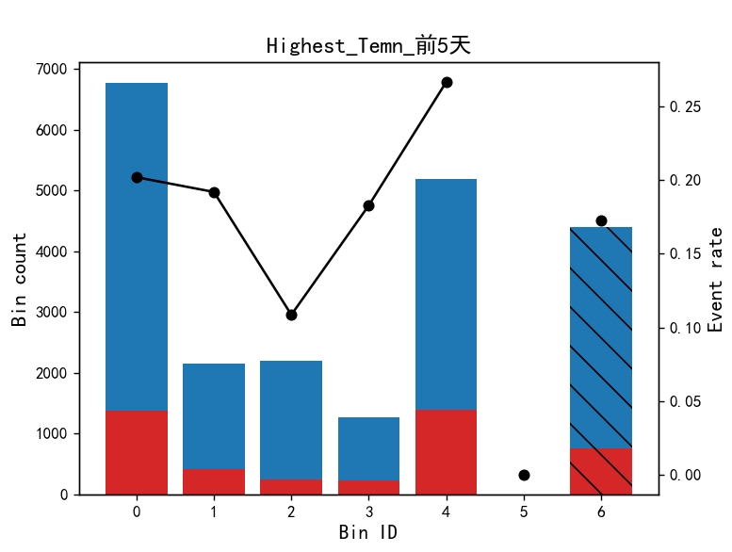
Bin Count Count (%) Non-event Event Event rate
0 (-inf, 29.61) 6767 0.308249 5400 1367 0.202010
1 [29.61, 30.75) 2151 0.097982 1738 413 0.192004
2 [30.75, 32.25) 2193 0.099895 1955 238 0.108527
3 [32.25, 33.05) 1258 0.057304 1028 230 0.182830
4 [33.05, inf) 5191 0.236460 3807 1384 0.266615
5 Special 0 0.000000 0 0 0.000000
6 Missing 4393 0.200109 3634 759 0.172775
Totals 21953 1.000000 17562 4391 0.200018

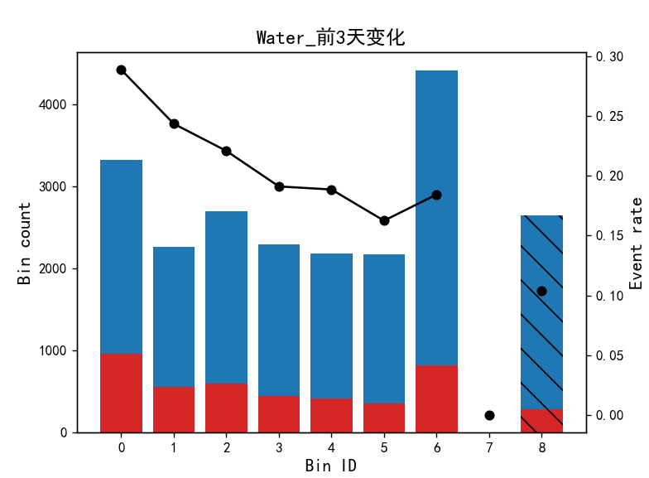
Bin Count Count (%) Non-event Event Event rate
0 (-inf, 0.57) 3324 0.151414 2364 960 0.288809
1 [0.57, 0.69) 2262 0.103038 1711 551 0.243590
2 [0.69, 0.84) 2689 0.122489 2095 594 0.220900
3 [0.84, 0.97) 2286 0.104132 1849 437 0.191164
4 [0.97, 1.09) 2174 0.099030 1764 410 0.188592
5 [1.09, 1.21) 2166 0.098665 1814 352 0.162512
6 [1.21, inf) 4409 0.200838 3596 813 0.184396
7 Special 0 0.000000 0 0 0.000000
8 Missing 2643 0.120394 2369 274 0.103670
Totals 21953 1.000000 17562 4391 0.200018

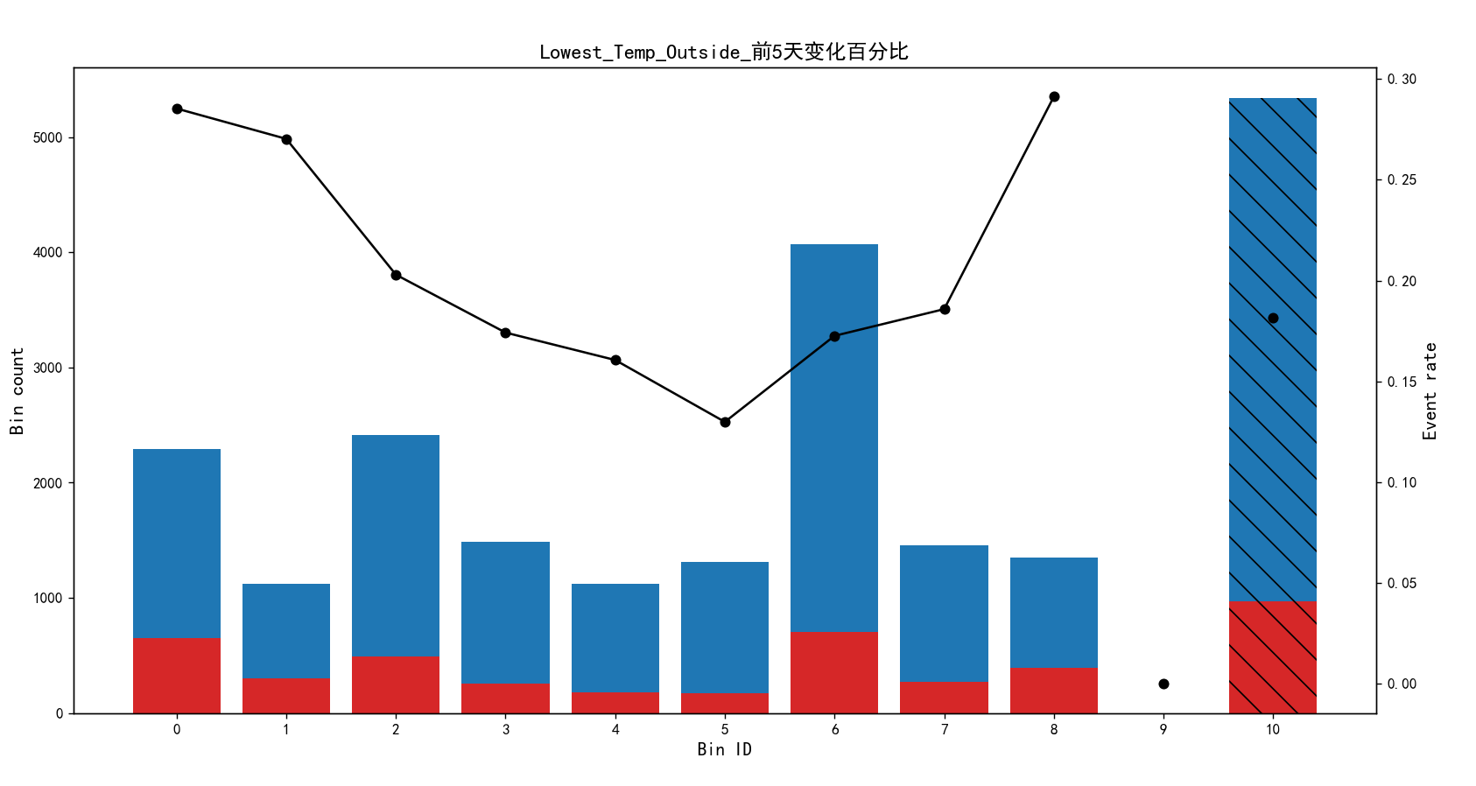
Bin Count Count (%) Non-event Event Event rate
0 (-inf, -120.83) 2292 0.104405 1638 654 0.285340
1 [-120.83, -85.16) 1121 0.051064 818 303 0.270294
2 [-85.16, -36.18) 2410 0.109780 1921 489 0.202905
3 [-36.18, -19.62) 1487 0.067736 1228 259 0.174176
4 [-19.62, -7.55) 1121 0.051064 941 180 0.160571
5 [-7.55, -1.79) 1309 0.059627 1139 170 0.129870
6 [-1.79, 24.26) 4068 0.185305 3366 702 0.172566
7 [24.26, 80.36) 1453 0.066187 1183 270 0.185822
8 [80.36, inf) 1353 0.061632 959 394 0.291205
9 Special 0 0.000000 0 0 0.000000
10 Missing 5339 0.243201 4369 970 0.181682
Totals 21953 1.000000 17562 4391 0.200018

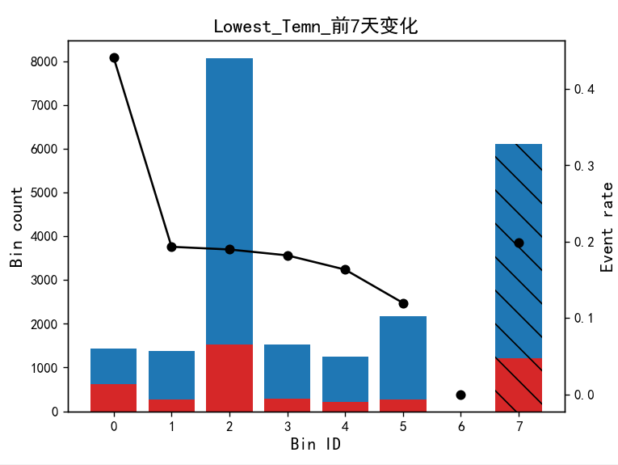
Bin Count Count (%) Non-event Event Event rate
0 (-inf, -4.15) 1426 0.064957 797 629 0.441094
1 [-4.15, -3.65) 1381 0.062907 1114 267 0.193338
2 [-3.65, -2.15) 8071 0.367649 6539 1532 0.189815
3 [-2.15, -1.75) 1532 0.069785 1253 279 0.182115
4 [-1.75, -1.28) 1254 0.057122 1049 205 0.163477
5 [-1.28, inf) 2170 0.098848 1910 260 0.119816
6 Special 0 0.000000 0 0 0.000000
7 Missing 6119 0.278732 4900 1219 0.199216
Totals 21953 1.000000 17562 4391 0.200018
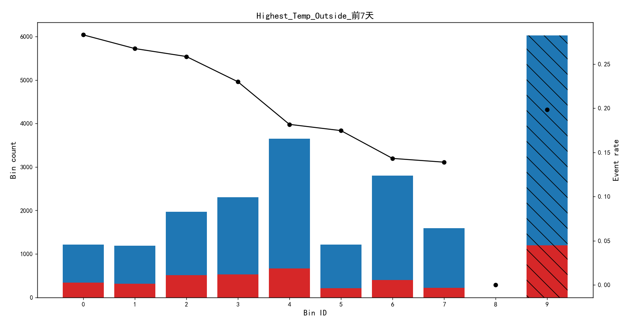

Bin Count Count (%) Non-event Event Event rate
0 (-inf, 6.50) 1212 0.055209 869 343 0.283003
1 [6.50, 8.50) 1185 0.053979 868 317 0.267511
2 [8.50, 10.50) 1969 0.089692 1460 509 0.258507
3 [10.50, 14.50) 2305 0.104997 1775 530 0.229935
4 [14.50, 23.50) 3649 0.166219 2986 663 0.181694
5 [23.50, 27.50) 1214 0.055300 1002 212 0.174629
6 [27.50, 34.50) 2801 0.127591 2400 401 0.143163
7 [34.50, inf) 1591 0.072473 1370 221 0.138906
8 Special 0 0.000000 0 0 0.000000
9 Missing 6027 0.274541 4832 1195 0.198274
Totals 21953 1.000000 17562 4391 0.200018

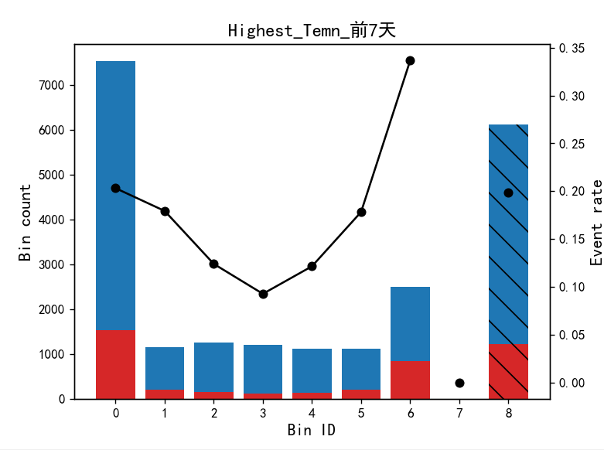
Bin Count Count (%) Non-event Event Event rate
0 (-inf, 30.75) 7526 0.342823 5997 1529 0.203162
1 [30.75, 31.45) 1143 0.052066 938 205 0.179353
2 [31.45, 32.45) 1250 0.056940 1095 155 0.124000
3 [32.45, 33.25) 1197 0.054526 1086 111 0.092732
4 [33.25, 33.85) 1119 0.050973 983 136 0.121537
5 [33.85, 34.55) 1105 0.050335 908 197 0.178281
6 [34.55, inf) 2498 0.113789 1657 841 0.336669
7 Special 0 0.000000 0 0 0.000000
8 Missing 6115 0.278550 4898 1217 0.199019
Totals 21953 1.000000 17562 4391 0.200018

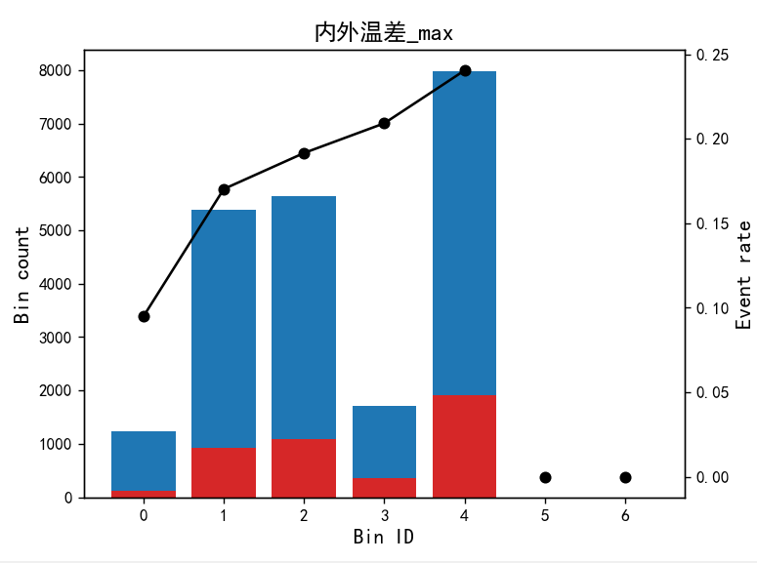

Bin Count Count (%) Non-event Event Event rate
0 (-inf, 3.25) 1232 0.056120 1115 117 0.094968
1 [3.25, 12.92) 5392 0.245616 4474 918 0.170252
2 [12.92, 22.55) 5643 0.257049 4562 1081 0.191565
3 [22.55, 24.58) 1707 0.077757 1350 357 0.209139
4 [24.58, inf) 7979 0.363458 6061 1918 0.240381
5 Special 0 0.000000 0 0 0.000000
6 Missing 0 0.000000 0 0 0.000000
Totals 21953 1.000000 17562 4391 0.200018

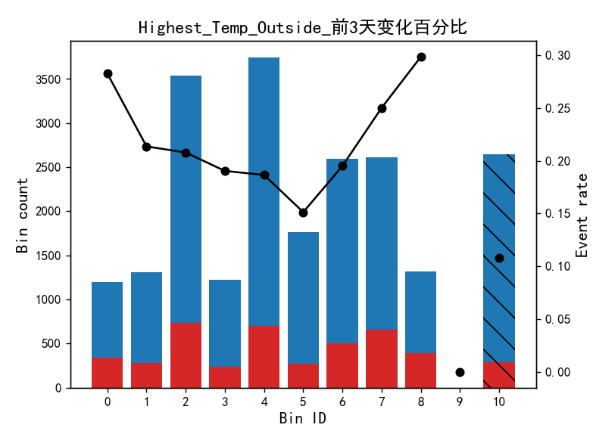
Bin Count Count (%) Non-event Event Event rate
0 (-inf, -46.41) 1196 0.054480 858 338 0.282609
1 [-46.41, -35.50) 1311 0.059718 1031 280 0.213577
2 [-35.50, -10.44) 3542 0.161345 2806 736 0.207792
3 [-10.44, -7.02) 1224 0.055755 991 233 0.190359
4 [-7.02, 2.99) 3742 0.170455 3044 698 0.186531
5 [2.99, 9.60) 1765 0.080399 1498 267 0.151275
6 [9.60, 23.30) 2594 0.118162 2088 506 0.195066
7 [23.30, 73.86) 2615 0.119118 1961 654 0.250096
8 [73.86, inf) 1317 0.059992 924 393 0.298405
9 Special 0 0.000000 0 0 0.000000
10 Missing 2647 0.120576 2361 286 0.108047
Totals 21953 1.000000 17562 4391 0.200018

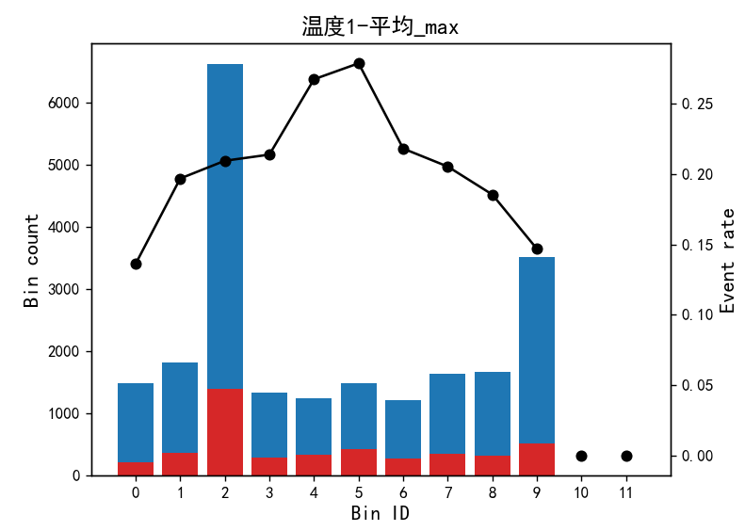
Bin Count Count (%) Non-event Event Event rate
0 (-inf, 25.25) 1483 0.067553 1281 202 0.136210
1 [25.25, 26.25) 1813 0.082586 1456 357 0.196911
2 [26.25, 29.18) 6615 0.301326 5229 1386 0.209524
3 [29.18, 29.73) 1323 0.060265 1040 283 0.213908
4 [29.73, 30.35) 1230 0.056029 901 329 0.267480
5 [30.35, 31.05) 1474 0.067143 1063 411 0.278833
6 [31.05, 31.63) 1210 0.055118 946 264 0.218182
7 [31.63, 32.45) 1631 0.074295 1296 335 0.205395
8 [32.45, 33.43) 1666 0.075889 1357 309 0.185474
9 [33.43, inf) 3508 0.159796 2993 515 0.146807
10 Special 0 0.000000 0 0 0.000000
11 Missing 0 0.000000 0 0 0.000000
Totals 21953 1.000000 17562 4391 0.200018

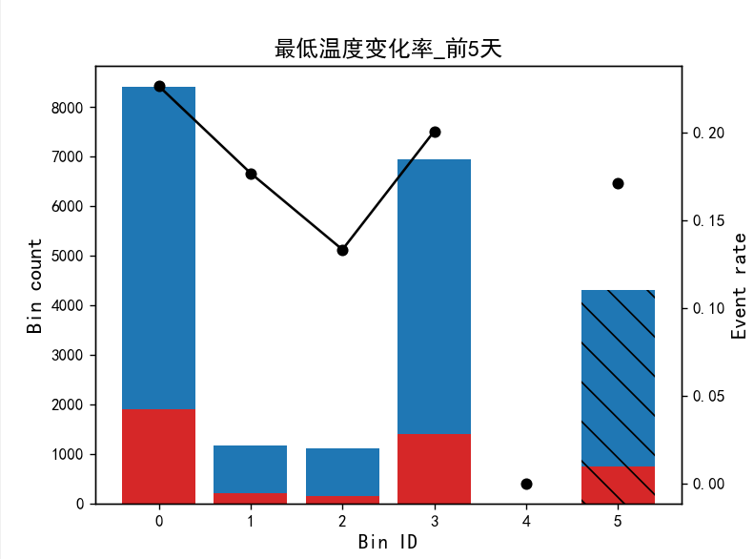

Bin Count Count (%) Non-event Event Event rate
0 (-inf, 0.00) 8410 0.383091 6506 1904 0.226397
1 [0.00, 0.00) 1171 0.053341 964 207 0.176772
2 [0.00, 0.00) 1111 0.050608 963 148 0.133213
3 [0.00, inf) 6956 0.316859 5560 1396 0.200690
4 Special 0 0.000000 0 0 0.000000
5 Missing 4305 0.196101 3569 736 0.170964
Totals 21953 1.000000 17562 4391 0.200018

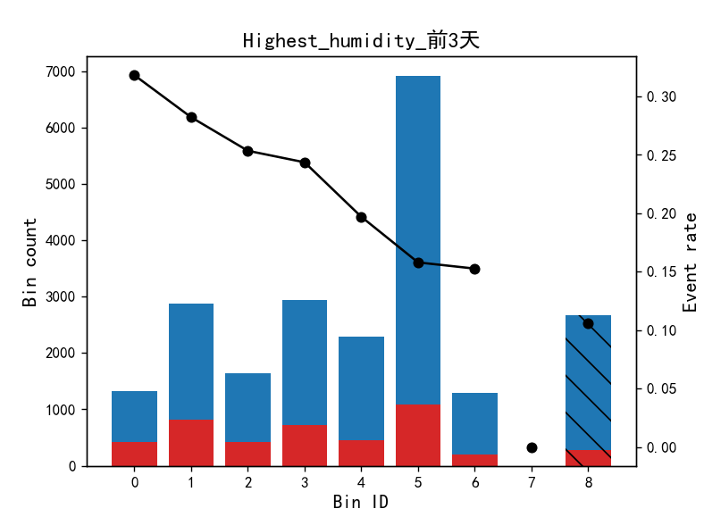
Bin Count Count (%) Non-event Event Event rate
0 (-inf, 0.63) 1317 0.059992 898 419 0.318147
1 [0.63, 0.74) 2881 0.131235 2068 813 0.282194
2 [0.74, 0.76) 1641 0.074751 1225 416 0.253504
3 [0.76, 0.81) 2947 0.134241 2229 718 0.243638
4 [0.81, 0.83) 2289 0.104268 1838 451 0.197029
5 [0.83, 0.94) 6917 0.315082 5824 1093 0.158016
6 [0.94, inf) 1290 0.058762 1093 197 0.152713
7 Special 0 0.000000 0 0 0.000000
8 Missing 2671 0.121669 2387 284 0.106327
Totals 21953 1.000000 17562 4391 0.200018

