Brown Institute Magic Grant Xiaoyao Lu and Xinrui Li

Haven
Haven combines a structured knowledge map of expert-curated sexual health content with a conversational AI that guides users toward what they need to know — but wouldn’t think to ask.

PROJECT DESCRIPTION
Ninety percent of Americans say sex education didn’t prepare them for real-world sexual experiences, and the reasons lie in the one-size-fits-all system: only 3 states require comprehensive sex ed while 29 emphasize abstinence despite evidence it increases teen pregnancy rates; LGBTQ+ students are actively excluded; and 93% of boys encounter pornography before 18 with zero media literacy response from schools. The result is that people know their knowledge is inadequate, but because they were never able to see a complete picture of comprehensive sex education, they don’t know what they don’t know—a problem neither online research nor AI chatbots can surface unprompted.
Haven, an AI-guided knowledge map, provides a bird's eye view of all the user can explore by selecting what the user seems to need or lack. Think of it as an expert whose value isn't answering your questions but helping you find what questions to ask. When a user shares an experience, Haven moves to a deeper branch of its map and asks follow-ups informed by what lies there, guiding users toward unknown unknowns that a static FAQ or search query will never reach. Standard AI retrieves evidence by similarity to the user's prompt, which runs risk of reinforcing their existing framing. Haven's tree-structured knowledge map retrieves every related sub-issue, giving it a landscape of credible source to check against. This branching structure surfaces niche academic media locked behind search systems that require you to already know what user is looking for and makes it personal and actionable: by session's end, Haven can build a concrete action plan drawing from an action library built with professionals from the Center for Social Transformation, SHARE, CAPS, and Title IX.

SYSTEM ARCHITECTURE & CONVERSATION FLOW
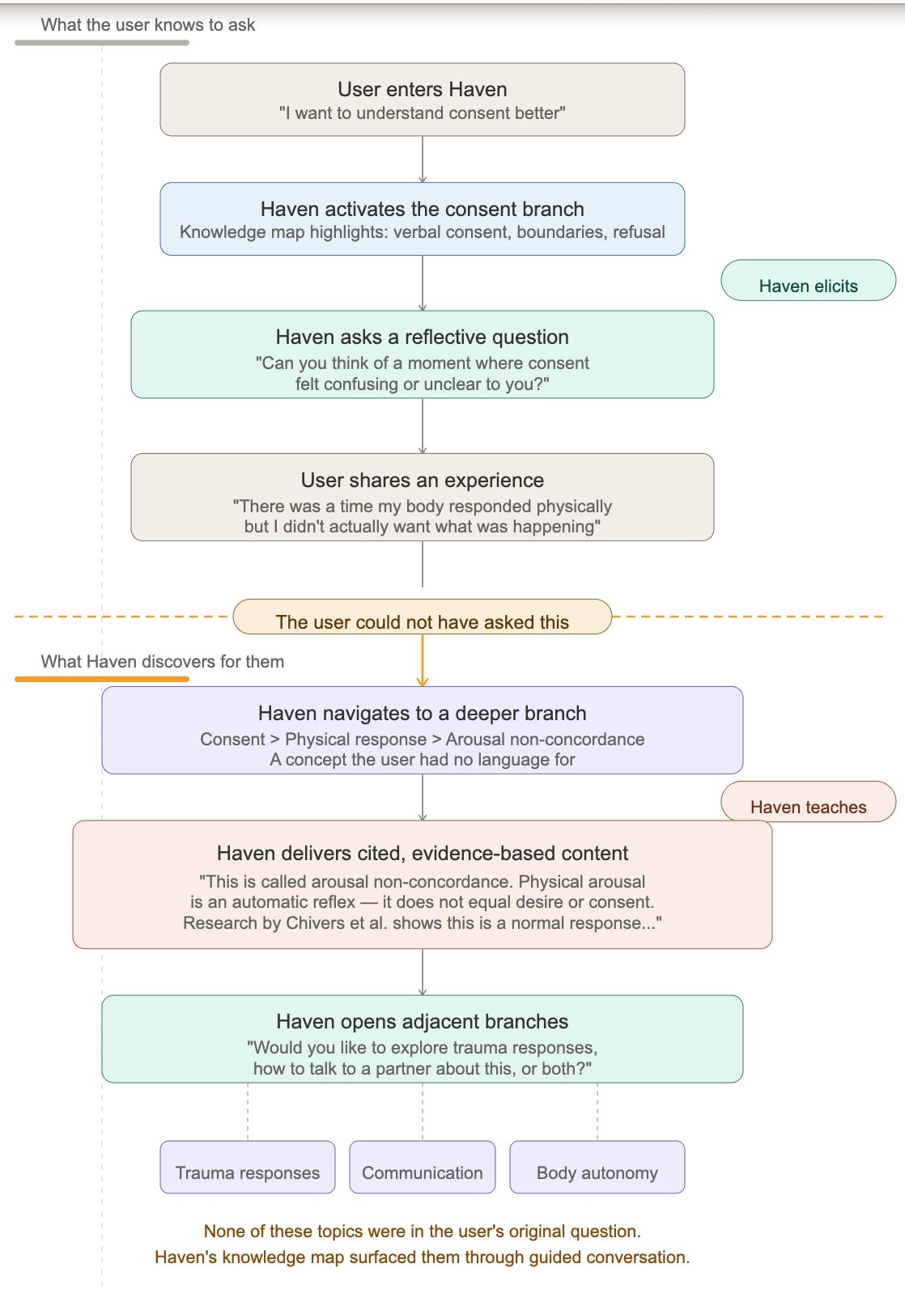  Fig 1: Guided conversation flow | 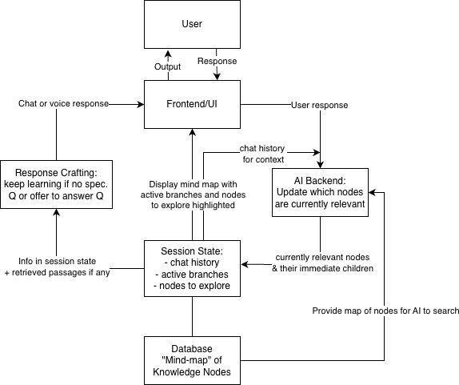  Fig 2: System architecture

TIMELINE
Q1 (Apr–Jun): MVP & Expert Feedback
Build a working prototype on 5–10 curated source texts, launching a text-based chat with map navigation and citation display. Campus experts from CST and SHARE review tone, conversational strategy, and safety.
Q2 (Jul–Sep): Scale, Pilot, Iterate
Expand the knowledge base to 50–100 open or permissioned sources and move to cloud deployment with analytics and monitoring. Targeted pilots with Greek life, religious groups, and freshmen generate the feedback that drives iteration.
Q3 (Oct–Dec): Repeat-Use & Privacy/Safety Infrastructure
We introduce user accounts, memory persistence, and interaction sharing to support repeat engagement. Counseling and technical professionals help formalize safety and data security, positioning Haven for sanctioned deployment through Stanford sexual health channels.
Q4 (Jan–Mar): Institutional Rollout & Expansion
Use pilot findings to refine the conversation flow, interface, and safety architecture. We prepare deployment materials for broader institutional use and begin expansion planning across additional campuses, including localization and age-tailored variants.

INNOVATION / ORIGINALITY
The core difference between Haven and existing tools is that it can both access comprehensive knowledge and narrow to a user’s specific needs when deciding what to talk about. Current solutions either completely rely on what the user asks (chatbots, search engines) or ignore their needs altogether by providing a highly generalized framework (lectures and websites).
This is also what the current RAG (Retrieval Augmented Generation) paradigm tries to do by matching the similarity of the user’s query against a collection of sources either stored in a database or actively collected from search, e.g. Roo by Planned Parenthood, ChatGPT’s search. However, if the criteria that a source is selected is based on its similarity with what the user has already said, it not only always agrees with the user but also fails to cover the user’s unknown unknowns, preventing such systems from having the comprehensive knowledge they advertise.
Through our knowledge map approach, we bin the similarity-matching paradigm altogether. The map gives Haven a hierarchical landscape of all the questions each sex & intimacy concern branches out to, so instead of trying to find the perfect answer based on one question from the user, we gradually narrow in on the questions that the user cares about and provide the answers we have. This allows us to achieve personalization without sacrificing comprehensiveness.

HAVEN VS. EXISTING SOLUTIONS
 | Haven | ChatGPT | Planned Parenthood Roo | AMAZE Sex Education | Title IX
Type | Mindmap | General Chatbot | RAG Chatbot | Website | Video Course Modules
Actively learns about the user’s context to recommend content | Yes | Sometimes | No | No | No
Answers targeted question by user | Yes | Yes | Sometimes | No | No
Bird’s eye view of all explorable topics | Yes | No | No | Yes | Yes
Identifies user’s unknown unknowns | Yes | No | No | Sometimes | Sometimes
Brown Institute Magic Grant Xiaoyao Lu and Xinrui Li

SUCCESS / IMPACT
In the grant year, we expect Haven to reach 1,800+ unique users (~23% of Stanford’s undergrad population), with 500+ completing a full session. Key targets: 12+ minute average sessions with 3+ branches explored (vs. 2–3 minutes for static Title IX modules), 20%+ 30-day return rate, 60%+ of users reporting Haven surfaced topics they wouldn’t have sought independently, and 40%+ articulating a specific behavior change post-session. We also aim to secure 3+ pilot partnerships outside Stanford within 12 months of the open-source release.
We measure engagement depth (session length, branches, return rate), discovery (“Did Haven surface a topic you wouldn’t have searched for?”), and actionability (a 60-second post-session survey asking users to name a concrete behavior change). Actionability results are compared against a control group completing the standard IFC workshop.

CHALLENGES & RISKS
Content Safety: Users may disclose crises Haven isn’t equipped to handle. We’ll set clear boundaries upfront, develop crisis-detection heuristics with Stanford’s CAPS and SARA offices, and test referral pathways before pilot deployment.
Knowledge Map Bias: LLM-based classification introduces potential bias. All source material is human-curated, and a content advisory board (educators, counselors, students) will review map structure. Regular traversal audits will identify gaps.
Privacy: Session-only data retention by default; persistent storage requires active user opt-in. All stored data uses encryption, minimal retention, and user-controlled deletion, with IRB review before deployment.
Over-Reliance & Sycophancy: Haven is positioned as an informational resource, not a substitute for human dialogue, and proposes real-world actionables (especially human interactions) at session end. Its retrieval architecture grounds responses in vetted sources, surfacing discrepancies with user beliefs rather than defaulting to agreement.
Institutional Liability: We pursue a graduated approach—offering Haven as an informational resource first, building trust through collaboration with Stanford’s health infrastructure before seeking endorsement.

ENTREPRENEURSHIP
Stage 1: University licensing (year 1–2)
Universities already invest heavily in sexual health and assault prevention programming, yet students widely report existing workshop formats as ineffective. Haven can be offered as a SaaS tool licensed to student health services and Title IX offices. Stanford's IFC mandate is our first deployment opportunity; from there, we plan to approach 3–5 peer institutions (targeting UC Berkeley, UCLA, and other UC system schools) within 12 months. Pricing follows a per-student annual license model ($3–8/student/year) with volume discounts for system-wide adoption.
Stage 2: Curriculum integration partnerships (year 2–3)
K–12 schools and healthcare organizations represent a larger market. Haven's branch-trimming feature lets providers customize which parts of the knowledge map are accessible. We would pursue 2–3 school district or healthcare network partnerships, offering institutionally branded versions with content oversight tools ($5,000–15,000/year per institution).
Stage 3: Platform generalization (year 3+)
Haven's architecture—structured knowledge maps, academic journal pipeline, conversational navigation—applies well beyond sexual health to mental health literacy, financial planning, civic engagement, and more. We open-source the core infrastructure (ingestion pipeline, navigation algorithm, map schema) to drive adoption, while reserving a commercial layer for institutional customization, analytics, and managed deployment.

