##### 使用zabbix监控nginx

###### 1：环境准备：

[root@agent scripts]# cat /etc/redhat-release

CentOS release 6.7 (Final)

[root@agent scripts]# sestatus

SELinux status: disabled

[root@agent scripts]# /etc/init.d/iptables stop

这里我的nginx服务器的ip是192.168.56.99

###### 2：启用nginx status

编辑nginx的配置文件的server标签中增加下面的location配置

location /nginx_status {

stub_status on; # 启用nginx status

access_log off; #不记录日志

allow 192.168.56.0/24; #允许局域网可以访问

allow 127.0.0.1; #允许本机自己可以访问

deny all; #禁止其他的访问，为了安全

}

###### 3：平滑重启nginx

[root@agent scripts]# service nginx reload

Reloading nginx: [ OK ]

###### 4：测试

打开浏览器输入 http://192.168.56.99/nginx_status

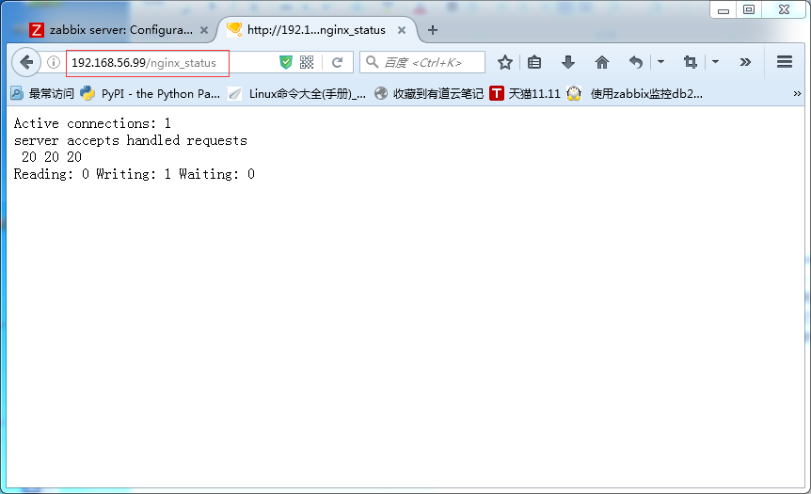

###### 5：配置自定义监控项

上传脚本

[root@agent ~]# mkdir /etc/zabbix/scripts/ -p

[root@agent ~]# cd /etc/zabbix/scripts/

[root@agent scripts]# ls

nginx_monitor.sh

脚本需要给执行权限！

脚本内容如下：

[root@agent scripts]# cat nginx_monitor.sh

#!/bin/bash

NGINX_COMMAND=$1

NGINX_PORT=80

CACHEFILE="/tmp/nginx_status.txt"

CMD="/usr/bin/curl http://127.0.0.1:"$NGINX_PORT"/nginx_status/"

if [ ! -f $CACHEFILE ];then

$CMD >$CACHEFILE 2>/dev/null

fi

# Check and run the script

TIMEFLM=`stat -c %Y $CACHEFILE`

TIMENOW=`date +%s`

if [ `expr $TIMENOW - $TIMEFLM` -gt 60 ]; then

rm -f $CACHEFILE

fi

if [ ! -f $CACHEFILE ];then

$CMD >$CACHEFILE 2>/dev/null

fi

nginx_active(){

grep 'Active' $CACHEFILE| awk '{print $NF}'

exit 0;

}

nginx_reading(){

grep 'Reading' $CACHEFILE| awk '{print $2}'

exit 0;

}

nginx_writing(){

grep 'Writing' $CACHEFILE | awk '{print $4}'

exit 0;

}

nginx_waiting(){

grep 'Waiting' $CACHEFILE| awk '{print $6}'

exit 0;

}

nginx_accepts(){

awk NR==3 $CACHEFILE| awk '{print $1}'

exit 0;

}

nginx_handled(){

awk NR==3 $CACHEFILE| awk '{print $2}'

exit 0;

}

nginx_requests(){

awk NR==3 $CACHEFILE| awk '{print $3}'

exit 0;

}

case $NGINX_COMMAND in

active)

nginx_active;

;;

reading)

nginx_reading;

;;

writing)

nginx_writing;

;;

waiting)

nginx_waiting;

;;

accepts)

nginx_accepts;

;;

handled)

nginx_handled;

;;

requests)

nginx_requests;

;;

*)

echo 'Invalid credentials';

exit 2;

esac:

创建zabbix agent的自定义监控项配置文件

[root@agent scripts]# cd /etc/zabbix/zabbix_agentd.d/

[root@agent zabbix_agentd.d]# cat nginx_monitor.conf

UserParameter=nginx_status[*],/etc/zabbix/scripts/nginx_monitor.sh $1

重启zabbix-agent使刚才的配置文件生效

[root@agent scripts]# /etc/init.d/zabbix-agent restart

Shutting down Zabbix agent: [ OK ]

Starting Zabbix agent: [ OK ]

###### 6：在zabbix-server上测试

[root@zabbix-server01 ~]# zabbix_get -s 192.168.56.99 -k nginx_status[active]

1

[root@zabbix-server01 ~]# zabbix_get -s 192.168.56.99 -k nginx_status[accepts]

32

###### 7：web上配置

导入模板



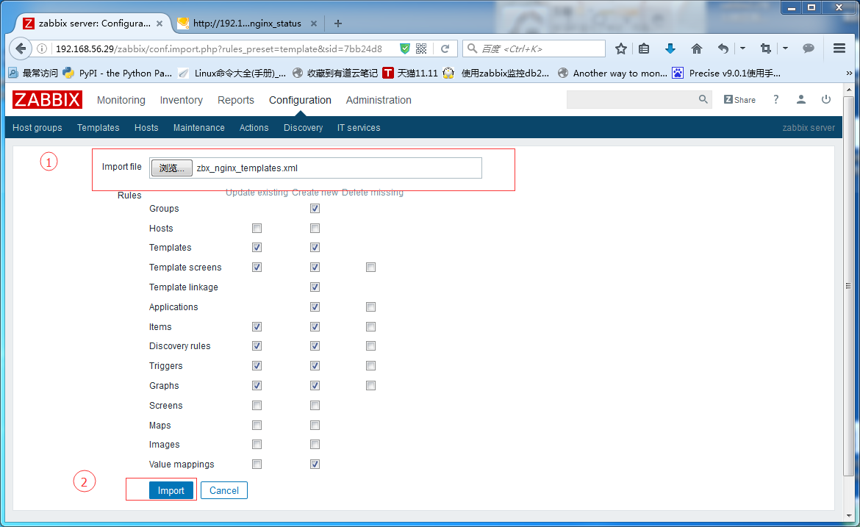

链接模板到主机

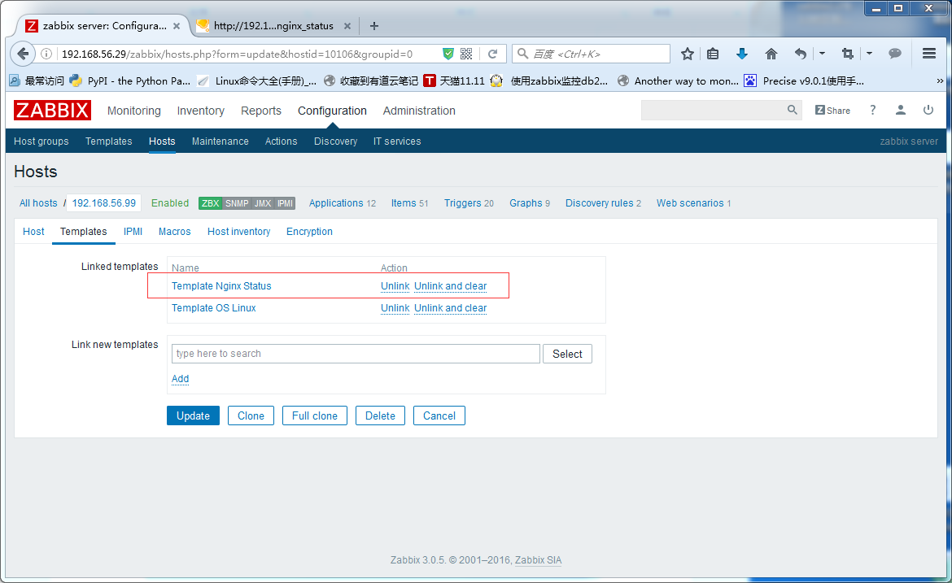

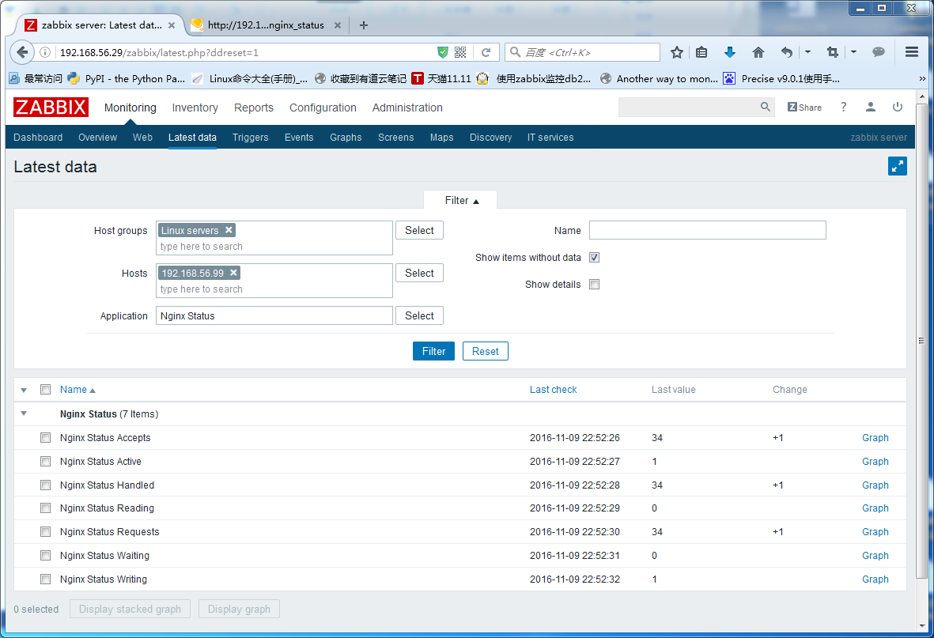

在Latest data中看到最新的数据，恭喜你，成功了！