安装环境出现问题总结：

一、

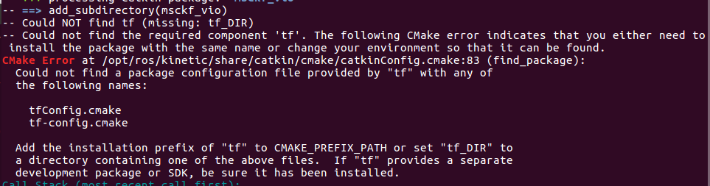

安装依赖和编译demo包：

sudo apt-get install ros-$ROS_DISTRO-turtle-tf2 ros-$ROS_DISTRO-tf2-tools ros-$ROS_DISTRO-tf

二、

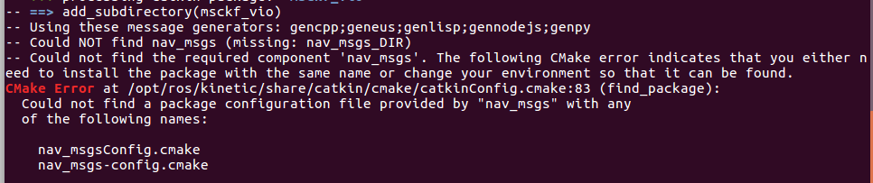

sudo apt-get install ros-kinetic-nav-msgs

通用解决方法：sudo apt-get install ros-kinetic-xxx-xxx

三、



sudo apt-get install ros-kinetic-rviz 安装失败，需要更新源

参考链接 https://www.cnblogs.com/zhaobinyouth/p/15471632.html

问题描述：Ubuntu每次安装软件都会出现这个错误，E: Unable to fetch some archives, maybe run apt-get update or try with --fix-missing?

问题解决：需要更改源，可以理解为更改软件的下载镜像地址

如何更改源

sudo vim /etc/apt/source.list

更改为可用源，将几个常用源写入该文件，保存后执行

sudo apt-get update

几个常用源包括有

阿里源：

# deb cdrom:[Ubuntu 16.04 LTS _Xenial Xerus_ - Release amd64 (20160420.1)]/ xenial main restricted

deb-src http://archive.ubuntu.com/ubuntu xenial main restricted #Added by software-properties

deb http://mirrors.aliyun.com/ubuntu/ xenial main restricted

deb-src http://mirrors.aliyun.com/ubuntu/ xenial main restricted multiverse universe #Added by software-properties

deb http://mirrors.aliyun.com/ubuntu/ xenial-updates main restricted

deb-src http://mirrors.aliyun.com/ubuntu/ xenial-updates main restricted multiverse universe #Added by software-properties

deb http://mirrors.aliyun.com/ubuntu/ xenial universe

deb http://mirrors.aliyun.com/ubuntu/ xenial-updates universe

deb http://mirrors.aliyun.com/ubuntu/ xenial multiverse

deb http://mirrors.aliyun.com/ubuntu/ xenial-updates multiverse

deb http://mirrors.aliyun.com/ubuntu/ xenial-backports main restricted universe multiverse

deb-src http://mirrors.aliyun.com/ubuntu/ xenial-backports main restricted universe multiverse #Added by software-properties

deb http://archive.canonical.com/ubuntu xenial partner

deb-src http://archive.canonical.com/ubuntu xenial partner

deb http://mirrors.aliyun.com/ubuntu/ xenial-security main restricted

deb-src http://mirrors.aliyun.com/ubuntu/ xenial-security main restricted multiverse universe #Added by software-properties

deb http://mirrors.aliyun.com/ubuntu/ xenial-security universe

deb http://mirrors.aliyun.com/ubuntu/ xenial-security multiverse

清华大学

# deb cdrom:[Ubuntu 16.04 LTS _Xenial Xerus_ - Release amd64 (20160420.1)]/ xenial main restricted

deb http://mirrors.tuna.tsinghua.edu.cn/ubuntu/ xenial main restricted

deb http://mirrors.tuna.tsinghua.edu.cn/ubuntu/ xenial-updates main restricted

deb http://mirrors.tuna.tsinghua.edu.cn/ubuntu/ xenial universe

deb http://mirrors.tuna.tsinghua.edu.cn/ubuntu/ xenial-updates universe

deb http://mirrors.tuna.tsinghua.edu.cn/ubuntu/ xenial multiverse

deb http://mirrors.tuna.tsinghua.edu.cn/ubuntu/ xenial-updates multiverse

deb http://mirrors.tuna.tsinghua.edu.cn/ubuntu/ xenial-backports main restricted universe multiverse

deb http://mirrors.tuna.tsinghua.edu.cn/ubuntu/ xenial-security main restricted

deb http://mirrors.tuna.tsinghua.edu.cn/ubuntu/ xenial-security universe

deb http://mirrors.tuna.tsinghua.edu.cn/ubuntu/ xenial-security multiverse