An important part of your project is your **process book**. Your process book details your steps in developing your solution, including the alternative designs you tried, and the insights you got. Develop your process book out of the project proposal. **Equally important to your final results is how you got there!** Your process book is the place you describe and document the space of possibilities you explored at each step of your project. It is not, however, a journal or lab notebook that describes every detail - you should think carefully about the important decisions you made and insights you gained and present your reasoning in a concise way.

We strongly advise you to include many figures in your process book, including photos of your sketches of potential designs, screen shots from different visualization tools you explored, inspirations of visualizations you found online, etc. Several images illustrating changes in your design or focus over time will be far more informative than text describing those changes. Instead, use text to describe the rationale behind the evolution of your project.

Your process book should include the following topics. Depending on your project type the amount of discussion you devote to each of them will vary:

* Overview and Motivation: Provide an overview of the project goals and the motivation for it. Consider that this will be read by people who did not see your project proposal.
* Related Work: Anything that inspired you, such as a paper, a web site, visualizations we discussed in class, etc.
* Questions: What questions are you trying to answer? How did these questions evolve over the course of the project? What new questions did you consider in the course of your analysis?
* Data: Source, scraping method, cleanup, etc.
* Exploratory Data Analysis: What visualizations did you use to initially look at your data? What insights did you gain? How did these insights inform your design?
* Design Evolution: What are the different visualizations you considered? Justify the design decisions you made using the perceptual and design principles you learned in the course. Did you deviate from your proposal?
* Implementation: Describe the intent and functionality of the interactive visualizations you implemented. Provide clear and well-referenced images showing the key design and interaction elements.
* Evaluation: What did you learn about the data by using your visualizations? How did you answer your questions? How well does your visualization work, and how could you further improve it?

As this will be your only chance to describe your project in detail make sure that your process book is a standalone document that fully describes your results and the final design. [Here](https://www.dataviscourse.net/2022/assets/process_books/bansal_cao_hou.pdf) are a [few examples](https://www.dataviscourse.net/2022/assets/process_books/walsh_trevino_bett.pdf) of process books from previous years. Note that those process books do not follow the exact structure laid out here, they are meant as inspiration and are not necessarily indicative of the format and scope of your project.

Here begins the skeleton(the proposal should be added to the first part of this document).

1. Inspiration comes from:

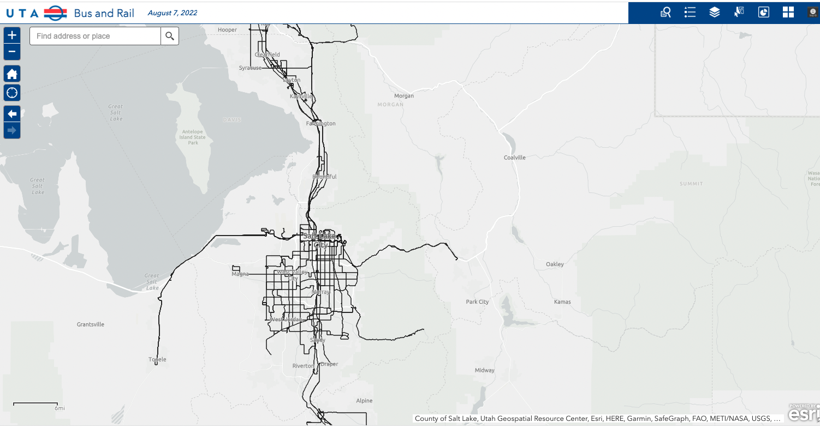

1. Our sketch about the final goal:

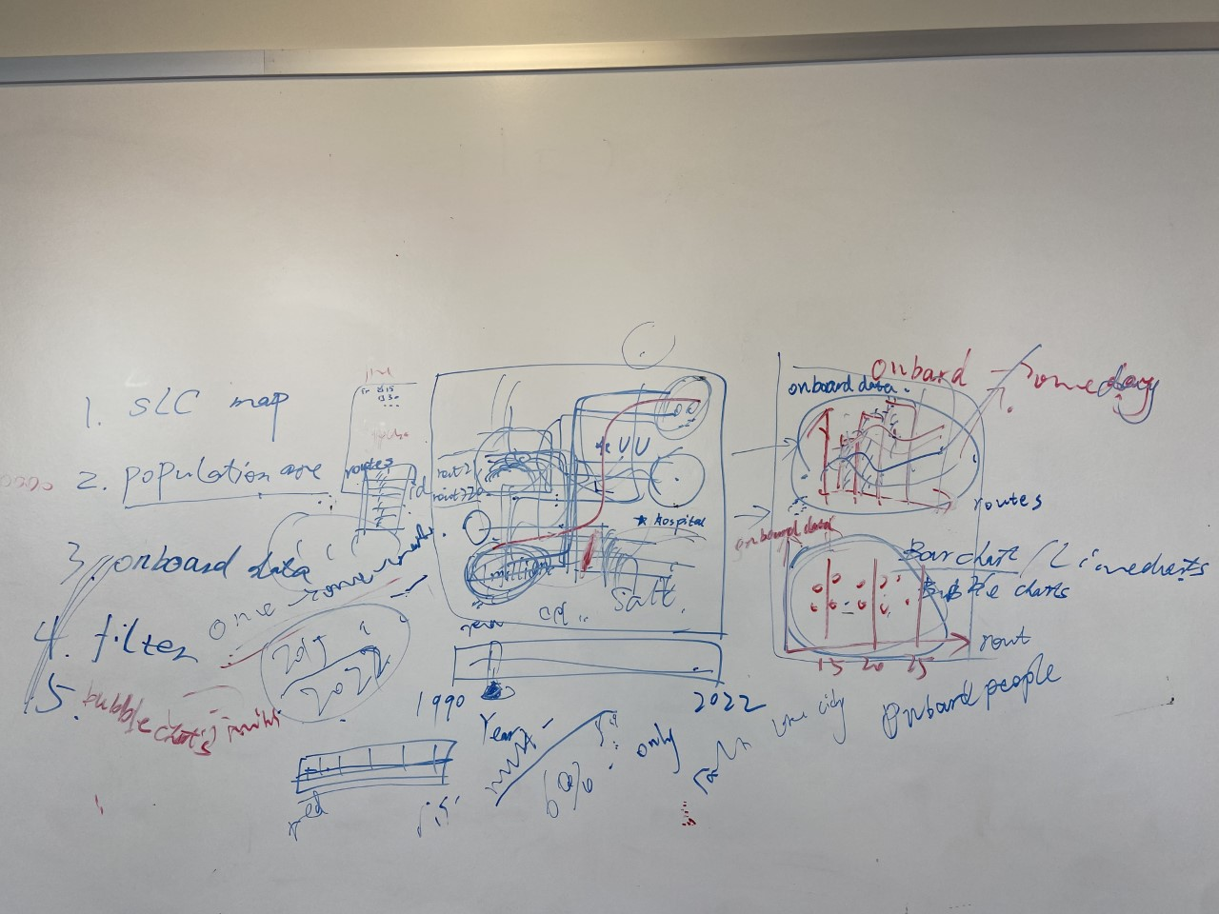

It includes:

Data:

routes json✅; bus stops✅;

onboard data(WKD,SAT,and SUN from 2017-2022)✅; Stop Boardings - Bus(WKD,SAT,and SUN from 2020-2022)✅

highlight positions locations❎; annual data of routes❎;Population distribution(optional)❎.

1. **Map** graph of traffic route in SLC:

*different **colors** for routes and **scale bar** for routes sort by ID (left) (e.g.,use red for buses and different saturated red for bus lines);

\***timeline** at the bottom of map(e.g.,from 2017-2022);

\***highlight special positions** on map(e.g., hospitals, schools, supermarkets);

\***filter** by time intervals( left side of map, small boxes for 15 mins, 20 mins and 30 mins);

*Use different saturated red to show population distribution in the city.(optional)

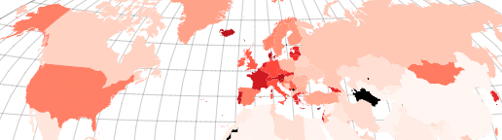(For example.)

1. **Bar chart** for interactions with map:

\***Basic settings:**

x-axis: WKD, SAT,SUN, y-axis: Onboard data(choose 10 typical lines in different time intervals);

Color: same in map;

Label: sort by ID, same in map;

Timeline: 2017-2022, same in map;

*Interactions: click on any routes in map it will add to line chart, also highlighted;

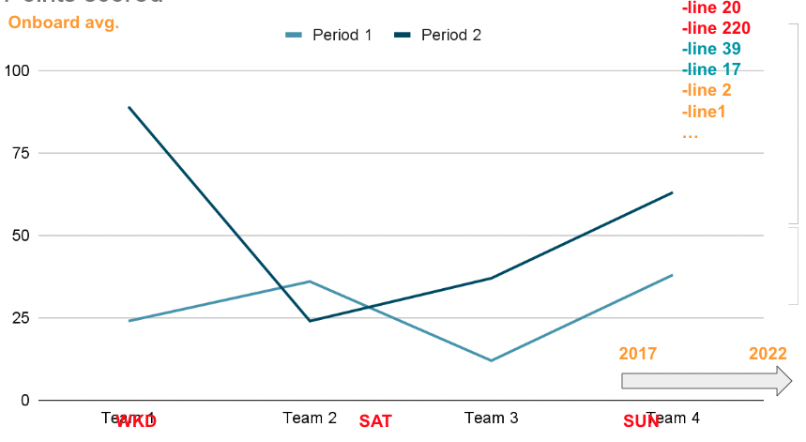

1. **Bubble charts** for interactions with map:

\***Basic settings:**

x-axis: WKD, SAT,SUN, y-axis: Onboard data(choose 10 typical lines in different time intervals);

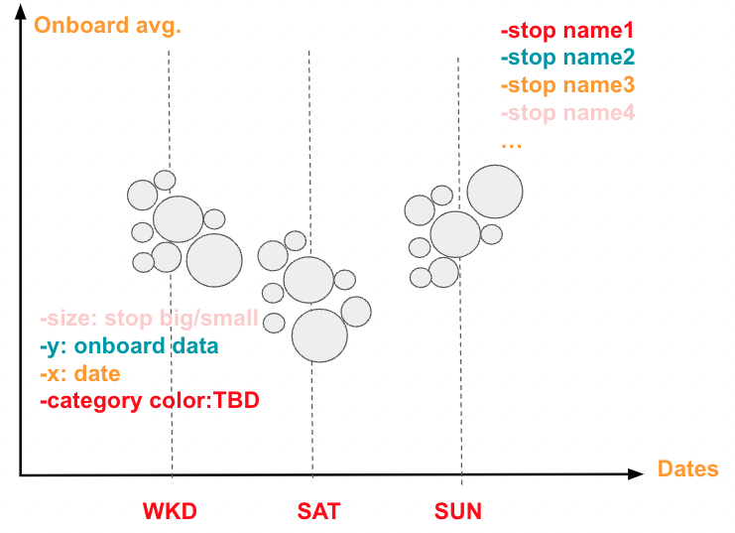

1. Timetables:

Overall timetable:

| Week | Milena’s part | Tark’s part | Xiaoya’s part | End result for the week |
| --- | --- | --- | --- | --- |
| Week 1  (fall break) | Send the request for data acquiring, document the progress. Work on the proposal, upload sketches. | ~ | Discussing the ideas.  Work on the proposal. | Acquired data for traffic routes, proposal draft. |
| Week 2 | Acquire data for bus stops, add files to the data folder on GitHub,  upload the proposal. | Help with data preprocessing | Collaborating with the dataset preprocessing.  Updating the repository. | Data processing, submit the proposal. |
| Week 3 | Division of working space through different divs, data binding (routes). | Set up basic map view of Utah and cities | Collaborating with the map view. | Initial space division for the map and its extras. |
| Week 4 (Peer Review) | Data binding (routes) finish, extra features. | Add bus and rail stops | Add highlighted locations on the map. | Transit data added to views. |
| Week 5 | Tooltips, graph ideas & some implementation | Add selecting cities from map vs | Collaborating with the interactivity for routes map and graphs. | Add interactivity for map routes and stops, add filters, add graphs. |
| Week 6 (Project Milestone) | TBD | Add info on route selection | Finishing the must-have visualizations. | Finish graphs and filters, debugging. |
| Week 7 | TBD | TBD | Optimizing the vis.  Add potential analysis. | Potential extra work for the visualization as described above. |
| Week 8 | TBD | TBD | Collecting the required files. | Finalize the changes made, make the presentation video, combine all the required files for submission. |

Milestone 1 timetable(Nov. 7th - Nov. 11th)

| Date | Milena’s part | Tark’s part | Xiaoya’s part | End result for the week |
| --- | --- | --- | --- | --- |
| Nov. 7th |  |  |  | 1. Hand in our code and our process book in its current state.  *Should have completed your data acquisition. You must have your data structures in place.  *You must have a working visualization prototype. The direction and the content must be clear.  *The milestone will be submitted by creating a release in GitHub.    2.Review with the staff  3.upload feedback exercise(feedback to their feedback to us) |
| Nov. 8th |  |  | Write the skeleton of process book, clarify graph details;  Specify timetable and tasks. |
| Nov. 9th |  |  | Data acquisition listed above. Data processing to right structures. |
| Nov. 10th |  | Map graph draft, with background and routes on it. | Write our feedback to theirs. |
| Nov. 11th |  |  | Update the code and documents;  Commit to github. |