**CIS-310 Database Design**

**Small Group Activity #7**

**30 points**

Names of group members: ______________________________________________________

____________________________________________________________________________

1. Get in touch with your group. (See Groups folder on Blackboard.)
2. Discuss and complete the assignment together via E-mail, Discussion Forum, Blackboard Collaborate Ultra, and/or MS Teams.
3. Choose a recorder to prepare the final copy (one per group) and submit it via the Blackboard Assignments/Small Group Activities folder to the instructor.
4. Be sure all group members' names are on final copy. Do not add names of your group classmates who did not participate in the assignment.

After you have successfully completed Assignment 4, the Premiere Products database containing five tables (REP, CUSTOMER, ORDERS, PART, and ORDER_LINE) populated with the data and the entity relationship diagram (ERD) should already be in your SQL Server account. You will find the five database tables at the end of this document.

IMPORTANT NOTE: Several students in the class have not submitted Assignment 4. These students have to run the script given in Assignment 4 to create and populate the Premiere Products database and the ERD now to be able to complete this Small Group Activity (due by Thu, Oct 20) and Assignment 7 (due by Sun, Oct 24). See the Assignments/Assignments/Assignment 4 folder. In Assignment 7 you will be working with the same Premiere Products database.

Using the Premiere Products database write the SQL queries for the following eight problems. Discuss each of the eight problems with your group, write a query for each problem, and run the query on SQL server. Save the eight queries in a single file or in eight separate files in your account on J drive. Every group member should run each of the eight queries and save them in his/her account on J drive. Paste your queries and the outputs they generated after each of the eight problems.

After you paste the queries and the output they produced save this document as Word or pdf file named SGA7_Groupxx, where xx stand for the group number and submit via Blackboard. See the Assignments/Small Group Activities/Small Group Activity 7 folder.

Problem 1. List the part number, description, and price for all parts. Paste your query and the output below.

SECLECT PART_NUM, DESCRIPTION, PRICE

FROM dbo.PART.

Problem 2. List the names of customers with credit limits of $10,000 or more. Paste your query and the output below.

SELECT CUSTOMER_NAME

FROM dbo.CUSTOMER

WHERE CREDIT_LIMIT>=10000;

Problem 3. List the number and name of each customer represented by sales rep 35 or sales rep 65. Paste your query and the output below.

SELECT CUSTOMER_NUM, CUSTOMER_NAME

FROM dbo.CUSTOMER

WHERE REP_NUM = 35 OR REP_NUM =65;

Problem 4. List the part number, part description, and on-hand value (units on hand * unit price) for each part whose on-hand value is at least $7,500. Assign the name ON_HAND_VALUE to the computed column. Paste your query and the output below.

SELECT PART_NUM, DESCRIPTION, ON_HAND*PRICE AS ON_HAND_VALUE

FROM dbo.PART

WHERE ON_HAND*PRICE>=7500;

Problem 5. List all details about all parts. Order the output by part number within warehouse. (That is order the output by warehouse and then by part number.) Paste your query and the output below.

SELECT PART_NUM, DESCRIPTION, ON_HAND, CLASS, WAREHOUSE, PRICE

FROM dbo.PART

ORDER BY WAREHOUSE, PART_NUM

Problem 6. What is the part number, description, and price of the least expensive part in the database? (Hint: Use a subquery, a nested query.) Paste your query and the output below.

SELECT PART_NUM, DESCRIPTION, PRICE

FROM dbo.PART

WHERE PRICE = (SELECT MIN(PRICE) FROM dbo.part);

Problem 7. List the names and credit limit of all customers whose credit limit is less than the average credit limit for all customers. Use one nested query. Paste your query and the output below.

SELECT CUSTOMER_NAME, CREDIT_LIMIT

FROM dbo.CUSTOMER

WHERE CREDIT_LIMIT < (SELECT AVG(CREDIT_LIMIT) FROM dbo.CUSTOMER);

Problem 8. For each order, list the order number and order date along with the number and name of the customer that placed the order. Paste your query and the output below.

SELECT ORDER_NUM, ORDER_DATE, CUSTOMER_NUM, CUSTOMER_NAME

FROM dbo.ORDERS

JOIN dbo. CUSTOMER ON dbo.CUSTOMER. CUSTOMER_NUM = dbo.ORDERS. CUSTOMER_NUM

PREMIERE PRODUCTS SCHEMA

TABLE REP

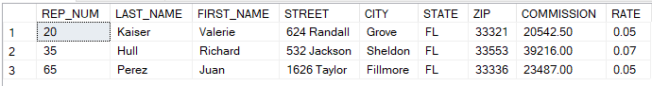

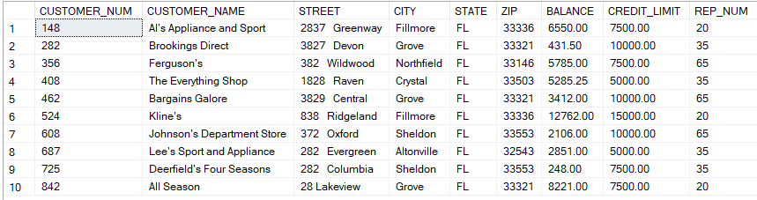TABLE CUSTOMER

TABLE ORDERS

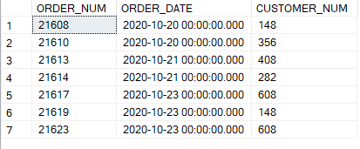

TABLE PART

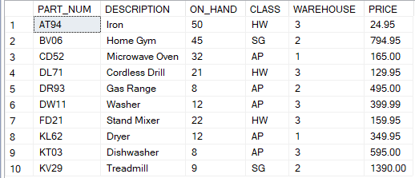

TABLE ORDER_LINE

