**CIS-310 Database Design**

**Small Group Activity #8**

**30 points**

Names of group members: ______________________________________________________

____________________________________________________________________________

1. Get in touch with your group. (See Groups folder on Blackboard.)
2. Discuss and complete the assignment together via E-mail, Discussion Forum, Blackboard Collaborate Ultra, and/or MS Teams.
3. Choose a recorder to prepare the final copy (one per group) and submit it via the Blackboard Assignments/Small Group Activities folder to the instructor.
4. Be sure all group members' names are on final copy. Do not add names of your group classmates who did not participate in the assignment.

After you have successfully completed Assignments 4 and 7 as well as Small Group Activity 7, the Premiere Products database containing five tables (REP, CUSTOMER, ORDERS, PART, and ORDER_LINE) populated with the data and the entity relationship diagram (ERD) should already be in your SQL Server account. You will find the five database tables at the end of this document.

Using the Premiere Products database write the SQL queries for the following ten problems. Discuss each of the ten problems with your group, write a query for each problem, and run the query on SQL server. Save the ten queries in a single file or in ten separate files in your account on J drive. Every group member should run each of the ten queries and save them in his/her account on J drive. Paste your queries and the outputs they generated after each of the ten problems.

After you paste the queries and the output they produced save this document as Word or pdf file named SGA8_Groupxx, where xx stand for the group number and submit via Blackboard. See the Assignments/Small Group Activities/Small Group Activity 8 folder.

Problem 1.

Use the IN operator to list the part number and part description of each part in item class AP or SG. Run the query on SQL server. Paste the query and the output from the query below.

Problem 2.

List the sales rep numbers and sum of the balances of all customers for each sales rep, but restrict the output to those sales reps for whom the sum is more than $10,000. Name the unnamed column as SUM_OF_BALANCES. Order and group the results by sales rep number. Use the HAVING clause. Run the query on SQL server. Paste the query and the output from the query below.

Problem 3.

List the order number, order date, customer number, and customer name for every customer that placed an order. Restrict the output to the orders placed on or after Oct 21 2020. Order the rows by the order number. Run the query on SQL server. Paste the query and the output from the query below.

Problem 4.

Use the IN operator to find the number and name of each customer that placed an order on October 23, 2020. Run the query on SQL server. Paste the query and the output from the query below.

Problem 5.

Find the number and name of each customer whose name begins with the letter “B”. Run the query on SQL server. Paste the query and the output from the query below.

Problem 6.

For each order, list the order number, order date, part number, part description, and item class for each part that makes up the order. Order the rows by item class and then by order number. (Note that you need to pull the data from several tables.) Run the query on SQL server. Paste the query and the output from the query below.

Problem 7.

Find the rep number, last name, and first name of each sales rep who represents at least one customer with a credit limit of $10,000. List each sales rep only once in the results. Do not use a subquery. Run the query on SQL server. Paste the query and the output from the query below.

Problem 8.

List the part number, part description, and item class for each pair of parts that are in the same item class. Order the output by class and then by part number. (Note that you need to link PART to itself.) Run the query on SQL server. Paste the query and the output from the query below.

Problem 9.

Find the number and name of each customer that currently has an order on file for an Iron. Run the query on SQL server. Paste the query and the output from the query below.

Problem 10.

List the order number and order date for each order that was placed by Ferguson’s and that contains an order line for a Gas Range. (Hint: Use the string literal as ‘Ferguson’’s’ for comparison.) Run the query on SQL server. Paste the query and the output from the query below.

PREMIERE PRODUCTS SCHEMA

TABLE REP

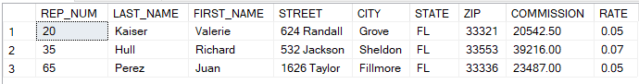

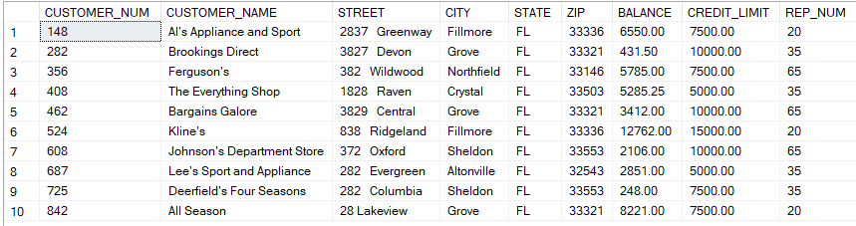TABLE CUSTOMER

TABLE ORDERS

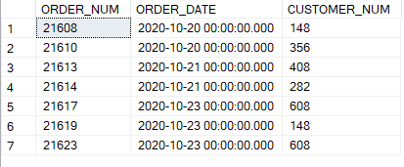

TABLE PART

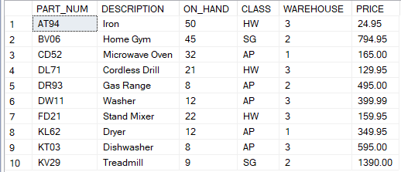

TABLE ORDER_LINE

