Appendix A
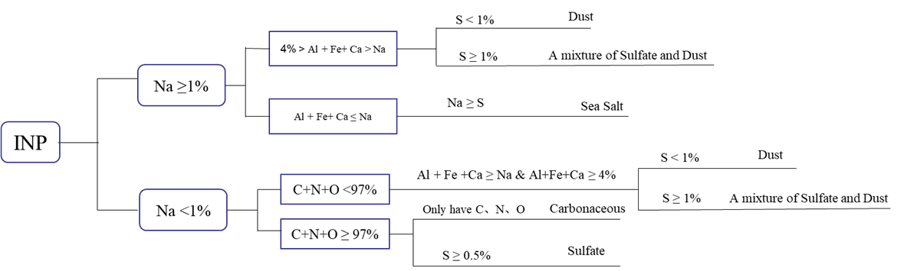
Figure A1 Classification of atmospheric INP sources based on single-particle chemical composition. Classification is performed using thresholds for atomic percentages of key elements (Na, Al, Fe, Ca, S, C, N, O). Major categories include dust, sea salt, sulfate, carbonaceous material, and mixed types.

Appendix B
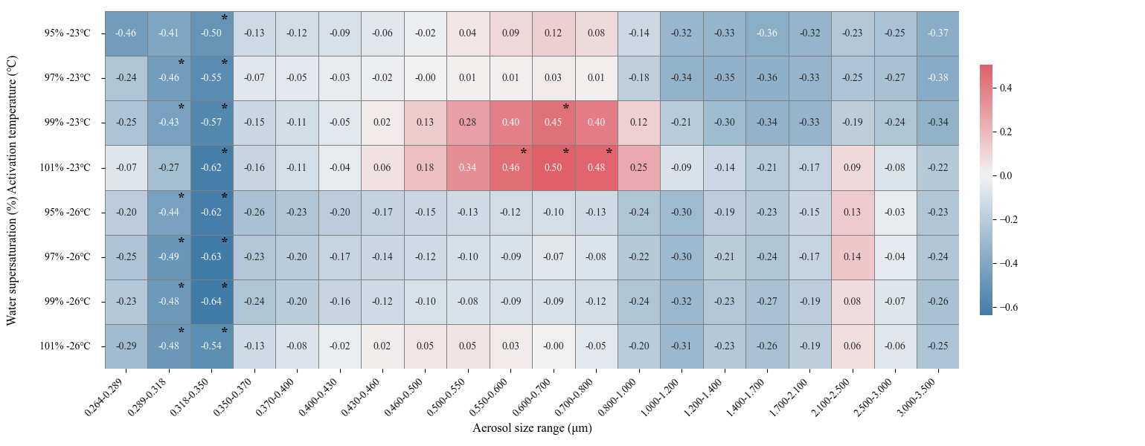
Figure B1 Pearson correlation coefficients between INP concentrations and aerosol number concentrations across different size ranges (0.264–3.5 μm) under varying relative humidity with respect to water (95%–101%) and activation temperatures (–23 °C and –26 °C). Asterisks (*) denote statistically significant correlations (p < 0.05). The color bar represents the strength and direction of the correlation

