Stat 101B Group Project Part 2 02/28/2014  
Group members:  
Xiaoyu Wang SID: 604327727 Junjie Qiu SID: 204213563

Chi Cho SID: 604210789 Xuan Lin SID: 204278880

Data:

42 obs

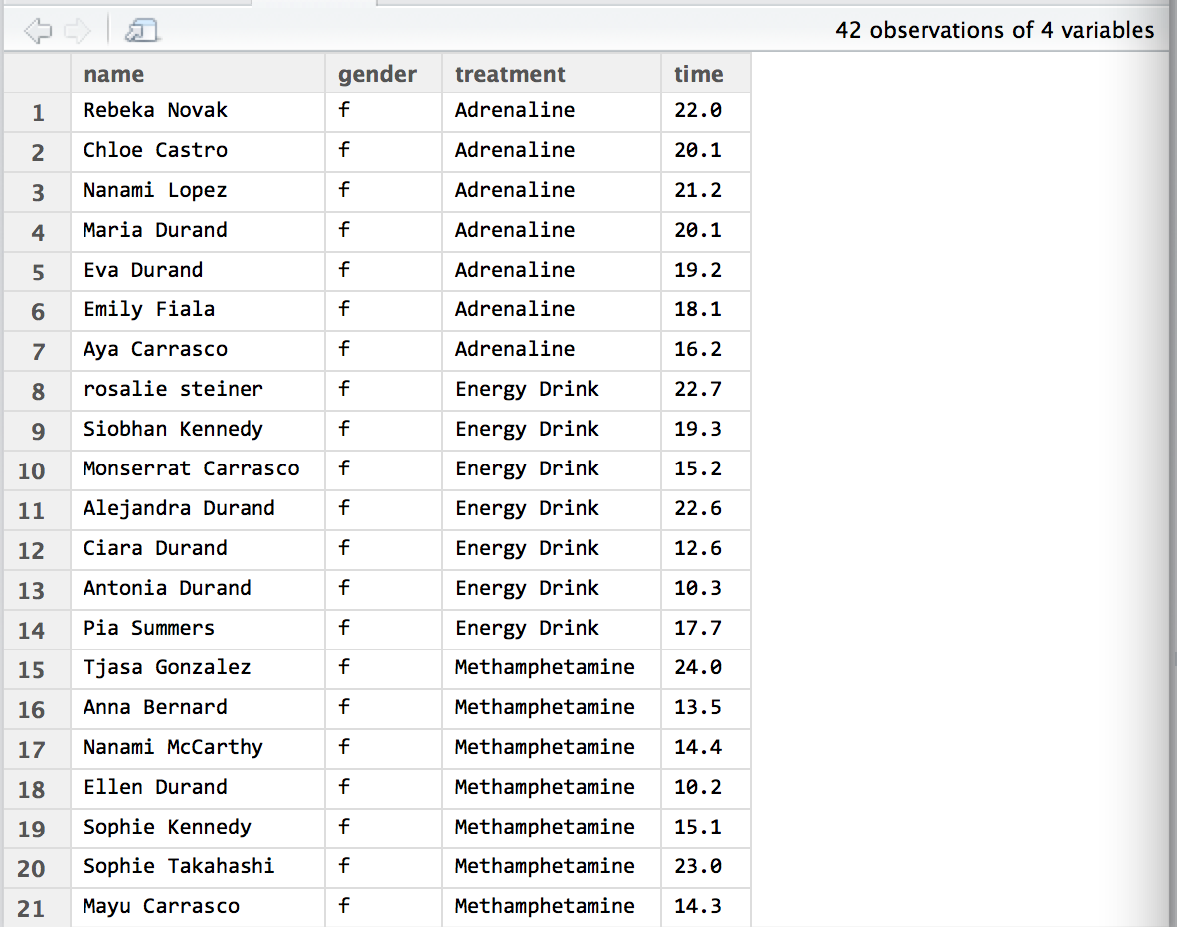

Sample size:

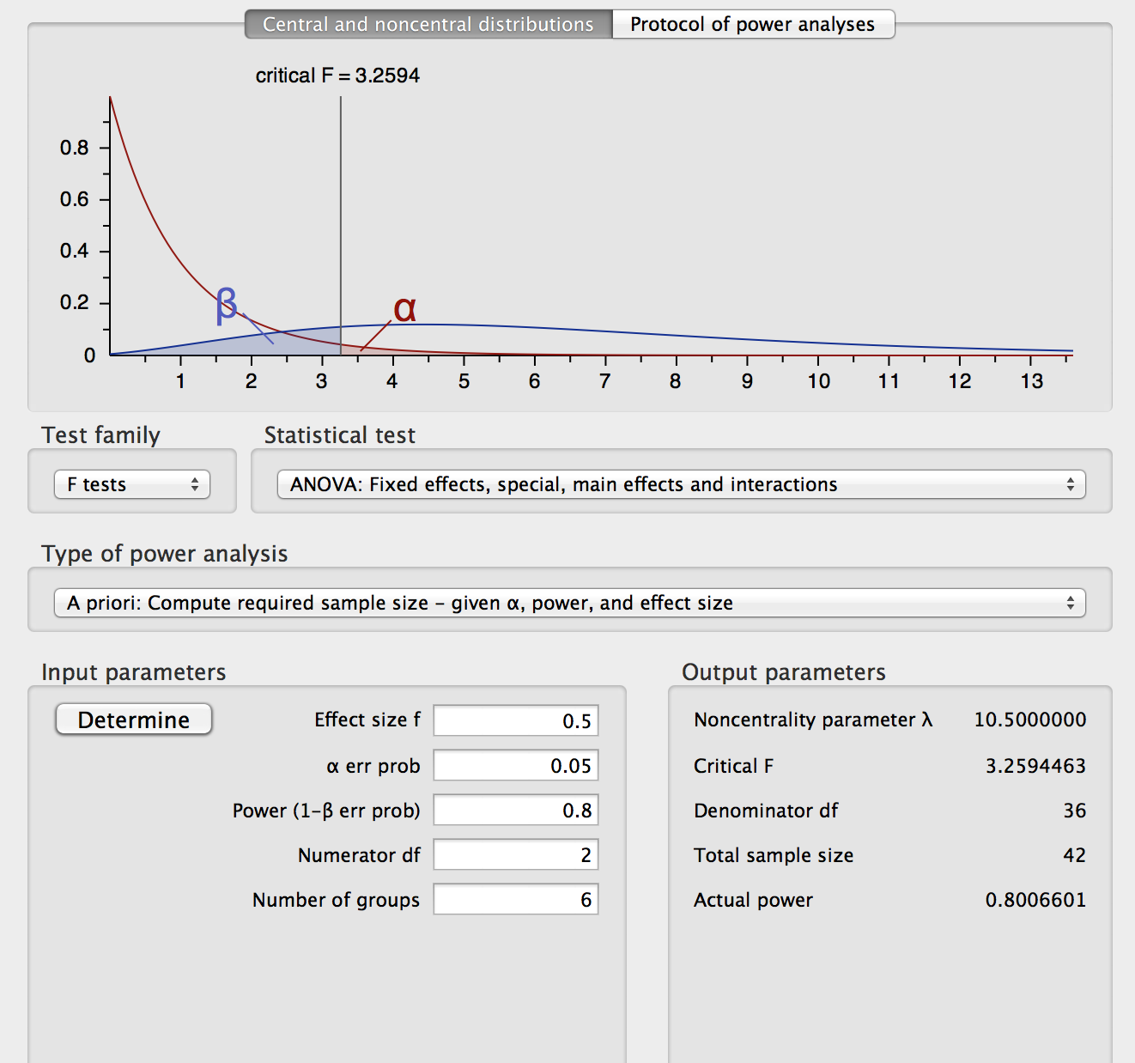

We tried BF[1] first.

> m0 <- aov(time~factor(treatment),data=d1)

> summary(m0)

Df Sum Sq Mean Sq F value Pr(>F)

factor(treatment) 2 196.3 98.14 3.803 0.031 *

Residuals 39 1006.4 25.81

---

Signif. codes: 0 ‘***’ 0.001 ‘**’ 0.01 ‘*’ 0.05 ‘.’ 0.1 ‘ ’ 1

>

> model.tables(m0)

Tables of effects

factor(treatment)

factor(treatment)

Adrenaline Energy Drink Methamphetamine

2.8357 -2.4071 -0.4286

# The estimated effects for Adrenaline is 2.8357.

# The estimated effects for Energy Drinkis -2.4071.

# The estimated effects for Methamphetamine is -0.4286.

|  |  |  |  |  |  |  |  |  |  |  |  |  |  |  |  |  |  |  |  |  |  |  |  |  |  |  |
| --- | --- | --- | --- | --- | --- | --- | --- | --- | --- | --- | --- | --- | --- | --- | --- | --- | --- | --- | --- | --- | --- | --- | --- | --- | --- | --- |
|  |  | n=21 |  |  |  |  |  |  |  |  |  |  |  |  |  |  |  |  |  |  |  |  |  |  |  |  |
|  | + | n=21 | + |  |  |  | + |  |  |  |  |  |  |  |  |  |  |  |  |  |  |  |  |  |  |  |
| Grand mean Gender (Blocking) Treatment Residual error | | | | | | | | | | | | | | | | | | | | | | | | | | |

------------------------------------------------------------------------------------------------------------

Blocking on the gender to increase power!

Factor Diagram CB[1]: Total 42 units and we blocking on gender. Our treatment has three levels (Adrenaline, Energy Drink, Methamphetamine), Each unit of block randomly get one treatment, and each block gets a complete set of treatment.

Plot of gender:

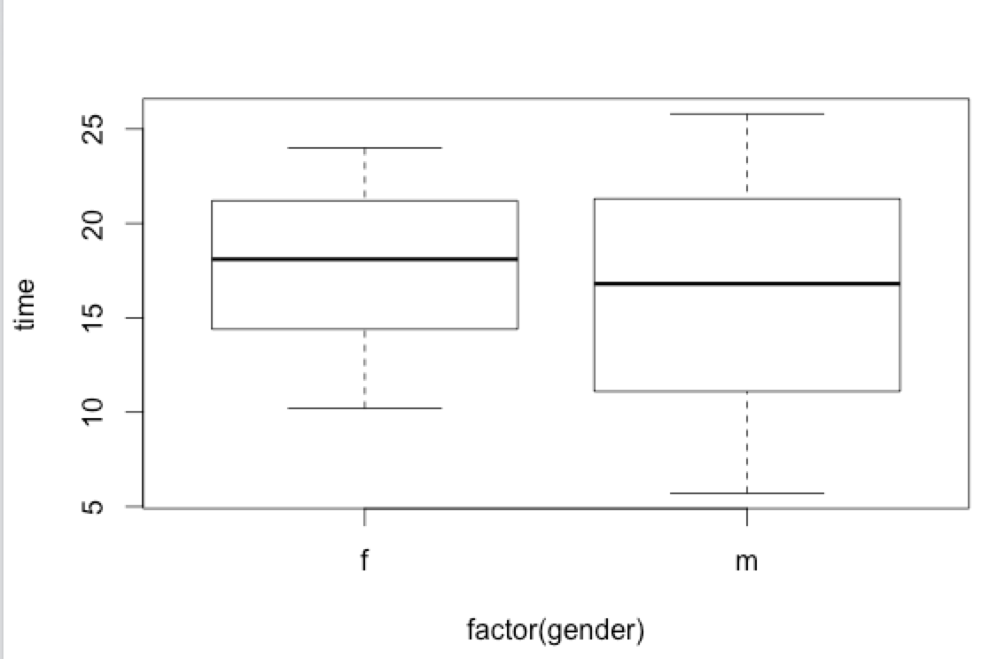

The mean difference between female and male are not that big.

------------------------------------------------------------------------------------------------------------

> m1 <- aov(time~factor(treatment)+factor(gender),data=d1)

> summary(m1)

Df Sum Sq Mean Sq F value Pr(>F)

factor(treatment) 2 196.3 98.14 3.816 0.0309 *

factor(gender) 1 29.2 29.17 1.134 0.2936

Residuals 38 977.2 25.72

---

Signif. codes: 0 ‘***’ 0.001 ‘**’ 0.01 ‘*’ 0.05 ‘.’ 0.1 ‘ ’ 1

>

Conclusion: Gender is a nuisance factor that we are not interesting, but after blocking on gender, the p-value decreased from 0.031 to 0.039 and power increased. The effect of treatments is become more statically significant after we blocking on gender.

Residual VS Fitted value and QQ Normal:

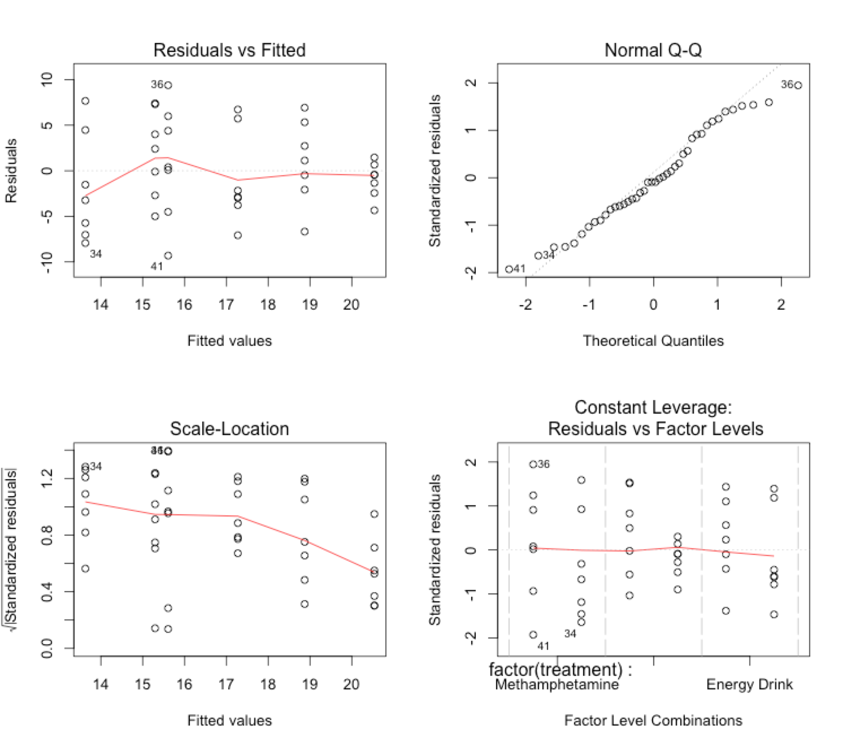

------------------------------------------------------------------------------------------------------------

# Try BF[2] to check whether interaction helps.

> m2 <- aov(time~factor(treatment)*factor(gender),data=d1)

> summary(m2)

Df Sum Sq Mean Sq F value Pr(>F)

factor(treatment) 2 196.3 98.14 3.920 0.0288 *

factor(gender) 1 29.2 29.17 1.165 0.2876

factor(treatment):factor(gender) 2 76.0 38.01 1.519 0.2327

Residuals 36 901.2 25.03

---

Signif. codes: 0 ‘***’ 0.001 ‘**’ 0.01 ‘*’ 0.05 ‘.’ 0.1 ‘ ’ 1

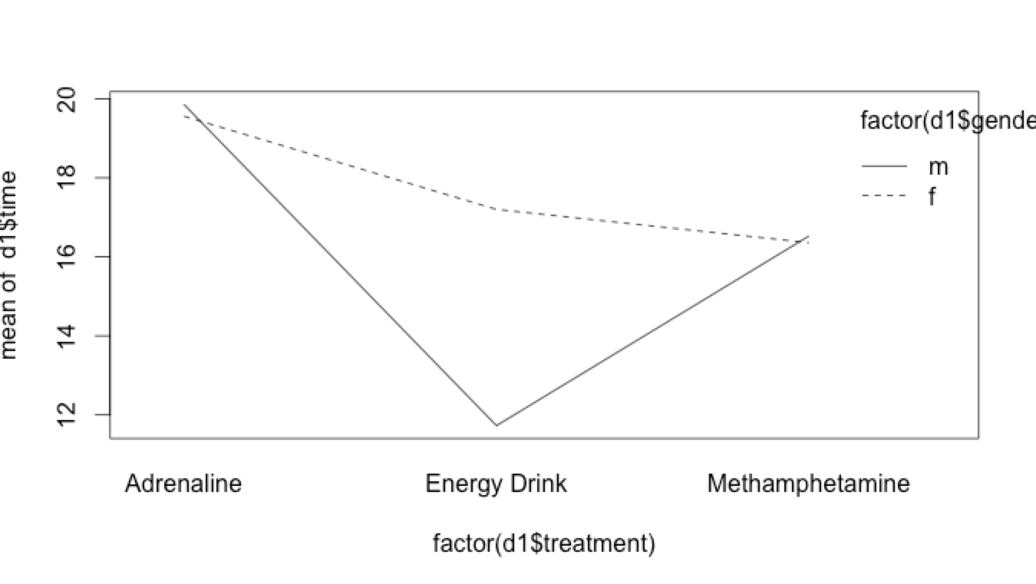

From the interaction we see difference between groups, since the p-value of interaction is greater than 0.05, we conclude that the interaction is not statistically significant. Therefore, the CB[1] is the best design for our experiment.