计算机图形学实验

姓 名： 刘钊宇
学 号： 20201050298
专 业： 计算机科学与技术
教 师： 钱文华

实验七 GLUT鼠标函数实验

实验时间：2022年4月26日
实验地点：信息学院机房
实验内容1：教材P458，GLUT鼠标函数
实验目的：调用鼠标函数完成相应功能，2-3个程序。
实验代码：
#include<stdlib.h>
#include<math.h>
#include<windows.h>
#define GLUT_DISABLE_ATEXIT_HACK
#include<gl/glut.h>
#include<windows.h>
#include<gl/glut.h>
#include<stdlib.h>

GLsizei winWidth = 400, winHeight = 300;
GLint ptCtr = 0;
class scrPt {
public:
GLint x, y;
};

void init(void)
{
glClearColor(0.0, 0.0, 1.0, 1.0);
glMatrixMode(GL_PROJECTION);
gluOrtho2D(0.0, 200.0, 0.0, 150.0);
}

void displayFcn(void)
{
glClear(GL_COLOR_BUFFER_BIT);
}

void winReshapeFcn(GLint newWidth, GLint newHeight)
{
glViewport(0, 0, newWidth, newHeight);
glMatrixMode(GL_PROJECTION);
glLoadIdentity();
gluOrtho2D(0.0, GLdouble(newWidth), 0.0, GLdouble(newHeight));

winWidth = newWidth;
winHeight = newHeight;
}

void drawLineSegment(scrPt endPt1, scrPt endPt2)
{
glBegin(GL_LINES);
glVertex2i(endPt1.x, endPt1.y);
glVertex2i(endPt2.x, endPt2.y);
glEnd();
}

void polyline(GLint button, GLint action, GLint xMouse, GLint yMouse)
{
static scrPt endPt1, endPt2;

if (ptCtr == 0) {
if (button == GLUT_LEFT_BUTTON && action == GLUT_DOWN) {
endPt1.x = xMouse;
endPt1.y = winHeight - yMouse;
ptCtr = 1;
}
}
else
if (button == GLUT_LEFT_BUTTON && action == GLUT_DOWN) {
endPt2.x = xMouse;
endPt2.y = winHeight - yMouse;
drawLineSegment(endPt1, endPt2);
endPt1 = endPt2;
}
else
if (button == GLUT_RIGHT_BUTTON)
exit(0);
glFlush();
}
int main(int argc, char** argv)
{
glutInit(&argc, argv);
glutInitDisplayMode(GLUT_SINGLE | GLUT_RGB);
glutInitWindowPosition(100, 100);
glutInitWindowSize(winWidth, winHeight);
glutCreateWindow("Draw Interactive Ployline");

init();
glutDisplayFunc(displayFcn);
glutReshapeFunc(winReshapeFcn);
glutMouseFunc(polyline);

glutMainLoop();
return 0;
}
实验结果：
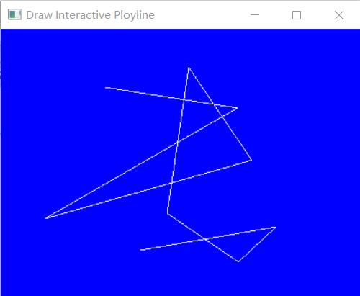

实验七 反走样技术

实验时间：2022年4月26日
实验地点：信息学院机房
实验内容2：使用opengl，实现任一反走样技术。
实验代码：
#include<stdlib.h>
#include<math.h>
#include<windows.h>
#define GLUT_DISABLE_ATEXIT_HACK
#include<gl/glut.h>

#define x_Screen 800
#define y_Screen 600
#define little 50
#define middle 20
#define large 8
void myBackground()
{
glClearColor(0.0,0.0,0.0,1.0);
glColor3f(1.0,1.0,1.0);
}

void myDisplay()
{
glEnable ( GL_DEPTH_TEST );
//如果没有抗锯齿，则点为方形的。如果我们启动抗锯齿设置，则点是一个圆点。
glEnable(GL_POINT_SMOOTH);
glEnable(GL_LINE_SMOOTH);
glHint(GL_POINT_SMOOTH_HINT, GL_NICEST); // Make round points, not square points
glHint(GL_LINE_SMOOTH_HINT, GL_NICEST); // Antialias the lines
glEnable(GL_BLEND);
glBlendFunc(GL_SRC_ALPHA, GL_ONE_MINUS_SRC_ALPHA);

glClear(GL_COLOR_BUFFER_BIT|GL_DEPTH_BUFFER_BIT);
int i;
glBegin(GL_POINTS);
for(i=0;i<little;i++)
glVertex2f(50.0+rand()%x_Screen,50.0+rand()%y_Screen);
glEnd();
glPointSize(2);
glBegin(GL_POINTS);
for(i=0;i<middle;i++)
glVertex2f(50.0+rand()%x_Screen,50.0+rand()%y_Screen);
glEnd();
glPointSize(8);
glBegin(GL_POINTS);
for(i=0;i<large;i++)
glVertex2f(50.0+rand()%x_Screen,50.0+rand()%y_Screen);
glEnd();

glBegin(GL_POLYGON);
for(i=0;i<64;i++)
glVertex2f(600+50.0*cos((float)i/10) ,500+50.0*sin((float)i/10) );
glEnd();
glLineWidth(3);
glBlendFunc(GL_SRC_ALPHA,GL_ONE_MINUS_SRC_ALPHA);
glEnable(GL_BLEND);
glEnable(GL_LINE_SMOOTH);
glBegin(GL_LINE_STRIP);
for(i=0;i<19;i++){
glVertex2f(rand()%10+i*70,rand()%50+50.0+(i%2)*80);
}
glEnd();
glutSwapBuffers();
}
void myChange(int w,int h)
{
glViewport(0,0,w,h);
glMatrixMode(GL_PROJECTION);
glLoadIdentity();
gluOrtho2D(0.0,x_Screen,0.0,y_Screen);
glMatrixMode(GL_MODELVIEW);
glLoadIdentity();
}

int main()
{
glutInitDisplayMode(GLUT_DOUBLE|GLUT_RGB|GLUT_DEPTH);
glutInitWindowSize(x_Screen,y_Screen);
glutCreateWindow("Star");
glutDisplayFunc(myDisplay);
glutReshapeFunc(myChange);
myBackground();
glutMainLoop();
}

实验结果：
