计算机图形学实验

姓 名： 刘钊宇
学 号： 20201050298
专 业： 计算机科学与技术
教 师： 钱文华

实验四 填充算法实验

时间：2022年4月6日
地点：信息学院2204机房

实验内容1：教材P66，填充六边形
实验目的：验证扫描线填充算法，指定任意的多边形边数， 填充多边形。
实验代码：
#include<stdlib.h>
#include<math.h>
#include<windows.h>
#define GLUT_DISABLE_ATEXIT_HACK
#include<gl/glut.h>

const double TWO_PI = 6.2831853;

GLsizei winWidth = 400, winHeight = 400;
GLuint regHex;

class screenPt {
private:
GLint x, y;
public:
screenPt() {
x = y = 0;
}
void setCoords(GLint xCoord, GLint yCoord) {
x = xCoord;
y = yCoord;
}
GLint getx() const {
return x;
}
GLint gety() const {
return y;
}
};

static void init(void) {
screenPt hexVertex, circCtr;
GLdouble theta;
GLint k;

circCtr.setCoords(winWidth / 2, winHeight / 2);
glClearColor(1.0, 1.0, 1.0, 0.0);

regHex = glGenLists(1);
glNewList(regHex, GL_COMPILE);
glColor3f(1.0, 0.0, 0.0);
glBegin(GL_POLYGON);
for (k = 0; k < 6; k++) {
theta = TWO_PI * k / 6.0;
hexVertex.setCoords(circCtr.getx() + 150 * cos(theta), circCtr.gety() + 150 * sin(theta));
glVertex2i(hexVertex.getx(), hexVertex.gety());
}
glEnd();
glEndList();
}

void regHexagon(void) {
glClear(GL_COLOR_BUFFER_BIT);

glCallList(regHex);

glFlush();
}

void winReshapeFcn(int newWidth, int newHeight) {
glMatrixMode(GL_PROJECTION);
glLoadIdentity();
gluOrtho2D(0.0, (GLdouble)newWidth, 0.0, (GLdouble)newHeight);
glClear(GL_COLOR_BUFFER_BIT);
}

int main(int argc, char** argv) {
glutInit(&argc, argv);
glutInitDisplayMode(GLUT_SINGLE | GLUT_RGB);
glutInitWindowPosition(100, 100);
glutInitWindowSize(winWidth, winHeight);
glutCreateWindow("Reshape-Function & Display-List Example");

init();
glutDisplayFunc(regHexagon);
glutReshapeFunc(winReshapeFcn);

glutMainLoop();
return 0;
}

实验结果：
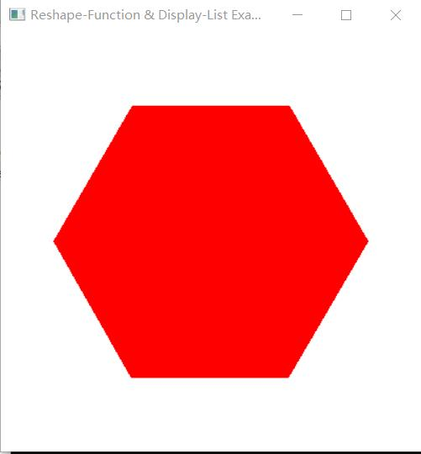
实验内容2：使用OPENGL，用扫描线填充算法填充多边形
实验目的：验证扫描线填充算法，指定任意的多边形边数， 填充多边形。
实验代码：
#include<stdlib.h>
#include<math.h>
#include<windows.h>
#define GLUT_DISABLE_ATEXIT_HACK
#include<gl/glut.h>

const double TWO_PI = 6.2831853;

GLsizei winWidth = 400, winHeight = 400;
GLuint regHex;

class screenPt {
private:
GLint x, y;
public:
screenPt() {
x = y = 0;
}
void setCoords(GLint xCoord, GLint yCoord) {
x = xCoord;
y = yCoord;
}
GLint getx() const {
return x;
}
GLint gety() const {
return y;
}
};

static void init(void) {
screenPt hexVertex, circCtr;
GLdouble theta;
GLint k;

circCtr.setCoords(winWidth / 2, winHeight / 2);
glClearColor(1.0, 1.0, 1.0, 0.0);

regHex = glGenLists(1);
glNewList(regHex, GL_COMPILE);
glColor3f(1.0, 0.0, 0.0);
glBegin(GL_POLYGON);
for (k = 0; k < 6; k++) {
theta = TWO_PI * k / 6.0;
hexVertex.setCoords(circCtr.getx() + 150 * cos(theta), circCtr.gety() + 150 * sin(theta));
glVertex2i(hexVertex.getx(), hexVertex.gety());
}
glEnd();
glEndList();
}

void regHexagon(void) {
glClear(GL_COLOR_BUFFER_BIT);

glCallList(regHex);

glFlush();
}

void winReshapeFcn(int newWidth, int newHeight) {
glMatrixMode(GL_PROJECTION);
glLoadIdentity();
gluOrtho2D(0.0, (GLdouble)newWidth, 0.0, (GLdouble)newHeight);
glClear(GL_COLOR_BUFFER_BIT);
}

int main(int argc, char** argv) {
glutInit(&argc, argv);
glutInitDisplayMode(GLUT_SINGLE | GLUT_RGB);
glutInitWindowPosition(100, 100);
glutInitWindowSize(winWidth, winHeight);
glutCreateWindow("Reshape-Function & Display-List Example");

init();
glutDisplayFunc(regHexagon);
glutReshapeFunc(winReshapeFcn);

glutMainLoop();
return 0;
}

实验结果：

