计算机图形学实验

姓 名： 刘钊宇
学 号： 20201050298
专 业： 计算机科学与技术
教 师： 钱文华

实验八 二维图像裁剪实验
实验时间：2022年5月3日
实验地点：信息学院机房
实验内容1：使用opengl，用Cohen-Sutherland线段裁剪算法对直线段进行裁剪
实验目的：验证Cohen-Sutherland裁剪算法，从键盘输入任意的直线段，用指定的裁剪窗口裁剪直线段。
实验代码：
#include<stdlib.h>
#include<math.h>
#include<windows.h>
#define GLUT_DISABLE_ATEXIT_HACK
#include<gl/glut.h>
class wcPt2D {
public:
float x, y;
};

GLubyte encode(wcPt2D pt, wcPt2D winMin, wcPt2D winMax);

void swapPts(wcPt2D *p1, wcPt2D *p2);

void swapCodes(GLubyte *c1, GLubyte *c2);

void lineClipCohSuth(wcPt2D winMin, wcPt2D winMax, wcPt2D p1, wcPt2D p2);

void myKeyBoard(unsigned char key, int x, int y);

const GLint winLeftBitCode = 0x1;
const GLint winRightBitCode = 0x2;
const GLint winBottomBitCode = 0x4;
const GLint winTopBitCode = 0x8;

inline GLint inside(GLint code) {
return GLint(!code);
}

inline GLint reject(GLint code1, GLint code2) {
return GLint(code1 & code2);
}

inline GLint accept(GLint code1, GLint code2) {
return GLint(!(code1 | code2));
}

GLubyte encode(wcPt2D pt, wcPt2D winMin, wcPt2D winMax) {
GLubyte code = 0x00;
if (pt.x < winMin.x) code = code | winLeftBitCode;
if (pt.x > winMax.x) code = code | winRightBitCode;
if (pt.y < winMin.y) code = code | winBottomBitCode;
if (pt.y > winMax.y) code = code | winTopBitCode;
return (code);
}

void swapPts(wcPt2D *p1, wcPt2D *p2) {
wcPt2D tmp;
tmp = *p1;
*p1 = *p2;
*p2 = tmp;
}

void swapCodes(GLubyte *c1, GLubyte *c2) {
GLubyte tmp;
tmp = *c1;
*c1 = *c2;
*c2 = tmp;
}

void lineClipCohSuth(wcPt2D winMin, wcPt2D winMax, wcPt2D p1, wcPt2D p2) {
GLubyte code1, code2;
GLint done = false, plotLine = false;
GLfloat m;
while (!done) {
code1 = encode(p1, winMin, winMax);
code2 = encode(p2, winMin, winMax);
if (accept(code1, code2)) {
done = true;
plotLine = true;
} else if (reject(code1, code2)) {
done = true;
} else {
if (inside(code1)) {
swapPts(&p1, &p2);
swapCodes(&code1, &code2);
}
if (p2.x != p1.x) m = (p2.y - p1.y) / (p2.x - p1.x);
if (code1 & winLeftBitCode) {
p1.y += (winMin.x - p1.x) * m;
p1.x = winMin.x;
} else if (code1 & winRightBitCode) {
p1.y += (winMax.x - p1.x) * m;
p1.x = winMax.x;
} else if (code1 & winBottomBitCode) {
if (p2.x != p1.x)
p1.x += (winMin.y - p1.y) / m;
p1.y = winMin.y;
} else if (code1 & winTopBitCode) {
if (p2.x != p1.x)
p1.x = (winMax.y - p1.y) / m;
p1.y = winMax.y;
}
}
}
if (plotLine)
glBegin(GL_LINES);
glLineWidth(10);
glColor3f(1, 0, 0);
glVertex2f(p1.x, p1.y);
glVertex2f(p2.x, p2.y);
glEnd();
}

void drawpolygon(double cd[]) {
glBegin(GL_LINE_LOOP);
glLineWidth(10);
for (int i = 0; i < 8; i = i + 2) {
glVertex2f(cd[i], cd[i + 1]);
}
glEnd();
}

void drawline(double cd[]) {
glBegin(GL_LINES);
glLineWidth(10);
for (int i = 0; i < 8; i = i + 2) {
glVertex2f(cd[i], cd[i + 1]);
}
glEnd();
}

void myKeyBoard(unsigned char key, int x, int y) {
wcPt2D winMin = {100, 100};
wcPt2D winMax = {400, 400};
wcPt2D p1 = {0, 0};
wcPt2D p2 = {500, 500};

wcPt2D p11 = {200, 300};
wcPt2D p21 = {300, 200};

wcPt2D p12 = {10, 50};
wcPt2D p22 = {50, 10};
if (key == 13) {
lineClipCohSuth(winMin, winMax, p1, p2);
lineClipCohSuth(winMin, winMax, p11, p21);
lineClipCohSuth(winMin, winMax, p12, p22);

}
glFlush();
if (key == 27)
exit(0);
}

void display(void) {
double cd[8] = {100, 100, 100, 400, 400, 400, 400, 100};
double line[4] = {0, 0, 500, 500};
double line1[4] = {200, 300, 300, 200};
double line2[4] = {10, 50, 50, 10};
glClear(GL_COLOR_BUFFER_BIT);
glViewport(0, 0, 500, 500);
glColor3f(0, 0, 0);
drawpolygon(cd);
drawline(line);
drawline(line1);
drawline(line2);
glFlush();
}

int main(int argc, char **argv) {
glutInit(&argc, argv);
glutInitDisplayMode(GLUT_SINGLE | GLUT_RED);
glutInitWindowSize(500, 500);
glutInitWindowPosition(100, 100);
glutCreateWindow("Cohen-Sutherland");
glClearColor(1, 1, 1, 0.0);
glMatrixMode(GL_PROJECTION);//投影模型
gluOrtho2D(0.0, 500.0, 0.0, 500.0);
glutKeyboardFunc(myKeyBoard);
glutDisplayFunc(display);
glutMainLoop();
return 0;

}
实验结果：
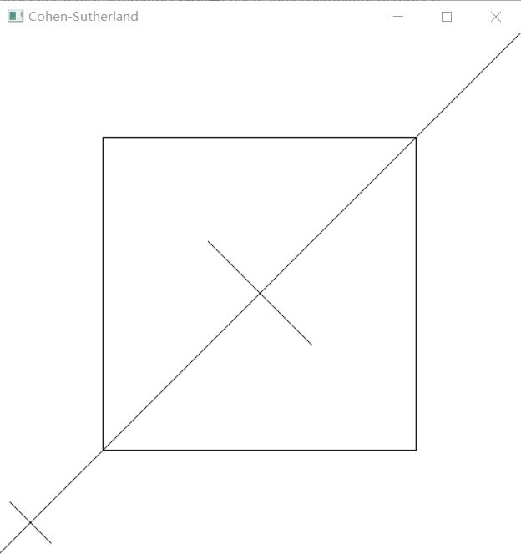

实验八 GLUT鼠标函数实验
实验时间：2022年4月27日
实验地点：信息学院机房
实验内容2：教材P458，GLUT鼠标函数
实验目的：调用鼠标函数完成相应功能，3个程序。
实验代码：
#include<stdlib.h>
#include<math.h>
#include<windows.h>
#define GLUT_DISABLE_ATEXIT_HACK
#include<gl/glut.h>
GLsizei winWidth = 400, winHeight = 300;

void init(void)
{
glClearColor(0.0, 0.0, 1.0, 1.0);
glMatrixMode(GL_PROJECTION);
gluOrtho2D(0.0, 200.0, 0.0, 150);
}

void displayFcn(void)
{
glClear(GL_COLOR_BUFFER_BIT);
glColor3f(1.0, 0.0, 0.0);
glPointSize(3.0);
}

void winReshapeFcn(GLint newWidth, GLint newHeight)
{
glViewport(0, 0, newWidth, newHeight);
glMatrixMode(GL_PROJECTION);
glLoadIdentity();
gluOrtho2D(0.0, GLdouble(newWidth), 0.0, GLdouble(newHeight));

winWidth = newWidth;
winHeight = newHeight;
}

void plotPoint(GLint x, GLint y)
{
glBegin(GL_POINTS);
glVertex2i(x, y);
glEnd();
}

void mousePtPlot(GLint button, GLint action, GLint xMouse, GLint yMouse)
{
if (button == GLUT_LEFT_BUTTON && action == GLUT_DOWN)
plotPoint(xMouse, winHeight - yMouse);
glFlush();
}
int main(int argc, char** argv)
{
glutInit(&argc, argv);
glutInitDisplayMode(GLUT_SINGLE | GLUT_RGB);
glutInitWindowPosition(100, 100);
glutInitWindowSize(winWidth, winHeight);
glutCreateWindow("Mouse Plot Points");

init();
glutDisplayFunc(displayFcn);
glutReshapeFunc(winReshapeFcn);
glutMouseFunc(mousePtPlot);

glutMainLoop();
return 0;
}

实验结果：
