计算机图形学实验

姓 名： 刘钊宇
学 号： 20201050298
专 业： 计算机科学与技术
教 师： 钱文华

实验十三 多面体实验
实验时间：2022年6月1日
实验地点：信息学院机房
实验内容：生成多面体线框图，P300、P307
实验目的：熟悉三维线框图相关内容
实验代码1：
#include<stdlib.h>
#include<math.h>
#include<windows.h>
#define GLUT_DISABLE_ATEXIT_HACK
#include<gl/glut.h>
GLsizei winWidth=500,winHeight=500;
void init(void)
{
glClearColor(1.0,1.0,1.0,0.0);
}
void displayWirePolyhedra(void)
{
glClear(GL_COLOR_BUFFER_BIT);
glColor3f(0.0,0.0,1.0);
gluLookAt(5.0,5.0,5.0,0.0,0.0,0.0,0.0,1.0,0.0);
glScalef(1.5,2.0,1.0);
glutWireCube(1.0);
glScalef(0.8,0.5,0.8);
glTranslatef(-6.0,-5.0,0.0);
glutWireDodecahedron();
glTranslatef(8.6,8.6,2.0);
glutWireTetrahedron();
glTranslatef(-3.0,-1.0,0.0);
glutWireOctahedron();
glScalef(0.8,0.8,1.0);
glTranslatef(4.3,-2.0,0.5);
glutWireIcosahedron();
glFlush();
}
void winReshapeFcn(GLint newWidth,GLint newHeight)
{
glViewport(0,0,newWidth,newHeight);
glMatrixMode(GL_PROJECTION);
glFrustum(-1.0,1.0,-1.0,1.0,2.0,20.0);
glMatrixMode(GL_MODELVIEW);
glClear(GL_COLOR_BUFFER_BIT);
}
int main(int argc,char** argv)
{
glutInit(&argc,argv);
glutInitDisplayMode(GLUT_SINGLE|GLUT_RGB);
glutInitWindowPosition(100,100);
glutInitWindowSize(winWidth,winHeight);
glutCreateWindow("Wire-Frame Polyhedra");
init();
glutDisplayFunc(displayWirePolyhedra);
glutReshapeFunc(winReshapeFcn);
glutMainLoop();
}
实验结果：
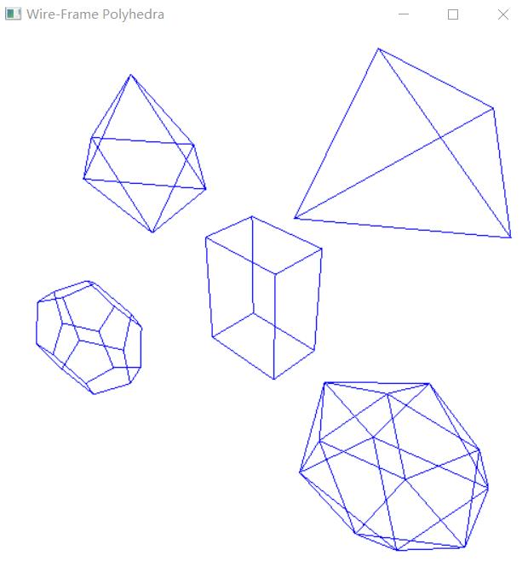

实验代码2：
#include<stdlib.h>
#include<math.h>
#include<windows.h>
#define GLUT_DISABLE_ATEXIT_HACK
#include<gl/glut.h>

GLsizei winWidth = 500, winHeight = 500;
void init(void) {
glClearColor(1.0, 1.0, 1.0, 0.0);
}

void wireQuadSurfs(void) {
glClear(GL_COLOR_BUFFER_BIT);
glColor3f(0.0, 0.0, 1.0);

glPushMatrix();
glTranslatef(1.0, 1.0, 0.0);
glutWireSphere(0.75, 8, 6);
glPopMatrix();

GLUquadricObj* cylinder;
glPushMatrix();
glTranslatef(0.0, 1.2, 0.8);
cylinder = gluNewQuadric();
gluQuadricDrawStyle(cylinder, GLU_LINE);
gluCylinder(cylinder, 0.6, 0.6, 1.5, 6, 4);
glPopMatrix();
glFlush();
}

void winReshapeFcn(GLint newWidth, GLint newHeight) {
glViewport(0, 0, newWidth, newHeight);
glMatrixMode(GL_PROJECTION);
glOrtho(-2.0, 2.0, -2.0, 2.0, 0.0, 5.0);
glMatrixMode(GL_MODELVIEW);
glClear(GL_COLOR_BUFFER_BIT);
}

int main(int argc, char** argv) {
glutInit(&argc, argv);
glutInitDisplayMode(GLUT_SINGLE | GLUT_RGB);
glutInitWindowPosition(100, 100);
glutInitWindowSize(winWidth, winHeight);
glutCreateWindow("Wire-Frame Quadric Surfaces");
init();
glutDisplayFunc(wireQuadSurfs);
glutReshapeFunc(winReshapeFcn);

glutMainLoop();
}
实验结果：
