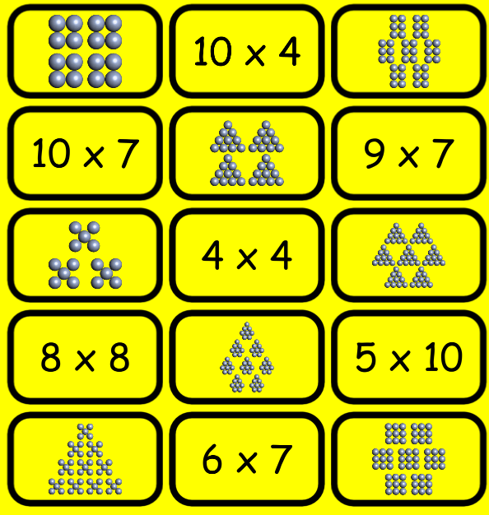

**2014-07-20 16:56:51.342 MathApp[8785:60b] shape Array: (**

**23, 🡪5x10**

**52, 🡪9x7**

**45, 🡪8x8**

**16, 🡪5x3**

**60, 🡪10x7**

**57, 🡪10x4**

**9, 🡪4x4**

**28 🡪6x7**

**)🡪8 total**

**2014-07-20 16:56:51.342 MathApp[8785:60b] equation Array: (**

**28, 🡪6x7**

**45, 🡪8x8**

**23, 🡪5x10**

**9, 🡪4x4**

**60, 🡪10x7**

**52, 🡪9x7**

**57 🡪10x4**

**)🡪7 total**

**Edge Cases: Consider**

* You have the following 7 matches:
  + [“3x10”, “10x3”, “6x6”, “6x7”, “7x6”, “8x9”, “9x8”]
* You match “3x10”

