**格式化日期**

**<fmt:formatDate value="date" [type="{time|date|both}"]**

**[dateStyle="{default|short|medium|long|full}"]**

**[timeStyle="{default|short|medium|long|full}"]**

**[pattern="customPattern"]**

**[timeZone="timeZone"]**

**[var="varName"]**

**[scope="{page|request|session|application}"]/>**

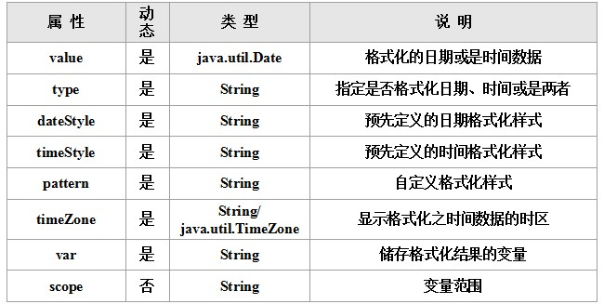

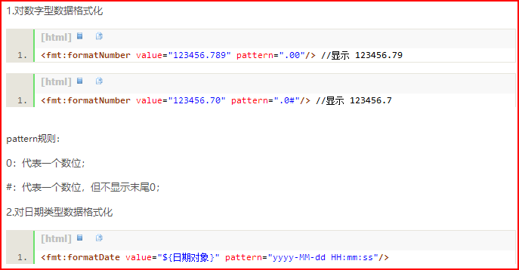

**函数标签**

**①函数的fn.tdl复制进工程**

**②配置web.xml**

**③<%@ taglib uri="http://java.sun.com/jsp/jstl/functions" prefix="fn" %>**

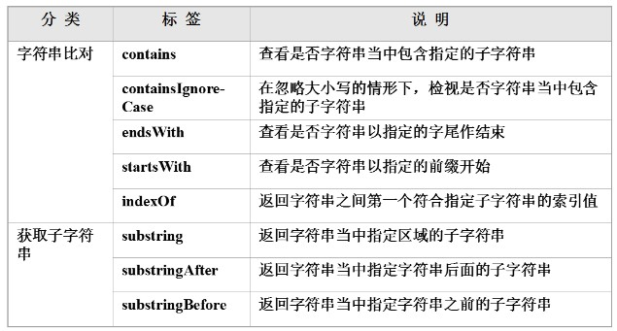

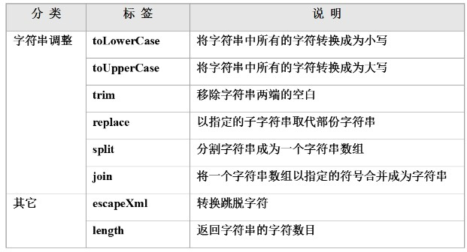

**contains**

**fn:contains(string, substring)**

**containsIgnoreCase**

**fn:containsIgnoreCase(string, substring)**

**endsWith**

**fn:endsWith(string, suffix) -> boolean**

**startsWith**

**fn:startsWith(string, prefix) -> boolean**

**indexOf**

**fn:indexOf(string, substring)**

**fn:substring(string, beginIndex, endIndex)**

**substringAfter**

**fn:substringAfter(string, substring)**

**substringBefore**

**fn:substringBefore(string, substring)**

**toLowerCase**

**fn:toLowerCase(string) -> String**

**toUpperCase**

**fn:toUpperCase (string) -> String**

**fn:trim(string) -> String**

**fn:replace(inputString, beforeSubstring, afterSubstring)**

**fn:length(input) -> integer**

**<c:set var="string1" value="This is first String."/>**

**<c:set var="string2" value="${fn:substring(string1, 5, 15)}" />**