**2003 - Structure and function of the feed-forward loop network motif (+)**

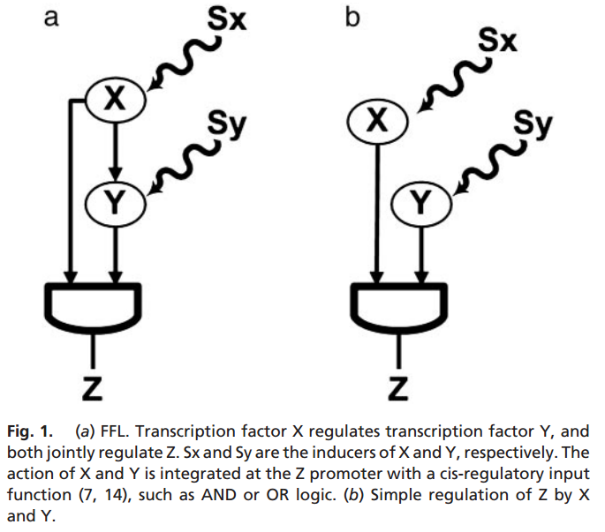

There are 8 FFLs of three nodes.

This paper found the functionalities of these FFLs.

Usually one or two FFLs are much more significant than others in one type of network. Their numbers are more than the others.

Sometimes only 1 or 2 FFLs can have certain functionality.

The definition of **Network Dynamics**:

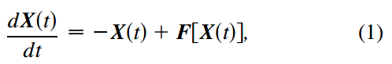

**Network Dynamics** is the network state changing over time.

**Periodic Dynamics over long period of time (from summer to winter, from winter to summer).**

In different network topologies, the type of significant Motifs may be different.

In different periods, the type of significant Motifs may also be different.

Motif types:

SIM: single input, multiple outputs. 1 to Many

MIM: Multiple inputs, multiple outputs. Many to Many

FFL: as above

**2003 – Evolutionary conservation of motif constituents in the yeast protein interaction network**

As the evolution of the proteins, the percentage of some of the motifs remains unchanged.

Motif purpose:

Motif properties:

Statistics:

Motif Detect tool:

**2004 – Dynamical Motifs (+)**

Use dynamical and statistical methods to identify dynamical motifs and to evaluate the probability of their occurrence in the structure of networks.

Periodic motif

Chaotic motif

Motif purpose:

Motif properties:

Statistics:

Motif Detect tool:

Motif purpose:

Motif properties:

Statistics:

Motif Detect tool:

Motif purpose:

Motif properties:

Statistics:

Motif Detect tool:

Motif purpose:

Motif properties:

Statistics:

Motif Detect tool:

Motif purpose:

Motif properties:

Statistics:

Motif Detect tool:

Motif purpose:

Motif properties:

Statistics:

Motif Detect tool:

Motif purpose:

Motif properties:

Statistics:

Motif Detect tool:

Motif purpose:

Motif properties:

Statistics:

Motif Detect tool:

Motif purpose:

Motif properties:

Statistics:

Motif Detect tool: