部分json

**一.示例：（菜单初版所需字段）**

{

"code": 200,

"data": [

{

"path": "/BasicData",

"component": "Layout",

"redirect ": "/BasicData/OrganizationalManagement/CompanyMaintenance",

"name": "BasicData",

"meta": {

"title": "BasicData",

"icon": "nested"

},

// 物料信息管理模块

"children": [

// 组织架构管理

{

"path": "OrganizationalManagement",

"component": "() => import('@/views/BasicData/OrganizationalManagement/index')",

"name": "OrganizationalManagement",

"meta": {

"title": "OrganizationalManagement"

},

"redirect": "/BasicData/OrganizationalManagement/CompanyMaintenance",

"children": [{

"path": "CompanyMaintenance",

"component": "() => import('@/views/BasicData/OrganizationalManagement/CompanyMaintenance')",

"name": "CompanyMaintenance",

"meta": {

"title": "CompanyMaintenance"

}

},

{

"path": "DepartmentMaintenance",

"component": "() => import('@/views/BasicData/OrganizationalManagement/DepartmentMaintenance')",

"name": "DepartmentMaintenance",

"meta": {

"title": "DepartmentMaintenance"

}

}

]

},

// 生产信息管理

{

"path": "ProductionManagement",

"component": "() => import('@/views/BasicData/ProductionManagement/index')",

"name": "ProductionManagement",

"meta": {

"title": "ProductionManagement"

},

"redirect": "/BasicData/ProductionManagement/LineMaintenance",

"children": [{

"path": "LineMaintenance",

"component": "() => import('@/views/BasicData/ProductionManagement/LineMaintenance')",

"name": "LineMaintenance",

"meta": {

"title": "LineMaintenance"

}

},

{

"path": "WorkMaintenance",

"component": "() => import('@/views/BasicData/ProductionManagement/WorkMaintenance')",

"name": "WorkMaintenance",

"meta": {

"title": "WorkMaintenance"

}

},

{

"path": "ProcessMaintenance",

"component": "() => import('@/views/BasicData/ProductionManagement/ProcessMaintenance')",

"name": "ProcessMaintenance",

"meta": {

"title": "ProcessMaintenance"

}

}

]

}

]

}

]

}

**二：基础数据----组织架构-----公司信息管理**

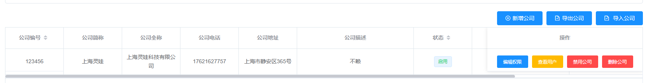

列表返回数据格式

{

"code": 200,

"data": [

{

id: 'xxx',

companyNo: '123456',

companyName: '上海灵娃',

companyAllName: '上海灵娃科技有限公司',

companyTel: '17621627757',

companyAddress: '上海市静安区365号',

companyDescription: '不赖',

status: '启用',

user: '张三',

time: '2020-8-19'

}

]

}

**三：基础数据----生产信息管理 ----工序信息维护**

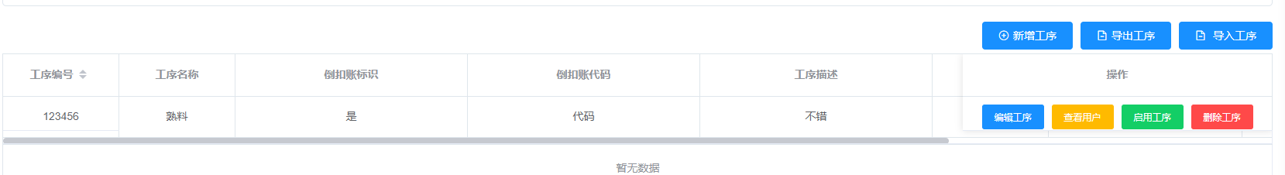

列表返回数据格式

{

"code": 200,

"data": [

{

id: 'xxx',

serialNo: '123456',

serialName: '熟料',

serialDescription: '不错',

serialIdentification: '是',

serialCode: '代码',

status: '禁用',

user: '张三',

time: '2020-8-19'

}

]

}

**四：基础数据---产品信息维护----BOM信息维护**

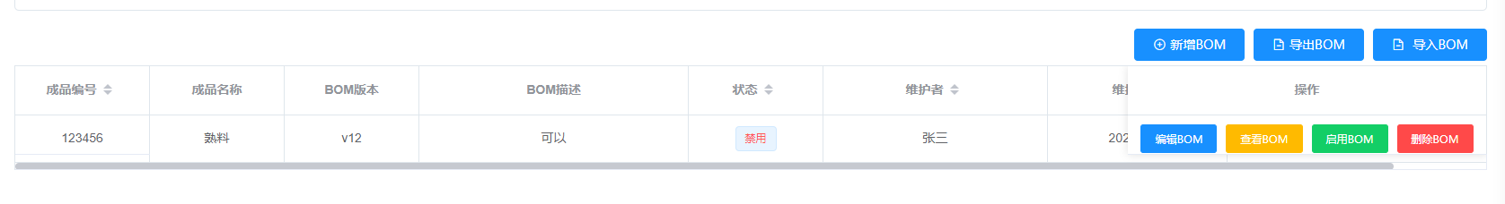

列表返回数据格式

{

"code": 200,

"data": [

{

id: 'xxx',

finishedNo: '123456',

finishedName: '熟料',

editionBom: 'v12',

descriptionBom: '可以',

status: '禁用',

user: '张三',

time: '2020-8-19'

}

]

}

**五：基础数据---物料信息管理 ----原料信息维护**

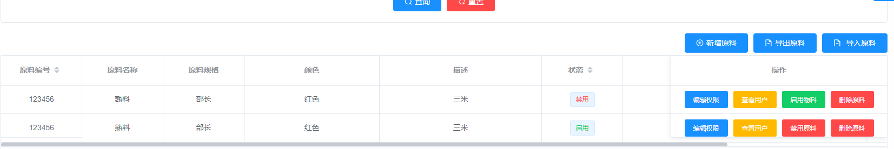

列表返回数据格式

{

"code": 200,

"data": [

{

id: 'xxx',

materialNo: '123456',

materialName: '熟料',

materialSpecifications: '部长',

description: '三米',

MaterialColor: '红色',

status: '禁用',

user: '张三',

time: '2020-8-19''

}

]

}

**六：基础数据---物料信息管理 ----成品信息维护**

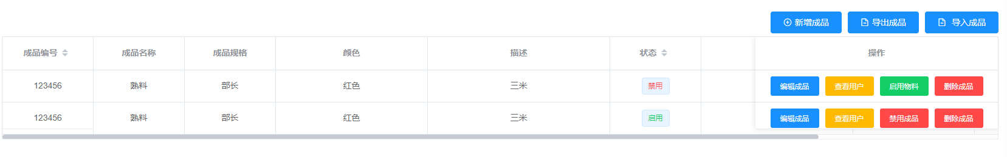

列表返回数据格式

{

"code": 200,

"data": [

{

id: 'xxx',

finishedNo: '123456',

finishedName: '熟料',

finishedSpecifications: '部长',

description: '三米',

finishedColor: '红色',

status: '禁用',

user: '张三',

time: '2020-8-19'

}

]

}

**七：系统管理---角色权限**

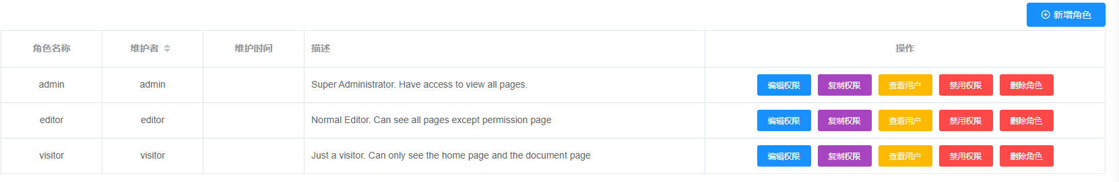

列表返回数据格式

{

"code": 200,

"data": [

{

id: 'xxx',

key: ' admin ', //角色名称

status: '禁用',

name: ' admin ', //维护者 status: '禁用',

time: '2020-8-19'

description: '描述 ',

}

]

}

**八：系统管理---用户管理**

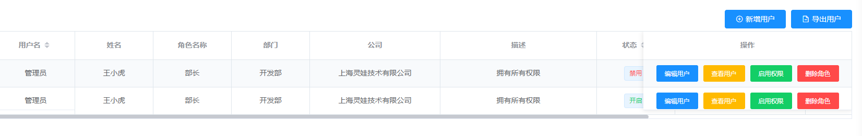

列表返回数据格式

{

"code": 200,

"data": [

{

id: 'xxx',

userName: '管理员',

fullName: '王小虎',

title: '部长',

department: '开发部',

company: '上海灵娃技术有限公司',

description: '拥有所有权限',

status: '禁用',

user: '张三',

time: '2020-8-19'

}

]

}