* 下载文件封装对象

public class GetFileInfo {

public String filename;//要下载的文件名

public String pathSrv;//要下载的服务器文件路径

public String myPath;//存放的本地相对路径

public String parentPath;// 存放的本地父路径

public String serverIp;

public int serverPort;

public int time;

public SocketObj socketObj;

public GetFileInfo(String filename, String pathSrv, String myPath, String parentPath, String serverIp, int serverPort, int time, SocketObj socketObj) {

this(filename, pathSrv, myPath, parentPath, serverIp, serverPort, time, PathType.pub.value(), socketObj);

}

**范例**：

**//下载单个文件**

File file=new File(MyApplication.rootPath+ "Data/rows/BASE/epuserlist.txt");

if (!file.exists()) {

GetFileInfo getFileInfoEp = new GetFileInfo

("epuserlist.txt",

"Data/rows/BASE",

"Data/rows/BASE",

MyApplication.rootPath,

MyApplication.socketObj.getIp(),

MyApplication.socketObj.getPort(),

1,MyApplication.socketObj);

SocketUtil.getFile(getFileInfoEp, null); }

**//下载指定目录下所有内容**

String docPath = "Data/rows/BASE/epuserlist";

file = new File(MyApplication.rootPath + docPath);

if (file.exists()) return;

GetFileInfo fileInfos = new GetFileInfo

(null, docPath ,

MyApplication.rootPath, null,

MyApplication.socketObj.getIp(),

MyApplication.socketObj.getPort(), 1,

MyApplication.socketObj);

SocketUtil.getFiles(fileInfos);

/**

* 服务器文件对象以及上传文件对象封装

*/

public class SendFileInfo {

public String filePath;// 本地文件路径

public String path;// 上传到服务器的路径

public String macto;// 发送给regCode

public String serverIp;// 目标服务器ip

public int serverPort;// 目标服务器port

public InfoType fileType;// 发送文件类型

public int time;// 实例化次数

public SocketObj socketObj;

public int _pathType;

public SendFileInfo(String filePath, String path, String macto,

InfoType fileType, String serverIp, int serverPort, int time, SocketObj socketObj) {

this(filePath, path, macto, fileType,

serverIp, serverPort, time, PathType.pub.value(), socketObj); }

**范例：**

**//上传单个文档到服务器**

File usericonfile = new File(Environment.getExternalStorageDirectory()+"/iHN.chng.com.cn/Data/rows/BASE/epuserlist.txt");

SendFileInfo info = new SendFileInfo(usericonfile.getAbsolutePath(), "icons", null,

InfoType.img,MyApplication.socketObj.getIp(),

MyApplication.socketObj.getPort(), 1,

MyApplication.socketObj);

SocketUtil.sendFile(info, null);

首先确保本地有此文件，找到要上传的文件路径

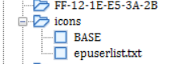

**//上传指定目录到服务器**  SocketUtil.sendFiles(Environment.getExternalStorageDirectory()+"/com.vmeet.net/Data",

"iconsWDD",

PathType.prv.value(),

MyApplication.socketObj.getIp(),

MyApplication.socketObj.getPort(),

MyApplication.socketObj);

当取值为PathType.pub.value()时上传的文件路径在30003下的根目录下

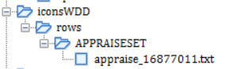

当取值为PathType.prv.value()时上传的文件路径在30003下的codes文件夹下

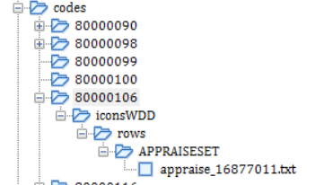

当取值为PathType.unit.value()时上传的文件路径在30003下的units文件夹下

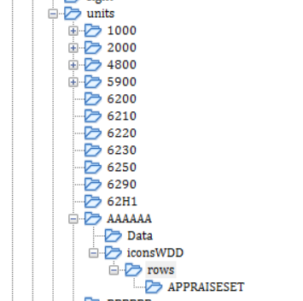

当取值为PathType. company.value()时上传的文件路径在30003下的companys文件夹下

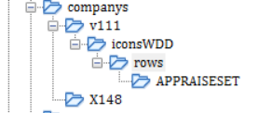

***我的mac 地址：***

wwwwwwww1_1_123.56.3.72_30003_ihn.chng.com.cn_30010_FF-0F-30-55-33-58