Test

Function: Admin add a new dish, so that update the configuration of the system
Input: dish information (including pictures)
Expected output: the dish inserted be presented on customer main page and be available for customers
Test result:
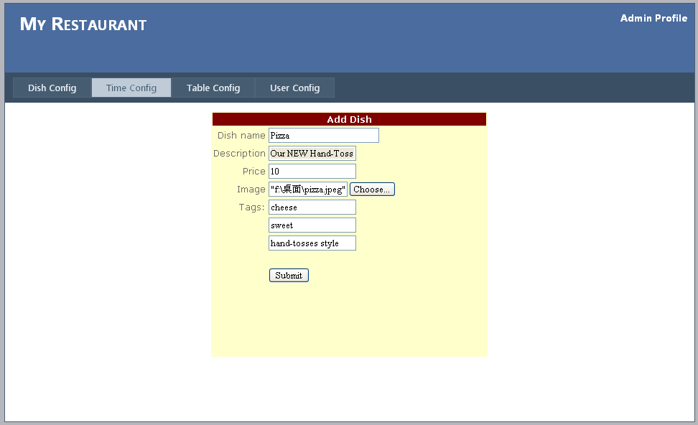

In customer profile: This new dish is added successfully.
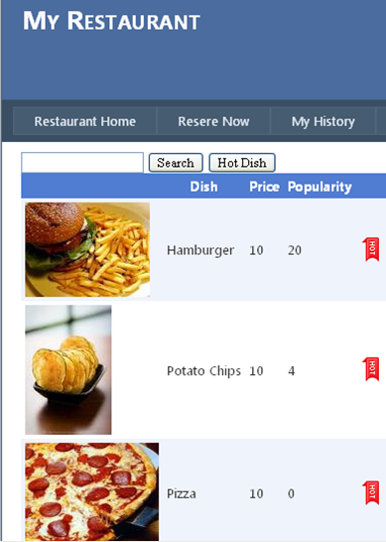

Function: Admin change the business time
Input: a time
Expected output: time should be presented for customer to choose
Test result:
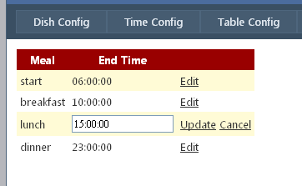

Function: Admin add the information of a table
Input: a table information
Expected output: table information be updated, is presented in customer profile
Test result:
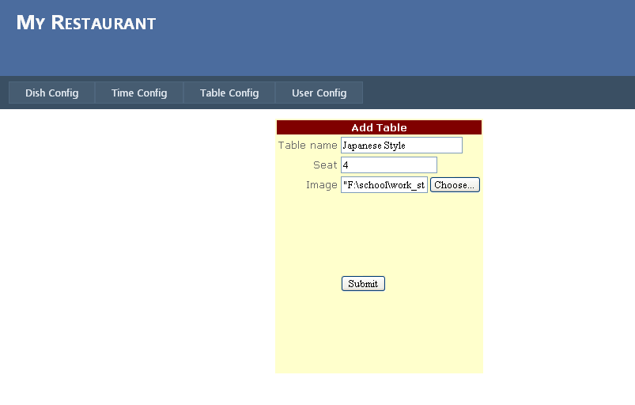
New table information added successfully
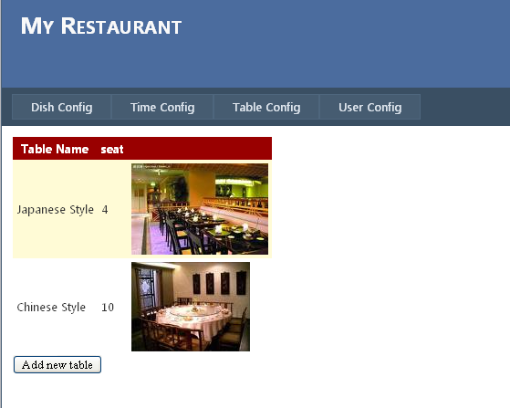

In customer profile: this table is now available
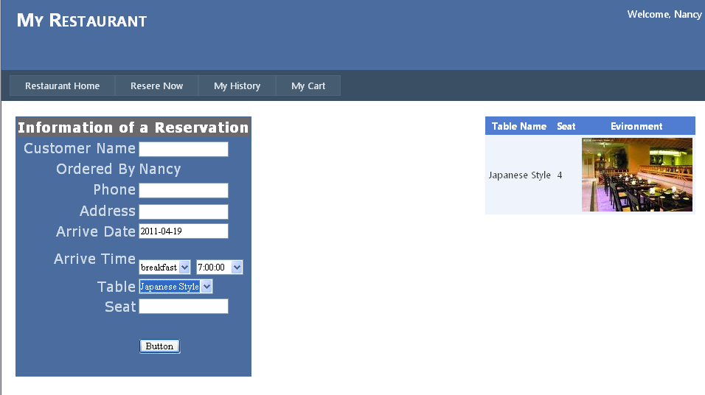

Function: search user
Input: keyword = ia
Expected output: All the records whose name contains the string "ia"
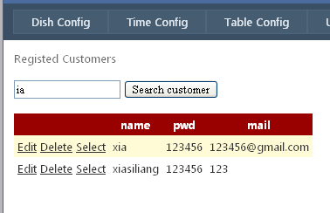

Function: Admin edit the information of a user
Input: information of an user， mail = Nancy@mail.com
Expected output: table information is updated in database
Test result:
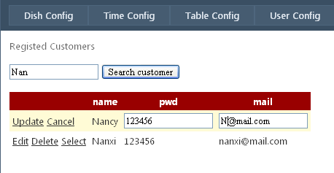

Record is updated
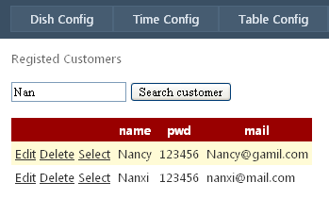

Function: Admin assign a new manager of the restaurant
Input: information of the new manager
Expected output: manager record is inserted into database, and be updated in view
Test result:
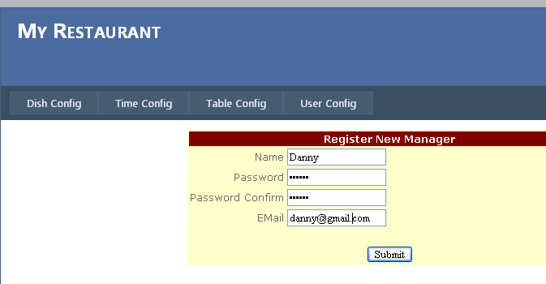

The new manager item I presented in records
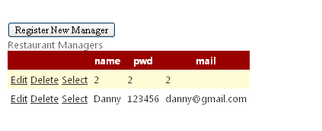

Function: Customer login
Case 1
Input: name=Nancy, password=123456
Expected output: login succeed
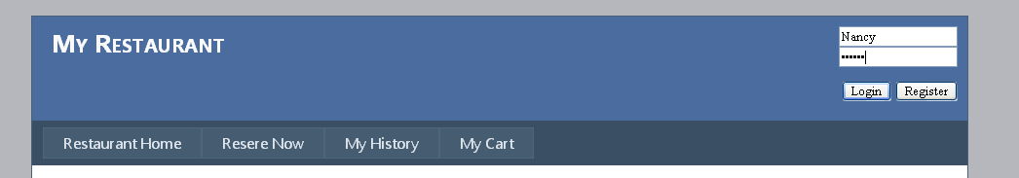

Login successfully
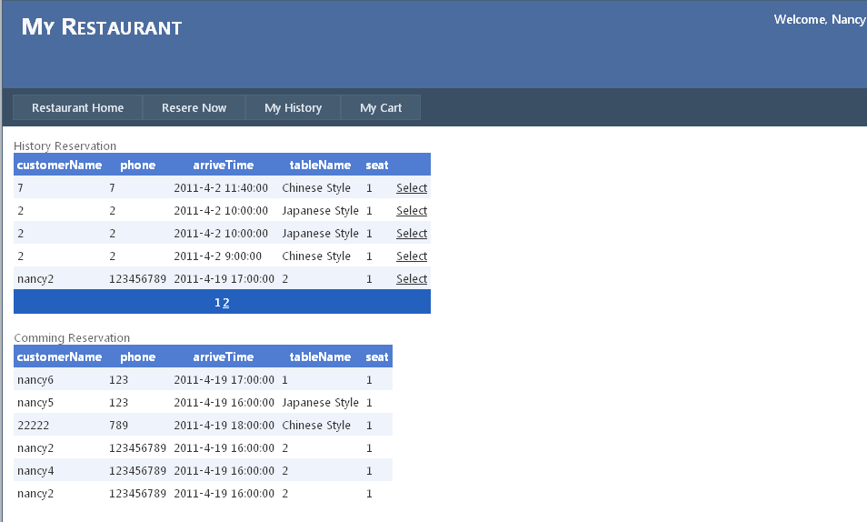
Case2
Input name=Nancy, password=1234
Expected output: login fails
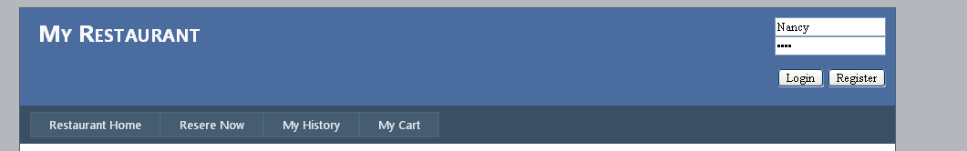

Error information:
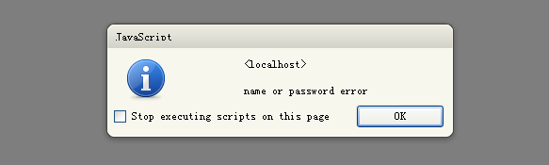

Function: name auto complete
Input: first three characters of user name
Expected Output: list of name begin with the input
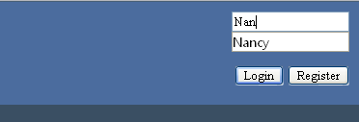

Function: customer reserve a meal in restaurant
Case 1:
Input time=2011-04-21 7:00 table number=1
Output:
all tables should available,
Time available in dropdownlist should be in the collection {7:00, 8:00, 9:00,10:00}
this reservation should be inserted into database
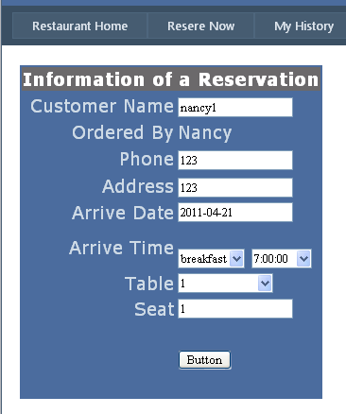

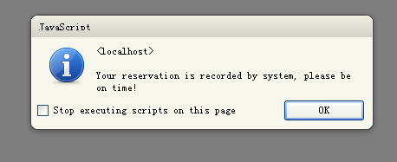
Case 2
Input time=2011-04-21 9:00 table number=2
Output: table ‘1’ should be excluded from the available table
In the same duration with another reservation, the table Japanese Style is not available now yet.

Test Result: success
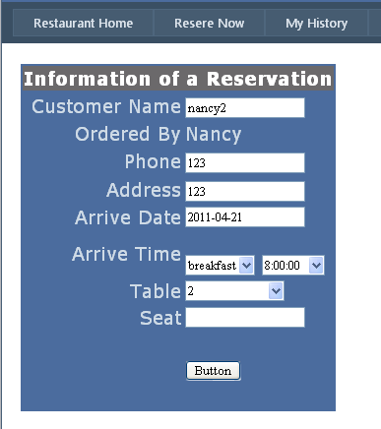

Function: add dishes to shopping cart
Input: click the button to add to shopping cart
Output: success information
Dish should be added to shopping cart and will be presented when customer check his shopping cart
Test Result:
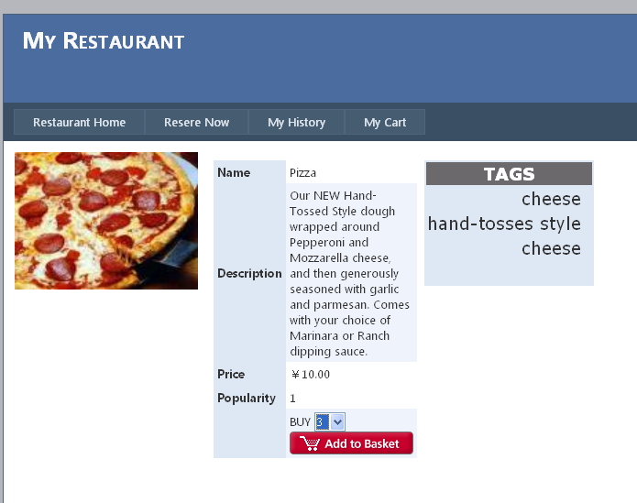

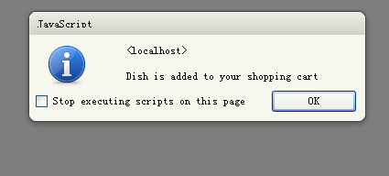

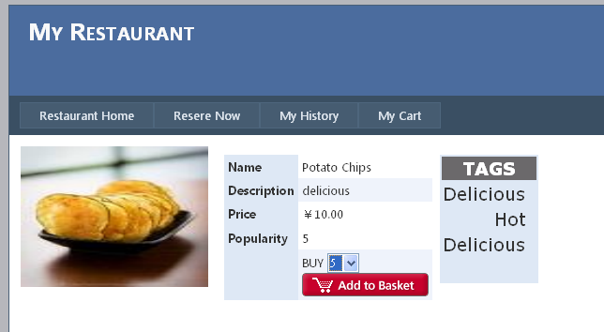

Shopping cart information:
Two items have been added successfully
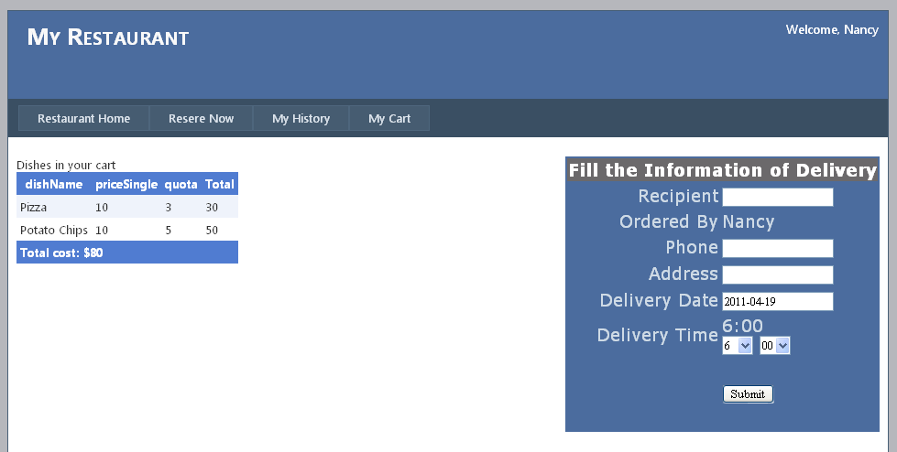

Function:
Tags popularity and dishes popularity are updated when clicked by customer
Input: click the tag and dish
Expected: Output: the popularity increase by 1
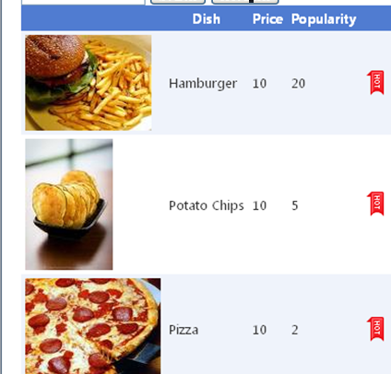

Pizza After being clicked, the popularity increased by 1:
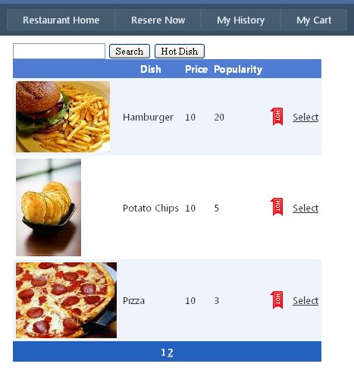

Function: recommended hot tags and dishes
Input: none
Expected Ouput: hot tags list order by popularity
Hot dish list order by popularity

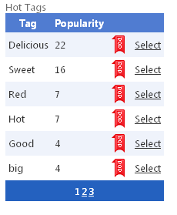
Hot dishsh
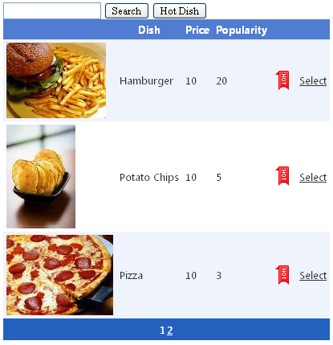

Function: search Dish
Input: search keyword
Output: dishes whose name or description contains the keyword
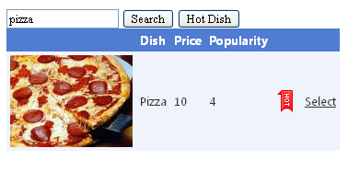

Function: Customer view history
Input: click link My History
Output: all the history of this certain customer

Function Show the state of all tables
Input: current time = 16:05
Reservation 1 arrive time = 16:00, table name=1
Reservation 2 arrive time = 17:00, table name= 2
Expected output: table #1state = TIMEOUT
table #2 state = RESERVED
Other table state = AVAILABLE

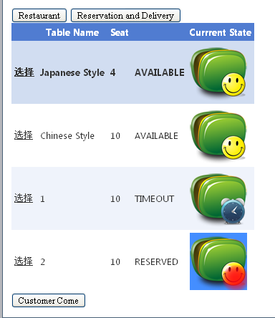

Function: Manager indicate the customer with a reservation comes
Input: table name = 2, click button Customer Come,
Expected output: table #2 state turn to BUSY from RESERVED
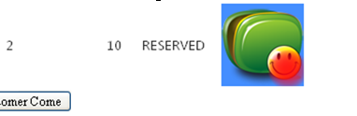

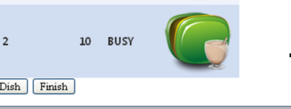

Function: Manager add a dish to a table
Input: table name = click dish=pizza and amount=3
Expected output: dish be added to the reservation in this table, and be presented in table details.
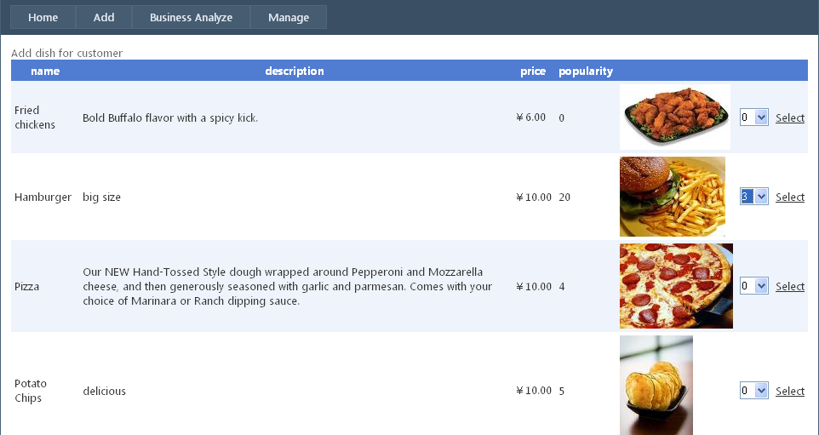

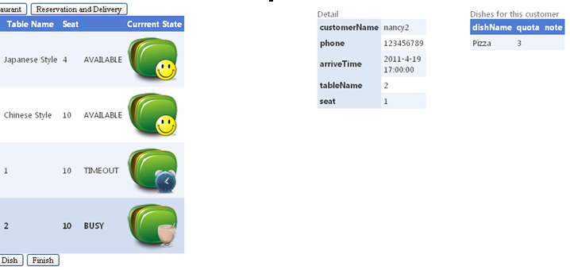

Function: Manager finish the meal in a table
Input: select table Japanese Style, click the button Finish
Expected Output: redirect to the page of the bill generated in this table and the table state turn to AVAILABLE
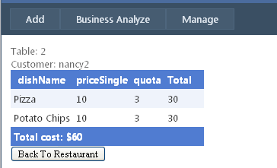

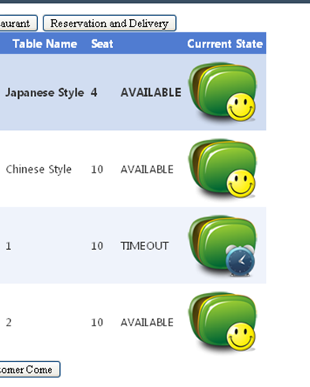

Function: assign a table to a customer without reservation
Input: click the button Customer Come
Expected output: table state turn to BUSY
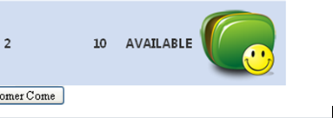

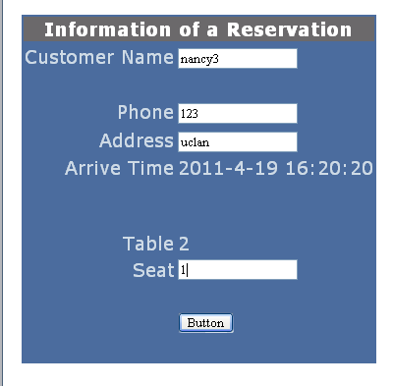

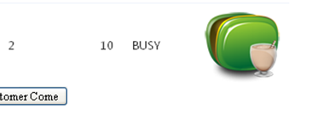

Function: Cancel the timeout reservation
Input: select a timeout reservation, click the button Cancel
Output: the reservation delete from the TIMEOUT list
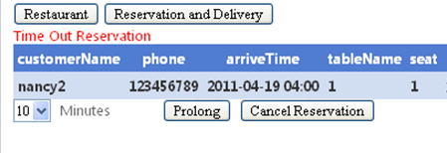

Function: Manager set a delivery delived
Input: select a delivery customer name = nancy, click the button Delive
Expected output: the delivery is delete from the list and state turn to DELIVED
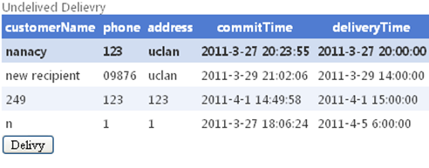

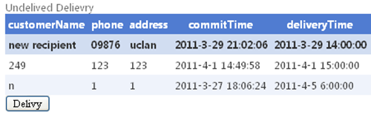

Function: Auto check the RESERVED and TIMOUT reservation
Auto check the TIMEOUT and UNDELIVED delivery
Input: current time = 17:15
Reservation case 1: customer name = nancy5, arrive time = 16:00
Reservation case 2: customer name = nancy6, arrive time = 17:00
Delivery case 1: customer name = nancy8, delive time = 17:10
Delivery case 2: customer name = nancy9, delive time = 17:30

Output: All the reservation and delivery matching the condition
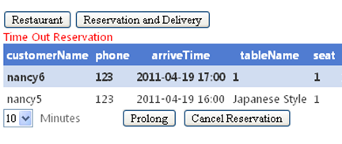
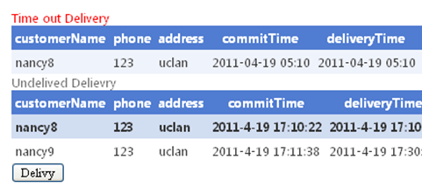

Function: History of search of a customer
Input: keyword of user name, keyword = Nancy
Expected Output : records of the history whose name absolutely match the keyword
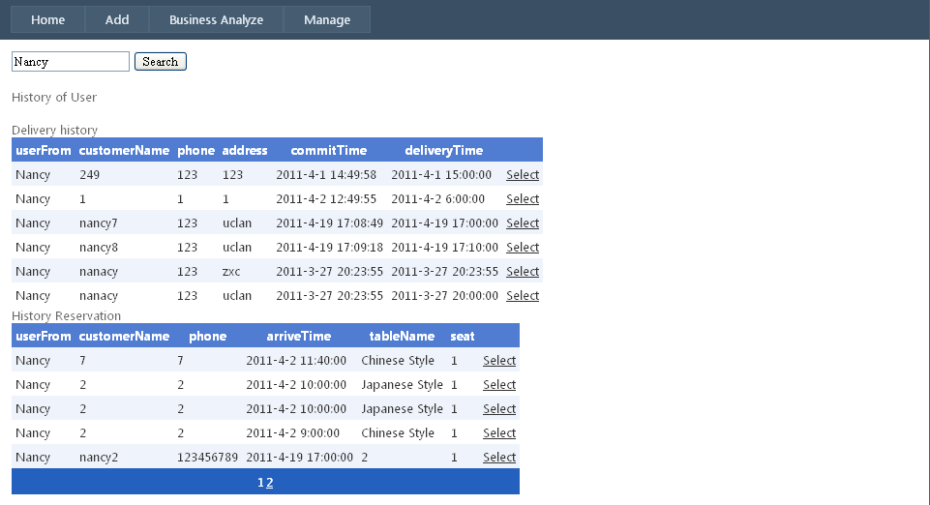

Function: Current reservation search
Input: keyword = 2
Expected Output : records of the history whose name or phone contains keyword

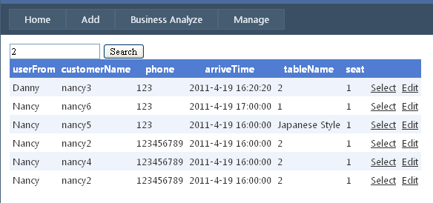

Function： publish news
Input: title = Pizza is available, content = Today, our restaurant is serving pizza~
Expected output: In customer profile, this news is presented
Result: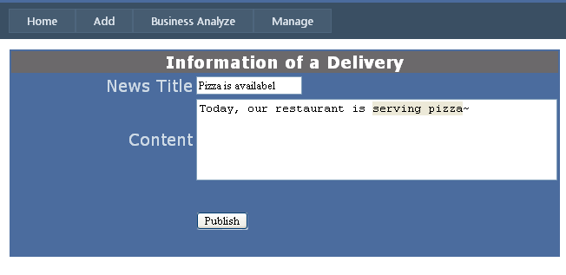
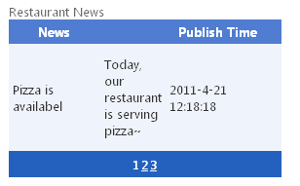

Function: Daily analyze
Input: click the daily analyze button
Output: table contain the dishes sold today, classified into two categories: reservation and delivery. And total business income today.
