**Ve270 Introduction to Logic Design Homework 1**

**Assigned: May 14, 2020**

**Due: May 21, 2020, 2:00pm.**

**A pop quiz will be given on the due date.**

1. Fill out the blank spaces, assuming unsigned numbers. Show steps to earn partial credits. (8 points)

11011101.001 2 = ________________10 = ___________________16

63.89 10 = __________________2 = ___________________8 = ____________________3

1. Fill out the blank spaces, assuming 2’s complement numbers. (16 points)

-7110 = __________________________2 = _______________16

7110 = ____________________________2 = ________________16

101101011012 = _______________10

FBA916= ____________________________2 = ______________________10

1. Perform the following arithmetic operations step by step, assuming 2’s complement numbers: (12 points)

(6FA49D + 73BD) 16 =

(10100 – 10101001) 2 =

(534 – 265) 8 =

1. Problem 2.14 (Boolean equation = logic equation) (4 points)
2. Problem 2.16 (10 points)
3. Problem 2.19 (10 points)
4. Problem 2.20 (10 points)
5. Problem 2.35 (10 points)
6. Build a truth table for the following circuit. (10 points)

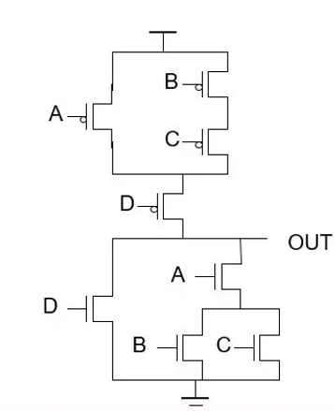

Vdd

1. Given a logic equation F = a’bc’ + b’c + abc, draw an output waveform for F based on the given input waveforms. (10 points)



a

F

c

b