**Ve270 Introduction to Logic Design Homework 4**

**Assigned: June 4, 2020**

**Due: June 11, 2020, 2:00pm.**

**A pop quiz will be given on the due date.**

***Note****: you may ignore the gate delay when drawing a timing diagram unless required differently.*

1. (10 points) Complete the following timing diagram for an SR latch. Assume Q begins at 1.

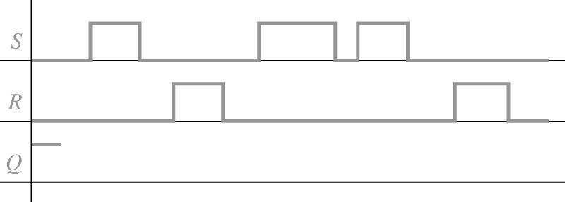

1. (10 points) Complete the following timing diagrams for a gated D latch. Assume Q begins at 0.

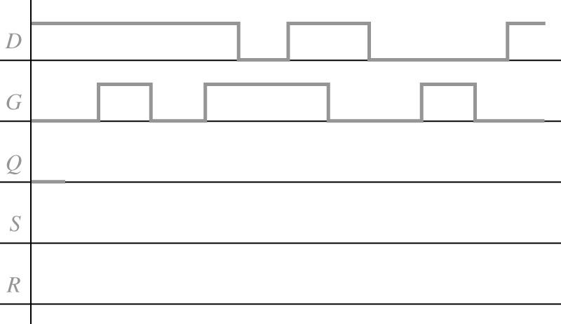

1. (10 points) Complete the following diagrams for the rising-edge triggered D flip-flop. Assume Q begins at 1.

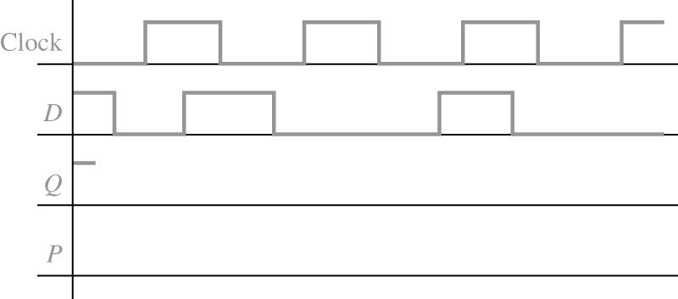

1. (10 points) Fill in the timing diagram below for a falling-edge triggered J-K flip-flop. Assume Q begins at 0.

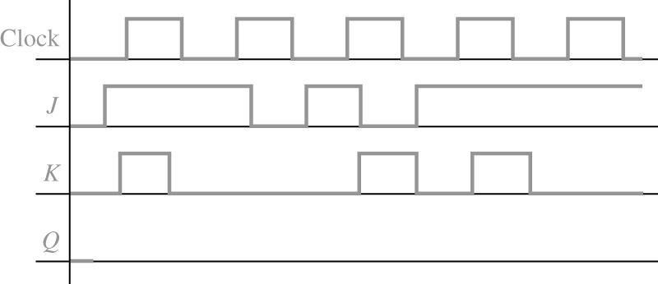

1. (15 points) Fill in the following timing diagram for a rising-edge triggered T flip-flop with an asynchronous active-low preset input (PreN, equivalent to set). Assume Q begins at 1.

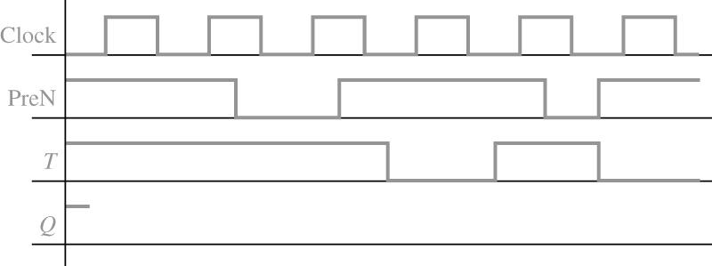

1. (15 points) Design a 4-bit register with an enable signal “REV”, such that when REV = 1, content of the 4-bit register is reverse (e.g. 1011 becomes 1101), and when REV = 0, the register works as normal.
2. (15 points) Problem 3.19. Draw schematic.
3. (15 points) Problem 3.20.

