2.

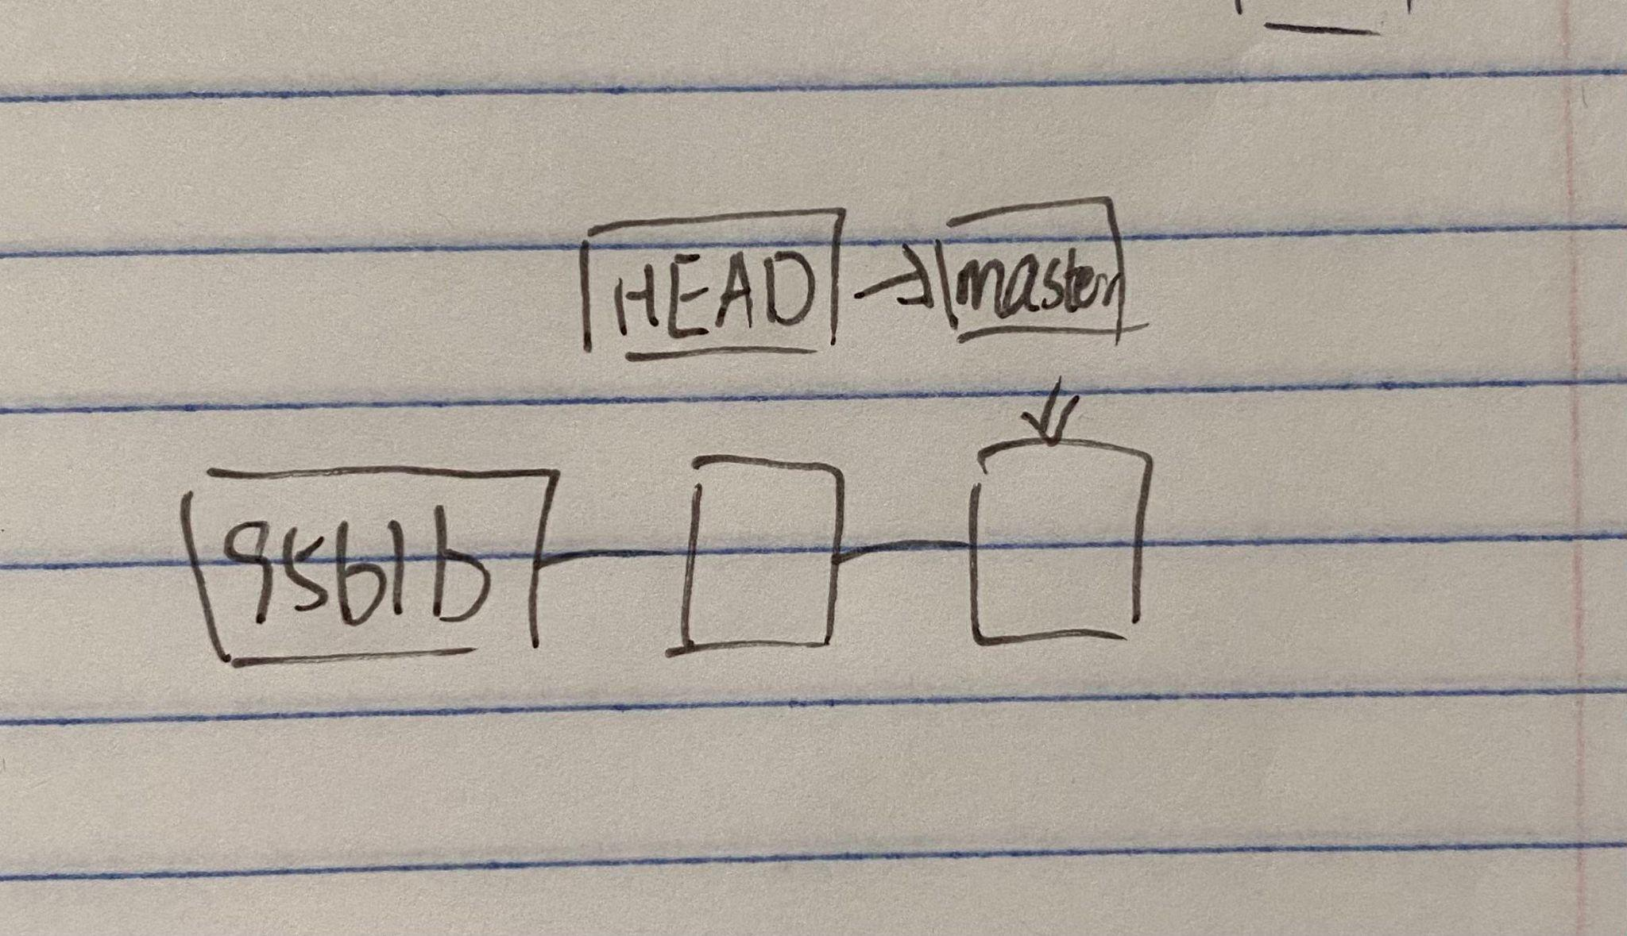

3.

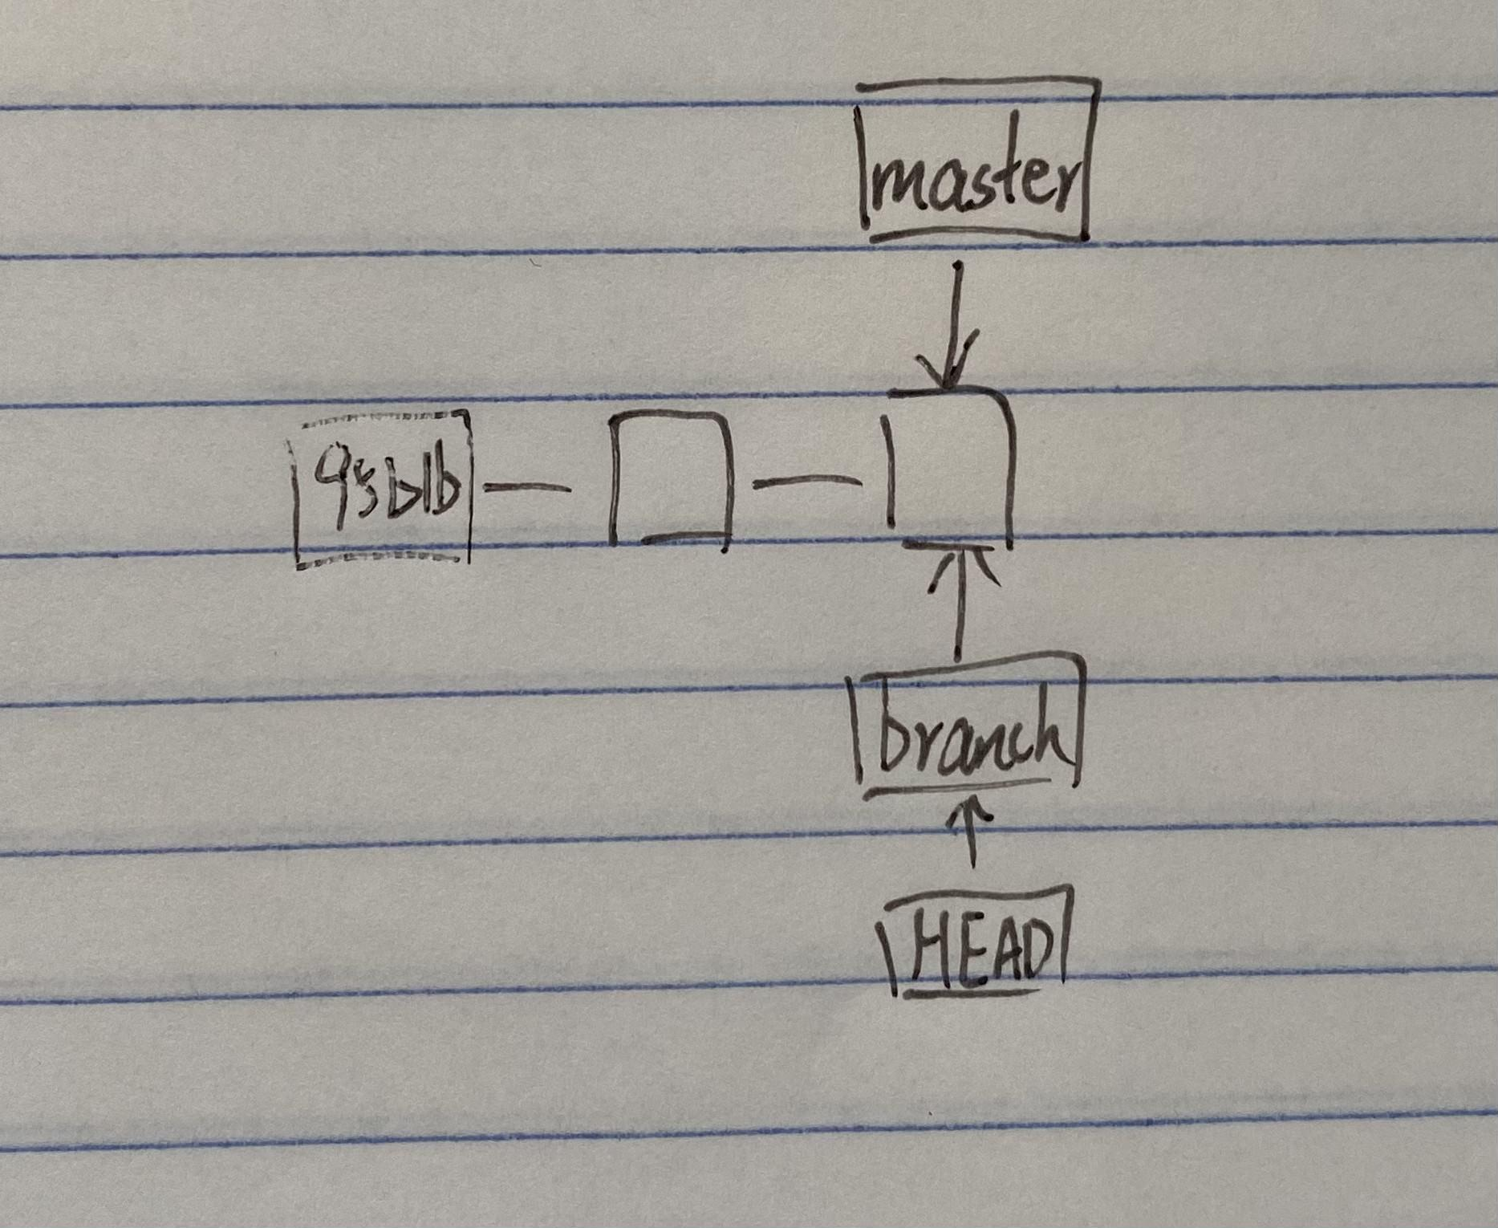

4.

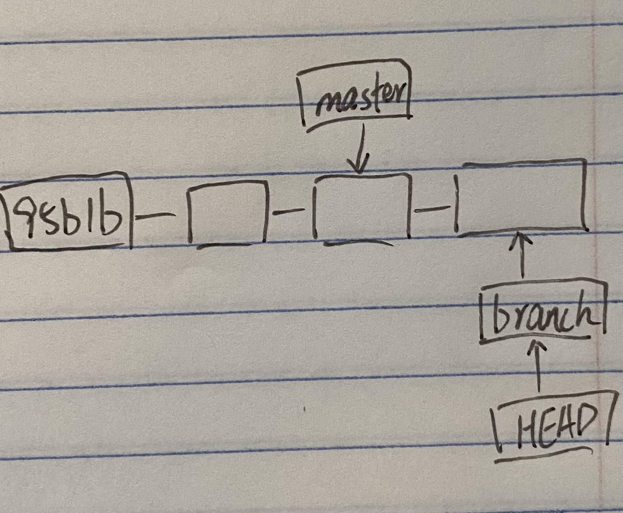

5.

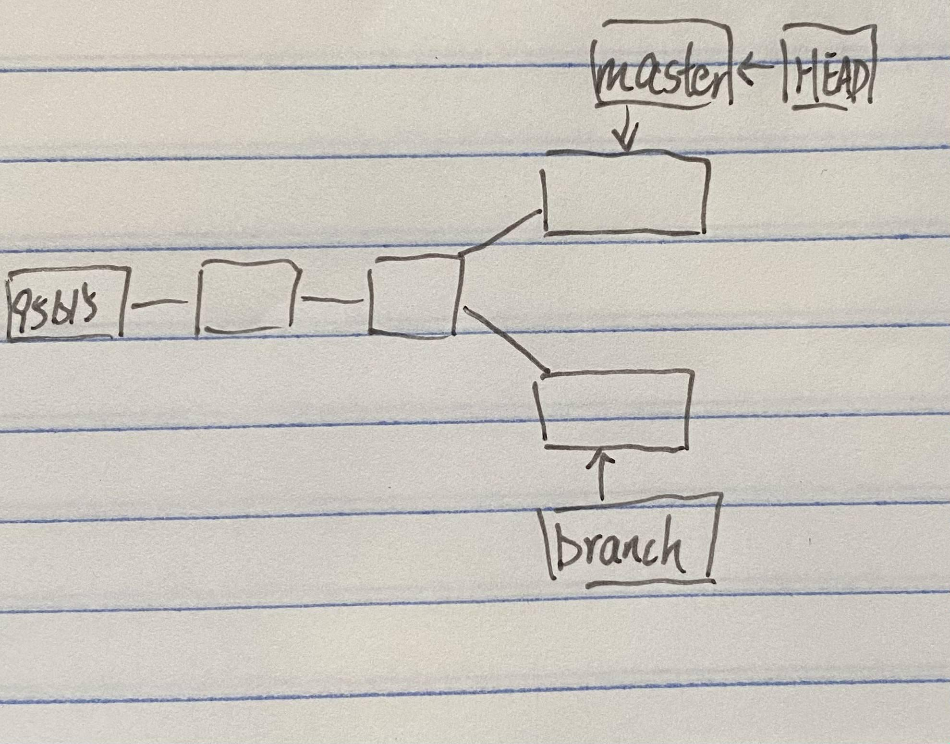

| situation | Git command | Resulting repo states |
| --- | --- | --- |
| Merge master into my-feature | Git checkout my-feature  Git merge master | Master pointer points to C4 |
| Make another commit on my-feature | Git checkout my-feature  Git add .  Git commit | My-feature points points to next block of c4 |
| Push you local change to my-feature to remote | Git push -u origin myfeature | Head points to updated my-feature pointer |
| Pull remote master into local master | Git checkout master  Git pull | Head points to latest master pointer |
| Merge my-feature branch into master | Git merge my-feature | My-feature points to the same node as master points to |

Pull request link

https://github.com/CSCI-3010-CUBoulder/Fall21_Section3_Team4/pull/2