1. df –h

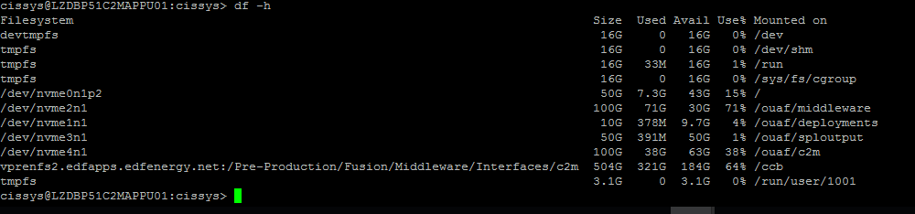

sar | sed s/%/#/g

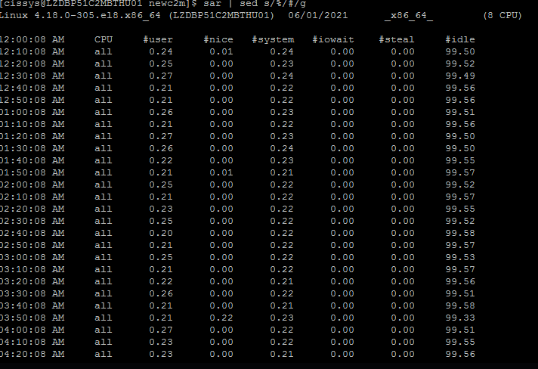

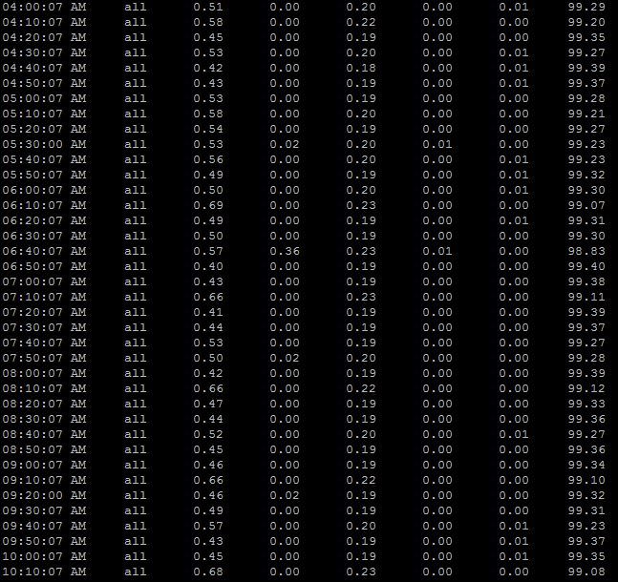

/sbin/sysctl .a

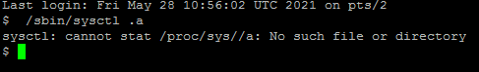

cat /proc/meminfo

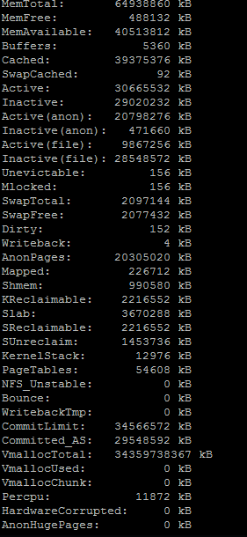

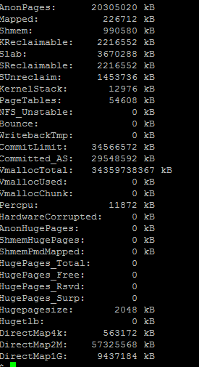

cat $SPLEBASE/etc/conf/service/hibernate.properties

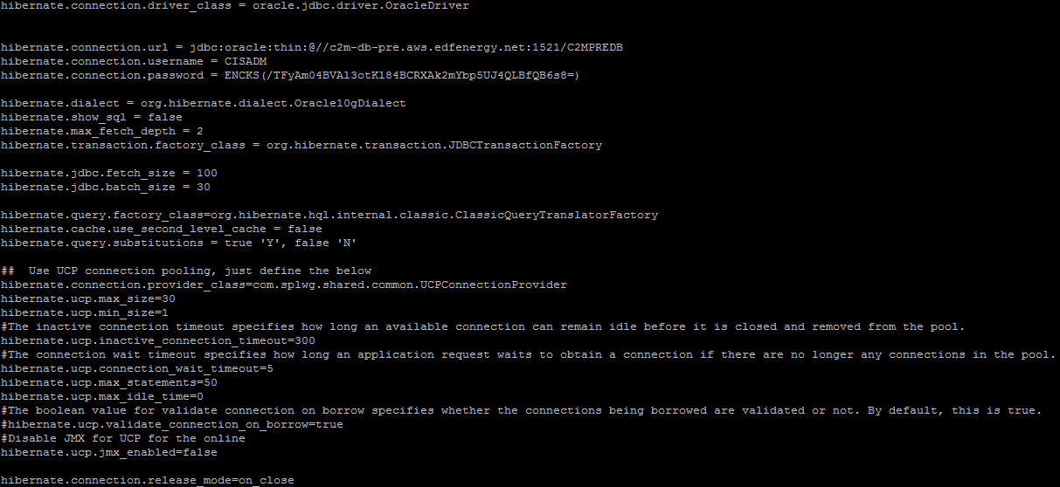

cat $SPLEBASE/splapp/standalone/config/hibernate.properties

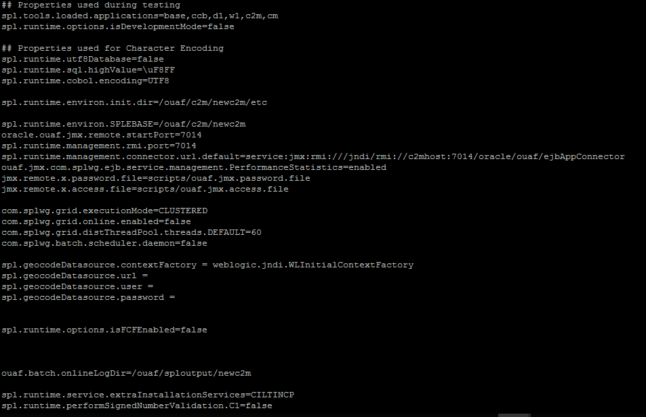

cat $SPLEBASE/splapp/standalone/config/threadpoolworker.properties

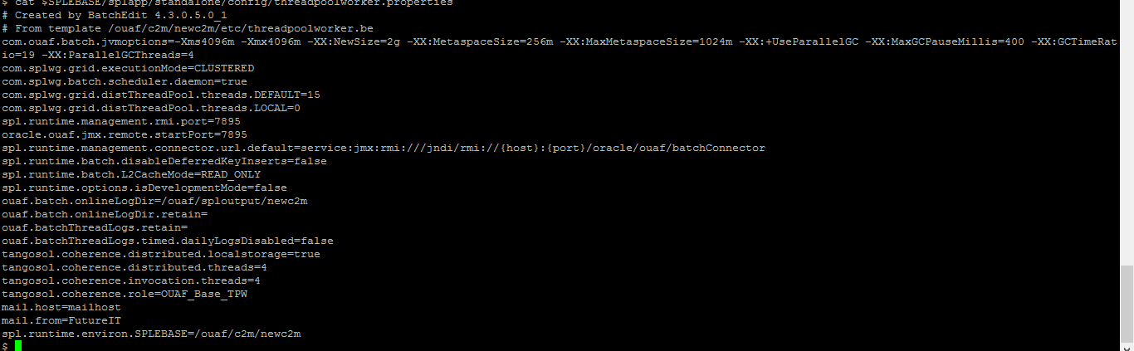

cat $SPLEBASE/splapp/standalone/config/submitbatch.properties

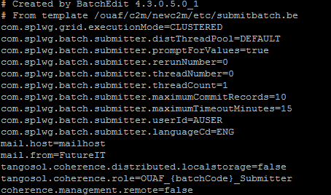

lscpu

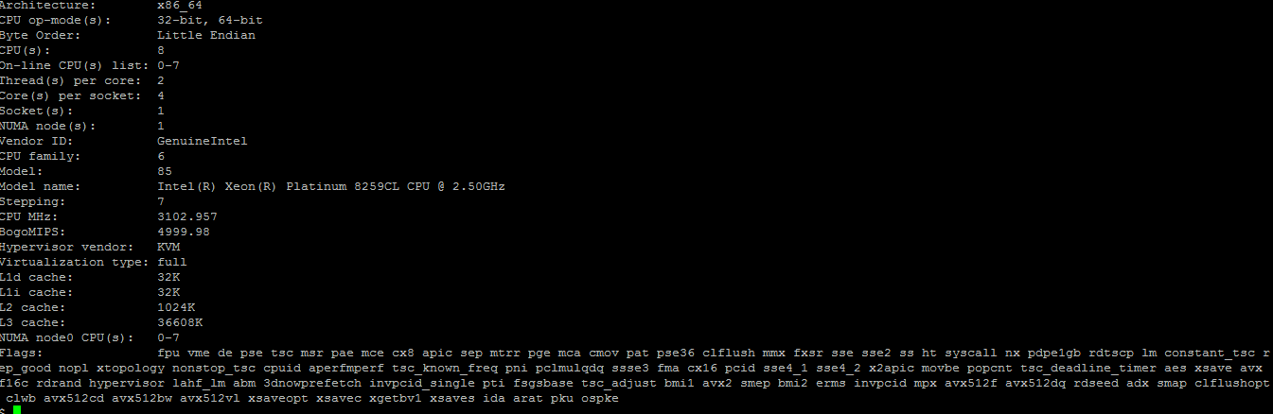

uname – a

