Supplementary Material

Risk Adjustment for ADRD in Medicare Advantage and Health Care Experiences

Supplementary eMethods
- eMethods 1: Difference-in-Differences Model
- eMethods 2: Event Study Model
- eMethods 3: Robustness Checks
- eMethods 4: Placebo Test
- eMethods 5: Compositional Change Test
Supplementary eFigures and eTables
- eFigure 1. Exclude MA ADRD Beneficiaries with Self-Response
- eFigure 2. Exclude MA Beneficiaries Under 65
- eFigure 3: Adjust for Dual-Eligible Status
- eFigure 4. Using Balanced Repeated Replications Method
- eFigure 5. Exclude Beneficiaries in Current MA Plan for Less than 3 Years
- eFigure 6: Include Partially Covered MA Beneficiaries
- eFigure 7: Sensitivity Test to Alternative Control Group
- eFigure 8. Using MA Beneficiaries with All non-ADRD Conditions as Control Group
- eFigure 9. Placebo Tests Using Other Conditions as Negative Control Group
- eFigure 10. Placebo Tests Using FFS Beneficiaries
- eFigure 11. Stratification Analysis
- eFigure 12: Test for Compositional Change
- eFigure 13: Test for Compositional Change - Event Study
- eTable 1: Summary of Care Experiences by Treatment and Over Time
- eTable 2: Summary of Care Experiences by Treatment
- eTable 3: Dynamic Association between the Inclusion of ADRD HCCs in Payment Model and Care Experiences (Event Study)
- eTable 4: Summary Statistics for Robustness Check using All Conditions as Control Group
- eTable 5 – eTable 19: Summary Statistics for Placebo Test using Other Conditions as Negative Control Group
- eTable 20: Summary Statistics for Placebo Test using FFS Beneficiaries

Supplementary eMethods

eMethods 1: Difference-in-Differences Model
We employ a DID model to exploit the inclusion of ADRD HCCs in the risk adjustment model for MA plans in 2020 as a quasi-natural experiment. This model compares care experiences between a treatment and a control group before and after the 2020 policy change.
The treated group is defined as MA enrollees who reported having ever been told they have symptoms of ADRD. To construct a comparable control group, we select MA enrollees who: (1) had never been diagnosed with ADRD, and (2) had been diagnosed with conditions such as stroke or brain hemorrhage, complete or partial paralysis, or Parkinson’s disease. The selection criteria are grounded in the rationale that patients with these conditions are also likely to see neurologists like those with ADRD. This parallel in healthcare pathways allows for a more equitable comparison, ensuring that differences observed can be more confidently attributed to the effects of the ADRD HCCs integration into the risk adjustment model.
Formally, we build a regression model as outlined in Equation (S.1) below.
$y_{it}= β_{0}+β_{1}treated_{it}×post_{t}+β_{2}treated_{it}+γX_{it}^{'}+α_{t}+ϵ_{it}$, | (S.1)
where $y_{it}$ represents the care experience measure for beneficiary $i$ in year $t$. The binary variable $treated_{it}$ indicates whether individual $i$ is classified as treated, as defined above. The binary variable $post_{t}$ takes the value of one for the years following the policy change (2020 and later), and zero otherwise. In a DID framework, the coefficient of the interaction term $treated_{it}×post_{t}$, $β_{1}$, captures the association between the inclusion of ADRD HCCs in the risk adjusted payment model and the care experience of MA beneficiaries with ADRD. A positive $β_{1}$ implies a position association. We apply robust standard errors in the analysis.
To reassure the estimated ${\hat{β}}_{1}$ unbiasedly measures the association of interest, rather than confounded by other unobserved factors, a critical assumption is that, in the absence of the payment model change, the evolution of the outcomes of interest for the control and treatment groups would have followed a similar trajectory over time. This assumption, commonly known as the parallel-trends assumption, is fundamental to the validity of the DID design. It enables the use of the control group’s outcomes as a reliable counterfactual for the treated group.
A notable threat to the parallel-trends assumption is the possibility that the estimated ${\hat{β}}_{1}$ may pick up confounding effects from some concurrent events, such as the onset of the COVID-19 pandemic in early 2020. To address this concern, we undertake several methodological adjustments. First, we include year fixed effects ($α_{t}$) to absorb national-level shocks and contemporary events. Additionally, to account for potential heterogeneous pandemic impacts across subpopulations, we incorporate several interaction terms in $X_{it}^{'}$. These include:
(1) interactions between demographic covariates and year indicators, where the demographic covariates encompass age categories, marital status, race/ethnicity, sex, educational attainment, and household size.
(2) the interactions between each health measure and each year indicator, where the health measures include number of functional limitations, number of chronic conditions, and BMI categories.
Our model with these interactions provides greater non-parametric flexibility in accounting for potential heterogeneous exposure to the pandemic, thereby enhancing the robustness of our estimates.
Another potential concern is measurement error arising from proxy reporting, as approximately 27% of the study sample comprises proxy respondents (Table 1). To mitigate the effects of such measurement errors, we include interactions between the self-respondent indicator and all previously described covariates, as well as each time indicator. These interactions allow for a more flexible adjustment, accounting for potential heterogeneity in the patterns and accuracy of proxy reporting.
Moreover, we conduct an event study model, detailed in Supplementary eMthods 2 to provide suggestive evidence for the parallel-trends assumption.

eMethods 2: Event Study Model
We conduct an event study analysis using Equation (S.2) to provide suggestive evidence for the parallel-trends assumption underlying Equation (S.1). All variables in Equation (S.2) are defined consistently as those in Equation (S.1).
$$y_{it}= β_{0}^{''}+\sum_{j=2015, j≠2019}^{2022}{ζ_{j}treated_{it}×I\left\{t=j\right\}}+β_{2}^{''}treated_{it}+γ^{''}X_{it}^{'}+α_{t}+ϵ_{it}^{''}$$ | (S.2)
In the equation above, $I\left\{t=j\right\} (2015≤j≤2022, j≠2019)$is an indicator function. For instance, $I\left\{t=2020\right\}$ takes the value of one if year is 2020 and otherwise zero. We interact the treatment group indicator, $treated_{it}$, with each year indicator, $I\left\{t=j\right\}$. The year 2019, the last year before the implementation of the new risk-adjusted payment model in 2020, serves as the reference year. The coefficient $ζ_{j}$ measures the association between the 2020 revised risk adjusted payment model with MA beneficiary’s care experience in year $j$.
This analysis serves two primary purposes. First, if ${\hat{ζ}}_{j}$ ( $j≤2018$ ) is statistically insignificant, it provides suggestive evidence supporting the parallel-trends assumption, meaning that in the absence of the 2020 payment model revision, the evolution of care experience among MA beneficiaries with ADRD would follow a parallel trajectory to that of the control group after 2019. Second, if ${\hat{ζ}}_{j}$ ( $j≥2020$ ) is statistically significant, it indicates the dynamics of the association between the revised payment model and care experience in the post-revision period. In Figure 4, the ${\hat{ζ}}_{j}$s are plotted with their associated 95% CIs.

eMethods 3: Robustness Tests
We performed multiple robustness tests. In eFigure 1, we excluded self-respondents with ADRD; the estimates were unchanged, showing that our results are less confounded by self-reporting bias among MA beneficiaries with ADRD. Our results are robust to the exclusion of MA beneficiaries under 65 in eFigure 2, and the adjustment of dual-eligible status in covariates in eFigure 3. Our results are also robust to alternative standard error calculations using balanced repeated replications in eFigure 4.
Robustness Test: Addressing Plan-Switching Behavior
We are also concerned about the plan-switching between MA and FFS potentially driven by risk adjustment. On one hand, the care-experience questions in MCBS reference experiences over the prior year; limiting to full-year MA enrollees ensures that reported access and affordability correspond to a stable and well-defined MA exposure window, rather than a mix of MA and traditional Medicare plans within the reporting period. Though our baseline sample requires beneficiaries enrolling in current MA plan for at least one full year, as a robustness check in eFigure 5, we restricted the sample to beneficiaries continuously enrolled in MA plans for at least 3 years, again yielding consistent results.
One the other hand, enrollment in MA is not random, and prior evidence has suggested an increasing rate of dementia diagnoses in MA beneficiaries who are Hispanic or Black, dual-eligible, or received low-income subsidies following the 2020 payment model change. Thus, restricting the analytic sample to full-year MA enrollees could therefore introduce selection if enrollment is correlated with care experiences, differs by ADRD status, or changes around the 2020 policy implementation. To address this concern, in eFigure 6, we expanded our sample by including MA beneficiaries who are enrolling in their current MA plan for less than one year. In this expanded sample, we continue to observe a statistically significant reduction in any trouble getting needed care. Estimates for the remaining outcomes are attenuated and less precisely estimated. This attenuation pattern could be due to heterogeneity in treatment classification brought by the partial-year MA covered beneficiaries. To be more specific, partial-year MA enrollees experiences both MA and FFS plans within the same survey period. Mid-year switching can mechanically change beneficiary’s exposure to benefit design, provider networks, cost-sharing, and care management intensity during the survey reference period. Thus, beneficiaries’ reported care experience reflects both a mixture of both plan environment. For instance, with partial-year MA, a beneficiary may spend part of the year in MA and part in FFS (or vice versa). These groups are more heterogeneous because of different timing of plan switching, different exposure to MA plans, different reasons for switching, etc. This heterogeneity likely weakens statistical power and the mapping between policy-relevant MA exposure and patient-reported experiences, which tends to pull our estimates toward the null.
Sensitivity Test: Alternative Control Group Constructions
We perform various tests to assess the sensitivity of our results to alternative control group constructions. Among the 3,715 MA beneficiaries in the baseline control group, 47 have Parkinson disease (PD), 1,039 have complete/partial paralysis, and 3,071 have stroke/brain hemorrhage (these categories are not mutually exclusive, so counts do not sum to the total). Conceptually, PD is neurodegenerative and shares some common clinical features with ADRD, However, in our sample PD constitutes a very small share of the control group (47 individuals), making it unlikely to drive baseline differences or the DID estimates.
In practice, we note that MA beneficiaries with stroke are our preferred neurological control group for MA beneficiaries with ADRD for the following reasons. (1) Beneficiaries with stroke/brain hemorrhage represent the largest component of the control group in our analytical sample. (2) Biologically, existing literature has linked cerebrovascular disease and clinical stroke to cognitive impairment and dementia and highlights the shared vascular pathways contributing to later-life cognitive decline between stroke and AD (Snyder et al., 2015; Anderle et al., 2025). Clinically, stroke survivals also have intensive and longitudinal healthcare needs (Hong et al., 2019) and frequently engage in ongoing specialist follow-up and chronic disease management (and often have cognitive sequelae), which makes their access-to-care and care-experience patterns more likely to move with MA network management and referral processes in ways that are comparable to ADRD-related care needs.
To test if our results are sensitive to the composition of our control group, we re-estimated our DID and event study models using alternative control group definitions and report results in eFigure 7.
- Dropping PD from the control group: Results are substantively unchanged. The DID estimates remain negative and statistically significant for (i) any trouble getting needed care ($β$ = −0.068, 95% CI −0.113 to −0.022, $p$ = 0.004) and (ii) any medical financial burden ($β$ = −0.092, 95% CI −0.161 to −0.023, $p$ = 0.0086). Estimates for satisfaction outcomes are similar in direction and remain statistically indistinguishable from zero (specialist access: $β$ = 0.040, 95% CI −0.0053 to 0.085, $p$ = 0.084; quality of care: $β$ = −0.013, 95% CI −0.056 to 0.029, $p$ = 0.544). This indicates the primary findings are not driven by PD beneficiaries.
- Stroke/brain hemorrhage control group. Results remain qualitatively consistent with the main findings. We continue to observe a negative association between the 2020 payment model change and (i) any trouble getting needed care ($β$ = −0.055, 95% CI −0.102 to −0.009, $p$ = 0.020) and (ii) any medical financial burden ($β$ = −0.093, 95% CI −0.163 to −0.022, $p$ = 0.0101), respectively. The associations for satisfaction outcomes remain imprecisely estimated (specialist access: $β$ = 0.028, 95% CI −0.0183 to 0.074, $p$ = 0.239; quality of care: $β$ = −0.025, 95% CI −0.069 to 0.018, $p$ = 0.259). These estimates are close to the baseline results, supporting robustness to using stroke as a cleaner comparison group.
- Complete/Partial paralysis control group. Estimates are directionally similar for trouble getting needed care (–0.114; 95% CI, –0.185 to –0.043; p=0.002), but are generally less precise for the other outcomes (e.g., medical financial burden becomes statistically insignificant), likely reflecting the smaller sample size and greater heterogeneity in the paralysis group. We therefore view paralysis-only as a less preferred standalone control group and present it as an additional robustness check rather than the primary control group.
Moreover, we also replicated our analysis using a broader control group. This expanded control group includes MA beneficiaries without ADRD but with a broader set of conditions, not just limited to PD, Stroke/brain hemorrhage, and Complete/Partial paralysis. Our results remain robust in eFigure 8.
Overall, these checks indicate that our conclusions—particularly for measures of perceived access barriers and financial burden—are not driven by PD inclusion (which represents a very small fraction of controls) nor by the broader mix of neurological control diagnoses.

eMethods 4: Placebo Tests
We also conduct a series of placebo tests as alternative approaches to support the parallel trends assumption and address the measurement errors described above. The design of these placebo tests involves comparing a group of Medicare Advantage beneficiaries who are not expected to be affected by the inclusion of the ADRD HCC in the risk-adjusted payment model with another group of MA beneficiaries who likewise should not be impacted by the new payment model. Formally, we estimate the following DID model specified in Equation (S.3):
$$y_{it}= β_{0}^{'}+β_{1}^{'}negativeControl_{it}×post_{t}+β_{2}^{'}negativeControl_{it} +γ^{'}X_{it}^{'}+α_{t}+ϵ_{it}^{'}$$ | (S.3)
Equation (S.3) mirrors Equation (S.1), with the primary difference being the definition of the negative control group, denoted as $negativeControl_{it}$. For instance, one illustrative placebo test designates a negative control group, consisting of MA enrollees diagnosed with diabetes/high blood sugar but not ADRD, and a comparison group comprising MA enrollees without either diabetes/high blood sugar or ADRD. Since individuals with diabetes and without ADRD are not the primary target of the policy integrating ADRD HCC into the risk adjustment model, we expect to observe a statistically insignificant ${\hat{β}}_{1}^{'}$ in this placebo test. This would imply that the 2020 revisions to the risk-adjusted payment model are not statistically associated with improved care experiences for non-ADRD MA beneficiaries with diabetes/high blood sugar. Conversely, if we observe a significant ${\hat{β}}_{1}^{'}$, it suggests that our benchmark analysis using Equation (S.1) likely picks up confounding bias from concurrent events such as the onset of the COVID-19 pandemic in 2020 or any potential proxy-response bias.
This approach is then extended to a series of placebo tests, with each negative control group focusing on a distinct health condition, including hypertension or high blood pressure, myocardial infarction (MI)/heart attack, stroke or brain hemorrhage, osteoarthritis or soft bones, congestive heart failure, emphysema/asthma/COPD, and complete or partial paralysis. The full list of chronic conditions serving as placebo-treatment groups is displayed along the horizontal axis in eFigure 9. In this figure, each coefficient of association, along with its corresponding 95% confidence interval, is derived from the results of a specific placebo test. Most coefficients were near zero and statistically insignificant, indicating no spurious associations between the revised payment model and care experience measures.
We replicated the baseline DID design in an FFS sample as another placebo test, using FFS beneficiaries with ADRD as the negative control group and FFS beneficiaries with other neurological conditions (stroke, paralysis, Parkinson’s) but not ADRD as the comparison group. In eFigure 10, we compared FFS beneficiaries with ADRD to FFS beneficiaries without ADRD but with stroke, paralysis, or Parkinson’s disease, finding no significant associations. These placebo results suggest that our main findings are unlikely to be driven by unobserved confounding differences across diseases.

eMethods 5: Compositional Change Test
A central challenge in our study is distinguishing changes attributable to the 2020 payment policy from compositional change in MA beneficiaries with ADRD around the time of policy implementation. For instance, if the 2020 risk-adjusted payment model policy induced people with severe disease burden to switch to MA plans, this compositional change is likely to undermine the interpretation of our estimation.
In direct response to this concern, we have also performed a series of robustness tests on compositional change using the same DID and event study designs as in our primary analysis. The treatment group consisted of MA enrollees with ADRD, while the control group comprised MA enrollees without ADRD but with stroke/brain hemorrhage, complete/partial paralysis, or Parkinson’s diseases.
Specifically, we re-estimated our models treating beneficiary demographic and health-status characteristics as outcomes and tested whether they changed differentially over time for MA beneficiaries with ADRD relative to our control group. The list of characteristics we tested includes age group, sex, race/ethnicity, education, marital status, BMI category, IADL/ADL limitations, and number of chronic conditions. We summarized all DID estimates in eFigure 12, in which the plotted estimates represent the coefficients for the interaction term between the treatment indicator and the post indicator from a DID estimation, with the dependent variable indicated on the y-axis. We also present dynamic event study estimates (relative to year 2019) in eFigure 13, where the plotted estimates represent the coefficients for the interaction term between treated indicator and year indicators.
Demographics. eFigure 12 indicates that for most demographic characteristics, including age categories, sex, education, and racial groups (non-Hispanic white, black), the DID estimates are close to zero and statistically indistinguishable from zero with the 95% CI overlapping zero, suggesting limited evidence of broad demographic compositional change in MA beneficiaries with ADRD relative to the control group following the inclusion of ADRD HCC in the payment model. Importantly, the event studies in eFigure 13 show no anticipatory jump or fall from 2019 to 2020 for these characteristics, directly addressing the reviewer’s concern that diagnostic changes may have occurred in the year before the payment model took effect. Moreover, for these characteristics, the post-2020 coefficients are not statistically significant and do not show a consistent pattern indicating a systematic compositional change in our treatment group after the payment model change.
Nevertheless, we do observe statistically significant and positive DID estimates in eFigure 12 and post-2020 coefficients in event studies in eFigure 13 for married share and Hispanic share, suggesting that following the inclusion of ADRD HCC in 2020, there is an increase in married and Hispanic population in the treatment group relative to the control group. Except for these two characteristics, overall demographic profile of our treatment group remains broadly stable across dimensions over years. At the end of this response, we will provide a discussion on these increases in married and Hispanic share bias our interpretation.
Health status and severity proxies. For BMI and IADL/ADL limitation categories, the DID estimates in eFigure 12 are generally small and not statistically significant; eFigure 13 similarly shows no sharp shift from 2019 to 2020 and no systematic post-2020 discontinuity in these measures. These findings are reassuring because functional limitations (ADL/IADL) are particularly salient proxies for severity in this setting.
For comorbidity burden, proxied by number of chronic conditions, eFigure 12 shows modest changes in selected bins (i.e, increase in # chronic conditions: 3-4 and decrease in # chronic conditions: 1), but the pattern is not monotonic across the burden distribution and does not indicate a coherent shift toward uniformly “healthier” or “sicker” beneficiaries after 2020. In the event study, the plots in eFigure 13 do not show a sharp anticipatory change from 2019 to 2020 nor a sudden discontinuity in 2020 for most of the chronic-condition groups. We do notice that for chronic-condition groups such as chronic condition group 2, 5-6, and 7-10, the post-2020 coefficients fluctuate modestly over time and do not follow a particular pattern. We also need to be cautious that there is a gradually increasing pattern for chronic condition groups 3-4 and 11+, and a decreasing pattern for chronic group 1. Taken patterns across all chronic-condition groups together, the comorbidity results do not jointly support a systematic compositional change of observed health status in our treatment group after 2020.
These empirical diagnostics show no broad, systematic compositional break around 2019–2020, and significant patterns of compositional change post-2020 for majority of individual’s characteristics. We report these tests in the revised Supplement and summarize them in the Results. We kindly invite the reviewer to refer to these sections for more details.
Implications for bias. We further discussed how significance changes, particularly in married and Hispanic population affect the bias of our estimation.
First, the relative increase in Hispanic share in our treatment group following the new payment model in 2020 likely attenuate our estimated improvements in care experiences. Hispanic beneficiaries often face greater structural barriers to care (e.g., language, navigation, access constraints). Mechanically, a treated group that becomes more disadvantaged would tend to report worse access/affordability in care delivery post 2020; therefore, this compositional change would tend to attenuate our DID and post-2020 coefficients in event study to zero. Therefore, we are likely to under-estimate the association between improved care experience and the inclusion of ADRD HCC in risk-adjusted payment model in MA.
Second, increase in the married share in our treatment group after 2020 could lead to over-estimation of improvement in care experience. Marriage can proxy for greater informal caregiving and support in navigating care. If the treatment group became more likely to have a spouse post-2020, this would tend to move reported experiences toward better access/satisfaction and lower burden independent of plan behavior, which would bias estimates away from the null.
Lastly, if the treatment group shifted towards higher comorbidity burden after 2020, the expected direction would be attenuated because higher need generally increases the probability of access problems and cost concerns. However, in our analysis, changes across comorbidity bins are not monotonic and do not indicate a uniform movement toward lower or higher burden; accordingly, any compositional bias from comorbidity shifts is likely limited and not consistently directional.
Overall, while some subgroup-specific shifts merit acknowledgment, the absence of a broad, coherent compositional change post 2020 and particularly the lack of a discrete shift from 2019 to 2020 across most measured characteristics reduce our concern that our primary findings are driven by large observed compositional change. We nevertheless treat residual compositional change, particularly in unobserved severity and diagnosis timing, as an important limitation and interpret results as changes in reported care experiences rather than definitive changes in utilization.

Supplementary eFigures and eTables

eFigure 1. Association between the Inclusion of ADRD HCCs in Payment Model and Care Experiences – Exclude MA ADRD Beneficiaries with Self-Response
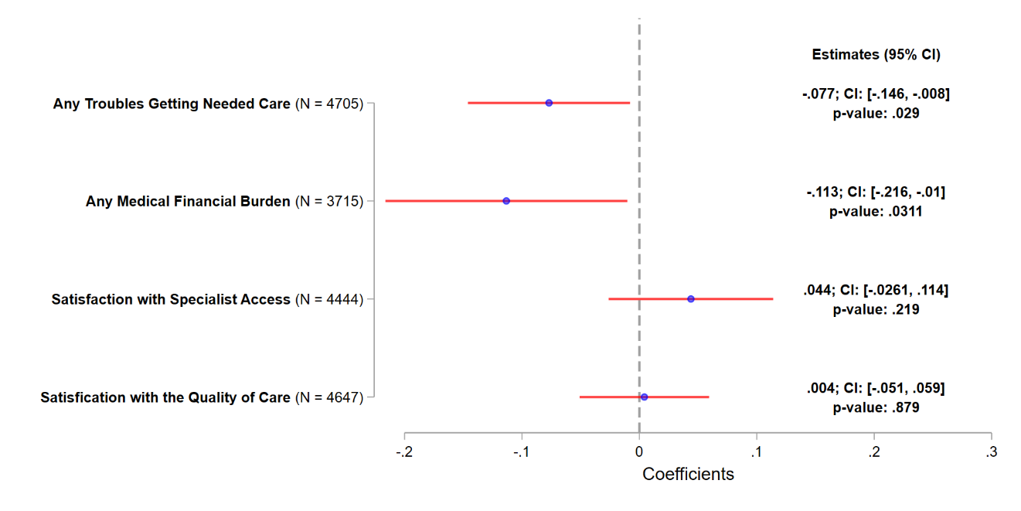
Notes: The working sample consists of MA beneficiaries from 2015-2022 MCBS. Beneficiaries with only partial enrollment in an MA plan during the past year at the time of the survey and veteran are excluded. MA ADRD beneficiaries with self-response in the survey are also removed. The plotted estimates represent the coefficients for interaction term between the treatment indicator and the post indicator from a DID estimation, with the dependent variable indicated on the y-axis. In each DID estimation, the treatment group consists of MA beneficiaries with ADRD, and the control group consists of MA beneficiaries without ADRD but with stroke/brain hemorrhage, complete/partial paralysis, or Parkinson’s diseases. The post indicator takes the value of one if 2020 or afterwards, and zero otherwise. The associated 95% CIs are plotted. Robust standard errors are applied.

eFigure 2. Association between the Inclusion of ADRD HCCs in Payment Model and Care Experiences – Exclude MA Beneficiaries Under 65
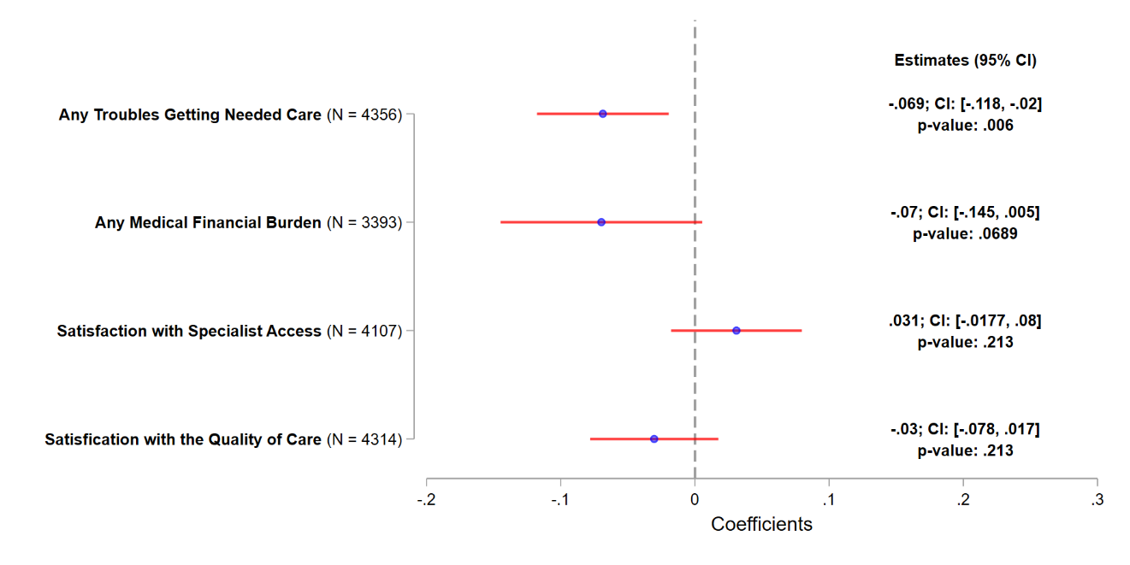
Notes: The working sample consists of MA beneficiaries from 2015-2022 MCBS. Beneficiaries with only partial enrollment in an MA plan during the past year at the time of the survey and veteran are excluded. MA beneficiaries less than 65 years old at the time of the survey are also removed. The plotted estimates represent the coefficients for the interaction term between the treatment indicator and the post indicator from a DID estimation, with the dependent variable indicated on the y-axis. In each DID estimation, the treated group consists of MA beneficiaries with ADRD, and the control group consists of MA beneficiaries without ADRD but with stroke/brain hemorrhage, complete/partial paralysis, or Parkinson’s diseases. The post indicator takes the value of one if 2020 or afterwards, and zero otherwise. The associated 95% CIs are plotted. Robust standard errors are applied.

eFigure 3. Association between the Inclusion of ADRD HCCs in Payment Model and Beneficiaries’ Characteristics – Adjust for Dual-Eligible Status
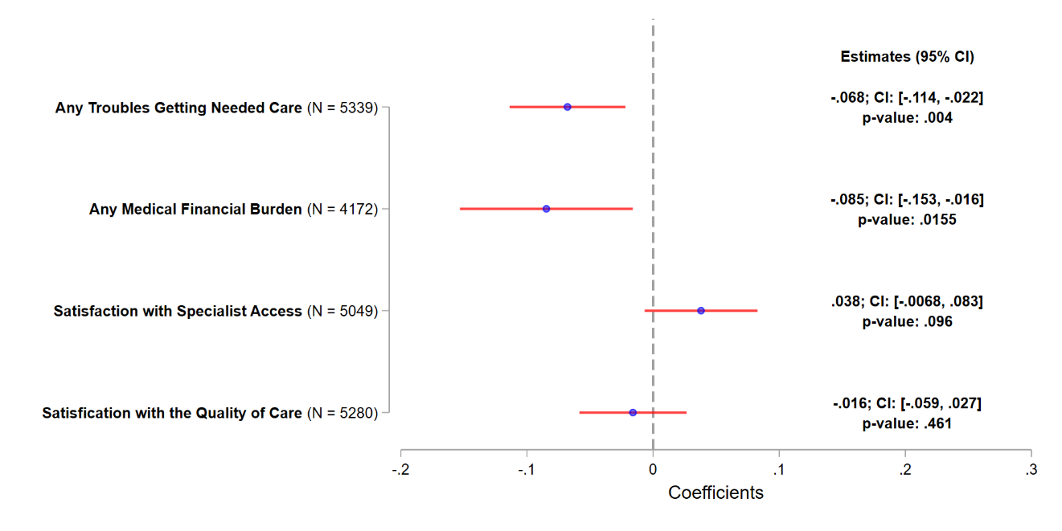
Notes: The working sample consists of MA beneficiaries from 2015-2022 MCBS. Beneficiaries with only partial enrollment in an MA plan during the past year at the time of the survey and veteran are excluded. The plotted estimates represent the coefficients for the interaction term between the treatment indicator and the post indicator from a DID estimation, with the dependent variable indicated on the y-axis. In each DID estimation, the treatment group consists of MA beneficiaries with ADRD, and the control group consists of MA beneficiaries without ADRD but with stroke/brain hemorrhage, complete/partial paralysis, or Parkinson’s diseases. The post indicator takes the value of one if 2020 or afterwards, and zero otherwise. The associated 95% CIs are plotted. Robust standard errors are applied.

eFigure 4. Association between the Inclusion of ADRD HCCs in Payment Model and Care Experiences using Balanced Repeated Replications Method
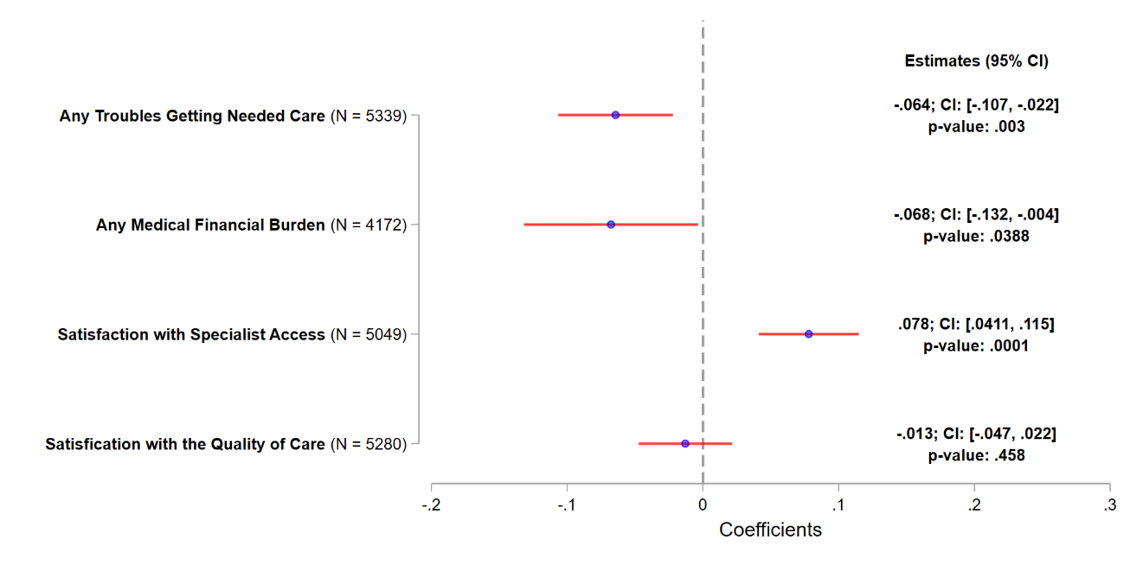
Notes: The working sample consists of MA beneficiaries from 2015-2022 MCBS. Beneficiaries with only partial enrollment in an MA plan during the past year at the time of the survey and veteran are excluded. The plotted estimates represent the coefficients for the interaction term between the treatment indicator and the post indicator from a DID estimation, with the dependent variable indicated on the y-axis. In each DID estimation, the treatment group consists of MA beneficiaries with ADRD, and the control group consists of MA beneficiaries without ADRD but with stroke/brain hemorrhage, complete/partial paralysis, or Parkinson’s diseases. The post indicator takes the value of one if 2020 or afterwards, and zero otherwise. The associated 95% CIs are plotted. Balanced repeated replications (BRR) for standard errors are applied.

eFigure 5. Association between the Inclusion of ADRD HCCs in Payment Model and Care Experiences – Exclude Beneficiaries in Current MA Plan for Less than 3 Years
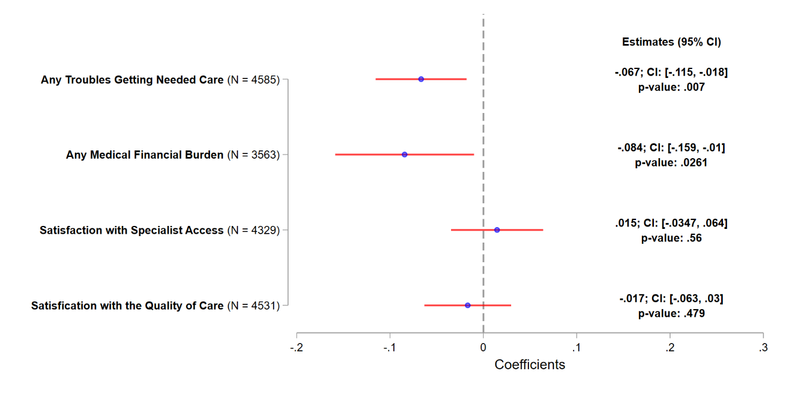
Notes: The working sample consists of MA beneficiaries from 2015-2022 MCBS. Beneficiaries with only partial enrollment in an MA plan during the past year at the time of the survey and veteran are excluded. MA beneficiaries who have been in current MA plans for less than 3 years at the time of the survey are also removed. The plotted estimates represent the coefficients for the interaction term between the treatment indicator and the post indicator from a DID estimation, with the dependent variable indicated on the y-axis. In each DID estimation, the treatment group consists of MA beneficiaries with ADRD, and the control group consists of MA beneficiaries without ADRD but with stroke/brain hemorrhage, complete/partial paralysis, or Parkinson’s diseases. The post indicator takes the value of one if 2020 or afterwards, and zero otherwise. The associated 95% CIs are plotted. Robust standard errors are applied.

eFigure 6. Association between the Inclusion of ADRD HCCs in Payment Model and Beneficiaries’ Characteristics – Including Partially Covered MA Beneficiaries
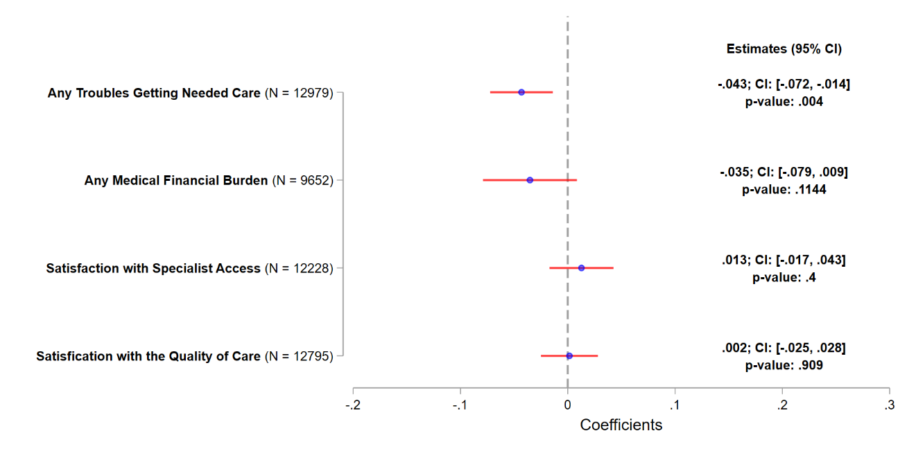
Notes: The working sample consists of MA beneficiaries from 2015-2022 MCBS. Beneficiaries with full-year MA coverage or with MA coverage for less than one year during the past year at the time of the survey are both included. Veterans are excluded. The plotted estimates represent the coefficients for the interaction term between the treatment indicator and the post indicator from a DID estimation, with the dependent variable indicated on the y-axis. In each DID estimation, the treatment group consists of MA beneficiaries with ADRD, and the control group consists of MA beneficiaries without ADRD but with stroke/brain hemorrhage, complete/partial paralysis, or Parkinson’s diseases. The post indicator takes the value of one if 2020 or afterwards, and zero otherwise. The associated 95% CIs are plotted. Robust standard errors are applied.

eFigure 7. Association between the Inclusion of ADRD HCCs in Payment Model and Beneficiaries’ Characteristics – Sensitivity Test to Alternative Control Group
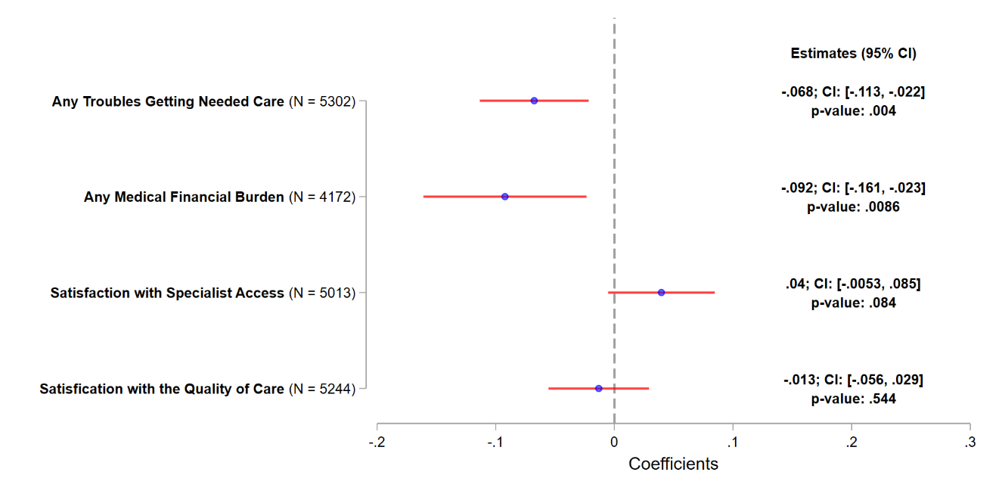
A. Dropping PD from Control Group

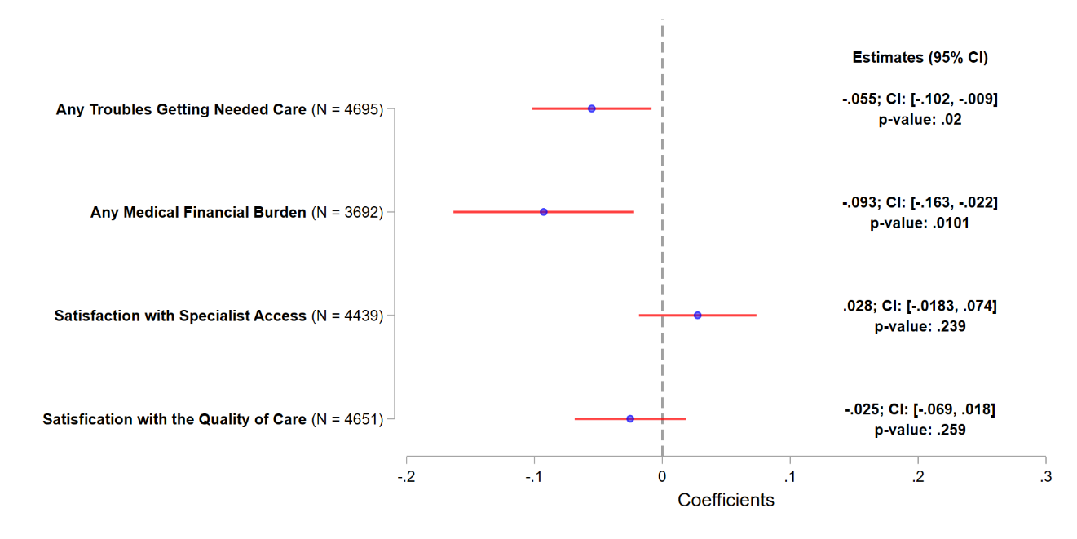
B. Using MA Beneficiaries with Stroke/brain hemorrhage as Control Group
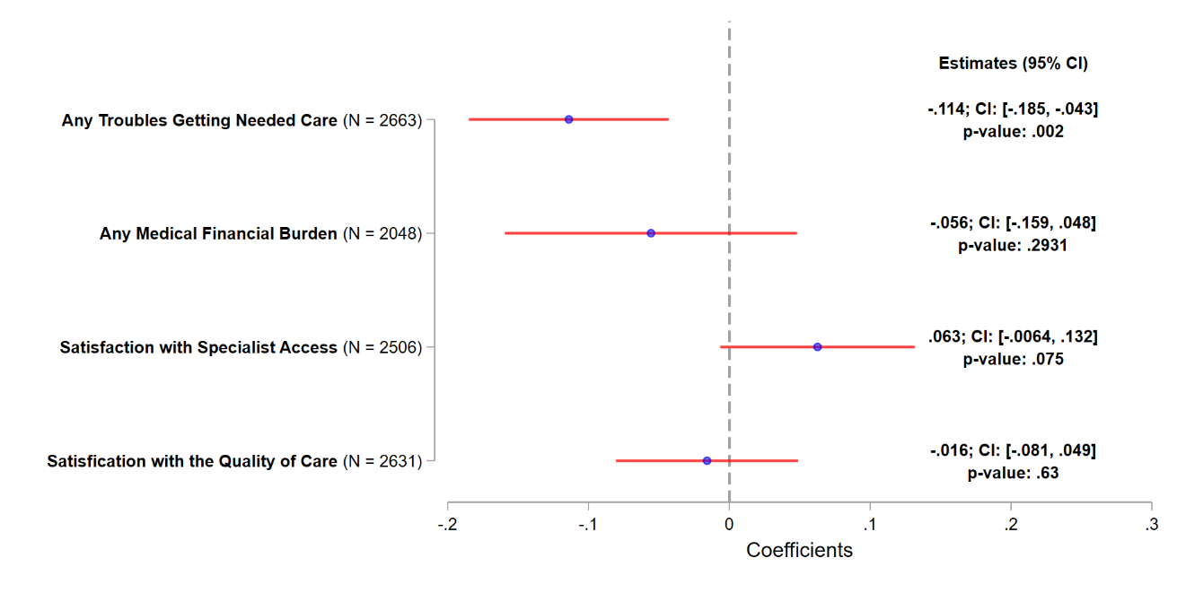
C. Using MA Beneficiaries with Complete/Partial paralysis as Control Group
Notes: The working sample consists of MA beneficiaries from 2015-2022 MCBS. Beneficiaries with only partial enrollment in an MA plan during the past year at the time of the survey and veteran are excluded. The plotted estimates represent the coefficients for the interaction term between the treatment indicator and the post indicator from a DID estimation, with the dependent variable indicated on the y-axis. In each DID estimation, the treatment group consists of MA beneficiaries with ADRD. The control group consists of MA beneficiaries without ADRD but with stroke/brain hemorrhage, or complete/partial paralysis in Panel A, MA beneficiaries without ADRD but with stroke/brain hemorrhage in Panel B, and MA beneficiaries without ADRD but with complete/partial paralysis in Panel C. The post indicator takes the value of one if 2020 or afterwards, and zero otherwise. The associated 95% CIs are plotted. Robust standard errors are applied.

eFigure 8. Association between the Inclusion of ADRD HCCs in Payment Model and Care Experiences – Using MA Beneficiaries with All non-ADRD Conditions as Control Group
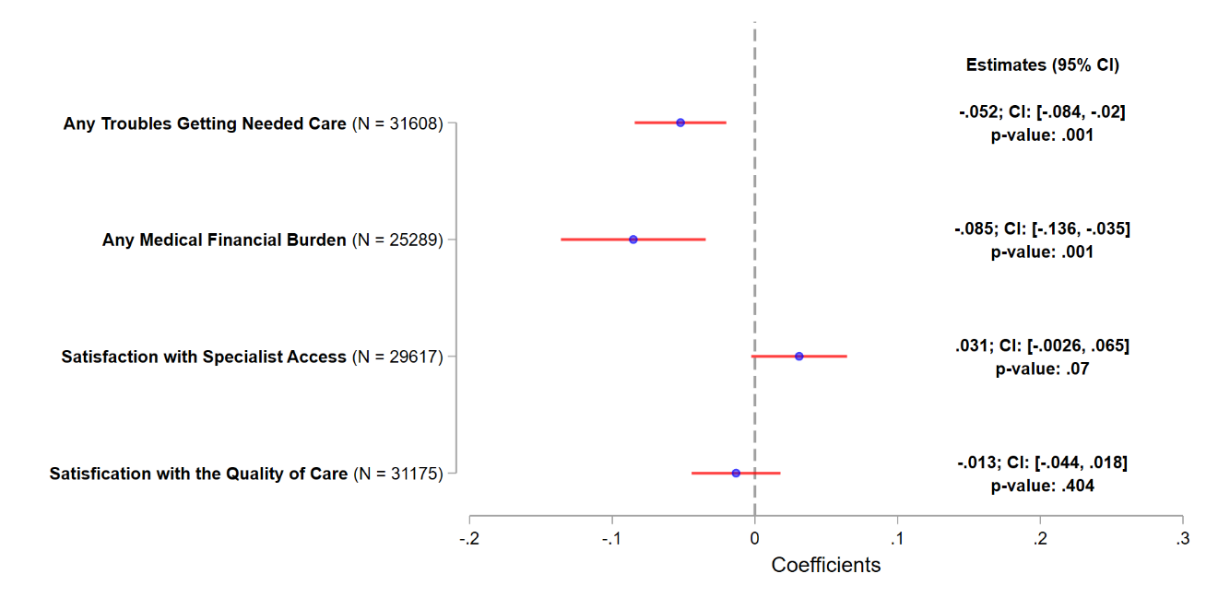
Notes: The working sample consists of MA beneficiaries from 2015-2022 MCBS. Beneficiaries with only partial enrollment in an MA plan during the past year at the time of the survey and veteran are excluded. MA ADRD beneficiaries with self-response in the survey are also removed. The plotted estimates represent the coefficients for the interaction term between the treatment indicator and the post indicator from a DID estimation, with the dependent variable indicated on the y-axis. In each DID estimation, the treatment group consists of MA beneficiaries with ADRD, and the control group consists of MA beneficiaries without ADRD but with other conditions, including but not limited to stroke/brain hemorrhage, complete/partial paralysis, or Parkinson’s diseases. The post indicator takes the value of one if 2020 or afterwards, and zero otherwise. The associated 95% CIs are plotted. Robust standard errors are applied.

eFigure 9. Placebo Tests Using Other Conditions as Negative Control Group

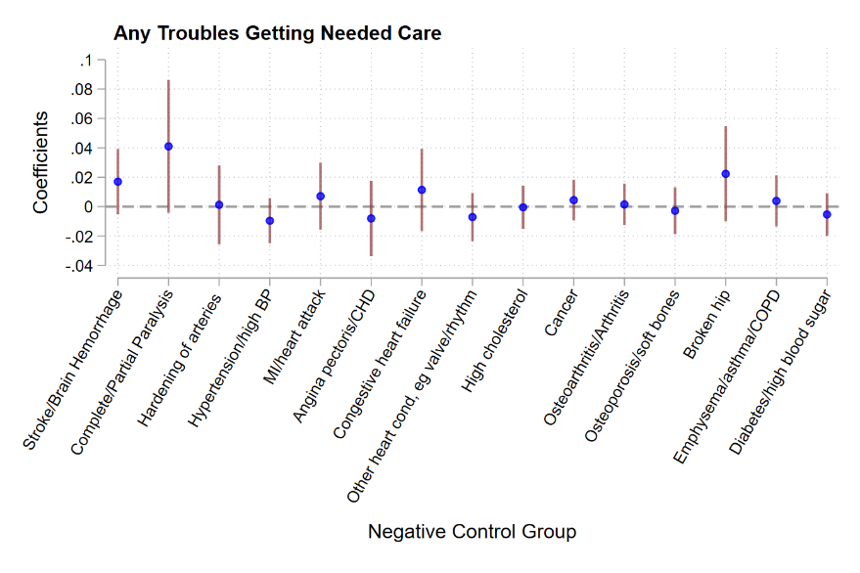
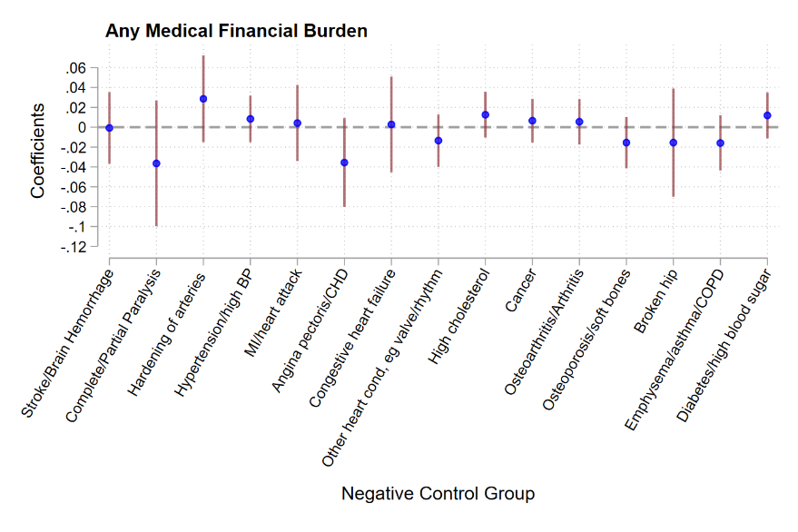

eFigure 9 (Cont.). Placebo Tests Using Other Conditions as Negative Control Group
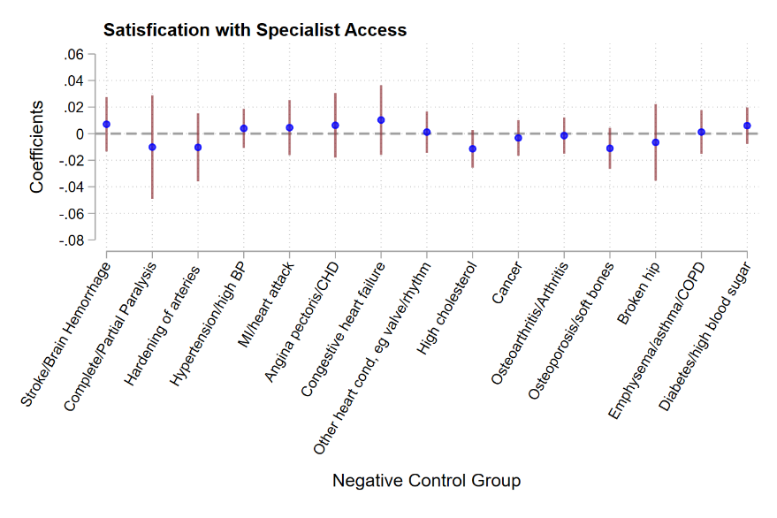
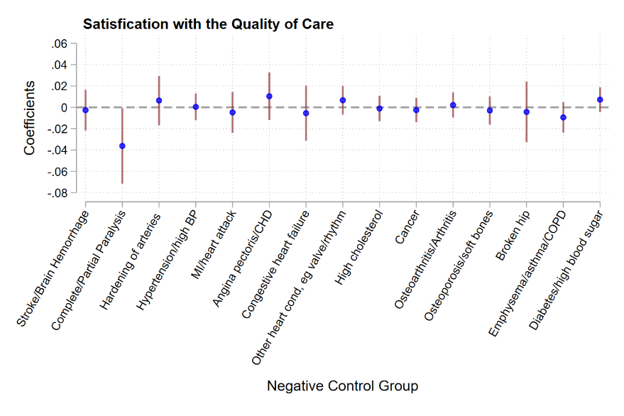
Notes: The working sample consists of MA beneficiaries from 2015-2022 MCBS. Beneficiaries with only partial enrollment in an MA plan during the past year at the time of the survey and veteran are excluded. The plotted estimates represent the coefficients for the interaction term between the negative control indicator (listed in the horizontal axis) and the post indicator from a DID estimation, with the dependent variable indicated in each panel title. In each DID estimation, the negative control group consists of non-ADRD MA beneficiaries with the disease specified in the x-axis, and the comparison group consists of non-ADRD MA beneficiaries without the disease specified in the x-axis. The post indicator takes the value of one if 2020 or afterwards, and zero otherwise. The associated 95% CIs are plotted. Robust standard errors are applied.

eFigure 10. Association between the Inclusion of ADRD HCCs in Payment Model and Care Experiences – Using Fee-For-Service (FFS) Beneficiaries
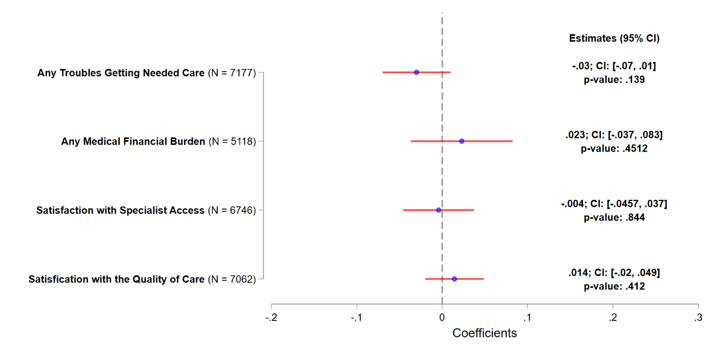
Notes: The working sample consists of TM beneficiaries from 2015-2022 MCBS. Veteran beneficiaries are excluded. The plotted estimates represent the coefficients for the interaction term between the treatment indicator and the post indicator from a DID estimation, with the dependent variable indicated on the y-axis. In each DID estimation, the treatment group consists of FFS beneficiaries with ADRD, and the control group consists of FFS beneficiaries without ADRD but with stroke/brain hemorrhage, complete/partial paralysis, or Parkinson’s diseases. The post indicator takes the value of one if 2020 or afterwards, and zero otherwise. The associated 95% CIs are plotted. Robust standard errors are applied.

eFigure 11. Association between the Inclusion of ADRD HCCs in Payment Model and Care Experiences – Stratification Analysis
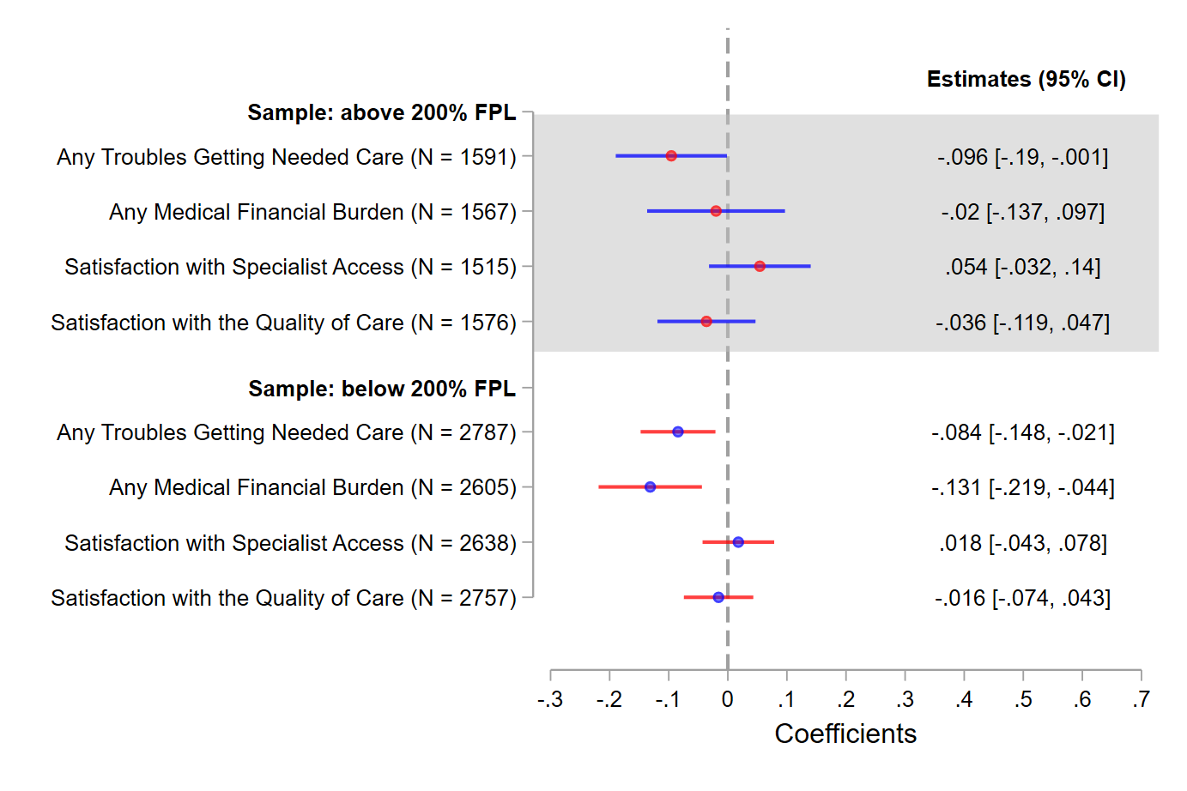
- By Income Level
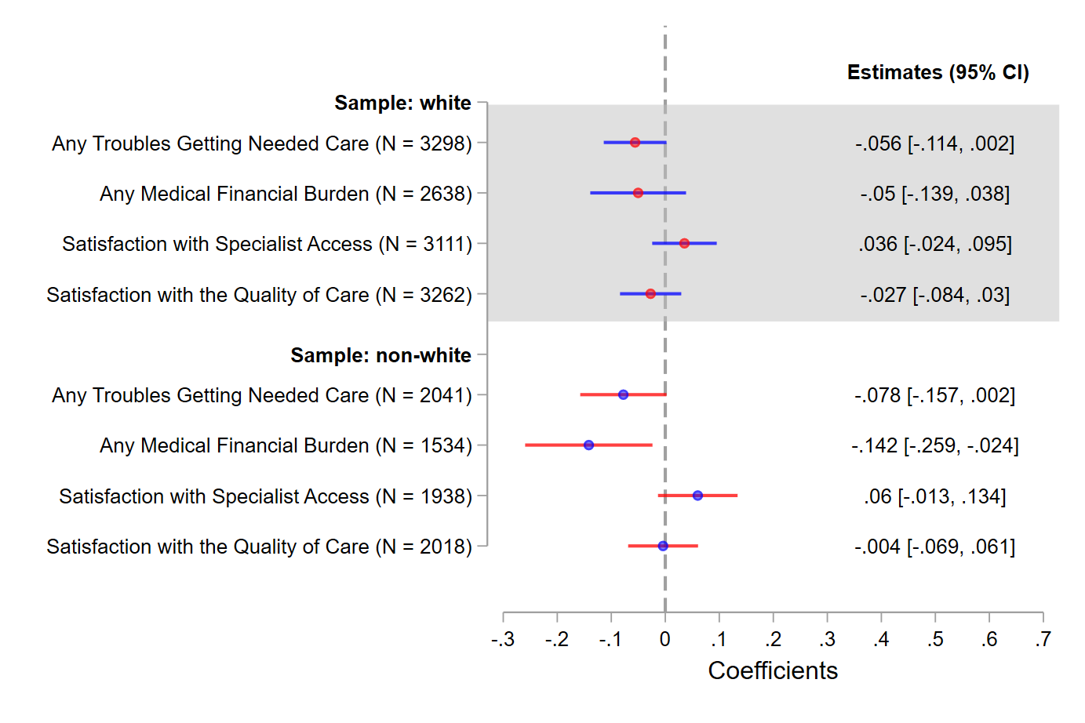
- By Race/Ethnicity

eFigure 11. (Cont.) Association between the Inclusion of ADRD HCCs in Payment Model and Care Experiences – Stratification Analysis
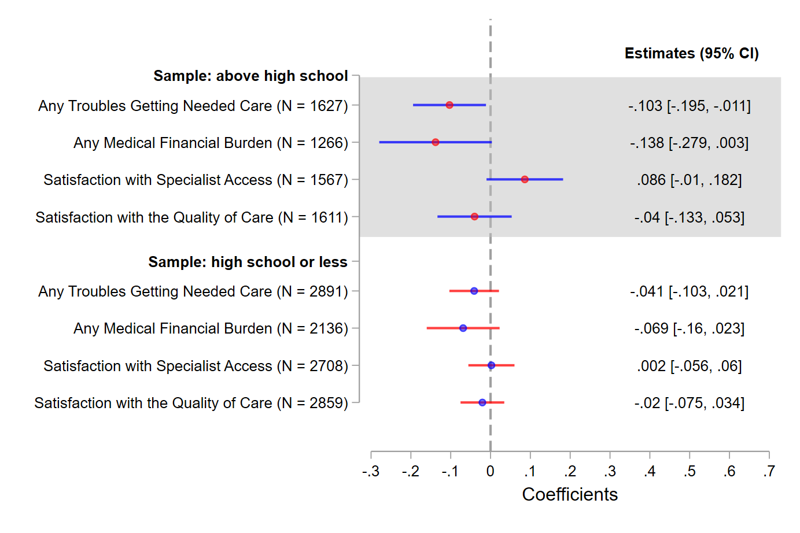
- By Education Level
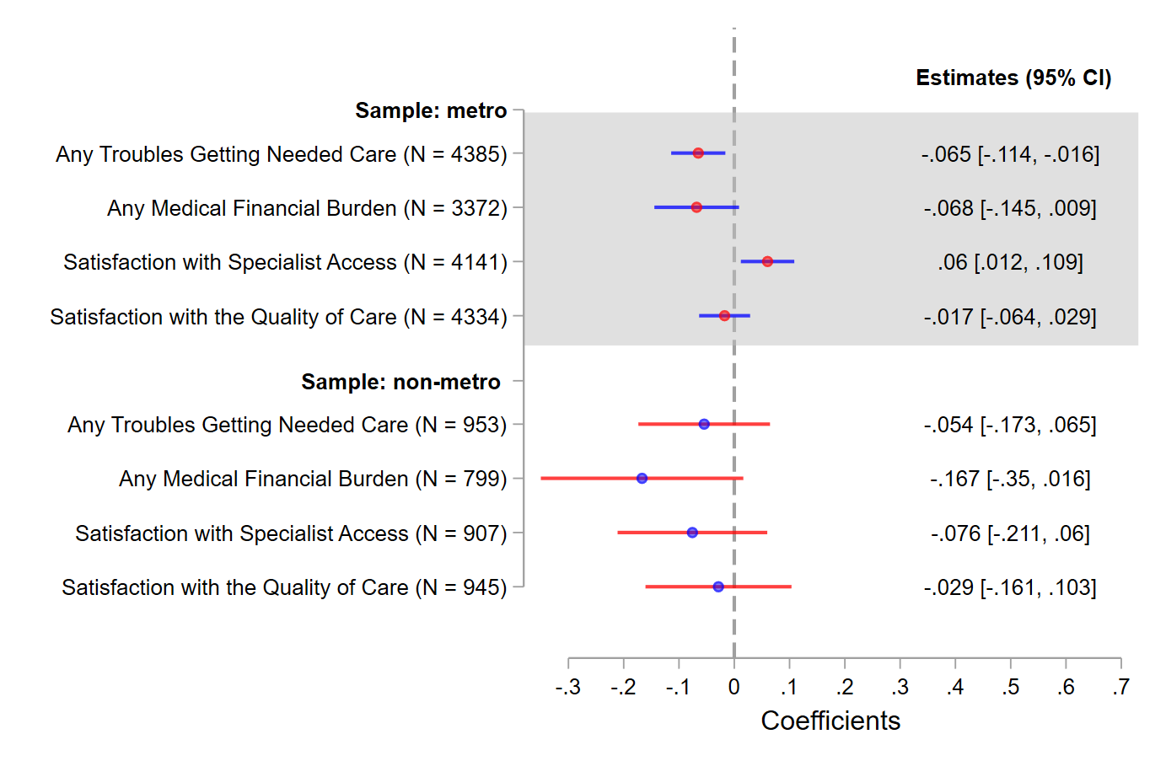
- By Metropolitan Status
Notes: The working sample consists of MA beneficiaries from 2015-2022 MCBS. Beneficiaries with only partial enrollment in an MA plan during the past year at the time of the survey and veteran are excluded. The plotted estimates represent the coefficients for the interaction term between the treatment indicator and the post indicator from a DID estimation, with the dependent variable indicated on the y-axis. In each DID estimation, the treatment group consists of MA beneficiaries with ADRD, and the control group consists of MA beneficiaries without ADRD but with stroke/brain hemorrhage, complete/partial paralysis, or Parkinson’s diseases. The post indicator takes the value of one if 2020 or afterwards, and zero otherwise. The associated 95% CIs are plotted. Robust standard errors are applied.

eFigure 12. Association between the Inclusion of ADRD HCCs in Payment Model and Beneficiaries’ Characteristics – Test for Compositional Change
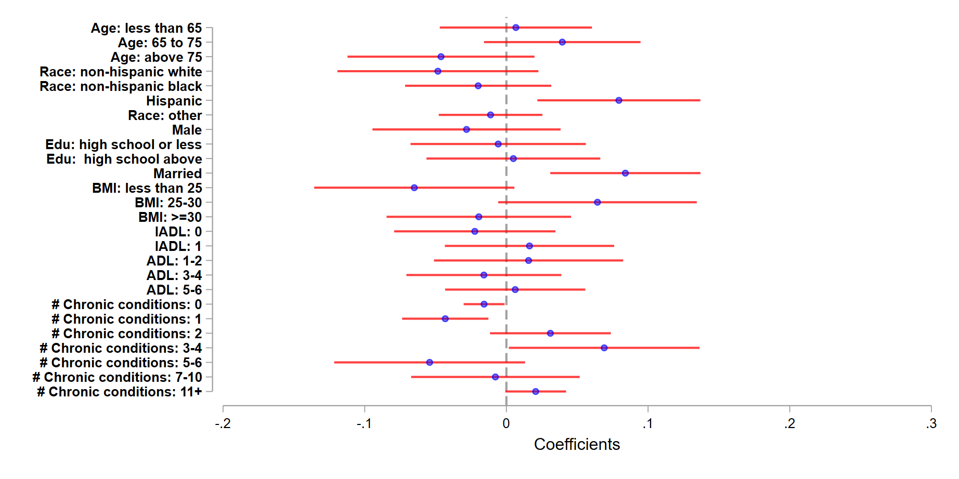
Notes: The working sample consists of MA beneficiaries from 2015-2022 MCBS. Beneficiaries with only partial enrollment in an MA plan during the past year at the time of the survey and veteran are excluded. The plotted estimates represent the coefficients for the interaction term between the treatment indicator and the post indicator from a DID estimation, with the dependent variable indicated on the y-axis. In each DID estimation, the treatment group consists of MA beneficiaries with ADRD, and the control group consists of MA beneficiaries without ADRD but with stroke/brain hemorrhage, complete/partial paralysis, or Parkinson’s diseases. The post indicator takes the value of one if 2020 or afterwards, and zero otherwise. The number of chronic conditions excludes ADRD. The associated 95% CIs are plotted. Robust standard errors are applied.

eFigure 13. Dynamic Association between the Inclusion of ADRD HCCs in Payment Model and Beneficiaries’ Characteristics – Test for Compositional Change
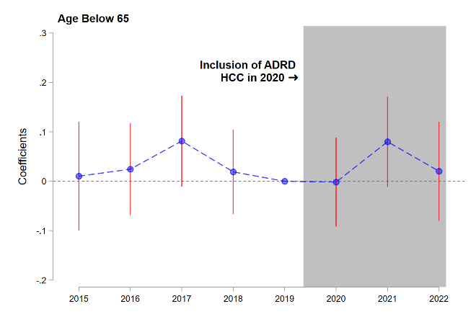 | 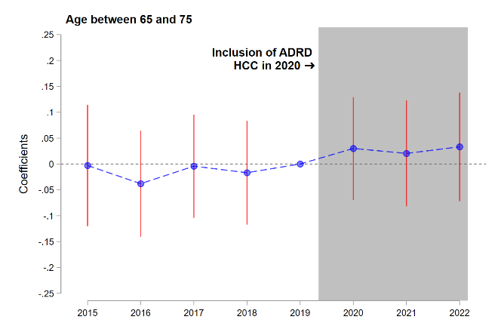 | 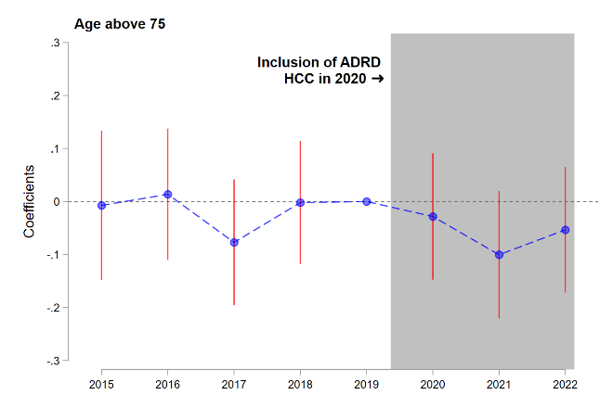
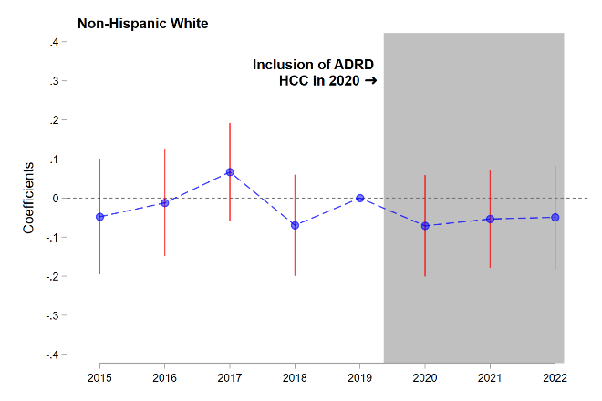 | 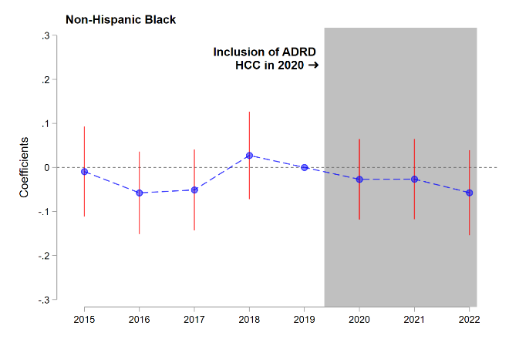 | 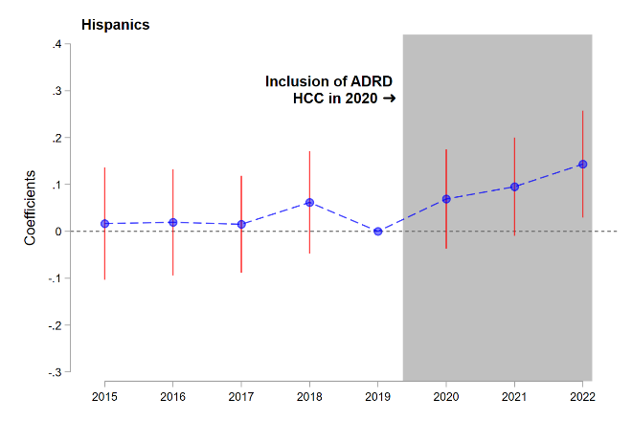
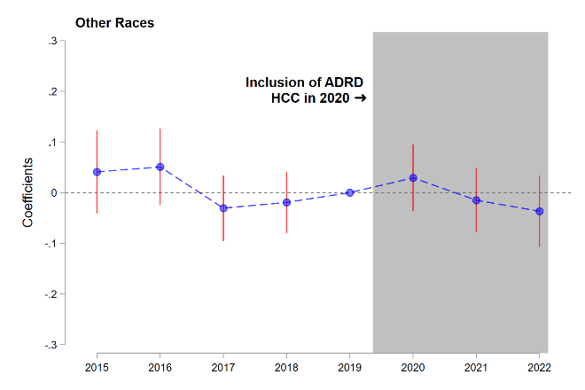 | 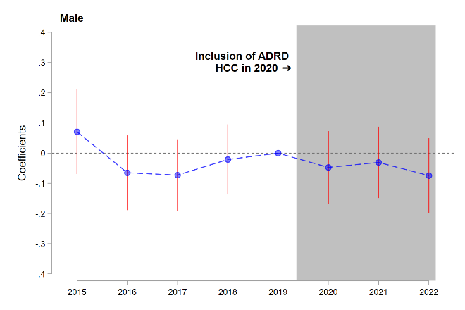 | 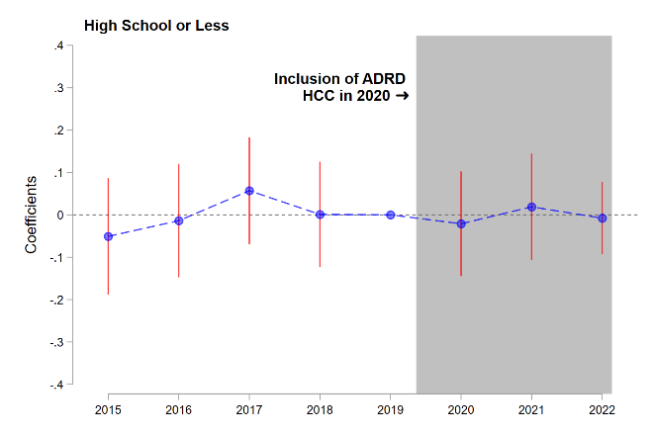
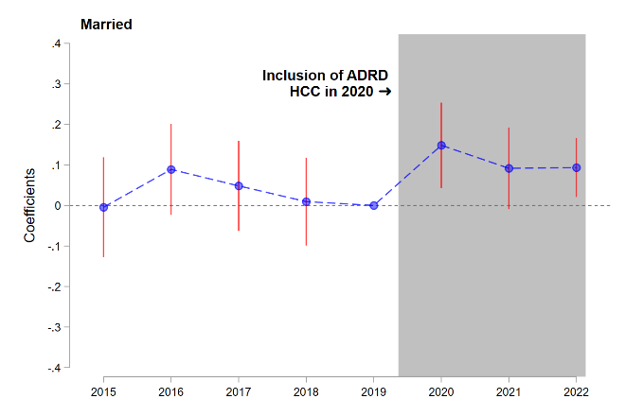 | 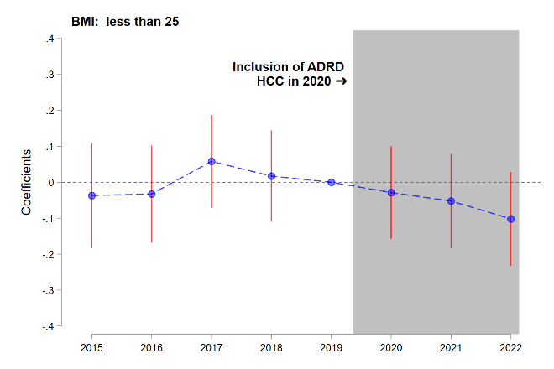 | 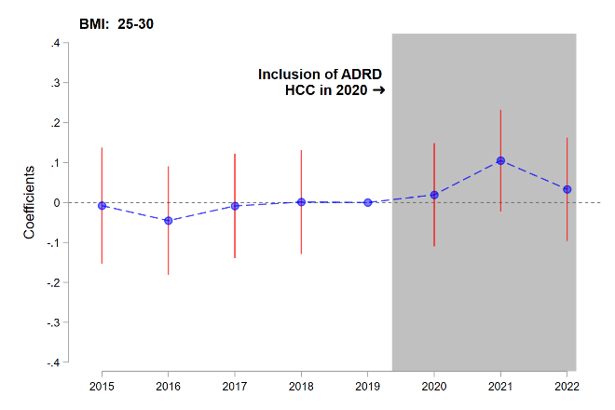
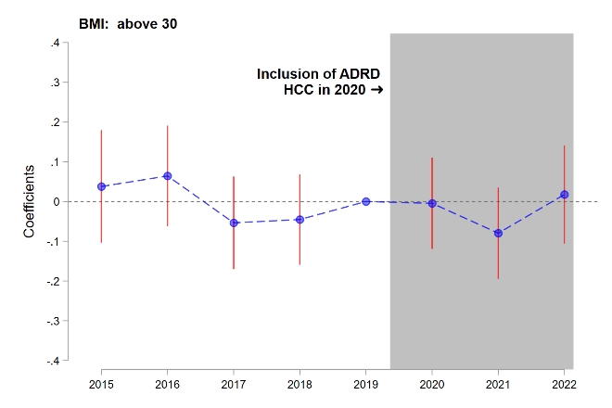 | 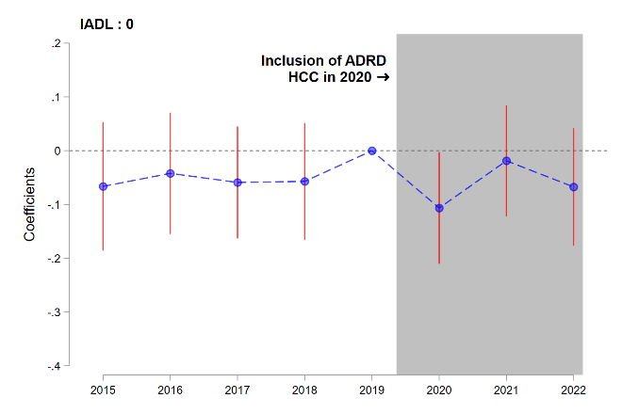 | 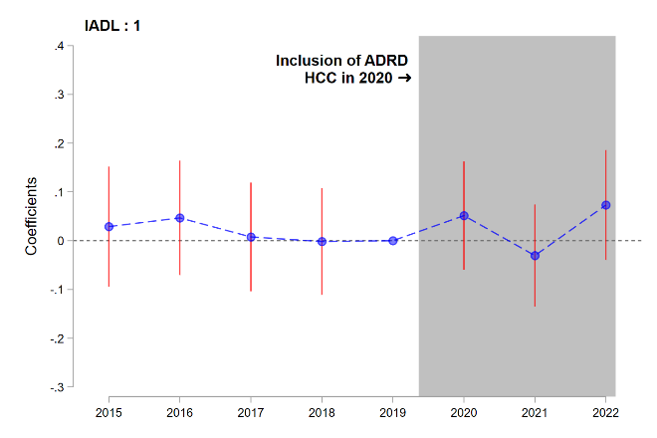
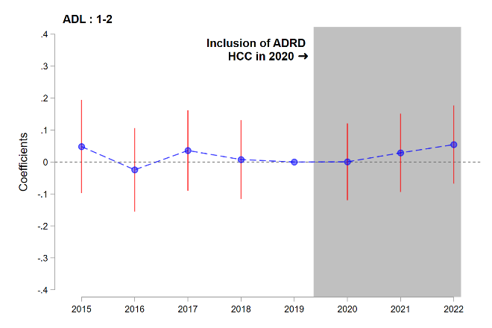 | 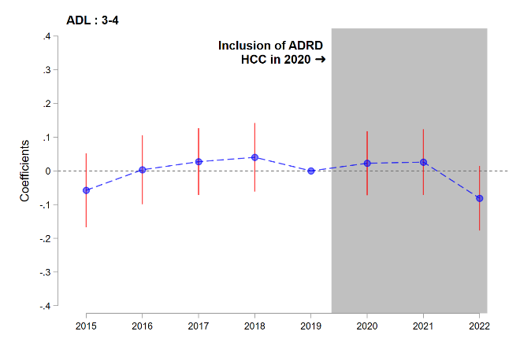 | 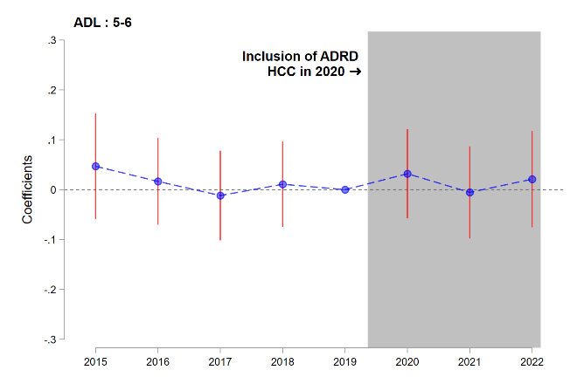
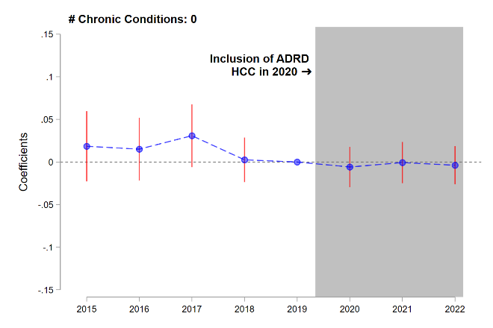 | 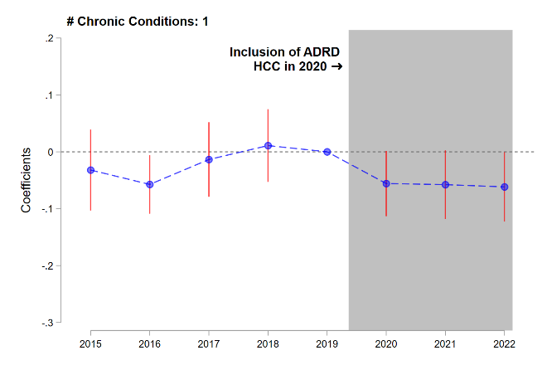 | 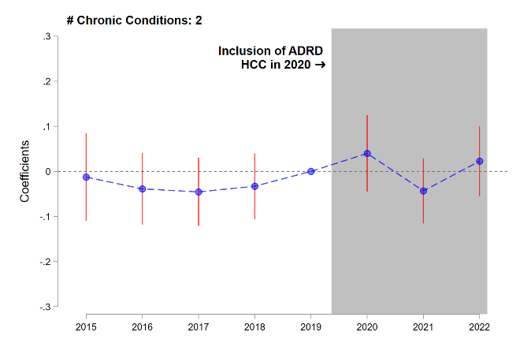
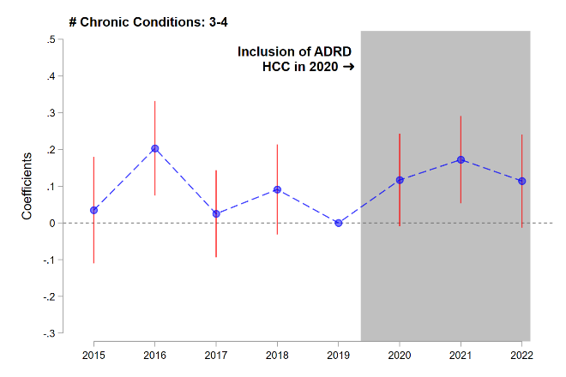 | 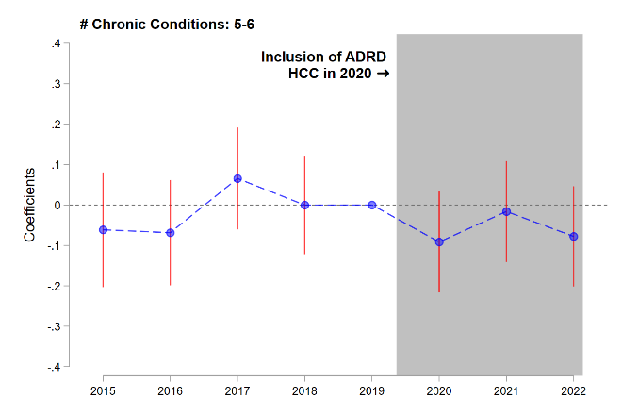 | 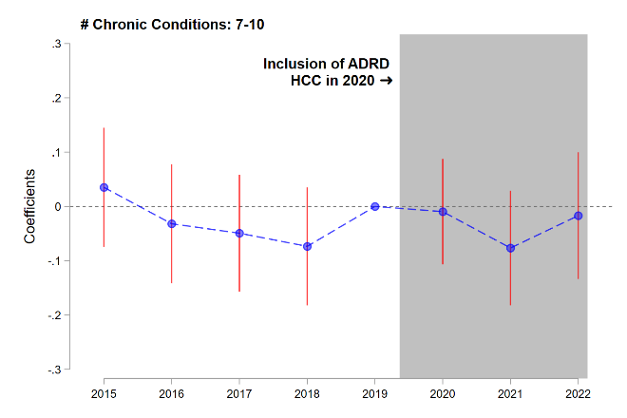
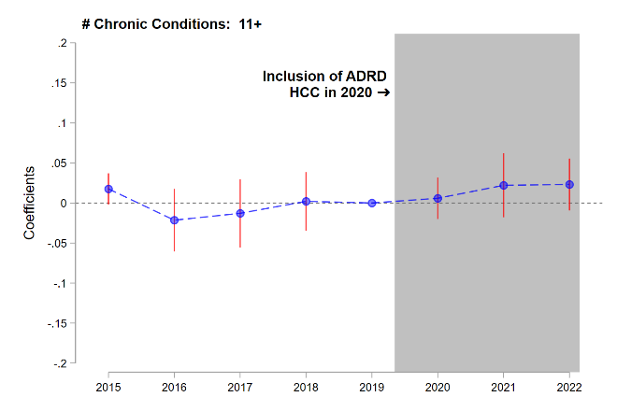
Notes: The working sample consists of MA beneficiaries from 2015-2022 MCBS. Beneficiaries with only partial enrollment in an MA plan during the past year at the time of the survey and veteran are excluded. Each figure presents results from an event study model, with the dependent variable specified above. The plotted estimates represent the coefficients for the interaction term between treated indicator and year indicators. In each estimation, the treatment group consists of MA beneficiaries with ADRD, and the control group consists of MA beneficiaries without ADRD but with stroke/brain hemorrhage, complete/partial paralysis, or Parkinson’s diseases. The number of chronic conditions excludes ADRD. The associated 95% CIs are also plotted. Robust standard errors are applied.

eTable 1: Summary of Care Experiences by Treatment and Over Time
Year | Any Troubles Getting Needed Care |  | Any Medical Financial Burden |  | Satisfaction with Specialist Access |  | Satisfaction with Quality of Care
 | Mean | S.D | Mean | S.D | Mean | S.D | Mean | S.D
Panel A: Control Group: MA beneficiaries with Stroke/Paralysis/PD and no ADRD
2015 | 0.067 | 0.251 | NA | NA | 0.935 | 0.247 | 0.963 | 0.188
2016 | 0.085 | 0.279 | NA | NA | 0.943 | 0.232 | 0.940 | 0.238
2017 | 0.111 | 0.314 | 0.326 | 0.469 | 0.927 | 0.261 | 0.937 | 0.243
2018 | 0.099 | 0.298 | 0.286 | 0.452 | 0.926 | 0.262 | 0.931 | 0.254
2019 | 0.091 | 0.288 | 0.268 | 0.443 | 0.926 | 0.262 | 0.935 | 0.247
2020 | 0.125 | 0.332 | 0.229 | 0.420 | 0.937 | 0.244 | 0.909 | 0.288
2021 | 0.116 | 0.321 | 0.199 | 0.400 | 0.913 | 0.282 | 0.932 | 0.252
2022 | 0.125 | 0.331 | 0.225 | 0.418 | 0.919 | 0.274 | 0.920 | 0.272
Panel B: Treatment Group: MA beneficiaries with ADRD
2015 | 0.073 | 0.261 | NA | NA | 0.903 | 0.297 | 0.948 | 0.223
2016 | 0.071 | 0.257 | NA | NA | 0.918 | 0.275 | 0.956 | 0.205
2017 | 0.105 | 0.307 | 0.227 | 0.420 | 0.909 | 0.289 | 0.928 | 0.259
2018 | 0.094 | 0.292 | 0.256 | 0.438 | 0.914 | 0.282 | 0.939 | 0.240
2019 | 0.109 | 0.312 | 0.249 | 0.433 | 0.889 | 0.314 | 0.941 | 0.236
2020 | 0.085 | 0.280 | 0.139 | 0.347 | 0.906 | 0.292 | 0.918 | 0.275
2021 | 0.064 | 0.245 | 0.120 | 0.326 | 0.913 | 0.283 | 0.926 | 0.262
2022 | 0.089 | 0.285 | 0.155 | 0.362 | 0.915 | 0.279 | 0.877 | 0.329
Notes: The working sample consists of MA beneficiaries from 2015-2022 MCBS. Beneficiaries with only partial enrollment in an MA plan during the past year at the time of the survey and veteran are excluded.

eTable 2. Summary of Care Experiences by Treatment and Year
 | Treatment | Control
Panel A: Any Troubles Getting Needed Care
Before 2020 | 0.093 (0.290) | 0.093 (0.290)
2020 and post | 0.08 (0.271) | 0.122 (0.328)
Panel B: Any Medical Finance Burden
Before 2020 | 0.244 (0.430) | 0.291 (0.455)
2020 and post | 0.138 (0.345) | 0.217 (0.413)
Panel C: Satisfaction with Specialist Access
Before 2020 | 0.906 (0.292) | 0.931 (0.254)
2020 and post | 0.911 (0.285) | 0.922 (0.268)
Panel D: Satisfaction with Quality of Care
Before 2020 | 0.942 (0.235) | 0.939 (0.240)
2020 and post | 0.907 (0.291) | 0.92 (0.271)
Notes: The working sample consists of MA beneficiaries from 2015-2022 MCBS. Beneficiaries with only partial enrollment in an MA plan during the past year at the time of the survey and veterans are excluded. The standard deviations are reported in parentheses

eTable 3. Dynamic Association between the Inclusion of ADRD HCCs in Payment Model and Care Experiences (Event Study)
variable | Coef. | Standard Error | P value | 95% CI: lower | 95% CI: upper
Outcome: Any Trouble Getting Needed Care (N = 5,339)
ADRD $×$ 2015 | -0.0446 | 0.0448 | 0.3199 | -0.1325 | -0.0433
ADRD $×$ 2016 | -0.0156 | 0.0421 | 0.7100 | -0.0981 | 0.0668
ADRD $×$ 2017 | 0.0029 | 0.0460 | 0.9492 | -0.0872 | 0.0930
ADRD $×$ 2018 | -0.0221 | 0.0438 | 0.6148 | -0.1080 | 0.0639
ADRD $×$ 2020 | -0.0481 | 0.0411 | 0.2422 | -0.1288 | 0.0325
ADRD $×$ 2021 | -0.0989 | 0.0421 | 0.0188 | -0.1814 | -0.0164
ADRD $×$ 2022 | -0.0909 | 0.0471 | 0.0536 | -0.1833 | 0.0014
Outcome: Any Medical Financial Burden (N = 4,172)
ADRD $×$ 2017 | -0.0639 | 0.0636 | 0.3148 | -0.1886 | 0.0608
ADRD $×$ 2018 | 0.0193 | 0.0624 | 0.7573 | -0.1031 | 0.1417
ADRD $×$ 2020 | -0.0974 | 0.0584 | 0.0953 | -0.2118 | 0.0171
ADRD $×$ 2021 | -0.1034 | 0.0565 | 0.0672 | -0.2141 | 0.0073
ADRD $×$ 2022 | -0.1174 | 0.0609 | 0.0542 | -0.2368 | 0.0021
Outcome: Satisfaction with Specialists Access (N = 5,049)
ADRD $×$ 2015 | -0.0301 | 0.0482 | 0.5319 | -0.1246 | 0.0644
ADRD $×$ 2016 | -0.0012 | 0.0446 | 0.9784 | -0.0886 | 0.0862
ADRD $×$ 2017 | 0.0094 | 0.0446 | 0.8323 | -0.0780 | 0.0969
ADRD $×$ 2018 | 0.0261 | 0.0411 | 0.5260 | -0.0545 | 0.1067
ADRD $×$ 2020 | 0.0119 | 0.0410 | 0.7711 | -0.0684 | 0.0923
ADRD $×$ 2021 | 0.0637 | 0.0419 | 0.1283 | -0.0184 | 0.1459
ADRD $×$ 2022 | 0.0526 | 0.0462 | 0.2548 | -0.0380 | 0.1432
Outcome: Satisfaction with Quality of Care (N = 5,280)
ADRD $×$ 2015 | -0.0346 | 0.0374 | 0.3554 | -0.1079 | 0.0388
ADRD $×$ 2016 | -0.0039 | 0.0354 | 0.9123 | -0.0734 | 0.0656
ADRD $×$ 2017 | -0.0281 | 0.0394 | 0.4766 | -0.1053 | 0.0492
ADRD $×$ 2018 | -0.0014 | 0.0344 | 0.9678 | -0.0687 | 0.0660
ADRD $×$ 2020 | -0.0351 | 0.0382 | 0.3587 | -0.1100 | 0.0398
ADRD $×$ 2021 | -0.0295 | 0.0380 | 0.4368 | -0.1040 | 0.0449
ADRD $×$ 2022 | -0.0103 | 0.0430 | 0.8102 | -0.0946 | 0.0740
Notes: The working sample consists of MA beneficiaries from 2015-2022 MCBS. Beneficiaries with only partial enrollment in an MA plan during the past year at the time of the survey and veteran are excluded. In each estimation, the treatment group consists of MA beneficiaries with ADRD, and the control group consists of MA beneficiaries without ADRD but with stroke/brain hemorrhage, complete/partial paralysis, or Parkinson’s diseases. The event study is specified in Appendix B.3. The year of 2019 is selected as the reference year. Robust standard errors are applied.

eTable 4. Summary Statistics: using All non-ADRD Conditions as Control Group
 | (1) |  |  | (2) |  |  | (3)
 | All |  |  | ADRD |  |  | All non-ADRD
 | Mean | SD | N | Mean | SD | N | Mean | SD | N
Any Troubles Getting Needed Care | 0.079 | 0.269 | 31608 | 0.087 | 0.283 | 1624 | 0.078 | 0.268 | 29984
Any Medical Financial Burden | 0.187 | 0.390 | 25289 | 0.193 | 0.395 | 1220 | 0.187 | 0.390 | 24069
Satisfaction with Access to Specialist | 0.933 | 0.249 | 29617 | 0.908 | 0.289 | 1524 | 0.935 | 0.247 | 28093
Satisfaction with Quality of Care | 0.951 | 0.217 | 31175 | 0.928 | 0.259 | 1611 | 0.952 | 0.214 | 29564
No ADRD | 0.949 | 0.221 | 31663 | 0.000 | 0.000 | 1629 | 1.000 | 0.000 | 30034
ADRD | 0.051 | 0.221 | 31663 | 1.000 | 0.000 | 1629 | 0.000 | 0.000 | 30034
Age Group <65 | 0.153 | 0.360 | 31663 | 0.069 | 0.254 | 1629 | 0.158 | 0.364 | 30034
Age Group 65 to 75 | 0.342 | 0.474 | 31663 | 0.138 | 0.344 | 1629 | 0.353 | 0.478 | 30034
Age Group 75+ | 0.505 | 0.500 | 31663 | 0.793 | 0.405 | 1629 | 0.490 | 0.500 | 30034
Non-Hispanic white | 0.650 | 0.477 | 31663 | 0.565 | 0.496 | 1629 | 0.655 | 0.475 | 30034
Non-Hispanic black | 0.128 | 0.335 | 31663 | 0.133 | 0.340 | 1629 | 0.128 | 0.334 | 30034
Hispanic | 0.163 | 0.369 | 31663 | 0.242 | 0.428 | 1629 | 0.159 | 0.365 | 30034
Other | 0.058 | 0.234 | 31663 | 0.060 | 0.238 | 1629 | 0.058 | 0.234 | 30034
Male | 0.326 | 0.469 | 31663 | 0.272 | 0.445 | 1629 | 0.329 | 0.470 | 30034
Female | 0.674 | 0.469 | 31663 | 0.728 | 0.445 | 1629 | 0.671 | 0.470 | 30034
Not Married | 0.473 | 0.499 | 31663 | 0.548 | 0.498 | 1629 | 0.469 | 0.499 | 30034
Married | 0.368 | 0.482 | 31663 | 0.320 | 0.467 | 1629 | 0.370 | 0.483 | 30034
Married: missing | 0.159 | 0.366 | 31663 | 0.133 | 0.339 | 1629 | 0.161 | 0.367 | 30034
High school or less | 0.483 | 0.500 | 31663 | 0.608 | 0.488 | 1629 | 0.477 | 0.499 | 30034
High School above | 0.354 | 0.478 | 31663 | 0.246 | 0.431 | 1629 | 0.360 | 0.480 | 30034
Education missing | 0.163 | 0.369 | 31663 | 0.145 | 0.353 | 1629 | 0.164 | 0.370 | 30034
Self-respondent | 0.897 | 0.304 | 31663 | 0.390 | 0.488 | 1629 | 0.925 | 0.264 | 30034
Proxy respondent | 0.103 | 0.304 | 31663 | 0.610 | 0.488 | 1629 | 0.075 | 0.264 | 30034
Household Size: 1 | 0.331 | 0.471 | 31663 | 0.229 | 0.420 | 1629 | 0.337 | 0.473 | 30034
Household Size: 2 | 0.452 | 0.498 | 31663 | 0.460 | 0.499 | 1629 | 0.452 | 0.498 | 30034
Household Size: 3+ | 0.216 | 0.412 | 31663 | 0.311 | 0.463 | 1629 | 0.211 | 0.408 | 30034
Underweight/healthy (<25) | 0.305 | 0.460 | 31663 | 0.431 | 0.495 | 1629 | 0.298 | 0.457 | 30034
Overweight (25-30) | 0.338 | 0.473 | 31663 | 0.292 | 0.455 | 1629 | 0.340 | 0.474 | 30034
Obese/high-risk obese (>=30) | 0.330 | 0.470 | 31663 | 0.233 | 0.423 | 1629 | 0.336 | 0.472 | 30034
BMI missing | 0.027 | 0.163 | 31663 | 0.045 | 0.207 | 1629 | 0.026 | 0.160 | 30034
IADLs or ADLs: 0 | 0.519 | 0.500 | 31663 | 0.130 | 0.337 | 1629 | 0.540 | 0.498 | 30034
IADLs: 1 | 0.157 | 0.364 | 31663 | 0.214 | 0.410 | 1629 | 0.154 | 0.361 | 30034
ADLs: 1-2 | 0.209 | 0.406 | 31663 | 0.252 | 0.434 | 1629 | 0.206 | 0.405 | 30034
ADLs: 3-4 | 0.074 | 0.261 | 31663 | 0.182 | 0.386 | 1629 | 0.068 | 0.252 | 30034
ADLs: 5-6 | 0.041 | 0.199 | 31663 | 0.223 | 0.416 | 1629 | 0.032 | 0.175 | 30034
Chronic Conditions (except ADRD): 0 | 0.001 | 0.035 | 31663 | 0.024 | 0.153 | 1629 | 0.000 | 0.000 | 30034
Chronic Conditions (except ADRD): 1 | 0.112 | 0.315 | 31663 | 0.076 | 0.265 | 1629 | 0.114 | 0.317 | 30034
Chronic Conditions (except ADRD): 2 | 0.173 | 0.378 | 31663 | 0.112 | 0.315 | 1629 | 0.176 | 0.381 | 30034
Chronic Conditions (except ADRD): 3-4 | 0.386 | 0.487 | 31663 | 0.319 | 0.466 | 1629 | 0.390 | 0.488 | 30034
Chronic Conditions (except ADRD): 5-6 | 0.221 | 0.415 | 31663 | 0.277 | 0.448 | 1629 | 0.218 | 0.413 | 30034
Chronic Conditions (except ADRD): 7-10 | 0.101 | 0.302 | 31663 | 0.172 | 0.378 | 1629 | 0.098 | 0.297 | 30034
Chronic Conditions (except ADRD): 11+ | 0.006 | 0.074 | 31663 | 0.019 | 0.137 | 1629 | 0.005 | 0.069 | 30034
Notes: The working sample consists of MA beneficiaries from 2015-2022 MCBS. Beneficiaries with only partial enrollment in an MA plan during the past year at the time of the survey and veterans are excluded.

eTable 5. Summary Statistics: Negative Control Group: Stroke/Brain Hemorrhage (non-ADRD), Comparison Group: non Stroke/Brain Hemorrhage (non ADRD)
 | (1) |  |  | (2) |  |  | (3)
 | Negative Control + Comparison |  |  | Negative Control |  |  | Comparison
 | Mean | SD | N | Mean | SD | N | Mean | SD | N
Any Troubles Getting Needed Care | 0.077 | 0.267 | 31608 | 0.092 | 0.290 | 3071 | 0.076 | 0.264 | 28537
Any Medical Financial Burden | 0.184 | 0.387 | 25321 | 0.242 | 0.428 | 2472 | 0.177 | 0.382 | 22849
Satisfaction with Access to Specialist | 0.935 | 0.247 | 29416 | 0.931 | 0.253 | 2915 | 0.935 | 0.246 | 26501
Satisfaction with Quality of Care | 0.952 | 0.214 | 31022 | 0.933 | 0.250 | 3040 | 0.954 | 0.209 | 27982
Comparison | 0.903 | 0.296 | 31657 | 0.000 | 0.000 | 3080 | 1.000 | 0.000 | 28577
Negative Control | 0.097 | 0.296 | 31657 | 1.000 | 0.000 | 3080 | 0.000 | 0.000 | 28577
Age Group <65 | 0.169 | 0.374 | 31657 | 0.193 | 0.394 | 3080 | 0.166 | 0.372 | 28577
Age Group 65 to 75 | 0.352 | 0.478 | 31657 | 0.276 | 0.447 | 3080 | 0.360 | 0.480 | 28577
Age Group 75+ | 0.480 | 0.500 | 31657 | 0.532 | 0.499 | 3080 | 0.474 | 0.499 | 28577
Non-Hispanic white | 0.655 | 0.475 | 31657 | 0.636 | 0.481 | 3080 | 0.657 | 0.475 | 28577
Non-Hispanic black | 0.129 | 0.335 | 31657 | 0.182 | 0.386 | 3080 | 0.123 | 0.329 | 28577
Hispanic | 0.158 | 0.365 | 31657 | 0.121 | 0.327 | 3080 | 0.162 | 0.368 | 28577
Other | 0.058 | 0.234 | 31657 | 0.060 | 0.238 | 3080 | 0.058 | 0.234 | 28577
Male | 0.334 | 0.472 | 31657 | 0.344 | 0.475 | 3080 | 0.333 | 0.471 | 28577
Female | 0.666 | 0.472 | 31657 | 0.656 | 0.475 | 3080 | 0.667 | 0.471 | 28577
Not Married | 0.473 | 0.499 | 31657 | 0.507 | 0.500 | 3080 | 0.469 | 0.499 | 28577
Married | 0.367 | 0.482 | 31657 | 0.342 | 0.474 | 3080 | 0.370 | 0.483 | 28577
Married: missing | 0.160 | 0.367 | 31657 | 0.151 | 0.358 | 3080 | 0.161 | 0.368 | 28577
High school or less | 0.477 | 0.499 | 31657 | 0.538 | 0.499 | 3080 | 0.470 | 0.499 | 28577
High School above | 0.360 | 0.480 | 31657 | 0.304 | 0.460 | 3080 | 0.366 | 0.482 | 28577
Education missing | 0.163 | 0.370 | 31657 | 0.158 | 0.365 | 3080 | 0.164 | 0.370 | 28577
Self-respondent | 0.920 | 0.271 | 31657 | 0.878 | 0.327 | 3080 | 0.925 | 0.264 | 28577
Proxy respondent | 0.080 | 0.271 | 31657 | 0.122 | 0.327 | 3080 | 0.075 | 0.264 | 28577
Household Size: 1 | 0.335 | 0.472 | 31657 | 0.351 | 0.477 | 3080 | 0.333 | 0.471 | 28577
Household Size: 2 | 0.450 | 0.498 | 31657 | 0.426 | 0.495 | 3080 | 0.453 | 0.498 | 28577
Household Size: 3+ | 0.215 | 0.411 | 31657 | 0.223 | 0.417 | 3080 | 0.214 | 0.410 | 28577
Underweight/healthy (<25) | 0.304 | 0.460 | 31657 | 0.300 | 0.458 | 3080 | 0.304 | 0.460 | 28577
Overweight (25-30) | 0.340 | 0.474 | 31657 | 0.361 | 0.480 | 3080 | 0.337 | 0.473 | 28577
Obese/high-risk obese (>=30) | 0.329 | 0.470 | 31657 | 0.314 | 0.464 | 3080 | 0.331 | 0.471 | 28577
BMI missing | 0.027 | 0.162 | 31657 | 0.025 | 0.156 | 3080 | 0.027 | 0.163 | 28577
IADLs or ADLs: 0 | 0.547 | 0.498 | 31657 | 0.356 | 0.479 | 3080 | 0.568 | 0.495 | 28577
IADLs: 1 | 0.155 | 0.362 | 31657 | 0.160 | 0.367 | 3080 | 0.155 | 0.362 | 28577
ADLs: 1-2 | 0.201 | 0.401 | 31657 | 0.297 | 0.457 | 3080 | 0.191 | 0.393 | 28577
ADLs: 3-4 | 0.066 | 0.248 | 31657 | 0.118 | 0.322 | 3080 | 0.060 | 0.238 | 28577
ADLs: 5-6 | 0.031 | 0.173 | 31657 | 0.070 | 0.255 | 3080 | 0.027 | 0.162 | 28577
Chronic Conditions (except ADRD): 0 | 0.052 | 0.222 | 31657 | 0.000 | 0.000 | 3080 | 0.058 | 0.233 | 28577
Chronic Conditions (except ADRD): 1 | 0.108 | 0.310 | 31657 | 0.014 | 0.119 | 3080 | 0.118 | 0.322 | 28577
Chronic Conditions (except ADRD): 2 | 0.167 | 0.373 | 31657 | 0.050 | 0.219 | 3080 | 0.179 | 0.384 | 28577
Chronic Conditions (except ADRD): 3-4 | 0.370 | 0.483 | 31657 | 0.287 | 0.453 | 3080 | 0.379 | 0.485 | 28577
Chronic Conditions (except ADRD): 5-6 | 0.207 | 0.405 | 31657 | 0.351 | 0.477 | 3080 | 0.191 | 0.393 | 28577
Chronic Conditions (except ADRD): 7-10 | 0.093 | 0.290 | 31657 | 0.271 | 0.445 | 3080 | 0.073 | 0.261 | 28577
Chronic Conditions (except ADRD): 11+ | 0.005 | 0.068 | 31657 | 0.026 | 0.160 | 3080 | 0.002 | 0.047 | 28577
Notes: The working sample consists of MA beneficiaries from 2015-2022 MCBS. Beneficiaries with only partial enrollment in an MA plan during the past year at the time of the survey and veterans are excluded. We also exclude beneficiaries with ADRD.

eTable 6. Summary Statistics: Negative Control Group: Complete/Partial Paralysis (non-ADRD), Comparison Group: non Complete/Partial Paralysis (non ADRD)
 | (1) |  |  | (2) |  |  | (3)
 | Negative Control + Comparison |  |  | Negative Control |  |  | Comparison
 | Mean | SD | N | Mean | SD | N | Mean | SD | N
Any Troubles Getting Needed Care | 0.077 | 0.267 | 31589 | 0.158 | 0.365 | 1037 | 0.074 | 0.263 | 30552
Any Medical Financial Burden | 0.184 | 0.387 | 25309 | 0.298 | 0.458 | 826 | 0.180 | 0.384 | 24483
Satisfaction with Access to Specialist | 0.935 | 0.247 | 29399 | 0.897 | 0.304 | 980 | 0.936 | 0.245 | 28419
Satisfaction with Quality of Care | 0.952 | 0.214 | 31004 | 0.917 | 0.277 | 1018 | 0.953 | 0.211 | 29986
Comparison | 0.967 | 0.178 | 31638 | 0.000 | 0.000 | 1041 | 1.000 | 0.000 | 30597
Negative Control | 0.033 | 0.178 | 31638 | 1.000 | 0.000 | 1041 | 0.000 | 0.000 | 30597
Age Group <65 | 0.168 | 0.374 | 31638 | 0.419 | 0.494 | 1041 | 0.160 | 0.367 | 30597
Age Group 65 to 75 | 0.352 | 0.478 | 31638 | 0.269 | 0.444 | 1041 | 0.355 | 0.478 | 30597
Age Group 75+ | 0.480 | 0.500 | 31638 | 0.312 | 0.464 | 1041 | 0.485 | 0.500 | 30597
Non-Hispanic white | 0.655 | 0.475 | 31638 | 0.652 | 0.476 | 1041 | 0.655 | 0.475 | 30597
Non-Hispanic black | 0.129 | 0.335 | 31638 | 0.112 | 0.316 | 1041 | 0.130 | 0.336 | 30597
Hispanic | 0.158 | 0.365 | 31638 | 0.183 | 0.386 | 1041 | 0.157 | 0.364 | 30597
Other | 0.058 | 0.234 | 31638 | 0.053 | 0.224 | 1041 | 0.058 | 0.235 | 30597
Male | 0.334 | 0.472 | 31638 | 0.404 | 0.491 | 1041 | 0.332 | 0.471 | 30597
Female | 0.666 | 0.472 | 31638 | 0.596 | 0.491 | 1041 | 0.668 | 0.471 | 30597
Not Married | 0.473 | 0.499 | 31638 | 0.533 | 0.499 | 1041 | 0.471 | 0.499 | 30597
Married | 0.367 | 0.482 | 31638 | 0.308 | 0.462 | 1041 | 0.369 | 0.483 | 30597
Married: missing | 0.160 | 0.367 | 31638 | 0.159 | 0.365 | 1041 | 0.160 | 0.367 | 30597
High school or less | 0.477 | 0.499 | 31638 | 0.414 | 0.493 | 1041 | 0.479 | 0.500 | 30597
High School above | 0.360 | 0.480 | 31638 | 0.425 | 0.495 | 1041 | 0.358 | 0.479 | 30597
Education missing | 0.163 | 0.370 | 31638 | 0.161 | 0.368 | 1041 | 0.163 | 0.370 | 30597
Self-respondent | 0.920 | 0.271 | 31638 | 0.886 | 0.318 | 1041 | 0.922 | 0.269 | 30597
Proxy respondent | 0.080 | 0.271 | 31638 | 0.114 | 0.318 | 1041 | 0.078 | 0.269 | 30597
Household Size: 1 | 0.335 | 0.472 | 31638 | 0.330 | 0.471 | 1041 | 0.335 | 0.472 | 30597
Household Size: 2 | 0.450 | 0.498 | 31638 | 0.378 | 0.485 | 1041 | 0.453 | 0.498 | 30597
Household Size: 3+ | 0.215 | 0.411 | 31638 | 0.292 | 0.455 | 1041 | 0.212 | 0.409 | 30597
Underweight/healthy (<25) | 0.304 | 0.460 | 31638 | 0.286 | 0.452 | 1041 | 0.304 | 0.460 | 30597
Overweight (25-30) | 0.340 | 0.474 | 31638 | 0.287 | 0.453 | 1041 | 0.341 | 0.474 | 30597
Obese/high-risk obese (>=30) | 0.329 | 0.470 | 31638 | 0.403 | 0.491 | 1041 | 0.327 | 0.469 | 30597
BMI missing | 0.027 | 0.163 | 31638 | 0.023 | 0.150 | 1041 | 0.027 | 0.163 | 30597
IADLs or ADLs: 0 | 0.547 | 0.498 | 31638 | 0.224 | 0.417 | 1041 | 0.558 | 0.497 | 30597
IADLs: 1 | 0.155 | 0.362 | 31638 | 0.137 | 0.344 | 1041 | 0.156 | 0.363 | 30597
ADLs: 1-2 | 0.201 | 0.401 | 31638 | 0.284 | 0.451 | 1041 | 0.198 | 0.399 | 30597
ADLs: 3-4 | 0.066 | 0.248 | 31638 | 0.197 | 0.398 | 1041 | 0.061 | 0.240 | 30597
ADLs: 5-6 | 0.031 | 0.173 | 31638 | 0.158 | 0.364 | 1041 | 0.027 | 0.161 | 30597
Chronic Conditions (except ADRD): 0 | 0.052 | 0.222 | 31638 | 0.000 | 0.000 | 1041 | 0.054 | 0.226 | 30597
Chronic Conditions (except ADRD): 1 | 0.108 | 0.310 | 31638 | 0.037 | 0.188 | 1041 | 0.110 | 0.313 | 30597
Chronic Conditions (except ADRD): 2 | 0.167 | 0.373 | 31638 | 0.086 | 0.281 | 1041 | 0.170 | 0.375 | 30597
Chronic Conditions (except ADRD): 3-4 | 0.370 | 0.483 | 31638 | 0.271 | 0.445 | 1041 | 0.373 | 0.484 | 30597
Chronic Conditions (except ADRD): 5-6 | 0.207 | 0.405 | 31638 | 0.327 | 0.469 | 1041 | 0.202 | 0.402 | 30597
Chronic Conditions (except ADRD): 7-10 | 0.092 | 0.290 | 31638 | 0.250 | 0.433 | 1041 | 0.087 | 0.282 | 30597
Chronic Conditions (except ADRD): 11+ | 0.005 | 0.068 | 31638 | 0.030 | 0.170 | 1041 | 0.004 | 0.061 | 30597
Notes: The working sample consists of MA beneficiaries from 2015-2022 MCBS. Beneficiaries with only partial enrollment in an MA plan during the past year at the time of the survey and veterans are excluded. We also exclude beneficiaries with ADRD.

eTable 7. Summary Statistics: Negative Control Group: Hardening of arteries (non-ADRD), Comparison Group: non Hardening of arteries (non ADRD)
 | (1) |  |  | (2) |  |  | (3)
 | Negative Control + Comparison |  |  | Negative Control |  |  | Comparison
 | Mean | SD | N | Mean | SD | N | Mean | SD | N
Any Troubles Getting Needed Care | 0.077 | 0.267 | 31465 | 0.085 | 0.279 | 2089 | 0.076 | 0.266 | 29376
Any Medical Financial Burden | 0.183 | 0.387 | 25216 | 0.225 | 0.418 | 1645 | 0.180 | 0.385 | 23571
Satisfaction with Access to Specialist | 0.935 | 0.247 | 29288 | 0.931 | 0.253 | 2019 | 0.935 | 0.246 | 27269
Satisfaction with Quality of Care | 0.952 | 0.214 | 30884 | 0.937 | 0.243 | 2076 | 0.953 | 0.212 | 28808
Comparison | 0.933 | 0.249 | 31514 | 0.000 | 0.000 | 2096 | 1.000 | 0.000 | 29418
Negative Control | 0.067 | 0.249 | 31514 | 1.000 | 0.000 | 2096 | 0.000 | 0.000 | 29418
Age Group <65 | 0.168 | 0.374 | 31514 | 0.106 | 0.308 | 2096 | 0.173 | 0.378 | 29418
Age Group 65 to 75 | 0.352 | 0.478 | 31514 | 0.312 | 0.464 | 2096 | 0.355 | 0.479 | 29418
Age Group 75+ | 0.479 | 0.500 | 31514 | 0.582 | 0.493 | 2096 | 0.472 | 0.499 | 29418
Non-Hispanic white | 0.656 | 0.475 | 31514 | 0.669 | 0.471 | 2096 | 0.655 | 0.475 | 29418
Non-Hispanic black | 0.129 | 0.335 | 31514 | 0.081 | 0.272 | 2096 | 0.132 | 0.339 | 29418
Hispanic | 0.158 | 0.364 | 31514 | 0.183 | 0.387 | 2096 | 0.156 | 0.363 | 29418
Other | 0.058 | 0.233 | 31514 | 0.067 | 0.251 | 2096 | 0.057 | 0.232 | 29418
Male | 0.334 | 0.472 | 31514 | 0.415 | 0.493 | 2096 | 0.328 | 0.470 | 29418
Female | 0.666 | 0.472 | 31514 | 0.585 | 0.493 | 2096 | 0.672 | 0.470 | 29418
Not Married | 0.473 | 0.499 | 31514 | 0.469 | 0.499 | 2096 | 0.473 | 0.499 | 29418
Married | 0.367 | 0.482 | 31514 | 0.386 | 0.487 | 2096 | 0.366 | 0.482 | 29418
Married: missing | 0.160 | 0.367 | 31514 | 0.145 | 0.352 | 2096 | 0.161 | 0.368 | 29418
High school or less | 0.477 | 0.499 | 31514 | 0.439 | 0.496 | 2096 | 0.479 | 0.500 | 29418
High School above | 0.360 | 0.480 | 31514 | 0.415 | 0.493 | 2096 | 0.356 | 0.479 | 29418
Education missing | 0.163 | 0.369 | 31514 | 0.146 | 0.354 | 2096 | 0.164 | 0.370 | 29418
Self-respondent | 0.921 | 0.270 | 31514 | 0.912 | 0.283 | 2096 | 0.921 | 0.269 | 29418
Proxy respondent | 0.079 | 0.270 | 31514 | 0.088 | 0.283 | 2096 | 0.079 | 0.269 | 29418
Household Size: 1 | 0.335 | 0.472 | 31514 | 0.317 | 0.466 | 2096 | 0.336 | 0.472 | 29418
Household Size: 2 | 0.450 | 0.498 | 31514 | 0.462 | 0.499 | 2096 | 0.450 | 0.497 | 29418
Household Size: 3+ | 0.215 | 0.411 | 31514 | 0.221 | 0.415 | 2096 | 0.214 | 0.410 | 29418
Underweight/healthy (<25) | 0.304 | 0.460 | 31514 | 0.306 | 0.461 | 2096 | 0.304 | 0.460 | 29418
Overweight (25-30) | 0.340 | 0.474 | 31514 | 0.375 | 0.484 | 2096 | 0.337 | 0.473 | 29418
Obese/high-risk obese (>=30) | 0.330 | 0.470 | 31514 | 0.301 | 0.459 | 2096 | 0.332 | 0.471 | 29418
BMI missing | 0.027 | 0.162 | 31514 | 0.018 | 0.133 | 2096 | 0.028 | 0.164 | 29418
IADLs or ADLs: 0 | 0.548 | 0.498 | 31514 | 0.433 | 0.496 | 2096 | 0.556 | 0.497 | 29418
IADLs: 1 | 0.155 | 0.362 | 31514 | 0.162 | 0.368 | 2096 | 0.155 | 0.362 | 29418
ADLs: 1-2 | 0.201 | 0.400 | 31514 | 0.260 | 0.438 | 2096 | 0.196 | 0.397 | 29418
ADLs: 3-4 | 0.065 | 0.247 | 31514 | 0.098 | 0.298 | 2096 | 0.063 | 0.243 | 29418
ADLs: 5-6 | 0.031 | 0.173 | 31514 | 0.048 | 0.213 | 2096 | 0.030 | 0.169 | 29418
Chronic Conditions (except ADRD): 0 | 0.052 | 0.222 | 31514 | 0.000 | 0.000 | 2096 | 0.056 | 0.230 | 29418
Chronic Conditions (except ADRD): 1 | 0.108 | 0.310 | 31514 | 0.004 | 0.062 | 2096 | 0.115 | 0.320 | 29418
Chronic Conditions (except ADRD): 2 | 0.167 | 0.373 | 31514 | 0.017 | 0.130 | 2096 | 0.178 | 0.382 | 29418
Chronic Conditions (except ADRD): 3-4 | 0.370 | 0.483 | 31514 | 0.145 | 0.352 | 2096 | 0.386 | 0.487 | 29418
Chronic Conditions (except ADRD): 5-6 | 0.206 | 0.405 | 31514 | 0.331 | 0.471 | 2096 | 0.197 | 0.398 | 29418
Chronic Conditions (except ADRD): 7-10 | 0.092 | 0.289 | 31514 | 0.452 | 0.498 | 2096 | 0.067 | 0.249 | 29418
Chronic Conditions (except ADRD): 11+ | 0.005 | 0.067 | 31514 | 0.051 | 0.219 | 2096 | 0.001 | 0.035 | 29418
Notes: The working sample consists of MA beneficiaries from 2015-2022 MCBS. Beneficiaries with only partial enrollment in an MA plan during the past year at the time of the survey and veterans are excluded. We also exclude beneficiaries with ADRD.

eTable 8. Summary Statistics: Negative Control Group: Hypertension/high BP (non-ADRD), Comparison Group: non Hypertension/high BP (non ADRD)
 | (1) |  |  | (2) |  |  | (3)
 | Negative Control + Comparison |  |  | Negative Control |  |  | Comparison
 | Mean | SD | N | Mean | SD | N | Mean | SD | N
Any Troubles Getting Needed Care | 0.077 | 0.267 | 31422 | 0.074 | 0.263 | 20751 | 0.082 | 0.274 | 10671
Any Medical Financial Burden | 0.183 | 0.387 | 25184 | 0.191 | 0.393 | 16576 | 0.169 | 0.374 | 8608
Satisfaction with Access to Specialist | 0.935 | 0.247 | 29250 | 0.938 | 0.242 | 19567 | 0.929 | 0.256 | 9683
Satisfaction with Quality of Care | 0.952 | 0.214 | 30843 | 0.954 | 0.209 | 20548 | 0.948 | 0.223 | 10295
Comparison | 0.340 | 0.474 | 31471 | 0.000 | 0.000 | 20786 | 1.000 | 0.000 | 10685
Negative Control | 0.660 | 0.474 | 31471 | 1.000 | 0.000 | 20786 | 0.000 | 0.000 | 10685
Age Group <65 | 0.168 | 0.374 | 31471 | 0.139 | 0.346 | 20786 | 0.225 | 0.417 | 10685
Age Group 65 to 75 | 0.353 | 0.478 | 31471 | 0.338 | 0.473 | 20786 | 0.380 | 0.485 | 10685
Age Group 75+ | 0.479 | 0.500 | 31471 | 0.522 | 0.500 | 20786 | 0.395 | 0.489 | 10685
Non-Hispanic white | 0.656 | 0.475 | 31471 | 0.620 | 0.486 | 20786 | 0.726 | 0.446 | 10685
Non-Hispanic black | 0.129 | 0.335 | 31471 | 0.154 | 0.361 | 20786 | 0.079 | 0.269 | 10685
Hispanic | 0.158 | 0.364 | 31471 | 0.167 | 0.373 | 20786 | 0.140 | 0.347 | 10685
Other | 0.058 | 0.233 | 31471 | 0.059 | 0.236 | 20786 | 0.055 | 0.229 | 10685
Male | 0.334 | 0.472 | 31471 | 0.328 | 0.469 | 20786 | 0.346 | 0.476 | 10685
Female | 0.666 | 0.472 | 31471 | 0.672 | 0.469 | 20786 | 0.654 | 0.476 | 10685
Not Married | 0.473 | 0.499 | 31471 | 0.485 | 0.500 | 20786 | 0.449 | 0.497 | 10685
Married | 0.367 | 0.482 | 31471 | 0.357 | 0.479 | 20786 | 0.386 | 0.487 | 10685
Married: missing | 0.160 | 0.367 | 31471 | 0.158 | 0.364 | 20786 | 0.165 | 0.371 | 10685
High school or less | 0.476 | 0.499 | 31471 | 0.504 | 0.500 | 20786 | 0.423 | 0.494 | 10685
High School above | 0.361 | 0.480 | 31471 | 0.336 | 0.472 | 20786 | 0.409 | 0.492 | 10685
Education missing | 0.163 | 0.369 | 31471 | 0.161 | 0.367 | 20786 | 0.168 | 0.374 | 10685
Self-respondent | 0.921 | 0.270 | 31471 | 0.923 | 0.266 | 20786 | 0.915 | 0.279 | 10685
Proxy respondent | 0.079 | 0.270 | 31471 | 0.077 | 0.266 | 20786 | 0.085 | 0.279 | 10685
Household Size: 1 | 0.335 | 0.472 | 31471 | 0.347 | 0.476 | 20786 | 0.310 | 0.463 | 10685
Household Size: 2 | 0.450 | 0.498 | 31471 | 0.438 | 0.496 | 20786 | 0.475 | 0.499 | 10685
Household Size: 3+ | 0.215 | 0.411 | 31471 | 0.215 | 0.411 | 20786 | 0.214 | 0.410 | 10685
Underweight/healthy (<25) | 0.304 | 0.460 | 31471 | 0.255 | 0.436 | 20786 | 0.400 | 0.490 | 10685
Overweight (25-30) | 0.340 | 0.474 | 31471 | 0.341 | 0.474 | 20786 | 0.337 | 0.473 | 10685
Obese/high-risk obese (>=30) | 0.330 | 0.470 | 31471 | 0.378 | 0.485 | 20786 | 0.235 | 0.424 | 10685
BMI missing | 0.027 | 0.162 | 31471 | 0.027 | 0.161 | 20786 | 0.028 | 0.164 | 10685
IADLs or ADLs: 0 | 0.548 | 0.498 | 31471 | 0.514 | 0.500 | 20786 | 0.616 | 0.486 | 10685
IADLs: 1 | 0.155 | 0.362 | 31471 | 0.155 | 0.362 | 20786 | 0.156 | 0.363 | 10685
ADLs: 1-2 | 0.201 | 0.400 | 31471 | 0.224 | 0.417 | 20786 | 0.154 | 0.361 | 10685
ADLs: 3-4 | 0.065 | 0.247 | 31471 | 0.074 | 0.261 | 20786 | 0.049 | 0.215 | 10685
ADLs: 5-6 | 0.031 | 0.173 | 31471 | 0.034 | 0.180 | 20786 | 0.025 | 0.156 | 10685
Chronic Conditions (except ADRD): 0 | 0.052 | 0.222 | 31471 | 0.000 | 0.000 | 20786 | 0.154 | 0.361 | 10685
Chronic Conditions (except ADRD): 1 | 0.108 | 0.310 | 31471 | 0.041 | 0.198 | 20786 | 0.238 | 0.426 | 10685
Chronic Conditions (except ADRD): 2 | 0.167 | 0.373 | 31471 | 0.133 | 0.340 | 20786 | 0.232 | 0.422 | 10685
Chronic Conditions (except ADRD): 3-4 | 0.370 | 0.483 | 31471 | 0.419 | 0.493 | 20786 | 0.274 | 0.446 | 10685
Chronic Conditions (except ADRD): 5-6 | 0.206 | 0.405 | 31471 | 0.269 | 0.444 | 20786 | 0.084 | 0.277 | 10685
Chronic Conditions (except ADRD): 7-10 | 0.092 | 0.290 | 31471 | 0.131 | 0.337 | 20786 | 0.018 | 0.131 | 10685
Chronic Conditions (except ADRD): 11+ | 0.005 | 0.067 | 31471 | 0.007 | 0.082 | 20786 | 0.000 | 0.017 | 10685
Notes: The working sample consists of MA beneficiaries from 2015-2022 MCBS. Beneficiaries with only partial enrollment in an MA plan during the past year at the time of the survey and veterans are excluded. We also exclude beneficiaries with ADRD.

eTable 9. Summary Statistics: Negative Control Group: MI/heart attack (non-ADRD), Comparison Group: non MI/heart attack (non ADRD)
 | (1) |  |  | (2) |  |  | (3)
 | Negative Control + Comparison |  |  | Negative Control |  |  | Comparison
 | Mean | SD | N | Mean | SD | N | Mean | SD | N
Any Troubles Getting Needed Care | 0.077 | 0.266 | 31387 | 0.080 | 0.272 | 2989 | 0.077 | 0.266 | 28398
Any Medical Financial Burden | 0.183 | 0.387 | 25156 | 0.260 | 0.439 | 2350 | 0.175 | 0.380 | 22806
Satisfaction with Access to Specialist | 0.935 | 0.247 | 29216 | 0.941 | 0.235 | 2887 | 0.934 | 0.248 | 26329
Satisfaction with Quality of Care | 0.952 | 0.214 | 30810 | 0.941 | 0.235 | 2966 | 0.953 | 0.211 | 27844
Comparison | 0.905 | 0.294 | 31436 | 0.000 | 0.000 | 2998 | 1.000 | 0.000 | 28438
Negative Control | 0.095 | 0.294 | 31436 | 1.000 | 0.000 | 2998 | 0.000 | 0.000 | 28438
Age Group <65 | 0.168 | 0.374 | 31436 | 0.142 | 0.349 | 2998 | 0.171 | 0.377 | 28438
Age Group 65 to 75 | 0.353 | 0.478 | 31436 | 0.296 | 0.457 | 2998 | 0.358 | 0.480 | 28438
Age Group 75+ | 0.479 | 0.500 | 31436 | 0.562 | 0.496 | 2998 | 0.470 | 0.499 | 28438
Non-Hispanic white | 0.656 | 0.475 | 31436 | 0.653 | 0.476 | 2998 | 0.656 | 0.475 | 28438
Non-Hispanic black | 0.129 | 0.335 | 31436 | 0.121 | 0.326 | 2998 | 0.130 | 0.336 | 28438
Hispanic | 0.158 | 0.364 | 31436 | 0.174 | 0.379 | 2998 | 0.156 | 0.363 | 28438
Other | 0.058 | 0.233 | 31436 | 0.052 | 0.223 | 2998 | 0.058 | 0.234 | 28438
Male | 0.334 | 0.472 | 31436 | 0.469 | 0.499 | 2998 | 0.320 | 0.466 | 28438
Female | 0.666 | 0.472 | 31436 | 0.531 | 0.499 | 2998 | 0.680 | 0.466 | 28438
Not Married | 0.473 | 0.499 | 31436 | 0.473 | 0.499 | 2998 | 0.473 | 0.499 | 28438
Married | 0.367 | 0.482 | 31436 | 0.385 | 0.487 | 2998 | 0.365 | 0.482 | 28438
Married: missing | 0.160 | 0.367 | 31436 | 0.142 | 0.350 | 2998 | 0.162 | 0.368 | 28438
High school or less | 0.476 | 0.499 | 31436 | 0.548 | 0.498 | 2998 | 0.469 | 0.499 | 28438
High School above | 0.361 | 0.480 | 31436 | 0.309 | 0.462 | 2998 | 0.366 | 0.482 | 28438
Education missing | 0.163 | 0.369 | 31436 | 0.144 | 0.351 | 2998 | 0.165 | 0.371 | 28438
Self-respondent | 0.921 | 0.270 | 31436 | 0.900 | 0.300 | 2998 | 0.923 | 0.267 | 28438
Proxy respondent | 0.079 | 0.270 | 31436 | 0.100 | 0.300 | 2998 | 0.077 | 0.267 | 28438
Household Size: 1 | 0.335 | 0.472 | 31436 | 0.321 | 0.467 | 2998 | 0.336 | 0.472 | 28438
Household Size: 2 | 0.450 | 0.498 | 31436 | 0.434 | 0.496 | 2998 | 0.452 | 0.498 | 28438
Household Size: 3+ | 0.215 | 0.411 | 31436 | 0.245 | 0.430 | 2998 | 0.212 | 0.408 | 28438
Underweight/healthy (<25) | 0.304 | 0.460 | 31436 | 0.279 | 0.448 | 2998 | 0.307 | 0.461 | 28438
Overweight (25-30) | 0.340 | 0.474 | 31436 | 0.355 | 0.479 | 2998 | 0.338 | 0.473 | 28438
Obese/high-risk obese (>=30) | 0.329 | 0.470 | 31436 | 0.341 | 0.474 | 2998 | 0.328 | 0.470 | 28438
BMI missing | 0.027 | 0.162 | 31436 | 0.026 | 0.159 | 2998 | 0.027 | 0.162 | 28438
IADLs or ADLs: 0 | 0.549 | 0.498 | 31436 | 0.441 | 0.497 | 2998 | 0.560 | 0.496 | 28438
IADLs: 1 | 0.155 | 0.362 | 31436 | 0.152 | 0.359 | 2998 | 0.155 | 0.362 | 28438
ADLs: 1-2 | 0.200 | 0.400 | 31436 | 0.257 | 0.437 | 2998 | 0.194 | 0.396 | 28438
ADLs: 3-4 | 0.065 | 0.247 | 31436 | 0.100 | 0.301 | 2998 | 0.062 | 0.240 | 28438
ADLs: 5-6 | 0.031 | 0.172 | 31436 | 0.049 | 0.217 | 2998 | 0.029 | 0.167 | 28438
Chronic Conditions (except ADRD): 0 | 0.052 | 0.222 | 31436 | 0.000 | 0.000 | 2998 | 0.058 | 0.233 | 28438
Chronic Conditions (except ADRD): 1 | 0.108 | 0.310 | 31436 | 0.009 | 0.093 | 2998 | 0.118 | 0.323 | 28438
Chronic Conditions (except ADRD): 2 | 0.167 | 0.373 | 31436 | 0.029 | 0.167 | 2998 | 0.182 | 0.385 | 28438
Chronic Conditions (except ADRD): 3-4 | 0.370 | 0.483 | 31436 | 0.201 | 0.401 | 2998 | 0.388 | 0.487 | 28438
Chronic Conditions (except ADRD): 5-6 | 0.206 | 0.405 | 31436 | 0.346 | 0.476 | 2998 | 0.191 | 0.393 | 28438
Chronic Conditions (except ADRD): 7-10 | 0.092 | 0.289 | 31436 | 0.383 | 0.486 | 2998 | 0.062 | 0.241 | 28438
Chronic Conditions (except ADRD): 11+ | 0.005 | 0.067 | 31436 | 0.033 | 0.179 | 2998 | 0.002 | 0.039 | 28438
Notes: The working sample consists of MA beneficiaries from 2015-2022 MCBS. Beneficiaries with only partial enrollment in an MA plan during the past year at the time of the survey and veterans are excluded. We also exclude beneficiaries with ADRD.

eTable 10. Summary Statistics: Negative Control Group: Angina pectoris/CHD (non-ADRD), Comparison Group: non Angina pectoris/CHD (non ADRD)
 | (1) |  |  | (2) |  |  | (3)
 | Negative Control + Comparison |  |  | Negative Control |  |  | Comparison
 | Mean | SD | N | Mean | SD | N | Mean | SD | N
Any Troubles Getting Needed Care | 0.077 | 0.266 | 31254 | 0.083 | 0.276 | 2406 | 0.076 | 0.266 | 28848
Any Medical Financial Burden | 0.183 | 0.386 | 25047 | 0.277 | 0.447 | 1894 | 0.175 | 0.380 | 23153
Satisfaction with Access to Specialist | 0.935 | 0.247 | 29088 | 0.930 | 0.256 | 2351 | 0.935 | 0.246 | 26737
Satisfaction with Quality of Care | 0.952 | 0.214 | 30678 | 0.940 | 0.237 | 2394 | 0.953 | 0.212 | 28284
Comparison | 0.923 | 0.267 | 31302 | 0.000 | 0.000 | 2411 | 1.000 | 0.000 | 28891
Negative Control | 0.077 | 0.267 | 31302 | 1.000 | 0.000 | 2411 | 0.000 | 0.000 | 28891
Age Group <65 | 0.168 | 0.374 | 31302 | 0.133 | 0.340 | 2411 | 0.171 | 0.377 | 28891
Age Group 65 to 75 | 0.353 | 0.478 | 31302 | 0.325 | 0.468 | 2411 | 0.355 | 0.479 | 28891
Age Group 75+ | 0.478 | 0.500 | 31302 | 0.542 | 0.498 | 2411 | 0.473 | 0.499 | 28891
Non-Hispanic white | 0.656 | 0.475 | 31302 | 0.689 | 0.463 | 2411 | 0.653 | 0.476 | 28891
Non-Hispanic black | 0.129 | 0.335 | 31302 | 0.105 | 0.307 | 2411 | 0.131 | 0.337 | 28891
Hispanic | 0.158 | 0.365 | 31302 | 0.152 | 0.359 | 2411 | 0.158 | 0.365 | 28891
Other | 0.058 | 0.233 | 31302 | 0.053 | 0.224 | 2411 | 0.058 | 0.234 | 28891
Male | 0.334 | 0.472 | 31302 | 0.450 | 0.498 | 2411 | 0.324 | 0.468 | 28891
Female | 0.666 | 0.472 | 31302 | 0.550 | 0.498 | 2411 | 0.676 | 0.468 | 28891
Not Married | 0.473 | 0.499 | 31302 | 0.470 | 0.499 | 2411 | 0.473 | 0.499 | 28891
Married | 0.367 | 0.482 | 31302 | 0.389 | 0.488 | 2411 | 0.365 | 0.482 | 28891
Married: missing | 0.160 | 0.366 | 31302 | 0.141 | 0.348 | 2411 | 0.161 | 0.368 | 28891
High school or less | 0.476 | 0.499 | 31302 | 0.491 | 0.500 | 2411 | 0.475 | 0.499 | 28891
High School above | 0.361 | 0.480 | 31302 | 0.367 | 0.482 | 2411 | 0.361 | 0.480 | 28891
Education missing | 0.163 | 0.369 | 31302 | 0.142 | 0.349 | 2411 | 0.165 | 0.371 | 28891
Self-respondent | 0.921 | 0.270 | 31302 | 0.916 | 0.277 | 2411 | 0.921 | 0.270 | 28891
Proxy respondent | 0.079 | 0.270 | 31302 | 0.084 | 0.277 | 2411 | 0.079 | 0.270 | 28891
Household Size: 1 | 0.335 | 0.472 | 31302 | 0.312 | 0.464 | 2411 | 0.337 | 0.473 | 28891
Household Size: 2 | 0.450 | 0.498 | 31302 | 0.474 | 0.499 | 2411 | 0.448 | 0.497 | 28891
Household Size: 3+ | 0.215 | 0.411 | 31302 | 0.214 | 0.410 | 2411 | 0.215 | 0.411 | 28891
Underweight/healthy (<25) | 0.304 | 0.460 | 31302 | 0.233 | 0.423 | 2411 | 0.310 | 0.463 | 28891
Overweight (25-30) | 0.340 | 0.474 | 31302 | 0.379 | 0.485 | 2411 | 0.336 | 0.472 | 28891
Obese/high-risk obese (>=30) | 0.329 | 0.470 | 31302 | 0.369 | 0.483 | 2411 | 0.326 | 0.469 | 28891
BMI missing | 0.027 | 0.162 | 31302 | 0.019 | 0.137 | 2411 | 0.028 | 0.164 | 28891
IADLs or ADLs: 0 | 0.550 | 0.498 | 31302 | 0.415 | 0.493 | 2411 | 0.561 | 0.496 | 28891
IADLs: 1 | 0.155 | 0.362 | 31302 | 0.173 | 0.379 | 2411 | 0.153 | 0.360 | 28891
ADLs: 1-2 | 0.200 | 0.400 | 31302 | 0.259 | 0.438 | 2411 | 0.195 | 0.396 | 28891
ADLs: 3-4 | 0.065 | 0.246 | 31302 | 0.100 | 0.301 | 2411 | 0.062 | 0.241 | 28891
ADLs: 5-6 | 0.031 | 0.172 | 31302 | 0.052 | 0.223 | 2411 | 0.029 | 0.167 | 28891
Chronic Conditions (except ADRD): 0 | 0.052 | 0.223 | 31302 | 0.000 | 0.000 | 2411 | 0.057 | 0.231 | 28891
Chronic Conditions (except ADRD): 1 | 0.108 | 0.311 | 31302 | 0.001 | 0.029 | 2411 | 0.117 | 0.322 | 28891
Chronic Conditions (except ADRD): 2 | 0.167 | 0.373 | 31302 | 0.011 | 0.103 | 2411 | 0.180 | 0.384 | 28891
Chronic Conditions (except ADRD): 3-4 | 0.370 | 0.483 | 31302 | 0.139 | 0.346 | 2411 | 0.389 | 0.488 | 28891
Chronic Conditions (except ADRD): 5-6 | 0.205 | 0.404 | 31302 | 0.339 | 0.473 | 2411 | 0.194 | 0.396 | 28891
Chronic Conditions (except ADRD): 7-10 | 0.092 | 0.289 | 31302 | 0.460 | 0.499 | 2411 | 0.061 | 0.240 | 28891
Chronic Conditions (except ADRD): 11+ | 0.005 | 0.067 | 31302 | 0.050 | 0.218 | 2411 | 0.001 | 0.027 | 28891
Notes: The working sample consists of MA beneficiaries from 2015-2022 MCBS. Beneficiaries with only partial enrollment in an MA plan during the past year at the time of the survey and veterans are excluded. We also exclude beneficiaries with ADRD.

eTable 11. Summary Statistics: Negative Control Group: Congestive heart failure (non-ADRD), Comparison Group: non Congestive heart failure (non ADRD)
 | (1) |  |  | (2) |  |  | (3)
 | Negative Control + Comparison |  |  | Negative Control |  |  | Comparison
 | Mean | SD | N | Mean | SD | N | Mean | SD | N
Any Troubles Getting Needed Care | 0.077 | 0.266 | 31205 | 0.094 | 0.292 | 1934 | 0.076 | 0.265 | 29271
Any Medical Financial Burden | 0.182 | 0.386 | 25014 | 0.305 | 0.460 | 1550 | 0.174 | 0.379 | 23464
Satisfaction with Access to Specialist | 0.935 | 0.247 | 29039 | 0.928 | 0.258 | 1886 | 0.935 | 0.246 | 27153
Satisfaction with Quality of Care | 0.952 | 0.214 | 30629 | 0.926 | 0.262 | 1923 | 0.954 | 0.210 | 28706
Comparison | 0.938 | 0.241 | 31253 | 0.000 | 0.000 | 1941 | 1.000 | 0.000 | 29312
Negative Control | 0.062 | 0.241 | 31253 | 1.000 | 0.000 | 1941 | 0.000 | 0.000 | 29312
Age Group <65 | 0.169 | 0.375 | 31253 | 0.190 | 0.392 | 1941 | 0.167 | 0.373 | 29312
Age Group 65 to 75 | 0.353 | 0.478 | 31253 | 0.251 | 0.434 | 1941 | 0.360 | 0.480 | 29312
Age Group 75+ | 0.478 | 0.500 | 31253 | 0.559 | 0.497 | 1941 | 0.473 | 0.499 | 29312
Non-Hispanic white | 0.656 | 0.475 | 31253 | 0.639 | 0.480 | 1941 | 0.657 | 0.475 | 29312
Non-Hispanic black | 0.129 | 0.335 | 31253 | 0.185 | 0.389 | 1941 | 0.125 | 0.331 | 29312
Hispanic | 0.158 | 0.364 | 31253 | 0.123 | 0.329 | 1941 | 0.160 | 0.367 | 29312
Other | 0.058 | 0.233 | 31253 | 0.052 | 0.222 | 1941 | 0.058 | 0.234 | 29312
Male | 0.334 | 0.472 | 31253 | 0.351 | 0.478 | 1941 | 0.333 | 0.471 | 29312
Female | 0.666 | 0.472 | 31253 | 0.649 | 0.478 | 1941 | 0.667 | 0.471 | 29312
Not Married | 0.473 | 0.499 | 31253 | 0.545 | 0.498 | 1941 | 0.468 | 0.499 | 29312
Married | 0.367 | 0.482 | 31253 | 0.302 | 0.459 | 1941 | 0.372 | 0.483 | 29312
Married: missing | 0.160 | 0.367 | 31253 | 0.153 | 0.360 | 1941 | 0.160 | 0.367 | 29312
High school or less | 0.476 | 0.499 | 31253 | 0.546 | 0.498 | 1941 | 0.471 | 0.499 | 29312
High School above | 0.361 | 0.480 | 31253 | 0.300 | 0.458 | 1941 | 0.365 | 0.482 | 29312
Education missing | 0.163 | 0.369 | 31253 | 0.155 | 0.362 | 1941 | 0.164 | 0.370 | 29312
Self-respondent | 0.921 | 0.270 | 31253 | 0.887 | 0.316 | 1941 | 0.923 | 0.267 | 29312
Proxy respondent | 0.079 | 0.270 | 31253 | 0.113 | 0.316 | 1941 | 0.077 | 0.267 | 29312
Household Size: 1 | 0.334 | 0.472 | 31253 | 0.388 | 0.487 | 1941 | 0.331 | 0.471 | 29312
Household Size: 2 | 0.450 | 0.498 | 31253 | 0.380 | 0.485 | 1941 | 0.455 | 0.498 | 29312
Household Size: 3+ | 0.215 | 0.411 | 31253 | 0.232 | 0.422 | 1941 | 0.214 | 0.410 | 29312
Underweight/healthy (<25) | 0.304 | 0.460 | 31253 | 0.230 | 0.421 | 1941 | 0.309 | 0.462 | 29312
Overweight (25-30) | 0.340 | 0.474 | 31253 | 0.308 | 0.462 | 1941 | 0.342 | 0.474 | 29312
Obese/high-risk obese (>=30) | 0.329 | 0.470 | 31253 | 0.439 | 0.496 | 1941 | 0.322 | 0.467 | 29312
BMI missing | 0.027 | 0.162 | 31253 | 0.022 | 0.147 | 1941 | 0.027 | 0.163 | 29312
IADLs or ADLs: 0 | 0.550 | 0.497 | 31253 | 0.303 | 0.460 | 1941 | 0.567 | 0.496 | 29312
IADLs: 1 | 0.155 | 0.362 | 31253 | 0.174 | 0.379 | 1941 | 0.154 | 0.361 | 29312
ADLs: 1-2 | 0.200 | 0.400 | 31253 | 0.332 | 0.471 | 1941 | 0.191 | 0.393 | 29312
ADLs: 3-4 | 0.065 | 0.246 | 31253 | 0.122 | 0.327 | 1941 | 0.061 | 0.239 | 29312
ADLs: 5-6 | 0.030 | 0.172 | 31253 | 0.068 | 0.252 | 1941 | 0.028 | 0.165 | 29312
Chronic Conditions (except ADRD): 0 | 0.052 | 0.223 | 31253 | 0.000 | 0.000 | 1941 | 0.056 | 0.230 | 29312
Chronic Conditions (except ADRD): 1 | 0.108 | 0.311 | 31253 | 0.001 | 0.032 | 1941 | 0.116 | 0.320 | 29312
Chronic Conditions (except ADRD): 2 | 0.167 | 0.373 | 31253 | 0.025 | 0.155 | 1941 | 0.177 | 0.382 | 29312
Chronic Conditions (except ADRD): 3-4 | 0.370 | 0.483 | 31253 | 0.159 | 0.366 | 1941 | 0.384 | 0.486 | 29312
Chronic Conditions (except ADRD): 5-6 | 0.205 | 0.404 | 31253 | 0.301 | 0.459 | 1941 | 0.199 | 0.399 | 29312
Chronic Conditions (except ADRD): 7-10 | 0.092 | 0.289 | 31253 | 0.457 | 0.498 | 1941 | 0.067 | 0.251 | 29312
Chronic Conditions (except ADRD): 11+ | 0.005 | 0.067 | 31253 | 0.057 | 0.231 | 1941 | 0.001 | 0.033 | 29312
Notes: The working sample consists of MA beneficiaries from 2015-2022 MCBS. Beneficiaries with only partial enrollment in an MA plan during the past year at the time of the survey and veterans are excluded. We also exclude beneficiaries with ADRD.

eTable 12. Summary Statistics: Negative Control Group: Other heart cond, eg valve/rhythm (non-ADRD), Comparison Group: non Other heart cond, eg valve/rhythm (non ADRD)
 | (1) |  |  | (2) |  |  | (3)
 | Negative Control + Comparison |  |  | Negative Control |  |  | Comparison
 | Mean | SD | N | Mean | SD | N | Mean | SD | N
Any Troubles Getting Needed Care | 0.078 | 0.268 | 29258 | 0.083 | 0.276 | 6106 | 0.076 | 0.266 | 23152
Any Medical Financial Burden | 0.182 | 0.386 | 24981 | 0.230 | 0.421 | 5175 | 0.170 | 0.376 | 19806
Satisfaction with Access to Specialist | 0.934 | 0.248 | 27325 | 0.927 | 0.260 | 5902 | 0.936 | 0.245 | 21423
Satisfaction with Quality of Care | 0.951 | 0.215 | 28790 | 0.947 | 0.224 | 6051 | 0.953 | 0.213 | 22739
Comparison | 0.791 | 0.406 | 29306 | 0.000 | 0.000 | 6115 | 1.000 | 0.000 | 23191
Negative Control | 0.209 | 0.406 | 29306 | 1.000 | 0.000 | 6115 | 0.000 | 0.000 | 23191
Age Group <65 | 0.170 | 0.375 | 29306 | 0.141 | 0.348 | 6115 | 0.177 | 0.382 | 23191
Age Group 65 to 75 | 0.351 | 0.477 | 29306 | 0.292 | 0.455 | 6115 | 0.367 | 0.482 | 23191
Age Group 75+ | 0.479 | 0.500 | 29306 | 0.567 | 0.496 | 6115 | 0.456 | 0.498 | 23191
Non-Hispanic white | 0.656 | 0.475 | 29306 | 0.738 | 0.440 | 6115 | 0.634 | 0.482 | 23191
Non-Hispanic black | 0.130 | 0.336 | 29306 | 0.099 | 0.298 | 6115 | 0.138 | 0.345 | 23191
Hispanic | 0.157 | 0.363 | 29306 | 0.105 | 0.306 | 6115 | 0.170 | 0.376 | 23191
Other | 0.058 | 0.233 | 29306 | 0.059 | 0.235 | 6115 | 0.058 | 0.233 | 23191
Male | 0.336 | 0.472 | 29306 | 0.331 | 0.471 | 6115 | 0.337 | 0.473 | 23191
Female | 0.664 | 0.472 | 29306 | 0.669 | 0.471 | 6115 | 0.663 | 0.473 | 23191
Not Married | 0.468 | 0.499 | 29306 | 0.463 | 0.499 | 6115 | 0.469 | 0.499 | 23191
Married | 0.362 | 0.481 | 29306 | 0.372 | 0.483 | 6115 | 0.359 | 0.480 | 23191
Married: missing | 0.170 | 0.376 | 29306 | 0.165 | 0.372 | 6115 | 0.172 | 0.377 | 23191
High school or less | 0.466 | 0.499 | 29306 | 0.449 | 0.497 | 6115 | 0.471 | 0.499 | 23191
High School above | 0.360 | 0.480 | 29306 | 0.384 | 0.486 | 6115 | 0.354 | 0.478 | 23191
Education missing | 0.173 | 0.378 | 29306 | 0.167 | 0.373 | 6115 | 0.175 | 0.380 | 23191
Self-respondent | 0.920 | 0.271 | 29306 | 0.929 | 0.257 | 6115 | 0.918 | 0.274 | 23191
Proxy respondent | 0.080 | 0.271 | 29306 | 0.071 | 0.257 | 6115 | 0.082 | 0.274 | 23191
Household Size: 1 | 0.334 | 0.472 | 29306 | 0.339 | 0.473 | 6115 | 0.332 | 0.471 | 23191
Household Size: 2 | 0.450 | 0.498 | 29306 | 0.459 | 0.498 | 6115 | 0.448 | 0.497 | 23191
Household Size: 3+ | 0.216 | 0.412 | 29306 | 0.203 | 0.402 | 6115 | 0.220 | 0.414 | 23191
Underweight/healthy (<25) | 0.304 | 0.460 | 29306 | 0.280 | 0.449 | 6115 | 0.310 | 0.463 | 23191
Overweight (25-30) | 0.339 | 0.473 | 29306 | 0.348 | 0.476 | 6115 | 0.336 | 0.472 | 23191
Obese/high-risk obese (>=30) | 0.330 | 0.470 | 29306 | 0.353 | 0.478 | 6115 | 0.324 | 0.468 | 23191
BMI missing | 0.027 | 0.163 | 29306 | 0.019 | 0.138 | 6115 | 0.030 | 0.169 | 23191
IADLs or ADLs: 0 | 0.553 | 0.497 | 29306 | 0.464 | 0.499 | 6115 | 0.576 | 0.494 | 23191
IADLs: 1 | 0.156 | 0.363 | 29306 | 0.168 | 0.374 | 6115 | 0.153 | 0.360 | 23191
ADLs: 1-2 | 0.196 | 0.397 | 29306 | 0.248 | 0.432 | 6115 | 0.182 | 0.386 | 23191
ADLs: 3-4 | 0.065 | 0.246 | 29306 | 0.084 | 0.278 | 6115 | 0.060 | 0.237 | 23191
ADLs: 5-6 | 0.031 | 0.172 | 29306 | 0.036 | 0.185 | 6115 | 0.029 | 0.168 | 23191
Chronic Conditions (except ADRD): 0 | 0.053 | 0.223 | 29306 | 0.000 | 0.000 | 6115 | 0.067 | 0.249 | 23191
Chronic Conditions (except ADRD): 1 | 0.107 | 0.309 | 29306 | 0.022 | 0.146 | 6115 | 0.130 | 0.336 | 23191
Chronic Conditions (except ADRD): 2 | 0.167 | 0.373 | 29306 | 0.061 | 0.239 | 6115 | 0.194 | 0.396 | 23191
Chronic Conditions (except ADRD): 3-4 | 0.367 | 0.482 | 29306 | 0.313 | 0.464 | 6115 | 0.382 | 0.486 | 23191
Chronic Conditions (except ADRD): 5-6 | 0.207 | 0.405 | 29306 | 0.338 | 0.473 | 6115 | 0.173 | 0.378 | 23191
Chronic Conditions (except ADRD): 7-10 | 0.094 | 0.292 | 29306 | 0.247 | 0.431 | 6115 | 0.054 | 0.226 | 23191
Chronic Conditions (except ADRD): 11+ | 0.005 | 0.069 | 29306 | 0.019 | 0.138 | 6115 | 0.001 | 0.031 | 23191
Notes: The working sample consists of MA beneficiaries from 2015-2022 MCBS. Beneficiaries with only partial enrollment in an MA plan during the past year at the time of the survey and veterans are excluded. We also exclude beneficiaries with ADRD.

eTable 13. Summary Statistics: Negative Control Group: High cholesterol (non-ADRD), Comparison Group: non High cholesterol (non ADRD)
 | (1) |  |  | (2) |  |  | (3)
 | Negative Control + Comparison |  |  | Negative Control |  |  | Comparison
 | Mean | SD | N | Mean | SD | N | Mean | SD | N
Any Troubles Getting Needed Care | 0.078 | 0.268 | 29172 | 0.077 | 0.266 | 18768 | 0.079 | 0.270 | 10404
Any Medical Financial Burden | 0.182 | 0.386 | 24912 | 0.188 | 0.391 | 16059 | 0.171 | 0.376 | 8853
Satisfaction with Access to Specialist | 0.934 | 0.248 | 27254 | 0.936 | 0.244 | 17776 | 0.930 | 0.255 | 9478
Satisfaction with Quality of Care | 0.952 | 0.214 | 28710 | 0.952 | 0.215 | 18616 | 0.952 | 0.214 | 10094
Comparison | 0.357 | 0.479 | 29219 | 0.000 | 0.000 | 18798 | 1.000 | 0.000 | 10421
Negative Control | 0.643 | 0.479 | 29219 | 1.000 | 0.000 | 18798 | 0.000 | 0.000 | 10421
Age Group <65 | 0.170 | 0.375 | 29219 | 0.140 | 0.347 | 18798 | 0.223 | 0.417 | 10421
Age Group 65 to 75 | 0.352 | 0.477 | 29219 | 0.359 | 0.480 | 18798 | 0.339 | 0.473 | 10421
Age Group 75+ | 0.479 | 0.500 | 29219 | 0.501 | 0.500 | 18798 | 0.438 | 0.496 | 10421
Non-Hispanic white | 0.656 | 0.475 | 29219 | 0.644 | 0.479 | 18798 | 0.676 | 0.468 | 10421
Non-Hispanic black | 0.130 | 0.336 | 29219 | 0.130 | 0.336 | 18798 | 0.129 | 0.335 | 10421
Hispanic | 0.157 | 0.364 | 29219 | 0.170 | 0.375 | 18798 | 0.134 | 0.341 | 10421
Other | 0.058 | 0.233 | 29219 | 0.056 | 0.230 | 18798 | 0.061 | 0.239 | 10421
Male | 0.336 | 0.472 | 29219 | 0.329 | 0.470 | 18798 | 0.349 | 0.477 | 10421
Female | 0.664 | 0.472 | 29219 | 0.671 | 0.470 | 18798 | 0.651 | 0.477 | 10421
Not Married | 0.468 | 0.499 | 29219 | 0.461 | 0.498 | 18798 | 0.479 | 0.500 | 10421
Married | 0.362 | 0.481 | 29219 | 0.371 | 0.483 | 18798 | 0.346 | 0.476 | 10421
Married: missing | 0.170 | 0.376 | 29219 | 0.168 | 0.374 | 18798 | 0.174 | 0.380 | 10421
High school or less | 0.466 | 0.499 | 29219 | 0.484 | 0.500 | 18798 | 0.434 | 0.496 | 10421
High School above | 0.361 | 0.480 | 29219 | 0.345 | 0.475 | 18798 | 0.388 | 0.487 | 10421
Education missing | 0.173 | 0.378 | 29219 | 0.170 | 0.376 | 18798 | 0.178 | 0.382 | 10421
Self-respondent | 0.921 | 0.270 | 29219 | 0.926 | 0.262 | 18798 | 0.911 | 0.285 | 10421
Proxy respondent | 0.079 | 0.270 | 29219 | 0.074 | 0.262 | 18798 | 0.089 | 0.285 | 10421
Household Size: 1 | 0.333 | 0.471 | 29219 | 0.331 | 0.471 | 18798 | 0.336 | 0.473 | 10421
Household Size: 2 | 0.450 | 0.498 | 29219 | 0.455 | 0.498 | 18798 | 0.442 | 0.497 | 10421
Household Size: 3+ | 0.216 | 0.412 | 29219 | 0.214 | 0.410 | 18798 | 0.221 | 0.415 | 10421
Underweight/healthy (<25) | 0.304 | 0.460 | 29219 | 0.270 | 0.444 | 18798 | 0.366 | 0.482 | 10421
Overweight (25-30) | 0.339 | 0.473 | 29219 | 0.356 | 0.479 | 18798 | 0.308 | 0.462 | 10421
Obese/high-risk obese (>=30) | 0.330 | 0.470 | 29219 | 0.351 | 0.477 | 18798 | 0.294 | 0.455 | 10421
BMI missing | 0.027 | 0.163 | 29219 | 0.024 | 0.153 | 18798 | 0.033 | 0.179 | 10421
IADLs or ADLs: 0 | 0.554 | 0.497 | 29219 | 0.542 | 0.498 | 18798 | 0.574 | 0.495 | 10421
IADLs: 1 | 0.156 | 0.363 | 29219 | 0.156 | 0.363 | 18798 | 0.156 | 0.363 | 10421
ADLs: 1-2 | 0.195 | 0.396 | 29219 | 0.204 | 0.403 | 18798 | 0.180 | 0.384 | 10421
ADLs: 3-4 | 0.065 | 0.246 | 29219 | 0.069 | 0.254 | 18798 | 0.056 | 0.231 | 10421
ADLs: 5-6 | 0.030 | 0.172 | 29219 | 0.029 | 0.167 | 18798 | 0.034 | 0.180 | 10421
Chronic Conditions (except ADRD): 0 | 0.052 | 0.223 | 29219 | 0.000 | 0.000 | 18798 | 0.147 | 0.354 | 10421
Chronic Conditions (except ADRD): 1 | 0.107 | 0.309 | 29219 | 0.040 | 0.195 | 18798 | 0.228 | 0.420 | 10421
Chronic Conditions (except ADRD): 2 | 0.166 | 0.373 | 29219 | 0.127 | 0.333 | 18798 | 0.237 | 0.425 | 10421
Chronic Conditions (except ADRD): 3-4 | 0.368 | 0.482 | 29219 | 0.416 | 0.493 | 18798 | 0.281 | 0.449 | 10421
Chronic Conditions (except ADRD): 5-6 | 0.207 | 0.405 | 29219 | 0.275 | 0.446 | 18798 | 0.086 | 0.280 | 10421
Chronic Conditions (except ADRD): 7-10 | 0.094 | 0.292 | 29219 | 0.135 | 0.342 | 18798 | 0.020 | 0.142 | 10421
Chronic Conditions (except ADRD): 11+ | 0.005 | 0.069 | 29219 | 0.007 | 0.084 | 18798 | 0.001 | 0.024 | 10421
Notes: The working sample consists of MA beneficiaries from 2015-2022 MCBS. Beneficiaries with only partial enrollment in an MA plan during the past year at the time of the survey and veterans are excluded. We also exclude beneficiaries with ADRD.

eTable 14. Summary Statistics: Negative Control Group: Cancer (non-ADRD), Comparison Group: non Cancer (non ADRD)
 | (1) |  |  | (2) |  |  | (3)
 | Negative Control + Comparison |  |  | Negative Control |  |  | Comparison
 | Mean | SD | N | Mean | SD | N | Mean | SD | N
Any Troubles Getting Needed Care | 0.078 | 0.268 | 29172 | 0.074 | 0.262 | 9066 | 0.079 | 0.270 | 20106
Any Medical Financial Burden | 0.182 | 0.386 | 24912 | 0.178 | 0.382 | 7948 | 0.184 | 0.387 | 16964
Satisfaction with Access to Specialist | 0.934 | 0.248 | 27254 | 0.937 | 0.243 | 8669 | 0.933 | 0.250 | 18585
Satisfaction with Quality of Care | 0.952 | 0.214 | 28710 | 0.954 | 0.210 | 8991 | 0.951 | 0.217 | 19719
Comparison | 0.689 | 0.463 | 29219 | 0.000 | 0.000 | 9074 | 1.000 | 0.000 | 20145
Negative Control | 0.311 | 0.463 | 29219 | 1.000 | 0.000 | 9074 | 0.000 | 0.000 | 20145
Age Group <65 | 0.170 | 0.375 | 29219 | 0.081 | 0.273 | 9074 | 0.210 | 0.407 | 20145
Age Group 65 to 75 | 0.352 | 0.477 | 29219 | 0.328 | 0.469 | 9074 | 0.362 | 0.481 | 20145
Age Group 75+ | 0.479 | 0.500 | 29219 | 0.591 | 0.492 | 9074 | 0.428 | 0.495 | 20145
Non-Hispanic white | 0.656 | 0.475 | 29219 | 0.810 | 0.392 | 9074 | 0.586 | 0.492 | 20145
Non-Hispanic black | 0.130 | 0.336 | 29219 | 0.057 | 0.232 | 9074 | 0.162 | 0.369 | 20145
Hispanic | 0.157 | 0.364 | 29219 | 0.087 | 0.282 | 9074 | 0.188 | 0.391 | 20145
Other | 0.058 | 0.233 | 29219 | 0.046 | 0.209 | 9074 | 0.063 | 0.243 | 20145
Male | 0.336 | 0.472 | 29219 | 0.331 | 0.471 | 9074 | 0.338 | 0.473 | 20145
Female | 0.664 | 0.472 | 29219 | 0.669 | 0.471 | 9074 | 0.662 | 0.473 | 20145
Not Married | 0.468 | 0.499 | 29219 | 0.423 | 0.494 | 9074 | 0.487 | 0.500 | 20145
Married | 0.362 | 0.481 | 29219 | 0.406 | 0.491 | 9074 | 0.343 | 0.475 | 20145
Married: missing | 0.170 | 0.376 | 29219 | 0.171 | 0.376 | 9074 | 0.170 | 0.375 | 20145
High school or less | 0.466 | 0.499 | 29219 | 0.401 | 0.490 | 9074 | 0.495 | 0.500 | 20145
High School above | 0.361 | 0.480 | 29219 | 0.425 | 0.494 | 9074 | 0.332 | 0.471 | 20145
Education missing | 0.173 | 0.378 | 29219 | 0.173 | 0.378 | 9074 | 0.173 | 0.378 | 20145
Self-respondent | 0.921 | 0.270 | 29219 | 0.941 | 0.235 | 9074 | 0.911 | 0.284 | 20145
Proxy respondent | 0.079 | 0.270 | 29219 | 0.059 | 0.235 | 9074 | 0.089 | 0.284 | 20145
Household Size: 1 | 0.333 | 0.471 | 29219 | 0.340 | 0.474 | 9074 | 0.330 | 0.470 | 20145
Household Size: 2 | 0.450 | 0.498 | 29219 | 0.495 | 0.500 | 9074 | 0.430 | 0.495 | 20145
Household Size: 3+ | 0.216 | 0.412 | 29219 | 0.165 | 0.371 | 9074 | 0.240 | 0.427 | 20145
Underweight/healthy (<25) | 0.304 | 0.460 | 29219 | 0.333 | 0.471 | 9074 | 0.291 | 0.454 | 20145
Overweight (25-30) | 0.339 | 0.473 | 29219 | 0.350 | 0.477 | 9074 | 0.334 | 0.472 | 20145
Obese/high-risk obese (>=30) | 0.330 | 0.470 | 29219 | 0.298 | 0.457 | 9074 | 0.345 | 0.475 | 20145
BMI missing | 0.027 | 0.163 | 29219 | 0.019 | 0.137 | 9074 | 0.031 | 0.173 | 20145
IADLs or ADLs: 0 | 0.554 | 0.497 | 29219 | 0.573 | 0.495 | 9074 | 0.545 | 0.498 | 20145
IADLs: 1 | 0.156 | 0.363 | 29219 | 0.145 | 0.352 | 9074 | 0.161 | 0.368 | 20145
ADLs: 1-2 | 0.195 | 0.396 | 29219 | 0.198 | 0.399 | 9074 | 0.194 | 0.395 | 20145
ADLs: 3-4 | 0.065 | 0.246 | 29219 | 0.060 | 0.237 | 9074 | 0.067 | 0.250 | 20145
ADLs: 5-6 | 0.030 | 0.172 | 29219 | 0.025 | 0.157 | 9074 | 0.033 | 0.178 | 20145
Chronic Conditions (except ADRD): 0 | 0.052 | 0.223 | 29219 | 0.000 | 0.000 | 9074 | 0.076 | 0.265 | 20145
Chronic Conditions (except ADRD): 1 | 0.107 | 0.309 | 29219 | 0.041 | 0.199 | 9074 | 0.136 | 0.343 | 20145
Chronic Conditions (except ADRD): 2 | 0.166 | 0.373 | 29219 | 0.105 | 0.307 | 9074 | 0.194 | 0.396 | 20145
Chronic Conditions (except ADRD): 3-4 | 0.368 | 0.482 | 29219 | 0.379 | 0.485 | 9074 | 0.363 | 0.481 | 20145
Chronic Conditions (except ADRD): 5-6 | 0.207 | 0.405 | 29219 | 0.306 | 0.461 | 9074 | 0.163 | 0.369 | 20145
Chronic Conditions (except ADRD): 7-10 | 0.094 | 0.292 | 29219 | 0.160 | 0.367 | 9074 | 0.065 | 0.246 | 20145
Chronic Conditions (except ADRD): 11+ | 0.005 | 0.069 | 29219 | 0.008 | 0.089 | 9074 | 0.003 | 0.058 | 20145
Notes: The working sample consists of MA beneficiaries from 2015-2022 MCBS. Beneficiaries with only partial enrollment in an MA plan during the past year at the time of the survey and veterans are excluded. We also exclude beneficiaries with ADRD.

eTable 15. Summary Statistics: Negative Control Group: Osteoarthritis/Arthritis (non-ADRD), Comparison Group: non Osteoarthritis/Arthritis (non ADRD)
 | (1) |  |  | (2) |  |  | (3)
 | Negative Control + Comparison |  |  | Negative Control |  |  | Comparison
 | Mean | SD | N | Mean | SD | N | Mean | SD | N
Any Troubles Getting Needed Care | 0.078 | 0.268 | 29172 | 0.091 | 0.288 | 12501 | 0.067 | 0.251 | 16671
Any Medical Financial Burden | 0.182 | 0.386 | 24912 | 0.218 | 0.413 | 10490 | 0.156 | 0.363 | 14422
Satisfaction with Access to Specialist | 0.934 | 0.248 | 27254 | 0.922 | 0.269 | 11917 | 0.944 | 0.230 | 15337
Satisfaction with Quality of Care | 0.952 | 0.214 | 28710 | 0.943 | 0.232 | 12410 | 0.958 | 0.200 | 16300
Comparison | 0.571 | 0.495 | 29219 | 0.000 | 0.000 | 12525 | 1.000 | 0.000 | 16694
Negative Control | 0.429 | 0.495 | 29219 | 1.000 | 0.000 | 12525 | 0.000 | 0.000 | 16694
Age Group <65 | 0.170 | 0.375 | 29219 | 0.159 | 0.366 | 12525 | 0.178 | 0.382 | 16694
Age Group 65 to 75 | 0.352 | 0.477 | 29219 | 0.330 | 0.470 | 12525 | 0.368 | 0.482 | 16694
Age Group 75+ | 0.479 | 0.500 | 29219 | 0.511 | 0.500 | 12525 | 0.454 | 0.498 | 16694
Non-Hispanic white | 0.656 | 0.475 | 29219 | 0.642 | 0.480 | 12525 | 0.666 | 0.472 | 16694
Non-Hispanic black | 0.130 | 0.336 | 29219 | 0.139 | 0.346 | 12525 | 0.122 | 0.327 | 16694
Hispanic | 0.157 | 0.364 | 29219 | 0.163 | 0.369 | 12525 | 0.153 | 0.360 | 16694
Other | 0.058 | 0.233 | 29219 | 0.056 | 0.230 | 12525 | 0.059 | 0.235 | 16694
Male | 0.336 | 0.472 | 29219 | 0.260 | 0.439 | 12525 | 0.393 | 0.488 | 16694
Female | 0.664 | 0.472 | 29219 | 0.740 | 0.439 | 12525 | 0.607 | 0.488 | 16694
Not Married | 0.468 | 0.499 | 29219 | 0.456 | 0.498 | 12525 | 0.476 | 0.499 | 16694
Married | 0.362 | 0.481 | 29219 | 0.325 | 0.469 | 12525 | 0.390 | 0.488 | 16694
Married: missing | 0.170 | 0.376 | 29219 | 0.219 | 0.414 | 12525 | 0.133 | 0.340 | 16694
High school or less | 0.466 | 0.499 | 29219 | 0.468 | 0.499 | 12525 | 0.465 | 0.499 | 16694
High School above | 0.361 | 0.480 | 29219 | 0.311 | 0.463 | 12525 | 0.398 | 0.490 | 16694
Education missing | 0.173 | 0.378 | 29219 | 0.221 | 0.415 | 12525 | 0.137 | 0.344 | 16694
Self-respondent | 0.921 | 0.270 | 29219 | 0.932 | 0.251 | 12525 | 0.912 | 0.283 | 16694
Proxy respondent | 0.079 | 0.270 | 29219 | 0.068 | 0.251 | 12525 | 0.088 | 0.283 | 16694
Household Size: 1 | 0.333 | 0.471 | 29219 | 0.355 | 0.478 | 12525 | 0.317 | 0.465 | 16694
Household Size: 2 | 0.450 | 0.498 | 29219 | 0.438 | 0.496 | 12525 | 0.460 | 0.498 | 16694
Household Size: 3+ | 0.216 | 0.412 | 29219 | 0.208 | 0.406 | 12525 | 0.223 | 0.416 | 16694
Underweight/healthy (<25) | 0.304 | 0.460 | 29219 | 0.262 | 0.440 | 12525 | 0.335 | 0.472 | 16694
Overweight (25-30) | 0.339 | 0.473 | 29219 | 0.329 | 0.470 | 12525 | 0.346 | 0.476 | 16694
Obese/high-risk obese (>=30) | 0.330 | 0.470 | 29219 | 0.383 | 0.486 | 12525 | 0.291 | 0.454 | 16694
BMI missing | 0.027 | 0.163 | 29219 | 0.026 | 0.159 | 12525 | 0.028 | 0.166 | 16694
IADLs or ADLs: 0 | 0.554 | 0.497 | 29219 | 0.447 | 0.497 | 12525 | 0.634 | 0.482 | 16694
IADLs: 1 | 0.156 | 0.363 | 29219 | 0.166 | 0.372 | 12525 | 0.149 | 0.356 | 16694
ADLs: 1-2 | 0.195 | 0.396 | 29219 | 0.256 | 0.437 | 12525 | 0.149 | 0.356 | 16694
ADLs: 3-4 | 0.065 | 0.246 | 29219 | 0.092 | 0.289 | 12525 | 0.045 | 0.206 | 16694
ADLs: 5-6 | 0.030 | 0.172 | 29219 | 0.040 | 0.196 | 12525 | 0.023 | 0.151 | 16694
Chronic Conditions (except ADRD): 0 | 0.052 | 0.223 | 29219 | 0.000 | 0.000 | 12525 | 0.092 | 0.289 | 16694
Chronic Conditions (except ADRD): 1 | 0.107 | 0.309 | 29219 | 0.030 | 0.171 | 12525 | 0.164 | 0.371 | 16694
Chronic Conditions (except ADRD): 2 | 0.166 | 0.373 | 29219 | 0.090 | 0.286 | 12525 | 0.224 | 0.417 | 16694
Chronic Conditions (except ADRD): 3-4 | 0.368 | 0.482 | 29219 | 0.371 | 0.483 | 12525 | 0.365 | 0.482 | 16694
Chronic Conditions (except ADRD): 5-6 | 0.207 | 0.405 | 29219 | 0.322 | 0.467 | 12525 | 0.121 | 0.326 | 16694
Chronic Conditions (except ADRD): 7-10 | 0.094 | 0.292 | 29219 | 0.175 | 0.380 | 12525 | 0.033 | 0.180 | 16694
Chronic Conditions (except ADRD): 11+ | 0.005 | 0.069 | 29219 | 0.011 | 0.105 | 12525 | 0.000 | 0.008 | 16694
Notes: The working sample consists of MA beneficiaries from 2015-2022 MCBS. Beneficiaries with only partial enrollment in an MA plan during the past year at the time of the survey and veterans are excluded. We also exclude beneficiaries with ADRD.

eTable 16. Summary Statistics: Negative Control Group: Osteoporosis/soft bones (non-ADRD), Comparison Group: non Osteoporosis/soft bones (non ADRD)
 | (1) |  |  | (2) |  |  | (3)
 | Negative Control + Comparison |  |  | Negative Control |  |  | Comparison
 | Mean | SD | N | Mean | SD | N | Mean | SD | N
Any Troubles Getting Needed Care | 0.077 | 0.267 | 29079 | 0.081 | 0.273 | 5974 | 0.077 | 0.266 | 23105
Any Medical Financial Burden | 0.182 | 0.385 | 24830 | 0.187 | 0.390 | 5076 | 0.180 | 0.384 | 19754
Satisfaction with Access to Specialist | 0.934 | 0.248 | 27173 | 0.929 | 0.257 | 5665 | 0.936 | 0.245 | 21508
Satisfaction with Quality of Care | 0.952 | 0.214 | 28622 | 0.946 | 0.226 | 5909 | 0.954 | 0.210 | 22713
Comparison | 0.795 | 0.404 | 29126 | 0.000 | 0.000 | 5982 | 1.000 | 0.000 | 23144
Negative Control | 0.205 | 0.404 | 29126 | 1.000 | 0.000 | 5982 | 0.000 | 0.000 | 23144
Age Group <65 | 0.170 | 0.375 | 29126 | 0.102 | 0.302 | 5982 | 0.187 | 0.390 | 23144
Age Group 65 to 75 | 0.352 | 0.478 | 29126 | 0.335 | 0.472 | 5982 | 0.356 | 0.479 | 23144
Age Group 75+ | 0.479 | 0.500 | 29126 | 0.563 | 0.496 | 5982 | 0.457 | 0.498 | 23144
Non-Hispanic white | 0.656 | 0.475 | 29126 | 0.704 | 0.457 | 5982 | 0.643 | 0.479 | 23144
Non-Hispanic black | 0.130 | 0.336 | 29126 | 0.081 | 0.272 | 5982 | 0.142 | 0.349 | 23144
Hispanic | 0.157 | 0.364 | 29126 | 0.165 | 0.372 | 5982 | 0.155 | 0.362 | 23144
Other | 0.058 | 0.233 | 29126 | 0.050 | 0.218 | 5982 | 0.060 | 0.237 | 23144
Male | 0.336 | 0.472 | 29126 | 0.081 | 0.272 | 5982 | 0.402 | 0.490 | 23144
Female | 0.664 | 0.472 | 29126 | 0.919 | 0.272 | 5982 | 0.598 | 0.490 | 23144
Not Married | 0.468 | 0.499 | 29126 | 0.511 | 0.500 | 5982 | 0.456 | 0.498 | 23144
Married | 0.363 | 0.481 | 29126 | 0.318 | 0.466 | 5982 | 0.374 | 0.484 | 23144
Married: missing | 0.170 | 0.375 | 29126 | 0.171 | 0.377 | 5982 | 0.169 | 0.375 | 23144
High school or less | 0.466 | 0.499 | 29126 | 0.469 | 0.499 | 5982 | 0.466 | 0.499 | 23144
High School above | 0.361 | 0.480 | 29126 | 0.358 | 0.480 | 5982 | 0.362 | 0.480 | 23144
Education missing | 0.173 | 0.378 | 29126 | 0.172 | 0.378 | 5982 | 0.173 | 0.378 | 23144
Self-respondent | 0.921 | 0.270 | 29126 | 0.936 | 0.244 | 5982 | 0.917 | 0.276 | 23144
Proxy respondent | 0.079 | 0.270 | 29126 | 0.064 | 0.244 | 5982 | 0.083 | 0.276 | 23144
Household Size: 1 | 0.333 | 0.471 | 29126 | 0.391 | 0.488 | 5982 | 0.318 | 0.466 | 23144
Household Size: 2 | 0.451 | 0.498 | 29126 | 0.410 | 0.492 | 5982 | 0.461 | 0.499 | 23144
Household Size: 3+ | 0.217 | 0.412 | 29126 | 0.200 | 0.400 | 5982 | 0.221 | 0.415 | 23144
Underweight/healthy (<25) | 0.304 | 0.460 | 29126 | 0.404 | 0.491 | 5982 | 0.278 | 0.448 | 23144
Overweight (25-30) | 0.338 | 0.473 | 29126 | 0.301 | 0.459 | 5982 | 0.348 | 0.476 | 23144
Obese/high-risk obese (>=30) | 0.330 | 0.470 | 29126 | 0.269 | 0.444 | 5982 | 0.346 | 0.476 | 23144
BMI missing | 0.027 | 0.162 | 29126 | 0.025 | 0.156 | 5982 | 0.028 | 0.164 | 23144
IADLs or ADLs: 0 | 0.554 | 0.497 | 29126 | 0.474 | 0.499 | 5982 | 0.575 | 0.494 | 23144
IADLs: 1 | 0.156 | 0.363 | 29126 | 0.172 | 0.377 | 5982 | 0.152 | 0.359 | 23144
ADLs: 1-2 | 0.195 | 0.396 | 29126 | 0.232 | 0.422 | 5982 | 0.185 | 0.389 | 23144
ADLs: 3-4 | 0.065 | 0.246 | 29126 | 0.084 | 0.278 | 5982 | 0.060 | 0.237 | 23144
ADLs: 5-6 | 0.030 | 0.171 | 29126 | 0.038 | 0.191 | 5982 | 0.028 | 0.165 | 23144
Chronic Conditions (except ADRD): 0 | 0.052 | 0.223 | 29126 | 0.000 | 0.000 | 5982 | 0.066 | 0.248 | 23144
Chronic Conditions (except ADRD): 1 | 0.107 | 0.309 | 29126 | 0.030 | 0.169 | 5982 | 0.127 | 0.333 | 23144
Chronic Conditions (except ADRD): 2 | 0.166 | 0.373 | 29126 | 0.093 | 0.290 | 5982 | 0.185 | 0.389 | 23144
Chronic Conditions (except ADRD): 3-4 | 0.368 | 0.482 | 29126 | 0.335 | 0.472 | 5982 | 0.376 | 0.484 | 23144
Chronic Conditions (except ADRD): 5-6 | 0.207 | 0.405 | 29126 | 0.323 | 0.468 | 5982 | 0.177 | 0.382 | 23144
Chronic Conditions (except ADRD): 7-10 | 0.094 | 0.292 | 29126 | 0.202 | 0.402 | 5982 | 0.066 | 0.249 | 23144
Chronic Conditions (except ADRD): 11+ | 0.005 | 0.069 | 29126 | 0.017 | 0.129 | 5982 | 0.002 | 0.040 | 23144
Notes: The working sample consists of MA beneficiaries from 2015-2022 MCBS. Beneficiaries with only partial enrollment in an MA plan during the past year at the time of the survey and veterans are excluded. We also exclude beneficiaries with ADRD.

eTable 17. Summary Statistics: Negative Control Group: Broken hip (non-ADRD), Comparison Group: non Broken hip (non ADRD)
 | (1) |  |  | (2) |  |  | (3)
 | Negative Control + Comparison |  |  | Negative Control |  |  | Comparison
 | Mean | SD | N | Mean | SD | N | Mean | SD | N
Any Troubles Getting Needed Care | 0.077 | 0.267 | 29072 | 0.075 | 0.263 | 1094 | 0.078 | 0.267 | 27978
Any Medical Financial Burden | 0.182 | 0.385 | 24824 | 0.224 | 0.417 | 899 | 0.180 | 0.384 | 23925
Satisfaction with Access to Specialist | 0.934 | 0.248 | 27166 | 0.945 | 0.227 | 1025 | 0.934 | 0.248 | 26141
Satisfaction with Quality of Care | 0.952 | 0.214 | 28615 | 0.946 | 0.226 | 1080 | 0.952 | 0.213 | 27535
Comparison | 0.962 | 0.190 | 29119 | 0.000 | 0.000 | 1096 | 1.000 | 0.000 | 28023
Negative Control | 0.038 | 0.190 | 29119 | 1.000 | 0.000 | 1096 | 0.000 | 0.000 | 28023
Age Group <65 | 0.170 | 0.375 | 29119 | 0.140 | 0.347 | 1096 | 0.171 | 0.376 | 28023
Age Group 65 to 75 | 0.352 | 0.478 | 29119 | 0.206 | 0.405 | 1096 | 0.358 | 0.479 | 28023
Age Group 75+ | 0.479 | 0.500 | 29119 | 0.654 | 0.476 | 1096 | 0.472 | 0.499 | 28023
Non-Hispanic white | 0.656 | 0.475 | 29119 | 0.685 | 0.465 | 1096 | 0.655 | 0.476 | 28023
Non-Hispanic black | 0.130 | 0.336 | 29119 | 0.112 | 0.316 | 1096 | 0.130 | 0.337 | 28023
Hispanic | 0.157 | 0.364 | 29119 | 0.153 | 0.360 | 1096 | 0.157 | 0.364 | 28023
Other | 0.058 | 0.233 | 29119 | 0.049 | 0.217 | 1096 | 0.058 | 0.234 | 28023
Male | 0.336 | 0.472 | 29119 | 0.297 | 0.457 | 1096 | 0.338 | 0.473 | 28023
Female | 0.664 | 0.472 | 29119 | 0.703 | 0.457 | 1096 | 0.662 | 0.473 | 28023
Not Married | 0.468 | 0.499 | 29119 | 0.573 | 0.495 | 1096 | 0.463 | 0.499 | 28023
Married | 0.363 | 0.481 | 29119 | 0.279 | 0.449 | 1096 | 0.366 | 0.482 | 28023
Married: missing | 0.170 | 0.375 | 29119 | 0.148 | 0.355 | 1096 | 0.171 | 0.376 | 28023
High school or less | 0.466 | 0.499 | 29119 | 0.523 | 0.500 | 1096 | 0.464 | 0.499 | 28023
High School above | 0.361 | 0.480 | 29119 | 0.329 | 0.470 | 1096 | 0.362 | 0.481 | 28023
Education missing | 0.173 | 0.378 | 29119 | 0.148 | 0.355 | 1096 | 0.174 | 0.379 | 28023
Self-respondent | 0.921 | 0.270 | 29119 | 0.896 | 0.305 | 1096 | 0.922 | 0.269 | 28023
Proxy respondent | 0.079 | 0.270 | 29119 | 0.104 | 0.305 | 1096 | 0.078 | 0.269 | 28023
Household Size: 1 | 0.333 | 0.471 | 29119 | 0.400 | 0.490 | 1096 | 0.330 | 0.470 | 28023
Household Size: 2 | 0.451 | 0.498 | 29119 | 0.404 | 0.491 | 1096 | 0.453 | 0.498 | 28023
Household Size: 3+ | 0.217 | 0.412 | 29119 | 0.196 | 0.397 | 1096 | 0.217 | 0.412 | 28023
Underweight/healthy (<25) | 0.304 | 0.460 | 29119 | 0.446 | 0.497 | 1096 | 0.298 | 0.458 | 28023
Overweight (25-30) | 0.339 | 0.473 | 29119 | 0.302 | 0.459 | 1096 | 0.340 | 0.474 | 28023
Obese/high-risk obese (>=30) | 0.330 | 0.470 | 29119 | 0.227 | 0.419 | 1096 | 0.335 | 0.472 | 28023
BMI missing | 0.027 | 0.162 | 29119 | 0.025 | 0.155 | 1096 | 0.027 | 0.163 | 28023
IADLs or ADLs: 0 | 0.554 | 0.497 | 29119 | 0.347 | 0.476 | 1096 | 0.563 | 0.496 | 28023
IADLs: 1 | 0.156 | 0.363 | 29119 | 0.121 | 0.327 | 1096 | 0.157 | 0.364 | 28023
ADLs: 1-2 | 0.195 | 0.396 | 29119 | 0.306 | 0.461 | 1096 | 0.191 | 0.393 | 28023
ADLs: 3-4 | 0.065 | 0.246 | 29119 | 0.150 | 0.357 | 1096 | 0.061 | 0.240 | 28023
ADLs: 5-6 | 0.030 | 0.171 | 29119 | 0.077 | 0.266 | 1096 | 0.028 | 0.166 | 28023
Chronic Conditions (except ADRD): 0 | 0.052 | 0.223 | 29119 | 0.000 | 0.000 | 1096 | 0.055 | 0.227 | 28023
Chronic Conditions (except ADRD): 1 | 0.107 | 0.309 | 29119 | 0.038 | 0.192 | 1096 | 0.110 | 0.312 | 28023
Chronic Conditions (except ADRD): 2 | 0.166 | 0.372 | 29119 | 0.091 | 0.288 | 1096 | 0.169 | 0.375 | 28023
Chronic Conditions (except ADRD): 3-4 | 0.368 | 0.482 | 29119 | 0.284 | 0.451 | 1096 | 0.371 | 0.483 | 28023
Chronic Conditions (except ADRD): 5-6 | 0.207 | 0.405 | 29119 | 0.314 | 0.464 | 1096 | 0.203 | 0.402 | 28023
Chronic Conditions (except ADRD): 7-10 | 0.094 | 0.292 | 29119 | 0.256 | 0.437 | 1096 | 0.088 | 0.283 | 28023
Chronic Conditions (except ADRD): 11+ | 0.005 | 0.069 | 29119 | 0.016 | 0.127 | 1096 | 0.004 | 0.066 | 28023
Notes: The working sample consists of MA beneficiaries from 2015-2022 MCBS. Beneficiaries with only partial enrollment in an MA plan during the past year at the time of the survey and veterans are excluded. We also exclude beneficiaries with ADRD.

eTable 18. Summary Statistics: Negative Control Group: Emphysema/asthma/COPD (non-ADRD), Comparison Group: non Emphysema/asthma/COPD (non ADRD)
 | (1) |  |  | (2) |  |  | (3)
 | Negative Control + Comparison |  |  | Negative Control |  |  | Comparison
 | Mean | SD | N | Mean | SD | N | Mean | SD | N
Any Troubles Getting Needed Care | 0.077 | 0.267 | 29052 | 0.108 | 0.310 | 5799 | 0.070 | 0.255 | 23253
Any Medical Financial Burden | 0.181 | 0.385 | 24809 | 0.267 | 0.442 | 4963 | 0.160 | 0.367 | 19846
Satisfaction with Access to Specialist | 0.934 | 0.248 | 27148 | 0.911 | 0.284 | 5558 | 0.940 | 0.237 | 21590
Satisfaction with Quality of Care | 0.952 | 0.214 | 28595 | 0.929 | 0.257 | 5741 | 0.958 | 0.201 | 22854
Comparison | 0.800 | 0.400 | 29099 | 0.000 | 0.000 | 5810 | 1.000 | 0.000 | 23289
Negative Control | 0.200 | 0.400 | 29099 | 1.000 | 0.000 | 5810 | 0.000 | 0.000 | 23289
Age Group <65 | 0.170 | 0.375 | 29099 | 0.254 | 0.435 | 5810 | 0.149 | 0.356 | 23289
Age Group 65 to 75 | 0.352 | 0.478 | 29099 | 0.325 | 0.468 | 5810 | 0.359 | 0.480 | 23289
Age Group 75+ | 0.478 | 0.500 | 29099 | 0.421 | 0.494 | 5810 | 0.493 | 0.500 | 23289
Non-Hispanic white | 0.656 | 0.475 | 29099 | 0.671 | 0.470 | 5810 | 0.652 | 0.476 | 23289
Non-Hispanic black | 0.130 | 0.336 | 29099 | 0.135 | 0.342 | 5810 | 0.128 | 0.335 | 23289
Hispanic | 0.157 | 0.364 | 29099 | 0.130 | 0.336 | 5810 | 0.164 | 0.370 | 23289
Other | 0.058 | 0.233 | 29099 | 0.064 | 0.245 | 5810 | 0.056 | 0.230 | 23289
Male | 0.336 | 0.472 | 29099 | 0.298 | 0.457 | 5810 | 0.346 | 0.476 | 23289
Female | 0.664 | 0.472 | 29099 | 0.702 | 0.457 | 5810 | 0.654 | 0.476 | 23289
Not Married | 0.468 | 0.499 | 29099 | 0.521 | 0.500 | 5810 | 0.454 | 0.498 | 23289
Married | 0.363 | 0.481 | 29099 | 0.307 | 0.461 | 5810 | 0.376 | 0.485 | 23289
Married: missing | 0.170 | 0.375 | 29099 | 0.172 | 0.377 | 5810 | 0.169 | 0.375 | 23289
High school or less | 0.466 | 0.499 | 29099 | 0.506 | 0.500 | 5810 | 0.456 | 0.498 | 23289
High School above | 0.361 | 0.480 | 29099 | 0.320 | 0.467 | 5810 | 0.371 | 0.483 | 23289
Education missing | 0.173 | 0.378 | 29099 | 0.174 | 0.379 | 5810 | 0.172 | 0.378 | 23289
Self-respondent | 0.921 | 0.270 | 29099 | 0.929 | 0.257 | 5810 | 0.919 | 0.273 | 23289
Proxy respondent | 0.079 | 0.270 | 29099 | 0.071 | 0.257 | 5810 | 0.081 | 0.273 | 23289
Household Size: 1 | 0.333 | 0.471 | 29099 | 0.348 | 0.476 | 5810 | 0.329 | 0.470 | 23289
Household Size: 2 | 0.451 | 0.498 | 29099 | 0.413 | 0.492 | 5810 | 0.460 | 0.498 | 23289
Household Size: 3+ | 0.217 | 0.412 | 29099 | 0.239 | 0.426 | 5810 | 0.211 | 0.408 | 23289
Underweight/healthy (<25) | 0.304 | 0.460 | 29099 | 0.278 | 0.448 | 5810 | 0.310 | 0.463 | 23289
Overweight (25-30) | 0.339 | 0.473 | 29099 | 0.285 | 0.451 | 5810 | 0.352 | 0.478 | 23289
Obese/high-risk obese (>=30) | 0.330 | 0.470 | 29099 | 0.412 | 0.492 | 5810 | 0.310 | 0.463 | 23289
BMI missing | 0.027 | 0.162 | 29099 | 0.025 | 0.155 | 5810 | 0.028 | 0.164 | 23289
IADLs or ADLs: 0 | 0.554 | 0.497 | 29099 | 0.388 | 0.487 | 5810 | 0.596 | 0.491 | 23289
IADLs: 1 | 0.156 | 0.363 | 29099 | 0.184 | 0.388 | 5810 | 0.149 | 0.356 | 23289
ADLs: 1-2 | 0.195 | 0.396 | 29099 | 0.278 | 0.448 | 5810 | 0.174 | 0.379 | 23289
ADLs: 3-4 | 0.065 | 0.246 | 29099 | 0.105 | 0.306 | 5810 | 0.055 | 0.227 | 23289
ADLs: 5-6 | 0.030 | 0.171 | 29099 | 0.045 | 0.207 | 5810 | 0.026 | 0.161 | 23289
Chronic Conditions (except ADRD): 0 | 0.052 | 0.223 | 29099 | 0.000 | 0.000 | 5810 | 0.066 | 0.248 | 23289
Chronic Conditions (except ADRD): 1 | 0.107 | 0.309 | 29099 | 0.035 | 0.185 | 5810 | 0.125 | 0.330 | 23289
Chronic Conditions (except ADRD): 2 | 0.166 | 0.372 | 29099 | 0.080 | 0.271 | 5810 | 0.188 | 0.391 | 23289
Chronic Conditions (except ADRD): 3-4 | 0.368 | 0.482 | 29099 | 0.317 | 0.465 | 5810 | 0.380 | 0.486 | 23289
Chronic Conditions (except ADRD): 5-6 | 0.207 | 0.405 | 29099 | 0.323 | 0.467 | 5810 | 0.179 | 0.383 | 23289
Chronic Conditions (except ADRD): 7-10 | 0.094 | 0.292 | 29099 | 0.227 | 0.419 | 5810 | 0.061 | 0.240 | 23289
Chronic Conditions (except ADRD): 11+ | 0.005 | 0.069 | 29099 | 0.018 | 0.132 | 5810 | 0.002 | 0.040 | 23289
Notes: The working sample consists of MA beneficiaries from 2015-2022 MCBS. Beneficiaries with only partial enrollment in an MA plan during the past year at the time of the survey and veterans are excluded. We also exclude beneficiaries with ADRD.

eTable 19. Summary Statistics: Negative Control Group: Diabetes/high blood sugar (non-ADRD), Comparison Group: non Diabetes/high blood sugar (non ADRD)
 | (1) |  |  | (2) |  |  | (3)
 | Negative Control + Comparison |  |  | Negative Control |  |  | Comparison
 | Mean | SD | N | Mean | SD | N | Mean | SD | N
Any Troubles Getting Needed Care | 0.077 | 0.267 | 29007 | 0.089 | 0.285 | 9899 | 0.072 | 0.258 | 19108
Any Medical Financial Burden | 0.181 | 0.385 | 24770 | 0.226 | 0.418 | 8454 | 0.159 | 0.365 | 16316
Satisfaction with Access to Specialist | 0.934 | 0.247 | 27108 | 0.931 | 0.253 | 9440 | 0.936 | 0.244 | 17668
Satisfaction with Quality of Care | 0.952 | 0.214 | 28552 | 0.948 | 0.222 | 9835 | 0.954 | 0.209 | 18717
Comparison | 0.659 | 0.474 | 29053 | 0.000 | 0.000 | 9913 | 1.000 | 0.000 | 19140
Negative Control | 0.341 | 0.474 | 29053 | 1.000 | 0.000 | 9913 | 0.000 | 0.000 | 19140
Age Group <65 | 0.170 | 0.375 | 29053 | 0.184 | 0.388 | 9913 | 0.162 | 0.369 | 19140
Age Group 65 to 75 | 0.352 | 0.477 | 29053 | 0.369 | 0.483 | 9913 | 0.343 | 0.475 | 19140
Age Group 75+ | 0.479 | 0.500 | 29053 | 0.447 | 0.497 | 9913 | 0.495 | 0.500 | 19140
Non-Hispanic white | 0.656 | 0.475 | 29053 | 0.544 | 0.498 | 9913 | 0.714 | 0.452 | 19140
Non-Hispanic black | 0.130 | 0.336 | 29053 | 0.168 | 0.374 | 9913 | 0.110 | 0.312 | 19140
Hispanic | 0.157 | 0.364 | 29053 | 0.214 | 0.410 | 9913 | 0.127 | 0.333 | 19140
Other | 0.058 | 0.233 | 29053 | 0.074 | 0.261 | 9913 | 0.049 | 0.217 | 19140
Male | 0.336 | 0.472 | 29053 | 0.359 | 0.480 | 9913 | 0.325 | 0.468 | 19140
Female | 0.664 | 0.472 | 29053 | 0.641 | 0.480 | 9913 | 0.675 | 0.468 | 19140
Not Married | 0.467 | 0.499 | 29053 | 0.470 | 0.499 | 9913 | 0.466 | 0.499 | 19140
Married | 0.363 | 0.481 | 29053 | 0.359 | 0.480 | 9913 | 0.365 | 0.481 | 19140
Married: missing | 0.170 | 0.375 | 29053 | 0.171 | 0.377 | 9913 | 0.169 | 0.375 | 19140
High school or less | 0.466 | 0.499 | 29053 | 0.498 | 0.500 | 9913 | 0.450 | 0.497 | 19140
High School above | 0.361 | 0.480 | 29053 | 0.328 | 0.469 | 9913 | 0.378 | 0.485 | 19140
Education missing | 0.173 | 0.378 | 29053 | 0.174 | 0.379 | 9913 | 0.172 | 0.377 | 19140
Self-respondent | 0.921 | 0.270 | 29053 | 0.921 | 0.270 | 9913 | 0.921 | 0.270 | 19140
Proxy respondent | 0.079 | 0.270 | 29053 | 0.079 | 0.270 | 9913 | 0.079 | 0.270 | 19140
Household Size: 1 | 0.332 | 0.471 | 29053 | 0.319 | 0.466 | 9913 | 0.339 | 0.474 | 19140
Household Size: 2 | 0.451 | 0.498 | 29053 | 0.431 | 0.495 | 9913 | 0.461 | 0.498 | 19140
Household Size: 3+ | 0.217 | 0.412 | 29053 | 0.250 | 0.433 | 9913 | 0.200 | 0.400 | 19140
Underweight/healthy (<25) | 0.304 | 0.460 | 29053 | 0.191 | 0.393 | 9913 | 0.363 | 0.481 | 19140
Overweight (25-30) | 0.338 | 0.473 | 29053 | 0.331 | 0.470 | 9913 | 0.342 | 0.474 | 19140
Obese/high-risk obese (>=30) | 0.331 | 0.470 | 29053 | 0.451 | 0.498 | 9913 | 0.269 | 0.443 | 19140
BMI missing | 0.027 | 0.162 | 29053 | 0.028 | 0.165 | 9913 | 0.026 | 0.161 | 19140
IADLs or ADLs: 0 | 0.555 | 0.497 | 29053 | 0.471 | 0.499 | 9913 | 0.598 | 0.490 | 19140
IADLs: 1 | 0.156 | 0.363 | 29053 | 0.165 | 0.371 | 9913 | 0.151 | 0.358 | 19140
ADLs: 1-2 | 0.195 | 0.396 | 29053 | 0.238 | 0.426 | 9913 | 0.173 | 0.378 | 19140
ADLs: 3-4 | 0.065 | 0.246 | 29053 | 0.088 | 0.283 | 9913 | 0.053 | 0.223 | 19140
ADLs: 5-6 | 0.030 | 0.171 | 29053 | 0.039 | 0.194 | 9913 | 0.026 | 0.158 | 19140
Chronic Conditions (except ADRD): 0 | 0.053 | 0.223 | 29053 | 0.000 | 0.000 | 9913 | 0.080 | 0.271 | 19140
Chronic Conditions (except ADRD): 1 | 0.107 | 0.309 | 29053 | 0.018 | 0.134 | 9913 | 0.152 | 0.359 | 19140
Chronic Conditions (except ADRD): 2 | 0.166 | 0.372 | 29053 | 0.076 | 0.264 | 9913 | 0.213 | 0.409 | 19140
Chronic Conditions (except ADRD): 3-4 | 0.368 | 0.482 | 29053 | 0.391 | 0.488 | 9913 | 0.356 | 0.479 | 19140
Chronic Conditions (except ADRD): 5-6 | 0.207 | 0.405 | 29053 | 0.320 | 0.466 | 9913 | 0.149 | 0.356 | 19140
Chronic Conditions (except ADRD): 7-10 | 0.094 | 0.292 | 29053 | 0.184 | 0.388 | 9913 | 0.048 | 0.213 | 19140
Chronic Conditions (except ADRD): 11+ | 0.005 | 0.069 | 29053 | 0.011 | 0.104 | 9913 | 0.002 | 0.040 | 19140
Notes: The working sample consists of MA beneficiaries from 2015-2022 MCBS. Beneficiaries with only partial enrollment in an MA plan during the past year at the time of the survey and veterans are excluded. We also exclude beneficiaries with ADRD.

eTable 20. Summary Statistics: using FFS Beneficiaries
 | (1) |  |  | (2) |  |  | (3)
 | All |  |  | ADRD |  |  | Stroke/Paralysis/  Parkinson's Disease
 | Mean | SD | N | Mean | SD | N | Mean | SD | N
Any Troubles Getting Needed Care | 0.102 | 0.303 | 7177 | 0.085 | 0.279 | 1921 | 0.109 | 0.311 | 5256
Any Medical Financial Burden | 0.235 | 0.424 | 5118 | 0.184 | 0.388 | 1350 | 0.253 | 0.435 | 3768
Satisfaction with Access to Specialist | 0.908 | 0.289 | 6746 | 0.918 | 0.275 | 1785 | 0.904 | 0.294 | 4961
Satisfaction with Quality of Care | 0.935 | 0.246 | 7062 | 0.940 | 0.237 | 1894 | 0.933 | 0.250 | 5168
No ADRD | 0.732 | 0.443 | 7206 | 0.000 | 0.000 | 1931 | 1.000 | 0.000 | 5275
ADRD | 0.268 | 0.443 | 7206 | 1.000 | 0.000 | 1931 | 0.000 | 0.000 | 5275
Age Group <65 | 0.233 | 0.423 | 7206 | 0.094 | 0.292 | 1931 | 0.284 | 0.451 | 5275
Age Group 65 to 75 | 0.222 | 0.416 | 7206 | 0.135 | 0.342 | 1931 | 0.254 | 0.435 | 5275
Age Group 75+ | 0.545 | 0.498 | 7206 | 0.771 | 0.421 | 1931 | 0.462 | 0.499 | 5275
Non-Hispanic white | 0.742 | 0.438 | 7206 | 0.692 | 0.462 | 1931 | 0.760 | 0.427 | 5275
Non-Hispanic black | 0.099 | 0.299 | 7206 | 0.097 | 0.296 | 1931 | 0.100 | 0.300 | 5275
Hispanic | 0.093 | 0.290 | 7206 | 0.133 | 0.340 | 1931 | 0.078 | 0.268 | 5275
Other | 0.066 | 0.248 | 7206 | 0.078 | 0.268 | 1931 | 0.062 | 0.241 | 5275
Male | 0.338 | 0.473 | 7206 | 0.242 | 0.428 | 1931 | 0.373 | 0.484 | 5275
Female | 0.662 | 0.473 | 7206 | 0.758 | 0.428 | 1931 | 0.627 | 0.484 | 5275
Not Married | 0.553 | 0.497 | 7206 | 0.579 | 0.494 | 1931 | 0.543 | 0.498 | 5275
Married | 0.353 | 0.478 | 7206 | 0.335 | 0.472 | 1931 | 0.359 | 0.480 | 5275
Married: missing | 0.094 | 0.292 | 7206 | 0.086 | 0.280 | 1931 | 0.097 | 0.297 | 5275
High school or less | 0.524 | 0.499 | 7206 | 0.597 | 0.491 | 1931 | 0.498 | 0.500 | 5275
High School above | 0.375 | 0.484 | 7206 | 0.303 | 0.460 | 1931 | 0.401 | 0.490 | 5275
Education missing | 0.101 | 0.301 | 7206 | 0.099 | 0.299 | 1931 | 0.101 | 0.301 | 5275
Self-respondent | 0.721 | 0.449 | 7206 | 0.379 | 0.485 | 1931 | 0.846 | 0.361 | 5275
Proxy respondent | 0.279 | 0.449 | 7206 | 0.621 | 0.485 | 1931 | 0.154 | 0.361 | 5275
Household Size: 1 | 0.309 | 0.462 | 7206 | 0.245 | 0.430 | 1931 | 0.333 | 0.471 | 5275
Household Size: 2 | 0.438 | 0.496 | 7206 | 0.455 | 0.498 | 1931 | 0.432 | 0.495 | 5275
Household Size: 3+ | 0.252 | 0.434 | 7206 | 0.299 | 0.458 | 1931 | 0.235 | 0.424 | 5275
Underweight/healthy (<25) | 0.367 | 0.482 | 7206 | 0.455 | 0.498 | 1931 | 0.335 | 0.472 | 5275
Overweight (25-30) | 0.304 | 0.460 | 7206 | 0.277 | 0.448 | 1931 | 0.314 | 0.464 | 5275
Obese/high-risk obese (>=30) | 0.291 | 0.454 | 7206 | 0.215 | 0.411 | 1931 | 0.318 | 0.466 | 5275
BMI missing | 0.038 | 0.192 | 7206 | 0.053 | 0.224 | 1931 | 0.033 | 0.179 | 5275
IADLs or ADLs: 0 | 0.255 | 0.436 | 7206 | 0.144 | 0.352 | 1931 | 0.295 | 0.456 | 5275
IADLs: 1 | 0.167 | 0.373 | 7206 | 0.177 | 0.381 | 1931 | 0.164 | 0.370 | 5275
ADLs: 1-2 | 0.283 | 0.450 | 7206 | 0.251 | 0.434 | 1931 | 0.294 | 0.456 | 5275
ADLs: 3-4 | 0.141 | 0.348 | 7206 | 0.169 | 0.375 | 1931 | 0.131 | 0.337 | 5275
ADLs: 5-6 | 0.155 | 0.362 | 7206 | 0.259 | 0.438 | 1931 | 0.116 | 0.321 | 5275
Chronic Conditions (except ADRD): 0 | 0.009 | 0.093 | 7206 | 0.033 | 0.178 | 1931 | 0.000 | 0.000 | 5275
Chronic Conditions (except ADRD): 1 | 0.055 | 0.228 | 7206 | 0.071 | 0.257 | 1931 | 0.049 | 0.216 | 5275
Chronic Conditions (except ADRD): 2 | 0.092 | 0.289 | 7206 | 0.123 | 0.328 | 1931 | 0.081 | 0.272 | 5275
Chronic Conditions (except ADRD): 3-4 | 0.296 | 0.456 | 7206 | 0.317 | 0.466 | 1931 | 0.288 | 0.453 | 5275
Chronic Conditions (except ADRD): 5-6 | 0.287 | 0.452 | 7206 | 0.256 | 0.437 | 1931 | 0.298 | 0.458 | 5275
Chronic Conditions (except ADRD): 7-10 | 0.239 | 0.426 | 7206 | 0.182 | 0.386 | 1931 | 0.259 | 0.438 | 5275
Chronic Conditions (except ADRD): 11+ | 0.023 | 0.150 | 7206 | 0.018 | 0.132 | 1931 | 0.025 | 0.156 | 5275
Notes: The working sample consists of MA beneficiaries from 2015-2022 MCBS. The sample includes beneficiaries who enroll in a FFS plan.

