Sex-Specific Handgrip Strength Trajectories and Cognitive Performance in Older Chinese Adults: A Longitudinal Cohort Study
[Laize Liu¹, Jiao Yu^{2*}, Xi Chen³]
¹ School of Public Affairs, Zhejiang University, Hangzhou, Zhejiang. China
laize_liu@outlook.com
²School of Public Health, Yale University, New Haven, CT. USA
jiao.yu@yale.edu
³ School of Public Health, Yale University, New Haven, CT. USA
xi.chen@yale.edu
*Corresponding Author
Jiao Yu, PhD,
Department of Health Policy and Management,
Yale School of Public Health,
60 College St, New Haven, CT 06520 |
jiao.yu@yale.edu

Abstract
Background: Handgrip strength (HGS) may signal cognitive vulnerability, yet whether longitudinal HGS trajectories are differentially associated with cognitive outcomes between men and women remains unclear.
Methods: We analysed 8,714 adults aged 45–80 years from the China Health and Retirement Longitudinal Study (2011–2018). HGS was measured at three time points (2011, 2013, and 2015); cognition was assessed in 2018 using the global cognitive score and four domain-specific Z-scores (orientation, episodic memory, calculation, visuospatial function). Sex-stratified group-based trajectory modelling classified participants into HGS trajectory groups, with robustness confirmed by K-means and hierarchical clustering. Prospective associations with cognitive outcomes were estimated using inverse-probability-weighted linear regression adjusted for sociodemographic, behavioural, and health covariates.
Results: Two trajectories (High and Low HGS) were identified in both sexes, with classification confirmed by K-means and hierarchical clustering. After adjustment for sociodemographic, behavioural, and health covariates, women in the High HGS group demonstrated higher global cognition (β = 0.093; 95% CI: 0.035–0.150). In domain-specific analyses, women also showed higher episodic memory (β = 0.091; 95% CI: 0.026–0.156) and orientation (β = 0.066; 95% CI: 0.001–0.131). Among men, the High HGS group showed better visuospatial performance only (β = 0.111; 95% CI: 0.031–0.192).
Conclusions: Sex-stratified longitudinal HGS trajectories are differentially associated with domain-specific cognitive performance in older Chinese adults. Repeated HGS measurement warrants further evaluation as a sex-differentiated marker of cognitive vulnerability in primary care.
Keywords: Handgrip Strength; Cognitive Function; Longitudinal Trajectory; Older People; Sex Differences

Key Points
- Persistently low handgrip strength trajectories were associated with worse cognitive performance, particularly among women.
- Among women, low HGS trajectories were linked to broader cognitive vulnerability spanning memory and orientation; among men, associations were confined to visuospatial function.
- A model-estimated intercept of approximately 22 kg in women may serve as an empirical reference point for research benchmarking, pending external validation.
- Associations strengthened among adults aged ≥60 years, supporting targeted screening in older populations.

Introduction
Preserving cognitive function is a priority in ageing societies, as cognitive impairment and dementia contribute substantially to disability, loss of independence, caregiver burden, and escalating health-system costs [1,2]. At the individual level, cognitive impairment can undermine older adults’ ability to recognise risks and make safe decisions, increasing vulnerability in daily life [3]. Yet implementing cognitive screening at scale remains difficult, particularly in low- and middle-income countries (LMICs) where diagnostic capacity and longitudinal follow-up are constrained [2]. Identifying modifiable risk factors and translating them into practical, low-cost tools for early risk stratification in primary-care settings is therefore a pressing public health priority.
Handgrip strength (HGS) offers such a pragmatic signal. It is quick, inexpensive, and objective, and has been widely used as a marker of overall physical function and biological ageing [4]. In older populations, HGS is associated with adverse outcomes including mortality, functional limitation, and falls [4–6]. Mounting evidence also suggests that HGS reflects neurobiological integrity and brain health: longitudinal and cross-sectional analyses from Sweden, the UK, Korea, Japan and the United States indicate that higher HGS is associated with better cognitive performance and slower cognitive decline, including in episodic memory and processing speed [7–14].
Despite these important findings, significant knowledge gaps remain. First, most prior studies infer HGS–cognition links from single-time-point values, cross-sectional comparisons, or two-wave change scores [11–16], which cannot resolve heterogeneous decline pathways that may carry distinct prognostic information. Second, although sex differences in HGS levels are well established [4], pooled sex-combined modelling risks producing trajectory groups driven by between-sex differences in absolute strength rather than within-sex heterogeneity [17]. Third, although a few studies have applied trajectory clustering to longitudinal HGS using parametric model-based methods such as group-based trajectory modelling (GBTM) [5, 29], the resulting groups can be sensitive to model specification and distributional assumptions [18, 19]; non-parametric comparators are rarely used as robustness checks. These gaps call for a longitudinal design that addresses sex heterogeneity and evaluates trajectory classification stability across multiple methods [5, 17].
We therefore used China Health and Retirement Longitudinal Study (CHARLS) to identify sex-stratified longitudinal HGS trajectories over 2011–2015 and examine their associations with subsequent global and domain-specific cognitive performance. By combining sex-stratified modelling with multi-method trajectory validation, we sought to advance understanding of HGS as a scalable marker of cognitive vulnerability in the context of LMICs [8,9,17,20].

Methods

Data
We conducted a longitudinal cohort analysis using CHARLS, a nationally representative survey of community-dwelling Chinese adults aged ≥45 years. Details of the CHARLS study design have been previously reported [21]. HGS was measured in 2011, 2013, and 2015 to capture the longitudinal HGS patterns; cognitive outcomes were assessed in 2018. Sequencing HGS trajectories before the cognitive endpoint reduces concerns that contemporaneous cognitive status directly influenced grip performance. CHARLS received ethical approval from Peking University; all participants provided informed consent [21].Figure 1 summarises sample selection. From 11,988 respondents completing all four waves, we excluded those aged >80 at baseline (n = 149), those with missing cognitive data at baseline or Wave 4 (n = 1,010), and those lacking baseline HGS or with only one HGS measurement (n = 1,702). The final sample comprised 8,714 respondents (54.6% women; mean age 58.2 years). CHARLS enrols adults from age 45, and the full age range was retained to ensure adequate sample size for stable trajectory estimation; a pre-specified subgroup analysis restricted to adults aged ≥60 years addressed the geriatric population most relevant to clinical practice.

Measures
Cognitive assessment. Cognitive performance was assessed using a battery, covering orientation (5 items), episodic memory (immediate and delayed recall, 10 items each), serial subtraction (5 items), and a drawing task (copying overlapping pentagons; hereafter the visuospatial skill score) [21,22]. A global cognitive score (range 0–31) was calculated by summing component scores. The standardised global cognition Z-score was the primary outcome; domain-specific Z-scores were secondary outcomes.
Handgrip strength. HGS was assessed in Waves 1–3 using a Yuejian WL-1000 dynamometer (Nantong, China). Two trials were performed per hand; HGS was defined as the maximum dominant-hand value (kg), top-coded at 60 kg.
Covariates. All covariates were measured at baseline to avoid adjusting for downstream variables on the causal pathway. Covariates were selected based on prior literature and directed acyclic graph reasoning and included age, marital status, education (primary or below, secondary, tertiary), rural or urban residence, log per-capita household expenditure, functional status (activities of daily living [ADL] and instrumental activities of daily living [IADL] scores) [23], smoking and drinking status, BMI (underweight <18, normal 18–23.9, overweight ≥24 kg/m², per Chinese obesity working group criteria), number of chronic conditions (hypertension, dyslipidaemia, diabetes, cancer, chronic lung disease, liver disease, heart disease, stroke, kidney disease, digestive disease, arthritis or rheumatism, asthma, and psychiatric disease), and baseline cognitive Z-score. We did not adjust for physical activity, as it may lie on the causal pathway between muscle strength and cognition.

Models
We used GBTM to identify subgroups with similar longitudinal HGS trajectories across three waves [24]. Models were estimated separately for women and men to avoid group identification being driven by between-sex differences rather than within-sex heterogeneity [14,17]. HGS was modelled as a censored normal distribution (0–60 kg) reflecting the bounded dynamometer readings. We tested one- to six-group solutions, and the optimal number of groups was selected at the elbow of the Bayesian Information Criterion (BIC) curve. Linear, quadratic, and cubic time terms were compared. Quadratic and cubic specifications yielded near-identical trajectory structures with negligible fit-index gains, so we retained a linear time term for parsimony. Baseline age was included as a risk factor for group probability estimation [25]. Participants were assigned to the group with the highest posterior probability [24,25], and classification diagnostics (average posterior probability, odds of correct classification, and alignment of estimated and observed proportions) were evaluated against recommended thresholds [25].
Weighted linear regression then examined associations between HGS trajectory group membership and cognitive Z-scores at Wave 4. The primary outcome was global cognition. Domain-specific Z-scores (orientation, episodic memory, calculation, visuospatial function) were secondary. Given that we tested four domain-specific outcomes within two sex strata, the domain-specific results should be interpreted as exploratory. Model 1 was unadjusted; Model 2 adjusted for all baseline covariates including baseline cognitive Z-score, with robust standard errors reported. To address survey design and selective attrition, we constructed an inverse-probability-of-inclusion weight (IPW) from a logistic model predicting inclusion based on baseline age, sex, education, marital status, and rural residence under a missing-at-random assumption [26], and multiplied it by the baseline CHARLS survey weight. A subgroup analysis was conducted by restricting the sample to respondents aged ≥60 years.
To ensure the robustness of HGS group classification , we implemented two non-parametric clustering analyses: longitudinal K-means clustering and longitudinal multivariate hierarchical clustering [27,28], evaluating cross-method agreement with Kendall’s W and polychoric correlations; technical details appear in the Supplementary Data. Analyses used R 4.4.2 and Stata 17.0 (GBTM via the traj plugin), with two-sided significance at P < 0.05.

Results

Descriptive statistics
Table 1 summarises weighted baseline characteristics (N = 8,714). The mean age was 58.2 years; 86.7% were currently married, and 63.3% resided in rural areas. Participants had an average of 1.33 chronic conditions, and the mean HGS was 32.7 kg. Notable sex differences were observed: compared to men, women exhibited substantially lower HGS (26.6 vs. 39.1 kg), lower global cognitive scores (13.3 vs. 15.5), lower scores across all cognitive domains, and lower educational attainment (57.8% vs. 28.3% with primary education or below). Women also had more chronic conditions and higher levels of ADL and IADL disability. These baseline sex disparities in both physical and cognitive measures motivated sex-stratified trajectory estimation throughout the analysis.

HGS trajectory groups
GBTM identified two trajectory groups in both sexes (Figure 2): a Low HGS group and a High HGS group. BIC values demonstrated a clear elbow for the two-group solution, after which fit improvements were negligible. In women, the Low HGS group comprised 2,266 (47.6%) participants with a mean observed HGS of 22.2 kg, and the High HGS group comprised 2,494 (52.4%) with a mean observed HGS of 31.0 kg. In men, the Low HGS group included 1,875 (47.4%) participants (mean observed HGS 29.1 kg) and the High HGS group 2,079 (52.6%; mean observed HGS 39.1 kg). Classification diagnostics exceeded recommended thresholds (AvePP > 0.7, OCC > 5) [25], and estimated group proportions aligned closely with observed assignment proportions. In both sexes, HGS declined over time, with the High HGS groups showing steeper absolute declines but maintaining clear separation from the Low HGS groups throughout the follow-up period. The Low HGS groups were characterised by older age, lower educational attainment, more chronic conditions, and higher levels of functional disability compared to the High HGS groups (Supplementary Table S1).

Associations with cognitive outcomes
Table 2 presents sex-stratified regression results for the association between HGS trajectory membership and cognitive Z-scores at Wave 4. In unadjusted models (Model 1), the High HGS group was associated with better performance across all cognitive domains for both women and men (P < 0.001). After adjustment for baseline cognition and other sociodemographic, behavioural, and health covariates (Model 2), the magnitude of associations attenuated substantially, indicating considerable confounding by education and other baseline factors. Yet meaningful associations persisted after full adjustment, with notable sex differences in the pattern of results.
Among women, the High HGS group demonstrated significantly higher global cognition (β = 0.093; 95% CI: 0.035–0.150), episodic memory (β = 0.091; 95% CI: 0.026–0.156), and orientation (β = 0.066; 95% CI: 0.001–0.131) compared to the Low HGS group. Associations with calculation (β = 0.049; 95% CI: −0.014–0.112) and visuospatial function (β = 0.065; 95% CI: −0.002–0.133) were not statistically significant, though point estimates were in the expected direction.
The pattern differed for men: global cognition did not differ significantly between groups after adjustment (β = 0.042; 95% CI: −0.020–0.104), nor did orientation, episodic memory, or calculation. Visuospatial performance, however, was significantly higher in the High HGS group (β = 0.111; 95% CI: 0.031–0.192). These results point to distinct sex-specific cognitive phenotypes: women’s vulnerability spanned memory and orientation, whereas men’s was confined to visuospatial function.

Subgroup analysis
In an exploratory subgroup analysis restricted to adults aged ≥60 years, associations were more pronounced (Supplementary Table S2), consistent with the expectation that physiological ageing processes become more salient in later life. This subgroup is also more closely aligned with the clinical population most relevant to geriatric risk stratification. High HGS membership was associated with higher global cognition in both older women (β = 0.176; 95% CI: 0.060–0.293) and older men (β = 0.114; 95% CI: 0.018–0.210)—the latter not observed in the full sample, suggesting that the HGS–cognition association among men may emerge after age-related declines become more pronounced. For older women, the association was driven by episodic memory (β = 0.220; 95% CI: 0.092–0.349), while the visuospatial pattern in older men was retained (β = 0.129; 95% CI: 0.005–0.253).

Robustness checks
Trajectory classification was highly consistent across GBTM, K-means, and hierarchical clustering (Kendall’s W = 0.80 in men, 0.81 in women; polychoric correlations with GBTM >0.85 in both sexes; Supplementary Figure S1). Model-estimated Low HGS intercepts were stable across algorithms—in women, 22.2 (95% CI: 21.9–22.4), 22.3 (95% CI: 22.0–22.5), and 21.4 kg (95% CI: 21.2–21.7) via GBTM, K-means, and hierarchical clustering respectively; in men, 33.5 (95% CI: 33.1–33.9), 33.3(95% CI: 33.0–33.6), and 30.9 kg (95% CI: 30.4–31.4). Fully adjusted regression estimates replicated the sex-specific pattern across all three methods— for global cognition (Figure 3) and for the four cognitive sub-domains (Supplementary Figure S2): women’s significant associations with global cognition and men’s domain-specific visuospatial association both persisted, suggesting that the two-group structure is unlikely to be an algorithm-specific artefact.

Discussion
Using nationally representative data from 8,714 middle-aged and older Chinese adults, we identified two HGS trajectory groups within each sex and found that persistently higher HGS over 2011–2015 was associated with better cognitive performance at follow-up. The pattern was strongest in women, for whom associations extended to global cognition, episodic memory, and orientation. In men, the adjusted association was confined to visuospatial performance. Associations were more pronounced among adults aged ≥60 years, the subgroup of greatest geriatric relevance, and the two-group structure was robust across three algorithmically distinct clustering methods.
The adjusted effect sizes were modest in absolute terms—approximately 0.1 SD for the significant outcomes. No established minimum clinically important difference exists for the CHARLS battery, and our estimates fall within the range reported by coordinated multi-study analyses of HGS and cognition in older adults [8]. These magnitudes are best interpreted as population-level signals of cognitive vulnerability rather than thresholds for individual-level intervention.
Our findings align with a growing body of evidence linking HGS to cognitive health. Longitudinal and coordinated multi-study analyses support positive associations between HGS and cognitive performance over time [7–9], and evidence from China similarly suggests that lower HGS and greater decline are associated with worse cognition and subjective memory complaints [10,20]. Prior research further indicates that dynamic HGS measures may be more informative than a single baseline value for capturing later cognitive vulnerability [17]. Cohort analyses in high-income settings have further demonstrated that grip-strength decline can diverge years before dementia diagnosis, with sex-differentiated timing of this divergence [29]. Extending this evidence, our population-based design characterises subclinical cognitive variation across specific domains over a longer pre-clinical horizon in a middle-income Chinese setting, reinforcing the case for HGS monitoring before clinical diagnosis becomes warranted.
While observational data preclude causal conclusions, HGS likely acts as an integrative proxy for systemic ageing processes that erode neural and muscular integrity in parallel [30–32]. Shared physiological drivers—chronic inflammation, vascular dysfunction, and muscle-derived endocrine signalling—have been proposed to bridge sarcopenia and cognitive decline [33–39]. The relationship is plausibly bidirectional, with reduced physical capacity constraining cognitively stimulating activity and early cognitive difficulties in turn lowering engagement in exercise [4,40].
The stronger associations observed in women underscore the value of sex-stratified modelling, because marked sexual dimorphism in HGS levels can cause pooled trajectory classification to be driven by between-sex rather than within-sex heterogeneity [17]. The sex-stratified design was chosen a priori on theoretical grounds, and domain-specific between-sex differences should be interpreted accordingly. Consistent with prior studies [8,13,29], women’s cognitive outcomes appear more sensitive to HGS variation than men’s. Two complementary mechanisms may account for this: biologically, postmenopausal endocrine change is associated with accelerated losses in muscle mass and strength [41,42]; socially, over half of our female participants had completed only primary education, limiting the cognitive reserve that otherwise buffers against age-related decline [43]. Sex differences in the HGS–cognition relationship thus reflect an interplay of biology and life-course social disadvantage, with direct relevance for sex-sensitive screening design.
Convergence of the two-group structure and consistent regression patterns across three grouping methods strengthen confidence that the HGS–cognition association is robust to modelling choices [27, 28]. The stable Low HGS intercepts—approximately 22 kg in women and 33 kg in men—are best read as model-estimated group averages, not diagnostic cut-offs; published sarcopenia criteria such as the AWGS <28 kg threshold remain the reference for case identification. These intercepts may nonetheless serve as empirical reference points for identifying individuals in community settings for whom closer cognitive attention is warranted when repeated measures confirm persistently low HGS, pending external validation in independent cohorts.
Cognitive impairment imposes growing burdens in LMICs, where specialist capacity is limited and families carry much of the caregiving load [44,45], and in China rapid population ageing amplifies the need for scalable primary-care-based risk identification [46]. Our findings suggest that repeated HGS measurement may offer a pragmatic, low-cost complement to existing cognitive screening, particularly for older adults already in contact with primary care. Whether repeated HGS achieves adequate discrimination for screening use requires prospective evaluation of sensitivity, specificity, and predictive value in primary-care samples. Embedding repeated HGS in primary-care platforms such as China’s Basic Public Health Service Program warrants pilot evaluation [47,48].

Strengths and limitations
By estimating HGS trajectories separately between men and women within a nationally representative cohort, this longitudinal analysis captures HGS–cognition associations over time and seeks to recover within-sex dynamic patterns that pooled classification can obscure; convergence of the two-group structure across GBTM and two non-parametric clustering algorithms lends further support to this partition. Several limitations should be noted. First, although we adjusted for baseline cognition, reverse causation cannot be ruled out, as preclinical neurodegenerative changes may impair motor function before cognitive deficits emerge; experimental designs (e.g., randomized resistance-training trials with repeated cognitive endpoints) could help disentangle directionality. Second, although survey weights and inverse-probability weighting were applied, selection bias due to attrition may persist; if individuals with both poor physical function and cognitive decline are preferentially lost to follow-up, IPW under MAR is insufficient and the true association may be underestimated [26]. Third, omitted variables may bias estimates: the brief CHARLS battery does not assess processing speed or executive function, so HGS–cognition associations in these domains could not be examined; residual confounding by unmeasured factors—lifetime physical activity, dietary patterns, APOE genotype—remains possible. Finally, external validity is limited: CHARLS predominantly samples Han Chinese community-dwelling adults, with rural residents comprising 63% of the analytic sample, so findings may not generalize to ethnic-minority populations within China, highly urbanized cohorts, or non-Chinese LMIC settings; external validation is needed before clinical implementation.

Conclusion
Higher HGS trajectories were associated with better cognitive performance among older Chinese adults, with sex-specific patterns: associations spanned global cognition and memory in women but were confined to visuospatial function in men. Embedding repeated HGS measurement in primary-care platforms such as China's Basic Public Health Service Program warrants prospective evaluation as a low-cost component of cognitive risk identification in middle-income settings.

Acknowledgements

Declaration of Conflicts of Interest
None declared.

Declaration of Sources of Funding
This research was conducted while Dr. Jiao Yu was a XPRIZE Healthspan Longitudinal Data Analysis Select Award recipient, supported by XPRIZE and the American Federation for Aging Research. This study was supported in part by the National Institute on Aging of the National Institutes of Health (P30AG021342), the Claude D. Pepper Older Americans Independence Center, Yale School of Medicine (P30AG021342).

Data Availability Statement
CHARLS data are publicly available at http://charls.pku.edu.cn/. Analytical code is available from the corresponding author upon reasonable request.

Author Contributions
Laize Liu: Data curation, Formal analysis, Statistical analysis, Writing - Original draft preparation. Jiao Yu: Conceptualization, Supervision, Writing - Reviewing and Editing. Xi Chen: Writing - Reviewing and Editing.

AI Disclosure
The authors used Claude (Anthropic) for language editing and manuscript formatting. All scientific content, data analysis, and interpretation are the sole responsibility of the authors.

Reporting Standards
This study is reported in accordance with the Strengthening the Reporting of Observational Studies in Epidemiology (STROBE) guidelines for cohort studies (checklist provided as Supplementary Data).

References
1. Alzheimer’s Association. 2023 Alzheimer’s disease facts and figures. Alzheimers Dement 2023; 19: 1598–1695.
- Alzheimer’s Disease International. World Alzheimer Report 2018. London: ADI; 2018.
- Amjad H, Roth DL, Samus QM, Yasar S, Wolff JL. Potentially unsafe activities and living conditions of older adults with dementia. J Am Geriatr Soc 2016; 64: 1223–32.
- Bohannon RW. Grip strength: an indispensable biomarker for older adults. Clin Interv Aging 2019; 14: 1681–91.
- Kim JH, Kim JM. Association of cognitive impairment and grip strength trajectories with mortality among middle-aged and elderly adults. Int Psychogeriatr 2019; 31: 723–34.
- Wang T, Wu Y, Li W et al. Weak grip strength and cognition predict functional limitation in older Europeans. J Am Geriatr Soc 2019; 67: 93–9.
- Nie W, Hu J. The relationship between grip strength and cognitive impairment: evidence from NHANES 2011–2014. Brain Behav 2025; 15: e70381.
- Zammit AR, Robitaille A, Piccinin AM et al. A coordinated multi-study analysis of the longitudinal association between handgrip strength and cognitive function in older adults. J Gerontol B Psychol Sci Soc Sci 2021; 76: 229–41.
- Cui M, Wang J, Deng M et al. Longitudinal relationship between grip strength and cognitive function in a European population older than 50 years: a cross-lagged panel model. Arch Gerontol Geriatr 2024; 122: 105396.
- Wang J, Cui Q, Xu X, Yang G. Bidirectional association between grip strength and cognitive function in Chinese older adults. BMC Public Health 2025; 25: 1880.
- Sternäng O, Reynolds CA, Finkel D, Ernsth-Bravell M, Pedersen NL, Dahl Aslan AK. Grip strength and cognitive abilities: associations in old age. J Gerontol B Psychol Sci Soc Sci 2016; 71: 841–8.
- Jiang R, Westwater ML, Noble S et al. Associations between grip strength, brain structure, and mental health in >40,000 participants from the UK Biobank. BMC Med 2022; 20: 286.
- Kim GR, Sun J, Han M, Nam CM, Park S. Evaluation of the directional relationship between handgrip strength and cognitive function: the Korean Longitudinal Study of Ageing. Age Ageing 2019; 48: 426–32.
- Chou MY, Nishita Y, Nakagawa T et al. Role of gait speed and grip strength in predicting 10-year cognitive decline among community-dwelling older people. BMC Geriatr 2019; 19: 186.
- Yang J, Deng Y, Yan H et al. Association between grip strength and cognitive function in US older adults of NHANES 2011–2014. J Alzheimers Dis 2022; 89: 427–36.
- Taekema DG, Ling CHY, Kurrle SE et al. Temporal relationship between handgrip strength and cognitive performance in oldest old people. Age Ageing 2012; 41: 506–12.
- Zeng Y, Song Z, Zhang L et al. Associations of absolute and relative grip strength with cognitive performance in Chinese middle-aged and older populations. J Alzheimers Dis 2025; 107: 257–66.
- van de Schoot R, Sijbrandij M, Winter SD, Depaoli S, Vermunt JK. The GRoLTS-Checklist: guidelines for reporting on latent trajectory studies. Struct Equ Modeling 2017; 24: 451–67.
- Mésidor M, Rousseau MC, O’Loughlin J, Sylvestre MP. Does group-based trajectory modeling estimate spurious trajectories? BMC Med Res Methodol 2022; 22: 194.
- Tao L, Wang X, Gao S et al. Longitudinal relationships between grip strength, subjective memory complaints and cognitive function among middle-aged and older adults in China. Aging Clin Exp Res 2023; 35: 2101–8.
- Zhao Y, Hu Y, Smith JP, Strauss J, Yang G. Cohort profile: the China Health and Retirement Longitudinal Study (CHARLS). Int J Epidemiol 2014; 43: 61–8.
- McArdle JJ, Fisher GG, Kadlec KM. Latent variable analyses of age trends of cognition in the Health and Retirement Study, 1992–2004. Psychol Aging 2007; 22: 525–45.
- Lawton MP, Brody EM. Assessment of older people: self-maintaining and instrumental activities of daily living. Gerontologist 1969; 9: 179–86.
- Nagin DS. Group-Based Modeling of Development. Cambridge, MA: Harvard University Press; 2005.
- Nagin DS, Odgers CL. Group-based trajectory modelling in clinical research. Annu Rev Clin Psychol 2010; 6: 109–38.
- Seaman SR, White IR. Review of inverse probability weighting for dealing with missing data. Stat Methods Med Res 2013; 22: 278–95.
- Genolini C, Alacoque X, Sentenac M, Arnaud C. kml and kml3d: R packages to cluster longitudinal data. J Stat Softw 2015; 65: 1–34.
- Zhou J, Zhang Y, Tu W. clusterMLD: an efficient hierarchical clustering method for multivariate longitudinal data. J Comput Graph Stat 2023; 32: 1131–44.
- Wu Z, Phyo AZZ, Cribb L et al. Trajectories of frailty, grip strength and gait speed preceding dementia: a nested case–control study. Age Ageing 2026; 55: afag062.
- Lee PL, Chou KH, Lee WJ et al. Altered cerebellar and caudate gray-matter volumes and structural covariance networks preceding dual cognitive and mobility impairments in older people. Alzheimers Dement 2024; 20: 2420–33.
- Su S, Yao N, Liu J, Zuo X. The causal effect of sarcopenia-associated traits on brain cortical structure: a Mendelian randomization study. Arch Gerontol Geriatr 2024; 118: 105302.
- Peterson MD, Collins S, Meier HCS, Brahmsteadt A, Faul JD. Grip strength is associated with DNA methylation age acceleration in an adult cohort. J Cachexia Sarcopenia Muscle 2023; 14: 108–15.
- Pedersen BK, Febbraio MA. Muscles, exercise and obesity: skeletal muscle as a secretory organ. Nat Rev Endocrinol 2012; 8: 457–65.
- Severinsen MCK, Pedersen BK. Muscle–organ crosstalk: the emerging roles of myokines. Endocr Rev 2020; 41: 594–609.
- Scisciola L, Fontanella RA, Cataldo V, Paolisso G, Barbieri M. Sarcopenia and cognitive function: role of myokines in muscle–brain cross-talk. Life (Basel) 2021; 11: 173.
- Lourenco MV, Frozza RL, de Freitas GB et al. Exercise-linked FNDC5/irisin rescues synaptic plasticity and memory defects in Alzheimer’s models. Nat Med 2019; 25: 165–75.
- Yaffe K, Lindquist K, Penninx BW et al. Inflammatory markers and cognition in well-functioning African-American and white elders. Neurology 2003; 61: 76–80.
- Teunissen CE, van Boxtel MPJ, Bosma H, Jolles J. Inflammation markers in relation to cognition in a healthy aging population. J Neuroimmunol 2003; 134: 142–50.
- Jo D, Yoon G, Kim OY, Song J. A new paradigm in sarcopenia: cognitive impairment caused by imbalanced myokine secretion and vascular dysfunction. Biomed Pharmacother 2022; 147: 112636.
- Jekel K, Damian M, Wattmo C et al. Mild cognitive impairment and deficits in instrumental activities of daily living: a systematic review. Alzheimers Res Ther 2015; 7: 17.
- Maltais ML, Desroches J, Dionne IJ. Changes in muscle mass and strength after menopause. J Musculoskelet Neuronal Interact 2009; 9: 186–97.
- Zhang C, Feng X, Zhang X, Chen Y, Kong J, Lou Y. Research progress on the correlation between estrogen and estrogen receptor on postmenopausal sarcopenia. Front Endocrinol (Lausanne) 2024; 15: 1494972.
- Meng X, D’Arcy C. Education and dementia in the context of the cognitive reserve hypothesis: a systematic review with meta-analyses. PLoS One 2012; 7: e38268.
- Prince M, Bryce R, Albanese E, Wimo A, Ribeiro W, Ferri CP. The global prevalence of dementia: a systematic review and meta-analysis. Alzheimers Dement 2013; 9: 63–75.
- Fam J, Mahendran R, Kua EH. Dementia care in LMICs. Curr Opin Psychiatry 2019; 32: 461–4.
- Chen X, Giles J, Yao Y et al. The path to healthy ageing in China: a Peking University-Lancet Commission. Lancet 2022; 400: 1967–2006.
- Fang G, Yang D, Wang L, Wang Z, Liang Y, Yang J. Experiences and challenges of implementing universal health coverage with China’s national basic public health service program. JMIR Public Health Surveill 2022; 8: e31289.
- Bian D, Zhang W, Yu C et al. Determinants influencing the implementation of community health management for cognitive impairment: a qualitative study. BMC Geriatr 2025; 25: 246.

Tables and Figures

Table 1. Baseline characteristics of the study population (N = 8,714), weighted estimates
 | Total | Women | Men | Diff.
Global cognitive score | 14.36 [14.19, 14.52] | 13.31 [13.07, 13.55] | 15.46 [15.23, 15.69] | -2.15***
Orientation score | 3.77 [3.73, 3.80] | 3.54 [3.49, 3.59] | 4.02 [3.97, 4.06] | -0.48***
Memory score | 6.66 [6.54, 6.77] | 6.45 [6.29, 6.60] | 6.87 [6.71, 7.04] | -0.43***
Calculation score | 3.27 [3.23, 3.32] | 2.78 [2.71, 2.84] | 3.80 [3.74, 3.86] | -1.02***
Visuospatial skill score | 0.66 [0.65, 0.67] | 0.55 [0.54, 0.57] | 0.77 [0.75, 0.78] | -0.22***
HGS (kg) | 32.67 [32.41, 32.93] | 26.57 [26.33, 26.81] | 39.08 [38.77, 39.40] | -12.51***
Age (years) | 58.22 [57.99, 58.45] | 57.47 [57.14, 57.80] | 59.01 [58.68, 59.34] | -1.54***
ADL score | 0.22 [0.21, 0.24] | 0.27 [0.24, 0.29] | 0.18 [0.16, 0.20] | 0.09***
IADL score | 0.32 [0.30, 0.34] | 0.40 [0.37, 0.43] | 0.24 [0.22, 0.27] | 0.15***
Log per capita expenditure | 8.53 [8.51, 8.56] | 8.51 [8.49, 8.54] | 8.56 [8.52, 8.59] | -0.04
Chronic conditions | 1.33 [1.30, 1.36] | 1.40 [1.35, 1.44] | 1.26 [1.21, 1.31] | 0.13***
Currently married | 86.7% [85.7%, 87.6%] | 83.6% [82.2%, 85.0%] | 89.9% [88.7%, 91.2%] | -6.3%***
Education
---Primary education or below | 43.4% [42.2%, 44.7%] | 57.8% [56.1%, 59.5%] | 28.3% [26.7%, 29.9%] | 29.5%***
---Secondary education | 23.6% [22.5%, 24.7%] | 18.6% [17.4%, 19.8%] | 28.9% [27.1%, 30.6%] | -10.3%***
--- Tertiary education | 33.0% [31.7%, 34.2%] | 23.6% [21.9%, 25.2%] | 42.8% [40.9%, 44.8%] | -19.3%***
Rural residence | 63.3% [61.9%, 64.6%] | 62.4% [60.6%, 64.1%] | 64.2% [62.2%, 66.2%] | -1.8%
Currently drink | 33.7% [32.5%, 35.0%] | 12.0% [10.9%, 13.0%] | 56.7% [54.8%, 58.5%] | -44.7%***
Currently smoke | 31.0% [29.8%, 32.1%] | 5.9% [5.2%, 6.7%] | 57.3% [55.4%, 59.2%] | -51.4%***
BMI
---Underweight | 4.3% [3.8%, 4.8%] | 4.5% [3.7%, 5.2%] | 4.2% [3.5%, 4.9%] | 0.2%
---Normal | 54.3% [53.0%, 55.6%] | 48.3% [46.6%, 50.0%] | 60.6% [58.7%, 62.5%] | -12.4%***
---Overweight | 41.4% [40.1%, 42.7%] | 47.3% [45.6%, 49.0%] | 35.2% [33.4%, 37.1%] | 12.0%***
Notes: Values are weighted mean [95% CI] for continuous variables and weighted % [95% CI] for categorical variables. Diff. = Women minus Men. HGS = handgrip strength; ADL = activities of daily living; IADL = instrumental activities of daily living; BMI = body mass index. *** P < 0.001, ** P < 0.01, * P < 0.05.

Table 2. Associations between HGS trajectory groups and cognitive performance at Wave 4, stratified by sex
Cognition Z-scores | Women |  |  | Men
 | Model 1 | Model 2 |  | Model 1 | Model 2
Global score | 0.670*** | 0.093** |  | 0.505*** | 0.043
 | [0.598, 0.742] | [0.035, 0.150] |  | [0.441, 0.568] | [-0.019, 0.105]
Orientation score | 0.474*** | 0.066* |  | 0.308*** | 0.013
 | [0.405, 0.542] | [0.001, 0.131] |  | [0.242, 0.374] | [-0.053, 0.079]
Memory score | 0.625*** | 0.091** |  | 0.494*** | 0.043
 | [0.552, 0.697] | [0.026, 0.156] |  | [0.428, 0.559] | [-0.028, 0.114]
Calculation score | 0.434*** | 0.049 |  | 0.304*** | 0.016
 | [0.368, 0.501] | [-0.014, 0.112] |  | [0.239, 0.369] | [-0.061, 0.093]
Visuospatial skill score | 0.433*** | 0.065 |  | 0.382*** | 0.111**
 | [0.368, 0.497] | [-0.002, 0.133] |  | [0.310, 0.455] | [0.031, 0.192]
Observations | 4,760 |  |  | 3,954
Notes: Values are regression coefficients (High HGS group vs. Low HGS group [reference]). 95% CI in brackets below each estimate. Model 1: unadjusted. Model 2: adjusted for age, baseline cognitive Z-score, education, marital status, rural residence, log per-capita household expenditure, ADL score, IADL score, smoking status, drinking status, BMI, and chronic condition count. Robust standard errors; inverse-probability-weighted estimates. HGS = handgrip strength. *** P < 0.001, ** P < 0.01, * P < 0.05.
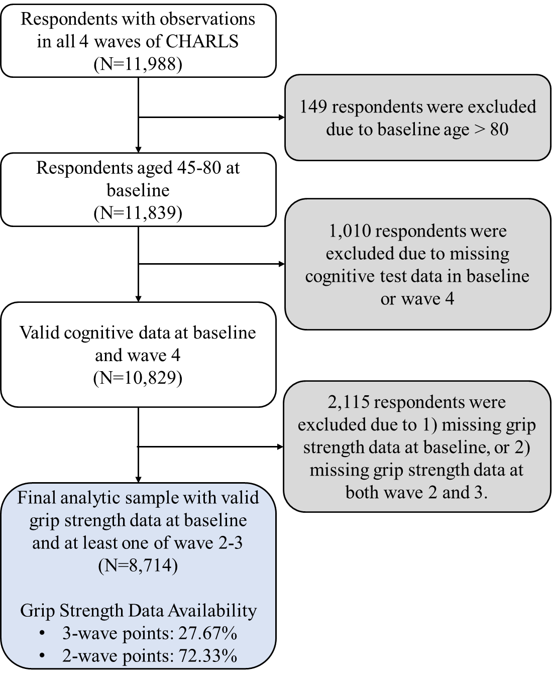

Figure 1. Flowchart of participant selection
Notes: The figure illustrates the exclusion criteria applied to the initial sample to derive the final analytic sample.
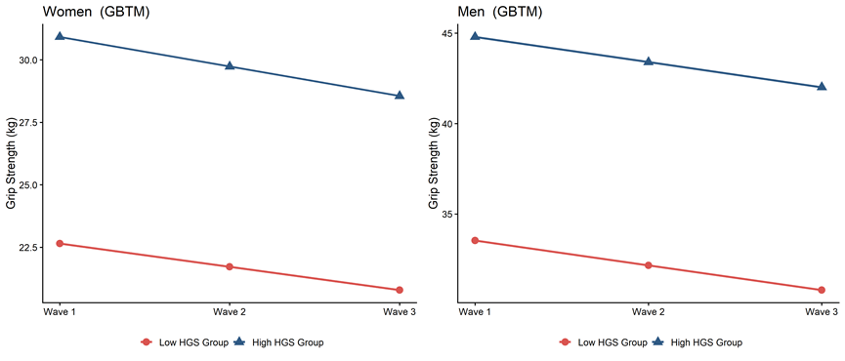

Figure 2. Longitudinal trajectories of HGS groups, stratified by sex
Notes: Trajectories were identified using group-based trajectory modeling (GBTM). The left panel displays trajectories for women (N= 4,760), and the right panel displays trajectories for men (N=3,954). The blue line indicates the High HGS group, and the red line indicates the Low HGS group. The y-axis represents the HGS in kilograms (kg) and the x-axis represents study waves.

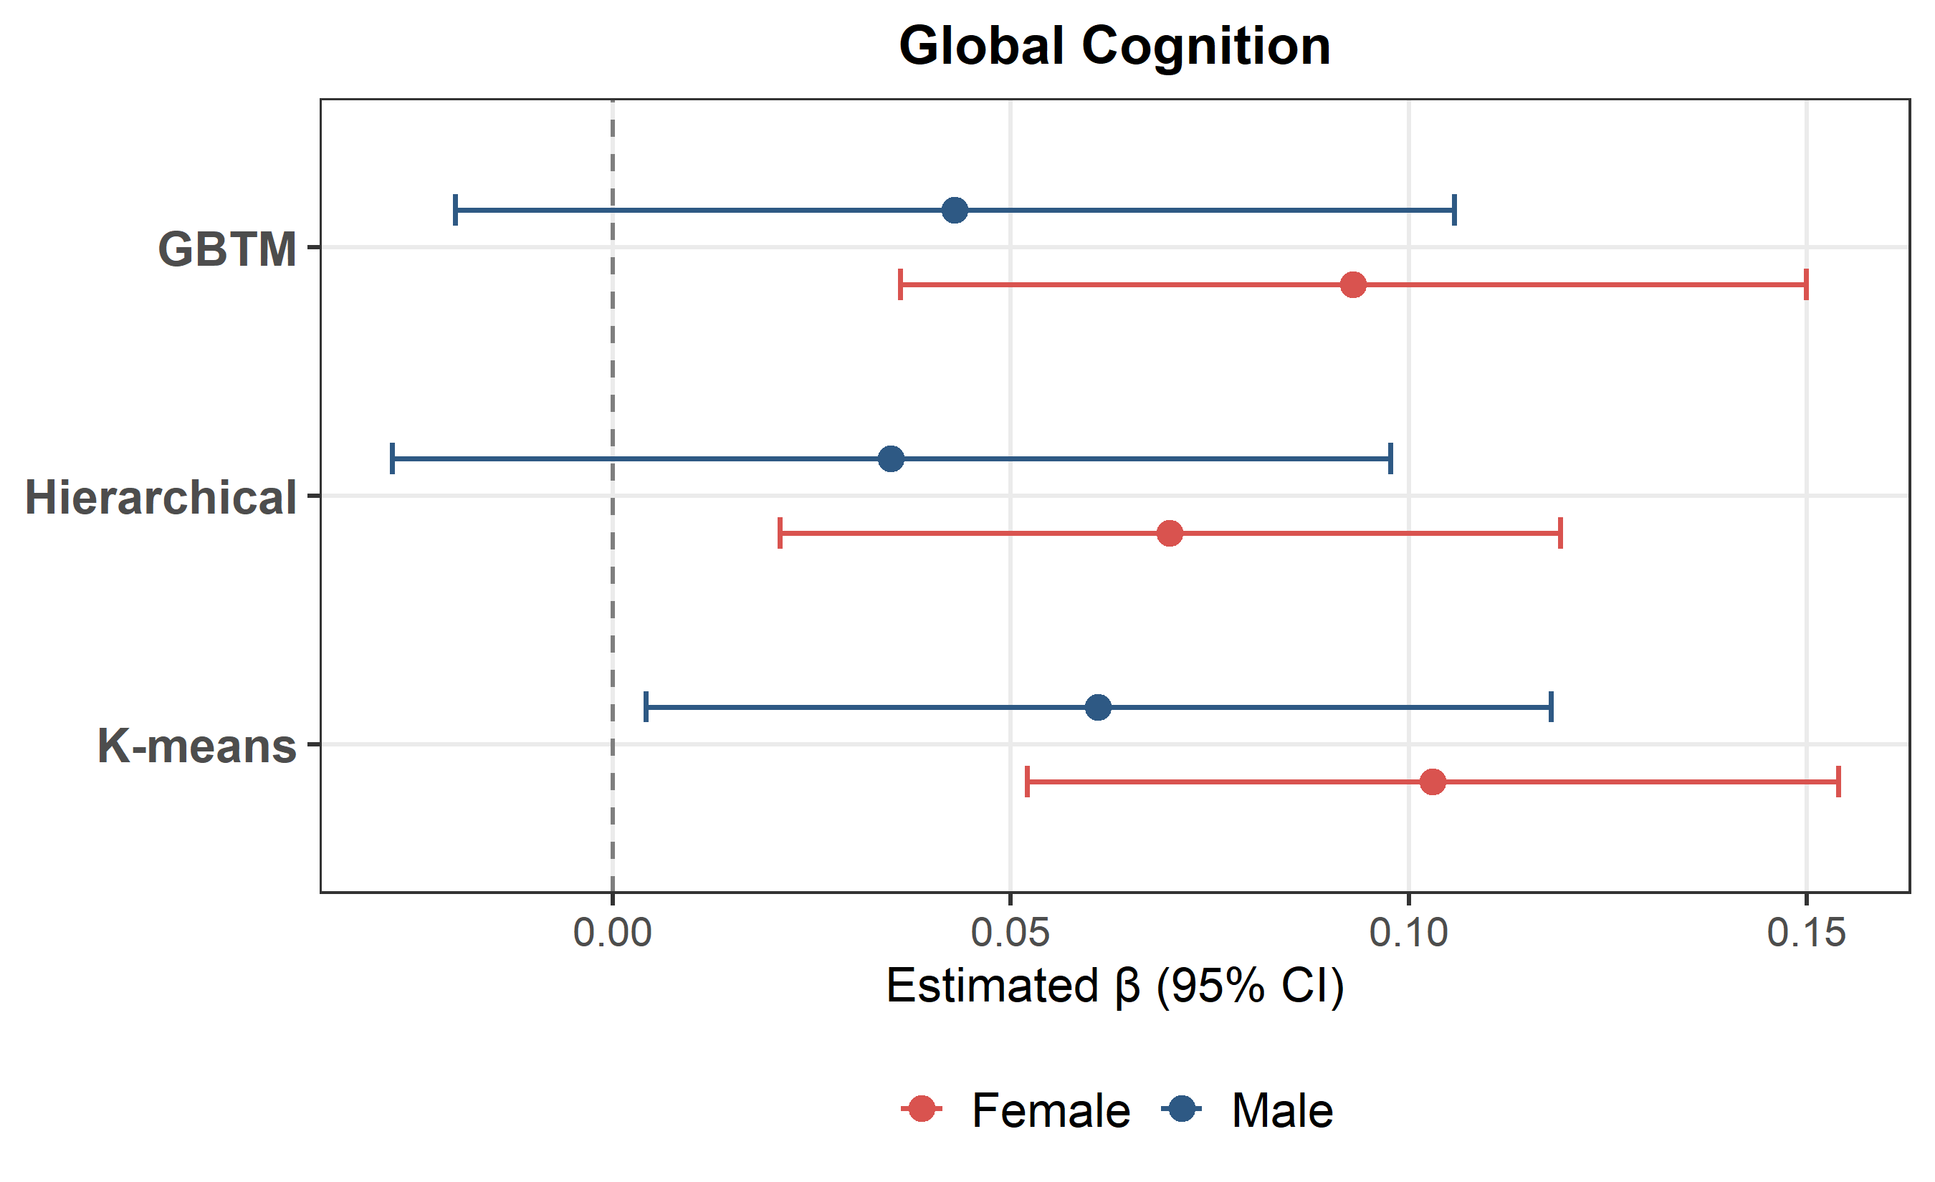
Figure 3. Associations between HGS groups and global cognitive performance across three clustering methods
Notes: The figures display fully adjusted standardized regression coefficients and 95% confidence intervals for the “High HGS group”, with the “Low HGS group” as the reference. The blue line represents estimates for men, and the red line represents estimates for women. Results are compared across three longitudinal clustering algorithms: GBTM: Group-Based Trajectory Modeling (primary method). Hierarchy: Hierarchical clustering for multivariate longitudinal data. Kmeans: Longitudinal K-means clustering.

