Supplementary Data
Sex-Specific Handgrip Strength Trajectories and Cognitive Performance in Older Chinese Adults

Supplementary Methods

GBTM Model Selection
To determine the optimal number of trajectory groups, we tested one- to six-group models, estimated separately for women and men. The Bayesian Information Criterion (BIC) guided model selection. The plot of BIC values demonstrated a clear “elbow” pattern: a substantial decrease was observed when moving to a two-group solution, after which improvements in BIC diminished markedly with additional groups. We subsequently evaluated models with higher-order polynomial terms (quadratic and cubic). These models showed negligible changes in fit indices and captured trajectory structures nearly identical to the linear specification. We therefore selected the two-group linear model for parsimony.
Classification diagnostics indicated robust assignment quality. Average posterior probabilities (AvePP) exceeded 0.7, and the odds of correct classification (OCC) exceeded 5, both surpassing the general recommendations for group-based trajectory modelling [25]. The estimated group proportions aligned closely with the observed assignment proportions, indicating good classification consistency.

Alternative Clustering Methods
Longitudinal K-means clustering was implemented using the kml package in R [27]. This approach partitions longitudinal sequences based on Euclidean distance between individual trajectories and cluster centroids, without imposing parametric distributional assumptions.
Hierarchical clustering for multivariate longitudinal data was implemented using the clusterMLD package in R [28]. This method uses a dissimilarity matrix derived from the multivariate longitudinal structure and applies agglomerative hierarchical clustering.
Cross-method agreement was evaluated using Kendall’s W (coefficient of concordance) and polychoric correlations.

Supplementary Table S1. Baseline Characteristics of HGS Groups, Stratified by Sex
 | Women |  |  |  | Men
 | Low HGS Group | High HGS Group | Diff. |  | Low HGS Group | High HGS Group | Diff.
Global cognitive score | 11.62 [11.34, 11.90] | 15.00 [14.66, 15.34] | 3.38*** |  | 12.93 [12.44, 13.41] | 15.64 [15.32, 15.97] | 2.72***
Orientation score | 3.22 [3.15, 3.29] | 3.85 [3.79, 3.92] | 0.63*** |  | 3.54 [3.42, 3.66] | 4.07 [4.01, 4.13] | 0.53***
Memory score | 5.56 [5.38, 5.73] | 7.34 [7.10, 7.58] | 1.78*** |  | 5.44 [5.14, 5.74] | 6.94 [6.71, 7.18] | 1.50***
Calculation score | 2.39 [2.30, 2.48] | 3.16 [3.07, 3.24] | 0.77*** |  | 3.33 [3.18, 3.47] | 3.85 [3.77, 3.94] | 0.53***
Visuospatial skill score | 0.45 [0.43, 0.48] | 0.65 [0.63, 0.67] | 0.20*** |  | 0.62 [0.58, 0.66] | 0.78 [0.76, 0.80] | 0.16***
HGS (kg) | 22.15 [21.90, 22.41] | 30.99 [30.73, 31.25] | 8.84*** |  | 28.93 [28.44, 29.43] | 38.96 [38.62, 39.30] | 10.03***
Age (years) | 62.61 [62.21, 63.01] | 52.33 [52.00, 52.65] | -10.28*** |  | 67.35 [66.78, 67.92] | 59.01 [58.62, 59.41] | -8.34***
ADL score | 0.38 [0.34, 0.42] | 0.15 [0.13, 0.18] | -0.23*** |  | 0.41 [0.32, 0.49] | 0.14 [0.12, 0.17] | -0.26***
IADL score | 0.55 [0.50, 0.60] | 0.25 [0.21, 0.28] | -0.30*** |  | 0.49 [0.41, 0.57] | 0.21 [0.18, 0.24] | -0.28***
Log per capita expenditure | 8.40 [8.36, 8.44] | 8.63 [8.58, 8.67] | 0.23*** |  | 8.39 [8.32, 8.45] | 8.56 [8.51, 8.60] | 0.17***
Chronic conditions | 1.61 [1.54, 1.68] | 1.18 [1.12, 1.24] | -0.43*** |  | 1.55 [1.42, 1.67] | 1.26 [1.20, 1.33] | -0.28***
Currently married | 75.7% [73.4%, 78.0%] | 91.5% [90.1%, 92.9%] | 15.8%*** |  | 81.1% [77.3%, 84.8%] | 90.6% [89.0%, 92.1%] | 9.5%***
Rural residence | 65.2% [62.9%, 67.6%] | 59.5% [56.9%, 62.0%] | -5.8%** |  | 81.1% [77.3%, 84.8%] | 90.6% [89.0%, 92.1%] | 9.5%***
Education
---Primary education or below | 69.0% [66.8%, 71.2%] | 46.6% [44.2%, 49.0%] | -22.4%*** |  | 44.4% [40.4%, 48.5%] | 28.6% [26.4%, 30.9%] | -15.8%***
---Secondary education | 18.2% [16.4%, 20.0%] | 19.0% [17.3%, 20.8%] | 0.90% |  | 33.9% [30.0%, 37.8%] | 30.8% [28.2%, 33.4%] | -3.1%***
---Tertiary education | 12.8% [11.2%, 14.4%] | 34.3% [31.8%, 36.9%] | 21.5%*** |  | 21.6% [18.3%, 24.9%] | 40.6% [37.8%, 43.3%] | 18.9%***
Currently drink | 12.3% [10.8%, 13.8%] | 11.6% [10.2%, 13.0%] | -0.70% |  | 46.9% [42.9%, 50.9%] | 57.3% [54.7%, 59.9%] | 10.4%***
Currently smoke | 7.9% [6.6%, 9.2%] | 4.0% [3.2%, 4.8%] | -3.9%*** |  | 55.3% [51.3%, 59.3%] | 57.0% [54.3%, 59.8%] | 1.7%
BMI
---Underweight | 7.2% [5.9%, 8.6%] | 1.7% [1.1%, 2.2%] | -5.6%*** |  | 10.0% [7.8%, 12.2%] | 3.4% [2.6%, 4.2%] | -6.6%***
---Normal | 52.7% [50.4%, 55.1%] | 43.8% [41.4%, 46.2%] | -9.0%*** |  | 67.8% [64.0%, 71.6%] | 63.5% [60.8%, 66.1%] | -4.3%***
---Overweight | 40.0% [37.7%, 42.3%] | 54.5% [52.1%, 56.9%] | 14.5%*** |  | 22.4% [18.9%, 26.0%] | 33.2% [30.6%, 35.8%] | 10.8%***
Notes: Data are presented as weighted means [95% confidence interval] or weighted percentages [95% confidence interval]. The “Diff.” column displays the differences between the High HGS group and the Low HGS group (Reference), assessed using survey-weighted Wald tests. *** P < 0.001, ** P < 0.01, * P < 0.05.

 | Women (60+) |  |  | Men (60+)
 | Model 1 | Model 2 |  | Model 1 | Model 2
Global score | 0.571*** | 0.176** |  | 0.530*** | 0.114*
 | [0.422, 0.719] | [0.060, 0.293] |  | [0.417, 0.642] | [0.018, 0.210]
Orientation score | 0.404*** | 0.066 |  | 0.325*** | 0.022
 | [0.260, 0.548] | [-0.053, 0.186] |  | [0.212, 0.438] | [-0.083, 0.127]
Memory score | 0.523*** | 0.220*** |  | 0.457*** | 0.104
 | [0.380, 0.667] | [0.092, 0.349] |  | [0.336, 0.578] | [-0.010, 0.217]
Calculation score | 0.416*** | 0.068 |  | 0.446*** | 0.112
 | [0.280, 0.551] | [-0.047, 0.184] |  | [0.339, 0.553] | [-0.007, 0.230]
Visuospatial skill score | 0.256*** | 0.024 |  | 0.393*** | 0.129*
 | [0.123, 0.389] | [-0.089, 0.138] |  | [0.268, 0.519] | [0.005, 0.253]
Observations | 1,664 |  |  | 1,653

Supplementary Table S2. Association between HGS Groups and Cognitive Performance among Older Adults (aged ≥60 years), Stratified by Sex
Notes: Data are presented as regression coefficients [95% confidence interval] from weighted linear regression models restricted to participants aged ≥60 years. Outcome variables are standardised Z-scores; the predictor is the HGS trajectory group (reference: Low HGS group). Model 1 is unadjusted. Model 2 adjusted for baseline age, marital status, rural residence, log per capita household expenditure, education, functional status (ADL, IADL), health behaviours (smoking, drinking), BMI, 13 physician-diagnosed chronic conditions, and baseline global cognition. *** P < 0.001, ** P < 0.01, * P < 0.05.

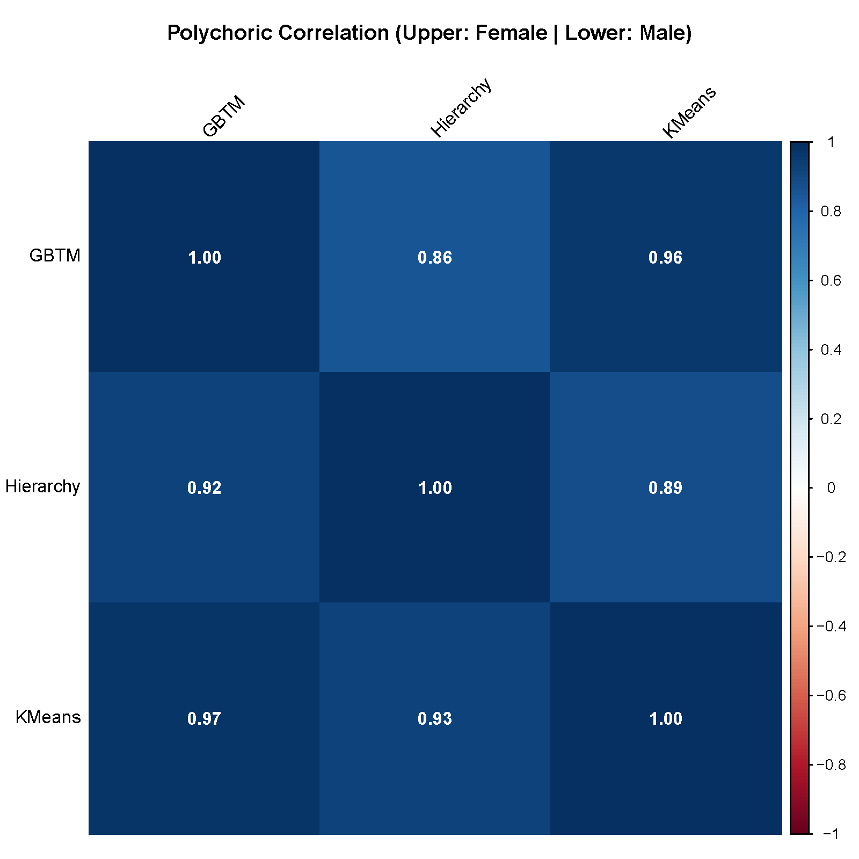
Supplementary Figure S1. Polychoric Correlation Matrix of HGS Trajectory Group Assignments across Three Longitudinal Clustering Algorithms
Notes: Values in the upper triangle represent correlations for women, and values in the lower triangle represent correlations for men. All pairwise polychoric correlations exceeded 0.85, indicating exceptional concordance in trajectory group assignment across methods.

Supplementary Figure S2. Associations between HGS Trajectory Groups and Cognitive Sub-domains across Three Clustering Algorithms, Stratified by Sex
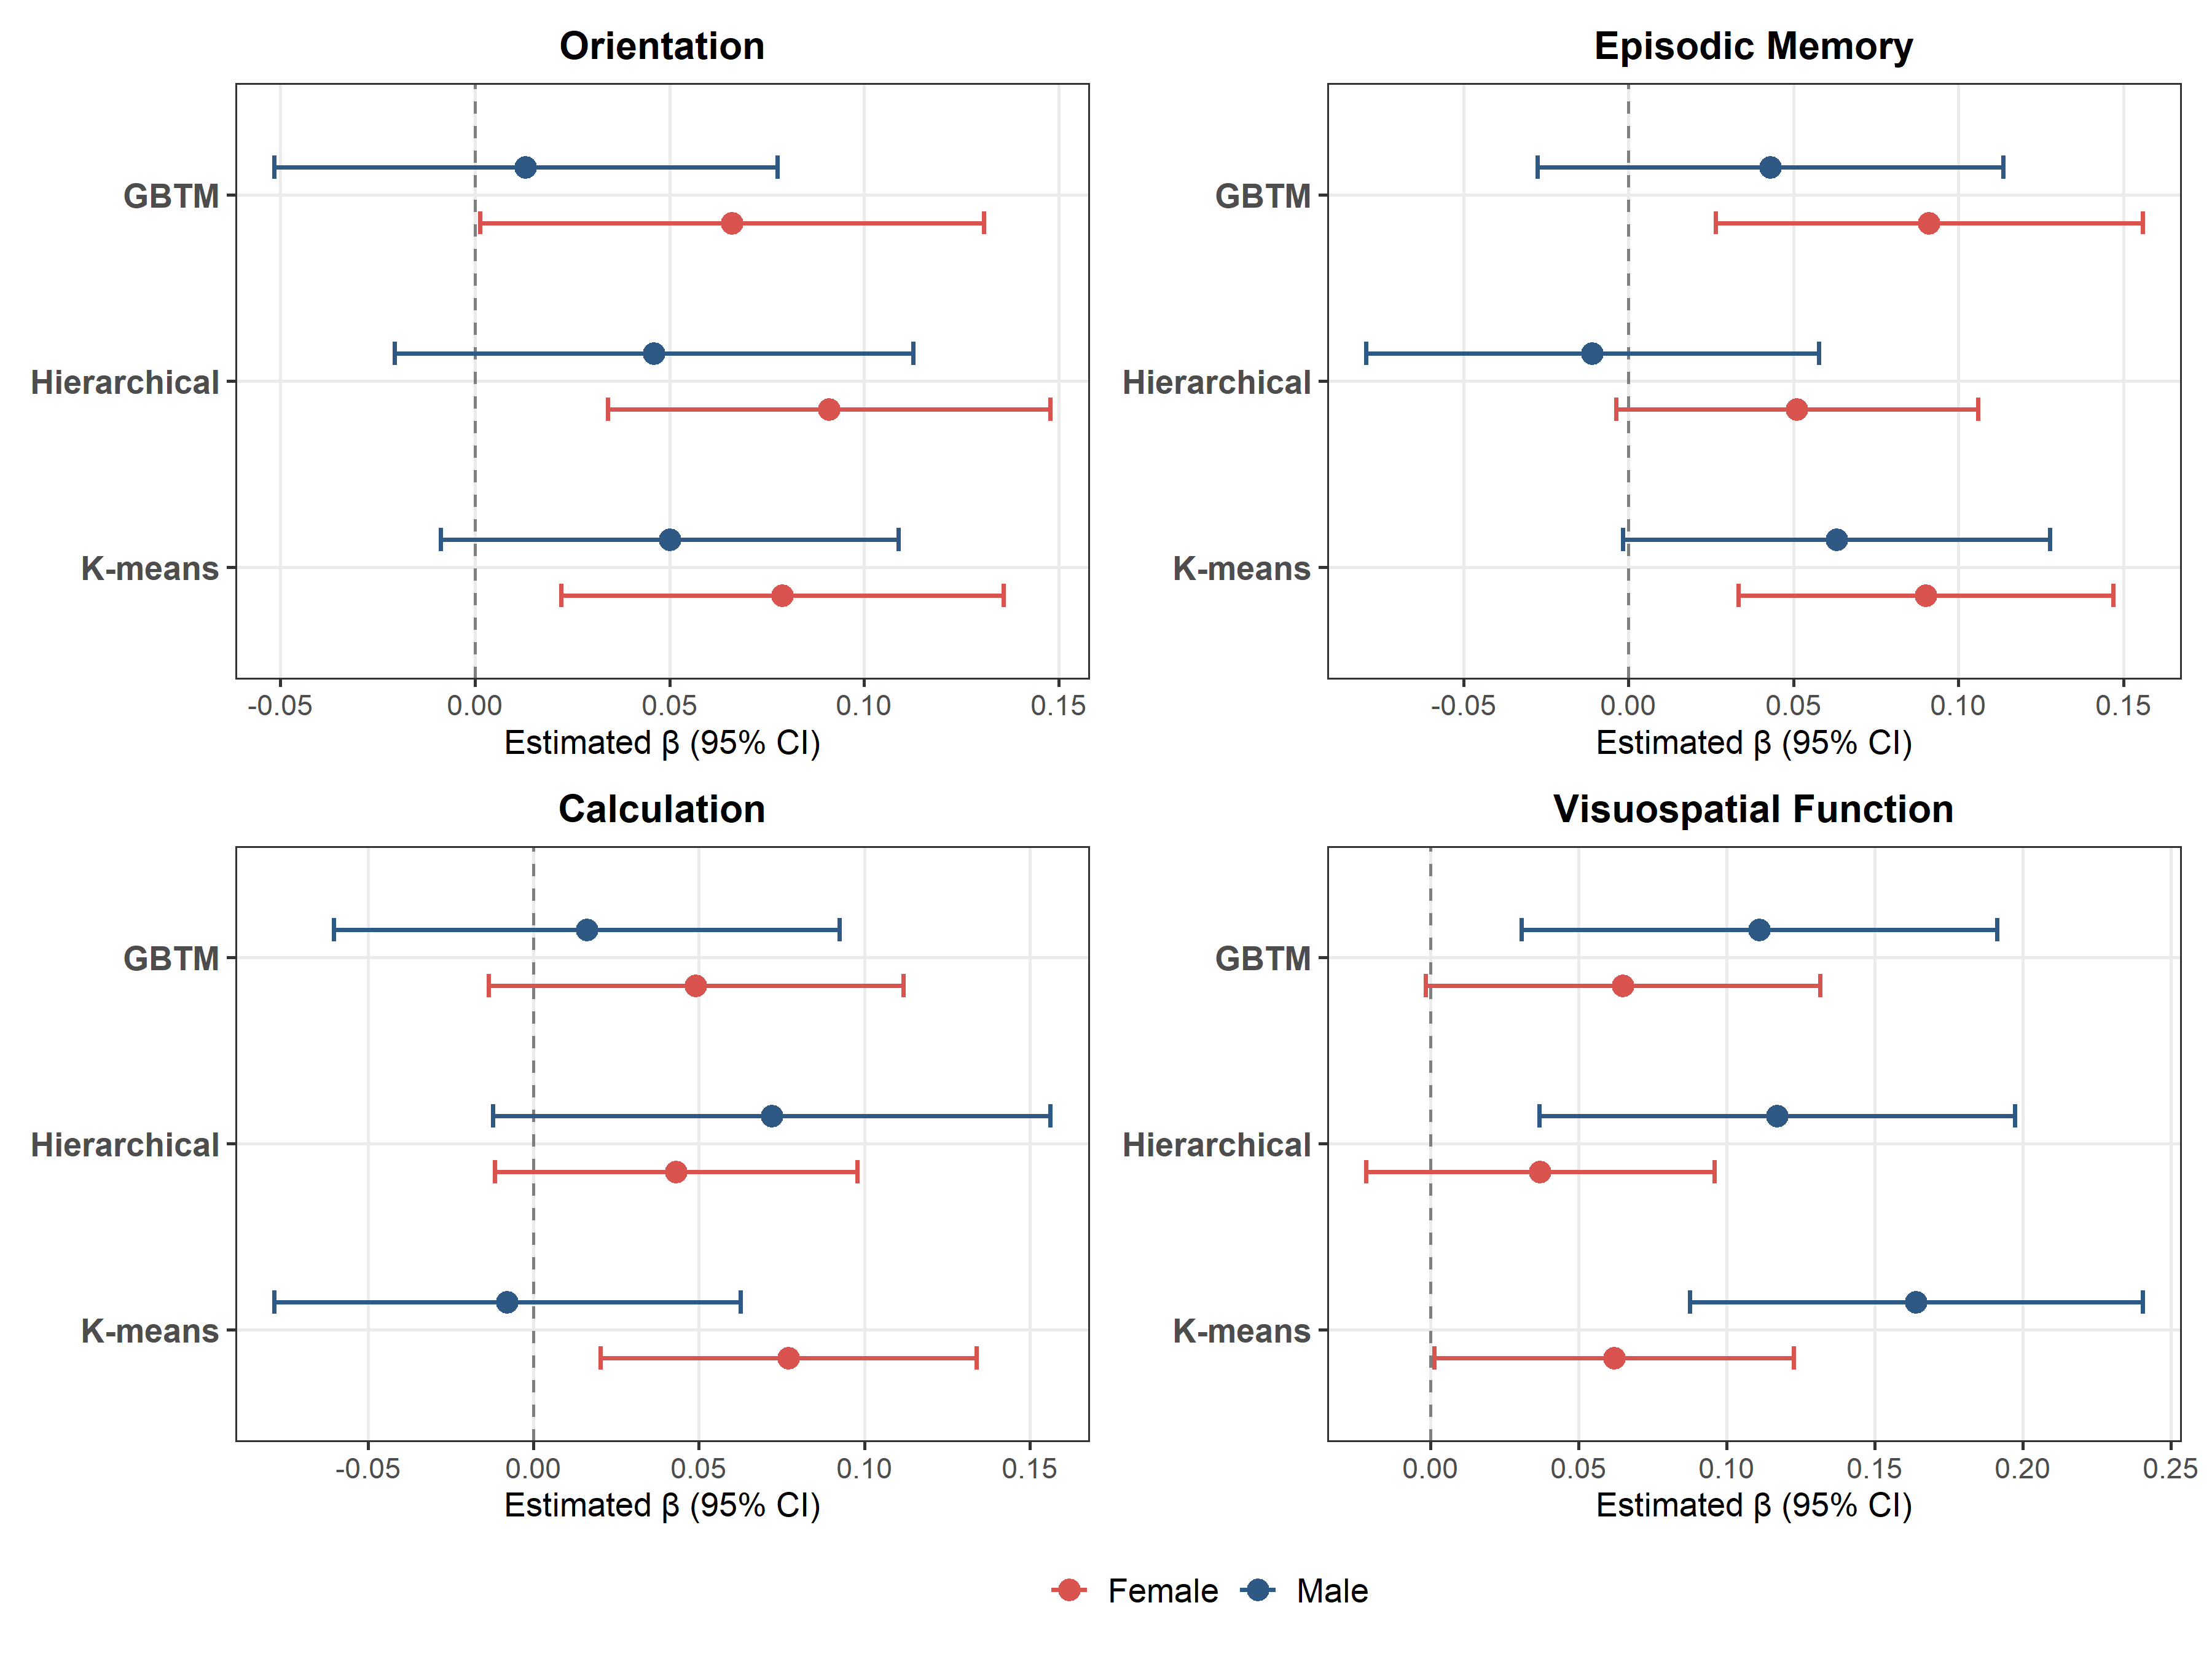
Notes: Four-panel forest plot showing fully adjusted standardised regression coefficients (β) and 95% confidence intervals for the association between High HGS group membership (reference: Low HGS group) and four cognitive sub-domains: orientation, episodic memory, calculation, and visuospatial function. Estimates are from inverse-probability-of-inclusion-weighted linear regression models adjusted for baseline age, marital status, rural residence, log per capita household expenditure, education, functional status (ADL, IADL), health behaviours (smoking, drinking), BMI, 13 physician-diagnosed chronic conditions, and baseline global cognition. Blue markers represent estimates for men; red markers represent estimates for women. The dashed vertical line marks β = 0 (no association). GBTM = group-based trajectory modelling; Hierarchical = hierarchical clustering for multivariate longitudinal data; K-means = longitudinal K-means clustering. The companion figure for global cognition is shown in main-text Figure 3.

