Simulated wealth redistribution and disability-free life expectancy in China: a multistate modelling study

Abstract
Background: Wealth inequality in China has widened considerably during its economic transition, but little is known about its impact on disability burden. This study aimed to examine the association between wealth and incidence, progression, and prognosis of disability, and estimate differences in disability-free life expectancy (DFLE) that could occur with simulated wealth redistributions.
Methods: Longitudinal data were sourced from the China Health and Retirement Longitudinal Study (CHARLS, 2011-2020). The Activities of Daily Living (ADL) scale was used to measure disability. Wealth was defined as couple-level net worth, derived from the sum of all assets minus the value of debts. A multistate Markov model estimated transitions between disability-free, disability, and death states. Microsimulation method was used to measure DFLE and simulate three redistribution strategies. DFLE differences at age 60 were projected under alternative wealth redistribution vs the current wealth distribution.
Results: The sample included 11,579 participants (median [interquartile range] age at study entry, 57 [50-63] years; 49.9% female). The hazard of incident disability generally decreased with increasing wealth, with hazard ratio of 0.89 (95% CI 0.87-0.91). A simulated equal distribution would increase DFLE by 1.42 (95% CI, 1.36-1.49) years, a simulated minimum inheritance proposal would increase DFLE by 1.21 (95% CI, 1.14-1.27) years, and a simulated balanced-minimum inheritance strategy would increase DFLE by 1.03 (95% CI, 0.97-1.10) years. Across all redistribution strategies, DFLE gains were consistently larger for rural participants than for their urban counterparts.
Conclusions: These findings suggest that wealth inequality is associated with reduced DFLE. Simulated wealth redistribution is associated with DFLE gains, which are consistently larger for rural than for urban populations.
Keywords: wealth redistribution; disability-free life expectancy; health equity; multistate model

Introduction
Population aging, accompanied by a substantial rise in disability, poses growing challenges for healthcare systems and social protection structures worldwide ^{[1, 2]}. Disability in later life is not a fixed endpoint but a health state from which individuals may transition to more severe limitation, partial recovery, or death. Disability-free life expectancy (DFLE), integrating both the quantity of survival and the quality of functional independence, has emerged as a key metric for evaluating healthy aging ^{[3]}.
By distinguishing years of healthy life from years lived with dependency, DFLE aligns with the growing public health emphasis on extending healthspan rather than merely lifespan. Understanding determinants that positively influence disability transitions and thereby extend DFLE is crucial for promoting equitable healthy aging.
While growing evidence elucidates that socioeconomic status (SES) plays a fundamental role in the onset and progression of disability ^{[4, 5]} and income inequality is associated with the incidence of adverse health outcomes ^{[6, 7]}, far less attention has been paid to the association of DFLE with accumulated wealth, a distinct dimension of SES that reflects long-term economic security and the capacity to buffer adverse health shocks. Additionally, emerging policy aimed at wealth redistribution—through mechanisms such as taxation or minimum inheritance—raises the possibility that reducing wealth disparities may contribute to gains in DFLE ^{[8, 9]}.
However, high-quality data on wealth are rarely collected in routine health surveys, which obscures the specific contribution of wealth inequality to health outcomes. Furthermore, most existing evidence is cross-sectional, failing to capture the long-term, dynamic impact of wealth on disability transitions ^{[10-12]}.
In China, the distinct urban–rural dual structure has generated marked differences in wealth accumulation, social security coverage, and access to healthcare, which may contribute to larger heterogeneity in the association between wealth and disability transitions compared with high-income welfare states ^{[13]}. This study leverages longitudinal data from the China Health and Retirement Longitudinal Study (CHARLS), we aimed to: (1) examine the longitudinal association between wealth and disability transition ; (2) simulate and compare the DFLE gain of alternative wealth redistribution strategies (equal distribution, minimum inheritance, and balanced-minimum inheritance). This study could provide empirical evidence for policy interventions aimed at fostering equitable healthy ageing in China.

2 Methods
2.1 Study population
The study participants were middle-aged and older adults from the CHARLS, an ongoing, nationally representative, prospective, longitudinal, population-based study in China. Details of the study design have been published elsewhere^{[14]}. Briefly, the probability-proportional-to-size (PPS) sampling approach was implemented in the 2011 CHARLS national baseline research. A total of 17,708 people were enlisted throughout China, and since then, each of the participants has been followed up with every two to three years (wave 2 in 2013, wave 3 in 2015, wave 4 in 2018, and wave 5 in 2020). The Ethical Review Committee approved the protocol of the CHARLS at Peking University. Written informed consent was obtained from all adults.
Participants who entered the study at baseline and had available follow-up data across Waves 2 to 5 (2011-2020) were initially included. We further excluded those who were younger than 45 years old at Wave 1 (n=76), with missing wealth information (n=4,603), and without at least 2 available checkups on disability status between waves 1-5 (n=1,450). Finally, 11,579 participants with 51,598 checkups on multistates were included (Figure S1).
2.2 Ascertainment of disability and mortality
This study used the international standard version of the Activities of Daily Living (ADL) scale^{[15]} to measure disability, which consisted of six items: eating, dressing, bathing, using the toilet, getting in or out of bed and controlling urination and defecation [33]. Four options were provided in response to each item: (1) “No, I don’t have any difficulty”; (2) “I have difficulty but can still do it”; (3) “Yes, I have difficulty and need help”; and (4) “I cannot do it”. Participants who selected the third or fourth option of any item were considered as having disability.
The mortality information in CHARLS was collected from the exit interview in 2013, 2015, 2018, and 2020 waves. As the exact date of death was not reported in CHARLS, we constructed a binary variable to denote the occurrence of death within the 8-year follow-up since baseline in this study. Participants were followed from enrollment until death, loss to follow-up, or wave 5 in 2020, whichever came first.
2.3 Measurement of wealth
Wealth was measured with couple-level wealth (total net worth of assets owned by one and one's spouse or partner) derived from CHARLS datasets provided on the Gateway to Global Aging Data website (https://g2aging.org/health-and-retirement-studies/overview). The components of wealth assessed in CHARLS comprise five categories: (1) primary residence and other real estate, with valuation incorporating the owner's percentage of ownership; (2) transportation, defined as the total value of household vehicles and measured at the household level; (3) business assets, which include the total value of non-financial assets, fixed capital assets, irrigable land, livestock, and aquatic life, also measured at the household level; (4) non-housing financial wealth; and (5) total household debts^{[16]}. Imputed wealth data were provided by survey study teams, except for the 2015 wealth data in CHARLS, which were the raw records reported by study participants.
To account for differences in household size and composition, wealth variables was equivalized using OECD-modified equivalence scale. Specifically, an equivalence weight of 1.0 was assigned to the first adult in the household, 0.5 to the second and each additional household member aged 14 years or older, and 0.3 to each child aged under 14 years[17]. Wealth (i.e., per capita wealth) was then derived by dividing household net wealth by the corresponding equivalence factor. Given the substantial inequality in the distribution of wealth, wealth exhibits a pronounced right-skewed distribution and includes zero and negative values. Accordingly, we apply the inverse hyperbolic sine (IHS) transformation (i.e., IHS-transformed equivalized wealth)[18].
2.4 Wealth redistribution strategies
First, an equal wealth distribution strategy was simulated in which all individuals were assigned the same wealth, corresponding to the mean wealth level of the simulated cohort (115,451 Chinese Yuan [CNY])^{[19]}.
We then modeled a minimum inheritance strategy, as proposed by Piketty^{[20]}, under which each adult is guaranteed a minimum wealth equal to 60% of national per-person wealth. Individuals with wealth below 69,271 CNY (60% of 115,451 CNY) were assigned this minimum value, while the wealth of individuals above this threshold remained unchanged due to government fiscal transfers.
We further considered a balanced minimum inheritance strategy in which the aggregate increase in wealth among individuals below the threshold was fully financed by proportional reductions among individuals in the fifth wealth quintile. In practice, such redistribution could be implemented through higher taxation on capital income or inheritances among wealthier households, with the proceeds used to expand welfare transfers or social protection for individuals with low initial wealth^{[8, 21]}.
The distributions of mean wealth across quintiles under the current wealth distribution and the three wealth redistribution strategies are visualized in Figure S1.
2.5 Statistical analysis
Multi-state Markov model
To examine transitions in disability states over time, multi-state Markov (MSM) models were constructed using the msm package in R (version 4.4.3)^{[22]}. The MSM is a commonly used method for describing the progression of health states over time. It therefore allowed us to estimate the expected duration of each state, the probability of transitions between them, and the risk ratio of transitions across groups. Using proportional hazard models, we performed parameter estimation via maximum likelihood estimation to derive the transition probabilities of health states for different subgroups^{[23]}.
We defined three possible states (disability-free marked as state 1, disability marked as 2, and death marked as 3), where disability-free and disability are designated as transient states, while death as the absorbing state. Transient states can move between adjacent states, but once an absorbing state is reached, no further transitions can occur. Individuals can advance or recover between adjacent states or die from any state. The Markov assumption claims that the rate of transition from one state to another depends only on the current state. The transition intensity matrix, which determines these transitions, is denoted as Q and is given below:
$$Q=\left(\begin{matrix}-\left(μ_{12}+μ_{13}\right) & μ_{12} & μ_{13} \\ μ_{21} & -\left(μ_{21}+μ_{23}\right) & μ_{23} \\ 0 & 0 & 0\end{matrix}\right)$$
The meaning of ${\text{q}}_{\text{rs}}$ is the instantaneous rate from state $\text{r}$ to $\text{s}$. Let x(t) = r denote the state time t of r. The transition intensity of the individual is calculated for the time interval (t, t + t) in which the move to state$\text{s}$ ($\text{s}$ = 1, 2, 3).
$$q_{rs}\left(t\right) = \lim_{δ t → 0}{} \frac{P\left(x\left(t + δ t\right) = s ∣ x\left(t\right) = r\right)}{δ t}$$
The ${\text{q}}_{\text{rs}}$ form a 3 × 3 matrix Q whose rows sum to zero, and the diagonal entries are defined by $q_{rr}=-\sum_{s≠r}{q_{rs}}$. As death is an absorbing state μ31, μ32, and μ33 are also set to 0. The process of fitting the model involves determining the four unknown transition intensities (μ12, μ13, μ21, and μ23) based on Markov assumptions with the Nelder-Mead method and maximizes the likelihood^{[24]}.
Covariates were incorporated into the MSM models to assess their effects on transition intensities, including wealth, age, gender, education, smoking status, drinking status, and rural-urban residence. Age was categorized into three groups (45-54 years, 55-64 years, and ≥65 years). Education was classified into three levels (below primary school, primary school, and secondary school or above). Smoking status and drinking status were coded as binary variables indicating current use. Rural-urban residence was defined as urban or rural.
Microsimulation and wealth redistribution analysis
A microsimulation approach was employed to estimate disability-free life expectancy (DFLE) under different wealth redistribution strategies. Specifically, a synthetic cohort of 100,000 individuals aged 60 years was generated, and individual health and survival trajectories were simulated from age 60 until death^{[25]}. Transitions between health states were governed by transition probabilities estimated from multi-state Markov models. For each simulated individual, the total time spent in each health state across the remaining lifespan was accumulated, and DFLE was calculated as the average time lived without disability in the simulated cohort. We then divided all individuals into five groups according to quintiles of wealth (Q1-Q5), with Q1 representing the lowest wealth group and Q5 the highest.
The initial distribution of disability status, wealth, and other covariates in the simulated cohort was calibrated to match that of participants aged 55-65 years in CHARLS Wave 1. This age range was used to approximate the characteristics of 60-year-olds due to the relatively small sample size at exactly age 60 in Wave 1.
To examine health trajectories under different wealth redistribution strategies, redistributed wealth values were reassigned to each individual to reflect wealth after simulated transfer. Holding all other covariates constant, transition probabilities between health states were recalculated using the MSM models^{[25]}, and DFLE was subsequently re-estimated for each strategy.
DFLE was estimated for the total population and stratified subgroups defined by gender and urban–rural residence under each redistribution strategy. All analyses were conducted using R software (version 4.4.3). The 95% CIs for DFLE estimates were obtained using nonparametric bootstrap resampling.
Sensitivity analyses
Because difficulties with Instrumental Activities of Daily Living (IADL) represent an earlier and milder stage of functional decline and combining both ADL and IADL limitations is a common approach in gerontological research to provide a more comprehensive measure of disability^{[26]}, we redefined the disability state: inability to perform any of the ADLs or IADLs. We conducted the sensitivity analysis using an alternative wealth equivalence scale that focuses more directly on the adult economic unit: wealth was constructed by dividing wealth by 1.5 for coupled households and by 1 for single households^{[16]}. Finally, stratified analyses were performed by gender and urban-rural residence.

3 Results
3.1 Baseline characteristics
A total of 11,579 participants were included, 49.9% were female, and the median age was 57 years (interquartile range [IQR] 50-63 years). At baseline, 1,770 (15.3%) participants had disability, and 9,809 (84.7%) participants were disability-free. The distribution of different states in each wave are summarized (Table S1). The baseline demographic, wealth, and disability characteristics of these participants are summarized (Figure 1 and Table S2).
3.2 Transitions between multistates
The mean follow-up time was 8.24 years (standard deviation 1.76 years), with 6,227 participants having 1 state follow-up, 4,904 participants having 2 state follow-ups, and 447 participants having 3 state follow-ups. This resulted in a total of 51,598 checkup records on multistates. By the last follow-up, 7,675 (66.3%) participants were disability-free, 2,553 (22.1%) had disability, and 1,351 (11.7%) died.
The observed transitions from the current state to the next state at follow-up were summarized (Table S3). For those with a current state of disability-free, 13.5% returned to disability, and 2.2% progressed to death at the next follow-up. For those with a current state of disability, 40.3% recovered to disability-free, and 8.5% progressed to death at the next follow-up.
The transition intensity between multistates was shown in Table 1. The transition intensity of recovery to disability-free from disability (0.295, 95% CI 0.283-0.308) was 3.1 times greater than that of deteriorating to disability from disability-free (0.096, 95% CI 0.093-0.100). For participants with disability, the transition intensity of recovery to disability-free (0.295, 95% CI 0.283-0.308) was 7 times greater than that of transitioning to death (0.042, 95% CI 0.036-0.050). The patterns of transition intensity were broadly similar for participants stratified by gender (female and male) and residence (rural and urban).
3.3 Probability of multistate transitions
The probability of multistate transitions during observation intervals of 1, 2, 3, and 5 years for participants with different states was estimated (Figure 2). For participants with disability, the estimated probabilities of recovering to disability-free, remaining as disability, and transitioning to death were 0.233, 0.731, and 0.037 within a 1‐year observation, and evolved into 0.581, 0.302, and 0.117 within a 5‐year observation, respectively. For participants free of disability, the estimated probabilities of deteriorating to disability, remaining as disability-free, and transitioning to death were 0.079, 0.919, and 0.002 within a 1‐year observation, and evolved into 0.198, 0.772, and 0.030 within a 5‐year observation, respectively (Figure 2A-D). The patterns of transition probability were broadly similar for participants stratified by gender (female [Figure 2E-H] and male [Figure 2I-L]) and residence (rural [Figure 2M-P] and urban [Figure 2Q-T]).
3.4 Wealth effects on multistate transitions
The effects of wealth on the hazard ratios (HRs) of transitions between multistates were estimated in Figure 3. Wealth was associated with deteriorating transitions from disability-free to disability, with HR of 0.89 (95% CI 0.87-0.91). Nevertheless, wealth was not significantly associated with recovery transition and death transition. The finding was robust when stratifying by gender and residence.
3.5 Modeling alternative wealth redistributions
Figure 4 plots the DFLE from age 60 to 85 under the current wealth distribution and three different wealth redistribution. All three alternative wealth redistribution strategies resulted in a longer DFLE compared to the current wealth distribution. Among the three strategies, the equal wealth distribution yielded the most significant DFLE extension, followed by the minimum inheritance strategy, and then the balanced-minimum inheritance strategy. Notably, this advantage was inversely related to age, as the DFLE gap between the strategies gradually converged in later life (Figure 4).
Figure 5A shows differences in DFLE at age 60 under alternative wealth redistribution compared with the current wealth distribution for each quintile of wealth. DFLE shows larger increases at the lower end of the wealth distribution. Under equal wealth distribution, participants’ DFLE increase by 1.42 (95% CI 1.36-1.49) years on average. Specifically, when broken down by quintile, the DFLE gains were 4.08 (95% CI 3.91-4.23), 2.44 (95% CI 2.28-2.62), 1.32 (95% CI 1.17-1.48), and 0.56 (95% CI 0.31-0.61) years in Q1-Q4 groups, respectively. Under minimum inheritance strategy, participants' DFLE increased by 1.21 (95% CI, 1.14-1.27) years, specifically, the DFLE gains for the Q1 to Q4 groups were 3.47 (95% CI, 3.32-3.63), 1.71 (95% CI, 1.57-1.85), 0.85 (95% CI, 0.58-0.99), and 0.19 (95% CI, 0.05-0.35) years, respectively. Under balanced-minimum inheritance strategy, participants' DFLE increased by 1.03 (95% CI, 0.97-1.10) years, specifically, the DFLE gains for the Q1 to Q3 groups were 3.44 (95% CI, 3.28-3.40), 1.64 (95% CI, 1.50-1.78), and 0.64 (95% CI, 0.49-0.78) years, respectively.
These patterns were broadly similar in both male (Figure 5B) and female (Figure 5C), with no substantial gender differences observed. In contrast, urban-rural difference was observed. Across all redistribution strategies, DFLE gains were consistently larger for rural participants than for their urban counterparts. (Figure 5D and 5E). For instance, under the minimum inheritance strategy, the DFLE gain in the all group was more pronounced in the rural population (1.48 years [95% CI, 1.40-1.56 years]) compared to the urban one (0.70 years [95% CI, 0.58-0.82 years]). Notably, this difference also extended to higher wealth groups. Among rural participants in the Q4, all three redistribution strategies yielded modest DFLE gains: 0.53 (95% CI, 0.33-0.72) years for equal wealth distribution, 0.29 (95% CI, 0.10-0.48) years for the minimum inheritance strategy, and 0.23 (95% CI, 0.03-0.43) years for the balanced-minimum inheritance strategy (Figure 5E). By contrast, among urban participants in the Q4, only the equal wealth distribution was associated with a modest gain of 0.34 (95% CI, 0.09-0.59) years (Figure 5D). This suggests potentially stronger marginal health returns to wealth in rural settings.
3.6 Sensitivity analyses
When we replicated the analyses using a broader definition of disability (inability to perform any ADL or IADL), the results remained consistent. The pattern of DFLE differences across wealth quintiles under each redistribution strategy was similar, with the largest gains observed in the lowest wealth quintiles (Figure 6A-E). The findings were also robust to an alternative wealth equivalence scale (dividing household wealth by 1.5 for couples and 1 for singles). Using this metric, we again observed that wealth redistribution was associated with DFLE gains, particularly for the more disadvantaged groups (Q1-Q3), mirroring the results of our main analysis (Figure 6F-J). Meanwhile, in the stratified analyses, similar results were observed in males and females (Figure 6B-C and 6G-H); while the more pronounced DFLE gains among rural participants compared to their urban counterparts were also replicated in the sensitivity analyses (Figure 6D-E and 6I-J).

Discussion
In this nationwide cohort study, we examined the association between wealth and disability transitions and estimated differences in DFLE that occurred with simulated wealth redistributions. First, higher wealth was significantly associated with lower risk of the incidence of disability. Second, the microsimulation showed that simulated wealth redistribution was associated with longer DFLE with equal distribution generated the largest DFLE gains. Third, redistribution-related DFLE gains were larger in rural than in urban population, suggesting stronger marginal health returns to rural residents when achieving the redistribution of wealth.
Our results extend existing evidence that wealth is an important determinant of aging health by demonstrating that wealth is linked not only to health status at a given time point, but also to the bidirectional dynamics of health transitions [27-29]. Participants with higher wealth had lower hazard of deteriorating to disability from disability-free, ultimately contributing to longer DFLE. This may be due to the sustained access to health care, healthier living environments, better nutrition, improved multimorbidity management, and reduced physiological and psychological burden, that come with wealth, which can further shape later life functioning [30-33]. Importantly, our findings thus underscore that wealth operates as a cumulative resource that can buffer functional decline, thereby influencing the trajectory of healthy ageing over time rather than acting as a static socioeconomic indicator.
The largest DFLE gains were observed in the lowest wealth quintile (approximately 3-4 years), consistent with diminishing marginal returns of economic resources to health, whereby additional economic resources yield greater health benefits among disadvantaged populations than among the affluent ^{[34]}. Equal distribution generated the largest overall gains in DFLE, plausibly because it produces the greatest compression of wealth inequality ^{[35]}. By contrast, targeted redistribution (minimum inheritance and balanced-minimum inheritance) produced modest DFLE gains, consistent with previous evidence that targeted transfers can reduce hardship but may not substantially reshape structural determinants of health ^{[36]}. These results suggest that policy formulation should balance overall gains against feasibility and targeting efficiency.
Notably, although minimum inheritance and balanced-minimum inheritance produced similar average DFLE gains at all population level, their impacts differed markedly across wealth groups. Balanced-minimum inheritance, which combines minimum inheritance guarantees with increased taxation of high-wealth individuals [37], was associated with a reduction in DFLE among the highest wealth quintile, whereas the Minimum inheritance did not significantly affect DFLE in this group. Several mechanisms may account for this contrast. Increased taxation of high-wealth individuals may induce behavioral responses such as reduced investment, tax avoidance, or labor supply adjustments, which can indirectly affect access to high-quality services or perceived economic security [38]. Moreover, perceived relative losses in wealth and social status may increase psychosocial stress, which has been linked to adverse health outcomes [39]. By comparison, minimum inheritance may improve outcomes among disadvantaged populations by strengthening intergenerational asset accumulation while avoiding potential negative spillover among the affluent [40]. Taken together, these findings suggest that minimum inheritance could represent a comparatively balanced and sustainable distribution option, achieving meaningful DFLE gains among disadvantaged groups while limiting unintended adverse effects in higher-wealth groups, though real-world impacts would depend on policy implementation and behavioural responses.
We observed that larger DFLE gains from wealth redistribution in rural than in urban population. This may be attributable to the structural disadvantages characterising of rural settings, including lower baseline wealth, poorer access to health care, inadequate infrastructure, and higher vulnerability to adverse living conditions [41, 42]. Therefore, a given increase in wealth may be more readily translated into improvements in nutrition, housing quality, health-care utilization, and reductions in chronic financial stress, yielding larger marginal health returns [34, 35, 43, 44]. By contrast, in urban areas where baseline access to services and infrastructure is relatively better, additional wealth may yield smaller incremental health benefits. Redistribution strategies that are uniform at the national level may generate unequal health benefits across regions, whereas policies explicitly tailored to rural disadvantage may be more effective in promoting aging health and in reducing geographic health inequalities. Future research should further explore context-specific mechanisms and examine whether rural-focused interventions can amplify the benefits of wealth redistribution.
Strengths and limitations
The primary strength of this study is the use of micro-simulation and multi-state transition modelling to estimate the DFLE of Chinese populations under various wealth redistribution scenarios, and provides novel insights into how socioeconomic policies influence healthy ageing across different population subgroups. Additionally, a series of sensitivity analyses confirmed the robustness of our results. Nevertheless, several limitations should also be noted. First, the nature of observational studies cannot prove causality between wealth redistribution and DFLE. Secondly, wealth was implemented as a static adjustment, without capturing the temporal dynamics through which wealth evolves and influences health ^{[45]}. Future research should incorporate dynamic modeling approaches capable of representing the co-evolution of wealth and health risks over time. Moreover, all covariates were held fixed, and the redistribution scenarios were implemented as changes in wealth only, without allowing for concomitant changes in consumption patterns, health-related behaviors, family support, or health care utilization. In fact, substantial wealth shifts could plausibly reconfigure these sociodemographic and behavioral conditions that shape subsequent health trajectories ^{[46]}. Finally, residual confounding may remain due to unmeasured factors, such as early-life health conditions and local institutional or environmental contexts ^{[47, 48]}, despite adjustment for observed covariates.
Conclusions
The findings of this cohort study suggest that unequal distribution of wealth is associated with reduced DFLE across the entire participants in CHARLS, with particularly harmful consequences for the DFLE of participants with low wealth and rural participants. The redistributive policy—Minimum inheritance—could improve DFLE of entire participants without harming the health benefit of those who are currently wealthy. Our study provided quantitative evidence on the potential health benefits of wealth redistribution across diverse population subgroups in China.
Declaration of interests
We declare no competing interests.
Ethics Statement
The CHARLS is approved by the Biomedical Ethics Review Committee of Peking University (No. IRB00001052-11015), and all participants provide informed consent.
Funding
This research was supported by grants from “Pioneer” and “Leading Goose” R&D Programs of Zhejiang Province (2025C02104, 2023C03163), Zhejiang University United Front Work Department’s Think Tank Project Grant, the National Natural Science Foundation of China (82171584), Research Center of Prevention and Treatment of Senescence Syndrome, School of Medicine Zhejiang University (2022010002), Zhejiang Key Laboratory of Intelligent Preventive Medicine (2020E10004), and Zhejiang University School of Public Health Interdisciplinary Research Innovation Team Development Project.

Table1. Transition intensity of multistates
 | Transition categories | Disability-free | Disability | Death | Transition intensity (95%CI)
Overall | Deteriorate transitions | Disability-free | Disability |  | 0.096 (0.093-0.100)
 | Recovery transitions | Disability-free | Disability |  | 0.295 (0.283-0.308)
 | Death transitions | Disability-free |  | Death | 0.002 (0.002-0.004)
 |  |  | Disability | Death | 0.042 (0.036-0.050)
Female | Deteriorate transitions | Disability-free | Disability |  | 0.121 (0.115-0.127)
 | Recovery transitions | Disability-free | Disability |  | 0.331 (0.312-0.350)
 | Death transitions | Disability-free |  | Death | 0.001 (0.000-0.001)
 |  |  | Disability | Death | 0.030 (0.026-0.034)
Male | Deteriorate transitions | Disability-free | Disability |  | 0.081 (0.077-0.085)
 | Recovery transitions | Disability-free | Disability |  | 0.281 (0.263-0.300)
 | Death transitions | Disability-free |  | Death | 0.000 (9.78e-05-0.002)
 |  |  | Disability | Death | 0.070 (0.061-0.080)
Urban | Deteriorate transitions | Disability-free | Disability |  | 0.080 (0.075-0.085)
 | Recovery transitions | Disability-free | Disability |  | 0.292 (0.269-0.318)
 | Death transitions | Disability-free |  | Death | 0.000 (3.85e-05-0.002)
 |  |  | Disability | Death | 0.061 (0.053-0.070)
Rural | Deteriorate transitions | Disability-free | Disability |  | 0.109 (0.104-0.114)
 | Recovery transitions | Disability-free | Disability |  | 0.300 (0.285-0.315)
 | Death transitions | Disability-free |  | Death | 0.001 (0.000-0.002)
 |  |  | Disability | Death | 0.038 (0.032-0.044)

Figures and legends
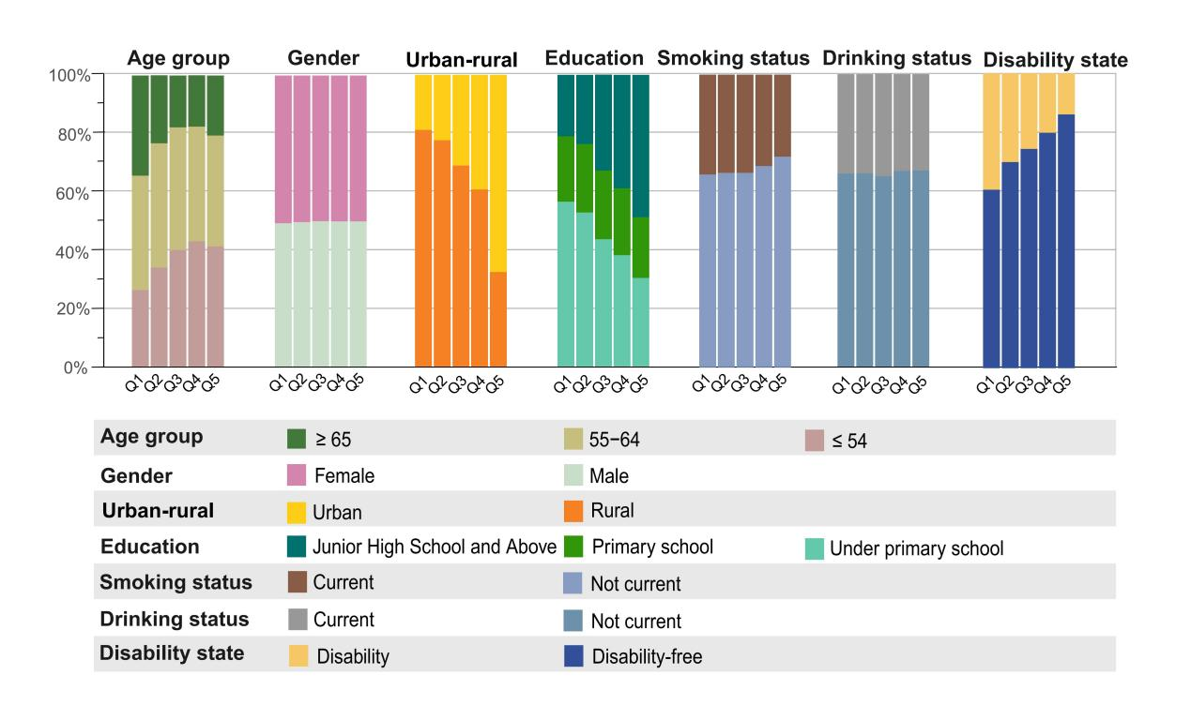
Figure 1. Baseline characteristics by wealth quintiles (Q1-Q5).
Distribution of baseline characteristics by wealth quintiles (Q1-Q5), where Q1 is the lowest and Q5 is the highest. Each panel displays a stacked bar chart showing the proportional composition for a specific characteristic, including age, gender, residence, education, smoking, drinking, and disability status.

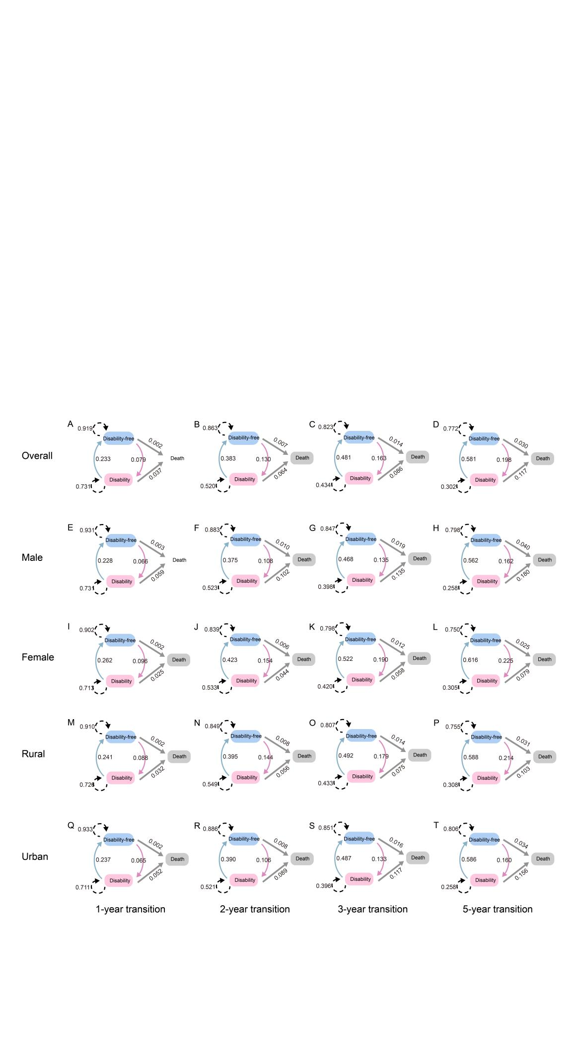
Figure 2. Transition diagrams of multistates within 1, 2, 3, and 5-year observation intervals.
The state transition diagrams are from the multi-state model (MSM) for the overall participants (A-D) and for participants stratified by gender (female [E-H] and male [I-L]) and residence (rural [M-P] and urban [Q-T]). Within each group, the diagrams illustrate transitions over 1-year, 2-year, 3-year, and 5-year observation intervals, respectively. To be specific, in (A), for participants in disability states, the estimated probability of observing maintaining the current state (dashed line from the box of disability), recovery to disability-free states (blue line from the box of disability) and progression to death (grey line from the box of disability) within 1 year was 0.713, 0.262, and 0.025, respectively.

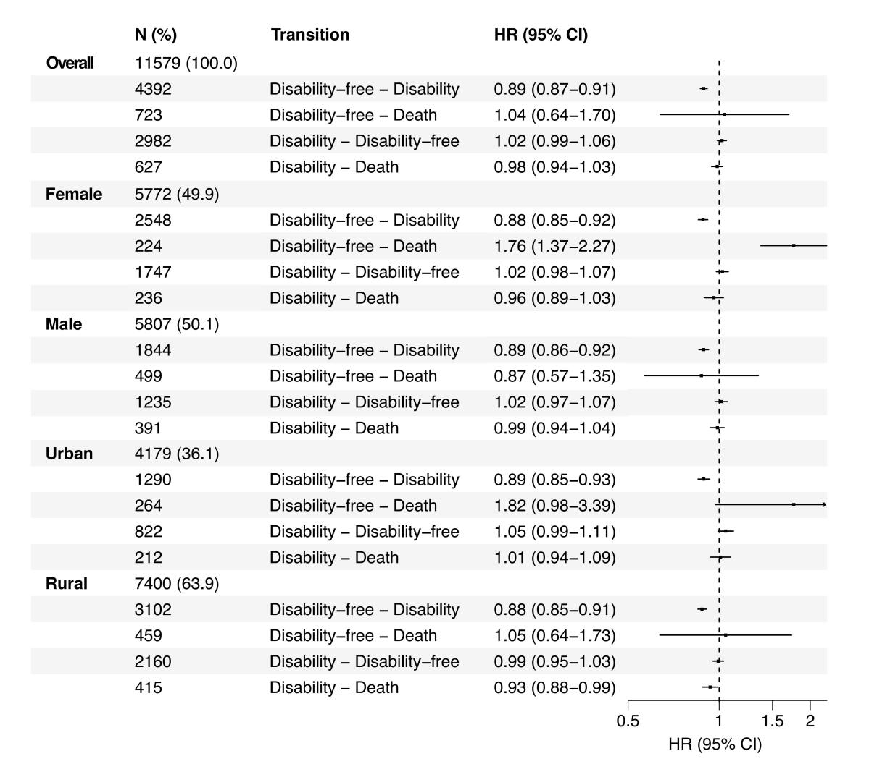
Figure 3. Effects of wealth on transitions between multistates.
The forest plot illustrates the hazard ratios (HRs) for effects of wealth on transitions between multistates (disability-free, disability, and death). The plot is shown for the overall participants and stratified by gender (female and male) and residence (urban and rural). Squares indicate the point estimates of the HRs, and the horizontal lines represent the corresponding 95% confidence intervals (CIs).

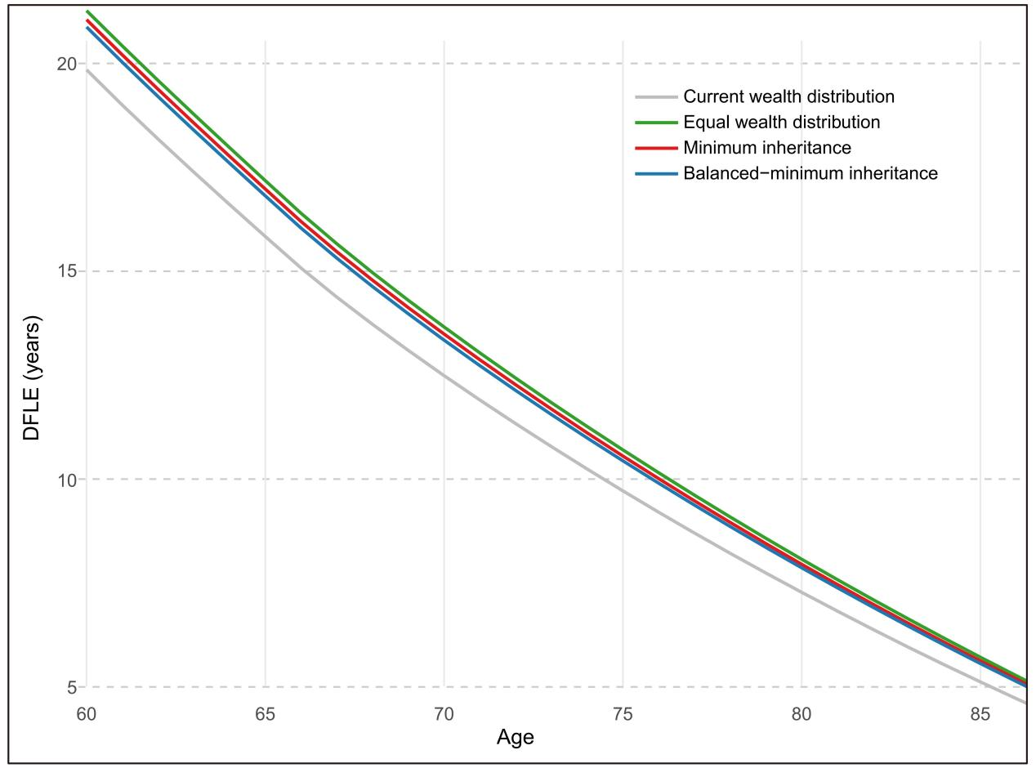
Figure 4. DFLE trajectories by age across wealth redistribution strategies.
The plots shows the DFLE from age 60 to 85 under the current wealth distribution and three different wealth redistribution. Each line represents a distinct wealth distribution strategy: the current distribution (grey), equal wealth distribution (green), minimum inheritance (red), and balanced-minimum inheritance (blue). DFLE, disability-free life expectancy.

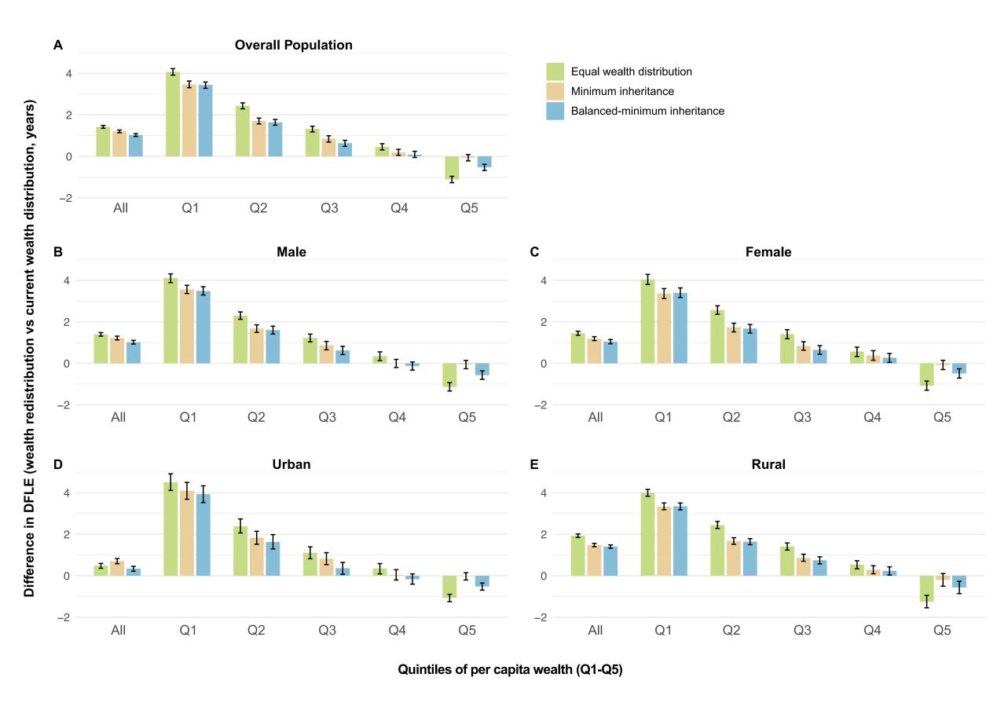
Figure 5. Differences in DFLE at age 60 under wealth redistribution strategies compared with the current wealth distribution.
Bars show the estimated change in DFLE (years) at age 60 under three redistribution strategies relative to the current wealth distribution across quintiles of wealth (Q1-Q5; Q1 lowest, Q5 highest). Green bars indicate Equal wealth distribution, orange bars indicate Minimum inheritance, and blue bars indicate Balanced-minimum inheritance. Results are presented for the overall population (A) and stratified by gender (male [B], female [C]) and residence (urban [D], rural [E]). Positive values indicate gains in DFLE relative to the current distribution. Each bar represents the DFLE gain for a specific wealth quintile, with error bars showing the 95% confidence intervals (CI). DFLE, disability-free life expectancy.

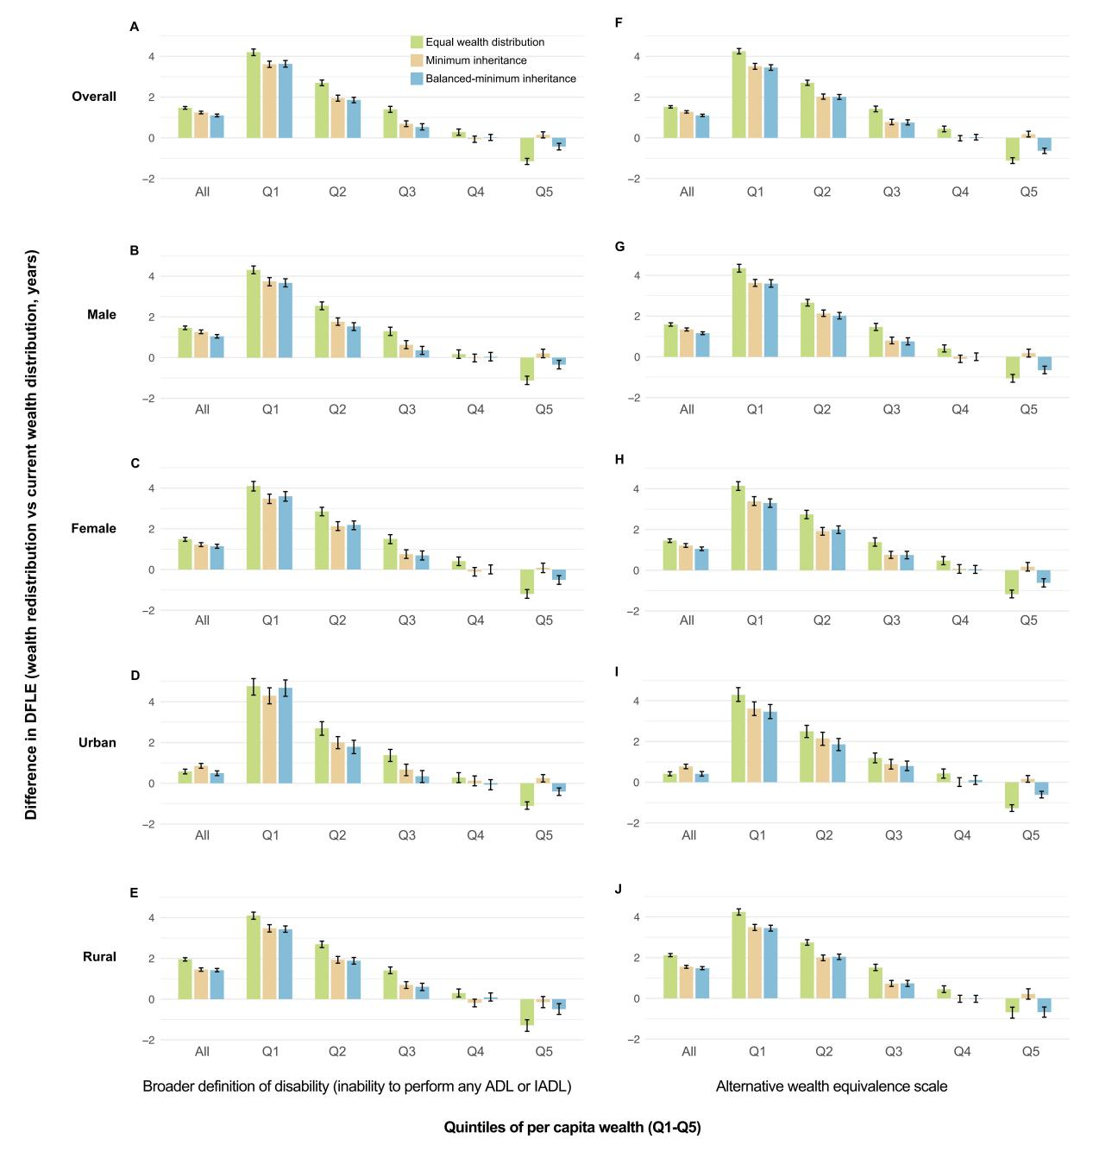
Figure 6. Sensitivity analyses for differences in DFLE at age 60.
The figure shows the difference in DFLE at age 60 under three wealth redistribution strategies compared to the current distribution, tested for robustness under two conditions: a broader disability definition (i.e., inability to perform any ADL or IADL) (A-E) and an alternative wealth equivalence scale (dividing household wealth by 1.5 for couples and 1 for singles) (F-J). Results are presented for the overall population (A and F) and stratified by gender (male [B and G], female [C and H]) and residence (urban [D and I], rural [E and J]). Each bar represents the DFLE gain for a specific wealth quintile, with error bars showing the 95% confidence intervals (CI). DFLE, disability-free life expectancy.
Reference
[1] CIEZA A, SABARIEGO C, BICKENBACH J, et al. Rethinking disability [J]. BMC medicine, 2018, 16(1): 14.
[2] GRÉAUX M, MORO M F, KAMENOV K, et al. Health equity for persons with disabilities: a global scoping review on barriers and interventions in healthcare services [J]. International Journal for Equity in Health, 2023, 22(1): 236.
[3] MURRAY C J, LOPEZ A D. Regional patterns of disability-free life expectancy and disability-adjusted life expectancy: Global Burden of Disease Study [J]. The Lancet, 1997, 349(9062): 1347-52.
[4] HARDING K E, WARDLE M, CARRUTHERS R, et al. Socioeconomic status and disability progression in multiple sclerosis: a multinational study [J]. Neurology, 2019, 92(13): e1497-e506.
[5] MATTHEWS R J, SMITH L K, HANCOCK R M, et al. Socioeconomic factors associated with the onset of disability in older age: a longitudinal study of people aged 75 years and over [J]. Social science & medicine, 2005, 61(7): 1567-75.
[6] MORENO X, LERA L, MORENO F, et al. Socioeconomic inequalities in life expectancy and disability-free life expectancy among Chilean older adults: evidence from a longitudinal study [J]. BMC geriatrics, 2021, 21(1): 176.
[7] DAVIES L E, SINCLAIR D R, TODD C, et al. Area-level socioeconomic inequalities in activities of daily living disability-free life expectancy in England: a modelling study [J]. The Lancet Healthy Longevity, 2025, 6(4).
[8] PIKETTY T, SAEZ E, ZUCMAN G. Rethinking capital and wealth taxation [J]. Oxford Review of Economic Policy, 2023, 39(3): 575-91.
[9] ATKINSON A B. Inequality: What can be done? [M]. Inequality. Harvard University Press. 2015.
[10] MAKAROUN L K, BROWN R T, DIAZ-RAMIREZ L G, et al. Wealth-associated disparities in death and disability in the United States and England [J]. JAMA internal medicine, 2017, 177(12): 1745-53.
[11] HOSSEINPOOR A R, STEWART WILLIAMS J A, GAUTAM J, et al. Socioeconomic inequality in disability among adults: a multicountry study using the World Health Survey [J]. American journal of public health, 2013, 103(7): 1278-86.
[12] TORRES J L, LIMA-COSTA M F, MARMOT M, et al. Wealth and disability in later life: the English Longitudinal Study of Ageing (ELSA) [J]. PloS one, 2016, 11(11): e0166825.
[13] GILES J, LEI X, WANG G, et al. One country, two systems: evidence on retirement patterns in China [J]. J Pension Econ Financ, 2023, 22(2): 188-210.
[14] ZHAO Y, HU Y, SMITH J P, et al. Cohort profile: the China Health and Retirement Longitudinal Study (CHARLS) [J]. Int J Epidemiol, 2014, 43(1): 61-8.
[15] SEATON M K, GROTH G N, MATHESON L, et al. Reliability and Validity of the Milliken Activities of Daily Living Scale [J]. Journal of Occupational Rehabilitation, 2005, 15(3): 343-51.
[16] CHO T C, YU X, GROSS A L, et al. Negative wealth shocks in later life and subsequent cognitive function in older adults in China, England, Mexico, and the USA, 2012-18: a population-based, cross-nationally harmonised, longitudinal study [J]. Lancet Healthy Longev, 2023, 4(9): e461-e9.
[17] MYSÍKOVÁ M, ŽELINSKÝ T, JIRKOVÁ M, et al. Equivalence Scale and Income Poverty: Two Approaches to Estimate Country-specific Scale for the Czech Republic [J]. Social Indicators Research, 2021, 156(1): 21-45.
[18] FRIEDLINE T, MASA R D, CHOWA G A. Transforming wealth: using the inverse hyperbolic sine (IHS) and splines to predict youth's math achievement [J]. Soc Sci Res, 2015, 49: 264-87.
[19] HIMMELSTEIN K E W, TSAI A C, VENKATARAMANI A S. Wealth Redistribution to Extend Longevity in the US [J]. JAMA Intern Med, 2024, 184(3): 311-20.
[20] SEABRIGHT P. Thomas Piketty, A Brief History of Inequality [J]. Society, 2023, 60(1): 114-7.
[21] WEI D, WEISS A C. Personal Finance: Basic Instruments, Taxation Strategies, & Unique Opportunities [J]. Hand Clin, 2024, 40(4): 549-55.
[22] JACKSON C. Multi-State Models for Panel Data: The msm Package for R [J]. Journal of Statistical Software, 2011, 38(8): 1 - 28.
[23] HOU C, LIN Y, REN M, et al. Cognitive functioning transitions, health expectancies, and inequalities among elderly people in China: A nationwide longitudinal study [J]. Int J Geriatr Psychiatry, 2018, 33(12): 1635-44.
[24] LUO Y X, ZHOU X H, HENG T, et al. Bidirectional transitions of sarcopenia states in older adults: The longitudinal evidence from CHARLS [J]. J Cachexia Sarcopenia Muscle, 2024, 15(5): 1915-29.
[25] ZHAN Y Y, HAN Y F, FANG Y. [Determinants of disability free life expectancy in Chinese elderly: based on Multi-states Markov model] [J]. Zhonghua Liu Xing Bing Xue Za Zhi, 2021, 42(6): 1024-9.
[26] ZHU X, WANG Y, LUO Y, et al. Bidirectional, longitudinal associations between depressive symptoms and IADL/ADL disability in older adults in China: a national cohort study [J]. BMC Geriatr, 2024, 24(1): 659.
[27] SHISHEHBOR M H, LITAKER D, POTHIER C E, et al. Association of socioeconomic status with functional capacity, heart rate recovery, and all-cause mortality [J]. JAMA, 2006, 295(7): 784-92.
[28] MIRANDA J J, BARRIENTOS-GUTIERREZ T, CORVALAN C, et al. Understanding the rise of cardiometabolic diseases in low- and middle-income countries [J]. Nat Med, 2019, 25(11): 1667-79.
[29] GAFFNEY A W, HIMMELSTEIN D U, CHRISTIANI D C, et al. Socioeconomic Inequality in Respiratory Health in the US From 1959 to 2018 [J]. JAMA Intern Med, 2021, 181(7): 968-76.
[30] SKALICKA V, VAN LENTHE F, BAMBRA C, et al. Material, psychosocial, behavioural and biomedical factors in the explanation of relative socio-economic inequalities in mortality: evidence from the HUNT study [J]. Int J Epidemiol, 2009, 38(5): 1272-84.
[31] DUGRAVOT A, FAYOSSE A, DUMURGIER J, et al. Social inequalities in multimorbidity, frailty, disability, and transitions to mortality: a 24-year follow-up of the Whitehall II cohort study [J]. Lancet Public Health, 2020, 5(1): e42-e50.
[32] ZHANG R, FENG D, XIA J, et al. The impact of household wealth gap on individual's mental health [J]. BMC Public Health, 2023, 23(1): 1936.
[33] HALLDORSDOTTIR K E, GEIRSDOTTIR O G, OGMUNDSSON O, et al. Socioeconomic Status and Associations with Nutrition in Icelandic Community-Dwelling Older Adults: Results from the AGES-Reykjavik Study [J]. Nutrients, 2025, 17(20).
[34] HENSHER M, BLIZZARD L, CAMPBELL J, et al. Diminishing marginal returns and sufficiency in health-care resource use: an exploratory analysis of outcomes, expenditure, and emissions [J]. Lancet Planet Health, 2024, 8(10): e744-e53.
[35] WILSON G, ROSCIGNO V, SAUER C, et al. Mobility, Inequality, and Beliefs About Distribution and Redistribution [J]. Social Forces, 2021, 100(3): 1053-79.
[36] HANNA R, OLKEN B A. Universal Basic Incomes versus Targeted Transfers: Anti-Poverty Programs in Developing Countries [J]. Journal of Economic Perspectives, 2018, 32(4): 201–26.
[37] ELINDER M, ERIXSON O, WALDENSTRÖM D. Inheritance and wealth inequality: Evidence from population registers [J]. Journal of Public Economics, 2018, 165: 17-30.
[38] BRÜLHART M, GRUBER J, KRAPF M, et al. Behavioral Responses to Wealth Taxes: Evidence from Switzerland [J]. American Economic Journal: Economic Policy, 2022, 14(4): 111–50.
[39] BAUM A, GAROFALO J P, YALI A M. Socioeconomic Status and Chronic Stress: Does Stress Account for SES Effects on Health? [J]. Annals of the New York Academy of Sciences, 1999, 896(1): 131-44.
[40] PIKETTYT. Technical appendix of the book A Brief History of Equality [Z]. 2023
[41] LIEPINS T, NIXON G, STOKES T. Rural–urban differences in health service utilization in upper-middle and high-income countries: a scoping review [J]. International Journal for Equity in Health, 2024, 23(1): 188.
[42] ZHANG X, DUPRE M E, QIU L, et al. Urban-rural differences in the association between access to healthcare and health outcomes among older adults in China [J]. BMC Geriatrics, 2017, 17(1): 151.
[43] AJAYI A A, CUDJOE-MENSAH Y M. Impact of socioeconomic factors on health outcomes [J].
[44] WU Y T, DASKALOPOULOU C, MUNIZ TERRERA G, et al. Education and wealth inequalities in healthy ageing in eight harmonised cohorts in the ATHLOS consortium: a population-based study [J]. Lancet Public Health, 2020, 5(7): e386-e94.
[45] RAN G, ZUO C, LIU D. Negative wealth shocks and subsequent depressive symptoms and trajectories in middle-aged and older adults in the USA, England, China, and Mexico: a population-based, multinational, and longitudinal study [J]. Psychological Medicine, 2024, 54(14): 3888-95.
[46] HIMMELSTEIN K E W, TSAI A C, VENKATARAMANI A S. Wealth Redistribution to Extend Longevity in the US [J]. JAMA Internal Medicine, 2024, 184(3): 311-20.
[47] CICCONE D K, VIAN T, MAURER L, et al. Linking governance mechanisms to health outcomes: a review of the literature in low-and middle-income countries [J]. Social science & medicine, 2014, 117: 86-95.
[48] SALES W B, MARANHÃO E F, RAMALHO C S T, et al. Early life circumstances and their impact on health in adulthood and later life: a systematic review [J]. BMC geriatrics, 2024, 24(1): 978.

