ONLINE SUPPLEMENT

Risk Adjustment for ADRD in Medicare Advantage and Health Care Experiences

eFigure 1: Drop MA ADRD Beneficiaries with Self-Response

eFigure 2: Exclude Beneficiaries in Current MA Plan for Less than 3 Years

eFigure 3: Using Balanced Repeated Replications Method

eFigure 4: Exclude MA Beneficiaries Under 65

eFigure 5: Using All Conditions as Control

eFigure 6: Placebo Tests Using Other Conditions as Placebo Treatment Group

eFigure 7: Placebo Tests Using Traditional Medicare Beneficiaries

eFigure 8: Stratification Analysis

eTable 1: Dynamic Association between the Inclusion of ADRD HCCs in Payment Model and Care Experiences (Event Study)

eMethods 1: Difference-in-Differences Model

eMethods 2: Event Study Model

eMethods 3: Placebo Tests

eFigure 1. Association between the Inclusion of ADRD HCCs in Payment Model and Care Experiences – Drop MA ADRD Beneficiaries with Self-Response

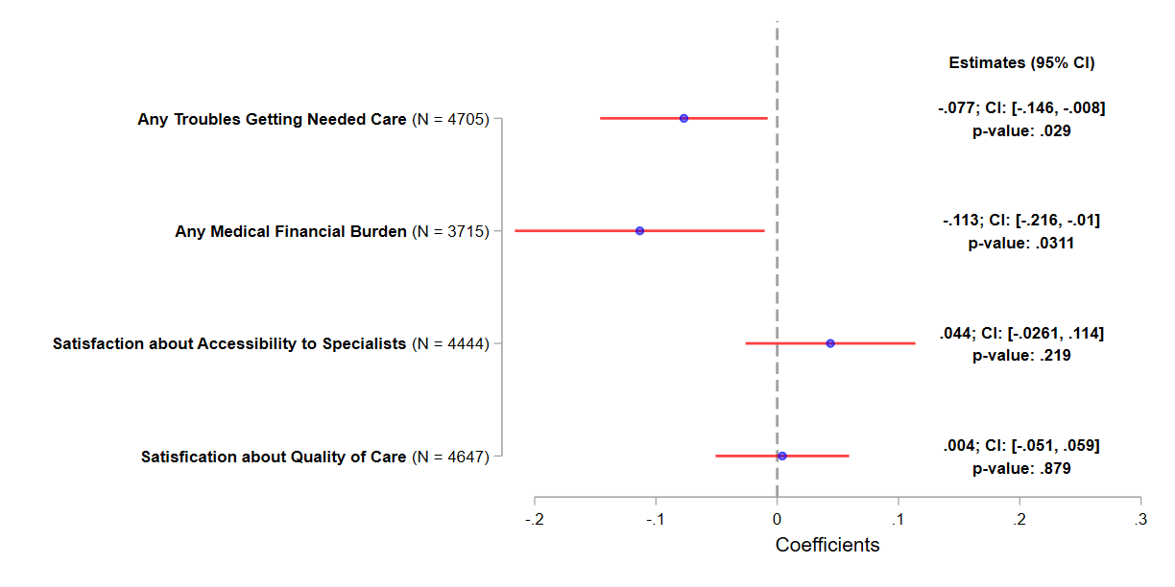

Notes: The working sample consists of MA beneficiaries from 2015-2022 MCBS. Beneficiaries with only partial enrollment in an MA plan during the past year at the time of the survey and veteran are excluded. MA ADRD beneficiaries with self-response in the survey are also removed. The plotted estimates represent the coefficients for interaction term between the treatment indicator and the post indicator from a DID estimation, with the dependent variable indicated on the y-axis. In each DID estimation, the treatment group consists of MA beneficiaries with ADRD, and the control group consists of MA beneficiaries without ADRD but with stroke/brain hemorrhage, complete/partial paralysis, or Parkinson’s diseases. The post indicator takes the value of one if 2020 or afterwards, and zero otherwise. The associated 95% CIs are plotted. Robust standard errors are applied.

eFigure 2. Association between the Inclusion of ADRD HCCs in Payment Model and Care Experiences – Exclude Beneficiaries in Current MA Plan for Less than 3 Years

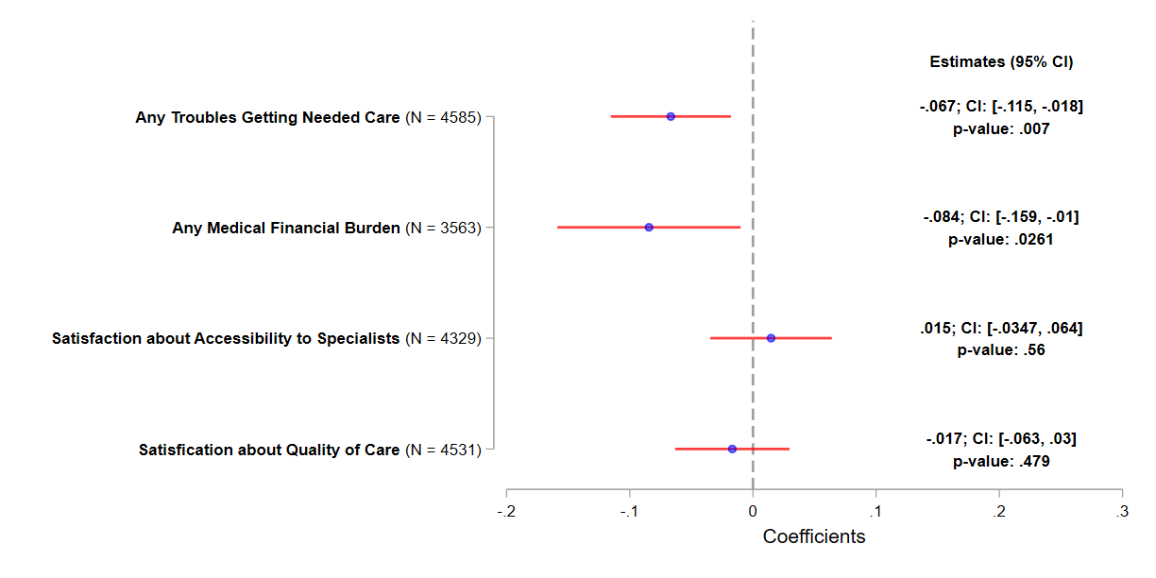

Notes: The working sample consists of MA beneficiaries from 2015-2022 MCBS. Beneficiaries with only partial enrollment in an MA plan during the past year at the time of the survey and veteran are excluded. MA beneficiaries who have been in current MA plans for less than 3 years at the time of the survey are also removed. The plotted estimates represent the coefficients for the interaction term between the treatment indicator and the post indicator from a DID estimation, with the dependent variable indicated on the y-axis. In each DID estimation, the treatment group consists of MA beneficiaries with ADRD, and the control group consists of MA beneficiaries without ADRD but with stroke/brain hemorrhage, complete/partial paralysis, or Parkinson’s diseases. The post indicator takes the value of one if 2020 or afterwards, and zero otherwise. The associated 95% CIs are plotted. Robust standard errors are applied.

eFigure 3. Association between the Inclusion of ADRD HCCs in Payment Model and Care Experiences using Balanced Repeated Replications Method

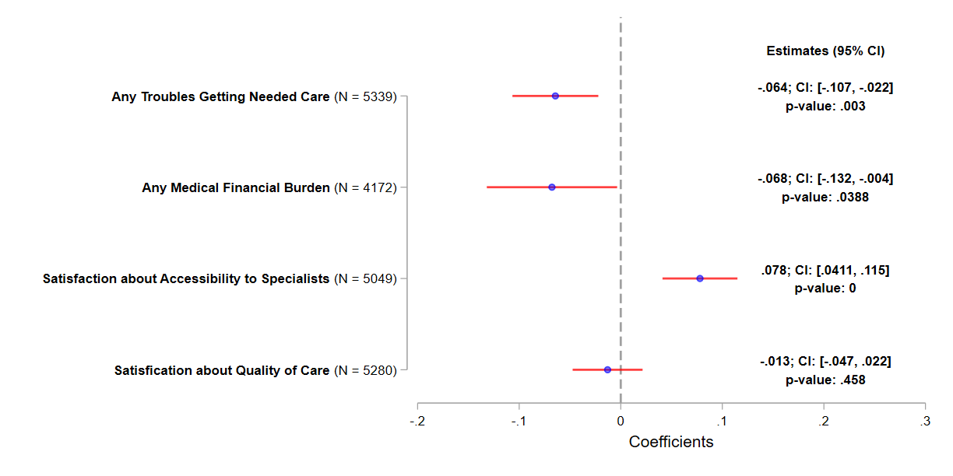

Notes: The working sample consists of MA beneficiaries from 2015-2022 MCBS. Beneficiaries with only partial enrollment in an MA plan during the past year at the time of the survey and veteran are excluded. The plotted estimates represent the coefficients for the interaction term between the treatment indicator and the post indicator from a DID estimation, with the dependent variable indicated on the y-axis. In each DID estimation, the treatment group consists of MA beneficiaries with ADRD, and the control group consists of MA beneficiaries without ADRD but with stroke/brain hemorrhage, complete/partial paralysis, or Parkinson’s diseases. The post indicator takes the value of one if 2020 or afterwards, and zero otherwise. The associated 95% CIs are plotted. Balanced repeated replications (BRR) for standard errors are applied.

eFigure 4. Association between the Inclusion of ADRD HCCs in Payment Model and Care Experiences – Exclude MA Beneficiaries Under 65

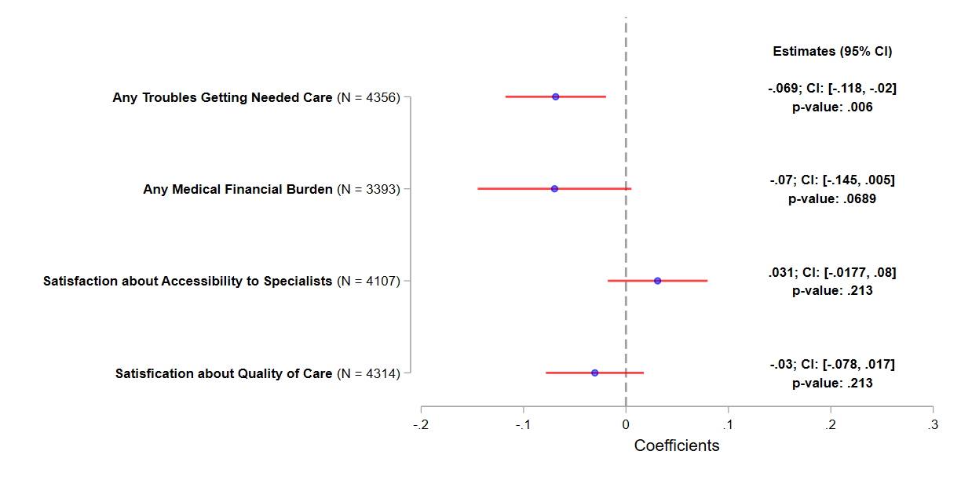

Notes: The working sample consists of MA beneficiaries from 2015-2022 MCBS. Beneficiaries with only partial enrollment in an MA plan during the past year at the time of the survey and veteran are excluded. MA beneficiaries less than 65 years old at the time of the survey are also removed. The plotted estimates represent the coefficients for the interaction term between the treatment indicator and the post indicator from a DID estimation, with the dependent variable indicated on the y-axis. In each DID estimation, the treated group consists of MA beneficiaries with ADRD, and the control group consists of MA beneficiaries without ADRD but with stroke/brain hemorrhage, complete/partial paralysis, or Parkinson’s diseases. The post indicator takes the value of one if 2020 or afterwards, and zero otherwise. The associated 95% CIs are plotted. Robust standard errors are applied.

eFigure 5. Association between the Inclusion of ADRD HCCs in Payment Model and Care Experiences – Using All Conditions as Control

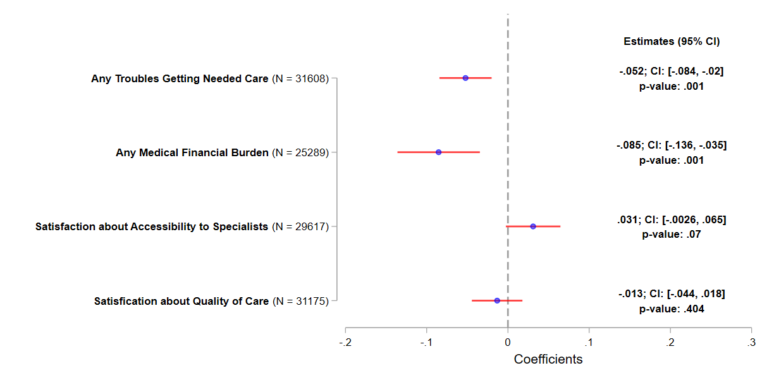

Notes: The working sample consists of MA beneficiaries from 2015-2022 MCBS. Beneficiaries with only partial enrollment in an MA plan during the past year at the time of the survey and veteran are excluded. MA ADRD beneficiaries with self-response in the survey are also removed. The plotted estimates represent the coefficients for the interaction term between the treatment indicator and the post indicator from a DID estimation, with the dependent variable indicated on the y-axis. In each DID estimation, the treatment group consists of MA beneficiaries with ADRD, and the control group consists of MA beneficiaries without ADRD but with other conditions, including but not limited to stroke/brain hemorrhage, complete/partial paralysis, or Parkinson’s diseases. The post indicator takes the value of one if 2020 or afterwards, and zero otherwise. The associated 95% CIs are plotted. Robust standard errors are applied.

eFigure 6. Placebo Tests Using Other Conditions as Placebo Treatment Group

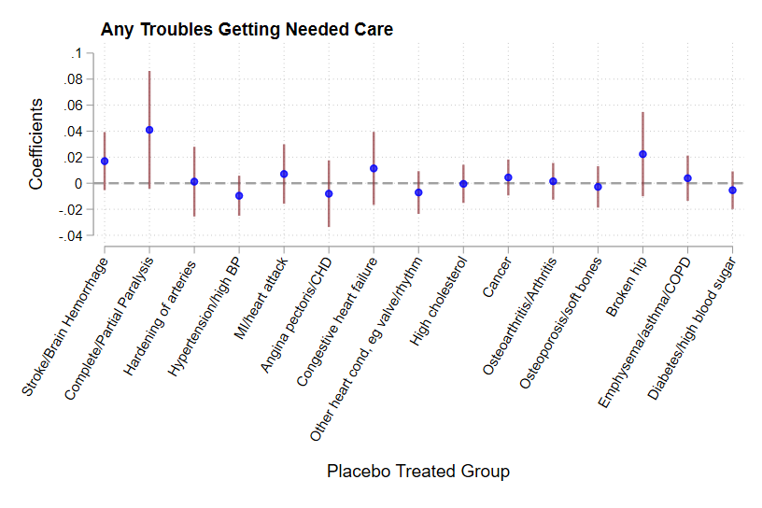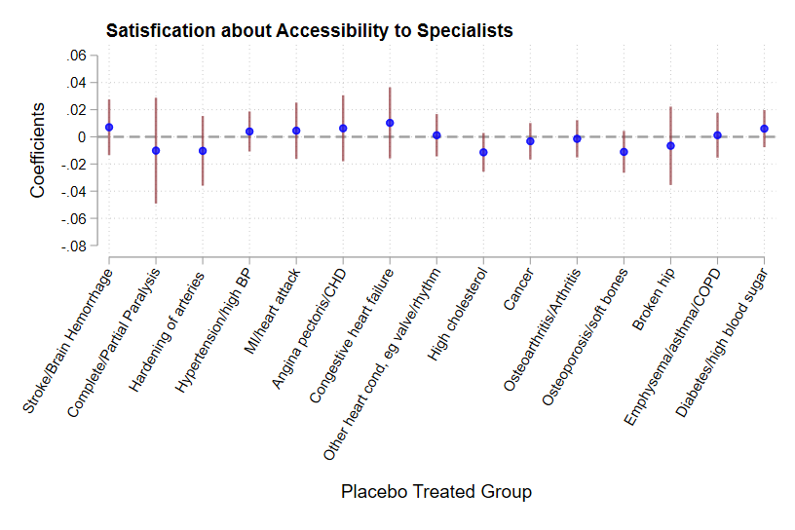
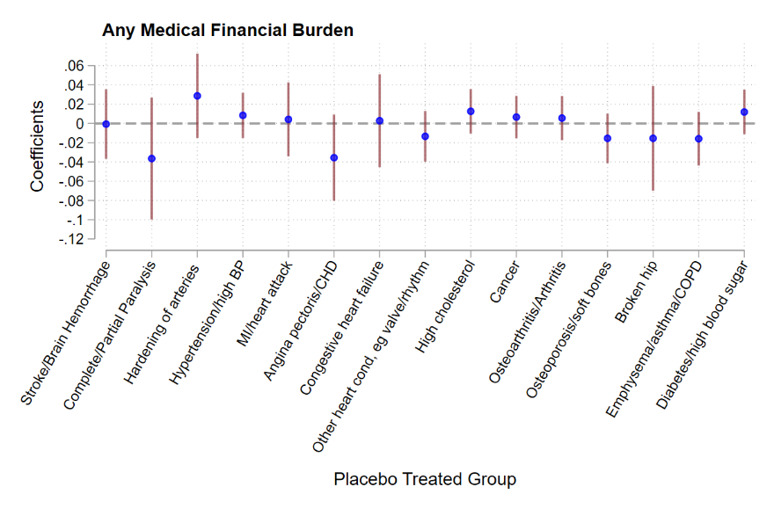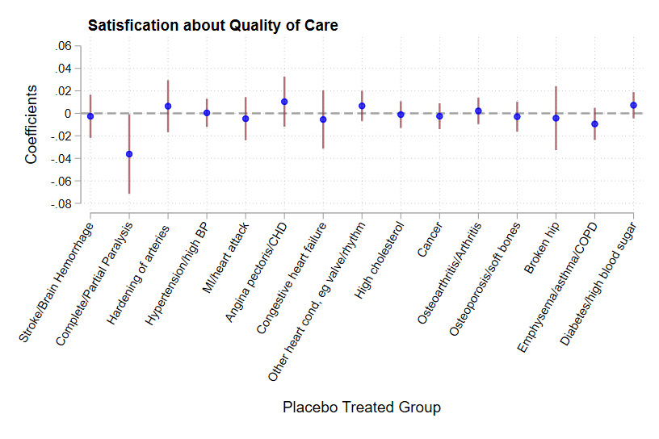

Notes: The working sample consists of MA beneficiaries from 2015-2022 MCBS. Beneficiaries with only partial enrollment in an MA plan during the past year at the time of the survey and veteran are excluded. The plotted estimates represent the coefficients for the interaction term between the treatment indicator and the post indicator from a DID estimation, with the dependent variable indicated in each panel. In each DID estimation, the treatment group consists of non-ADRD MA beneficiaries with the disease specified in the x-axis, and the control group consists of non-ADRD MA beneficiaries without the disease specified in the x-axis. The post indicator takes the value of one if 2020 or afterwards, and zero otherwise. The associated 95% CIs are plotted. Robust standard errors are applied.

eFigure 7. Association between the Inclusion of ADRD HCCs in Payment Model and Care Experiences – Using Traditional Medicare Beneficiaries

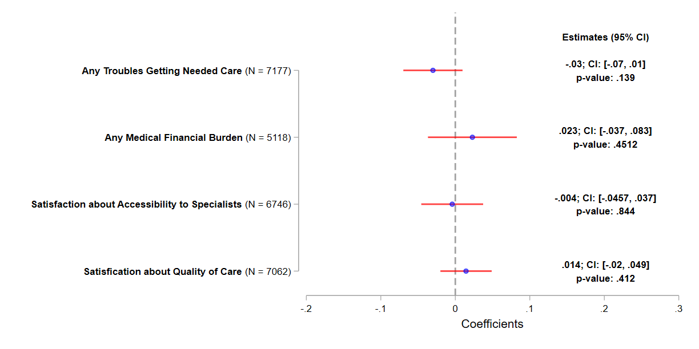

Notes: The working sample consists of TM beneficiaries from 2015-2022 MCBS. Veteran beneficiaries are excluded. The plotted estimates represent the coefficients for the interaction term between the treatment indicator and the post indicator from a DID estimation, with the dependent variable indicated on the y-axis. In each DID estimation, the treatment group consists of TM beneficiaries with ADRD, and the control group consists of TM beneficiaries without ADRD but with stroke/brain hemorrhage, complete/partial paralysis, or Parkinson’s diseases. The post indicator takes the value of one if 2020 or afterwards, and zero otherwise. The associated 95% CIs are plotted. Robust standard errors are applied.

eFigure 8. Association between the Inclusion of ADRD HCCs in Payment Model and Care Experiences – Stratification Analysis

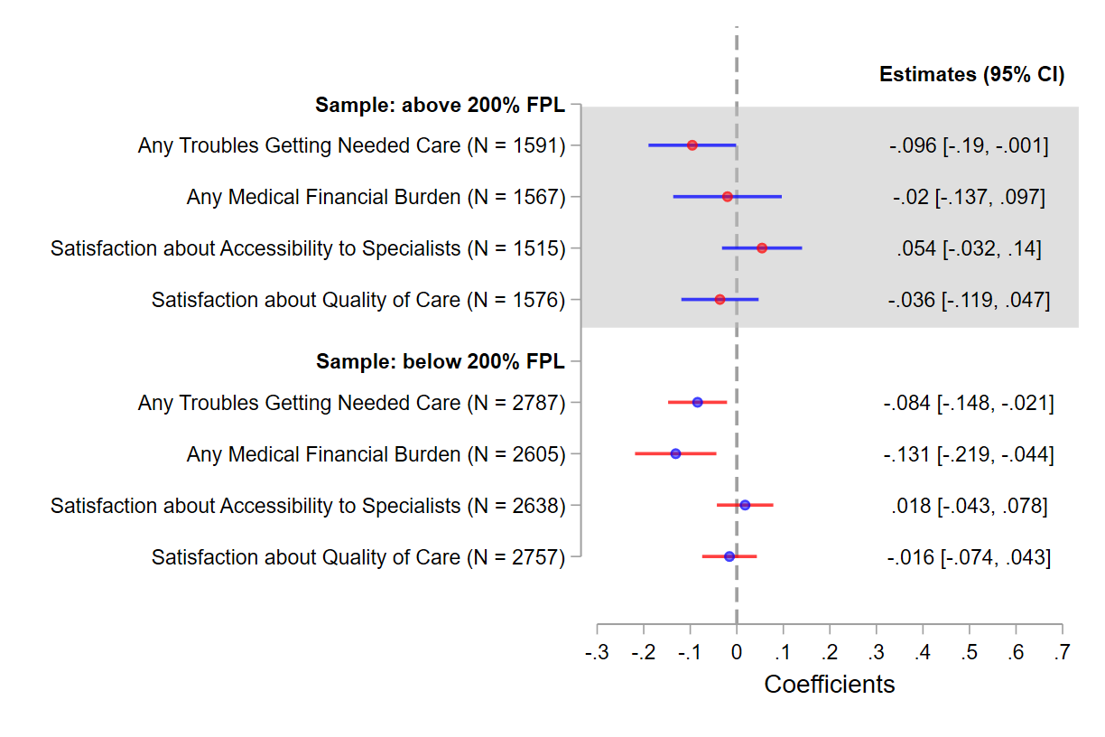 |  | 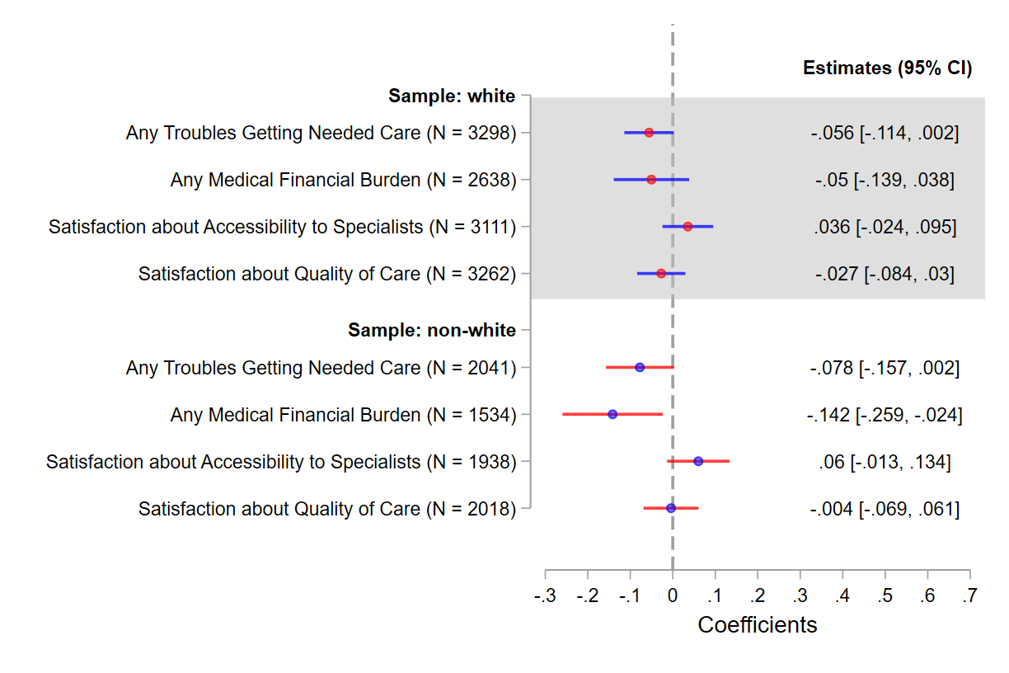
By Income Level |  | By Race/Ethnicity
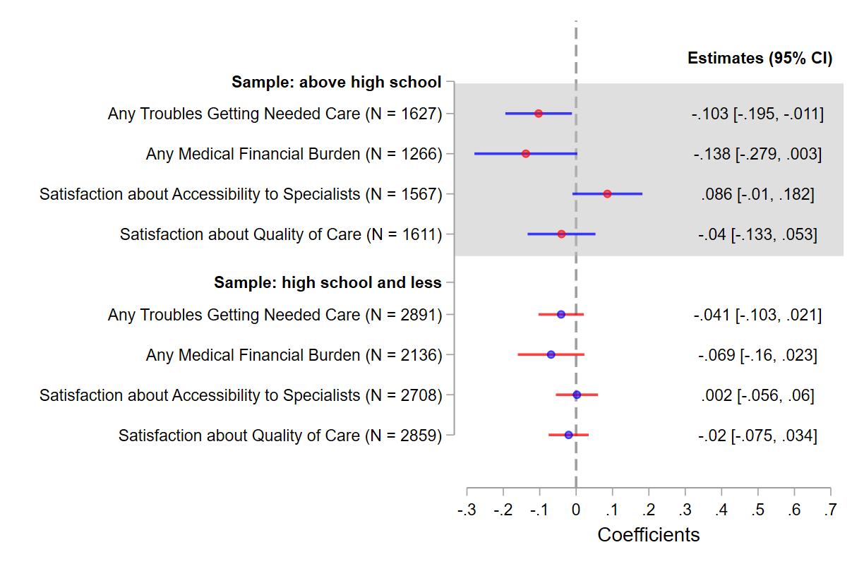 | 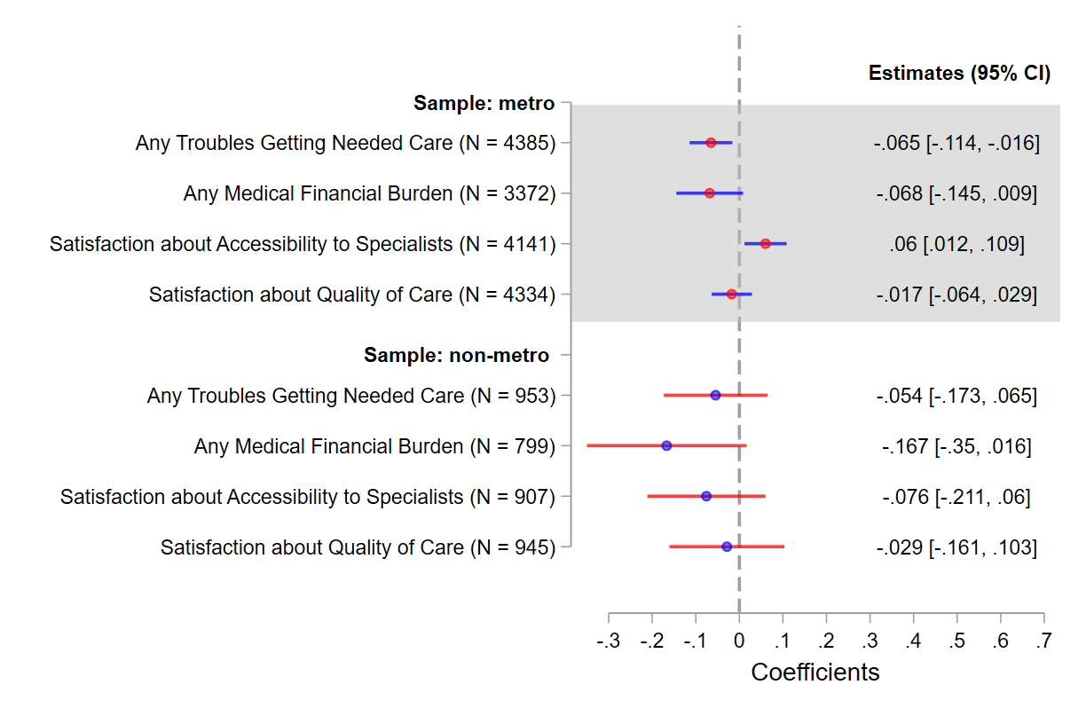
By Education Level | By Metropolitan Status

Notes: The working sample consists of MA beneficiaries from 2015-2022 MCBS. Beneficiaries with only partial enrollment in an MA plan during the past year at the time of the survey and veteran are excluded. The plotted estimates represent the coefficients for the interaction term between the treatment indicator and the post indicator from a DID estimation, with the dependent variable indicated on the y-axis. In each DID estimation, the treatment group consists of MA beneficiaries with ADRD, and the control group consists of MA beneficiaries without ADRD but with stroke/brain hemorrhage, complete/partial paralysis, or Parkinson’s diseases. The post indicator takes the value of one if 2020 or afterwards, and zero otherwise. The associated 95% CIs are plotted. Robust standard errors are applied.

eTable 1. Dynamic Association between the Inclusion of ADRD HCCs in Payment Model and Care Experiences (Event Study)
variable | Coef. | Standard Error | P value | 95% CI: lower | 95% CI: upper
Outcome: Any Trouble Getting Needed Care (N = 5,339)
ADRD $×$ 2015 | -0.0446 | 0.0448 | 0.3199 | -0.1325 | -0.0433
ADRD $×$ 2016 | -0.0156 | 0.0421 | 0.7100 | -0.0981 | 0.0668
ADRD $×$ 2017 | 0.0029 | 0.0460 | 0.9492 | -0.0872 | 0.0930
ADRD $×$ 2018 | -0.0221 | 0.0438 | 0.6148 | -0.1080 | 0.0639
ADRD $×$ 2020 | -0.0481 | 0.0411 | 0.2422 | -0.1288 | 0.0325
ADRD $×$ 2021 | -0.0989 | 0.0421 | 0.0188 | -0.1814 | -0.0164
ADRD $×$ 2022 | -0.0909 | 0.0471 | 0.0536 | -0.1833 | 0.0014
Outcome: Any Medical Financial Burden (N = 4,172)
ADRD $×$ 2017 | -0.0639 | 0.0636 | 0.3148 | -0.1886 | 0.0608
ADRD $×$ 2018 | 0.0193 | 0.0624 | 0.7573 | -0.1031 | 0.1417
ADRD $×$ 2020 | -0.0974 | 0.0584 | 0.0953 | -0.2118 | 0.0171
ADRD $×$ 2021 | -0.1034 | 0.0565 | 0.0672 | -0.2141 | 0.0073
ADRD $×$ 2022 | -0.1174 | 0.0609 | 0.0542 | -0.2368 | 0.0021
Outcome: Satisfaction about Access to Specialists (N = 5,049)
ADRD $×$ 2015 | -0.0301 | 0.0482 | 0.5319 | -0.1246 | 0.0644
ADRD $×$ 2016 | -0.0012 | 0.0446 | 0.9784 | -0.0886 | 0.0862
ADRD $×$ 2017 | 0.0094 | 0.0446 | 0.8323 | -0.0780 | 0.0969
ADRD $×$ 2018 | 0.0261 | 0.0411 | 0.5260 | -0.0545 | 0.1067
ADRD $×$ 2020 | 0.0119 | 0.0410 | 0.7711 | -0.0684 | 0.0923
ADRD $×$ 2021 | 0.0637 | 0.0419 | 0.1283 | -0.0184 | 0.1459
ADRD $×$ 2022 | 0.0526 | 0.0462 | 0.2548 | -0.0380 | 0.1432
Outcome: Satisfaction about Quality of Care (N = 5,280)
ADRD $×$ 2015 | -0.0346 | 0.0374 | 0.3554 | -0.1079 | 0.0388
ADRD $×$ 2016 | -0.0039 | 0.0354 | 0.9123 | -0.0734 | 0.0656
ADRD $×$ 2017 | -0.0281 | 0.0394 | 0.4766 | -0.1053 | 0.0492
ADRD $×$ 2018 | -0.0014 | 0.0344 | 0.9678 | -0.0687 | 0.0660
ADRD $×$ 2020 | -0.0351 | 0.0382 | 0.3587 | -0.1100 | 0.0398
ADRD $×$ 2021 | -0.0295 | 0.0380 | 0.4368 | -0.1040 | 0.0449
ADRD $×$ 2022 | -0.0103 | 0.0430 | 0.8102 | -0.0946 | 0.0740

Notes: The working sample consists of MA beneficiaries from 2015-2022 MCBS. Beneficiaries with only partial enrollment in an MA plan during the past year at the time of the survey and veteran are excluded. In each estimation, the treatment group consists of MA beneficiaries with ADRD, and the control group consists of MA beneficiaries without ADRD but with stroke/brain hemorrhage, complete/partial paralysis, or Parkinson’s diseases. The event study is specified in Appendix B.3. The year of 2019 is selected as the reference year. Robust standard errors are applied.

eMethods 1. Difference-in-Differences Model

We employ a DID model to exploit the inclusion of ADRD HCCs in the risk adjustment model for MA plans in 2020 as a quasi-natural experiment. This model compares care experiences between a treatment and a control group before and after the 2020 policy change.
The treated group is defined as MA enrollees who reported having ever been told they have symptoms of ADRD. To construct a comparable control group, we select MA enrollees who: (1) had never been diagnosed with ADRD, and (2) had been diagnosed with conditions such as stroke or brain hemorrhage, complete or partial paralysis, or Parkinson’s disease. The selection criteria are grounded in the rationale that patients with these conditions are also likely to see neurologists like those with ADRD. This parallel in healthcare pathways allows for a more equitable comparison, ensuring that differences observed can be more confidently attributed to the effects of the ADRD HCCs integration into the risk adjustment model.
Formally, we build a regression model as outlined in Equation (B.1) below.
$y_{it}= β_{0}+β_{1}treated_{it}×post_{t}+β_{2}treated_{it}+γX_{it}^{'}+α_{t}+ϵ_{it}$, | (B.1)
where $y_{it}$ represents the care experience measure for beneficiary $i$ in year $t$. The binary variable $treated_{it}$ indicates whether individual $i$ is classified as treated, as defined above. The binary variable $post_{t}$ takes the value of one for the years following the policy change (2020 and later), and zero otherwise. In a DID framework, the coefficient of the interaction term $treated_{it}×post_{t}$, $β_{1}$, captures the association between the inclusion of ADRD HCCs in the risk adjusted payment model and the care experience of MA beneficiaries with ADRD. A positive $β_{1}$ implies a position association. We apply robust standard errors in the analysis.
To reassure the estimated ${\hat{β}}_{1}$ unbiasedly measures the association of interest, rather than confounded by other unobserved factors, a critical assumption is that, in the absence of the payment model change, the evolution of the outcomes of interest for the control and treatment groups would have followed a similar trajectory over time. This assumption, commonly known as the parallel-trends assumption, is fundamental to the validity of the DID design. It enables the use of the control group’s outcomes as a reliable counterfactual for the treated group.
A notable threat to the parallel-trends assumption is the possibility that the estimated ${\hat{β}}_{1}$ may pick up confounding effects from some concurrent events, such as the onset of the COVID-19 pandemic in early 2020. To address this concern, we undertake several methodological adjustments. First, we include year fixed effects ($α_{t}$) to absorb national-level shocks and contemporary events. Additionally, to account for potential heterogeneous pandemic impacts across subpopulations, we incorporate several interaction terms in $X_{it}^{'}$. These include:
(1) interactions between demographic covariates and year indicators, where the demographic covariates encompass age categories, marital status, race/ethnicity, sex, educational attainment, and household size.
(2) the interactions between each health measure and each year indicator, where the health measures include number of functional limitations, number of chronic conditions, and BMI categories.
Our model with these interactions provides greater non-parametric flexibility in accounting for potential heterogeneous exposure to the pandemic, thereby enhancing the robustness of our estimates.
Another potential concern is measurement error arising from proxy reporting, as approximately 27% of the study sample comprises proxy respondents (Table 1). To mitigate the effects of such measurement errors, we include interactions between the self-respondent indicator and all previously described covariates, as well as each time indicator. These interactions allow for a more flexible adjustment, accounting for potential heterogeneity in the patterns and accuracy of proxy reporting.
Moreover, we conduct an event study model, detailed in Appendix B.3 to provide suggestive evidence for the parallel-trends assumption.

eMethods 2. Event Study Model

We conduct an event study analysis using Equation (B.3) to provide suggestive evidence for the parallel-trends assumption underlying Equation (B.1). All variables in Equation (B.3) are defined consistently as those in Equation (B.1).
$$y_{it}= β_{0}^{''}+\sum_{j=2015, j≠2019}^{2022}{ζ_{j}treated_{it}×I\left\{t=j\right\}}+β_{2}^{''}treated_{it}+γ^{''}X_{it}^{'}+α_{t}+ϵ_{it}^{''}$$ | (B.3)
In the equation above, $I\left\{t=j\right\} (2015≤j≤2022, j≠2019)$is an indicator function. For instance, $I\left\{t=2020\right\}$ takes the value of one if year is 2020 and otherwise zero. We interact the treatment group indicator, $treated_{it}$, with each year indicator, $I\left\{t=j\right\}$. The year 2019, the last year before the implementation of the new risk-adjusted payment model in 2020, serves as the reference year. The coefficient $ζ_{j}$ measures the association between the 2020 revised risk adjusted payment model with MA beneficiary’s care experience in year $j$.
This analysis serves two primary purposes. First, if ${\hat{ζ}}_{j}$ ( $j≤2018$ ) is statistically insignificant, it provides suggestive evidence supporting the parallel-trends assumption, meaning that in the absence of the 2020 payment model revision, the evolution of care experience among MA beneficiaries with ADRD would follow a parallel trajectory to that of the control group after 2019. Second, if ${\hat{ζ}}_{j}$ ( $j≥2020$ ) is statistically significant, it indicates the dynamics of the association between the revised payment model and care experience in the post-revision period. In Figure 4, the ${\hat{ζ}}_{j}$s are plotted with their associated 95% CIs.

eMethods 3. Placebo Tests

We also conduct a series of placebo tests as alternative approaches to support the parallel trends assumption and address the measurement errors described above. The design of these placebo tests involves comparing a group of Medicare Advantage beneficiaries who are not expected to be affected by the inclusion of the ADRD HCC in the risk-adjusted payment model with another group of MA beneficiaries who likewise should not be impacted by the new payment model. Formally, we estimate the following DID model specified in Equation (B.2):
$$y_{it}= β_{0}^{'}+β_{1}^{'}placeboTreated_{it}×post_{t}+β_{2}^{'}placeboTreated_{it} +γ^{'}X_{it}^{'}+α_{t}+ϵ_{it}^{'}$$ | (B.2)
Equation (B.2) mirrors Equation (B.1), with the primary difference being the definition of the placebo-treatment group, denoted as $placeboTreated_{it}$. For instance, one illustrative placebo test designates a placebo treatment group, consisting of MA enrollees diagnosed with diabetes/high blood sugar but not ADRD, and a control group comprising MA enrollees without either diabetes/high blood sugar or ADRD. Since individuals with diabetes and without ADRD are not the primary target of the policy integrating ADRD HCC into the risk adjustment model, we expect to observe a statistically insignificant ${\hat{β}}_{1}^{'}$ in this placebo test. This would imply that the 2020 revisions to the risk-adjusted payment model are not statistically associated with improved care experiences for non-ADRD MA beneficiaries with diabetes/high blood sugar. Conversely, if we observe a significant ${\hat{β}}_{1}^{'}$, it suggests that our benchmark analysis using Equation (B.1) likely picks up confounding bias from concurrent events such as the onset of the COVID-19 pandemic in 2020 or any potential proxy-response bias.
This approach is then extended to a series of placebo tests, with each placebo treated group focusing on a distinct health condition, including hypertension or high blood pressure, myocardial infarction (MI)/heart attack, stroke or brain hemorrhage, osteoarthritis or soft bones, congestive heart failure, emphysema/asthma/COPD, and complete or partial paralysis. The full list of chronic conditions serving as placebo-treatment groups is displayed along the horizontal axis in Figure A6. In this figure, each coefficient of association, along with its corresponding 95% confidence interval, is derived from the results of a specific placebo test.

