|  |
| --- |
| **用户界面设计与分析**  **实验报告**  项目名称 实验四  专业班级 软件1906  学 号 XJ20192501347  姓 名 解梦华  **实验成绩：**  **批阅教师：郁松**  年 月 日 |

### **1．需求分析**

* 此任务是创建一个实现完整日期/时间控制面板(以标准Windows 98控制面板为模式)的接口。如下所示，这个接口应该包含一个选项卡带有两个窗格的控件：一个用于设置日期和时间，另一个用于设置时区。“日期和时间”选项卡将是此作业的新选项，应与此处显示的选项相同，另外可以在右面的面板中设置一个时钟，此处时钟显示的是北京时间，以此设置时间。  
    总的来说，这个接口维护了九条数据：  
    (1)秒钟设置(0到59)  
    (2)分钟设置(0到59)  
    (3)小时设置(在24小时时间内，0到23)  
    (4)一个月中的一天  
    (5)一年中的一个月  
    (6)年份  
    (7)当前选定时区的索引。  
    (8)当前选定时区从格林尼治时间到格林尼治时间的偏移量(以分钟为单位)。  
    (9)当前选定时区的标题。
* **复刻界面如下：**

主界面：

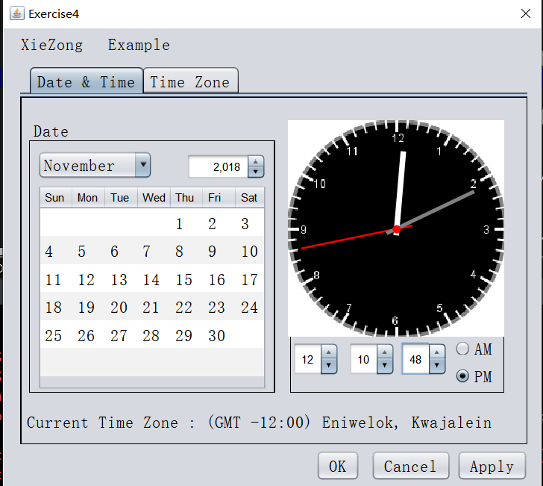

时区选择：

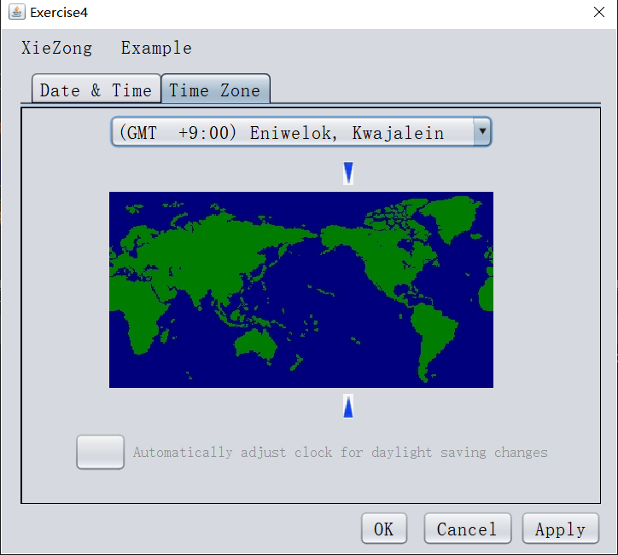

用户根据设置当前日期，设置完成后如果用户点击“OK”按钮，或者是“Cancel”按钮，就会弹出一个小提示窗口，如果用户点击“Apply”按钮，就会应用用户设置的时间日期，并弹出一个包含用户设置的日期，时间等信息的提示框。

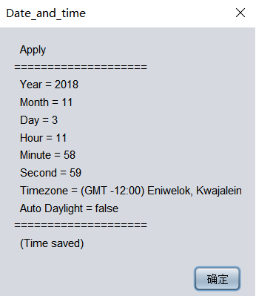

### **概要设计**

* 首先用NetBeans设置主界面，时间与日期的面板会用到jSpinner, jLabel, jButton, jTable, jComboBox等组件，时区面板则需要jComboBox, 以及一些提供的图片；
* 将实验三中与此次实验有关的时间设置模块的代码移植到实验四中，以及对一些组件进行初始化；
* 日历功能的实现：用户通过选择年份，月份，日来自定义当前的日期，通过用户选择的年份，月份会计算出当前月份的天数以及对应的第一天是星期几，然后在表格中填充数据；
* 时区更改实现：用户通过选择下拉框的选项选择时区，以及通过两个图片上下标变更地图中的位置显示；
* 自动调整时间与时区的实现，时区选择面板下会有一个按钮显示“√”如果用户选中的话用户更改时区时间会发生变化，若未选中，则时间不会变化；
* 绘制时钟表盘，具体实现思路就是随着时间来更新表盘，实现每秒重绘一下表盘，另外表盘显示的是北京时间，方便用户进行时间的调整；
* 实现“OK”，“Cancel”，“Apply”按钮，以及弹出窗口的信息显示。

### **详细设计**

* 时间日期面板主要就是用NetBeans进行组件的拖拽，实现位置的布局，表格的单元格的大小设计，以及各种组件之间的距离，边框。时区选择面板实现与此类似；
* 实现实验三中时间设置部分的复刻，具体的数值变化等的判断同实验三；
* 实现相应的日历显示功能，首先定义一个Calendar 类型的变量，然后根据用户当前选中的日期，然后通过Calendar类中的函数获取详细的日期信息，然后进行填充表格的信息；
* 通过选择时区下拉框更改指示图标的位置，并进行时区的更改，这里的实现用到了jLabel的定位设计；
* 自动时间更新功能实现：获取用户是否已选择自动更新时间的按钮，然后与时间显示的模块相关联；
* 时钟面板则是首先获取到当前时间，然后编写绘制函数，以及时分秒指针重绘函数，部分实现的代码如下：

//开始画整个表  
public void paint*(*Graphics g*)  
{* //long t1=System.currentTimeMillis();  
 int size = Math.*min(*getWidth*()***,** getHeight*())***;** //System.out.println(size);  
 Graphics2D g2d=*(*Graphics2D*)*g**;** //图像基础类下溯造型成2D的图像类  
 //为呈现算法设置单个首选项的值,这里设置的是开启抗锯齿  
 if*(*RenderingHints.*KEY_ANTIALIASING*!=null&&RenderingHints.*VALUE_ANTIALIAS_ON*!=null*)* g2d.setRenderingHint*(*RenderingHints.*KEY_ANTIALIASING***,**RenderingHints.*VALUE_ANTIALIAS_ON)***;** //画表盘  
 //图像的左上角位于（0,0），第四个参数是非透明部分下的背景色（白色），第五个参数是转化了更多图像时要通知的对象？？  
 g2d.drawImage*(*getBufferedImage*(*size*)***, 0,0,** new Color*(***255,255,255,255***)***,** null*)***;** //画时分秒针  
 drawSeconds*(*g2d*)***;** drawMinutes*(*g2d*)***;** drawHours*(*g2d*)***;** //画中心的一个小圆圈  
 int center = size/**2;** int point = *(*int*)(*center\***0.97***)***;** int pointR = *(*int*)(*center\***0.08***)***;** g2d.setColor*(*Color.*red)***;** g2d.fillArc*(*point**,** point**,** pointR**,** pointR**, 0, 360***)***;** //long t2=System.currentTimeMillis();  
 //System.out.println("paint cost :"+(t2-t1));  
*}*//画秒针  
public void drawSeconds*(*Graphics2D g2d*)  
{* int size = Math.*min(*getWidth*()***,**getHeight*())***;** int center = size/**2;** int r = *(*int*)(*center\***0.9***)***;** int rr = *(*int*)(*center\***0.15***)***;** double angle=Calendar.*getInstance()*.get*(*Calendar.*SECOND)*/*(***60d***)*\***360;** //int angle=date.getSeconds()/60*360;  
 long m = Calendar.*getInstance()*.getTime*()*.getTime*()***;** //得到毫秒数  
 angle = angle+*((*m%**1000***)*/**1000**\***6***)***;** //画秒针的线  
 g2d.setColor*(*Color.*red)***;** //System.out.println(angle);  
 drawLine*(*g2d**,**center**,**angle**,**r**,**rr**,2***)***;***}*

* 进行“OK”，“Cancel”，“Apply”按钮的实现，这三个按钮点击事件很相似，区别就是“OK”，“Cancel”按钮点击后会关闭程序应用窗口，部分代码实现如下：

jButton3.addMouseListener*(*new java.awt.event.MouseAdapter*() {* public void mouseClicked*(*java.awt.event.MouseEvent evt*) {* int year = Integer.*parseInt(*calendarSpinner1.getValue*()*.toString*())***;** int month = calendarBox1.getSelectedIndex*()*+**1;** Calendar cal = Calendar.*getInstance()***;** int a = **1;** cal.set*(*year**,**month - **1,**a*)***;** int index1 = jTable1.getSelectedRow*()***;**//获取选中的行  
 int column1 = jTable1.getSelectedColumnCount*()***;**//获取选中的列  
 System.*out*.println*(*"行："+index1+"列:"+column1+"值："+*(*int*)* jTable1.getValueAt*(*index1**,** column1*))***;** int key = *(*int*)* jTable1.getValueAt*(*index1**,** column1*)***;** int day =key**;** //cal.getActualMaximum(Calendar.DATE);  
 String hour = hourSpinner.getValue*()*.toString*()***;** String minute = minuteSpinner.getValue*()*.toString*()***;** String second = secondSpinner.getValue*()*.toString*()***;** String timezone = jComboBox2.getSelectedItem*()*.toString*()***;** String autoDaylight**;** if*(*jButton1.getText*()*.length*()* == **0***)* autoDaylight = "false"**;** else  
 autoDaylight = "true"**;** String s = " OK\n====================\n Year = "+year  
 +"\n Month = "+month+"\n Day = "+day+"\n Hour = "+hour+"\n Minute = "+minute  
 +"\n Second = "+second+"\n Timezone = "+timezone+"\n Auto Daylight = "+autoDaylight  
 +"\n====================\n (Time saved)"**;** JOptionPane.*showMessageDialog(*null**,** s**,** "Date_and_time"**,**JOptionPane.*PLAIN_MESSAGE)***;** System.*exit(***1***)***;** *}  
})***;**

### **调试分析**

* 首先日历实现功能实现过程中总是虽然获取了当前用户选择的月份了，但是具体日期数据显示到表格中时会出现日期与其对应的星期几匹配错误，主要原因是实现过程中总是将天数的第一天数据填充到表格的固定位置，没有考虑到具体的实现逻辑。
* 时钟表盘将表盘添加到相应的面板时时钟表盘总是显示不全，只能显示部分，多次改变表盘绘制函数中表盘大小参数后还是显示不全，通过请教同学明白了添加表盘应实现流式布局添加。

### **用户使用说明**

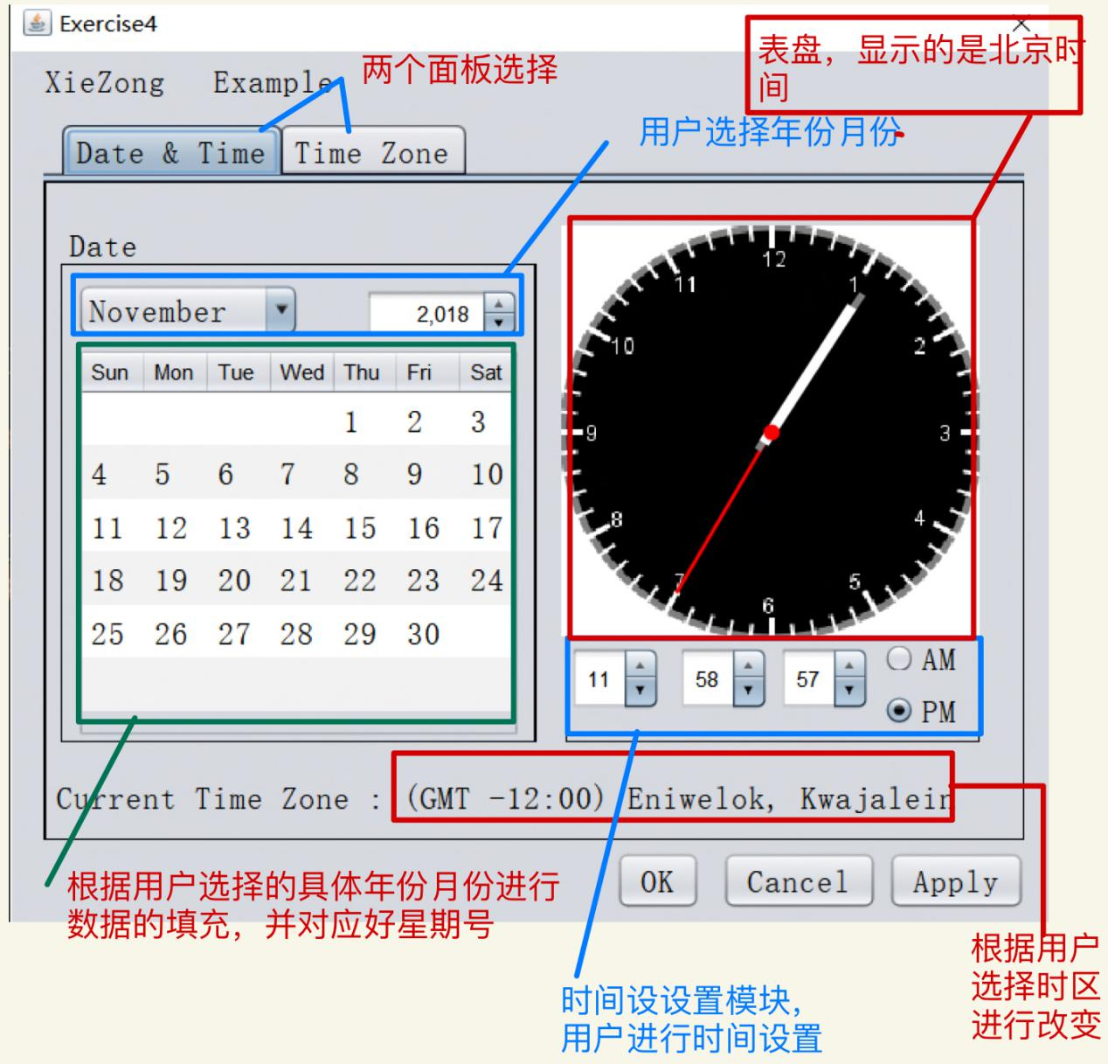

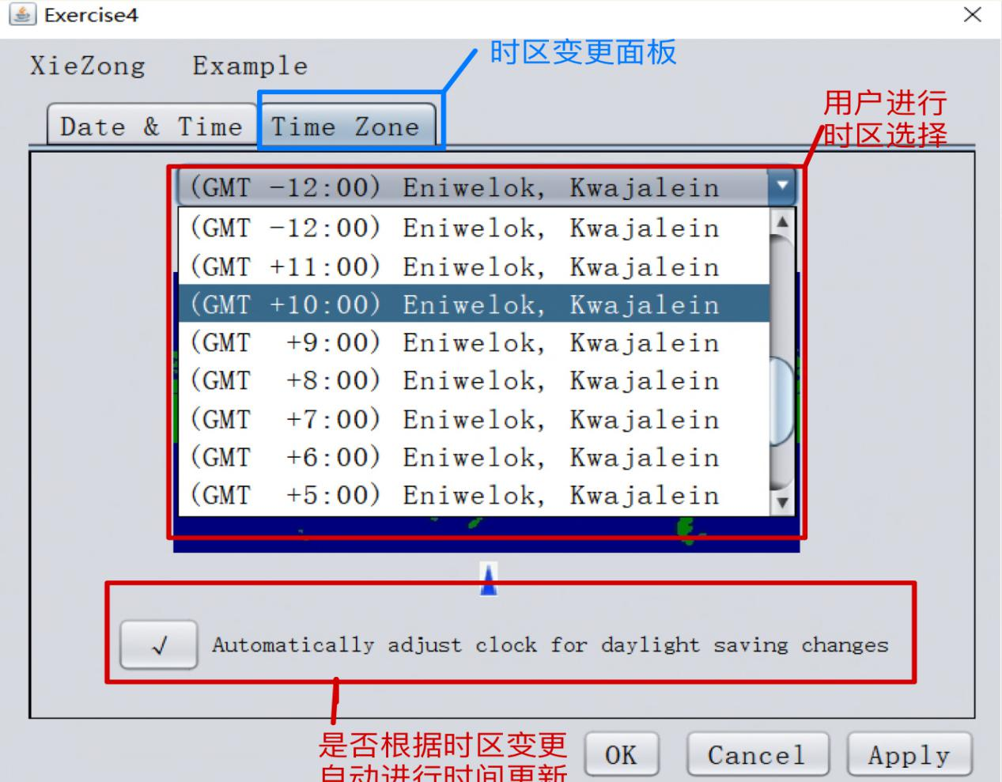

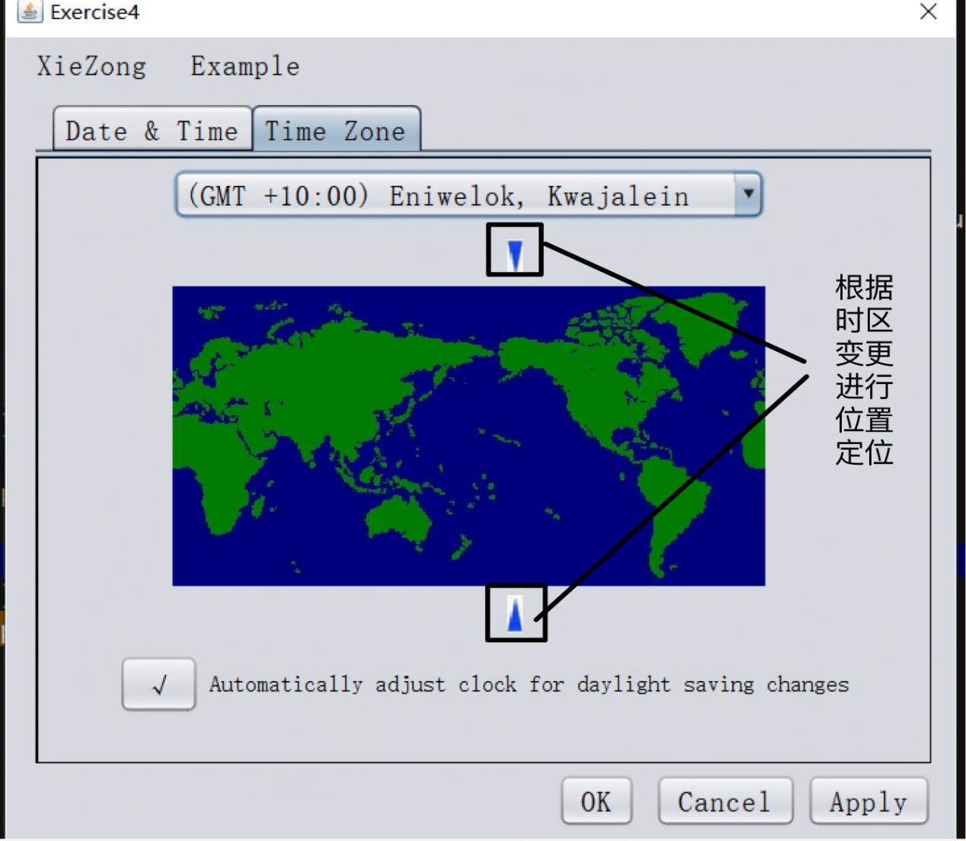

* 用户进行日期设置，通过下拉框改变年份与月份，然后选择表格里相应的日期进行当前日期的变更：

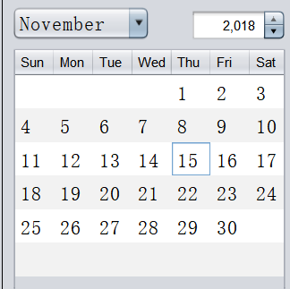

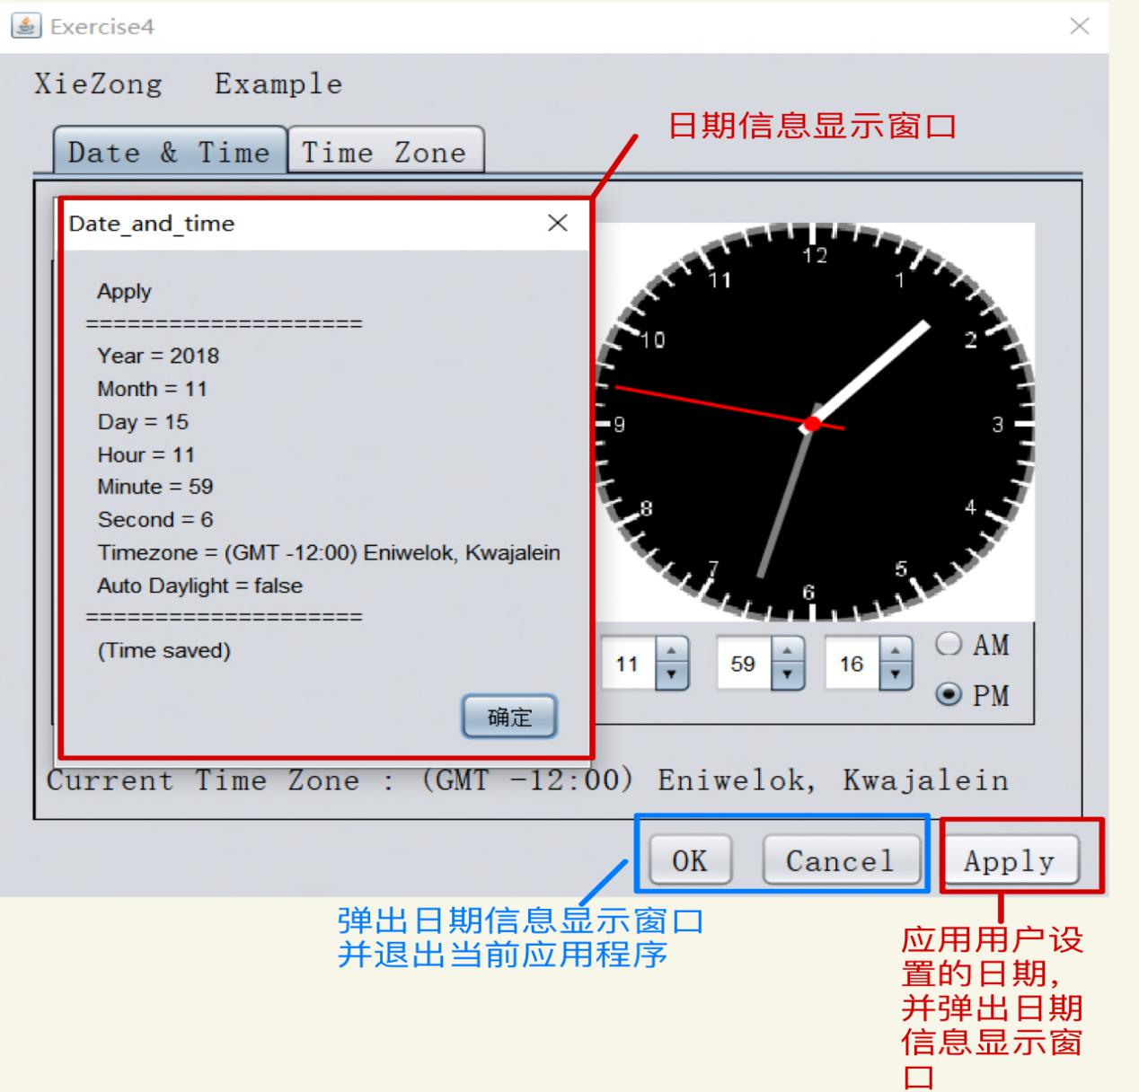

### **测试结果**

* 变更日期

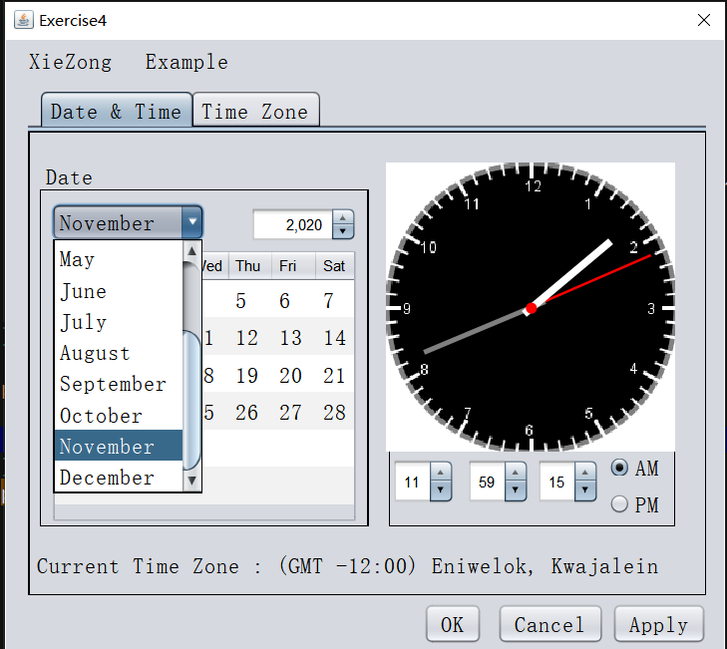

* 更改时区

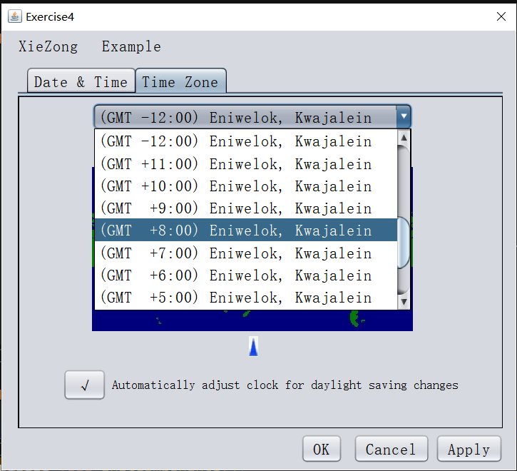

* 点击“OK”、“Cancel”、“Apply”按钮

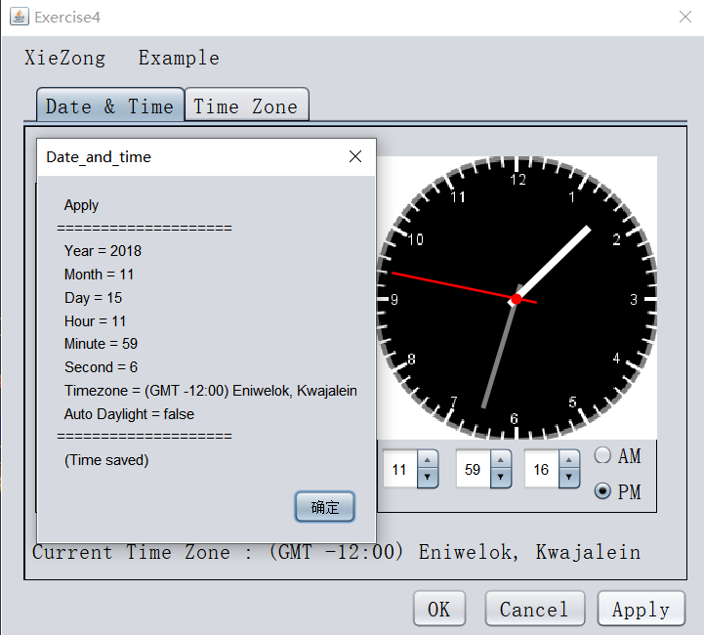

### **附录**

* **实验架构：**

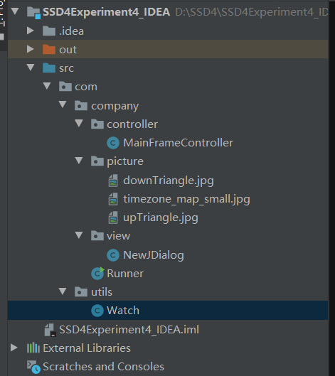

* **实验源码：**

package com.company.controller**;**import com.company.view.NewJDialog**;**import com.utils.Watch**;**import javax.swing.\***;**import javax.swing.event.ChangeEvent**;**import javax.swing.event.ChangeListener**;**import java.awt.\***;**import java.util.Calendar**;**import java.util.Timer**;**import java.util.TimerTask**;**public class MainFrameController extends JFrame *{* public MainFrameController*(){* initComponents*()***;** initListeners*()***;** Timer timer=new Timer*()***;** //定时器执行任务  
 timer.schedule*(*new TimerTask*() {* @Override  
 public void run*() {* int second=Integer.*parseInt(*secondSpinner.getValue*()*.toString*())***;** second++**;** secondSpinner.setValue*(*second*)***;** repaint*()***;** *}  
 }***,0,1000***)***;** *}* public void showMainWindows*(){* windowFrame.setVisible*(*true*)***;** //paintCanvas();  
 *}* public void initComponents*(){* windowFrame= new NewJDialog*()***;** hourSpinner=windowFrame.getjSpinner2*()***;** minuteSpinner=windowFrame.getjSpinner4*()***;** secondSpinner=windowFrame.getjSpinner3*()***;** okButton=windowFrame.getjButton1*()***;** cancelButton=windowFrame.getjButton2*()***;** applyButton=windowFrame.getjButton3*()***;** calendarBox1=windowFrame.getjComboBox1*()***;** jComboBox2=windowFrame.getjComboBox2*()***;** calendarSpinner1=windowFrame.getjSpinner1*()***;** jTable1=windowFrame.getjTable1*()***;** jButton1=windowFrame.getjButton1*()***;** jButton2=windowFrame.getjButton2*()***;** jButton3=windowFrame.getjButton3*()***;** jButton4=windowFrame.getjButton4*()***;** jButton5=windowFrame.getjButton5*()***;** jButton6=windowFrame.getjButton6*()***;** jLabel5=windowFrame.getjLabel5*()***;** jLabel3=windowFrame.getjLabel3*()***;** watchPanel=windowFrame.getjPanel4*()***;** *}* public void initListeners*(){* //分钟状态改变事件  
 hourSpinner.addChangeListener*(*new ChangeListener*() {* @Override  
 public void stateChanged*(*ChangeEvent e*) {* //获取到当前时  
 int hour = Integer.*parseInt(*hourSpinner.getValue*()*.toString*())***;** //时的变化退位  
 if *(*hour== -**1***) {* hourSpinner.setValue*(***23***)***;** *}* //时的变化进位  
 if *(*hour == **24***) {* hourSpinner.setValue*(***0***)***;** *}  
 }  
 })***;** //分钟状态改变事件  
 minuteSpinner.addChangeListener*(*new ChangeListener*() {* @Override  
 public void stateChanged*(*ChangeEvent e*) {* //获取到当前时分  
 int hour = Integer.*parseInt(*hourSpinner.getValue*()*.toString*())***;** int minute = Integer.*parseInt(*minuteSpinner.getValue*()*.toString*())***;** //时分的变化退位  
 if *(*minute== -**1***) {* if *(*hour == **0***) {* hourSpinner.setValue*(***23***)***;** *}* else *{* hourSpinner.setValue*(*hour - **1***)***;** *}* minuteSpinner.setValue*(***59***)***;** *}* //时分的变化进位  
 if *(*minute == **60***) {* if *(*hour == **23***) {* hourSpinner.setValue*(***0***)***;** *}* else *{* hourSpinner.setValue*(*hour + **1***)***;** *}* minuteSpinner.setValue*(***0***)***;** *}  
 }  
 })***;** //秒钟状态改变事件  
 secondSpinner.addChangeListener*(*new ChangeListener*() {* @Override  
 public void stateChanged*(*ChangeEvent e*) {* //获取到当前时分秒  
 int hour = Integer.*parseInt(*hourSpinner.getValue*()*.toString*())***;** int minute = Integer.*parseInt(*minuteSpinner.getValue*()*.toString*())***;** int second = Integer.*parseInt(*secondSpinner.getValue*()*.toString*())***;** //秒时分的变化退位  
 if *(*second == -**1***) {* if *(*minute == **0***) {* if *(*hour == **0***) {* hourSpinner.setValue*(***23***)***;** *}* else *{* hourSpinner.setValue*(*hour - **1***)***;** *}* minuteSpinner.setValue*(***59***)***;** *}* else *{* minuteSpinner.setValue*(*minute - **1***)***;** *}* secondSpinner.setValue*(***59***)***;** *}* //秒时分的变化进位  
 if *(*second == **60***) {* if *(*minute == **59***) {* if *(*hour == **23***) {* hourSpinner.setValue*(***0***)***;** *}* else *{* hourSpinner.setValue*(*hour + **1***)***;** *}* minuteSpinner.setValue*(***0***)***;** *}* else *{* minuteSpinner.setValue*(*minute + **1***)***;** *}* secondSpinner.setValue*(***0***)***;** *}  
 }  
 })***;** calendarBox1.addItemListener*(*new java.awt.event.ItemListener*() {* public void itemStateChanged*(*java.awt.event.ItemEvent evt*) {* int year = Integer.*parseInt(*calendarSpinner1.getValue*()*.toString*())***;** int month = calendarBox1.getSelectedIndex*()*+**1;** int day = **1;** Calendar cal = Calendar.*getInstance()***;** cal.set*(*year**,**month - **1,**day*)***;** int days = cal.getActualMaximum*(*Calendar.*DATE)***;** int week = cal.get*(*Calendar.*DAY_OF_WEEK)***;** //初始化日历  
 //清空表格数据  
 int count = **0;** while*(*count<**6***) {* jTable1.setValueAt*(*null**,** count**, 0***)***;** jTable1.setValueAt*(*null**,** count**, 1***)***;** jTable1.setValueAt*(*null**,** count**, 2***)***;** jTable1.setValueAt*(*null**,** count**, 3***)***;** jTable1.setValueAt*(*null**,** count**, 4***)***;** jTable1.setValueAt*(*null**,** count**, 5***)***;** jTable1.setValueAt*(*null**,** count**, 6***)***;** count++**;** *}* //输出指定年月日的日历  
 int day_count = **1;** //输出日历第一行数据  
 for*(*int i=week-**1;** i<**7;** i++*){* jTable1.setValueAt*(*day_count++**, 0,** i*)***;** *}* //输出日历剩余数据  
 for*(*int i=**1;** i<**6;** i++*){* //控制行数  
 for*(*int j=**0;** j<**7;** j++*){* //控制列数  
 if*(*day_count <= days*){* jTable1.setValueAt*(*day_count++**,** i**,** j*)***;** *}* else*{* i = **6;** break**;** *}  
 }  
 }  
 }  
 })***;** jComboBox2.addItemListener*(*new java.awt.event.ItemListener*() {* public void itemStateChanged*(*java.awt.event.ItemEvent evt*) {* int x1 = **78;** int y1 = **50;** int x2 = **78;** int y2 = **269;** int width = **10;** int height = **23;** int n = jComboBox2.getSelectedIndex*()***;** jButton2.setBounds*(*x1+n\***16,** y1**,** width**,** height*)***;** jButton6.setBounds*(*x2+n\***16,** y2**,** width**,** height*)***;** jLabel3.setText*(*"Current Time Zone : "+jComboBox2.getSelectedItem*())***;** *}  
 })***;** calendarSpinner1.addChangeListener*(*new javax.swing.event.ChangeListener*() {* public void stateChanged*(*javax.swing.event.ChangeEvent evt*) {* // *TODO add your handling code here:* int year = Integer.*parseInt(*calendarSpinner1.getValue*()*.toString*())***;** int month = calendarBox1.getSelectedIndex*()*+**1;** int day = **1;** Calendar cal = Calendar.*getInstance()***;** cal.set*(*year**,**month - **1,**day*)***;** int days = cal.getActualMaximum*(*Calendar.*DATE)***;** int week = cal.get*(*Calendar.*DAY_OF_WEEK)***;** //初始化日历  
 //清空表格数据  
 int count = **0;** while*(*count<**6***) {* jTable1.setValueAt*(*null**,** count**, 0***)***;** jTable1.setValueAt*(*null**,** count**, 1***)***;** jTable1.setValueAt*(*null**,** count**, 2***)***;** jTable1.setValueAt*(*null**,** count**, 3***)***;** jTable1.setValueAt*(*null**,** count**, 4***)***;** jTable1.setValueAt*(*null**,** count**, 5***)***;** jTable1.setValueAt*(*null**,** count**, 6***)***;** count++**;** *}* //输出指定年月日的日历  
 int day_count = **1;** //输出日历第一行数据  
 for*(*int i=week-**1;** i<**7;** i++*){* jTable1.setValueAt*(*day_count++**, 0,** i*)***;** *}* //输出日历剩余数据  
 for*(*int i=**1;** i<**6;** i++*){* //控制行数  
 for*(*int j=**0;** j<**7;** j++*){* //控制列数  
 if*(*day_count <= days*){* jTable1.setValueAt*(*day_count++**,** i**,** j*)***;** *}* else*{* i = **6;** break**;** *}  
 }  
 }  
 }  
 })***;** jButton1.addMouseListener*(*new java.awt.event.MouseAdapter*() {* public void mouseClicked*(*java.awt.event.MouseEvent evt*) {* if*(*jButton1.getText*()*.length*()* == **0***){* jButton1.setText*(*"√"*)***;** jLabel5.setEnabled*(*true*)***;** *}* else*{* jButton1.setText*(*""*)***;** jLabel5.setEnabled*(*false*)***;** *}  
 }  
 })***;** jButton3.addMouseListener*(*new java.awt.event.MouseAdapter*() {* public void mouseClicked*(*java.awt.event.MouseEvent evt*) {* int year = Integer.*parseInt(*calendarSpinner1.getValue*()*.toString*())***;** int month = calendarBox1.getSelectedIndex*()*+**1;** Calendar cal = Calendar.*getInstance()***;** int a = **1;** cal.set*(*year**,**month - **1,**a*)***;** int index1 = jTable1.getSelectedRow*()***;**//获取选中的行  
 int column1 = jTable1.getSelectedColumnCount*()***;**//获取选中的列  
 System.*out*.println*(*"行："+index1+"列:"+column1+"值："+*(*int*)* jTable1.getValueAt*(*index1**,** column1*))***;** int key = *(*int*)* jTable1.getValueAt*(*index1**,** column1*)***;** int day =key**;** //cal.getActualMaximum(Calendar.DATE);  
 String hour = hourSpinner.getValue*()*.toString*()***;** String minute = minuteSpinner.getValue*()*.toString*()***;** String second = secondSpinner.getValue*()*.toString*()***;** String timezone = jComboBox2.getSelectedItem*()*.toString*()***;** String autoDaylight**;** if*(*jButton1.getText*()*.length*()* == **0***)* autoDaylight = "false"**;** else  
 autoDaylight = "true"**;** String s = " OK\n====================\n Year = "+year  
 +"\n Month = "+month+"\n Day = "+day+"\n Hour = "+hour+"\n Minute = "+minute  
 +"\n Second = "+second+"\n Timezone = "+timezone+"\n Auto Daylight = "+autoDaylight  
 +"\n====================\n (Time saved)"**;** JOptionPane.*showMessageDialog(*null**,** s**,** "Date_and_time"**,**JOptionPane.*PLAIN_MESSAGE)***;** System.*exit(***1***)***;** *}  
 })***;** jButton4.addMouseListener*(*new java.awt.event.MouseAdapter*() {* public void mouseClicked*(*java.awt.event.MouseEvent evt*) {* int year = Integer.*parseInt(*calendarSpinner1.getValue*()*.toString*())***;** int month = calendarBox1.getSelectedIndex*()*+**1;** Calendar cal = Calendar.*getInstance()***;** int a = **1;** cal.set*(*year**,**month - **1,**a*)***;** int index1 = jTable1.getSelectedRow*()***;**//获取选中的行  
 int column1 = jTable1.getSelectedColumnCount*()***;**//获取选中的列  
 System.*out*.println*(*"行："+index1+"列:"+column1+"值："+*(*int*)* jTable1.getValueAt*(*index1**,** column1*))***;** int key = *(*int*)* jTable1.getValueAt*(*index1**,** column1*)***;** int day =key**;** //cal.getActualMaximum(Calendar.DATE);  
 String hour = hourSpinner.getValue*()*.toString*()***;** String minute = minuteSpinner.getValue*()*.toString*()***;** String second = secondSpinner.getValue*()*.toString*()***;** String timezone = jComboBox2.getSelectedItem*()*.toString*()***;** String autoDaylight**;** if*(*jButton1.getText*()*.length*()* == **0***)* autoDaylight = "false"**;** else  
 autoDaylight = "true"**;** String s = " Cancel\n====================\n Year = "+year  
 +"\n Month = "+month+"\n Day = "+day+"\n Hour = "+hour+"\n Minute = "+minute  
 +"\n Second = "+second+"\n Timezone = "+timezone+"\n Auto Daylight = "+autoDaylight  
 +"\n====================\n (Time not saved)"**;** JOptionPane.*showMessageDialog(*null**,** s**,** "Date_and_time"**,**JOptionPane.*PLAIN_MESSAGE)***;** System.*exit(***1***)***;** *}  
 })***;** jButton5.addMouseListener*(*new java.awt.event.MouseAdapter*() {* public void mouseClicked*(*java.awt.event.MouseEvent evt*) {* int year = Integer.*parseInt(*calendarSpinner1.getValue*()*.toString*())***;** int month = calendarBox1.getSelectedIndex*()*+**1;** Calendar cal = Calendar.*getInstance()***;** int a = **1;** cal.set*(*year**,**month - **1,**a*)***;** int index1 = jTable1.getSelectedRow*()***;**//获取选中的行  
 int column1 = jTable1.getSelectedColumn*()***;**//获取选中的列  
 // System.out.println("行："+index1+"列:"+column1+"值："+(int) jTable1.getValueAt(index1, column1));  
 int key = *(*int*)* jTable1.getValueAt*(*index1**,** column1*)***;** int day =key**;** cal.getActualMaximum*(*Calendar.*DATE)***;** String hour = hourSpinner.getValue*()*.toString*()***;** String minute = minuteSpinner.getValue*()*.toString*()***;** String second = secondSpinner.getValue*()*.toString*()***;** String timezone = jComboBox2.getSelectedItem*()*.toString*()***;** String autoDaylight**;** if*(*jButton1.getText*()*.length*()* == **0***)* autoDaylight = "false"**;** else  
 autoDaylight = "true"**;** String s = " Apply\n====================\n Year = "+year  
 +"\n Month = "+month+"\n Day = "+day+"\n Hour = "+hour+"\n Minute = "+minute  
 +"\n Second = "+second+"\n Timezone = "+timezone+"\n Auto Daylight = "+autoDaylight  
 +"\n====================\n (Time saved)"**;** JOptionPane.*showMessageDialog(*null**,** s**,** "Date_and_time"**,**JOptionPane.*PLAIN_MESSAGE)***;** *}  
 })***;** *}* //内存画布  
 private void paintCanvas*(){* //清空当前画布  
  
  
 Watch myWatch = new Watch*(***232***)***;** watchPanel.add*(*myWatch**,**BorderLayout.*CENTER)***;** //函数作用：更新容器中组件排布  
  
  
 *}* NewJDialog windowFrame**;** private JButton okButton**;** private JButton cancelButton**;** private JButton applyButton**;** private JSpinner hourSpinner**;** private JSpinner minuteSpinner**;** private JSpinner secondSpinner**;** private javax.swing.JComboBox*<*String*>* calendarBox1**;** private javax.swing.JComboBox*<*String*>* jComboBox2**;** private javax.swing.JSpinner calendarSpinner1**;** private javax.swing.JTable jTable1**;** private javax.swing.JButton jButton1**;** private javax.swing.JButton jButton2**;** private javax.swing.JButton jButton3**;** private javax.swing.JButton jButton4**;** private javax.swing.JButton jButton5**;** private javax.swing.JButton jButton6**;** private javax.swing.JLabel jLabel5**;** private javax.swing.JLabel jLabel3**;** private javax.swing.JPanel watchPanel**;***}*

/*  
 * To change this license header, choose License Headers in Project Properties.  
 * To change this template file, choose Tools | Templates  
 * and open the template in the editor.  
 */  
package com.company.view**;**import javax.swing.\***;**import java.util.Calendar**;***/**  
 *  
 \** ***@author*** *25070  
 */*public class NewJDialog extends JDialog *{  
  
 /**  
 * Creates new form NewJDialog  
 */* public NewJDialog*() {* this.setTitle*(*"Exercise4"*)***;** initComponents*()***;** this.setLocationRelativeTo*(*null*)***;** jComboBox1.setSelectedIndex*(***10***)***;** int hour = Integer.*parseInt(*jSpinner1.getValue*()*.toString*())***;** if*(***0**<=hour && hour<**12***){* jRadioButton1.setSelected*(*true*)***;** jRadioButton2.setSelected*(*false*)***;** *}* else*{* jRadioButton1.setSelected*(*false*)***;** jRadioButton2.setSelected*(*true*)***;** *}* jButton1.setText*(*""*)***;** jLabel5.setEnabled*(*false*)***;** jComboBox2.setSelectedIndex*(***11***)***;** int year = Integer.*parseInt(*jSpinner1.getValue*()*.toString*())***;** int month = jComboBox1.getSelectedIndex*()*+**1;** int day = **1;** Calendar cal = Calendar.*getInstance()***;** cal.set*(*year**,**month - **1,**day*)***;** int days = cal.getActualMaximum*(*Calendar.*DATE)***;** int week = cal.get*(*Calendar.*DAY_OF_WEEK)***;** //初始化日历  
 //清空表格数据  
 int count = **0;** while*(*count<**6***) {* jTable1.setValueAt*(*null**,** count**, 0***)***;** jTable1.setValueAt*(*null**,** count**, 1***)***;** jTable1.setValueAt*(*null**,** count**, 2***)***;** jTable1.setValueAt*(*null**,** count**, 3***)***;** jTable1.setValueAt*(*null**,** count**, 4***)***;** jTable1.setValueAt*(*null**,** count**, 5***)***;** jTable1.setValueAt*(*null**,** count**, 6***)***;** count++**;** *}* //输出指定年月日的日历  
 int day_count = **1;** //输出日历第一行数据  
 for*(*int i=week-**1;** i<**7;** i++*){* jTable1.setValueAt*(*day_count++**, 0,** i*)***;** *}* //输出日历剩余数据  
 for*(*int i=**1;** i<**6;** i++*){* //控制行数  
 for*(*int j=**0;** j<**7;** j++*){* //控制列数  
 if*(*day_count <= days*){* jTable1.setValueAt*(*day_count++**,** i**,** j*)***;** *}* else*{* i = **6;** break**;** *}  
 }  
 }* //设置默认定位东西12区  
 int x1 = jButton2.getX*()***;** int y1 = jButton2.getY*()***;** int x2 = jButton6.getX*()***;** int y2 = jButton6.getY*()***;** int width = **10;** int height = **23;** jButton2.setBounds*(*x1+**8**\***22,** y1**,** width**,** height*)***;** jButton6.setBounds*(*x2+**8**\***22,** y2**,** width**,** height*)***;** //使时区可以定位变动  
 jPanel2.setLayout*(*null*)***;** *}  
  
  
  
 /**  
 * This method is called from within the constructor to initialize the form.  
 * WARNING: Do NOT modify this code. The content of this method is always  
 * regenerated by the Form Editor.  
 */* @SuppressWarnings*(*"unchecked"*)* // <editor-fold defaultstate="collapsed" desc="Generated Code">  
 private void initComponents*() {* buttonGroup2 = new javax.swing.ButtonGroup*()***;** jTabbedPane1 = new javax.swing.JTabbedPane*()***;** jPanel1 = new javax.swing.JPanel*()***;** jPanel3 = new javax.swing.JPanel*()***;** jScrollPane1 = new javax.swing.JScrollPane*()***;** jTable1 = new javax.swing.JTable*()***;** jSpinner1 = new javax.swing.JSpinner*()***;** jComboBox1 = new javax.swing.JComboBox*<>()***;** jPanel4 = new javax.swing.JPanel*()***;** jSpinner2 = new javax.swing.JSpinner*()***;** jRadioButton1 = new javax.swing.JRadioButton*()***;** jSpinner4 = new javax.swing.JSpinner*()***;** jRadioButton2 = new javax.swing.JRadioButton*()***;** jSpinner3 = new javax.swing.JSpinner*()***;** jLabel3 = new javax.swing.JLabel*()***;** jPanel2 = new javax.swing.JPanel*()***;** jComboBox2 = new javax.swing.JComboBox*<>()***;** jPanel5 = new javax.swing.JPanel*()***;** jButton1 = new javax.swing.JButton*()***;** jLabel5 = new javax.swing.JLabel*()***;** jLabel4 = new javax.swing.JLabel*()***;** jButton2 = new javax.swing.JButton*()***;** jButton6 = new javax.swing.JButton*()***;** jButton3 = new javax.swing.JButton*()***;** jButton4 = new javax.swing.JButton*()***;** jButton5 = new javax.swing.JButton*()***;** jLabel1 = new javax.swing.JLabel*()***;** jLabel2 = new javax.swing.JLabel*()***;** //setDefaultCloseOperation(javax.swing.WindowConstants.EXIT_ON_CLOSE);  
  
 jTabbedPane1.setFont*(*new java.awt.Font*(*"宋体"**, 0, 18***))***;** // NOI18N  
  
 jPanel1.setBorder*(*javax.swing.BorderFactory.*createLineBorder(*new java.awt.Color*(***0, 0, 0***)))***;** jPanel1.setFont*(*new java.awt.Font*(*"宋体"**, 0, 18***))***;** // NOI18N  
  
 jPanel3.setBorder*(*javax.swing.BorderFactory.*createTitledBorder(*javax.swing.BorderFactory.*createLineBorder(*new java.awt.Color*(***0, 0, 0***))***,** "Date"**,** javax.swing.border.TitledBorder.*DEFAULT_JUSTIFICATION***,** javax.swing.border.TitledBorder.*DEFAULT_POSITION***,** new java.awt.Font*(*"宋体"**, 0, 18***)))***;** // NOI18N  
  
 jTable1.setFont*(*new java.awt.Font*(*"宋体"**, 0, 18***))***;** // NOI18N  
 jTable1.setModel*(*new javax.swing.table.DefaultTableModel*(* new Object *[][] {  
 {*null**,** null**,** null**,** null**,** null**,** null**,** null*}***,** *{*null**,** null**,** null**,** null**,** null**,** null**,** null*}***,** *{*null**,** null**,** null**,** null**,** null**,** null**,** null*}***,** *{*null**,** null**,** null**,** null**,** null**,** null**,** null*}***,** *{*null**,** null**,** null**,** null**,** null**,** null**,** null*}***,** *{*null**,** null**,** null**,** null**,** null**,** null**,** null*}  
 }***,** new String *[] {* "Sun"**,** "Mon"**,** "Tue"**,** "Wed"**,** "Thu"**,** "Fri"**,** "Sat"  
 *}  
 ) {* boolean*[]* canEdit = new boolean *[] {* false**,** false**,** false**,** false**,** false**,** false**,** false  
 *}***;** public boolean isCellEditable*(*int rowIndex**,** int columnIndex*) {* return canEdit *[*columnIndex*]***;** *}  
 })***;** jTable1.setRowHeight*(***30***)***;** jTable1.setRowSelectionAllowed*(*false*)***;** jScrollPane1.setViewportView*(*jTable1*)***;** jTable1.getColumnModel*()*.getSelectionModel*()*.setSelectionMode*(*javax.swing.ListSelectionModel.*SINGLE_SELECTION)***;** if *(*jTable1.getColumnModel*()*.getColumnCount*()* > **0***) {* jTable1.getColumnModel*()*.getColumn*(***0***)*.setMinWidth*(***35***)***;** jTable1.getColumnModel*()*.getColumn*(***0***)*.setPreferredWidth*(***35***)***;** jTable1.getColumnModel*()*.getColumn*(***0***)*.setMaxWidth*(***35***)***;** jTable1.getColumnModel*()*.getColumn*(***1***)*.setMinWidth*(***35***)***;** jTable1.getColumnModel*()*.getColumn*(***1***)*.setPreferredWidth*(***35***)***;** jTable1.getColumnModel*()*.getColumn*(***1***)*.setMaxWidth*(***35***)***;** jTable1.getColumnModel*()*.getColumn*(***2***)*.setMinWidth*(***35***)***;** jTable1.getColumnModel*()*.getColumn*(***2***)*.setPreferredWidth*(***35***)***;** jTable1.getColumnModel*()*.getColumn*(***2***)*.setMaxWidth*(***35***)***;** jTable1.getColumnModel*()*.getColumn*(***3***)*.setMinWidth*(***35***)***;** jTable1.getColumnModel*()*.getColumn*(***3***)*.setPreferredWidth*(***35***)***;** jTable1.getColumnModel*()*.getColumn*(***3***)*.setMaxWidth*(***35***)***;** jTable1.getColumnModel*()*.getColumn*(***4***)*.setMinWidth*(***35***)***;** jTable1.getColumnModel*()*.getColumn*(***4***)*.setPreferredWidth*(***35***)***;** jTable1.getColumnModel*()*.getColumn*(***4***)*.setMaxWidth*(***35***)***;** jTable1.getColumnModel*()*.getColumn*(***5***)*.setMinWidth*(***35***)***;** jTable1.getColumnModel*()*.getColumn*(***5***)*.setPreferredWidth*(***35***)***;** jTable1.getColumnModel*()*.getColumn*(***5***)*.setMaxWidth*(***35***)***;** jTable1.getColumnModel*()*.getColumn*(***6***)*.setMinWidth*(***35***)***;** jTable1.getColumnModel*()*.getColumn*(***6***)*.setPreferredWidth*(***35***)***;** jTable1.getColumnModel*()*.getColumn*(***6***)*.setMaxWidth*(***35***)***;** *}* jSpinner1.setFont*(*new java.awt.Font*(*"宋体"**, 0, 18***))***;** // NOI18N  
 jSpinner1.setModel*(*new javax.swing.SpinnerNumberModel*(***2018,** null**,** null**, 1***))***;** jComboBox1.setFont*(*new java.awt.Font*(*"宋体"**, 0, 18***))***;** // NOI18N  
 jComboBox1.setModel*(*new javax.swing.DefaultComboBoxModel*<>(*new String*[] {* "January"**,** "February"**,** "March"**,** "April"**,** "May"**,** "June"**,** "July"**,** "August"**,** "September"**,** "October"**,** "November"**,** "December" *}))***;** javax.swing.GroupLayout jPanel3Layout = new javax.swing.GroupLayout*(*jPanel3*)***;** jPanel3.setLayout*(*jPanel3Layout*)***;** jPanel3Layout.setHorizontalGroup*(* jPanel3Layout.createParallelGroup*(*javax.swing.GroupLayout.Alignment.*LEADING)* .addGroup*(*jPanel3Layout.createSequentialGroup*()* .addContainerGap*()* .addComponent*(*jComboBox1**,** javax.swing.GroupLayout.*PREFERRED_SIZE***, 124,** javax.swing.GroupLayout.*PREFERRED_SIZE)* .addGap*(***36, 36, 36***)* .addComponent*(*jSpinner1**,** javax.swing.GroupLayout.*PREFERRED_SIZE***, 86,** javax.swing.GroupLayout.*PREFERRED_SIZE)* .addContainerGap*(*javax.swing.GroupLayout.*DEFAULT_SIZE***,** Short.*MAX_VALUE))* .addGroup*(*javax.swing.GroupLayout.Alignment.*TRAILING***,** jPanel3Layout.createSequentialGroup*()* .addContainerGap*(*javax.swing.GroupLayout.*DEFAULT_SIZE***,** Short.*MAX_VALUE)* .addComponent*(*jScrollPane1**,** javax.swing.GroupLayout.*PREFERRED_SIZE***, 246,** javax.swing.GroupLayout.*PREFERRED_SIZE)* .addContainerGap*())  
 )***;** jPanel3Layout.setVerticalGroup*(* jPanel3Layout.createParallelGroup*(*javax.swing.GroupLayout.Alignment.*LEADING)* .addGroup*(*jPanel3Layout.createSequentialGroup*()* .addGroup*(*jPanel3Layout.createParallelGroup*(*javax.swing.GroupLayout.Alignment.*LEADING)* .addGroup*(*jPanel3Layout.createSequentialGroup*()* .addGap*(***11, 11, 11***)* .addComponent*(*jSpinner1**,** javax.swing.GroupLayout.*PREFERRED_SIZE***,** javax.swing.GroupLayout.*DEFAULT_SIZE***,** javax.swing.GroupLayout.*PREFERRED_SIZE))* .addGroup*(*javax.swing.GroupLayout.Alignment.*TRAILING***,** jPanel3Layout.createSequentialGroup*()* .addContainerGap*()* .addComponent*(*jComboBox1**,** javax.swing.GroupLayout.*PREFERRED_SIZE***,** javax.swing.GroupLayout.*DEFAULT_SIZE***,** javax.swing.GroupLayout.*PREFERRED_SIZE)))* .addPreferredGap*(*javax.swing.LayoutStyle.ComponentPlacement.*RELATED)* .addComponent*(*jScrollPane1**,** javax.swing.GroupLayout.*PREFERRED_SIZE***, 220,** javax.swing.GroupLayout.*PREFERRED_SIZE)* .addContainerGap*())  
 )***;** jPanel4.setBorder*(*javax.swing.BorderFactory.*createTitledBorder(*javax.swing.BorderFactory.*createLineBorder(*new java.awt.Color*(***0, 0, 0***))***,** "Time"**,** javax.swing.border.TitledBorder.*DEFAULT_JUSTIFICATION***,** javax.swing.border.TitledBorder.*DEFAULT_POSITION***,** new java.awt.Font*(*"宋体"**, 0, 18***)))***;** // NOI18N  
  
 jSpinner2.setFont*(*new java.awt.Font*(*"宋体"**, 0, 18***))***;** // NOI18N  
 jSpinner2.setModel*(*new javax.swing.SpinnerNumberModel*(***11,** -**1, 24, 1***))***;** buttonGroup2.add*(*jRadioButton1*)***;** jRadioButton1.setFont*(*new java.awt.Font*(*"宋体"**, 0, 18***))***;** // NOI18N  
 jRadioButton1.setText*(*"AM"*)***;** jSpinner4.setFont*(*new java.awt.Font*(*"宋体"**, 0, 18***))***;** // NOI18N  
 jSpinner4.setModel*(*new javax.swing.SpinnerNumberModel*(***58,** -**1, 60, 1***))***;** buttonGroup2.add*(*jRadioButton2*)***;** jRadioButton2.setFont*(*new java.awt.Font*(*"宋体"**, 0, 18***))***;** // NOI18N  
 jRadioButton2.setText*(*"PM"*)***;** jSpinner3.setFont*(*new java.awt.Font*(*"宋体"**, 0, 18***))***;** // NOI18N  
 jSpinner3.setModel*(*new javax.swing.SpinnerNumberModel*(***52,** -**1, 60, 1***))***;** javax.swing.GroupLayout jPanel4Layout = new javax.swing.GroupLayout*(*jPanel4*)***;** jPanel4.setLayout*(*jPanel4Layout*)***;** jPanel4Layout.setHorizontalGroup*(* jPanel4Layout.createParallelGroup*(*javax.swing.GroupLayout.Alignment.*LEADING)* .addGroup*(*jPanel4Layout.createSequentialGroup*()* .addComponent*(*jSpinner2**,** javax.swing.GroupLayout.*PREFERRED_SIZE***, 50,** javax.swing.GroupLayout.*PREFERRED_SIZE)* .addGap*(***10, 10, 10***)* .addComponent*(*jSpinner4**,** javax.swing.GroupLayout.*PREFERRED_SIZE***, 50,** javax.swing.GroupLayout.*PREFERRED_SIZE)* .addPreferredGap*(*javax.swing.LayoutStyle.ComponentPlacement.*RELATED)* .addComponent*(*jSpinner3**,** javax.swing.GroupLayout.*PREFERRED_SIZE***, 50,** javax.swing.GroupLayout.*PREFERRED_SIZE)* .addGap*(***7, 7, 7***)* .addGroup*(*jPanel4Layout.createParallelGroup*(*javax.swing.GroupLayout.Alignment.*LEADING)* .addComponent*(*jRadioButton2*)* .addComponent*(*jRadioButton1*))* .addContainerGap*(***10,** Short.*MAX_VALUE))  
 )***;** jPanel4Layout.setVerticalGroup*(* jPanel4Layout.createParallelGroup*(*javax.swing.GroupLayout.Alignment.*LEADING)* .addGroup*(*javax.swing.GroupLayout.Alignment.*TRAILING***,** jPanel4Layout.createSequentialGroup*()* .addContainerGap*(*javax.swing.GroupLayout.*DEFAULT_SIZE***,** Short.*MAX_VALUE)* .addGroup*(*jPanel4Layout.createParallelGroup*(*javax.swing.GroupLayout.Alignment.*LEADING)* .addGroup*(*jPanel4Layout.createSequentialGroup*()* .addComponent*(*jRadioButton1**,** javax.swing.GroupLayout.*PREFERRED_SIZE***, 14,** javax.swing.GroupLayout.*PREFERRED_SIZE)* .addPreferredGap*(*javax.swing.LayoutStyle.ComponentPlacement.*UNRELATED)* .addComponent*(*jRadioButton2**,** javax.swing.GroupLayout.*PREFERRED_SIZE***, 20,** javax.swing.GroupLayout.*PREFERRED_SIZE))* .addGroup*(*jPanel4Layout.createParallelGroup*(*javax.swing.GroupLayout.Alignment.*BASELINE)* .addComponent*(*jSpinner2**,** javax.swing.GroupLayout.*PREFERRED_SIZE***, 36,** javax.swing.GroupLayout.*PREFERRED_SIZE)* .addComponent*(*jSpinner4**,** javax.swing.GroupLayout.*PREFERRED_SIZE***, 36,** javax.swing.GroupLayout.*PREFERRED_SIZE)* .addComponent*(*jSpinner3**,** javax.swing.GroupLayout.*PREFERRED_SIZE***, 36,** javax.swing.GroupLayout.*PREFERRED_SIZE)))* .addContainerGap*())  
 )***;** jLabel3.setFont*(*new java.awt.Font*(*"宋体"**, 0, 18***))***;** // NOI18N  
 jLabel3.setText*(*"Current Time Zone : (GMT -12:00) Eniwelok, Kwajalein"*)***;** javax.swing.GroupLayout jPanel1Layout = new javax.swing.GroupLayout*(*jPanel1*)***;** jPanel1.setLayout*(*jPanel1Layout*)***;** jPanel1Layout.setHorizontalGroup*(* jPanel1Layout.createParallelGroup*(*javax.swing.GroupLayout.Alignment.*LEADING)* .addGroup*(*jPanel1Layout.createSequentialGroup*()* .addContainerGap*()* .addGroup*(*jPanel1Layout.createParallelGroup*(*javax.swing.GroupLayout.Alignment.*LEADING)* .addGroup*(*jPanel1Layout.createSequentialGroup*()* .addComponent*(*jPanel3**,** javax.swing.GroupLayout.*PREFERRED_SIZE***,** javax.swing.GroupLayout.*DEFAULT_SIZE***,** javax.swing.GroupLayout.*PREFERRED_SIZE)* .addPreferredGap*(*javax.swing.LayoutStyle.ComponentPlacement.*UNRELATED)* .addComponent*(*jPanel4**,** javax.swing.GroupLayout.*PREFERRED_SIZE***,** javax.swing.GroupLayout.*DEFAULT_SIZE***,** javax.swing.GroupLayout.*PREFERRED_SIZE))* .addComponent*(*jLabel3*))* .addContainerGap*(*javax.swing.GroupLayout.*DEFAULT_SIZE***,** Short.*MAX_VALUE))  
 )***;** jPanel1Layout.setVerticalGroup*(* jPanel1Layout.createParallelGroup*(*javax.swing.GroupLayout.Alignment.*LEADING)* .addGroup*(*jPanel1Layout.createSequentialGroup*()* .addGap*(***24, 24, 24***)* .addGroup*(*jPanel1Layout.createParallelGroup*(*javax.swing.GroupLayout.Alignment.*LEADING***,** false*)* .addComponent*(*jPanel4**,** javax.swing.GroupLayout.*DEFAULT_SIZE***,** javax.swing.GroupLayout.*DEFAULT_SIZE***,** Short.*MAX_VALUE)* .addComponent*(*jPanel3**,** javax.swing.GroupLayout.*PREFERRED_SIZE***, 294,** Short.*MAX_VALUE))* .addGap*(***18, 18, 18***)* .addComponent*(*jLabel3*)* .addContainerGap*(***13,** Short.*MAX_VALUE))  
 )***;** jTabbedPane1.addTab*(*"Date & Time"**,** jPanel1*)***;** jPanel2.setBorder*(*javax.swing.BorderFactory.*createLineBorder(*new java.awt.Color*(***0, 0, 0***)))***;** jPanel2.setFont*(*new java.awt.Font*(*"宋体"**, 0, 18***))***;** // NOI18N  
  
 jComboBox2.setFont*(*new java.awt.Font*(*"宋体"**, 0, 18***))***;** // NOI18N  
 jComboBox2.setModel*(*new javax.swing.DefaultComboBoxModel*<>(*new String*[] {* "(GMT -1:00) Eniwelok, Kwajalein"**,** "(GMT -2:00) Eniwelok, Kwajalein"**,** "(GMT -3:00) Eniwelok, Kwajalein"**,** "(GMT -4:00) Eniwelok, Kwajalein"**,** "(GMT -5:00) Eniwelok, Kwajalein"**,** "(GMT -6:00) Eniwelok, Kwajalein"**,** "(GMT -7:00) Eniwelok, Kwajalein"**,** "(GMT -8:00) Eniwelok, Kwajalein"**,** "(GMT -9:00) Eniwelok, Kwajalein"**,** "(GMT -10:00) Eniwelok, Kwajalein"**,** "(GMT -11:00) Eniwelok, Kwajalein"**,** "(GMT -12:00) Eniwelok, Kwajalein"**,** "(GMT +11:00) Eniwelok, Kwajalein"**,** "(GMT +10:00) Eniwelok, Kwajalein"**,** "(GMT +9:00) Eniwelok, Kwajalein"**,** "(GMT +8:00) Eniwelok, Kwajalein"**,** "(GMT +7:00) Eniwelok, Kwajalein"**,** "(GMT +6:00) Eniwelok, Kwajalein"**,** "(GMT +5:00) Eniwelok, Kwajalein"**,** "(GMT +4:00) Eniwelok, Kwajalein"**,** "(GMT +3:00) Eniwelok, Kwajalein"**,** "(GMT +2:00) Eniwelok, Kwajalein"**,** "(GMT +1:00) Eniwelok, Kwajalein" *}))***;** jButton1.setFont*(*new java.awt.Font*(*"宋体"**, 0, 18***))***;** // NOI18N  
  
  
 jLabel5.setFont*(*new java.awt.Font*(*"宋体"**, 0, 14***))***;** // NOI18N  
 jLabel5.setText*(*"Automatically adjust clock for daylight saving changes"*)***;** javax.swing.GroupLayout jPanel5Layout = new javax.swing.GroupLayout*(*jPanel5*)***;** jPanel5.setLayout*(*jPanel5Layout*)***;** jPanel5Layout.setHorizontalGroup*(* jPanel5Layout.createParallelGroup*(*javax.swing.GroupLayout.Alignment.*LEADING)* .addGroup*(*jPanel5Layout.createSequentialGroup*()* .addComponent*(*jButton1**,** javax.swing.GroupLayout.*PREFERRED_SIZE***, 49,** javax.swing.GroupLayout.*PREFERRED_SIZE)* .addPreferredGap*(*javax.swing.LayoutStyle.ComponentPlacement.*RELATED)* .addComponent*(*jLabel5*)* .addContainerGap*())  
 )***;** jPanel5Layout.setVerticalGroup*(* jPanel5Layout.createParallelGroup*(*javax.swing.GroupLayout.Alignment.*LEADING)* .addGroup*(*jPanel5Layout.createSequentialGroup*()* .addContainerGap*()* .addComponent*(*jLabel5**,** javax.swing.GroupLayout.*DEFAULT_SIZE***, 24,** Short.*MAX_VALUE)* .addContainerGap*())* .addComponent*(*jButton1**,** javax.swing.GroupLayout.*DEFAULT_SIZE***,** javax.swing.GroupLayout.*DEFAULT_SIZE***,** Short.*MAX_VALUE)  
 )***;** jLabel4.setIcon*(*new javax.swing.ImageIcon*(*getClass*()*.getResource*(*"../picture/timezone_map_small.jpg"*)))***;** // NOI18N  
  
 jButton2.setIcon*(*new javax.swing.ImageIcon*(*getClass*()*.getResource*(*"../picture/downTriangle.jpg"*)))***;** // NOI18N  
  
 jButton6.setIcon*(*new javax.swing.ImageIcon*(*getClass*()*.getResource*(*"../picture/upTriangle.jpg"*)))***;** // NOI18N  
  
 javax.swing.GroupLayout jPanel2Layout = new javax.swing.GroupLayout*(*jPanel2*)***;** jPanel2.setLayout*(*jPanel2Layout*)***;** jPanel2Layout.setHorizontalGroup*(* jPanel2Layout.createParallelGroup*(*javax.swing.GroupLayout.Alignment.*LEADING)* .addGroup*(*jPanel2Layout.createSequentialGroup*()* .addGroup*(*jPanel2Layout.createParallelGroup*(*javax.swing.GroupLayout.Alignment.*LEADING)* .addGroup*(*jPanel2Layout.createSequentialGroup*()* .addGap*(***82, 82, 82***)* .addGroup*(*jPanel2Layout.createParallelGroup*(*javax.swing.GroupLayout.Alignment.*LEADING***,** false*)* .addComponent*(*jLabel4**,** javax.swing.GroupLayout.*DEFAULT_SIZE***,** javax.swing.GroupLayout.*DEFAULT_SIZE***,** Short.*MAX_VALUE)* .addComponent*(*jComboBox2**, 0,** javax.swing.GroupLayout.*DEFAULT_SIZE***,** Short.*MAX_VALUE)* .addComponent*(*jButton2**,** javax.swing.GroupLayout.*PREFERRED_SIZE***, 10,** javax.swing.GroupLayout.*PREFERRED_SIZE)* .addComponent*(*jButton6**,** javax.swing.GroupLayout.*PREFERRED_SIZE***, 10,** javax.swing.GroupLayout.*PREFERRED_SIZE)))* .addGroup*(*jPanel2Layout.createSequentialGroup*()* .addGap*(***49, 49, 49***)* .addComponent*(*jPanel5**,** javax.swing.GroupLayout.*PREFERRED_SIZE***,** javax.swing.GroupLayout.*DEFAULT_SIZE***,** javax.swing.GroupLayout.*PREFERRED_SIZE)))* .addContainerGap*(***51,** Short.*MAX_VALUE))  
 )***;** jPanel2Layout.setVerticalGroup*(* jPanel2Layout.createParallelGroup*(*javax.swing.GroupLayout.Alignment.*LEADING)* .addGroup*(*jPanel2Layout.createSequentialGroup*()* .addContainerGap*()* .addComponent*(*jComboBox2**,** javax.swing.GroupLayout.*PREFERRED_SIZE***,** javax.swing.GroupLayout.*DEFAULT_SIZE***,** javax.swing.GroupLayout.*PREFERRED_SIZE)* .addGap*(***12, 12, 12***)* .addComponent*(*jButton2**,** javax.swing.GroupLayout.*PREFERRED_SIZE***, 23,** javax.swing.GroupLayout.*PREFERRED_SIZE)* .addPreferredGap*(*javax.swing.LayoutStyle.ComponentPlacement.*RELATED)* .addComponent*(*jLabel4*)* .addPreferredGap*(*javax.swing.LayoutStyle.ComponentPlacement.*RELATED)* .addComponent*(*jButton6**,** javax.swing.GroupLayout.*PREFERRED_SIZE***, 23,** Short.*MAX_VALUE)* .addPreferredGap*(*javax.swing.LayoutStyle.ComponentPlacement.*UNRELATED)* .addComponent*(*jPanel5**,** javax.swing.GroupLayout.*PREFERRED_SIZE***,** javax.swing.GroupLayout.*DEFAULT_SIZE***,** javax.swing.GroupLayout.*PREFERRED_SIZE)* .addGap*(***30, 30, 30***))  
 )***;** jTabbedPane1.addTab*(*"Time Zone"**,** jPanel2*)***;** jButton3.setFont*(*new java.awt.Font*(*"宋体"**, 0, 18***))***;** // NOI18N  
 jButton3.setText*(*"OK"*)***;** jButton4.setFont*(*new java.awt.Font*(*"宋体"**, 0, 18***))***;** // NOI18N  
 jButton4.setText*(*"Cancel"*)***;** jButton5.setFont*(*new java.awt.Font*(*"宋体"**, 0, 18***))***;** // NOI18N  
 jButton5.setText*(*"Apply"*)***;** jLabel1.setFont*(*new java.awt.Font*(*"宋体"**, 0, 18***))***;** // NOI18N  
 jLabel1.setText*(*"XieZong"*)***;** jLabel2.setFont*(*new java.awt.Font*(*"宋体"**, 0, 18***))***;** // NOI18N  
 jLabel2.setText*(*"Example"*)***;** javax.swing.GroupLayout layout = new javax.swing.GroupLayout*(*getContentPane*())***;** getContentPane*()*.setLayout*(*layout*)***;** layout.setHorizontalGroup*(* layout.createParallelGroup*(*javax.swing.GroupLayout.Alignment.*LEADING)* .addGroup*(*layout.createSequentialGroup*()* .addGap*(***18, 18, 18***)* .addGroup*(*layout.createParallelGroup*(*javax.swing.GroupLayout.Alignment.*LEADING***,** false*)* .addGroup*(*layout.createSequentialGroup*()* .addComponent*(*jLabel1*)* .addGap*(***27, 27, 27***)* .addComponent*(*jLabel2*))* .addGroup*(*layout.createSequentialGroup*()* .addGap*(***317, 317, 317***)* .addComponent*(*jButton3*)* .addPreferredGap*(*javax.swing.LayoutStyle.ComponentPlacement.*UNRELATED)* .addComponent*(*jButton4*)* .addPreferredGap*(*javax.swing.LayoutStyle.ComponentPlacement.*RELATED)* .addComponent*(*jButton5*))* .addComponent*(*jTabbedPane1**,** javax.swing.GroupLayout.*PREFERRED_SIZE***, 0,** Short.*MAX_VALUE))* .addGap*(***0, 13,** Short.*MAX_VALUE))  
 )***;** layout.setVerticalGroup*(* layout.createParallelGroup*(*javax.swing.GroupLayout.Alignment.*LEADING)* .addGroup*(*layout.createSequentialGroup*()* .addContainerGap*()* .addGroup*(*layout.createParallelGroup*(*javax.swing.GroupLayout.Alignment.*BASELINE)* .addComponent*(*jLabel2*)* .addComponent*(*jLabel1*))* .addPreferredGap*(*javax.swing.LayoutStyle.ComponentPlacement.*UNRELATED)* .addComponent*(*jTabbedPane1**,** javax.swing.GroupLayout.*PREFERRED_SIZE***, 407,** javax.swing.GroupLayout.*PREFERRED_SIZE)* .addPreferredGap*(*javax.swing.LayoutStyle.ComponentPlacement.*RELATED)* .addGroup*(*layout.createParallelGroup*(*javax.swing.GroupLayout.Alignment.*BASELINE)* .addComponent*(*jButton3*)* .addComponent*(*jButton4*)* .addComponent*(*jButton5*))* .addContainerGap*(*javax.swing.GroupLayout.*DEFAULT_SIZE***,** Short.*MAX_VALUE))  
 )***;** pack*()***;** *}*// </editor-fold>//GEN-END:initComponents  
  
 */**  
 \** ***@param*** *args the command line arguments  
 */* // Variables declaration - do not modify//GEN-BEGIN:variables  
 private javax.swing.ButtonGroup buttonGroup2**;** private javax.swing.JButton jButton1**;** private javax.swing.JButton jButton2**;** private javax.swing.JButton jButton3**;** private javax.swing.JButton jButton4**;** private javax.swing.JButton jButton5**;** private javax.swing.JButton jButton6**;** private javax.swing.JComboBox*<*String*>* jComboBox1**;** private javax.swing.JComboBox*<*String*>* jComboBox2**;** private javax.swing.JLabel jLabel1**;** private javax.swing.JLabel jLabel2**;** private javax.swing.JLabel jLabel3**;** private javax.swing.JLabel jLabel4**;** private javax.swing.JLabel jLabel5**;** private javax.swing.JPanel jPanel1**;** private javax.swing.JPanel jPanel2**;** private javax.swing.JPanel jPanel3**;** private javax.swing.JPanel jPanel4**;** private javax.swing.JPanel jPanel5**;** private javax.swing.JRadioButton jRadioButton1**;** private javax.swing.JRadioButton jRadioButton2**;** private javax.swing.JScrollPane jScrollPane1**;** private javax.swing.JSpinner jSpinner1**;** private javax.swing.JSpinner jSpinner2**;** private javax.swing.JSpinner jSpinner3**;** private javax.swing.JSpinner jSpinner4**;** private javax.swing.JTabbedPane jTabbedPane1**;** private javax.swing.JTable jTable1**;** public ButtonGroup getButtonGroup2*() {* return buttonGroup2**;** *}* public JButton getjButton1*() {* return jButton1**;** *}* public JButton getjButton2*() {* return jButton2**;** *}* public JButton getjButton3*() {* return jButton3**;** *}* public JButton getjButton4*() {* return jButton4**;** *}* public JButton getjButton5*() {* return jButton5**;** *}* public JButton getjButton6*() {* return jButton6**;** *}* public JComboBox*<*String*>* getjComboBox1*() {* return jComboBox1**;** *}* public JComboBox*<*String*>* getjComboBox2*() {* return jComboBox2**;** *}* public JLabel getjLabel1*() {* return jLabel1**;** *}* public JLabel getjLabel2*() {* return jLabel2**;** *}* public JLabel getjLabel3*() {* return jLabel3**;** *}* public JLabel getjLabel4*() {* return jLabel4**;** *}* public JLabel getjLabel5*() {* return jLabel5**;** *}* public JPanel getjPanel1*() {* return jPanel1**;** *}* public JPanel getjPanel2*() {* return jPanel2**;** *}* public JPanel getjPanel3*() {* return jPanel3**;** *}* public JPanel getjPanel4*() {* return jPanel4**;** *}* public JPanel getjPanel5*() {* return jPanel5**;** *}* public JRadioButton getjRadioButton1*() {* return jRadioButton1**;** *}* public JRadioButton getjRadioButton2*() {* return jRadioButton2**;** *}* public JScrollPane getjScrollPane1*() {* return jScrollPane1**;** *}* public JSpinner getjSpinner1*() {* return jSpinner1**;** *}* public JSpinner getjSpinner2*() {* return jSpinner2**;** *}* public JSpinner getjSpinner3*() {* return jSpinner3**;** *}* public JSpinner getjSpinner4*() {* return jSpinner4**;** *}* public JTabbedPane getjTabbedPane1*() {* return jTabbedPane1**;** *}* public JTable getjTable1*() {* return jTable1**;** *}*// End of variables declaration//GEN-END:variables  
  
  
*}*

package com.utils**;**import java.awt.\***;**import java.awt.image.BufferedImage**;**import javax.swing.\***;**import java.util.\***;**public class Watch extends JComponent*{* public static final int *BORD_SIZE*=**4;** //表盘内圈的线宽  
 public Timmer timmer**;** //一个线程  
 public Watch*()  
 {* timmer = new Timmer*()***;** timmer.start*()***;** *}* public Watch*(*int size*)  
 {* this*()***;** //在有参构造函数里面调用无参构造函数  
 this.setSize*(*size*)***;** *}* public void setSize*(*int size*)  
 {* super.setSize*(*size**,**size*)***;** *}* //开始画整个表  
 public void paint*(*Graphics g*)  
 {* //long t1=System.currentTimeMillis();  
 int size = Math.*min(*getWidth*()***,** getHeight*())***;** //System.out.println(size);  
 Graphics2D g2d=*(*Graphics2D*)*g**;** //图像基础类下溯造型成2D的图像类  
 //为呈现算法设置单个首选项的值,这里设置的是开启抗锯齿  
 if*(*RenderingHints.*KEY_ANTIALIASING*!=null&&RenderingHints.*VALUE_ANTIALIAS_ON*!=null*)* g2d.setRenderingHint*(*RenderingHints.*KEY_ANTIALIASING***,**RenderingHints.*VALUE_ANTIALIAS_ON)***;** //画表盘  
 //图像的左上角位于（0,0），第四个参数是非透明部分下的背景色（白色），第五个参数是转化了更多图像时要通知的对象？？  
 g2d.drawImage*(*getBufferedImage*(*size*)***, 0,0,** new Color*(***255,255,255,255***)***,** null*)***;** //画时分秒针  
 drawSeconds*(*g2d*)***;** drawMinutes*(*g2d*)***;** drawHours*(*g2d*)***;** //画中心的一个小圆圈  
 int center = size/**2;** int point = *(*int*)(*center\***0.97***)***;** int pointR = *(*int*)(*center\***0.08***)***;** g2d.setColor*(*Color.*red)***;** g2d.fillArc*(*point**,** point**,** pointR**,** pointR**, 0, 360***)***;** //long t2=System.currentTimeMillis();  
 //System.out.println("paint cost :"+(t2-t1));  
 *}* //画秒针  
 public void drawSeconds*(*Graphics2D g2d*)  
 {* int size = Math.*min(*getWidth*()***,**getHeight*())***;** int center = size/**2;** int r = *(*int*)(*center\***0.9***)***;** int rr = *(*int*)(*center\***0.15***)***;** double angle=Calendar.*getInstance()*.get*(*Calendar.*SECOND)*/*(***60d***)*\***360;** //int angle=date.getSeconds()/60*360;  
 long m = Calendar.*getInstance()*.getTime*()*.getTime*()***;** //得到毫秒数  
 angle = angle+*((*m%**1000***)*/**1000**\***6***)***;** //画秒针的线  
 g2d.setColor*(*Color.*red)***;** //System.out.println(angle);  
 drawLine*(*g2d**,**center**,**angle**,**r**,**rr**,2***)***;** *}* //画分针的线  
 public void drawMinutes*(*Graphics2D g2d*)  
 {* int size = Math.*min(*getWidth*()***,**getHeight*())***;** int center = size/**2;** int r = *(*int*)(*center\***0.8***)***;** int rr = *(*int*)(*center\***0.1***)***;** double angle = Calendar.*getInstance()*.get*(*Calendar.*MINUTE)*/**60d**\***360;** double angleSec = Calendar.*getInstance()*.get*(*Calendar.*SECOND)*/**60d**\***6;** angle = angle+angleSec**;** g2d.setColor*(*Color.*gray)***;** drawLine*(*g2d**,**center**,**angle**,**r**,**rr**,4***)***;** //画秒针的线  
 *}* //画时针的线  
 public void drawHours*(*Graphics2D g2d*)  
 {* int size = Math.*min(*getWidth*()***,**getHeight*())***;** int center = size/**2;** int r = *(*int*)(*center\***0.7***)***;** int rr = *(*int*)(*center\***0.05***)***;** double angle = Calendar.*getInstance()*.get*(*Calendar.*HOUR)*/**12d**\***360;** double angleMin = Calendar.*getInstance()*.get*(*Calendar.*MINUTE)*/**60d**\***30;** angle = angle+angleMin**;** g2d.setColor*(*Color.*white)***;** drawLine*(*g2d**,**center**,**angle**,**r**,**rr**,6***)***;** *}* //=============================================================  
 public void drawLine*(*Graphics2D g2d**,**int center**,**double angle**,**int r**,**int rr**,**int lineWidth*)  
 {* g2d.setStroke*(*new BasicStroke*(*lineWidth*))***;** //设置线宽  
 Point end = new Point*()***;** //秒针终点  
 calculatePointPos*(*center**,**r**,**angle**,**end*)***;** //计算终点位置  
  
 Point start = new Point*()***;** //秒针起点  
 angle = *(*angle+**180***)*%**360;** calculatePointPos*(*center**,**rr**,**angle**,**start*)***;** //计算起点位置  
  
 //画线  
 g2d.drawLine*(*start.x**,**start.y**,**end.x**,**end.y*)***;** *}* public void calculatePointPos*(*int center**,**int r**,**double angle**,**Point end*)  
 {* double arc = angle/**180**\*Math.*PI***;** if*(*angle == **0**||angle == **360***)  
 {* end.setLocation*(*center**,**center-r*)***;** *}* else if*(*angle == **90***)  
 {* end.setLocation*(*center+r**,**center*)***;** *}* else if*(*angle==**180***)  
 {* end.setLocation*(*center**,**center+r*)***;** *}* else if*(*angle == **270***)  
 {* end.setLocation*(*center-r**,**center*)***;** *}* else if*(*angle>**0** && angle<**90***)  
 {* int x = *(*int*)(*r*Math.*sin(*arc*))***;** int y =*(*int*)(*r*Math.*cos(*arc*))***;** end.setLocation*(*center+x**,**center-y*)***;** *}* else if*(*angle>**90** && angle<**180***)  
 {* int y = *(*int*)(*r*Math.*sin(*arc-Math.*PI*/**2***))***;** int x = *(*int*)(*r*Math.*cos(*arc-Math.*PI*/**2***))***;** end.setLocation*(*center+x**,**center+y*)***;** *}* else if*(*angle>**180** && angle<**270***)  
 {* int x = *(*int*)(*r*Math.*sin(*arc-Math.*PI))***;** int y = *(*int*)(*r*Math.*cos(*arc-Math.*PI))***;** end.setLocation*(*center-x**,**center+y*)***;** *}* else if*(*angle>**270** && angle<**360***)  
 {* int y = *(*int*)(*r*Math.*sin(*arc-Math.*PI*\***3**/**2***))***;** int x = *(*int*)(*r*Math.*cos(*arc-Math.*PI*\***3**/**2***))***;** end.setLocation*(*center-x**,**center-y*)***;** *}  
 }* BufferedImage baseImage=null**;** //表的地盘的图像  
 public BufferedImage getBufferedImage*(*int size*)  
 {* if*(*baseImage == null*)  
 {* //构造一个类型为预定义图像类型之一的 BufferedImage。  
 //图像高度，宽度，图像类型。  
 //TYPE_4BYTE_ABGR表示一个具有 8 位 RGBA 颜色分量的图像，具有用 3 字节存储的 Blue、Green 和 Red 颜色以及 1 字节的 alpha  
 baseImage = new BufferedImage*(*size**,**size**,**BufferedImage.*TYPE_4BYTE_ABGR)***;** Graphics2D g2d = baseImage.createGraphics*()***;** //创建一个 Graphics2D，可以将它绘制到此 BufferedImage 中。  
 g2d.setRenderingHint*(*RenderingHints.*KEY_ANTIALIASING***,**RenderingHints.*VALUE_ANTIALIAS_ON)***;**//开抗锯齿  
 drawBase*(*g2d**,**size*)***;** //画表盘  
 g2d.dispose*()***;** *}* return baseImage**;** *}* public void drawBase*(*Graphics2D g2d**,**int size*)  
 {* //画黑色表盘  
 g2d.setColor*(*Color.*black)***;** g2d.fillArc*(***0,0,**size**,**size**,0,360***)***;** //画灰色内圈  
 g2d.setColor*(*Color.*gray)***;** g2d.setStroke*(*new BasicStroke*(BORD_SIZE))***;** g2d.drawArc*(***0, 0,** size**,** size**, 0, 360***)***;** //白色刻度  
 g2d.setColor*(*Color.*white)***;** int center = size/**2;** int rmin = *(*int*)(*center\***0.95***)***;** int rhour = *(*int*)(*center\***0.92***)***;** int rstring = *(*int*)(*center\***0.85***)***;** Point endmin = new Point*()***;** Point endhour = new Point*()***;** Point start = new Point*()***;** Point string = new Point*()***;** for*(*int i = **0;**i<**360;**i+=**6***)  
 {* if*(*i%**30**==**0***)  
 {* g2d.setStroke*(*new BasicStroke*(***3***))***;** calculatePointPos*(*center**,**rhour**,**i**,**endhour*)***;** calculatePointPos*(*center**,**size-**2,**i**,**start*)***;** calculatePointPos*(*center**,**rstring**,**i**,**string*)***;** g2d.drawLine*(*start.x**,**start.y**,**endhour.x**,**endhour.y*)***;** if*(*i==**0***)* g2d.drawString*(*"12"**,** string.x-**5,** string.y+**5***)***;** else  
 g2d.drawString*(*Integer.*toString(*i/**30***)***,** string.x-**5,** string.y+**5***)***;** *}*else  
 *{* g2d.setStroke*(*new BasicStroke*(***2***))***;** calculatePointPos*(*center**,**rmin**,**i**,**endmin*)***;** calculatePointPos*(*center**,**size-**2,**i**,**start*)***;** g2d.drawLine*(*start.x**,**start.y**,**endmin.x**,**endmin.y*)***;** *}  
 }  
 }* class Timmer extends Thread  
 *{* public void run*()  
 {* while *(*true*)  
 {* long time = System.*currentTimeMillis()***;** if *(*time % **1000** == **0***)  
 {* //导致 doRun.run() 在 AWT 事件指派线程上异步执行。在所有挂起的 AWT 事件被处理后才发生。此方法应该在应用程序线程需要更新该 GUI 时使用  
 SwingUtilities.*invokeLater(*new Runnable*()* //SwingUtilities是swing使用方法的集合，  
 *{* public void run*()  
 {* Watch.this.paint*(*Watch.this.getGraphics*())***;** *}  
 })***;** try  
 *{* Thread.*currentThread()***;** Thread.*sleep(***985***)***;** *}* catch *(*InterruptedException e*)  
 {* // *TODO Auto-generated catch block* e.printStackTrace*()***;** *}  
 }  
 }  
 }  
 }  
}*

package com.company**;**import com.company.controller.MainFrameController**;**import com.company.view.NewJDialog**;**public class Runner *{* public static void main*(*String args*[]) {* /* Set the Nimbus look and feel */  
 //<editor-fold defaultstate="collapsed" desc=" Look and feel setting code (optional) ">  
 /* If Nimbus (introduced in Java SE 6) is not available, stay with the default look and feel.  
 * For details see http://download.oracle.com/javase/tutorial/uiswing/lookandfeel/plaf.html  
 */  
 try *{* for *(*javax.swing.UIManager.LookAndFeelInfo info : javax.swing.UIManager.*getInstalledLookAndFeels()) {* if *(*"Nimbus".equals*(*info.getName*())) {* javax.swing.UIManager.*setLookAndFeel(*info.getClassName*())***;** break**;** *}  
 }  
 }* catch *(*ClassNotFoundException ex*) {* java.util.logging.Logger.*getLogger(*NewJDialog.class.getName*())*.log*(*java.util.logging.Level.*SEVERE***,** null**,** ex*)***;** *}* catch *(*InstantiationException ex*) {* java.util.logging.Logger.*getLogger(*NewJDialog.class.getName*())*.log*(*java.util.logging.Level.*SEVERE***,** null**,** ex*)***;** *}* catch *(*IllegalAccessException ex*) {* java.util.logging.Logger.*getLogger(*NewJDialog.class.getName*())*.log*(*java.util.logging.Level.*SEVERE***,** null**,** ex*)***;** *}* catch *(*javax.swing.UnsupportedLookAndFeelException ex*) {* java.util.logging.Logger.*getLogger(*NewJDialog.class.getName*())*.log*(*java.util.logging.Level.*SEVERE***,** null**,** ex*)***;** *}* //</editor-fold>  
  
 /* Create and display the dialog */  
 java.awt.EventQueue.*invokeLater(*new Runnable*() {* public void run*() {* MainFrameController mainFrameController = new MainFrameController*()***;** mainFrameController.showMainWindows*()***;** *}  
 })***;** *}  
  
}*