import com.luo.domain.User;

public interface UserDao {

/\*\*

\* @param userId

\* @return User

\*/

public User selectUserById(Integer userId);

}

4.3、com.luo.service下添加UserService.java接口和UserServiceImpl实现类：

package com.luo.service;

import com.luo.domain.User;

public interface UserService {

User selectUserById(Integer userId);

}

package com.luo.service;

import org.springframework.beans.factory.annotation.Autowired;

import org.springframework.stereotype.Service;

import com.luo.dao.UserDao;

import com.luo.domain.User;

@Service

public class UserServiceImpl implements UserService {

@Autowired

private UserDao userDao;

public User selectUserById(Integer userId) {

return userDao.selectUserById(userId);

}

}

5、单元测试

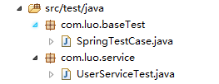

5.1、com.luo.baseTest下添加SpringTestCase.java：

package com.luo.baseTest;

import org.junit.runner.RunWith;

import org.springframework.test.context.ContextConfiguration;

import org.springframework.test.context.junit4.AbstractJUnit4SpringContextTests;

import org.springframework.test.context.junit4.SpringJUnit4ClassRunner;

//指定bean注入的配置文件

@ContextConfiguration(locations = { "classpath:application.xml" })

//使用标准的JUnit @RunWith注释来告诉JUnit使用Spring TestRunner

@RunWith(SpringJUnit4ClassRunner.class)

public class SpringTestCase extends AbstractJUnit4SpringContextTests {

}

5.2、com.luo.service添加UserServiceTest.java：

package com.luo.service;

import org.junit.Test;

import org.springframework.beans.factory.annotation.Autowired;

import com.luo.baseTest.SpringTestCase;

import com.luo.domain.User;

public class UserServiceTest extends SpringTestCase {

@Autowired

private UserService userService;

@Test

public void selectUserByIdTest(){

User user = userService.selectUserById(1);

System.out.println(user.getUserName() + ":" + user.getUserPassword());

}

}

5.3、运行单元测试，UserServiceTest右键Run As –>Junit Test，运行结果：

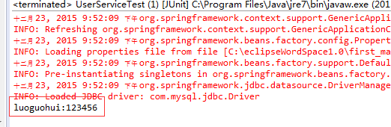

6、实例源码下载

<http://download.csdn.net/detail/u013142781/9374560>