这篇文章主要讲解使用eclipse对Spirng+SpringMVC+Maven+Mybatis+MySQL项目搭建过程，包括里面步骤和里面的配置文件如何配置等等都会详细说明。

如果还没有搭建好环境（主要是Maven+MySQL的配置）的猿友可以参考博主以前的一篇文章：   
<http://blog.csdn.net/u013142781/article/details/50300233>

接下来马上进入项目搭建过程：

### 1、创建表，并插入数据：

CREATE TABLE `t_user` (

`USER_ID` int(11) NOT NULL AUTO_INCREMENT,

`USER_NAME` char(30) NOT NULL,

`USER_PASSWORD` char(10) NOT NULL,

PRIMARY KEY (`USER_ID`),

KEY `IDX_NAME` (`USER_NAME`)

) ENGINE=InnoDB AUTO_INCREMENT=11 DEFAULT CHARSET=utf8

INSERT INTO t_user (USER_ID, USER_NAME, USER_PASSWORD) VALUES (1, 'luoguohui', '123456');

INSERT INTO t_user (USER_ID, USER_NAME, USER_PASSWORD) VALUES (2, 'zhangsan', '123456');

### 2、Maven工程创建

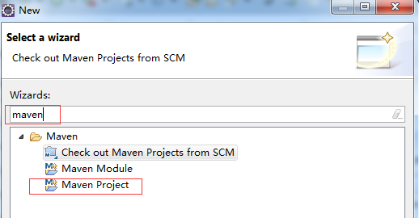

### 3、选择快速框架

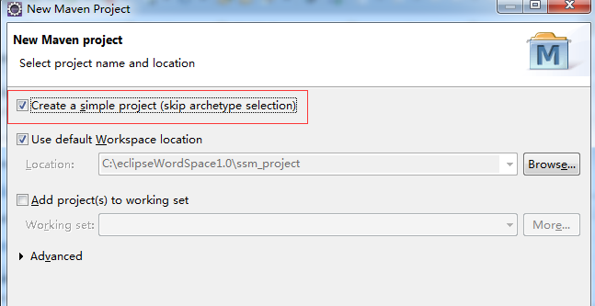

### 4、输出项目名，包（Packaging，如果只是普通的项目，选jar就好了，如果是web项目就选war，这里是web项目，所以选择war）

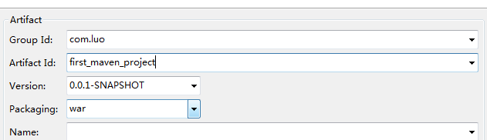

### 5、创建好的目录如下：

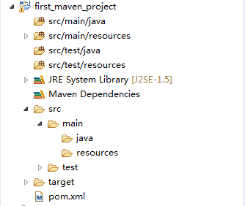

### 6、添加包的依赖，编辑pom.xml文件添加如下依赖：

<project xmlns="http://maven.apache.org/POM/4.0.0" xmlns:xsi="http://www.w3.org/2001/XMLSchema-instance" xsi:schemaLocation="http://maven.apache.org/POM/4.0.0 http://maven.apache.org/xsd/maven-4.0.0.xsd">

<modelVersion>4.0.0</modelVersion>

<groupId>com.luo</groupId>

<artifactId>first_maven_project</artifactId>

<version>0.0.1-SNAPSHOT</version>

<packaging>war</packaging>

<properties>

<!-- spring版本号 -->

<spring.version>3.2.8.RELEASE</spring.version>

<!-- log4j日志文件管理包版本 -->

<slf4j.version>1.6.6</slf4j.version>

<log4j.version>1.2.12</log4j.version>

<!-- junit版本号 -->

<junit.version>4.10</junit.version>

<!-- mybatis版本号 -->

<mybatis.version>3.2.1</mybatis.version>

</properties>

<dependencies>

<!-- 添加Spring依赖 -->

<dependency>

<groupId>org.springframework</groupId>

<artifactId>spring-core</artifactId>

<version>${spring.version}</version>

</dependency>

<dependency>

<groupId>org.springframework</groupId>

<artifactId>spring-webmvc</artifactId>

<version>${spring.version}</version>

</dependency>

<dependency>

<groupId>org.springframework</groupId>

<artifactId>spring-context</artifactId>

<version>${spring.version}</version>

</dependency>

<dependency>

<groupId>org.springframework</groupId>

<artifactId>spring-context-support</artifactId>

<version>${spring.version}</version>

</dependency>

<dependency>

<groupId>org.springframework</groupId>

<artifactId>spring-aop</artifactId>

<version>${spring.version}</version>

</dependency>

<dependency>

<groupId>org.springframework</groupId>

<artifactId>spring-aspects</artifactId>

<version>${spring.version}</version>

</dependency>

<dependency>

<groupId>org.springframework</groupId>

<artifactId>spring-tx</artifactId>

<version>${spring.version}</version>

</dependency>

<dependency>

<groupId>org.springframework</groupId>

<artifactId>spring-jdbc</artifactId>

<version>${spring.version}</version>

</dependency>

<dependency>

<groupId>org.springframework</groupId>

<artifactId>spring-web</artifactId>

<version>${spring.version}</version>

</dependency>

<!--单元测试依赖 -->

<dependency>

<groupId>junit</groupId>

<artifactId>junit</artifactId>

<version>${junit.version}</version>

<scope>test</scope>

</dependency>

<!-- 日志文件管理包 -->

<!-- log start -->

<dependency>

<groupId>log4j</groupId>

<artifactId>log4j</artifactId>

<version>${log4j.version}</version>

</dependency>

<dependency>

<groupId>org.slf4j</groupId>

<artifactId>slf4j-api</artifactId>

<version>${slf4j.version}</version>

</dependency>

<dependency>

<groupId>org.slf4j</groupId>

<artifactId>slf4j-log4j12</artifactId>

<version>${slf4j.version}</version>

</dependency>

<!-- log end -->

<!--spring单元测试依赖 -->

<dependency>

<groupId>org.springframework</groupId>

<artifactId>spring-test</artifactId>

<version>${spring.version}</version>

<scope>test</scope>

</dependency>

<!--mybatis依赖 -->

<dependency>

<groupId>org.mybatis</groupId>

<artifactId>mybatis</artifactId>

<version>${mybatis.version}</version>

</dependency>

<!-- mybatis/spring包 -->

<dependency>

<groupId>org.mybatis</groupId>

<artifactId>mybatis-spring</artifactId>

<version>1.2.0</version>

</dependency>

<!-- mysql驱动包 -->

<dependency>

<groupId>mysql</groupId>

<artifactId>mysql-connector-java</artifactId>

<version>5.1.29</version>

</dependency>

</dependencies>

</project>

### 7、配置文件：

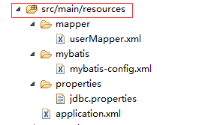

7.1、mybatis包下添加mybatis-config.xml文件（mybatis配置文件）：

<?xml version="1.0" encoding="UTF-8"?>

<!DOCTYPE configuration PUBLIC "-//mybatis.org//DTD Config 3.0//EN"

"http://mybatis.org/dtd/mybatis-3-config.dtd">

<configuration>

</configuration>

7.2、properties包下添加jdbc.properties文件（数据源配置文件）：

jdbc_driverClassName=com.mysql.jdbc.Driver

jdbc_url=jdbc:mysql://localhost:3306/luo

jdbc_username=root

jdbc_password=root

7.3、mapper包下userMapper.xml配置文件（表映射文件）：

<?xml version="1.0" encoding="UTF-8"?>

<!DOCTYPE mapper PUBLIC "-//mybatis.org//DTD Mapper 3.0//EN"

"http://mybatis.org/dtd/mybatis-3-mapper.dtd">

<mapper namespace="com.luo.dao.UserDao">

<!--设置domain类和数据库中表的字段一一对应，注意数据库字段和domain类中的字段名称不致，此处一定要！-->

<resultMap id="BaseResultMap" type="com.luo.domain.User">

<id column="USER_ID" property="userId" jdbcType="INTEGER" />

<result column="USER_NAME" property="userName" jdbcType="CHAR" />

<result column="USER_PASSWORD" property="userPassword" jdbcType="CHAR" />

</resultMap>

<!-- 查询单条记录 -->

<select id="selectUserById" parameterType="int" resultMap="BaseResultMap">

SELECT * FROM t_user WHERE USER_ID = #{userId}

</select>

</mapper>

7.4、spring配置文件application.xml：

<?xml version="1.0" encoding="UTF-8"?>

<beans xmlns="http://www.springframework.org/schema/beans"

xmlns:xsi="http://www.w3.org/2001/XMLSchema-instance" xmlns:context="http://www.springframework.org/schema/context"

xmlns:aop="http://www.springframework.org/schema/aop"

xsi:schemaLocation="

http://www.springframework.org/schema/beans

http://www.springframework.org/schema/beans/spring-beans-3.0.xsd

http://www.springframework.org/schema/aop

http://www.springframework.org/schema/aop/spring-aop-3.0.xsd

http://www.springframework.org/schema/context

http://www.springframework.org/schema/context/spring-context-3.0.xsd">

<!-- 引入jdbc配置文件 -->

<bean id="propertyConfigurer" class="org.springframework.beans.factory.config.PropertyPlaceholderConfigurer">

<property name="locations">

<list>

<value>classpath:properties/*.properties</value>

<!--要是有多个配置文件，只需在这里继续添加即可 -->

</list>

</property>

</bean>

<!-- 配置数据源 -->

<bean id="dataSource"

class="org.springframework.jdbc.datasource.DriverManagerDataSource">

<!-- 不使用properties来配置 -->

<!-- <property name="driverClassName" value="com.mysql.jdbc.Driver" />

<property name="url" value="jdbc:mysql://localhost:3306/learning" />

<property name="username" value="root" />

<property name="password" value="christmas258@" /> -->

<!-- 使用properties来配置 -->

<property name="driverClassName">

<value>${jdbc_driverClassName}</value>

</property>

<property name="url">

<value>${jdbc_url}</value>

</property>

<property name="username">

<value>${jdbc_username}</value>

</property>

<property name="password">

<value>${jdbc_password}</value>

</property>

</bean>

<!-- 自动扫描了所有的XxxxMapper.xml对应的mapper接口文件，这样就不用一个一个手动配置Mpper的映射了，只要Mapper接口类和Mapper映射文件对应起来就可以了。 -->

<bean class="org.mybatis.spring.mapper.MapperScannerConfigurer">

<property name="basePackage"

value="com.luo.dao" />

</bean>

<!-- 配置Mybatis的文件 ，mapperLocations配置**Mapper.xml文件位置，configLocation配置mybatis-config文件位置-->

<bean id="sqlSessionFactory" class="org.mybatis.spring.SqlSessionFactoryBean">

<property name="dataSource" ref="dataSource" />

<property name="mapperLocations" value="classpath:mapper/*.xml"/>

<property name="configLocation" value="classpath:mybatis/mybatis-config.xml" />

<!-- <property name="typeAliasesPackage" value="com.tiantian.ckeditor.model"

/> -->

</bean>

<!-- 自动扫描注解的bean -->

<context:component-scan base-package="com.luo.service" />

</beans>

### 8、接口和类的配置：

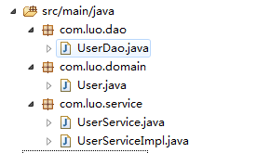

8.1、com.luo.domain下添加User.java文件：

package com.luo.domain;

public class User {

private Integer userId;

private String userName;

private String userPassword;

public Integer getUserId() {

return userId;

}

public void setUserId(Integer userId) {

this.userId = userId;

}

public String getUserName() {

return userName;

}

public void setUserName(String userName) {

this.userName = userName;

}

public String getUserPassword() {

return userPassword;

}

public void setUserPassword(String userPassword) {

this.userPassword = userPassword;

}

}

8.2、com.luo.dao下添加UserDao.java文件：

package com.luo.dao;

import com.luo.domain.User;

public interface UserDao {

/**

* @param userId

* @return User

*/

public User selectUserById(Integer userId);

}

8.3、com.luo.service下添加UserService.java接口和UserServiceImpl实现类：

package com.luo.service;

import com.luo.domain.User;

public interface UserService {

User selectUserById(Integer userId);

}

package com.luo.service;

import org.springframework.beans.factory.annotation.Autowired;

import org.springframework.stereotype.Service;

import com.luo.dao.UserDao;

import com.luo.domain.User;

@Service

public class UserServiceImpl implements UserService {

@Autowired

private UserDao userDao;

public User selectUserById(Integer userId) {

return userDao.selectUserById(userId);

}

}

### 9、单元测试

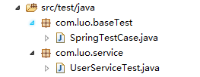

9.1、com.luo.baseTest下添加SpringTestCase.java：

package com.luo.baseTest;

import org.junit.runner.RunWith;

import org.springframework.test.context.ContextConfiguration;

import org.springframework.test.context.junit4.AbstractJUnit4SpringContextTests;

import org.springframework.test.context.junit4.SpringJUnit4ClassRunner;

//指定bean注入的配置文件

@ContextConfiguration(locations = { "classpath:application.xml" })

//使用标准的JUnit @RunWith注释来告诉JUnit使用Spring TestRunner

@RunWith(SpringJUnit4ClassRunner.class)

public class SpringTestCase extends AbstractJUnit4SpringContextTests {

}

9.2、com.luo.service添加UserServiceTest.java：

package com.luo.service;

import org.junit.Test;

import org.springframework.beans.factory.annotation.Autowired;

import com.luo.baseTest.SpringTestCase;

import com.luo.domain.User;

public class UserServiceTest extends SpringTestCase {

@Autowired

private UserService userService;

@Test

public void selectUserByIdTest(){

User user = userService.selectUserById(1);

System.out.println(user.getUserName() + ":" + user.getUserPassword());

}

}

9.3、运行单元测试，UserServiceTest右键Run As –>Junit Test，运行结果：

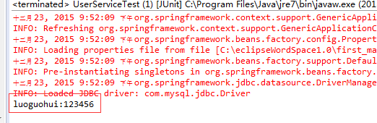

下面加入springmvc，并转换maven工程为web项目

### 10、转换成web项目：

如果上面webapp为空的，说明这个项目还不是web项目：

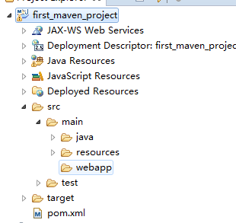

接下来打开如下页面。将红框里面的勾去掉，确定（OK）：

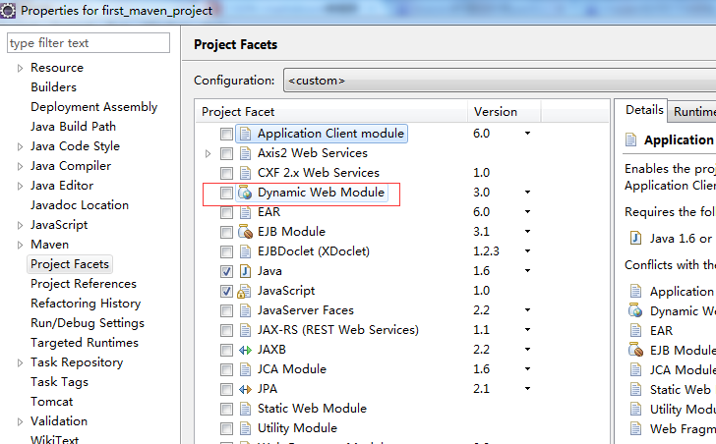

然后重新打开刚刚那个页面，把Dynamic web Module勾上，就会看到红框的内容，点击：

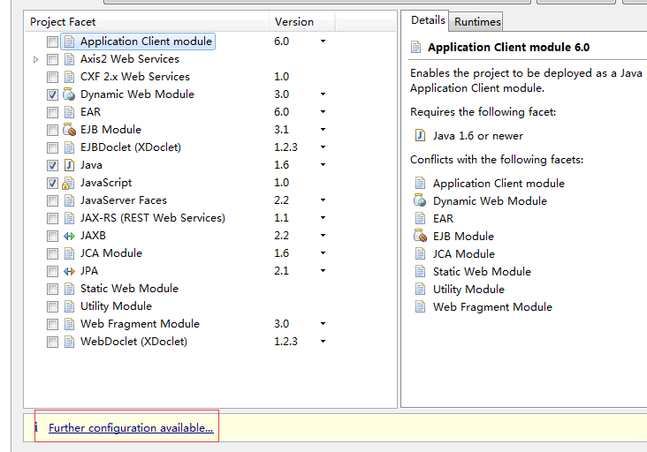

然后配置如下：

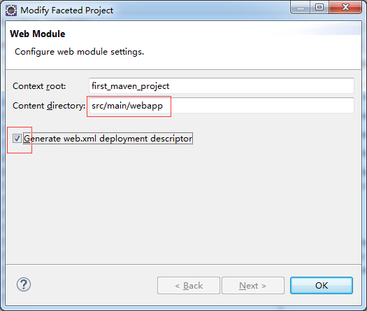

那么webapp下就会生成这些东西：

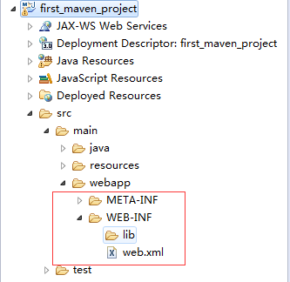

### 11、配置springmvc

11.1、pom.xml文件添加依赖，修改后配置如下：

<project xmlns="http://maven.apache.org/POM/4.0.0" xmlns:xsi="http://www.w3.org/2001/XMLSchema-instance" xsi:schemaLocation="http://maven.apache.org/POM/4.0.0 http://maven.apache.org/xsd/maven-4.0.0.xsd">

<modelVersion>4.0.0</modelVersion>

<groupId>com.luo</groupId>

<artifactId>first_maven_project</artifactId>

<version>0.0.1-SNAPSHOT</version>

<packaging>war</packaging>

<properties>

<!-- spring版本号 -->

<spring.version>3.2.8.RELEASE</spring.version>

<!-- junit版本号 -->

<junit.version>4.10</junit.version>

<!-- mybatis版本号 -->

<mybatis.version>3.2.1</mybatis.version>

</properties>

<dependencies>

<!-- 添加Spring依赖 -->

<dependency>

<groupId>org.springframework</groupId>

<artifactId>spring-core</artifactId>

<version>${spring.version}</version>

</dependency>

<dependency>

<groupId>org.springframework</groupId>

<artifactId>spring-webmvc</artifactId>

<version>${spring.version}</version>

</dependency>

<dependency>

<groupId>org.springframework</groupId>

<artifactId>spring-context</artifactId>

<version>${spring.version}</version>

</dependency>

<dependency>

<groupId>org.springframework</groupId>

<artifactId>spring-context-support</artifactId>

<version>${spring.version}</version>

</dependency>

<dependency>

<groupId>org.springframework</groupId>

<artifactId>spring-aop</artifactId>

<version>${spring.version}</version>

</dependency>

<dependency>

<groupId>org.springframework</groupId>

<artifactId>spring-aspects</artifactId>

<version>${spring.version}</version>

</dependency>

<dependency>

<groupId>org.springframework</groupId>

<artifactId>spring-tx</artifactId>

<version>${spring.version}</version>

</dependency>

<dependency>

<groupId>org.springframework</groupId>

<artifactId>spring-jdbc</artifactId>

<version>${spring.version}</version>

</dependency>

<dependency>

<groupId>org.springframework</groupId>

<artifactId>spring-web</artifactId>

<version>${spring.version}</version>

</dependency>

<!--单元测试依赖 -->

<dependency>

<groupId>junit</groupId>

<artifactId>junit</artifactId>

<version>${junit.version}</version>

<scope>test</scope>

</dependency>

<!--spring单元测试依赖 -->

<dependency>

<groupId>org.springframework</groupId>

<artifactId>spring-test</artifactId>

<version>${spring.version}</version>

<scope>test</scope>

</dependency>

<!--mybatis依赖 -->

<dependency>

<groupId>org.mybatis</groupId>

<artifactId>mybatis</artifactId>

<version>${mybatis.version}</version>

</dependency>

<!-- mybatis/spring包 -->

<dependency>

<groupId>org.mybatis</groupId>

<artifactId>mybatis-spring</artifactId>

<version>1.2.0</version>

</dependency>

<!-- mysql驱动包 -->

<dependency>

<groupId>mysql</groupId>

<artifactId>mysql-connector-java</artifactId>

<version>5.1.29</version>

</dependency>

<!-- javaee-api包 注意和项目使用的JDK版本对应 -->

<dependency>

<groupId>javax</groupId>

<artifactId>javaee-api</artifactId>

<version>6.0</version>

<scope>provided</scope>

</dependency>

<!-- javaee-web-api包 注意和项目使用的JDK版本对应 -->

<dependency>

<groupId>javax</groupId>

<artifactId>javaee-web-api</artifactId>

<version>6.0</version>

<scope>provided</scope>

</dependency>

</dependencies>

</project>

其实也就增加了下面两个

<!-- javaee-api包 注意和项目使用的JDK版本对应 -->

<dependency>

<groupId>javax</groupId>

<artifactId>javaee-api</artifactId>

<version>6.0</version>

<scope>provided</scope>

</dependency>

<!-- javaee-web-api包 注意和项目使用的JDK版本对应 -->

<dependency>

<groupId>javax</groupId>

<artifactId>javaee-web-api</artifactId>

<version>6.0</version>

<scope>provided</scope>

</dependency>

11.2、在src/main/resource中添加springmvc文件夹，然后添加文件spring-mvc.xml，内容如下：

<?xml version="1.0" encoding="UTF-8"?>

<beans xmlns="http://www.springframework.org/schema/beans"

xmlns:p="http://www.springframework.org/schema/p"

xmlns:xsi="http://www.w3.org/2001/XMLSchema-instance"

xmlns:context="http://www.springframework.org/schema/context"

xmlns:mvc="http://www.springframework.org/schema/mvc"

xsi:schemaLocation="

http://www.springframework.org/schema/beans

http://www.springframework.org/schema/beans/spring-beans-3.2.xsd

http://www.springframework.org/schema/context

http://www.springframework.org/schema/context/spring-context-3.2.xsd

http://www.springframework.org/schema/mvc

http://www.springframework.org/schema/mvc/spring-mvc-3.2.xsd">

<mvc:annotation-driven />

<!-- 扫描controller（controller层注入） -->

<context:component-scan base-package="com.luo.controller"/>

<!-- 对模型视图添加前后缀 -->

<bean id="viewResolver" class="org.springframework.web.servlet.view.InternalResourceViewResolver"

p:prefix="/WEB-INF/view/" p:suffix=".jsp"/>

</beans>

11.3、配置web.xml

<?xml version="1.0" encoding="UTF-8"?>

<web-app xmlns:xsi="http://www.w3.org/2001/XMLSchema-instance"

xmlns="http://java.sun.com/xml/ns/javaee" xmlns:web="http://java.sun.com/xml/ns/javaee/web-app_2_5.xsd"

xsi:schemaLocation="http://java.sun.com/xml/ns/javaee http://java.sun.com/xml/ns/javaee/web-app_2_5.xsd"

id="WebApp_ID" version="2.5">

<display-name>Archetype Created Web Application</display-name>

<!-- 起始欢迎界面 -->

<welcome-file-list>

<welcome-file>index.jsp</welcome-file>

</welcome-file-list>

<!-- 读取spring配置文件 -->

<context-param>

<param-name>contextConfigLocation</param-name>

<param-value>classpath:application.xml</param-value>

</context-param>

<!-- 设计路径变量值 -->

<context-param>

<param-name>webAppRootKey</param-name>

<param-value>springmvc.root</param-value>

</context-param>

<!-- Spring字符集过滤器 -->

<filter>

<filter-name>SpringEncodingFilter</filter-name>

<filter-class>org.springframework.web.filter.CharacterEncodingFilter</filter-class>

<init-param>

<param-name>encoding</param-name>

<param-value>UTF-8</param-value>

</init-param>

<init-param>

<param-name>forceEncoding</param-name>

<param-value>true</param-value>

</init-param>

</filter>

<filter-mapping>

<filter-name>SpringEncodingFilter</filter-name>

<url-pattern>/*</url-pattern>

</filter-mapping>

<listener>

<listener-class>org.springframework.web.context.ContextLoaderListener</listener-class>

</listener>

<!-- springMVC核心配置 -->

<servlet>

<servlet-name>dispatcherServlet</servlet-name>

<servlet-class>org.springframework.web.servlet.DispatcherServlet</servlet-class>

<init-param>

<param-name>contextConfigLocation</param-name>

<!--spingMVC的配置路径 -->

<param-value>classpath:springmvc/spring-mvc.xml</param-value>

</init-param>

<load-on-startup>1</load-on-startup>

</servlet>

<!-- 拦截设置 -->

<servlet-mapping>

<servlet-name>dispatcherServlet</servlet-name>

<url-pattern>/</url-pattern>

</servlet-mapping>

<!-- 错误跳转页面 -->

<error-page>

<!-- 路径不正确 -->

<error-code>404</error-code>

<location>/WEB-INF/errorpage/404.jsp</location>

</error-page>

<error-page>

<!-- 没有访问权限，访问被禁止 -->

<error-code>405</error-code>

<location>/WEB-INF/errorpage/405.jsp</location>

</error-page>

<error-page>

<!-- 内部错误 -->

<error-code>500</error-code>

<location>/WEB-INF/errorpage/500.jsp</location>

</error-page>

</web-app>

11.4、添加index.jsp，在src/main/webapp/WEB-INF下新建一个文件夹view,添加一个index.jsp，内容如下：

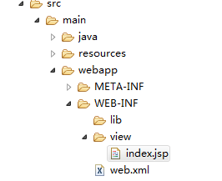

<%@ page language="java" contentType="text/html; charset=UTF-8" pageEncoding="UTF-8"%>

<html>

<body>

<h2>Hello World!</h2>

用户名： ${user.userName}<br>

密码：${user.userPassword}<br>

</body>

</html>

11.5、写controller

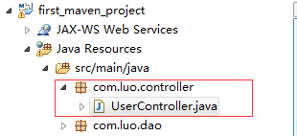

在src/main/java下新建一个包com.luo.controller.然后新建一个类UserController.java,其内容如下

package com.luo.controller;

import javax.annotation.Resource;

import org.springframework.stereotype.Controller;

import org.springframework.web.bind.annotation.RequestMapping;

import org.springframework.web.servlet.ModelAndView;

import com.luo.domain.User;

import com.luo.service.UserService;

@Controller

public class UserController {

@Resource

private UserService userService;

@RequestMapping("/")

public ModelAndView getIndex(){

ModelAndView mav = new ModelAndView("index");

User user = userService.selectUserById(1);

mav.addObject("user", user);

return mav;

}

}

11.6 运行！！！！完成！

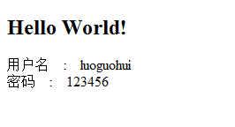

### 12、源码下载

<http://download.csdn.net/detail/u013142781/9376381>