APPLICATION NOTE | GENE EXPRESSION
scChromatic: reproducible, context-aware color systems for single-cell data visualization
Shaojun Xie · ORCID 0000-0002-6719-9814
Frederick National Laboratory for Cancer Research, Frederick, MD 21702, USA
Summary: Single-cell figures frequently assign colors by factor position, so filtering or reordering can silently change the visual identity of a cell type. scChromatic is an R package that treats label-to-color assignments as persistent, versioned objects. It combines provenance-aware palette selection, append-only label maps, hierarchy- and relationship-aware assignments, color-vision-deficiency diagnostics, redundant shape or pattern allocation, and ggplot2-compatible scales. The design separates stable semantic identity from plot-specific data and records the choices required to reproduce a figure.
Availability and implementation: scChromatic 0.1.0 is implemented in R (R ≥4.2.0) and released under GPL-3.0-or-later. Source code, documentation, examples and tests are freely available at https://github.com/xie186/scChromatic and https://xie186.github.io/scChromatic/.
Contact: xies4@nih.gov
Supplementary information: Vignettes, a deterministic synthetic example dataset, the JSON Schema and an executable validation scaffold are distributed with the package and documentation site.
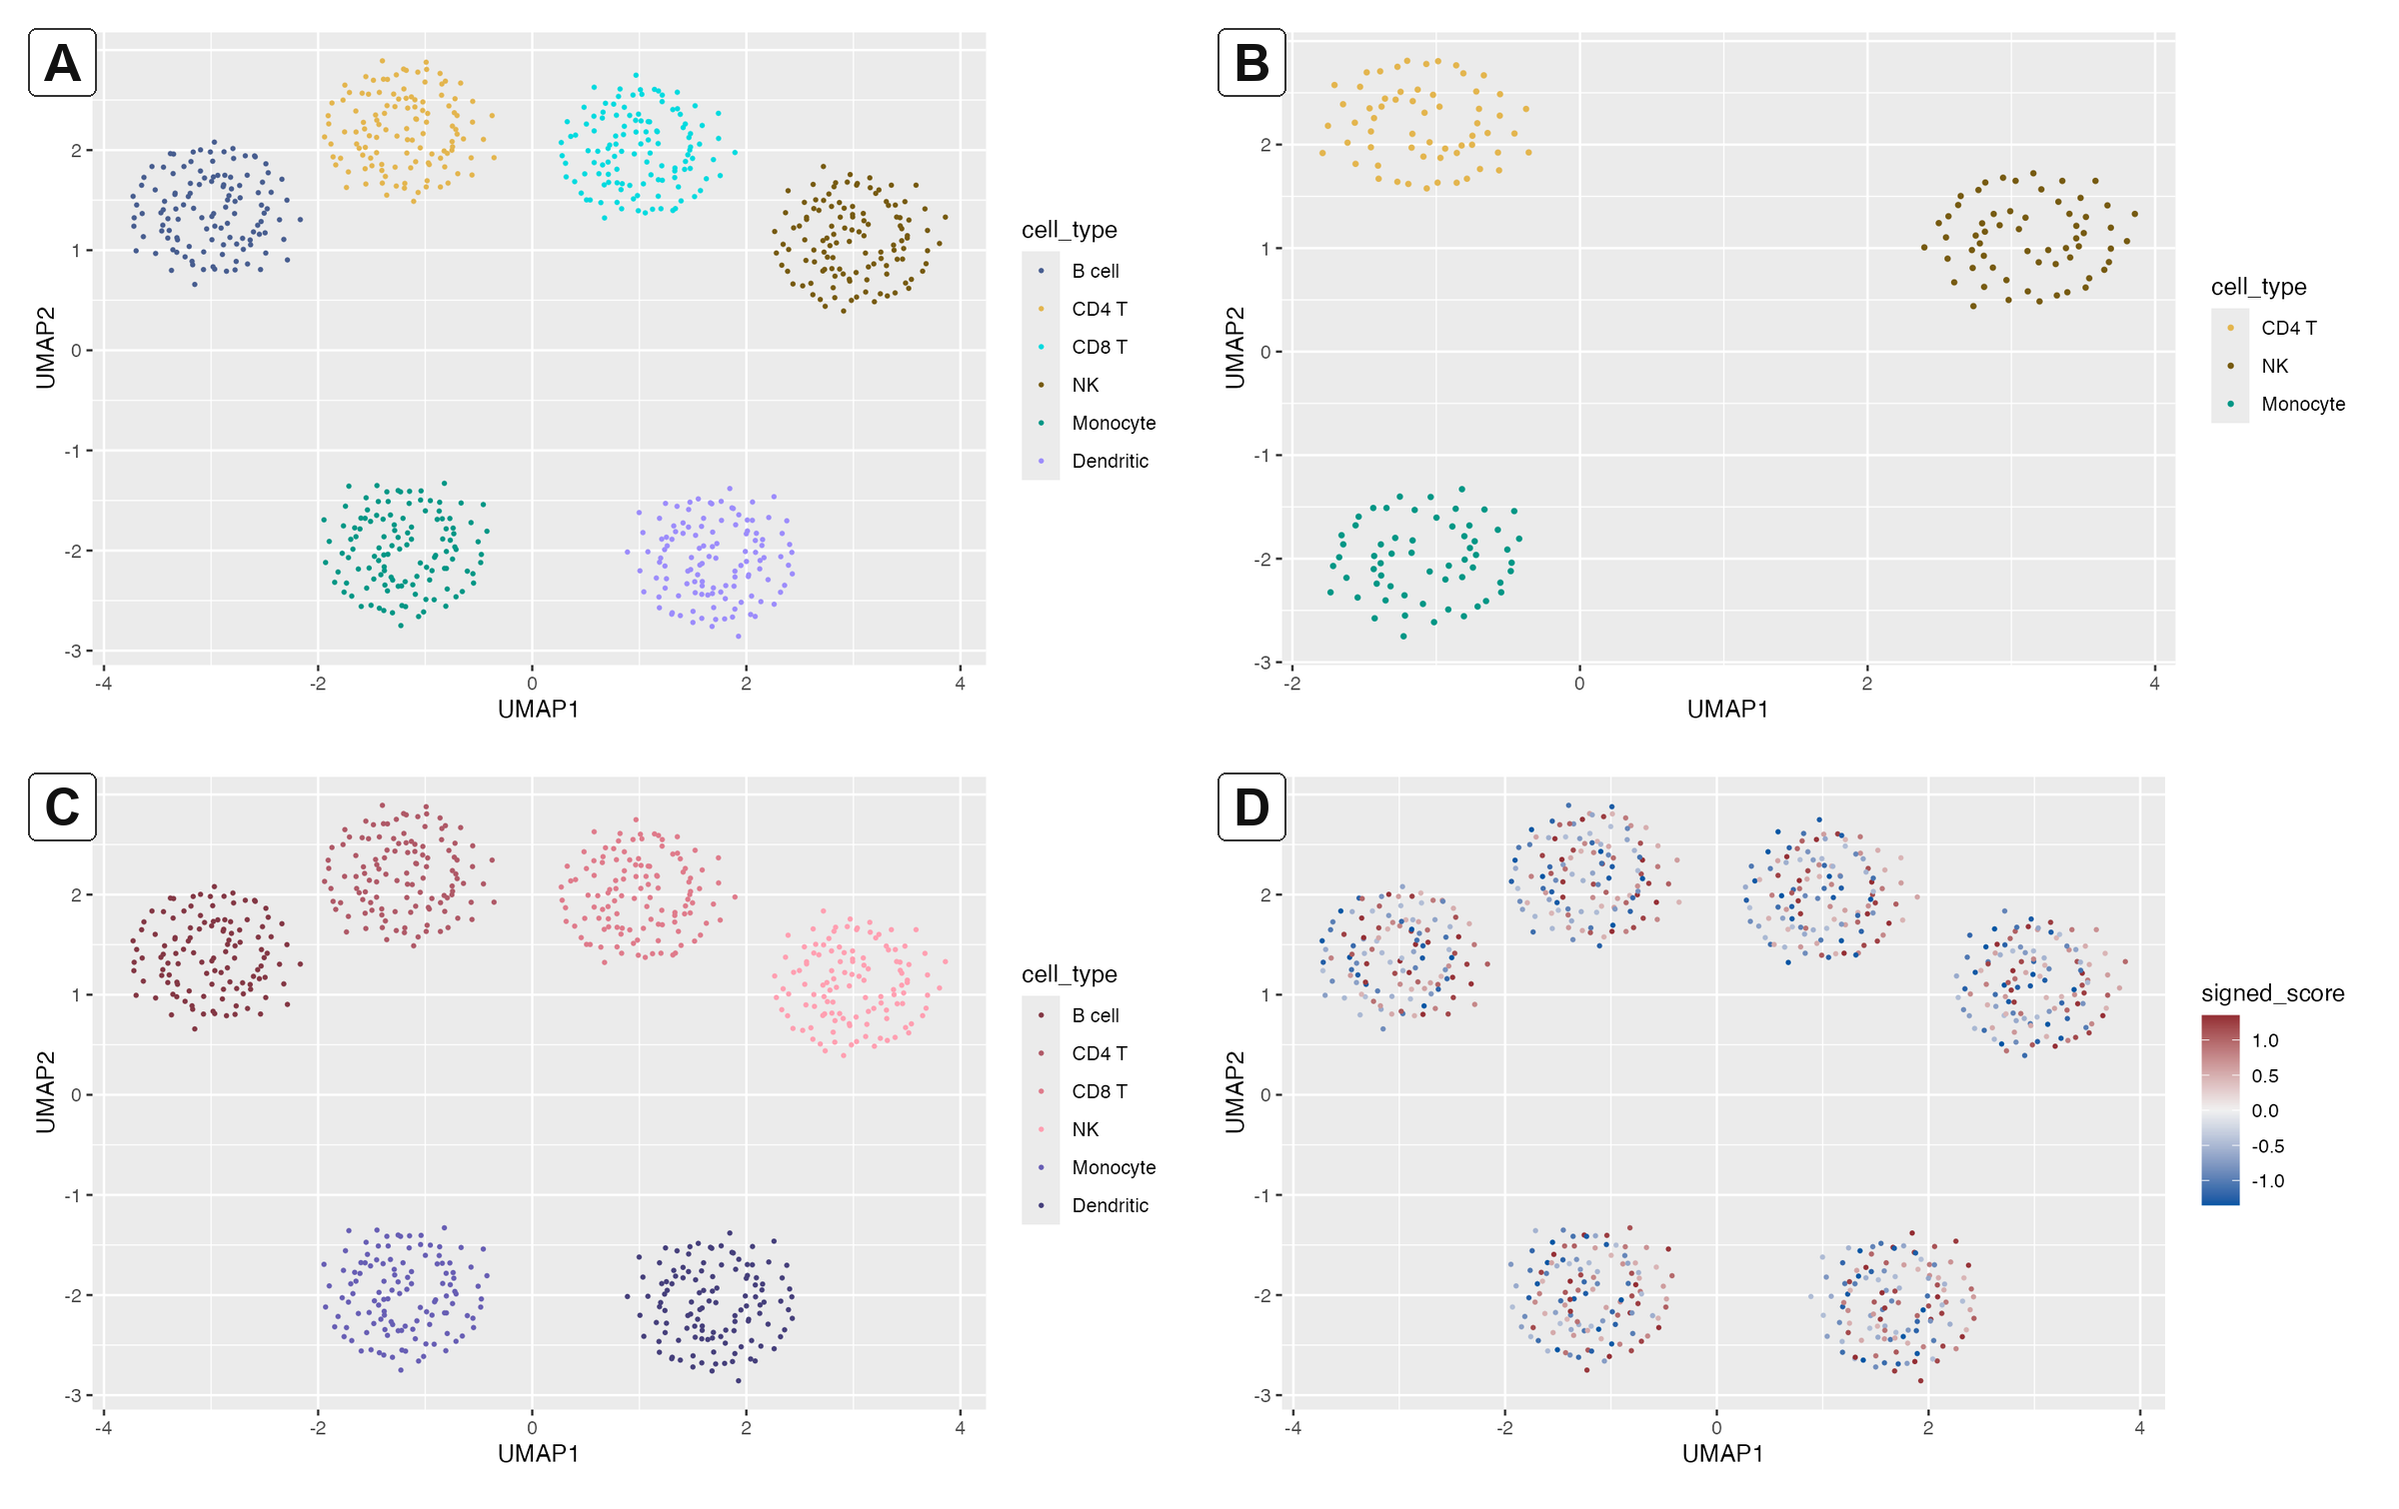
Fig. 1. scChromatic color semantics on the deterministic synthetic PBMC-like example. (A) A persistent named map assigns six cell identities. (B) Filtering to three identities preserves their original colors without recalculating the palette. (C) A hierarchy map expresses two parent lineages through related child colors while retaining distinct labels. (D) The diverging chromatic_balance scale maps a signed score around an explicit midpoint of zero. Coordinates and values are synthetic and demonstrate the interface only; they are not biological validation.

1 Introduction
Low-dimensional embeddings, marker-expression plots, trajectories and heatmaps make color a recurring semantic layer in single-cell analysis (Amezquita et al., 2020; Hao et al., 2021). Most plotting interfaces, however, receive an ordered vector of colors. When a dataset is filtered, factor levels are reordered or a figure is rebuilt in another framework, the same label can inherit a different color. The resulting figure may remain attractive while changing the meaning of an established visual cue. This failure is difficult to detect when panels are produced at different stages of a long analysis.
Accessibility creates a second constraint. Dense point clouds, many categories and small marks reduce effective color separation, and color-vision-deficiency (CVD) simulations can reveal collisions that are inconspicuous under normal vision (Crameri et al., 2020; Szafir, 2018). Existing single-cell visualization packages provide strong plotting systems and accessible palettes (Bunis et al., 2020; Guha et al., 2022), but palette choice alone does not establish persistent cross-figure identity, auditable provenance or controlled updates as a label taxonomy grows.
scChromatic addresses these concerns by representing color as a reusable data contract. The package stores named assignments and their construction metadata, applies those assignments through ordinary ggplot2 scales or named vectors, and offers optional hierarchy, neighborhood context, accessibility diagnostics and redundant encodings. Figure 1 summarizes the principal color semantics on a synthetic dataset.

2 Implementation

2.1 Persistent maps and interoperability
sc_color_map() constructs an sc_color_map object from the complete label universe. The object contains named hexadecimal colors rather than an unnamed positional sequence. scale_color_sc_map() and scale_fill_sc_map() therefore select colors by label, and assignments are never recomputed from the plotted subset. update_sc_color_map() is append-only: existing labels keep their colors and only new labels receive assignments. Explicit locks, aliases, focus metadata, construction history, seeds and context records travel with the map.
as_named_colors() exposes a conventional named vector for use in Seurat plotting arguments, SingleCellExperiment metadata workflows, ArchR and ComplexHeatmap without making those frameworks package dependencies. AnnData users can index the named map in categorical-level order immediately before writing the corresponding .uns color vector. JSON and CSV writers retain the complete contract, and a bundled Draft 2020-12 JSON Schema supports validation outside R. Readers reject unknown future schema versions instead of guessing their interpretation.

2.2 Palette registry and semantic scales
The package registry contains 19 qualitative, sequential, diverging and cyclic resources. Each entry records intended uses, native capacity, plotting geometry, background guidance, source URL, exact source version or checksum where available, citation, license, derivation status and frozen audit metrics. sc_palette_recommend() ranks compatible entries using transparent rules for data use, geometry, background, capacity and optional CVD separation; it does not fit a learned model or declare a universal pass threshold.
Fixed qualitative palettes are truncated but never interpolated. Oversubscribed palettes fail by default and can be extended only through an explicit deterministic generation option. The count- and order-dependent d3_rainbow sequence is available for CELLXGENE compatibility but is intentionally excluded from persistent map construction. Continuous scales interpolate registered anchors in Lab space, and an explicit midpoint uses value-aware rescaling for signed statistics rather than merely placing a neutral color at the center of a legend.

2.3 Hierarchy and relationship context
sc_hierarchy_map() assigns distinct parent anchors and controlled lightness/chroma variants to child labels. When a hierarchy is extended, established anchors and child colors are retained exactly. This lightweight constructor assumes one canonical parent per child; multiple-parent ontologies remain outside its scope.
For analyses in which local context should influence color, sc_relationship_from_knn() derives a symmetric label-affinity matrix from exact Euclidean k-nearest neighbors within each sample. Directed neighbor proportions are symmetrized, samples receive equal weight regardless of cell count, and a label pair is aggregated only over samples containing both labels. Pairs never observed together are errors unless the analyst explicitly assigns zero affinity. PCA, a model-derived latent representation or spatial coordinates are preferable to UMAP when distances are intended to have quantitative meaning.
sc_relationship_map() applies a seeded heuristic to an affinity matrix. It fits normal-vision CIEDE2000 distance to the target 8 + 32(1 − affinity) and separately penalizes shortfalls in the worst distance across normal, deutan, protan and tritan views (Luo et al., 2001; Machado et al., 2009). Hard-locked canonical labels never move, and a stability budget caps changes to the remaining canonical assignments. The effective matrix, canonical before/after values, method version, seed, objective and support summaries are stored as immutable construction provenance. Affinity is a display context, not direct evidence of biological similarity.

2.4 Accessibility diagnostics and redundancy
sc_palette_audit() reports minimum and median CIEDE2000 separation under requested normal and simulated CVD views, the worst label pair, duplicate collisions and contrast against the plotting background. These quantities are diagnostics for a specified palette and geometry, not guarantees that every viewer can distinguish every mark. Simulation likewise does not substitute for evaluation with people who have color-vision differences.
When pairs remain confusable, sc_redundant_encoding() constructs a conflict graph and uses a deterministic DSATUR heuristic to allocate ggplot2 shapes, pattern names or joint shape-pattern groups. Colors remain unchanged, preserving identity while adding a second channel. Because graph priorities can change with the label universe, an encoding is allocated once for the full set and then reused or subset across figures.

3 Demonstration and software verification
The package includes sc_example, a deterministic 720-cell PBMC-like dataset with six identities, two lineages, four samples, two conditions, a synthetic marker, signed score, pseudotime and quality-control variables. It exercises categorical, hierarchy, sequential and diverging scales without distributing biological measurements. In the documented subset example, selecting CD4 T, NK and Monocyte from the full named map preserves the three corresponding hexadecimal assignments exactly (Fig. 1A,B). JSON and CSV round trips, hierarchy growth, label locking and map subsetting are covered by package tests.
A local R CMD check of version 0.1.0 completed with zero errors and zero warnings; the single note identified the package as a new submission and reported license metadata. The recorded testthat run passed 334 expectations with no failures, warnings or skips. The repository also contains an executable scaffold for real-data comparator benchmarks, stability/fit ablations and a participant-study feasibility pilot. Those longer analyses are opt-in and remain a protocol; their synthetic smoke test is not presented as performance or biological evidence in this Application Note.

4 Discussion
scChromatic moves color assignment from local plot styling into a persistent, portable and inspectable object. This makes a basic invariant—one biological label, one stable color—testable across subsets and software boundaries. The same object can also preserve an evolving hierarchy, constrain context-aware reassignment and document palette provenance. Because outputs reduce to ggplot2 scales and named vectors, adoption does not require replacement of established single-cell analysis frameworks.
The package deliberately limits its claims. CIEDE2000 and simulated CVD views are useful stress tests, but perception depends on mark size, density, background, display conditions and the viewer. Neighborhood affinities depend on preprocessing, coordinate scale, label prevalence and k. High-cardinality annotations may remain unreadable even after optimization; direct labels, facets, interaction, shapes or patterns should then share the encoding load. Empirical real-data and participant evaluation will be required to quantify whether stable and redundant mappings improve cross-panel tracking and task accuracy.

Acknowledgements
The author acknowledges the maintainers of R, ggplot2, colorspace and the palette sources recorded in the package registry. OpenAI Codex was used to assist with initial manuscript drafting and document formatting; the author is responsible for verification and the final content.

Funding
No external funding was declared for this software manuscript.

Conflict of interest
None declared.

Data availability
No biological dataset underlies the claims in this manuscript. The deterministic synthetic data, source code, schema, documentation and tests are distributed in the scChromatic repository. The real-data validation notebook is an unexecuted analysis protocol and is not used as evidence here.

References
Amezquita,R.A. et al. (2020) Orchestrating single-cell analysis with Bioconductor. Nat. Methods, 17, 137–145. https://doi.org/10.1038/s41592-019-0654-x.
Bunis,D.G. et al. (2020) dittoSeq: universal user-friendly single-cell and bulk RNA sequencing visualization toolkit. Bioinformatics, 36, 5535–5536. https://doi.org/10.1093/bioinformatics/btaa1011.
Crameri,F. et al. (2020) The misuse of colour in science communication. Nat. Commun., 11, 5444. https://doi.org/10.1038/s41467-020-19160-7.
Guha,T. et al. (2022) Generating colorblind-friendly scatter plots for single-cell data. eLife, 11, e82128. https://doi.org/10.7554/eLife.82128.
Hao,Y. et al. (2021) Integrated analysis of multimodal single-cell data. Cell, 184, 3573–3587.e29. https://doi.org/10.1016/j.cell.2021.04.048.
Luo,M.R. et al. (2001) The development of the CIE 2000 colour-difference formula: CIEDE2000. Color Res. Appl., 26, 340–350. https://doi.org/10.1002/col.1049.
Machado,G.M. et al. (2009) A physiologically-based model for simulation of color vision deficiency. IEEE Trans. Vis. Comput. Graph., 15, 1291–1298. https://doi.org/10.1109/TVCG.2009.113.
McCarthy,D.J. et al. (2017) Scater: pre-processing, quality control, normalization and visualization of single-cell RNA-seq data in R. Bioinformatics, 33, 1179–1186. https://doi.org/10.1093/bioinformatics/btw777.
R Core Team (2026) R: A Language and Environment for Statistical Computing. R Foundation for Statistical Computing, Vienna, Austria.
Szafir,D.A. (2018) Modeling color difference for visualization design. IEEE Trans. Vis. Comput. Graph., 24, 392–401. https://doi.org/10.1109/TVCG.2017.2744359.
Zeileis,A. et al. (2020) colorspace: a toolbox for manipulating and assessing colors and palettes. J. Stat. Softw., 96, 1–49. https://doi.org/10.18637/jss.v096.i01.

