**Assignment 1**

**Lingyan Xie**

**2/23/2022**

1. What is JDK? JRE? JVM?

JDK - Java Development Kit, is a development environment for building applications, applets, and components using Java language. JDK is needed to convert source code into a format that the Java Runtime Environment can execute. The JDK includes the Java Runtime Environment (JRE), an interpreter (java), a compiler (javac), an archiver (jar), a documentation generator (javadoc), and some other development tools.

JRE - Java Runtime Environment, is a set of components to create and run a Java application. A JRE is part of a Java development kit (JDK). A JRE is made up of a Java virtual machine (JVM), Java class libraries, and the Java class loader.

JVM - Java Virtual Machine, loads, verifies and executes Java bytecode. It allows Java programs to run on any device or operating system (known as the "Write once, run anywhere" principle), and to manage and optimize program memory.

In general, JDKs are used to develop Java software; JREs provide programming tools and deployment technologies; and JVMs execute Java programs.

1. What is java compiler?

Java compiler refers to a program which translates Java language source code into the Java Virtual Machine (JVM) bytecodes.

1. Why is java platform independent?

It does not depend on any type of platform, because in Java, programs are compiled into bytecode and any machine can execute the bytecode via JVM.

1. What is IDE? Why is it important for developers?

IDE is Integrated Development Environment. It is important because it helps improve developer productivity by combining common activities of writing software into a single application: editing source code, building executables, and debugging.

1. Is java case sensitive?

Yes.

1. What do the following key words do?  
   static, final, public, private, void, null, package, Class, new

static: A non-access modifier used for methods and attributes. Static methods/attributes can be accessed without creating an object of a class

final: A non-access modifier used for classes, attributes and methods, which makes them non-changeable (impossible to inherit or override)

public: An access modifier used for classes, attributes, methods and constructors, making them accessible by any other class

private: An access modifier used for attributes, methods and constructors, making them only accessible within the declared class

void: Specifies that a method should not have a return value

null: It is a literal that represents a null reference

package: Declares a package

class: defines a class

new: Creates new objects

1. What is primitive type and reference type?

primitives are data types, while references are pointers, which do not hold their values but point to their values and are used on/with objects.

1. Is parameter passed by value or reference?

Java always passes parameter variables by value

1. What is the output: System.out.println(1 > 0 : “A”:”B”);

Error, build failed.

1. How to define constants in java?

add the keyword “final” in front of the variable declaration.

1. What is String? Is it primitive type?

A Java string is a sequence of characters that exist as an object. String is an object, it isn't a primitive type at all, just an array of chars.

1. How to check if a String is representing a number?

The easiest way is to use Java's built-in methods:

Integer.parseInt(String)

Float.parseFloat(String)

Double.parseDouble(String)

Long.parseLong(String)

new BigInteger(String)

If these methods don't throw any NumberFormatException, then it means that the parsing was successful and the String is numeric.

1. Write a program to implement the following activity diagram:

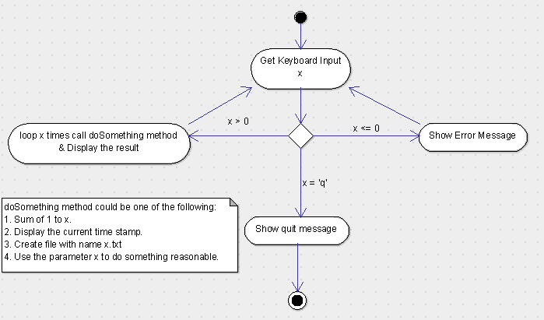

<https://github.com/xie18ly/Java_Batch_2022_5_6/blob/master/src/main/java/AssignmentOne/DoSomething.java>

1. Write a program to merge two array of int.

<https://github.com/xie18ly/Java_Batch_2022_5_6/blob/master/src/main/java/AssignmentOne/MergeTwoArray.java>

1. Write a program to find the second largest number inside an array of int.

<https://github.com/xie18ly/Java_Batch_2022_5_6/blob/master/src/main/java/AssignmentOne/SecondLargest.java>