实验3实验报告

姓名：谢宝玛 学号：1120233506

安装neo4j,启动
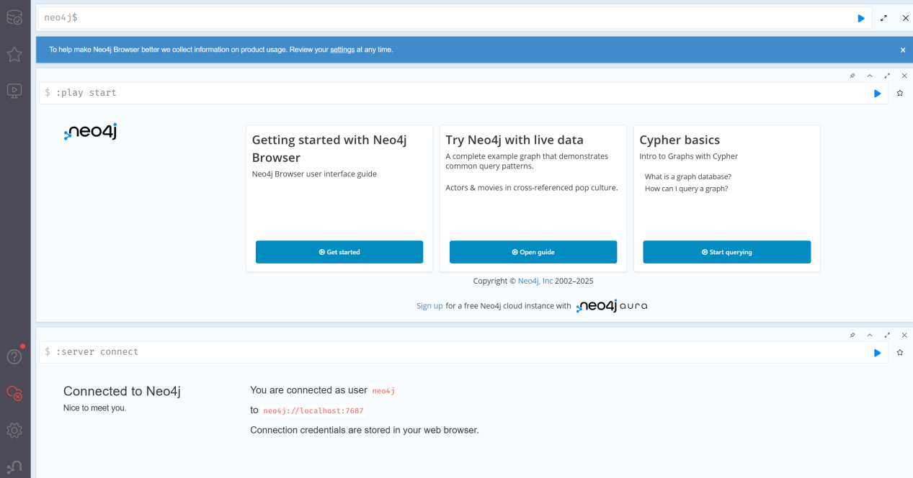

新建Java项目
注：尝试添加jar包，但是报错，所以使用maven添加依赖
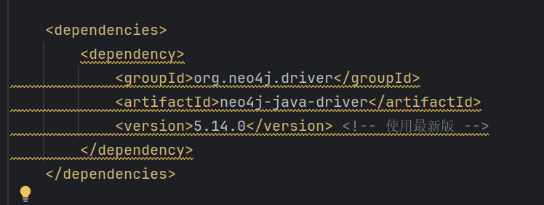

编写程序，创建知识图谱
构建一个“学术领域知识图谱”，包含以下实体和关系：
节点类型（实体）：
Person：研究人员（属性：name, affiliation）
Paper：论文（属性：title, year）
Conference：会议（属性：name, location）
关系类型：
AUTHORED：(Person)-[:AUTHORED]->(Paper)
PRESENTED_AT：(Paper)-[:PRESENTED_AT]->(Conference)
COLLABORATES_WITH：(Person)-[:COLLABORATES_WITH]->(Person)

源码：
package com.alibaba.cloud;
import org.neo4j.driver.*;
public class AcademicGraph implements AutoCloseable {
private final Driver driver;
public AcademicGraph(String uri, String user, String password) {
driver = GraphDatabase.driver(uri, AuthTokens.basic(user, password));
}
@Override
public void close() {
driver.close();
}
// 创建研究人员
public void createPerson(String name, String affiliation) {
try (Session session = driver.session()) {
session.run("MERGE (p:Person {name: $name, affiliation: $affiliation})",
Values.parameters("name", name, "affiliation", affiliation));
}
}
// 创建论文
public void createPaper(String title, int year) {
try (Session session = driver.session()) {
session.run("MERGE (p:Paper {title: $title, year: $year})",
Values.parameters("title", title, "year", year));
}
}
// 创建会议
public void createConference(String name, String location) {
try (Session session = driver.session()) {
session.run("MERGE (c:Conference {name: $name, location: $location})",
Values.parameters("name", name, "location", location));
}
}
// 创建作者与论文的关系
public void createAuthorship(String personName, String paperTitle) {
try (Session session = driver.session()) {
session.run(
"MATCH (p:Person {name: $personName}), (pa:Paper {title: $paperTitle}) " +
"MERGE (p)-[:AUTHORED]->(pa)",
Values.parameters("personName", personName, "paperTitle", paperTitle));
}
}
// 创建论文和会议的关系
public void createPresentation(String paperTitle, String confName) {
try (Session session = driver.session()) {
session.run(
"MATCH (pa:Paper {title: $paperTitle}), (c:Conference {name: $confName}) " +
"MERGE (pa)-[:PRESENTED_AT]->(c)",
Values.parameters("paperTitle", paperTitle, "confName", confName));
}
}
// 创建合作关系
public void createCollaboration(String name1, String name2) {
try (Session session = driver.session()) {
session.run(
"MATCH (a:Person {name: $name1}), (b:Person {name: $name2}) " +
"MERGE (a)-[:COLLABORATES_WITH]->(b)",
Values.parameters("name1", name1, "name2", name2));
}
}
// 示例数据写入
public static void main(String[] args) {
try (AcademicGraph graph = new AcademicGraph("bolt://localhost:7687", "neo4j", "13883880881xs")) {
graph.createPerson("Alice", "Tsinghua University");
graph.createPerson("Bob", "MIT");
graph.createPaper("A Study on AI", 2023);
graph.createPaper("Graph Databases", 2022);
graph.createConference("ICML", "Vienna");
graph.createConference("NeurIPS", "New Orleans");
graph.createAuthorship("Alice", "A Study on AI");
graph.createAuthorship("Bob", "Graph Databases");
graph.createPresentation("A Study on AI", "ICML");
graph.createPresentation("Graph Databases", "NeurIPS");
graph.createCollaboration("Alice", "Bob");
}
}
}

查看数据库
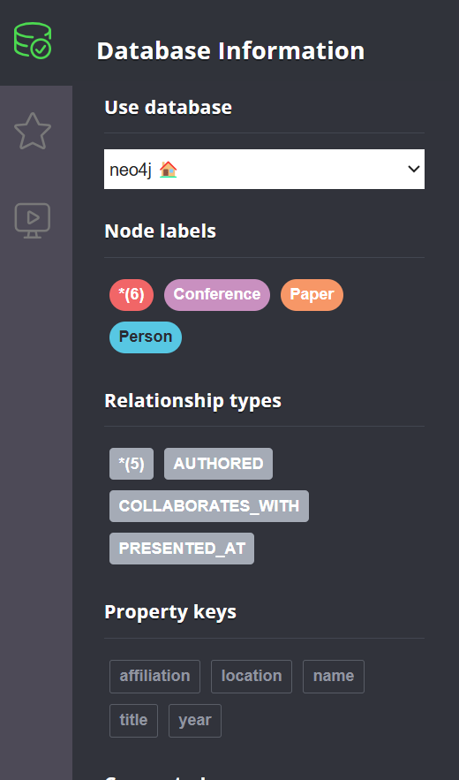

查询 Alice 写过哪些论文：
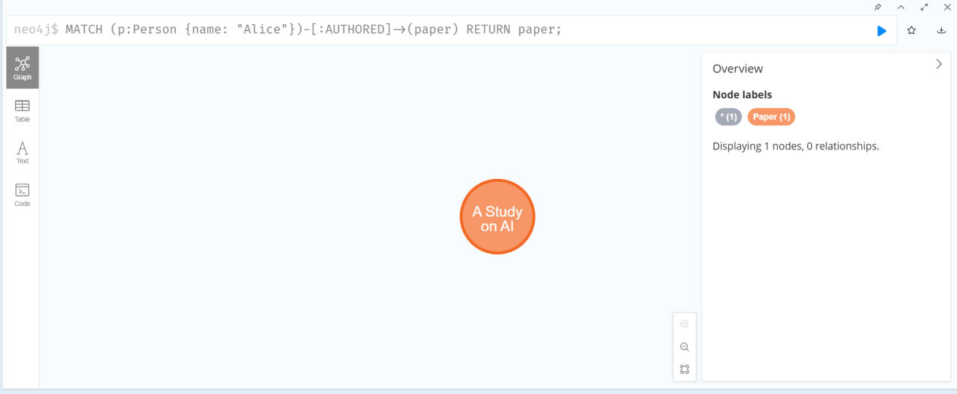

查看哪些人合作过
