实验4

谢宝玛 1120233506

(一) 编程实现文件合并和去重操作
编写 MapReduce 程序，实现对多个文件的合并，并剔除其中重复的内容，去重
后的内容输出到一个新的文件。

实验过程（完全按照GPT）：

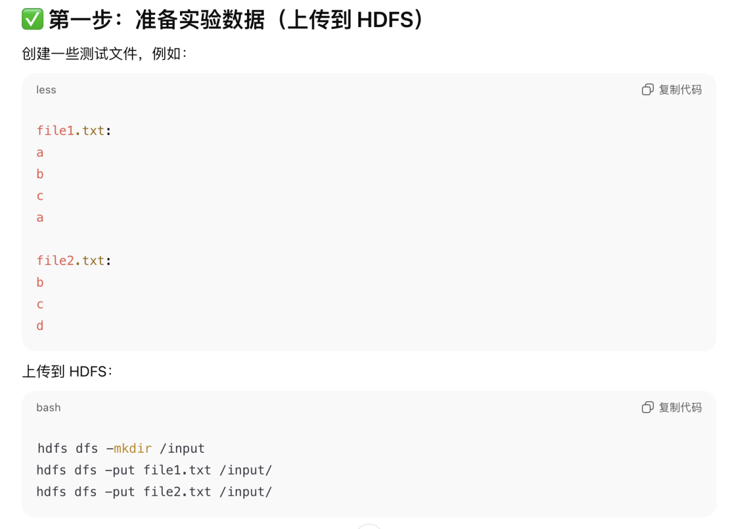
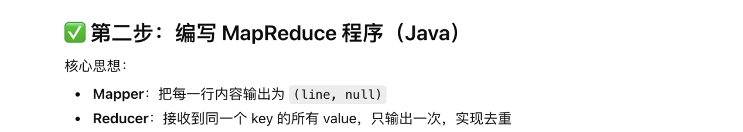
源代码：
import java.io.IOException;
import org.apache.hadoop.conf.Configuration;
import org.apache.hadoop.fs.Path;
import org.apache.hadoop.io.NullWritable;
import org.apache.hadoop.io.Text;
import org.apache.hadoop.mapreduce.Job;
import org.apache.hadoop.mapreduce.Mapper;
import org.apache.hadoop.mapreduce.Reducer;
import org.apache.hadoop.mapreduce.lib.input.FileInputFormat;
import org.apache.hadoop.mapreduce.lib.output.FileOutputFormat;

public class Dedup {

public static class DedupMapper extends Mapper<Object, Text, Text, NullWritable> {
private Text line = new Text();
public void map(Object key, Text value, Context context) throws IOException, InterruptedException {
line.set(value.toString());
context.write(line, NullWritable.get());
}
}

public static class DedupReducer extends Reducer<Text, NullWritable, Text, NullWritable> {
public void reduce(Text key, Iterable<NullWritable> values, Context context)
throws IOException, InterruptedException {
context.write(key, NullWritable.get()); // 输出唯一值，实现去重
}
}

public static void main(String[] args) throws Exception {
Configuration conf = new Configuration();
Job job = Job.getInstance(conf, "Dedup Job");
job.setJarByClass(Dedup.class);
job.setMapperClass(DedupMapper.class);
job.setReducerClass(DedupReducer.class);

job.setOutputKeyClass(Text.class);
job.setOutputValueClass(NullWritable.class);

FileInputFormat.addInputPath(job, new Path(args[0]));
FileOutputFormat.setOutputPath(job, new Path(args[1]));

System.exit(job.waitForCompletion(true) ? 0 : 1);
}
}

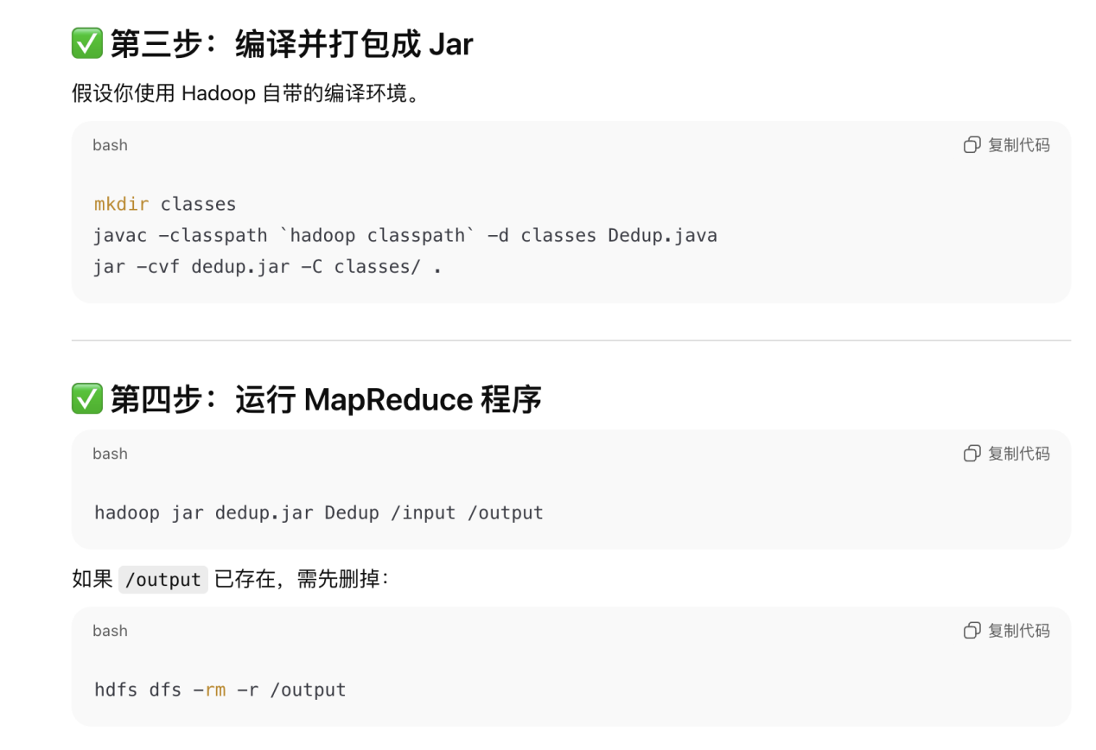
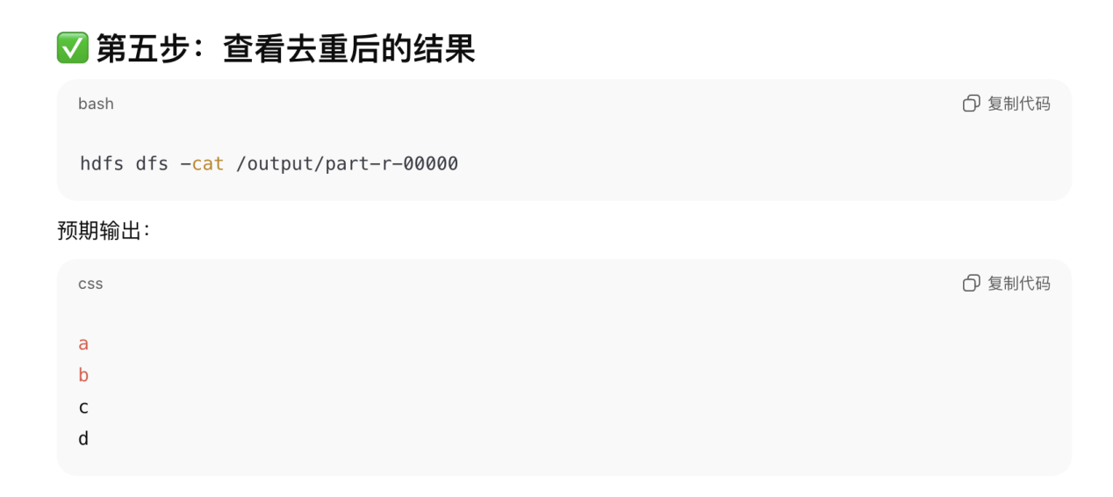

实际运行结果（没有问题）：
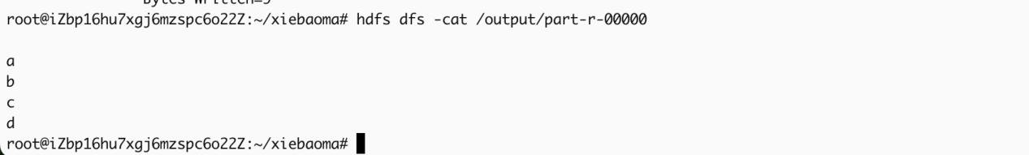

(二) 编写 MapReduce 程序，实现对输入文件中的 child-parent 关系进行挖掘， 输出
grandchild-grandparent 的对应关系表。

思路（根据GPT）
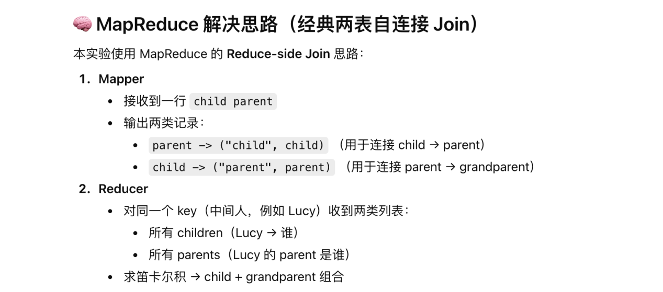
源代码：
import java.io.IOException;
import java.util.ArrayList;

import org.apache.hadoop.conf.Configuration;
import org.apache.hadoop.fs.Path;
import org.apache.hadoop.io.Text;
import org.apache.hadoop.mapreduce.Job;
import org.apache.hadoop.mapreduce.Mapper;
import org.apache.hadoop.mapreduce.Reducer;
import org.apache.hadoop.mapreduce.lib.input.FileInputFormat;
import org.apache.hadoop.mapreduce.lib.output.FileOutputFormat;

public class GrandchildGrandparent {

public static class RelationMapper extends Mapper<Object, Text, Text, Text> {
private Text k = new Text();
private Text v = new Text();

public void map(Object key, Text value, Context context) throws IOException, InterruptedException {
// 一行：child parent
String[] arr = value.toString().split("\\s+");
if (arr.length != 2) return;

String child = arr[0];
String parent = arr[1];

// 1. child 的 parent（用于反向连接 grandparent）
k.set(parent); // key = parent
v.set("C:" + child); // 标记为 child
context.write(k, v);

// 2. parent 的 parent（用于正向连接 grandparent）
k.set(child); // key = child
v.set("P:" + parent); // 标记为 parent
context.write(k, v);
}
}

public static class RelationReducer extends Reducer<Text, Text, Text, Text> {
private Text gc = new Text();
private Text gp = new Text();

public void reduce(Text key, Iterable<Text> values, Context context)
throws IOException, InterruptedException {

ArrayList<String> children = new ArrayList<>();
ArrayList<String> parents = new ArrayList<>();

// values 里有：C:child 或 P:parent
for (Text v : values) {
String s = v.toString();
if (s.startsWith("C:")) {
children.add(s.substring(2));
} else if (s.startsWith("P:")) {
parents.add(s.substring(2));
}
}

// 笛卡尔积：每个 child 对每个 parent（= grandparent）
for (String c : children) {
for (String p : parents) {
gc.set(c);
gp.set(p);
context.write(gc, gp);
}
}
}
}

public static void main(String[] args) throws Exception {
Configuration conf = new Configuration();
Job job = Job.getInstance(conf, "GrandchildGrandparent");
job.setJarByClass(GrandchildGrandparent.class);

job.setMapperClass(RelationMapper.class);
job.setReducerClass(RelationReducer.class);

job.setOutputKeyClass(Text.class);
job.setOutputValueClass(Text.class);

FileInputFormat.addInputPath(job, new Path(args[0]));
FileOutputFormat.setOutputPath(job, new Path(args[1]));

System.exit(job.waitForCompletion(true) ? 0 : 1);
}
}

实验步骤：

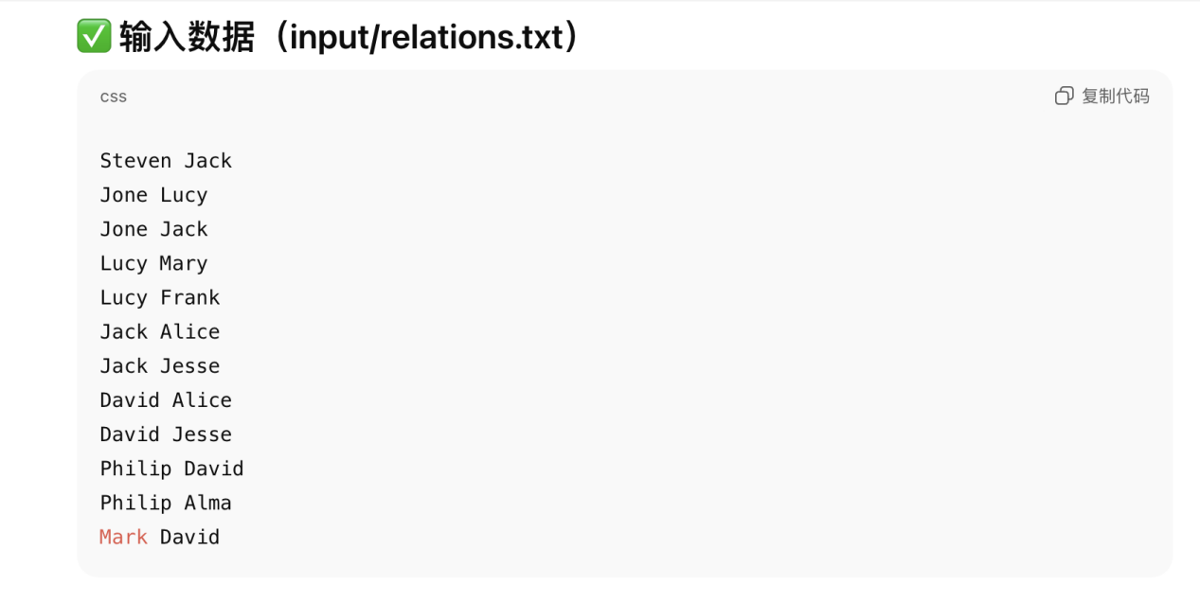
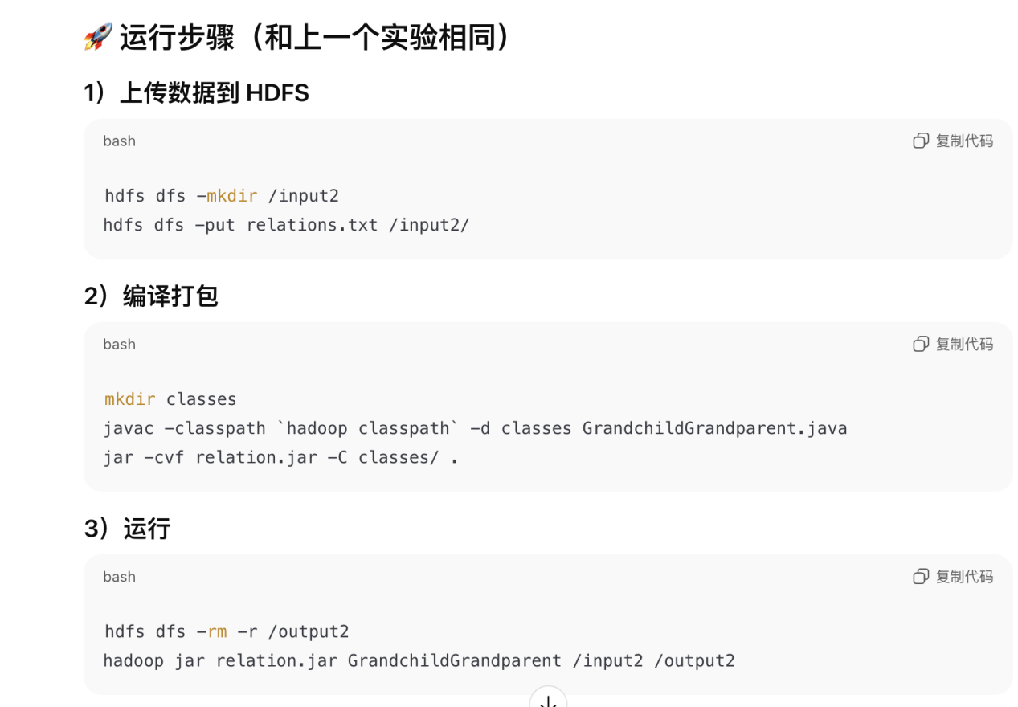

实验结果（没有问题）：
