***Geophysical Research Letters***

Supporting Information for

**Constraining projected changes in rare intense precipitation events across global land regions**

Chao Li 1, 2, Qiaohong Sun 3, 4, Jianyu Wang 5, 6, Yongxiao Liang 7, Francis Zwiers 8, 3, 4, Xuebin Zhang 7, and Tong Li 8, 3, 4

1Key Laboratory of Geographic Information Science, Ministry of Education, East China Normal University, Shanghai, China.

2School of Geographic Sciences, East China Normal University, Shanghai, China.

3Joint International Research Laboratory of Climate and Environment Change, Key Laboratory of Meteorological Disaster of Ministry of Education, Nanjing University of Information Science and Technology, Nanjing, China.

4Collaborative Innovation Center on Forecast and Evaluation of Meteorological Disaster, Nanjing University of Information Science and Technology, Nanjing, China.

5State Key Laboratory of Severe Weather, Chinese Academy of Meteorological Sciences, Beijing, China.

6University of Chinese Academy of Sciences, Beijing, China

7Climate Research Division, Environment and Climate Change Canada, Toronto, Ontario, Canada.

8Pacific Climate Impacts Consortium, University of Victoria, Victoria, British Columbia, Canada.

**Contents of this file**

Figures S1 to S15

Tables S1 to S2

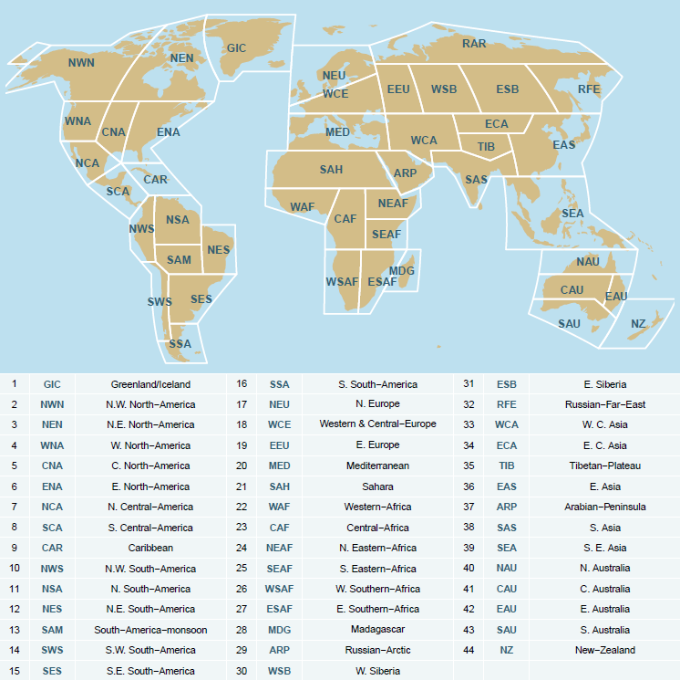

**Figure S1. The IPCC AR6 reference land regions**. Definitions for the regions are adopted from Iturbide et al. (2020).

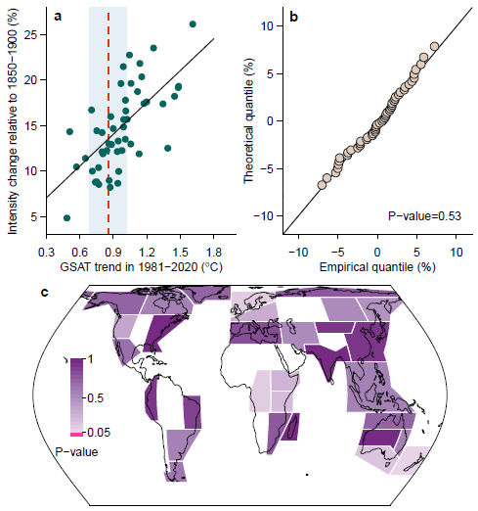

**Figure S2. Evaluation of the Gaussian assumption underlying emergent constraint for the intensification of future rare precipitation events**. (**a**) The scatter plot of global land median changes in the intensity of 50-year daily precipitation event in 2028-2057 relative to 1850-1900 under the 8.5 W/m2 scenario versus the 1981-2020 GSAT trends in the considered CMIP6/5 models. The solid black line shows the emergent constraint regression line. The dashed vertical line and the gray shading mark the observed 1981-2020 GSAT trend in HadCRUT5 and its central 90% uncertainty range arising from internal climate variability. (**b**) The quantile-quantile plot assessing whether the residuals of data points in (**a**) relative to the emergent constraint regression line follow a standard normal distribution. The p-value of a Kolmogorov-Smirnov normality test is presented at the bottom right of the plot. (**c**) The corresponding p-values for individual regions. Kolmogorov-Smirnov test is only performed for regions with significant direct emergent relationships at the 5% level for all considered rare precipitation events (i.e., 10-, 50-, and 100-year events) and projection periods (i.e., 2028-2057 and 2050-2079 under the 8.5 W/m2 scenario).

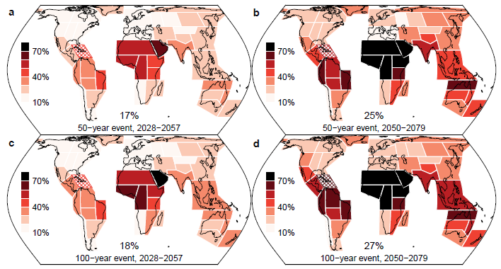

**Figure S3. Larger uncertainty in the projected intensification of rare precipitation events in further future periods**. The widths of central 90% ranges of changes in the intensity of daily precipitation events with return periods of 50 (**a**-**b**) and 100 years (**c**-**d**) during 2028-2057 (2 °C warmer; **a**, **c**) and 2050-2079 (3 °C warmer; **b**, **d**) relative to 1850-1900 in response to the 8.5 W/m2 scenario based on unconstrained projections in the CMIP6/5 models. The bottom numbers show values for the global land change. Cross-hatching marks regions where <80% of the considered models agree on the tendency of intensification.

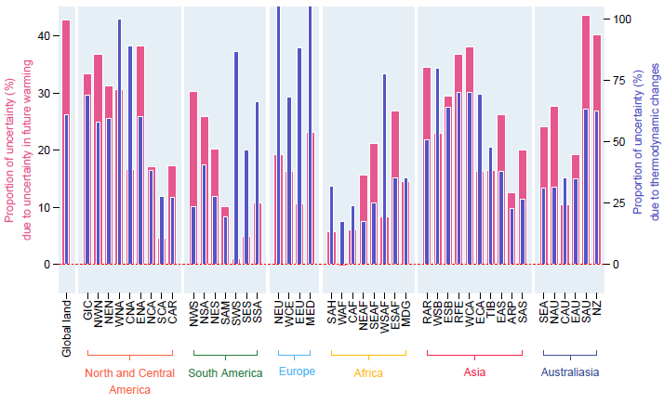

**Figure S4. Uncertainty analysis of the projected intensification of future rare precipitation events.** Pink bars show the results as in Fig 1c, i.e.,the proportions of uncertainty in the projected 50-year event intensity changes during 2028-2057 (2 °C warmer) relative to 1850-1900 in response to the 8.5 W/m2 scenario due to uncertainty in the projected warming. Blue bars show the proportions of uncertainty in the corresponding changes in *the mean of annual maxima of daily precipitation* (i.e., 2-year event intensity) caused by thermodynamic increases in atmospheric moisture, as diagnosed by the physical scaling in O’Gorman and Schneider (2009) following the procedure in Pfahl et al. (2017). The physical scaling diagnostic requires surface pressure and the vertical profiles of air temperature and vertical velocity conditional on the occurrence of extreme precipitation events. As these variables are unavailable for 50-year events given the relatively small simulation ensembles in most of the considered climate models, evaluating the proportions of uncertainty in the thermodynamic changes in annual maxima of daily precipitation is a necessary choice. Despite that, the results suggest that the warming-induced intensification uncertainty generally is similar to the uncertainty of the intensification contributed from thermodynamic increases in atmospheric moisture in the majority regions.

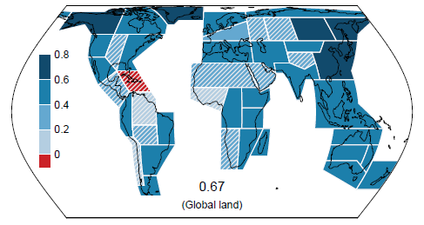

**Figure S5. Correlations of emergent constraint relations for future rare precipitation intensity**. The averaged correlations between the projected changes in the intensity of daily precipitation events with return periods of 10, 50, and 100 years during 2028-2057 and 2050-2079 relative to 1850-1900 in response to the 8.5 W/m2 scenario and the trends in GSAT during 1981-2020 in the considered CMIP6/5 models. The bottom number shows the averaged correlation for the global land changes. Hatching marks regions where the emergent constraint relation is not significant at the 5% level for at least one of the precipitation events during at least one of the projection periods.

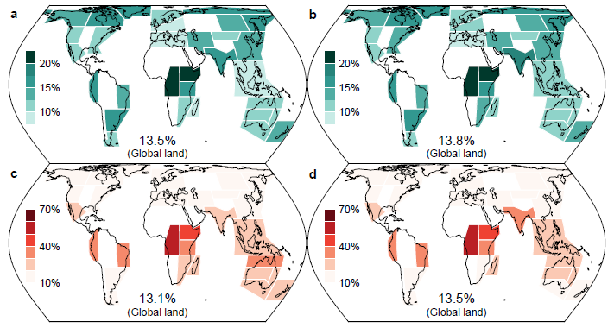

**Figure S6.** **Comparison of the constrained intensification of future 50-year daily precipitation events by the proposed approaches**. The constrained best estimates (**a-b**) and widths of the central 90% ranges (**c-d**) of changes in the intensity of 50-year daily precipitation event in 2028-2057 relative to 1850-1900 in response to the 8.5 W/m2 scenario by the observed 1981-2020 GSAT trend in terms of direct emergent constraint (**a**, **c**) and constrained future warming (**b**, **d**). The bottom numbers show values for the global land change. Comparison is only shown for regions with significant direct emergent relationships at the 5% level for all considered rare precipitation events (i.e., 10-, 50-, and 100-year events) and projection periods (i.e., 2028-2057 and 2050-2079 under the 8.5 W/m2 scenario).

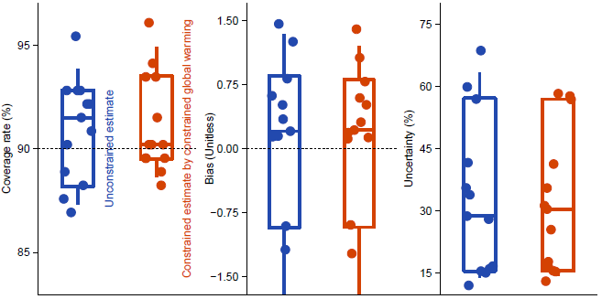

**Figure S7. Model-based cross-validation of temperature constraint for the intensification of future rare precipitation events in regions without a valid emergent constraint**. The coverage rates of the central 90% ranges in the estimated intensity changes of rare precipitation events containing the true reference values (left) and the relative biases (middle) and widths of 90% ranges (right) in the estimated changes. Colors of the boxplots distinguish different estimation methods as marked in the left panel. The boxplots reflect regional variations. The values for different regions are also marked by different points. All considered precipitation events during 2028-2057 under the 8.5 W/m2 scenario are aggregated to compute these validation statistics.

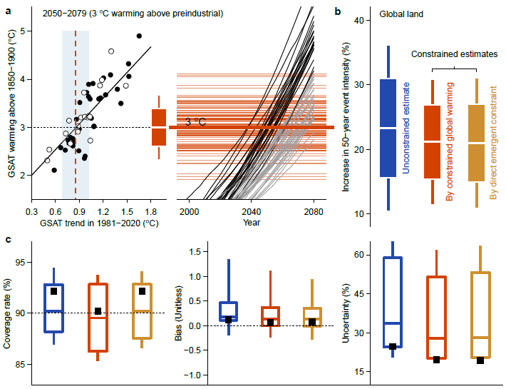

**Figure S8.** **Temperature constraint for the intensification of rare precipitation events during 2050-2079 under the 8.5 W/m2 scenario.** As in Fig 2 in the main text, but for changes in the intensity of 50-year event during 2050-2079 under the 8.5 W/m2 scenario, which is 3 °C above the 1850-1900 average according to the projected GSAT increases in the CMIP6/5 models constrained by its trend observed during 1981-2020. Gray curves in panel (**a**) mark climate models that do not simulate adequate warming to attain all the constrained plausible GSAT increases as marked by horizontal orange lines.

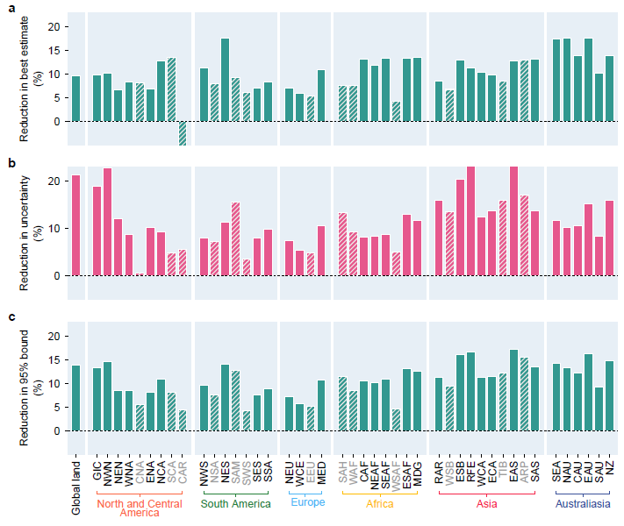

**Figure S9. Reduced bias and uncertainty in the constrained intensification of future rare precipitation events by observed past warming trend**. The percentage reductions in the constrained best estimates (**a**), widths (**b**), and upper bounds (**c**) of the central 90% ranges of future rare precipitation intensification relative to the corresponding values in unconstrained projections. Presented are percentage reductions averaged over *all considered precipitation events and projection periods* under the 8.5 W/m2 scenario. The direct emergent constraint on precipitation is adopted for regions with significant emergent relationships at the 5% level for all considered precipitation events and projection periods (solid shading). Constrained future warming is used to constrain precipitation in other regions (hatched shading).

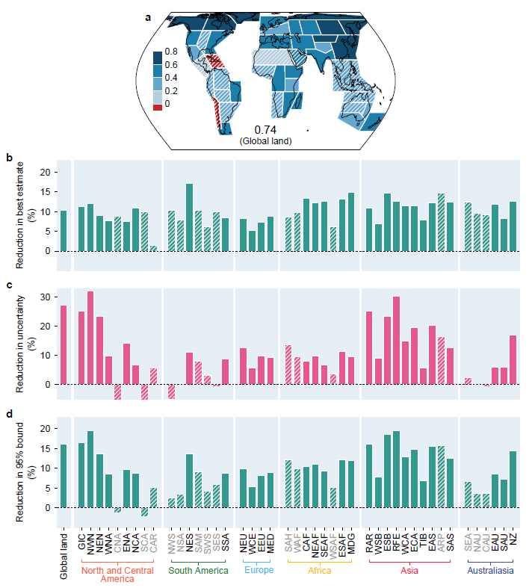

**Figure S10. The observed past warming constraint remains effective when a more recent reference period is employed to evaluate the intensification of future rare precipitation events.** Panels show the counterparts ofFig S5 and Fig S9, but for changes in the intensity of rare precipitation events under the 8.5 W/m2 scenario *relative to a recent reference period of 1950-2000*. Note the difference in the y-axis scale when comparing panel (**c**) with Fig S9(b).

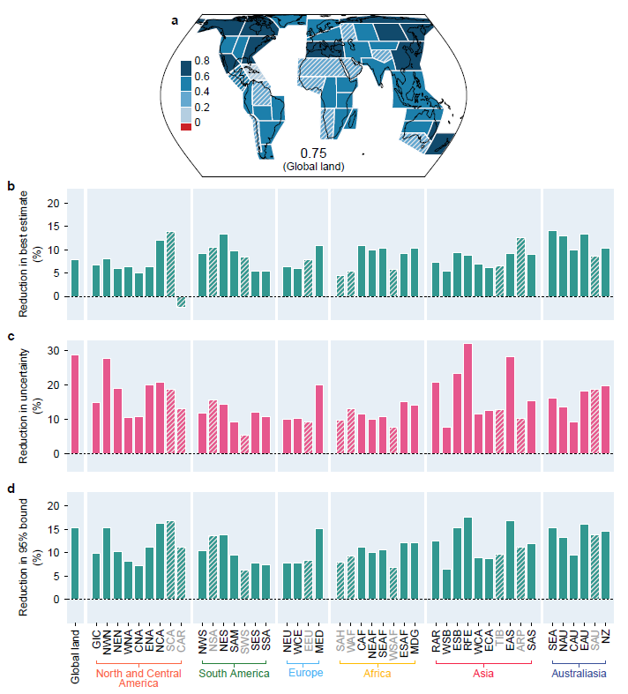

**Figure S11. The observed past warming constraint on the intensification of future rare precipitation events under the moderate 4.5 W/m2 scenario.** Panels show the counterparts ofFig S5 and Fig S9, but for changes in the intensity of rare precipitation events under the 4.5 W/m2 scenario relative to 1850-1900. Note the difference in the y-axis scale when comparing panel (**c**) with Fig S9(b).

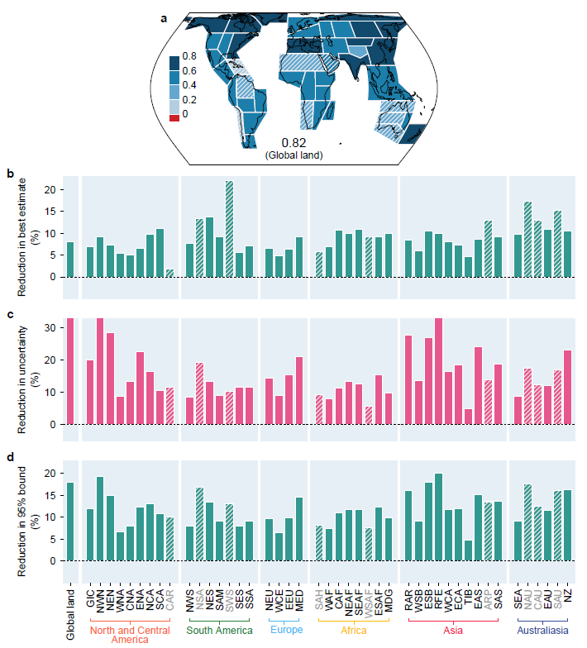

**Figure S12. The observed past warming constraint remains effective when a more recent reference period is employed to evaluate the intensification of future rare precipitation events.** As in Fig S11, but for changes in the intensity of rare precipitation events under the 4.5 W/m2 scenario *relative to a recent reference period of 1950-2000*.

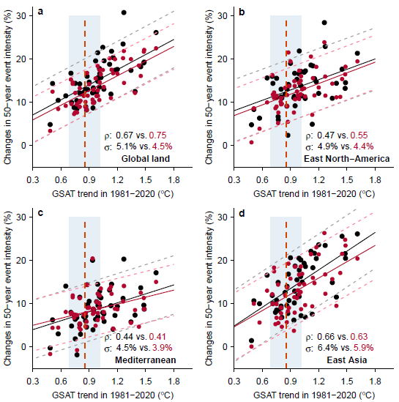

**Figure S13. The impact of reference period on emergent constraint relationships under the 8.5 W/m2 forcing scenario for some selected regions.** Panels show scatterplots and emergent constraint regression lines for changes in the intensity of 50-year daily precipitation events in 2028-2057 relative to 1850-1900 (black points and lines) and a more recent period of 1950-2000 (red points and lines) under the 8.5 W/m2 scenario versus the 1981-2020 GSAT trends in the considered CMIP6/5 models for selected regions. The emergent constraint regression lines are shown as solid lines, while 5-95% uncertainty ranges are marked by dashed lines. The bottom-right numbers show the emergent constraint correlations and inter-model standard deviations of the unconstrained projections of intensity changes. It can be seen that the more recent 1950-2000 reference period tends to produce projections of intensity changes with relatively smaller inter-model standard deviations, which facilitate slightly stronger emergent constraint relationships and thus greater relative uncertainty reductions. The dashed vertical line and the gray shading mark the observed 1981-2020 global mean temperature trend in HadCRUT5 and associated central 90% uncertainty range due to internal climate variability.

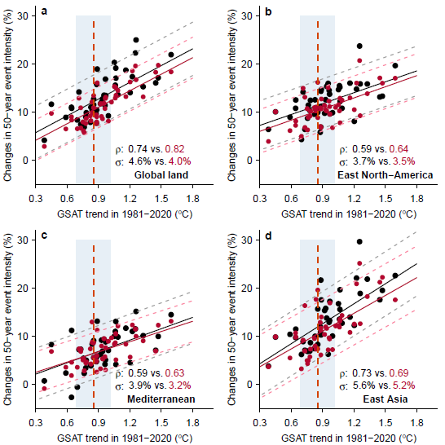

**Figure S14.** **The impact of reference period on emergent constraint relationships under the 4.5 W/m2 forcing scenario for some selected regions.** As in Fig S13, but for the 4.5 W/m2 forcing scenario.

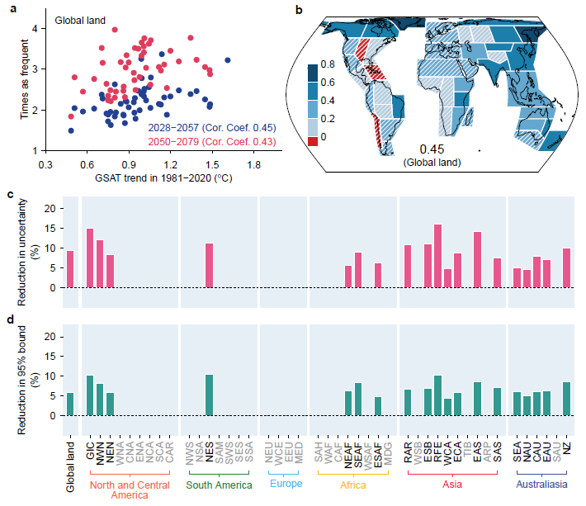

**Figure S15. The observed past warming trend is not effective at constraining the frequency of future rare precipitation events.** (**a**) The scatter plot of global land median changes in the frequency of 50-year daily precipitation event in 2028-2057 (blue) and 2050-2079 (red) relative to 1850-1900 under the 8.5 W/m2 scenario versus the 1981-2020 GSAT trends in the considered CMIP6/5 models. The 50-year event is defined based on the 1850-1900 period. Frequency change is expressed as the ratio of the event frequency in a projection period to the reference frequency in the 1850-1900 base period. Correlations of the scattered points are marked at the bottom right of the plot. (**b**) The averaged correlations for the projected frequency changes during 2028-2057 and 2050-2079 under the 8.5 W/m2 scenario relative to 1850-1900 for daily precipitation events with return periods of 10, 50, and 100 years during the base period. The bottom number shows the value for the global land change. Hatching marks regions where the correlation is not significant at the 5% level for at least one of the precipitation events during at least one of the projection periods. (**c**-**d**) The percentage reductions in the constrained widths (**c**) and upper bounds (**d**) of the central 90% ranges of changes in the frequency of 50-year daily precipitation event in 2028-2057 under the 8.5 W/m2 scenario relative to the corresponding values in unconstrained projections for regions with a valid emergent constraint.

**Table S1. A list of the analyzed models and the corresponding numbers of simulations**

|  |  |  |  |  |  |
| --- | --- | --- | --- | --- | --- |
| **CMIP6 models** (33 models) | | | | | |
| ACCESS-CM2 | 5 | ACCESS-ESM1-5 | 40 | BCC-CSM2-MR | 1 |
| CAMS-CSM1-0 | 1 | CanESM5 | 50 | CESM2-WACCM | 5 |
| CESM2 | 5 | CMCC-CM2-SR5 | 1 | CNRM-CM6-1-HR | 1 |
| CNRM-CM6-1 | 1 | CNRM-ESM2-1 | 1 | EC-Earth3-Veg | 8 |
| EC-Earth3 | 20 | FGOALS-g3 | 4 | GFDL-ESM4 | 1 |
| HadGEM3-GC31-LL | 4 | HadGEM3-GC31-MM | 4 | IITM-ESM | 1 |
| INM-CM4-8 | 1 | INM-CM5-0 | 1 | IPSL-CM6A-LR | 7 |
| KACE-1-0-G | 3 | KIOST-ESM | 1 | MIROC-ES2L | 1 |
| MIROC6 | 50 | MPI-ESM1-2-HR | 2 | MPI-ESM1-2-LR | 10 |
| MRI-ESM2-0 | 2 | NESM3 | 2 | NorESM2-LM | 1 |
| NorESM2-MM | 1 | TaiESM1 | 1 | UKESM1-0-LL | 5 |
| **CMIP5 models** (18 models) | | | | | |
| ACCESS1-0 | 2 | CanESM2 | 10 | CMCC-CESM | 2 |
| CMCC-CM | 2 | CMCC-CMS | 2 | CNRM-CM5 | 2 |
| CSIRO-Mk3-6-0 | 20 | FGOALS-s2 | 6 | inmcm4 | 2 |
| IPSL-CM5A-LR | 8 | IPSL-CM5B-LR | 2 | MIROC-ESM-CHEM | 2 |
| MIROC-ESM | 2 | MIROC5 | 6 | MPI-ESM-L | 6 |
| MPI-ESM-MR | 2 | MRI-CGCM3 | 1 | NorESM1-M | 2 |

**Table S2. The intensity of 50-year precipitation events during the 1850-1900 baseline period and the constrained changes.**

|  |  |  |  |  |  |
| --- | --- | --- | --- | --- | --- |
| Region | 1850-1900 reference intensity  (mm/day) | Constrained changes under 8.5 W/m2 forcing scenario  (%) | | Constrained changes under 4.5 W/m2 forcing scenario  (%) | |
| 2028-2057  (2 oC above preindustrial) | 2050-2079  (3 oC above preindustrial) | 2028-2057 | 2050-2079 |
| Global land | 54.5 | 13.5  (7.0, 20.1) | 21.0  (11.1, 30.9) | 12.2  (6.6, 17.8) | 15.8  (9.1, 22.4) |
| GIC | 33.7 | 15.4  (6.7, 24.0) | 24.4  (22.0, 36.8) | 14.7  (5.6, 23.9) | 19.0  (8.5, 29.5) |
| NWN | 46.3 | 14.5  (7.2, 21.7) | 22.5  (12.0, 33.0) | 12.7  (6.2, 19.1) | 17.0  (9.5, 24.6) |
| NEN | 42.1 | 16.2  (8.5, 24.0) | 25.3  (14.0, 36.6) | 14.3  (8.1, 20.6) | 18.5  (10.2, 26.7) |
| WNA | 59.9 | 10.4  (3.4, 17.4) | 16.5  (4.1, 29.0) | 9.5  (2.2, 16.8) | 12.3  (4.3, 20.4) |
| CAN | 79.7 | **12.2**  **(4.2, 20.2)** | **18.0**  **(8.0, 28.1)** | 11.4  (5.0, 17.7) | 14.0  (6.7, 21.4) |
| ENA | 89.6 | 12.5  (5.3, 19.7) | 19.2  (9.8, 28.7) | 11.4  (6.3, 16.6) | 14.3  (7.3, 21.3) |
| NCA | 94.9 | 10.9  (0.3, 21.5) | 16.2  (-1.5, 34.0) | 9.2  (1.4, 17.0) | 12.9  (2.4, 23.5) |
| SCA | 116.8 | **9.1**  **(-4.9, 23.3)** | **14.6**  **(-6.4, 35.7)** | **7.4**  **(-3.2, 17.9)** | **10.7**  **(-2.4, 23.8)** |
| CAR | 84.0 | **3.1**  **(-17.1, 23.4)** | **3.4**  **(-23.1, 29.9)** | **3.7**  **(-9.9, 17.3)** | **4.3**  **(-12.2, 20.7)** |
| NWS | 88.5 | 15.9  (-0.1, 31.8) | 25.7  (-2.0, 53.4) | 13.4  (0.5, 26.4) | 18.8  (0.8, 36.9) |
| NSA | 73.4 | **11.5**  **(-4.9, 27.9)** | **17.5**  **(-9.1, 44.1)** | **10.3**  **(-2.9, 23.5)** | **13.8**  **(-4.8, 32.3)** |
| NES | 90.6 | 12.9  (-4.9, 30.7) | 21.4  (-8.1, 50.9) | 12.1  (-3.6, 27.8) | 15.9  (-3.8, 35.5) |
| SAM | 94.4 | **12.3**  **(-2.4, 27.0)** | **19.8**  **(-3.3, 42.8)** | 11.6  (-1.6, 24.8) | 14.9  (-3.0, 32.6) |
| SWS | 65.6 | **2.8**  **(-3.3, 8.9)** | **4.0**  **(-3.5, 11.5)** | **2.5**  **(-2.7, 7.7)** | **3.3**  **(-2.2, 8.9)** |
| SES | 103.6 | 15.9  (6.3, 25.4) | 23.6  (8.1, 39.1) | 14.0  (6.2, 21.8) | 18.4  (9.0, 27.9) |
| SSA | 48.1 | 10.0  (3.3, 16.8) | 15.5  (5.1, 25.8) | 9.3  (4.3, 14.3) | 11.4  (4.6, 18.2) |
| NEU | 41.2 | 11.7  (3.8, 15.9) | 17.5  (6.6, 28.5) | 11.0  (2.9, 19.1) | 13.4  (4.1, 22.7) |
| WCE | 46.2 | 10.0  (3.5, 16.5) | 15.7  (5.6, 25.8) | 9.5  (3.0, 16.1) | 12.7  (5.0, 20.3) |
| EEU | 39.2 | **10.9**  **(3.5, 18.4)** | **16.0**  **(6.7, 25.2)** | **9.8**  **(3.8, 16.0)** | **12.3**  **(5.0, 19.5)** |
| MED | 50.9 | 7.8  (1.0, 14.6) | 10.9  (2.7, 19.2) | 6.5  (1.1, 11.9) | 8.2  (1.9, 14.5) |
| SAH | 30.0 | **16.5**  **(-9.3, 42.4)** | **24.1**  **(-21.2, 69.3)** | **13.1**  **(-10.8, 37.0)** | **16.8**  **(-13.2, 46.9)** |
| WAF | 91.7 | **25.5**  **(-1.9, 52.3)** | **37.8**  **(-7.8, 83.4)** | **21.0**  **(1.9, 40.1)** | **26.8**  **(4.0, 49.5)** |
| CAF | 59.4 | 21.2  (-5.3, 47.6) | 35.0  (-7.7, 77.7) | 17.8  (-2.7, 38.3) | 22.1  (-4.3, 48.5) |
| NEAF | 53.3 | 21.4  (-2.0, 44.8) | 33.4  (-1.0, 67.7) | 16.5  (-3.3, 36.2) | 22.5  (-2.0, 46.9) |
| SEAF | 67.8 | 16.4  (-2.5, 35.4) | 26.2  (-3.5, 55.9) | 14.7  (-1.6, 31.0) | 18.3  (-3.2, 39.7) |
| WSAF | 59.8 | **9.5**  **(1.2, 17.8)** | **13.3**  **(1.9, 24.7)** | **8.5**  **(1.1, 15.9)** | **10.6**  **(2.3, 18.9)** |
| ESAF | 104.2 | 12.4  (0.1, 24.7) | 19.7  (1.4, 38.0) | 11.3  (2.2, 20.4) | 14.5  (2.3, 26.7) |
| MDG | 150.4 | 9.8  (-1.1, 20.7) | 16.6  (1.5, 31.7) | 9.5  (0.4, 18.6) | 13.0  (0.4, 25.7) |
| RAR | 34.0 | 16.9  (8.2, 25.7) | 26.5  (13.3, 39.7) | 15.5  (7.2, 23.8) | 20.0  (10.0, 30.0) |
| WSB | 37.5 | **11.4**  **(4.0, 18.9)** | **16.8**  **(6.8, 26.8)** | 10.4  (2.5, 18.3) | 13.5  (5.0, 21.9) |
| ESB | 53.0 | 12.9  (3.7, 22.1) | 20.9  (7.2, 34.6) | 12.3  (3.5, 21.1) | 15.6  (7.0, 24.1) |
| RFE | 58.8 | 16.4  (7.8, 25.0) | 27.3  (14.2, 40.5) | 14.3  (7.3, 21.2) | 19.3  (11.2, 27.3) |
| WCA | 42.8 | 12.8  (3.1, 22.6) | 19.5  (6.2, 32.7) | 12.0  (2.8, 21.3) | 14.8  (5.2, 24.4) |
| ECA | 35.2 | 11.9  (3.9, 19.8) | 19.0  (7.3, 30.8) | 10.9  (3.9, 18.0) | 14.7  (6.7, 22.7) |
| TIB | 57.1 | **13.4**  **(1.4, 25.4)** | **21.5**  **(4.0, 38.9)** | **12.6**  **(1.4, 23.9)** | **15.5**  **(2.3, 28.6)** |
| EAS | 122.6 | 12.8  (4.5, 21.1) | 21.0  (8.6, 33.3) | 12.0  (5.3, 18.7) | 16.1  (7.8, 24.3) |
| ARP | 39.1 | **18.0**  **(-9.4, 45.3)** | **26.7**  **(-10.6, 64.0)** | **13.4**  **(-9.6, 36.5)** | **17.1**  **(-11.6, 45.8)** |
| SAS | 115.2 | 17.0  (2.3, 31.8) | 27.2  (2.4, 52.0) | 16.6  (2.6, 30.5) | 21.6  (5.5, 37.7) |
| SEA | 122.4 | 9.4  (-3.6, 22.5) | 16.1  (-5.7, 37.8) | 8.1  (-2.6, 18.9) | 11.8  (-2.4, 26.0) |
| NAU | 147.3 | 10.6  (-4.9, 26.0) | 17.7  (-9.6, 44.9) | 10.6  (-2.1, 23.2) | 14.4  (-5.3, 34.2) |
| CAU | 94.9 | 10.6  (-0.4, 21.7) | 17.0  (-1.6, 35.7) | 9.3  (-2.3, 20.8) | 12.4  (0.0, 24.8) |
| EAU | 115.2 | 10.6  (-2.9, 24.1) | 16.6  (-1.8, 35.0) | 10.4  (-0.9, 21.7) | 12.3  (-0.9, 25.5) |
| SAU | 64.3 | 11.8  (0.6, 23.0) | 18.0  (2.7, 33.2) | **10.8**  **(2.2, 19.4)** | **13.2**  **(2.1, 24.2)** |
| NZ | 88.2 | 12.6  (0.5, 24.8) | 20.1  (2.7, 37.4) | 11.2  (1.9, 20.5) | 14.6  (3.1, 26.0) |

**Table notes:**

1. See Fig. S1 for the full names and geographic boundaries of these regions.
2. Correlation coefficients of the emergent constraint relationships are shown in Fig. S5 for the 8.5 W/m2 forcing scenario and in Fig. S11(a) for the 4.5 W/m2 forcing scenario.
3. The numbers in parenthesis show the 5-95% uncertainty ranges of the constrained changes.
4. Regions where constrained future warming method is adopted are marked in bold.