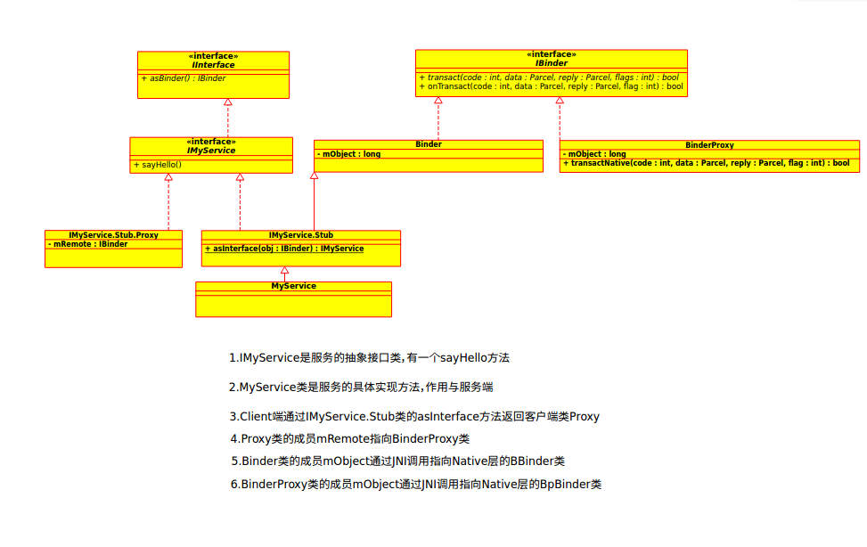
1.APP层Binder相关

通常在APP层使用AIDL时会用到Binder来进行APP通信。比如自定义个IMyService.aidl接口，APP层类图关系如下:

针对上面这个类图，有3个疑问？
(1)BinderProxy类的mObject成员如何被赋值的?
(2)自定义的服务是如何被加入的？
(3)怎么获取到自定义的服务？

2.JNI层Binder相关

Android系统开机过程中，Zygote启动时会有一个虚拟机的注册过程，该过程调用AndroidRuntime::startReg方法来完成jni方法的注册。

2.1 startReg方法分析(AndroidRuntime.cpp)
int AndroidRuntime::startReg(JNIEnv* env){
…
//注册jni方法
if (register_jni_procs(gRegJNI, NELEM(gRegJNI), env) < 0) {
env->PopLocalFrame(NULL);
return -1;
}
return 0;
}
注册JNI方法，其中gRegJNI是一个数组，记录所有需要注册的jni方法，其中有一项便是REG_JNI(register_android_os_Binder)，下面说说register_android_os_Binder过程。

2.2 register_android_os_Binder方法分析(android_util_Binder.cpp)
int register_android_os_Binder(JNIEnv* env){
//注册Binder类的jni方法
if (int_register_android_os_Binder(env) < 0)
return -1;
//注册BinderInternal类的jni方法
if (int_register_android_os_BinderInternal(env) < 0)
return -1;
//注册BinderProxy类的jni方法
if (int_register_android_os_BinderProxy(env) < 0)
return -1;
...
return 0;
}

2.3 JNI注册Binder类(android_util_Binder.cpp)
const char* const kBinderPathName = "android/os/Binder";
static int int_register_android_os_Binder(JNIEnv* env){
//java层的Binder类转化为Native层的class对象
jclass clazz = FindClassOrDie(env, kBinderPathName);
//保存java层Binder类的class对象
gBinderOffsets.mClass = MakeGlobalRefOrDie(env, clazz);
//保存java层Binder类的execTransact 方法
gBinderOffsets.mExecTransact = GetMethodIDOrDie(env, clazz, "execTransact", "(IJJI)Z");
//保存java层Binder类的 mObject 对象
gBinderOffsets.mObject = GetFieldIDOrDie(env, clazz, "mObject", "J");
//注册JNI方法
return RegisterMethodsOrDie(
env, kBinderPathName,
gBinderMethods, NELEM(gBinderMethods));
}
gBinderOffsets是全局静态结构体(struct)，定义如下：
static struct bindernative_offsets_t
{
// Class state.
jclass mClass;
jmethodID mExecTransact;

// Object state.
jfieldID mObject;

} gBinderOffsets;
gBinderOffsets保存了Binder.java类本身以及其成员方法execTransact()和成员属性mObject，这为JNI层访问Java层提供通道。另外通过查询获取Java层 Binder信息后保存到gBinderOffsets，而不再需要每次查找Binder类信息的方式能大幅度提高效率，是由于每次查询需要花费较多的CPU时间，尤其是频繁访问时，但用额外的结构体来保存这些信息，是以空间换时间的方法。

同理注册BinderInternal,BinderProxy类似，不在分析。

3.注册服务

3.1 addService方法分析(ServiceManager.java)
public static void addService(String name, IBinder service, boolean allowIsolated,
int dumpPriority) {
try {
//获取servicemanger的代理对象
getIServiceManager().addService(name, service, allowIsolated, dumpPriority);
} catch (RemoteException e) {
Log.e(TAG, "error in addService", e);
}
}

3.2 getIServiceManager方法分析(ServiceManager.java)
private static IServiceManager getIServiceManager() {
if (sServiceManager != null) {
return sServiceManager;
}

// Find the service manager
sServiceManager = ServiceManagerNative
.asInterface(Binder.allowBlocking(BinderInternal.getContextObject()));
return sServiceManager;
}
采用了单例模式获取 IserviceManager,返回的实际是ServiceManagerProxy对象。

3.2.1 getContextObject方法分析(BinderInternal.java)
public static final native IBinder getContextObject();
直接调用native方法(android_util_Binder.cpp)
static jobject android_os_BinderInternal_getContextObject(JNIEnv* env, jobject clazz)
{
sp<IBinder> b = ProcessState::self()->getContextObject(NULL);
return javaObjectForIBinder(env, b);
}
对于ProcessState::self()->getContextObject()，跟踪代码发现即ProcessState::self()->getContextObject()等价于 new BpBinder(0);

3.2.2 javaObjectForIBinder方法分析(android_util_Binder.cpp)
jobject javaObjectForIBinder(JNIEnv* env, const sp<IBinder>& val)
{
if (val == NULL) return NULL;

if (val->checkSubclass(&gBinderOffsets)) {
// It's a JavaBBinder created by ibinderForJavaObject. Already has Java object.
jobject object = static_cast<JavaBBinder*>(val.get())->object();
LOGDEATH("objectForBinder %p: it's our own %p!\n", val.get(), object);
return object;
}

// For the rest of the function we will hold this lock, to serialize
// looking/creation/destruction of Java proxies for native Binder proxies.
AutoMutex _l(gProxyLock);

BinderProxyNativeData* nativeData = gNativeDataCache;
if (nativeData == nullptr) {
nativeData = new BinderProxyNativeData();
}
// gNativeDataCache is now logically empty.
//创建BinderProxy对象
jobject object = env->CallStaticObjectMethod(gBinderProxyOffsets.mClass,
gBinderProxyOffsets.mGetInstance, (jlong) nativeData, (jlong) val.get());
if (env->ExceptionCheck()) {
// In the exception case, getInstance still took ownership of nativeData.
gNativeDataCache = nullptr;
return NULL;
}
BinderProxyNativeData* actualNativeData = getBPNativeData(env, object);
if (actualNativeData == nativeData) {
// New BinderProxy; we still have exclusive access.
nativeData->mOrgue = new DeathRecipientList;
nativeData->mObject = val;
gNativeDataCache = nullptr;
++gNumProxies;
if (gNumProxies >= gProxiesWarned + PROXY_WARN_INTERVAL) {
ALOGW("Unexpectedly many live BinderProxies: %d\n", gNumProxies);
gProxiesWarned = gNumProxies;
}
} else {
// nativeData wasn't used. Reuse it the next time.
gNativeDataCache = nativeData;
}

return object;
}

根据BpBinder(C++)生成BinderProxy(Java)对象. 主要工作是创建BinderProxy对象,并把BpBinder对象地址保存到BinderProxy.mObject成员变量. 到此，可知ServiceManagerNative.asInterface(BinderInternal.getContextObject()) 等价于

ServiceManagerNative.asInterface(new BinderProxy())

3.3 asInterface方法分析(ServiceManagerNative.java)
static public IServiceManager asInterface(IBinder obj){
//obj为BinderProxy对象
if (obj == null) {
return null;
}
//由于obj为BinderProxy对象，下面方法默认返回null
IServiceManager in = (IServiceManager)obj.queryLocalInterface(descriptor);
if (in != null) {
return in;
}

return new ServiceManagerProxy(obj);
}
由此，可知ServiceManagerNative.asInterface(new BinderProxy()) 等价于new ServiceManagerProxy(new BinderProxy())

3.3.1 ServiceManagerProxy的初始化(ServiceManagerNative.java)
public ServiceManagerProxy(IBinder remote) {
mRemote = remote;
}

mRemote为BinderProxy对象，该BinderProxy对象对应于C++层的BpBinder(0)，其作为Binder代理端，指向Native层大管家ServiceManager。
ServiceManager.getIServiceManager最终等价于new ServiceManagerProxy(new BinderProxy()),意味着【3.1】中的getIServiceManager().addService()，等价于ServiceManagerProxy.addService().
Framework层的ServiceManager的调用实际的工作确实交给ServiceManagerProxy的成员变量BinderProxy；而BinderProxy通过jni方式，最终会调用BpBinder对象；可见上层binder架构的核心功能依赖native架构的服务来完成的。

3.4 addService方法分析(ServiceManagerNative$ServiceManagerProxy)
public void addService(String name, IBinder service, boolean allowIsolated, int dumpPriority)
throws RemoteException {
Parcel data = Parcel.obtain();
Parcel reply = Parcel.obtain();
data.writeInterfaceToken(IServiceManager.descriptor);
data.writeString(name);
data.writeStrongBinder(service);
data.writeInt(allowIsolated ? 1 : 0);
data.writeInt(dumpPriority);
///mRemote为BinderProxy
mRemote.transact(ADD_SERVICE_TRANSACTION, data, reply, 0);
reply.recycle();
data.recycle();
}

3.5 writeStrongBinder方法分析(Parcel.java)
public final void writeStrongBinder(IBinder val) {
//此处为jni调用
nativeWriteStrongBinder(mNativePtr, val);
}
3.5.1 android_os_Parcel_writeStrongBinder方法分析(android_os_Parcel.cpp)
static void android_os_Parcel_writeStrongBinder(JNIEnv* env, jclass clazz, jlong nativePtr, jobject object)
{
//将java层的parcel转化为native层的Parcel
Parcel* parcel = reinterpret_cast<Parcel*>(nativePtr);
if (parcel != NULL) {
const status_t err = parcel->writeStrongBinder(ibinderForJavaObject(env, object));
if (err != NO_ERROR) {
signalExceptionForError(env, clazz, err);
}
}
}

3.5.2 binderForJavaObject方法分析(android_util_Binder.cpp)
sp<IBinder> ibinderForJavaObject(JNIEnv* env, jobject obj)
{
if (obj == NULL) return NULL;
// Instance of Binder?
//Java层的Binder对象,添加服务时走这个分支
if (env->IsInstanceOf(obj, gBinderOffsets.mClass)) {
JavaBBinderHolder* jbh = (JavaBBinderHolder*)
env->GetLongField(obj, gBinderOffsets.mObject);
return jbh->get(env, obj);
}
// Instance of BinderProxy?
//Java层的BinderProxy对象
if (env->IsInstanceOf(obj, gBinderProxyOffsets.mClass)) {
return getBPNativeData(env, obj)->mObject;
}
ALOGW("ibinderForJavaObject: %p is not a Binder object", obj);
return NULL;
}
根据Binde(Java)生成JavaBBinderHolder(C++)对象. 主要工作是创建JavaBBinderHolder对象,并把JavaBBinderHolder对象地址保存到Binder.mObject成员变量.

3.5.3 JavaBBinderHolder的get方法分析(android_util_Binder.cpp)
sp<JavaBBinder> get(JNIEnv* env, jobject obj)
{
AutoMutex _l(mLock);
sp<JavaBBinder> b = mBinder.promote();
if (b == NULL) {
//首次进来，创建JavaBBinder对象
b = new JavaBBinder(env, obj);
mBinder = b;
ALOGV("Creating JavaBinder %p (refs %p) for Object %p, weakCount=%" PRId32 "\n",
b.get(), b->getWeakRefs(), obj, b->getWeakRefs()->getWeakCount());
}
return b;
}
JavaBBinderHolder有一个成员变量mBinder，保存当前创建的JavaBBinder对象，这是一个wp类型的，可能会被垃圾回收器给回收，所以每次使用前，都需要先判断是否存在。

3.5.4 JavaBBinder的初始化(android_util_Binder.cpp)
JavaBBinder(JNIEnv* env, jobject /* Java Binder */ object)
: mVM(jnienv_to_javavm(env)), mObject(env->NewGlobalRef(object))
{
ALOGV("Creating JavaBBinder %p\n", this);
gNumLocalRefsCreated.fetch_add(1, std::memory_order_relaxed);
gcIfManyNewRefs(env);
}
创建JavaBBinder，该对象继承于BBinder对象。
data.writeStrongBinder(service)最终等价于parcel->writeStrongBinder(new JavaBBinder(env, obj));

3.6 writeStrongBinder方法分析(frameworks/native/libs/binder/Parcel.cpp)
status_t Parcel::writeStrongBinder(const sp<IBinder>& val)
{
return flatten_binder(ProcessState::self(), val, this);
}

3.6.1 flatten_binder方法分析
status_t flatten_binder(const sp<ProcessState>& /*proc*/,
const sp<IBinder>& binder, Parcel* out)
{
flat_binder_object obj;

if (IPCThreadState::self()->backgroundSchedulingDisabled()) {
/* minimum priority for all nodes is nice 0 */
obj.flags = FLAT_BINDER_FLAG_ACCEPTS_FDS;
} else {
/* minimum priority for all nodes is MAX_NICE(19) */
obj.flags = 0x13 | FLAT_BINDER_FLAG_ACCEPTS_FDS;
}

if (binder != NULL) {
IBinder *local = binder->localBinder();
if (!local) {
//远程Binder进入这个分支
BpBinder *proxy = binder->remoteBinder();
if (proxy == NULL) {
ALOGE("null proxy");
}
const int32_t handle = proxy ? proxy->handle() : 0;
obj.hdr.type = BINDER_TYPE_HANDLE;
obj.binder = 0; /* Don't pass uninitialized stack data to a remote process */
obj.handle = handle;
obj.cookie = 0;
} else {
//本地Binder进入这个分支
obj.hdr.type = BINDER_TYPE_BINDER;
obj.binder = reinterpret_cast<uintptr_t>(local->getWeakRefs());
obj.cookie = reinterpret_cast<uintptr_t>(local);
}
} else {
obj.hdr.type = BINDER_TYPE_BINDER;
obj.binder = 0;
obj.cookie = 0;
}

return finish_flatten_binder(binder, obj, out);
}
将Binder对象扁平化，转换成flat_binder_object对象。
- 对于Binder实体，则cookie记录Binder实体的指针；
- 对于Binder代理，则用handle记录Binder代理的句柄；
关于localBinder，代码见Binder.cpp
BBinder* BBinder::localBinder()
{
return this;
}
3.6.2 finish_flatten_binder方法分析
inline static status_t finish_flatten_binder(
const sp<IBinder>& /*binder*/, const flat_binder_object& flat, Parcel* out)
{
return out->writeObject(flat, false);
}
再回到小节3.4的addService过程，则接下来进入transact。

3.7 transact方法分析(BinderProxy.java)
public boolean transact(int code, Parcel data, Parcel reply, int flags) throws RemoteException {
Binder.checkParcel(this, code, data, "Unreasonably large binder buffer");
...
try {
return transactNative(code, data, reply, flags);
}
...
}
3.8 android_os_BinderProxy_transact方法分析(android_util_Binder.cpp)
static jboolean android_os_BinderProxy_transact(JNIEnv* env, jobject obj,
jint code, jobject dataObj, jobject replyObj, jint flags) // throws RemoteException
{
...
//java层parcel转化为native层parcel
Parcel* data = parcelForJavaObject(env, dataObj);
Parcel* reply = parcelForJavaObject(env, replyObj);
...
//mObject对象保存的是new BpBinder(0)对象
IBinder* target = getBPNativeData(env, obj)->mObject.get();
...
//经过native层进入binder驱动
status_t err = target->transact(code, *data, reply, flags);
...
}

3.9 小结

addService的核心过程(ServiceManagerNative$ServiceManagerProxy)：

public void addService(String name, IBinder service, boolean allowIsolated, int dumpPriority)
throws RemoteException {
...
data.writeStrongBinder(service);
data.writeInt(allowIsolated ? 1 : 0);
data.writeInt(dumpPriority);
//与底层Binder驱动交互
mRemote.transact(ADD_SERVICE_TRANSACTION, data, reply, 0);
...
}

4.获取服务

4.1 getService方法分析(ServiceManager.java)
public static IBinder getService(String name) {
try {
//从缓存中获取是否已经存在这个服务
IBinder service = sCache.get(name);
if (service != null) {
return service;
} else {
//最终调用到ServiceManagerNative$ServiceManagerProxy
return Binder.allowBlocking(rawGetService(name));
}
} catch (RemoteException e) {
Log.e(TAG, "error in getService", e);
}
return null;
}

4.2 getService方法分析(ServiceManagerNative$ServiceManagerProxy)
public IBinder getService(String name) throws RemoteException {
Parcel data = Parcel.obtain();
Parcel reply = Parcel.obtain();
data.writeInterfaceToken(IServiceManager.descriptor);
data.writeString(name);
//从前面分析可以知道，最终会调用到Native层的BpBinder(0)
mRemote.transact(GET_SERVICE_TRANSACTION, data, reply, 0);
IBinder binder = reply.readStrongBinder();
reply.recycle();
data.recycle();
return binder;
}

4.3 transact方法分析(BpBinder.cpp)

status_t BpBinder::transact(
uint32_t code, const Parcel& data, Parcel* reply, uint32_t flags)
{
// Once a binder has died, it will never come back to life.
if (mAlive) {
//mHandle=0，代表servicemanager
status_t status = IPCThreadState::self()->transact(
mHandle, code, data, reply, flags);
if (status == DEAD_OBJECT) mAlive = 0;
return status;
}

return DEAD_OBJECT;
}

4.4 transact方法分析(IPCThreadState .cpp)
status_t IPCThreadState::transact(int32_t handle,
uint32_t code, const Parcel& data,
Parcel* reply, uint32_t flags)
{
status_t err;
flags |= TF_ACCEPT_FDS;
..
err = writeTransactionData(BC_TRANSACTION, flags, handle, code, data, NULL);
//默认情况下非ONE_WAY方式，需要等待服务端返回结果
if ((flags & TF_ONE_WAY) == 0) {
...
if (reply) {
//等待返回结果
err = waitForResponse(reply);
} else {
Parcel fakeReply;
err = waitForResponse(&fakeReply);
}
...
} else {
err = waitForResponse(NULL, NULL);
}
return err;
}

上面会与驱动的Binder打交到，暂时不分析Binder的驱动层。这里知道最后会把数据返回到reply对象中。回到 ServiceManagerNative$ServiceManagerProxy的getService方法分析
IBinder binder = reply.readStrongBinder();

4.5 readStrongBinder方法分析(Parcel.java)

public final IBinder readStrongBinder() {
//调用jni方法
return nativeReadStrongBinder(mNativePtr);
}
4.5.1 android_os_Parcel_readStrongBinder方法分析(android_util_Parcel.cpp)

static jobject android_os_Parcel_readStrongBinder(JNIEnv* env, jclass clazz, jlong nativePtr)
{
Parcel* parcel = reinterpret_cast<Parcel*>(nativePtr);
if (parcel != NULL) {
return javaObjectForIBinder(env, parcel->readStrongBinder());
}
return NULL;
}

从3.2.2小节知道，javaObjectForIBinder 将native层BpBinder对象转换为Java层BinderProxy对象。

4.5.2 readStrongBinder方法分析(Parcel.cpp)
status_t Parcel::readNullableStrongBinder(sp<IBinder>* val) const
{
return unflatten_binder(ProcessState::self(), *this, val);
}

sp<IBinder> Parcel::readStrongBinder() const
{
sp<IBinder> val;
// Note that a lot of code in Android reads binders by hand with this
// method, and that code has historically been ok with getting nullptr
// back (while ignoring error codes).
readNullableStrongBinder(&val);
return val;
}

4.5.3 unflatten_binder方法分析(Parcel.cpp)

status_t unflatten_binder(const sp<ProcessState>& proc,
const Parcel& in, sp<IBinder>* out)
{
const flat_binder_object* flat = in.readObject(false);

if (flat) {
switch (flat->hdr.type) {
case BINDER_TYPE_BINDER:
*out = reinterpret_cast<IBinder*>(flat->cookie);
return finish_unflatten_binder(NULL, *flat, in);
case BINDER_TYPE_HANDLE:
//进入该分支
*out = proc->getStrongProxyForHandle(flat->handle);
//创建BpBinder对象
return finish_unflatten_binder(
static_cast<BpBinder*>(out->get()), *flat, in);
}
}
return BAD_TYPE;
}

4.5.4 getStrongProxyForHandle方法分析(ProcessState.cpp)
sp<IBinder> ProcessState::getStrongProxyForHandle(int32_t handle)
{
…
//查找handle对应的资源
handle_entry* e = lookupHandleLocked(handle);
if (e != NULL) {
...
IBinder* b = e->binder;
//当handle值所对应的IBinder不存在或弱引用无效时，则创建BpBinder对象
if (b == NULL || !e->refs->attemptIncWeak(this)) {
//handle = 0是servicemanger
if (handle == 0) {
...
Parcel data;
status_t status = IPCThreadState::self()->transact(
0, IBinder::PING_TRANSACTION, data, NULL, 0);
if (status == DEAD_OBJECT)
return NULL;
}
//创建BpBinder对象
b = BpBinder::create(handle);
e->binder = b;
if (b) e->refs = b->getWeakRefs();
result = b;
} else {
...
}
}

return result;
}
经过该方法，最终创建了指向Binder服务端的BpBinder代理对象。回到[小节4.5.1] 经过javaObjectForIBinder将native层BpBinder对象转换为Java层BinderProxy对象。 也就是说通过getService()最终获取了指向目标Binder服务端的代理对象BinderProxy。

4.6 小结

getService核心过程(ServiceManagerNative$ServiceManagerProxy)
public IBinder getService(String name) throws RemoteException {
Parcel data = Parcel.obtain();
Parcel reply = Parcel.obtain();
data.writeInterfaceToken(IServiceManager.descriptor);
data.writeString(name);
//从前面分析可以知道，最终会调用到Native层的BpBinder(0)
mRemote.transact(GET_SERVICE_TRANSACTION, data, reply, 0);
//将Native层的BpBinder存储在Java层的BinderProxy对象中
IBinder binder = reply.readStrongBinder();
reply.recycle();
data.recycle();
return binder;
}

javaObjectForIBinder作用是创建BinderProxy对象，并将BpBinder对象的地址保存到BinderProxy对象的mObjects中。 获取服务过程就是通过BpBinder来发送GET_SERVICE_TRANSACTION命令，与实现与binder驱动进行数据交互。

5.Native层Binder类图

下面是以MediaPlayerService服务为例绘制的Binder在Native层应用的类图。

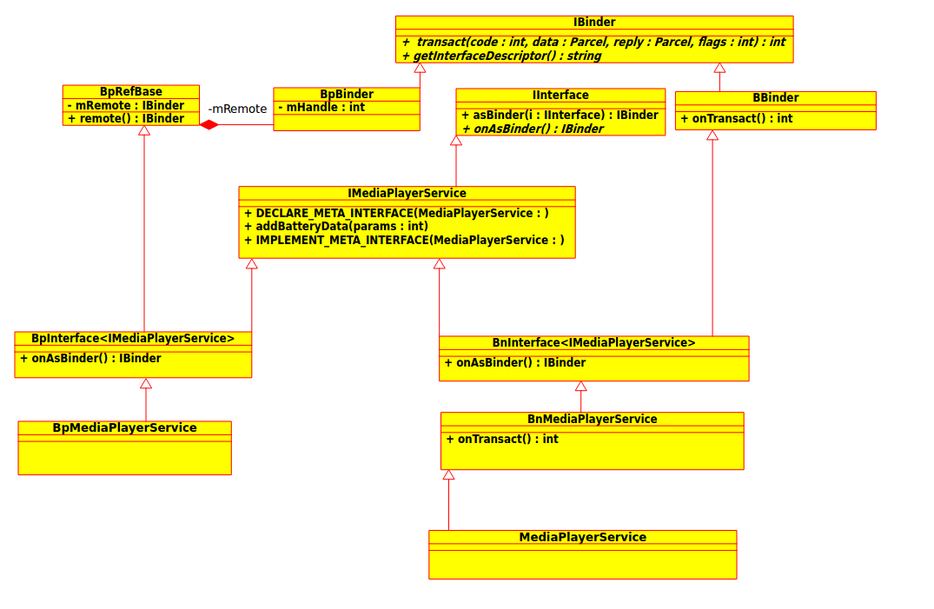

上图中的DECLARE_META_INTERFACE(INTERFACE)与IMPLEMENT_META_INTERFACE(INTERFACE, NAME)方法定义如下:

>>>Iinterface.h

// ----------------------------------------------------------------------

#define DECLARE_META_INTERFACE(INTERFACE) \
static const ::android::String16 descriptor; \
static ::android::sp<I##INTERFACE> asInterface( \
const ::android::sp<::android::IBinder>& obj); \
virtual const ::android::String16& getInterfaceDescriptor() const; \
I##INTERFACE(); \
virtual ~I##INTERFACE(); \

#define IMPLEMENT_META_INTERFACE(INTERFACE, NAME) \
const ::android::String16 I##INTERFACE::descriptor(NAME); \
const ::android::String16& \
I##INTERFACE::getInterfaceDescriptor() const { \
return I##INTERFACE::descriptor; \
} \
::android::sp<I##INTERFACE> I##INTERFACE::asInterface( \
const ::android::sp<::android::IBinder>& obj) \
{ \
::android::sp<I##INTERFACE> intr; \
if (obj != NULL) { \
intr = static_cast<I##INTERFACE*>( \
obj->queryLocalInterface( \
I##INTERFACE::descriptor).get()); \
if (intr == NULL) { \
intr = new Bp##INTERFACE(obj); \
} \
} \
return intr; \
} \
I##INTERFACE::I##INTERFACE() { } \
I##INTERFACE::~I##INTERFACE() { } \

#define CHECK_INTERFACE(interface, data, reply) \
if (!(data).checkInterface(this)) { return PERMISSION_DENIED; } \

// ----------------------------------------------------------------------

使用例子(IMediaPlayerService.h):

>>> IMediaPlayerService.h
public:
DECLARE_META_INTERFACE(MediaPlayerService);

>>>ImediaPlayerService.cpp
IMPLEMENT_META_INTERFACE(MediaPlayerService, "android.media.IMediaPlayerService");

请用 MediaPlayerService替换上面宏定义中的“ INTERFACE”即可。

Native层关于服务的注册与获取跟Java层的服务的注册与获取过程差不多。这里就不做分析。

6.Binder大管家ServiceManager

从前面分析可以知道，不管是Java层还是Native层要注册与获取服务，都是通过ServiceManager来注册与获取的。ServiceManager是Binder IPC通信过程中的守护进程，本身也是一个Binder服务。ServiceManager是由init通过解析servicemanager..rc文件而创建的，其所对应的可执行程序/system/bin/servicemanager，所对应的源文件是service_manager.c，进程名为/system/bin/servicemanager。

service servicemanager /system/bin/servicemanager
class core animation
user system
group system readproc
critical
onrestart exec - system system -- /system/bin/clmcheck -s init -n /system/bin/servicemanager
onrestart restart healthd
onrestart restart zygote
onrestart restart audioserver
onrestart restart media
onrestart restart surfaceflinger
onrestart restart inputflinger
onrestart restart drm
onrestart restart cameraserver
onrestart restart keystore
onrestart restart gatekeeperd
writepid /dev/cpuset/system-background/tasks
shutdown critical
6.1 main方法分析(service_manager.c)
int main(int argc, char** argv)
{
//打开binder设备/dev/binder
bs = binder_open(driver, 128*1024);
…
//成为上下文管理者
if (binder_become_context_manager(bs)) {
ALOGE("cannot become context manager (%s)\n", strerror(errno));
return -1;
}
..
//进入无限循环，处理Client端发来的请求
binder_loop(bs, svcmgr_handler);
return 0;
}
6.2 binder_open方法分析(servicemanager/binder.c)
struct binder_state *binder_open(const char* driver, size_t mapsize)
{
//通过系统调用，调用驱动binder的binder_open方法，打开Binder驱动文件
bs->fd = open(driver, O_RDWR | O_CLOEXEC);
...
//通过系统调用，调用Binder驱动的binder_ioctl函数获取binder版本
if ((ioctl(bs->fd, BINDER_VERSION, &vers) == -1) ||
...
}
bs->mapsize = mapsize;
//通过系统调用，调用驱动binder的binder_mmap方法，内存映射
bs->mapped = mmap(NULL, mapsize, PROT_READ, MAP_PRIVATE, bs->fd, 0);
...
return NULL;
}
打开binder驱动相关操作:
先调用open()打开binder设备，open()方法经过系统调用，进入Binder驱动，然后调用方法binder_open，该方法会在Binder驱动层创建一个binder_proc对象，再将binder_proc对象赋值给fd->private_data，同时放入全局链表binder_procs。再通过ioctl()检验当前binder版本与Binder驱动层的版本是否一致。
调用mmap()进行内存映射，同理mmap()方法经过系统调用，对应于Binder驱动层的binder_mmap方法，该方法会在Binder驱动层创建Binder_buffer对象，并放入当前binder_proc的proc->buffers链表。

6.3 binder_become_context_manager方法分析(servicemanager/binder.c)
int binder_become_context_manager(struct binder_state *bs)
{
//通过系统调用，调用Binder驱动的binder_ioctl函数设置为管理者
return ioctl(bs->fd, BINDER_SET_CONTEXT_MGR, 0);
}

6.3.1 binder_ioctl方法分析(drivers/android/binder.c)
static long binder_ioctl(struct file *filp, unsigned int cmd, unsigned long arg)
{
…
//走这里分支
case BINDER_SET_CONTEXT_MGR:
ret = binder_ioctl_set_ctx_mgr(filp);
if (ret)
goto err;
break;
...
}

6.3.2 binder_ioctl_set_ctx_mgr方法分析(drivers/android/binder.c)
static int binder_ioctl_set_ctx_mgr(struct file *filp)
{
//保证只创建一次mgr_node
if (context->binder_context_mgr_node) {
pr_err("BINDER_SET_CONTEXT_MGR already set\n");
ret = -EBUSY;
goto out;
}

//创建新的node，注意参数为NULL
new_node = binder_new_node(proc, NULL);
…
//设置全局mgr_node对象，即ServiceManager对应的node
context->binder_context_mgr_node = new_node;
...
return ret;
}
6.3.2 binder_new_node方法分析( drivers/android/binder.c)
static struct binder_node *binder_new_node(struct binder_proc *proc,
struct flat_binder_object *fp)
{
...
node = binder_init_node_ilocked(proc, new_node, fp);
...
return node;
}
6.3.3 binder_init_node_ilocked方法分析(drivers/android/binder.c)
static struct binder_node *binder_init_node_ilocked(
struct binder_proc *proc,
struct binder_node *new_node,
struct flat_binder_object *fp)
{
//fp传递的NULL，所以ptr=0,还记得new BpBinder(0)吗？0对应的就是ServiceManager
binder_uintptr_t ptr = fp ? fp->binder : 0;
//ServiceManager的fp传递的NULL，所以cookie =0
binder_uintptr_t cookie = fp ? fp->cookie : 0;
__u32 flags = fp ? fp->flags : 0;
return node;
}
6.4 binder_loop
ServiceManager进程循环读取底层Binder设备的数据并分给相应的Service处理。这里不在分析。

7.Binder的Kernel层暂不做分析。

